

Senior Practitioner report 2012–13


If you would like to receive this publication in an accessible format, please phone 9096 8427 using the National Relay Service 13 36 77 if required, or email officeofprofessionalpractice@dhs.vic.gov.au
This document is also available on the Internet at www.dhs.vic.gov.au/officeofprofessionalpractice
Unless indicated otherwise, this work is made available under the terms of the Creative Commons Attribution 3.0 Australia licence. The licence DOES NOT apply to any software, artistic works, images, photographs or branding, including the Victorian Coat of Arms, the Victorian Government logo and any Victorian Government departmental logos.
To view a copy of this licence, visit creativecommons.org/licenses/by/3.0/au
It is a condition of this Creative Commons Attribution 3.0 Licence that you must give credit to the original author who is the State of Victoria.
Authorised and published by the Victorian Government,
1 Treasury Place, Melbourne.
ISBN 978-0-7311-6673-2 (print)
ISBN 978-0-7311-6672-5 (online)
June 2014 (2981112).
Cover: ‘Demons Hidden’, painting by Hannah Wilkinson, winner of the VALID art competition, sponsored by the Senior Practitioner and presented at the VALID annual Having a Say Conference 2013.
Contents
Foreword from the Chief Practitioner of Human Services 1
Message from the Senior Practitioner – Disability 3
About the Senior Practitioner 5
Overview 5
Vision of the Senior Practitioner 5
Using an evidence-based cycle of evaluation/research to inform policy and practice 5
Our focus in 2012–13 6
Restrictive interventions reported to the Senior Practitioner 7
The use of restrictive interventions in Victoria 7
Compulsory treatment 15
Compulsory treatment data 15
Behaviour support plans 18
How well did behaviour support plans meet the legislative requirements of the Disability Act? 18
What do we know about the quality of behaviour support plans? 18
Quality of BSPs 19
From research to practice 21
Workforce development 21
Helping support professionals find alternative solutions to physical restraint 23
Assisting organisations to support clients with complex needs without restraint and seclusion 27
Informing policy and practice 28
Published research articles 28
Conference papers: 2012–13 30
Victorian Government published articles – July 2012 to June 2013 31
References 32

Foreword from the Chief Practitioner of Human Services

As the inaugural director of the Office of Professional Practice and Chief Practitioner of Human Services, I welcome this report, which outlines the substantial and significant achievements and progress of the Senior Practitioner – Disability.
I am delighted to be leading the new Office of Professional Practice, formed in December 2012 when the Office of the Principal Practitioner (Child Protection and Youth Justice) and the Office of the Senior Practitioner were brought together.
Already, the coming together of the areas of disability, child protection and youth justice has delivered benefits for our most vulnerable children and adults in Victoria such as the development of positive behaviour support for children with a disability in out-of-home care. I look forward to documenting these examples in detail in future annual reports.
The role of the office is to develop and drive best practice that delivers positive outcomes for human services clients – working with people and organisations to improve clients’ quality of life, protect them from harm, promote their development and safeguard their rights. The Senior Practitioner’s work has shown that change in practice is possible and can make a significant difference to the lives of people with a disability. The declines in the number of people subjected to seclusion over the past five years (see page 12) have seen reductions of at least 20 per cent of people over the past three years. This is a compelling finding and this represents an improvement in the quality of life and dignity of people accessing disability services.
The report documents the learning and development opportunities provided in 2012–13 which were used by staff to develop good-quality behaviour support plans. Recent findings that the quality of behaviour support plans is associated with reductions in the use of restrictive interventions for people with a disability is assisting services to provide best practice to the people they support.
Victoria is the only jurisdiction in the world that collects and analyses population-level data on people with a disability who are subjected to restrictive interventions. The Senior Practitioner’s team has used this data to amass a substantial evidence base. The number and impact of the peer-reviewed publications that have been published by staff in the Office of Professional Practice in partnership with other researchers in the past three years is highly significant. You can find a list of these publications on page 28. I am extremely proud of this contribution to the evidence base and to the disability field more broadly.
The ongoing work of the office in collaboration with a wide range of committed stakeholders, much of which is described within this annual report, underlines the critical importance that effective partnerships play in optimising outcomes for the vulnerable Victorians with whom we work.
Finally, I want to take this opportunity to thank the Senior Practitioner – Disability, Dr Frank Lambrick, who was formally appointed to the role in 2013, and to commend the team for their excellent work and contribution to the field over the past year.

Robyn Miller
Chief Practitioner, Human Services
Director, Office of Professional Practice
Department of Human Services

Message from the Senior Practitioner – Disability

This past year has been one of significant change for the role of the Senior Practitioner and team. During the year the team merged with the Office of the Principal Practitioner (Children, Youth and Families) to form the Office of Professional Practice. This new office provides practice leadership, encourages practice excellence and fosters continuous improvement to disability, child protection and youth justice professionals in Victoria. It is charged with supporting these professionals to enable them to provide support and care that is consistent with leading practice and with foremost regard for the safety and wellbeing of all clients, some of whom are Victoria’s most vulnerable people.
The role of the Senior Practitioner under the Disability Act 2006 continues under this new structure, ensuring that the rights of people with a disability who are subject to restrictive interventions and compulsory treatment are protected and that appropriate standards in relation to these practices are met. In what has been our sixth year of operation we have continued to work in collaboration with key stakeholders across three levels of intervention, ranging from involvement in individual cases and the provision of staff training and consultancy, through to the use of broader systemic strategies such as the ongoing refinements to the operation of the Restrictive Interventions Data System and capacity building work in collaboration with our mental health colleagues. Intervention across all of these levels is absolutely essential in order to ensure change in our practices and improvement in outcomes for one of the most vulnerable groups in our community.
There have been a number of key personnel changes over 2012–13. Two staff members from the Compulsory Treatment team went on maternity leave during the year, with Rebecca O’Sullivan taking leave in October 2012 and Kylie Bowden in February 2013 – both resulting in sensational outcomes! Jasreen Abeyaratne from Austrac began acting in Rebecca’s position in November and Carol O’Dwyer from the Specialist Services team in the West also started working in November as a practice advisor in Integrated Health Care, adding a needed psychological focus to that team.
I would like to take this opportunity to thank my team for their ongoing hard, innovative work and outstanding commitment, in what has been a year of significant and exciting change, both in terms of our immediate work and the broader context of the Department of Human Services and other partners. The team has continued to provide high-quality consultancy, education, information, monitoring, evaluation and research throughout the year. Finally I would like to acknowledge the contributions of our colleagues, both internal and external to the department, disability service providers, families, carers, advocates and other professionals who collaborate with us in our work. We look forward to continuing this relationship over the coming year and in meeting the challenges that lie ahead. This coming year will continue to see significant change unfold and the team’s skill and energy in approaching the challenges and great opportunities will be called upon and greatly appreciated.
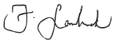
Dr Frank Lambrick
Senior Practitioner – Disability
Office of Professional Practice
Department of Human Services

About the Senior Practitioner

Overview
The Senior Practitioner role was established in 2007 by the Disability Act 2006 to protect the rights of people who are subjected to restrictive interventions such as restraint and seclusion, as well as those who receive compulsory treatment in Victoria. In addition, the Senior Practitioner is responsible for ensuring appropriate support standards are complied with.
According to the Disability Act, the Senior Practitioner must:
- evaluate and monitor the use of restrictive interventions across disability services and recommend improvements in practice to the Minister and Secretary
- undertake research into restrictive interventions and compulsory treatment and provide advice on practice options to disability support providers
- develop links and access to professionals, professional bodies and academic institutions for the purpose of facilitating knowledge and training in clinical practice for people supporting people with a disability
- develop guidelines and standards and provide education and information regarding restrictive interventions and compulsory treatment
- provide information regarding the rights of people who are subjected to restrictive interventions and compulsory treatment
- give directions to disability service providers in relation to behaviour support plans and treatment plans.

Vision of the Senior Practitioner
The vision of the Senior Practitioner is for an inclusive and safe community that supports people with disabilities to achieve dignity without restraints. The Senior Practitioner works with services to protect the rights of people with a disability and to influence practices that support people to achieve dignity without restraints.

Using an evidence-based cycle of evaluation/research to inform policy and practice
The use of restrictive interventions and compulsory treatment are evaluated annually. Findings are analysed, with identified areas of need researched in more detail. The results of research are used to inform policy and practice through publications and conference presentations to service providers and professionals. Education and information is also presented to service providers in the form of structural interventions using the Restrictive Interventions Data System (RIDS) – for example, structured questions within the electronic behaviour support plan (eBSP) and outreach clinical assessments and information at an individual level. The impacts of these interventions are reassessed at the end of every financial year.

Our focus in 2012–13

How the Senior Practitioner’s team made a difference to the quality of life for a young woman
Abby showed aggressive behaviour towards other people such as charging at and hitting others. As a result she was physically restrained by staff and excluded from accessing many activities in the community. Staff from the Senior Practitioner’s team assisted Abby’s support team to introduce positive support for Abby and to get her a much-needed mental health review by a psychiatrist. The psychiatrist suggested the team use a mood chart to monitor Abby’s changes in mood so staff could see when she was feeling unwell and what they could do to support her during this time. The staff also completed the positive behaviour support course ‘Getting it right from the start’ as well as ethical response training. In addition, they were provided with information from the local mental health team on how best to support a person with a mental illness. Twelve months on and Abby now accesses the community freely and she has not been subjected to any physical restraint in the past 12 months.
Abby’s story is one of the many individual achievements of the work of the Senior Practitioner. When the needs of people like Abby (who has high complex mental health needs) are well understood and supported appropriately, the need to use restrictive interventions decreases. This is consistent with our recent research, which shows that improvements in the quality of behaviour support plans (BSPs) can lead to reductions in restraint and seclusion use (Webber et al. 2011a; 2012). These findings have important implications for policy and practice; clearly if restraint and seclusion is to be decreased it is important to find ways to help disability services improve the quality of support they provide. The evaluation of the use of restrictive interventions across Victorian disability services showed that over the past financial year services reported fewer people as being subjected to seclusion when compared with the previous four years. On the other hand, services reported more people as being subjected to the use of mechanical restraint, physical restraint and routine chemical restraint (administered on a regular basis) while the number of people subjected to prn (as needed) chemical restraint has stayed the same.
To assist services to reduce their use of restrictive interventions, in 2012–13 two major strategies were put in place to assist services to produce good-quality BSPs: (1) workforce development, helping services improve the quality of the support provided to clients; and (2) Helping support professionals to find alternative interventions. In addition, to promote practice change across services, staff from the Senior Practitioner’s team have worked directly with disability service organisations (such as in developing the Roadmap for achieving dignity without restraint) and supporting organisations (such as by building the capacity of mental health services to assist dual disability clients). The impact of these strategies will be assessed over time, but the workforce development strategy is already showing significant changes in BSP quality.

Restrictive interventions reported to the Senior Practitioner
The Senior Practitioner evaluates and monitors the use of restrictive interventions across disability services and recommends improvements in practice to the Minister for Disability Services and Reform and the Secretary to the Department of Human Services. Every year the Senior Practitioner examines the trends from RIDS and identifies the priorities for supporting services to reduce the use of restrictive interventions. The following results are based on restrictive interventions reported to the Senior Practitioner in the past financial year (July 2012 to June 2013) compared with the previous four years.
Disability service providers must report to the Senior Practitioner about their use of four types of restrictive interventions: chemical restraint, mechanical restraint, physical restraint and seclusion. Chemical restraint refers to the use of medications where the primary purpose is to control a person’s behaviour. This precludes the use of medications for treating an identified/diagnosed medical illness or condition. Mechanical restraint refers to using a device (such as splints or restrictive clothing) to control a person’s movement. This precludes devices used for therapeutic purposes or to enable safe transportation (such as a buckle guard on a seatbelt in a car). Physical restraint is defined by the Senior Practitioner as the use of physical force that is not physical guidance (such as helping someone across the street) or physical assistance (such as assistance provided to help a person get dressed). Seclusion refers to the sole confinement of a person with a disability at any hour of the day or night in any room or area where disability services are being provided.
Every time a disability service provider uses a restrictive intervention they must provide the following information to the Senior Practitioner:
- information about the person subjected to the restrictive intervention, such as their gender and disability types
- the type of restrictive intervention used (chemical, mechanical, physical restraint or seclusion)
- the type of administration (whether it was: ‘routine’, which is administered on a ongoing basis such as daily or weekly; ‘prn’, which is administered in response to an incident when authorised within a BSP; or ‘emergency’, which is that administered in response to an incident but not included in a BSP).
This section of the annual report summarises the findings of this reporting from disability services in Victoria in 2012–13 and, where possible, compares these findings with the previous four years.

The use of restrictive interventions in Victoria
In the past financial year from July 2012 to June 2013, 1,975 individuals were reported to be subjected to restrictive interventions at least once during the year. To examine the proportion of people who were subjected to restrictive interventions who received a government-funded disability service, the RIDS data was compared with the total number of people with an intellectual disability who were reported by service providers as having received a disability service in the past financial year 2012–13 (Department of Human Services, 2013).This showed that approximately 9.6 per cent of people who had an intellectual disability were also reported to be routinely chemically restrained.
The majority of people who were reported to the Senior Practitioner in 2012–13 (77 per cent) were also reported in the four previous years as well. Thirteen per cent of people reported in 2012–13 had not been reported to the Senior Practitioner prior to 2012–13. This finding shows that the majority of people are reported to be restrained or secluded in the long term (at least over five years).
Over the past two financial years (2011–12 to 2012–13) the number of people reported to be restrained or secluded has changed depending on the type of restrictive intervention. Apart from routine chemical restraint and physical restraint showing an increase in the number of people from 2011–12 to 2012–13, the total number of people who were reported to be mechanically restrained has increased by 19 per cent from 2011–12 to 2012–13. The total number of people who were reported to be administered a prn chemical restraint has stayed unchanged, while the findings show that the total number of people who were reported to be secluded has decreased by 20 per cent from 2011–12 to 2012–13. The trends and factors associated with these trends for each of the restrictive interventions that are monitored by the Senior Practitioner are described in some detail below.

Chemical restraint
As seen in Figure 1 the majority of people who were reported to have been restrained or secluded in Victoria in the past five years were administered a chemical restraint on a routine or regular basis (chemical routine). The total number of people who are routinely chemically restrained has slightly increased over the past three financial years. This equates to an increase from 88 per cent of all people reported to the Senior Practitioner in 2010–11 to 90 per cent of all those who were reported in 2012–13. The total number of people reported to be administered a chemical prn restraint (chemical restraint used when needed) had been decreasing over the years from 2008–09 to 2011–12, and there was no change in total numbers restrained using prn chemical restraint in the past two financial years (2011–12 to 2012–13).
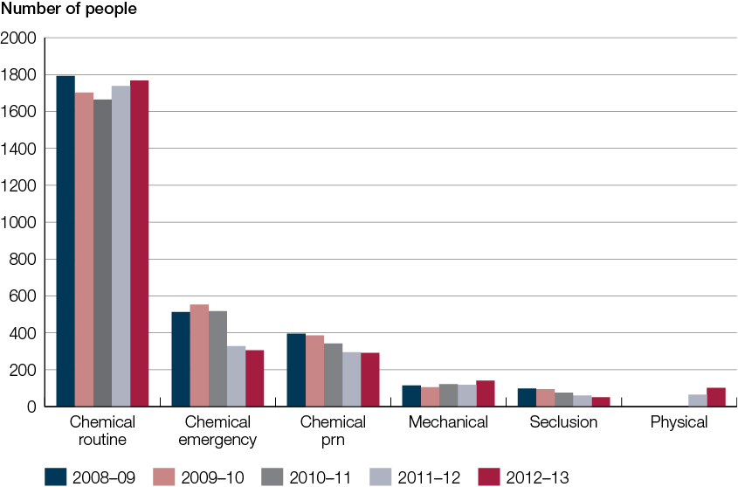
Figure 1: People with a disability reported to be subjected to chemical restraint, mechanical restraint or seclusion, 2008–09 to 2012–13
The total number of people who were reported to be administered chemical restraint in an emergency (where there is no BSP) has decreased since 2010–11. This is most likely due to more accurate reporting by services and/or detection by the Senior Practitioner.

Types of chemical restraint
Figure 2 shows the total number of people reported to the Senior Practitioner who were reported to be administered different types of chemical restraint over the past five years. As can be seen the majority of people in every year were reported to be administered an atypical antipsychotic. In contrast, fewer people have been administered typical antipsychotics over the past few years (15 per cent in 2012–13 compared with 25 per cent in 2008–09), while more people each year were administered atypical antipsychotics (60 per cent in 2012–13 compared with 53 per cent in 2008–09). This demonstrates a change in prescribing practice and may be due to the significant work the Senior Practitioner’s team has done with the Royal Australian and New Zealand College of Psychiatrists. The reported use of benzodiazepines has also decreased from 26 per cent in 2008–09 to 20 per cent in 2012–13) while the use of other chemical restraints has remained unchanged.
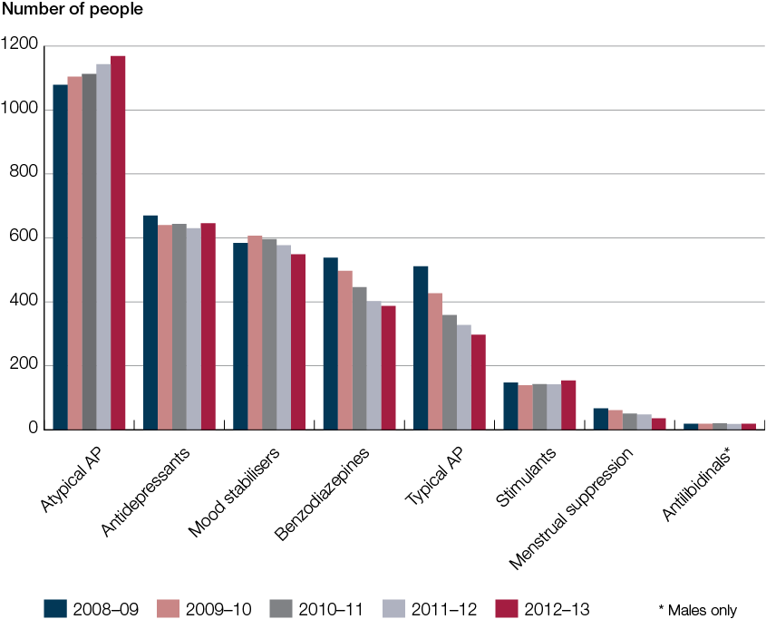
Figure 2: People with a disability reported to be chemically restrained, by type of restraint, 2008–09 to 2012–13

Polypharmacy of antipsychotics
Some people are administered more than one antipsychotic medication at the same time. The practice of polypharmacy of antipsychotics is questionable in people with an intellectual disability, especially given the lack of research regarding the efficacy of antipsychotics for managing behaviours of concern (Tsiouris et al., 2012). The number of people who were administered two or more antipsychotics at the same time has been decreasing gradually from 288 in 2008–09 to 231 people in 2011–12; however, there were no further decreases found in 2012–13. When the total number of people reported to be chemically restrained is taken into account, the proportion of people who were reported to be administered more than one antipsychotic medication at the same time has decreased from 15 per cent in 2008–09 to 12 per cent in 2012–13. This decreasing trend may in part be due to the reviews by the Senior Practitioner’s integrated health team as well as a more collaborative approach prescribers are taking to address this complex issue (see page 27 Assisting organisations to support clients with complex needs without restraint and seclusion).

Mechanical restraint
The reported use of mechanical restraint has shown a 19 per cent increase in the past financial year (2012–13) when compared with the previous year (2011–12). As can be seen in Figure 3, the increase can be accounted for by an increase in adults who were reported. In addition, the majority of the increase has been reported from group homes and from day services and includes 46 people who were not reported to be mechanically restrained in the previous year.
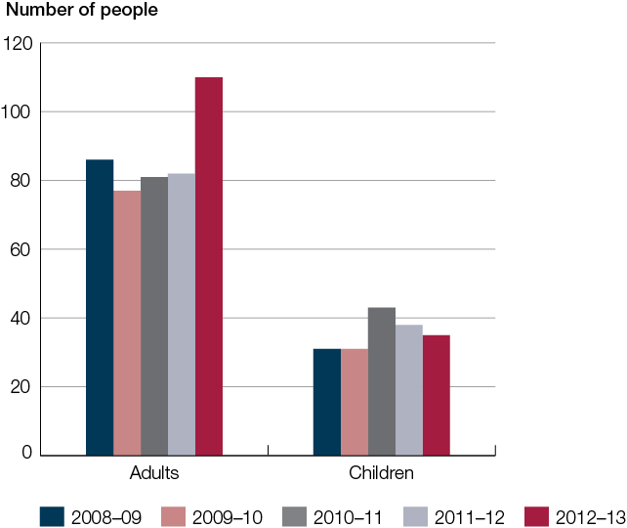
Figure 3: People with a disability reported to be mechanically restrained, by age category, 2008–09 to 2012–13
On average, 68 per cent of people who were reported to be mechanically restrained over two years were also reported to be mechanically restrained the following year, suggesting the use of mechanical restraint tends to be long term (at least over three years). It is unclear why there has been an increase in the number of people reported; however, some of this increase appears to be due to services being better informed about what constitutes mechanical restraint rather than a change in practice. The increased awareness and compliance with reporting to the Senior Practitioner is seen as a positive step towards a more accurate oversight of practice on the ground.

Types of mechanical restraints
Figure 4 shows the four most commonly used mechanical restraints reported by disability services in Victoria. In the past three years the most commonly reported mechanical restraint is some form of restrictive clothing (this includes any kind of clothing that restricts movement in any way, including clothing that the person cannot remove themselves). The increases in mechanical restraint in 2012–13 are accounted for by the increased reported use of restrictive clothing. As can be seen in Figure 4, the number of people reported to be mechanically restrained with belts, straps and splints has decreased. While the number of people reported to be mechanically restrained with gloves has stayed the same.
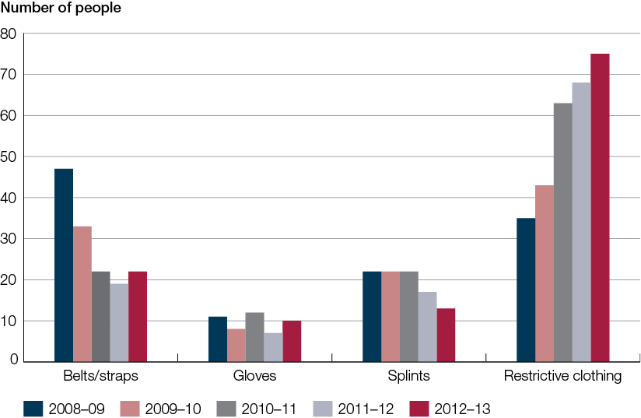
Figure 4: People with a disability reported to be mechanically restrained using the four most common types of mechanical restraint, 2008–09 to 2012–13
The majority of people (97–99 per cent each year) who are mechanically restrained are reported to show harm to self. This finding suggests that people who show harm to self may be at risk of being mechanically restrained. Best support practice suggests that people who show harm to self should be provided with a comprehensive assessment of their needs including physical and mental health, past trauma and a functional behaviour assessment of all behaviours of concern to determine appropriate positive behaviour supports. Although mechanical restraints may prevent self-harm while they are applied, they do not solve the problem(s) that cause the person to self-harm in the first place. In addition, there is evidence that mechanical restraint over time can become self-restraining; that is, the person seeks to be mechanically restrained because what they have learnt is that mechanical restraint is the solution. Engaging the client in positive strategies and other replacement behaviours that staff and carers feel confident to implement are key drivers to better outcomes.

Seclusion
The reduction in the use of seclusion is a very pleasing and significant finding. It represents increased competence and skills in our service providers who are finding alternative ways to support people who show behaviours of concern by using more compassionate and trauma-informed ways. Seclusion is a form of social isolation known to be associated with morbidity and mortality. The harm caused by seclusion includes both physical harm, such as broken bones or soft tissue damage, as well as emotional harm. Social isolation is thought to be one of the worst types of punishment. People who have experienced seclusion tend to feel negative about the experience and say that the worst aspects were the loneliness, lack of autonomy and violation of trust. The majority of people who undergo seclusion have already been traumatised and seclusion just adds to their trauma. Not surprisingly, in times of crisis most people say that what they need is the support of other people, not to be isolated from them.
The reported use of seclusion in 2012–13 shows a decrease of 20 per cent compared with
2011–12. Indeed, the reported use of seclusion over the past three years has shown a significant decrease each successive year since 2008–09 (see Figure 5).
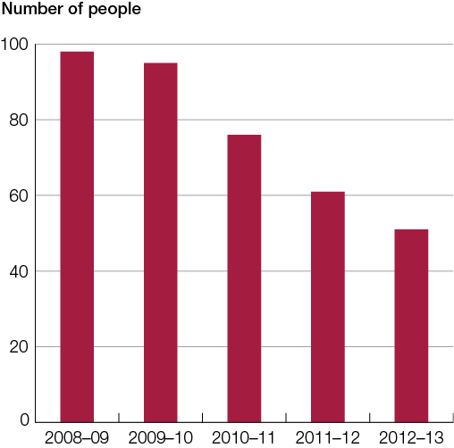
Figure 5: People with a disability reported to be subjected to seclusion, 2008–09 to 2012–13
Figure 5 shows the total number of people secluded between 2008–09 and 2012–13. From
2008–09 to 2009–10 there was a three per cent decrease in the number of people reported to be secluded. However, from 2010–13 there have been between 20 and 24 per cent each successive year. In addition, decreases in numbers of people reported to be secluded has been seen in most service types and in both males and females. This decreasing trend may in part be due to increases in the quality of BSPs and is a testament to the work of the Senior Practitioner’s team.
Our data show that some people are more likely to be secluded than others (Webber, Richardson and Lambrick, in press). People with a reported psychiatric disorder are 2.8 times more likely to be secluded than people without a psychiatric disorder and people with autism are also more likely to be secluded than people without autism. People living in residential institutions are more likely to be secluded than people who don’t live in institutions, but the risk of seclusion for those living in institutions in 2012–13 has decreased slightly since 2011–12.

Physical restraint
In July 2011 the Senior Practitioner requested service providers to report on their use of physical restraint for the first time. A total of 61 people (three per cent of all those reported to the Senior Practitioner) were reported to be physically restrained in 2011–12 and this has increased to 102 in 2012–13. This is likely to be the result of more accurate reporting as services become more familiar with exactly what constitutes physical restraint.
The results showed that more males than females were restrained (73 per cent of those restrained were males and 27 per cent were females). A significant proportion of people who were physically restrained were reported to have autism (45 per cent). The majority of people were reported from day services (41 per cent) and supported accommodation (34 per cent). The majority of people who were physically restrained were also chemically restrained (60 per cent).
While the total number of people reported to be physically restrained increased in 2012–13, the average number of episodes per person of reported physical restraint decreased by 7 per cent and the average number of reported prohibited physical restraint episodes per person decreased by 5 per cent. These decreases may be a result of the outreach offered by the Senior Practitioner’s team.
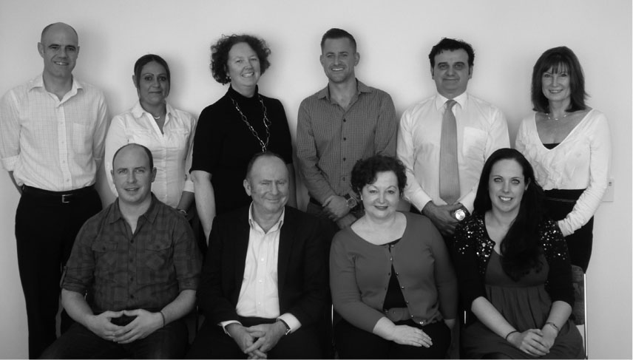
Part of the Senior Practitioner team:
Back row left to right: Robin Dale, Bonnie O’Leary, Mandy Donley, Brent Hayward, Anthony La Sala, Dr Lynne Webber
Front row left to right: Padraig Fitzpatrick, Dr Frank Lambrick, Maree Skiadas, Dr Fiona Murphy

Compulsory treatment
A small percentage of people subject to restrictive interventions (two per cent of the people reported to the Senior Practitioner) are also detained for the purposes of treatment because they pose a significant risk of serious harm to others. Part 8 of the Disability Act allows for civil detention through supervised treatment orders (STOs) made by the Victorian Civil and Administrative Tribunal (VCAT). It also permits court-mandated detention and treatment in a residential treatment facility through orders such as residential treatment orders, parole orders, custodial supervision orders and extended supervision orders. The Senior Practitioner is responsible for supervising the implementation of treatment provided to these people through monitoring the approved treatment plan and ensuring it will be of benefit to the person. VCAT determines whether a treatment plan is appropriate (having regard to specific criteria) and may confirm or vary a treatment plan.

Compulsory treatment data
In the 2012–13 financial year, 33 people were subject to compulsory treatment, with 39 VCAT hearings attended by the office to fulfil functions under the Disability Act. During this time there were 18 STOs and 12 residential treatment facility based orders issued. The average length of treatment plan certificates over this period was 10 months, which was similar to the average length in 2011–12.
While the total number of people subject to compulsory treatment over the previous four years (2008–2011) has not varied significantly (41–42 people per year) the number in the past financial year was significantly less. It is unclear why there has been a marked reduction in numbers but the Senior Practitioner is undertaking a project to examine possible reasons for this change.

Material change to treatment plans
A material change is a change that results in a treatment plan no longer reflecting the terms that the parties originally intended (those approved through the Senior Practitioner and VCAT). To be material, the change must be ‘significant and relevant’ – affecting an important part of the plan and the rights of the parties to it.
An example of a material change would be an increase in chemical restraint for a person. If the dosage of the medication a person is prescribed is increased to a level greater than the range specified in their treatment plan, this proposed change would warrant VCAT’s approval. No variation to the treatment plan or to the medication administered to the person can occur without VCAT approving an application for material change.
If an emergency situation arises, under the Disability Act the Senior Practitioner can approve a material change, and this will subsequently be heard by VCAT. Approval by the Senior Practitioner can only be made in an emergency situation (needing prn medication) and if the change is likely to occur again, the Authorised Program Officer (APO) must lodge an application with VCAT to vary the treatment plan.
Three material change applications were lodged in 2012–13, and all but one was approved by VCAT. These three applications related to emergency material changes.

Revocations
Under the Disability Act, the Senior Practitioner, APO or person with a disability can apply to VCAT to have an STO revoked. If a person subject to an STO no longer meets the legislative criteria to warrant an order being in place, a submission is prepared and submitted to VCAT so it can make a decision regarding revocation of the order. As an STO is a civil order that mandates the detention and supervision of an individual with an intellectual disability, it is important that if a person no longer meets all of the necessary legislative criteria that require compulsory treatment, that their support requirements are reviewed and, where appropriate, the order revoked.
Prior to preparing a revocation submission to VCAT, the APO and the office liaise about the particular individual and the reasons that an STO is no longer applicable. This discussion assists both parties in compiling separate submissions to VCAT outlining the legislative criteria the person no longer satisfies.
A revocation hearing at VCAT subsequently takes place and if VCAT is satisfied the person no longer meets the necessary criteria to be subject to an STO, the order is revoked. Even if a person subject to an STO has their order revoked, continuing services for the individual are organised. If restrictive interventions (including ongoing community supervision in the absence of detention) are still in place, a BSP under Part 7 of the Disability Act is necessary. In 2012–13 four STOs were submitted for revocation consideration to VCAT and all of these were subsequently revoked.
All people who are subject to revocation are reviewed by the compulsory treatment team for a minimum of six months post-revocation. This follow-up fulfils legislative requirements under section 24 of the Disability Act and ensures that continued support and advice is available for service providers in regard to restrictive interventions and BSPs.
This process also allows for information to be gathered about the framework of support available post-revocation and will inform future advice regarding successful treatment strategies hat result in removing STOs and what support is necessary for people moving into the community without the need for a treatment order.

Compulsory Treatment Team:
Kylie Bowden, Fiona Murphy, Jasreen Abeyaratne

Compulsory treatment case study
Jack is a young man with moderate intellectual disability and autism. He is generally quiet, sensitive and gentle, with a playful sense of humour. He is able to form strong bonds with others and enjoys regular visits from his mother. He also enjoys spending time with staff in the community.
However, approximately 18 months ago Jack was spending the majority of his time in seclusion due to behaviours of concern such as punching, kicking and biting others, as well as kicking and punching walls and vehicles, causing harm to himself. As a result, Jack was withdrawn and isolated. He had not had a day service for many years and he spent the vast majority of his time secluded in an area of the group home.
Establishing a clinical team to find ways to identify and increase support for Jack’s unmet needs was an important step towards changing things for Jack. This team included all line managers, a practice leader, members of the Behaviour Support Service and an external clinician. The team guided the work that needed to be done to change things for Jack by establishing good teamwork and effective communication, and by following the principles of positive behaviour support. Importantly, the group established close working relationships with the house supervisor and the staff via a strong physical presence in the group home, leading the practice change with role modelling and staff coaching. Members of the clinical team provided support and direction to the staff as and when required, even working alongside staff on active night shifts and on the weekends and after hours.
The good work by staff paid off and Jack is now a changed man. The overall time Jack spends in seclusion has decreased and there have been significant improvements in both the severity and the frequency of his behaviours of concern. Importantly, he has developed relationships with all the staff who support him, which has allowed staff to engage with him at home and in the community. He has also recently begun to participate in an outreach-type day service, which is allowing him opportunity to explore a range of community-based activities and to develop new relationships outside the service. He is currently engaging in a variety of independent living skills and communicating verbally much more than previously. Jack’s mother reports that he is the happiest she has even seen him.

Behaviour support plans
Any person who is subjected to restraint or seclusion in disability services in Victoria must have a BSP that describes how the person will be supported so that the use of restrictive intervention is only used as a last resort. One of the Senior Practitioner’s roles is to provide information and directions to disability service providers in relation to BSPs and treatment plans.
To assess BSPs, the Senior Practitioner reviews BSPs for:
- legislative compliance by using the aspects specified in the Disability Act
- the presence of evidence-based quality components of a BSP using the Behaviour Support Plan – Quality Evaluation II (BSP-QE II) (Browning-Wright, Saren and Mayer, 2003) – for example, the presence of a functional behaviour assessment
- presence of clinical aspects – for example, whether the restrictive intervention is the least restrictive under the circumstances.

How well did behaviour support plans meet the legislative requirements of the Disability Act?
The Disability Act requires service providers to provide information about the person, the disability provider, the independent person and that the BSP is approved by the authorised program officer. The results of the past two years show that services were 97–100 per cent compliant in providing this information. This result is due to the professionalism of program staff and the RIDS system changes – this information must be provided in order to complete and authorise a BSP successfully.

What do we know about the quality of behaviour support plans?
The Senior Practitioner uses the BSP-QE II to objectively assess the quality of BSPs received from disability service providers in Victoria. The BSP-QE II uses 12 evidence-based quality components to determine the overall quality of BSPs. Although the BSP-QE II was developed in the United States for children, it was validated by the Senior Practitioner for use in Victoria with adults with an intellectual disability and found it to be a valid and reliable assessment of the quality of BSPs written for adults living in Victoria (Webber et al., 2011b). In previous work, the Senior Practitioner also found evidence that BSP quality impacts on prn restrictive intervention use (Webber et al. 2011a). More recently evidence was found that higher quality plans as determined by the objective assessment obtained through the use of BSP-QE II are more likely to result in decreases in the use of restrictive interventions than lower quality plans (Webber et al., 2012).
This study also showed that those BSPs that completed a functional behaviour assessment (assessments that attempt to understand the reason why the person used the behaviours of concern) were more likely to result in the largest decreases in the use of restraint and seclusion. The results of this study are clear: to decrease the use of restrictive interventions it is important to make sure functional behaviour assessments are done for each behaviour of concern.
The following example shows that when the function of the person’s behaviour is understood and the person is supported to obtain what they need or want their behaviours of concern can decrease dramatically so that restraint and seclusion are no longer necessary.

How understanding and supporting a person’s sensory needs helped to reduce behaviours of concern and restraint
Ali showed a behaviour of concern that put her health at risk – eating inedible objects. In seeking a solution, her respite provider read through her file notes and noticed that Ali had previously had a sensory assessment done a few years ago. He used this information to create a healthy alternative solution to her behaviour of concern by matching each of her sensory-seeking behaviours with a type of food or activity that could be used throughout her time at respite. The staff developed a daily timeline that showed changes of activities throughout the day to meet all of Ali’s sensory needs. For example, if Ali went to eat inedible items on the ground, she was to be given crunchy edible foods such as celery or carrot sticks. The importance of providing Ali with a mixture of different sensory sensations, including chewy objects such as liquorice, jelly or rice yoghurt and rice cakes, is essential to meeting her sensory needs. Soft gooey foods were given at night to help her relax before bed. In addition, when Ali was ready for bed she was given a soft sensory item like a soft scarf or some wool she could run her fingers through. For optimum success, all of the items needed were prepared ahead of time ready for her visit to respite so that her support person could grab what was needed quickly. Within a weekend period of three days, the number of behaviours of concern reduced from 10 in a day to one incident and Ali showed she was calmer and happier to be at respite. Understanding Ali’s sensory needs and being able to provide for these reduced her need to eat inedible objects. The next step for Ali would be to teach her to use some alternative communication (such as using a personal communication dictionary) to let her carers know what she wants. This way she will have a replacement behaviour that she can use anywhere to have her needs met.

Quality of BSPs
The overall quality of BSPs remain unchanged since 2011–12 and on average services are achieving 10.5/24, which is below the standard required to decrease the use of restraint and seclusion (Webber et al., 2012). As can be seen in Figure 6, on average half of the quality components are well written while the other half are not covered in most plans.
BSPs written in 2012–13 continue to provide a good description of:
- the predictors of behaviours of concern
- the behaviour of concern
- the factors that make the behaviour of concern occur
- the function or what the behaviour of concern might mean for the person using it
- environmental changes staff should make to reduce the likelihood the person will show the behaviour of concern
- reactive strategies staff should use when a person shows the behaviour of concern.
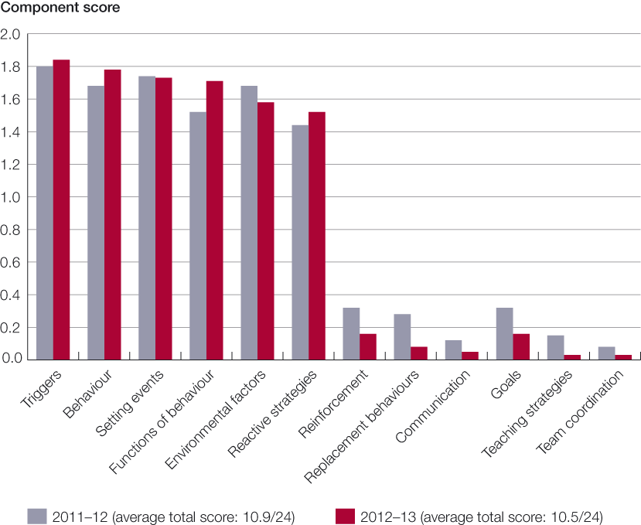
Figure 6: Average score for BSP components on the BSP-QE II, 2011–12 and 2012–13
However, BSPs still need to provide information about:
- what replacement skills could be taught to the person that would enable the person to meet the function of the behaviour of concern in an appropriate way
- how these replacement skills would be taught by staff and carers, and how the person would be encouraged (reinforced) to use the replacement behaviour
- the goals of the BSP
- the team coordination of the plan (who will do what)
- how the plan will be reviewed over time.
Based on these findings, the Senior Practitioner’s team put in place several strategies to assist services to improve the quality of their BSPs. These initiatives are described in the next section.

From research to practice
In 2011–12 the data showed that the quality of BSPs was related to the use of restrictive interventions and that plans that reached a certain level of quality showed decreases in restrictive interventions, while plans that did not showed increases or stayed the same (Webber et al., 2012). The data also showed differences across organisations as to whether or not seclusion was used and that people with dual disability (people with an intellectual disability and psychiatric disorder) were more likely than people without dual disability to be secluded (Webber, Richardson and Lambrick, in press). Finally, the data showed that some services required information and alternative strategies to use instead of restraint and seclusion. Two major strategies were put in place to achieve this: (1) workforce development – working with services to help them improve the quality of the support plans developed for clients and (2) working with organisations to support people with high support needs without using physical restraint.

Workforce development

Supporting staff to develop high-quality behaviour support plans: the Positive Behaviour Support – Behaviour Support Planning pilot project
Although previous research showed there had been improvements in the quality of BSPs from 2007 to 2009 (McVilly et al., 2012), the overall quality of BSPs has remained unchanged since 2009. On the basis of recent findings the Senior Practitioner put two strategies in place:
- to improve the RIDSeBSP to incorporate all components of quality (see the RIDSeBSP toolkit)
- to revise the ‘Getting it right from the start’ program to include information about how to improve the quality of BSPs . The revised ‘Getting it right from the start’ program was renamed the Positive Behaviour Support – Behaviour Support Planning (PBS-BSP) pilot project.
The PBS–BSP pilot project was designed to provide disability support staff with the information needed to design high-quality behaviour support for people with high needs. It was designed as a train–the-trainer program so that disability managers and authorised program officers could mentor and lead other staff to deliver high-quality behaviour support to their clients. The pilot project was designed in collaboration with services (Yooralla) and with Department of Human Services learning and development staff.
A total of 172 people attended the four-day PBS-BSP workshops held in May and October 2013. Representatives from 59 community service organisations and three Department of Human Services divisions attended, which provided training for one authorised program officer and one manager from each organisation. Preliminary data on behaviour support quality shows significant changes in quality for those who attended the course. Associate Professor Keith McVilly from Deakin University is comprehensively evaluating the impact of the course on staff and outcomes for clients. It is expected that a final report and recommendations for rollout in Victoria will be available in May 2014.
It should be noted that there has been much interstate interest in this course. Five departmental officers from the South Australian Government and the Senior Practitioner from Tasmania attended the workshops with a view to implementing the program in their respective states. In addition, Dr Lynne Webber was invited by the Western Australia Disability Services Commission to pilot the course in Western Australia early in April 2013 for implementation by the WA positive behaviour support teams. Dr Webber was also invited to present this work at the Behaviour Support Conference 2013 in Sydney as keynote speaker on 6 June 2013 and in Brisbane at the Queensland Advocacy Incorporated Restrictive Practices Forum on 30 August 2013.

Providing quality support materials to services: The RIDSeBSP toolkit
The Senior Practitioner’s team has revised the Restrictive Intervention Data System electronic Behaviour support plan practice guide. The new practice guide, called the RIDSeBSP toolkit, will help disability staff design high-quality support plans. The RIDSeBSP toolkit includes a new behaviour support planning guide that includes questions about all components of quality. The RIDSeBSP toolkit was published in July 2013 and training in its use has been provided to all disability service providers since August 2013. Training will continue on an as-needs basis for all disability service providers in Victoria.
During 2013–14 the Office of Professional Practice is providing training to all disability professionals in how best to use the toolkit. Training covers the four sections of the toolkit:
- Why we should develop good-quality plans
- How to develop a good-quality plan with the support team
- How to upload a BSP into the Restrictive Intervention Data System
- Some useful assessment tools and forms.
Training in how to use the toolkit began in July 2013. It should be noted that there has also been interstate and overseas interest in the toolkit. One service that operates across all eastern states will be using it in all states. Interest in using the toolkit was also sought from a disability service in New Zealand.

Small change projects: the Promoting Dignity Grants
The Senior Practitioner regularly sponsors small change projects through the Promoting Dignity Grants. The aim of the Promoting Dignity Grant initiative is to provide opportunities for disability support workers to develop and implement creative, practical and alternative solutions for people with a disability who are subject to restrictive interventions. In December 2012 the Disability Research Reference Panel chaired by Associate Professor Paul Ramcharan recommended to the Senior Practitioner that 14 teams from different services be granted $2000 each to implement creative solutions.
The creative solutions trialled by services included: increasing community participation to reduce restrictive interventions; teaching people skills they wanted to learn and finding out people’s preferred ways to relax; finding out the important things in people’s lives; and using an iPad to assist a person communicate their needs. Eleven final reports were received and these were showcased as posters at the Senior Practitioner’s Seminar Series in October 2013. The example below shows how a service listened to a young man’s concerns, involved him in planning and supported him to have choice and control over his life. The service collected evidence about the numbers of behaviours of concern and restrictive interventions and found that their interventions made a difference in reducing both behaviours of concern and restrictive interventions.

Increasing quality of life through understanding a person’s needs
Luke is an 18-year-old man who showed behaviours of concern such as physical aggression towards others. The response from services in the past had been to physically restrain Luke when he showed this behaviour. But this response did not reduce his behaviours of concern. Although he had been involved for some time in anger management and self-esteem programs, Luke’s behaviours of concern were not decreasing. Luke didn’t have a BSP so the team set about to design one. A functional behaviour assessment revealed that Luke’s behaviours of concern were mostly behaviours of protest at not having choice to do what he wanted in his day. As a result, Luke was involved in planning his own support. His key worker asked him what he wanted to achieve and do, and he was given choice and control over participation in the program. His support team listened to him carefully and taught him if he needed a break he could ask for one and staff would assist him to relax using mindfulness and other relaxation techniques (like relaxing with his iPod). Over a period of eight months, the results showed major reductions in both the use of physical restraint by staff (no physical restraint in seven months) and behaviours of concern (a decrease in physical aggression to others from four in a month to none in three months). This provided evidence that the interventions put in place by the service made a real difference to Luke’s quality of life.

Practice seminars
The Senior Practitioner sponsored a two day emerging practice seminar in November 2012 for service providers called Fostering Quality of Life and Goal Mastery for Individuals with Significant Disabilities. The workshop was led by Dr Lisa Marshall, Ms Kim Sanders and Ms Shamsi Sadeghzadeh from Grafton Incorporated Health Services, Virginia, USA. Grafton has been able to reduce the use of restrictive interventions significantly through the use of trans-disciplinary assessment, planning and treatment. The team covered trans-disciplinary treatment planning and assessment, strategies to promote quality of life and self-determination and how to use goal mastery to promote self-determination and quality of life and measure outcomes of interventions. The seminar was well attended by a variety of services including some special education teachers.

Helping support professionals find alternative solutions to physical restraint
As part of the physical restraint reduction strategy, funding was made available from the Victorian Government to disability support providers for clinical assessments, training and equipment. The Senior Practitioner’s office helped to identify that many of the referrals were for children and young people with a disability under the age of 18 as well as five referrals for adult residents of Colanda. Two discrete projects were developed to examine the impact on both of these groups. Both projects collated the recommendations made from speech pathologists and occupational therapists and examined common themes and strategies to promote better practice.
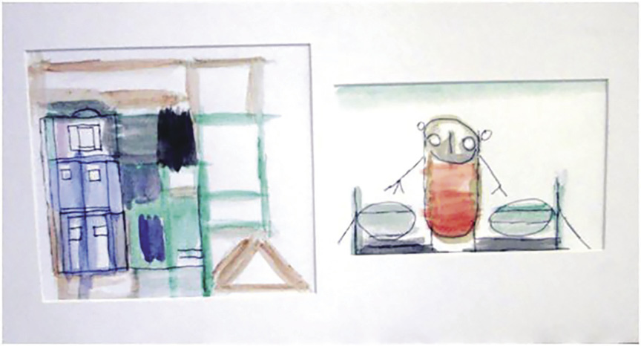
Painting by Timothy Ryan, winner of the VALID ‘Having a Say’ 2013 Conference Art Competition
Theme: Expression of My Community

Early intervention
This project assisted children attending a children’s respite facility managed by a community service organisation, Villa Maria. The primary aims of the project were to:
- complete outstanding assessments for those people identified as being physically restrained
- review all people under age 18 who were identified as being physically restrained
- reduce the use of restrictive interventions for this group
- develop alternative strategies to help reduce restrictive interventions
- promote best practice in supporting people under age 18 who receive disability services.
Employees completed intensive training through Scope’s Communication Resource Centre, which resulted in a reduction in restrictive interventions for those children involved in the project.
A final report for this study will be made available by May 2014.

Active support
This project included four residents of Colanda, one of the last residential institutions in Victoria. Staff from two units were included in training specifically designed to implement recommendations from clinical assessments, which formed the basis for transition plans into the community for these residents. The primary aims of the project were to:
- complete outstanding assessments for those people identified in the physical restraint reduction strategy
- reduce the use of restrictive interventions for these people
- develop alternative strategies to help reduce restrictive interventions
- inform the individual transition plans for this group.
Ron is a 52-year-old man who has lived most of his life in a group home. He has limited ability to communicate and has a limited number of phrases he uses with several meanings, which makes it difficult to get his needs known. When he gets frustrated he damages property and the staff have been using chemical and physical restraint and seclusion when this happens. Speech and occupational therapy assessments found that he loves gardening and needs a personal communication dictionary. The Active Support project team followed up these recommendations with his support staff and the staff established a garden for him.
The garden made a difference. Six months prior to establishing the garden Ron had 30 episodes of seclusion and this decreased to 13 episodes. Physical restraint episodes have stayed the same at one in each six-month time period and chemical restraint has increased from none during the six months prior to the garden to four episodes of chemical restraint during the six months of having the garden. Taken together, the establishment of the garden seems to have decreased seclusion but not physical or chemical restraint. What is needed now is to give Ron a way to communicate his needs by developing and helping him and support staff to use a personal communication dictionary. This way Ron will have a replacement behaviour that he can use instead of his behaviour of concern.
Outcomes for this project demonstrated a reduction in the total number of restrictive interventions for those involved in the project, as well as highlighting areas of practice that could be built upon. A final report for this study will be made available by May 2014. The above case study is an example of the outcomes for one of the participants in the Active Support project.

Building collaborative partnerships with services: Roadmap for achieving dignity without restraint
The Roadmap for achieving dignity without restraint was commissioned in 2009 from Associate Professor Paul Ramcharan from RMIT University to provide human services organisations with an innovative, evidence-based practical tool for promoting dignity, choice, wellbeing and self-determination as well as improved outcomes for clients. The roadmap resource was developed in partnership with services during 2011–12 and, in June 2013, Associate Professor Paul Ramcharan commenced a pilot, which provided training to three organisations (two community services organisations) and one departmental area team on how to use the roadmap resource within their organisation.
The focus of the roadmap resource is to help disability service organisations attempt to understand people’s behaviours of resistance or protest (behaviours of concern such as harm to others) and find ways to promote human rights, choice and wellbeing for people with a disability to reduce restraint and seclusion.
The pilot is currently being evaluated and the final report is expected to be available in May 2014.

Developing links and access to professionals
The Senior Practitioner’s team worked in collaboration with the Monash University occupational therapy department to provide placements for two occupational therapy students to complete a project on finding better support for people with complex support needs. Elleesha Teichman and Katie White completed two very successful projects while on placement, as detailed below.

Environmental influences on the use of restraint in children’s respite services
The purpose of this project was to examine the environmental influences on behaviours of children with developmental and/or intellectual disabilities in order to create engaging and inclusive environments in children’s respite facilities. This was achieved over time by considering factors of both the physical and social environments to implement changes to the way children’s respite facilities are built and managed by disability services across Victoria. The report compiled a literature review of architectural design principles to inform policy on the planning and building of new government-funded children’s respite houses for a transitional population of children with developmental and/or intellectual disabilities. The Victorian Government is now using this report in its design of new accommodation planned by the Department of Human Services’ Service Development and Design branch.

Sensory cataloguing and sensory equipment system
The purpose of this project was to find ways to help calm children to prevent behaviours of concern from arising or escalating. The sensory equipment within the catalogue was categorised into different sensory use by their most obvious sensory use: oral motor; visual and auditory; vestibular and proprioception; tactile and touch; and deep pressure. Each category was coded with a colour for ease of use and toys were categorised into tubs based on category of sensory use. Using a child’s sensory preferences they are allocated coloured dots that represent the sensory toy categories that they will find calming. This was so successful the service has purchased another two kits.
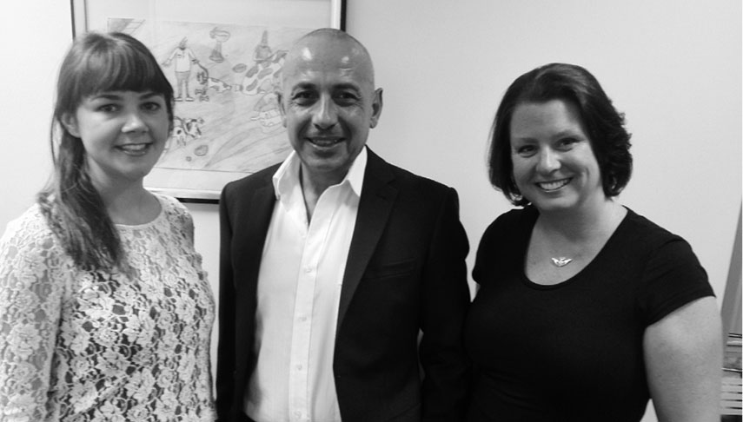
More staff members:
Carol O’Dwyer, Savva Zavou, Moira Buchholtz

Painting by Carolyn Norman, winner of the VALID ‘Having a Say’ 2013 Conference Art Competition
Theme: Expression of My Community

Assisting organisations to support clients with complex needs without restraint and seclusion

Building capacity to assist dual disability clients through mental health services
In Victoria, area mental health services hold the primary responsibility for assessing and treating mental health problems, including in people with intellectual disability (ID). People with ID and mental health disorder are referred to as having a dual disability. Staff in general mental health services routinely report a lack of confidence, skill and training in dealing with clients with dual disability. They also frequently report frustration at the difficulties of managing people with ID in inpatient settings, and at times there is overt conflict with disability services regarding the location of responsibility for the core provision of treatment and care.
The aim of this project is to develop and trial service development interventions to enhance the capacity of area mental health services to support dual disability clients well. The study will provide the Senior Practitioner with a comprehensive literature review focusing on:
- different service models for assessing and managing dual disability
- service models for capacity building of skills in ID psychiatry in generic mental health services
- different service models that might best enhance the capacity of mental health services to address the needs of clients with intellectual disability.
The report about this study is available online at
<www.dhs.vic.gov.au/officeofprofessionalpractice>.

Informing policy and practice
The Senior Practitioner and his team have been active in developing an evidence base in the area of restrictive interventions and behaviour support to inform policy and best practice options. As can be seen below this has been in partnership with researchers, service providers and other professionals including international researchers. The following is a list of articles published in peer-reviewed journals and books since 2010.

Published research articles
Bigby C, Ramcharan P and Frawley P 2010, ‘Researching self advocacy: the first 3 years of an inclusive study by self advocates and academics’, Journal of Applied Research on Intellectual Disability, vol. 23, no. 5, p. 453.
Bigby C, Frawley P, Ramcharan P (in press), ‘A collaborative group a method of inclusive research: That’s how you get things done by working together’, Journal of Applied Research in Intellectual Disability.
Bigby C, Frawley P, Ramcharan P (in press), ‘Conceptualising inclusive research with people with intellectual disability’, Journal of Applied Research in Intellectual Disability.
Brooker J, Julian J, Webber L, Chan J, Shawyer F and Meadows M 2013, ‘Evaluation of an occupational mindfulness program for staff employed in the disability sector in Australia’, Mindfulness, vol. 4, no. 2, pp. 122–136. ‘Online First’ on Springer Link, <http://www.springerlink.com/openurl.asp?genre=article&id=doi:10.1007/s12671-012-0112-7>.
Chan J, French P, Hudson C and Webber L 2011, ‘Applying the CRPD to safeguard the rights of people with a disability in contact with the criminal justice system’, Psychiatry, Psychology and Law, vol. 19 no. 4, pp. 558–565.
Chan J, Arnold SRC, Webber LS, Riches VC, Parmenter TR and Stancliffe RJ 2012, ‘Behaviour of concern: rethinking the term challenging behaviour’, Learning Disability Practice, vol. 15, no. 5, pp. 36–38.
Chan J, French P and Webber LS 2011, ‘Positive behavioural support and the UNCRPD: strengthening human rights in practice’, International Journal of Positive Behavioural Support, no. 1, pp. 7–13.
Chan J, LeBel J and Webber L 2012, ‘The dollars and sense of restraints and seclusion’, Journal of Law and Medicine, vol. 20, no. 1, pp. 73–81.
Chan J, Webber LS and Hayward B 2013, ‘Examining the use of restrictive interventions in respite services in an Australian jurisdiction’, Psychiatry, Psychology and Law, vol. 20, no. 6, pp. 921–931.
Donley M, Chan J and Webber LS 2011, ‘Disability support workers’ knowledge and education needs about psychotropic medication’, British Journal of Learning Disabilities, doi:10.1111/j.1468-3156.2011.00707.
Hayward B 2011, Limiting the use of physical restraint in disability services in Victoria, Australia. In: I Needham et al. (eds), Proceedings of the 7th European Congress on Violence in Clinical Psychiatry, Kavanah, Amsterdam.
Hayward B 2011, The use of risperidone in young people with intellectual disability and/or autism spectrum disorder and challenging behaviour plus a review of the literature. In: I Needham et al. (eds), Proceedings of the 7th European Congress on Violence in Clinical Psychiatry, Kavanah, Amsterdam.
Hayward B 2011, Understanding the nature of aggression in autistic disorder: a case example using a framework of cognitive deficits, positive behaviour support and quality of life to reduce restrictive treatment. In: I Needham et al. (eds), Proceedings of the 7th European Congress on Violence in Clinical Psychiatry, Kavanah, Amsterdam.
McVilly K, Webber L, Paris M and Sharp G 2012a, ‘Reliability and utility of the Behaviour Support Plan Quality Evaluation tool (BSP-QEII) for auditing and quality development in services for adults with intellectual disability and challenging behaviour’, Journal of Intellectual Disability Research. vol. 57, no. 8, pp. 716-727,
McVilly K, Webber L, Sharp G and Paris M 2012b, ‘The content validity of the Behaviour Support Plan Quality Evaluation tool (BSP-QEII) and its potential application in accommodation and day support services for adults with intellectual disability’, Journal of Intellectual Disability Research, vol. 57, no. 8, pp. 703–715
Richardson B, Webb J, Webber LS and Smith K 2013, Age discrimination in the evaluation of job applicants. Journal of Applied Social Psychology, vol. 43, no. 1, pp. 35–44.
Webber LS, Lambrick F and Chan J 2011, Preventing restraint and seclusion in disability services Victoria, Australia: one or two things that could be done differently. In: I Needham et al. (eds), Proceedings of the 7th European Congress on Violence in Clinical Psychiatry (pp. 433–439), Kavanah, Amsterdam.
Webber LS, Chan J and French P (in press), Best practices in Australia in the use of restraint reduction practices for people with intellectual disabilities and autism spectrum disorders. In: S Karim (ed), A human rights perspective on reducing restrictive practices.
Webber LS, McVilly K and Chan J 2011, ‘Restrictive interventions for people with a disability exhibiting challenging behaviours: analysis of a population database’, Journal of Applied Research in Intellectual Disability, vol. 24, no. 6, pp. 495–507.
Webber LS, McVilly K, Fester T, Chan J 2011, ‘Factors influencing quality of behaviour support plans and the impact of quality of plans on restrictive intervention use’, International Journal of Positive Behavioural Support, no. 1, pp. 24–31.
Webber LS, McVilly K, Fester T and Zazelis T 2011, ‘Assessing behaviour support plans for Australian adults with intellectual disability using the “Behavior Support Plan Quality Evaluation II” (BSP-QE II), Journal of Intellectual and Developmental Disability, no. 36, pp. 1–5.
Webber LS, Richardson B and Lambrick F (in press), ‘Individual and organisational factors associated with the use of seclusion in disability services’, Journal of Intellectual and Developmental Disability.
Webber LS, Richardson B, Lambrick F and Fester T 2012, ‘The impact of the quality of behaviour support plans on the use of restraint and seclusion in disability services’, International Journal of Positive Behavioural Support, vol. 2, no. 2, pp. 3–11.

Painting by Jeremy Grant, winner of the VALID ‘Having a Say’ 2013 Conference Art Competition
Theme: Expression of My Community

Conference papers: 2012–13
The Senior Practitioner’s team presented the following conference papers in 2012–13.
Hayward B 2012, Nursing in state government: the value of clinical and practice expertise in disability services, presented at the Professional Issues in Nursing Conference, Melbourne, Victoria, 20–21 September.
Hayward B and Pridding A 2012, Risperidone use in adult autism spectrum disorder: an analysis of two Victorian databases, presented at the 13th Victorian Collaborative Psychiatric Nursing Conference, Melbourne, Victoria, 9–10 August.
Hayward B 2012, Regulating the use of physical restraint in disability services: a new legislative direction in Victoria, presented at the 13th Victorian Collaborative Psychiatric Nursing Conference, Melbourne, Victoria, 9–10 August.
Ely L, James B and Hayward B 2012, An interagency response to behaviour support planning in the eastern metropolitan region, presented at the National Disability Services/Disability Professionals Victoria Conference, Melbourne, Victoria, 1–2 March.
Hayward B 2012, Risperidone use in ASD – What are we really hoping for?, presented at the Victorian Autism Conference, Melbourne, Victoria, 9–10 August.
Hayward B, Donley M, La Sala A and Dale R 2012, Monitoring the use of drugs used as chemical restraint in disability services, presented at the National Medicines Symposium, Sydney, Australia, 24–25 May.
Donley M, Hayward B and Thomas, S 2012, Chemical restraint - how the Disability Act has changed perceptions, presented at the National Medicines Symposium, Sydney, Australia, 24–25 May.
Hayward B, Donley M and Dale R 2013, Identifying trends in chemical restraint: the Restrictive Intervention Data System, presented at the ICN 25th Quadrennial Congress, Melbourne, Victoria: 18–23 May.
Hayward B, Thomas S and Donley M 2013, Chemical intervention for sexual behaviours of concern in people with intellectual disabilities: clinical, social and human rights considerations, presented at the ICN 25th Quadrennial Congress, Melbourne, Victoria: 18–23 May.
Webber LS, Richardson B, Lambrick F and Chan J 2013, Key strategies that lead to restraint and seclusion reduction: A four-year study of the use of restrictive interventions in Victoria, Australia. 3rd International Association for the Scientific Study of Intellectual and Developmental Disabilities Asia Pacific Regional conference, Tokyo, Japan.
Webber LS 2013, Improving the quality of behaviour support plans to decrease restrictive interventions and increase quality of life. Invited keynote address at the NSW Annual Behaviour Support conference, Sydney.
Brooker J, Webber L, Julian J, Graham A, Chan J and Meadows G 2013, Mindful staff can reduce their use of restrictive interventions in residential services. Mindfulness Science and Practice Conference, Melbourne, March, 2013.
Webber LS, Richardson B and Lambrick F 2012, The impact of the quality of behaviour support plans on the use of restraint and seclusion in disability services. 47th Annual Conference for Australasian Society for Intellectual Disability: Research to Practice, Wellington, New Zealand.
Webber LS, Richardson B and Lambrick F 2012, Factors that lead to seclusion use in disability services. 47th Annual Conference for Australasian Society for Intellectual Disability: Research to Practice, Wellington, New Zealand.
The Senior Practitioner’s team have also published several practice resources and frequently asked question fact sheets for services. Practice resources published in the year 2012–13 are listed below and copies are available on the Office of Professional Practice website at <www.dhs.vic.gov.au/officeofprofessionalpractice>.

Victorian Government published articles – July 2012 to June 2013
Positive solutions in practice: finding alternatives to restrictive interventions, 2012; Department of Human Services
Senior Practitioner report 2011–12, 2013; Department of Human Services
Senior Practitioner report 2011–12 – plain English, 2013; Department of Human Services
Roadmap resource for achieving dignity without restraint, 2012; Department of Human Services
Prescribing psychotropic medication to people with an intellectual disability, 2012; Department of Human Services
Prescribing psychotropic medication to people with an intellectual disability: final report and recommendations, 2012; Department of Human Services
Behaviour support plan toolkit, 2013; Department of Human Services

Restrictive Intervention Data System frequently asked questions
RIDS and eBSP Senior Practitioner FAQ #1 & 2, 2011 When does a behaviour support plan become operational? And how can authorised program officers (APOs) change/adjust the dates on shared eBSPs on RIDS? Department of Human Services
RIDS and eBSP Senior Practitioner FAQ #3, 2012, Who reports the administration of chemical restraint that is given on a routine basis? Department of Human Services
RIDS and eBSP Senior Practitioner FAQ #4, 2012, How do I deactivate a person’s record if a current authorised eBSP is no longer required at any agency for that person? Department of Human Services
RIDS and eBSP Senior Practitioner FAQ # 5, 2012, How do I reactivate a person’s record if it has previously been deactivated in RIDS-eBSP? Department of Human Services
RIDS and eBSP Senior Practitioner FAQ #6, 2012, What is a replacement behaviour? Department of Human Services
RIDS and eBSP Senior Practitioner FAQ # 7, 2013, How does copying and editing an eBSP work? Department of Human Services
RIDS and eBSP Senior Practitioner FAQ # 8, How can a RIDS eBSP be shared? Department of Human Services

References
Browning-Wright D, Saren D and Mayer GR 2003, The behaviour support plan – quality evaluation guide, viewed September 2012, <www.pent.ca.gov>.
Department of Human Services 2013, Victorian Minimum Dataset 2012–13 (unpublished data).
McVilly K, Webber L, Paris M and Sharp G 2012 ‘Reliability and utility of the Behaviour Support Plan Quality Evaluation tool (BSP-QEII) for auditing and quality development in services for adults with intellectual disability and challenging behaviour’, Journal of Intellectual Disability Research, vol. 57, no. 8, pp. 716–727.
Tsiouris JA, Kim S-Y, Brown YT, Pettinger J, and Cohen IL 2013, ‘Prevalence of psychotropic drug use in adults with intellectual disability: positive and negative findings from a large scale study’ Journal of Autism and Developmental Disorders, vol. 43, pp. 719–731.
Webber LS, McVilly K, Fester T, Chan J 2011a, ‘Factors influencing quality of behaviour support plans and the impact of quality of plans on restrictive intervention use’, International Journal of Positive Behavioural Support, no. 1, pp. 24–31.
Webber LS, McVilly K, Fester T and Zazelis T 2011b, ‘Assessing behaviour support plans for Australian adults with intellectual disability using the “Behavior Support Plan Quality Evaluation II” (BSP-QE II)’, Journal of Intellectual and Developmental Disability, no. 36, pp. 1–5.
Webber, LS, McVilly, K and Chan, J 2011, ‘Restrictive interventions for people with a disability exhibiting challenging behaviours: analysis of a population database’, Journal of Applied Research in Intellectual Disability, vol. 24, no. 6, pp. 495–507.
Webber LS, Richardson B and Lambrick F (in press), ‘Individual and organizational factors associated with the use of seclusion in disability services’, Journal of Intellectual and Developmental Disability.
Webber LS, Richardson B, Lambrick F and Fester T 2012, ‘The impact of the quality of behaviour support plans on the use of restraint and seclusion in disability services’, International Journal of Positive Behavioural Support, vol. 2, no. 2, pp. 3–11.

Painting by Lisa Brigham, winner of the VALID ‘Having a Say’ 2013 Conference Art Competition
Theme: Expression of My Community

