

|  |
| --- |
| Victorian Senior Practitioner report 2020–2021  Plain English |
|  |



Cover: Painting by David Waterhouse, a winner of the Barbara Donovan Art Competition Award at the Having a Say Conference 2020 (Theme: ‘A good life – are we there yet!’)

To receive this publication in another format phone   
9096 8427, using the National Relay Service 13 36 77   
if required, or [email the Victorian Senior Practitioner](mailto:VictorianSeniorPractitioner@dffh.vic.gov.au) <VictorianSeniorPractitioner@dffh.vic.gov.au>.

Authorised and published by the Victorian Government,   
1 Treasury Place, Melbourne.

© State of Victoria, Australia, Department of Families, Fairness and Housing, June 2022.

ISSN 2653-0260 (online/PDF/Word)

Available at the [Victorian Senior Practitioner web page](https://www.dffh.vic.gov.au/victorian-senior-practitioner)   
<https://www.dffh.vic.gov.au/victorian-senior-practitioner>.

(2203205 – cover, artwork)

# Message from the Victorian Senior Practitioner



Welcome to my report. My name is Frank Lambrick. I am the Victorian Senior Practitioner. I work with a team of people.

This is my report about our work. It is our 14th annual report. It is about what we did from July 2020 to June 2021. In the rest of the report, I will just write 2020–2021.

This report is written in Plain English. We have a complex copy if you want more information.

The way that we work has changed as more people get services from the National Disability Insurance Scheme (NDIS). The National Disability Insurance Scheme Quality and Safeguards Commission (NDIS Commission) works on the safety and quality of services. It is involved in restrictive practices that are used with people with disability across Australia.

There are some jobs that are done by me and my team and some jobs that are done by the NDIS Commission. Supporters of people who get services from the NDIS must ask us for permission to use restrictive practices. They must tell the NDIS Commission when they use restrictive practices. People who do not get their support from NDIS have to ask us for permission and let us know when restrictive practices are used.

This report has five sections:

* Restrictive practices used with people with disability in Victoria
* Learning more about restrictive practices through projects
* Teaching other people about supporting people who use behaviours of concern
* Working with other people to help reduce use of restrictive practices
* Making things better by writing and talking about restrictive practices.

Thank you to all the staff who work for me. Staff had to work from their home during the COVID-19 lockdown. Thank you to the families and services that work with us. We keep working with the NDIS Commission too.

Dr Frank Lambrick's signature

Dr Frank Lambrick  
Victorian Senior Practitioner

Contents

Message from the Victorian Senior Practitioner 3

The job of the Victorian Senior Practitioner 7

Restrictive practices 8

Knowing about the restrictive practices used with people with disability in Victoria 10

Restrictive practices with people who had funding from the Victorian Government: The number of times restrictive practices were used 11

Restrictive practices with people who have NDIS funding and Victorian Government funding in Victoria: The number of times restrictive practices plans were approved 13

Behaviour support plans 14

Visiting services to see if restrictive practices are being used 15

Compulsory treatment 16

Learning more about restrictive practices through special projects 18

COVID-19 response 18

The environmental restraint project 18

Online behaviour support planning training for behaviour support practitioners 18

Online training for authorised program officers 19

Teaching other people about supporting people who use behaviours of concern 20

Using less restrictive practices training 20

Communication reports project 21

ARMIDILO-S 21

Working with other people to help reduce use of restrictive practices 22

Answering questions 22

Project focusing on getting support in country towns 22

Compulsory treatment practice workshops 22

Care team meetings for people under compulsory treatment 22

Victorian Senior Practitioner website 23

Making things better by writing and talking about restrictive practices 24

# The job of the Victorian Senior Practitioner

This report is about the job of the Senior Practitioner. It is about the Senior Practitioner’s work from July 2020 to June 2021. Victoria has had a Senior Practitioner since 2006, when the Disability Act started. In 2019 there was a change in the Disability Act because NDIS started. The changes said what we must do and what the NDIS Commission must do.

The job of the Victorian Senior Practitioner is to protect the rights of people with disability who have restrictive practices in Victoria.

This year, the Senior Practitioner must:

* Know about the restrictive practices used with people with disability in Victoria
  + Know whenever restrictive practices were used on people living in services where people did not have NDIS funding
  + Say yes or no to other disability services when they ask for permission to use restrictive practices with people with disability in services through NDIS
  + Give special instructions to disability services if there are worries about restrictive practices
  + Talk with the NDIS Commission
* Write guidelines about the best way to use restrictive practices
* Teach people about restrictive practices and supporting people who use behaviours of concern
* Learn more about restrictive practices by doing special projects and research.

The Senior Practitioner has an important role for people in compulsory treatment. Compulsory treatment is when the law courts have said that someone with a disability has broken the law and must have specific treatment. The Senior Practitioner must see the Treatment Plan and know about any Restrictive Practices used with these people.

We can do research on things that change and things that stay the same.

This report is about how we did these important jobs.

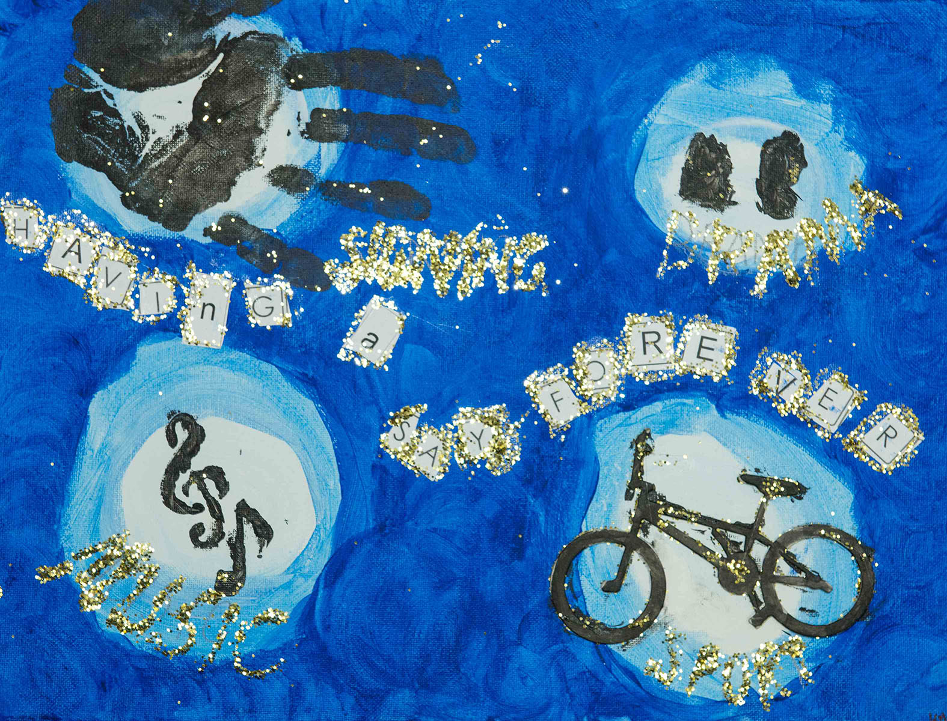

Painting by Kyra Drummond, 2019 VALID ‘Having a Say Conference’ Art Competition (Theme: ‘Having a say forever’)

# Restrictive practices

|  |
| --- |
| Restrictive practices are things done to another person to stop them from doing behaviours of concern.  A **behaviour of concern** might be a behaviour like hurting yourself or hurting another person. It might be behaviours like deliberately breaking furniture.  Restrictive practices are things that restrict the rights of a person using behaviours of concern. There are a few different types of restrictive practices: chemical, mechanical, physical, and seclusion.   * **Chemical restraint** is medication given to someone just to stop them doing a behaviour. It does not include medications for health problems or mental illness. * **Mechanical restraint** is use of equipment to stop someone moving. Mechanical restraint could be a bodysuit that stops someone touching their body, or splints to stop someone moving their arm. A seatbelt and buckle guard used in a car is not a mechanical restraint. * **Physical restraint** is another person strongly holding someone to stop them from moving. It is different from helping someone gently. * **Seclusion** is locking someone in a room so they cannot get out. * **Environmental restraint** is changing a person’s house or space so they cannot get to their things freely. For example, locking the door so someone cannot get their food or technology is environmental restraint. |

# Knowing about the restrictive practices used with people with disability in Victoria

One of the jobs of the Senior Practitioner is knowing about restrictive practices in Victoria. There were some different rules for people living in services paid for by the Victorian Government and people living in other services through NDIS.

In Victorian Government funded services:

* The Authorised Program Officer decides whether a restrictive practice can be used with a person who uses behaviours of concern – this must be done at least once a year
* We are told whenever restrictive practices are used.

In services run with NDIS funding:

* We decide whether a restrictive practice can be used with a person who uses behaviours of concern – this must be done at least once a year
* The NDIS Commission are told whenever restrictive practices are used.

There are a few sections in this part of the report:

* People getting Victorian Government funding and people getting NDIS funding – numbers of times restrictive practices are used and permission to use restrictive practices
* The quality of behaviour support plans
* Visits to services to see how much restrictive practices are used
* People under Compulsory Treatment.

## Restrictive practices with people who had funding from the Victorian Government: The number of times restrictive practices were used

Services funded by the Victorian Government must tell us about all the restrictive practices that they plan to use. Some of the people lived in group homes and some of the people used respite services.

We compare the numbers every year. This year the numbers are very different because there are less people who are funded by the Victorian Government. More people are funded through NDIS. We will talk about these people in the next section.

### Number of people restrained

1,252 people with disability were restrained this year. This number is about 2 people in every disability service or house. In 2018–2019, we learnt about 2,484 people who were restrained. The number this year was less, but this is probably because many of the people now get NDIS funding.

### Chemical restraint

Chemical restraint is the use of tablets or medicine to control someone’s behaviours of concern.

Over 900 of the people with restrictive practices had chemical restraint. They were given tablets or medicine to control their behaviour every day.

Some of the people had medication for their behaviour only sometimes. This can be called PRN chemical restraint.

There were lots of different types of medications used for chemical restraint. More than half of the people who had chemical restraint took more than one type of medication.

### Mechanical restraint

Mechanical restraint is the use of bodysuits, straps, bedrails, or other things to stop a person from moving their body.

114 people had mechanical restraints this year. This number is higher than in 2019–2020. The number might have changed because services better understand what they must report to us. There were more people who had bedrails and wheelchairs that stopped them from moving freely.

About half of the people with mechanical restraints had straps put on them to stop them moving. Some of them had clothes that they could not take off by themselves.

### Seclusion

Seclusion is being locked in a room or place where you cannot get out.

Twenty-four people were secluded this year. This is fewer people than last year. There might be less people because many people now get NDIS support.

### Physical restraint

Physical restraint is holding or blocking a person’s body with force. Physical restraint stops people from moving about.

Twenty-two people were physically restrained this year. This is nearly the same number as last year.

### Environmental restraint

Environmental restraint is changing a person’s house or space so they cannot get to their things freely. For example, locking the door so someone cannot get their food or technology when they want it is environmental restraint. This was the first year that environment restraint had to be reported to us.

591 people had environmental restraints this year. Many people could not go out their front door because it was locked. About half of the people had doors locked in their house so they could not get into rooms. About half of the people had their food and drink locked away in their house.

### Types of people with restrictive practices

Most of the people who were restrained were people with intellectual disability. Some of the people had a diagnosis of autism. Some of the people had hearing impairments, and some had a vision impairment. Many of the people may have had communication difficulties.

## Restrictive practices with people who have NDIS funding and Victorian Government funding in Victoria: The number of times restrictive practices plans were approved

Disability services in Victoria that are funded by NDIS and the Victorian Government must ask for permission to use restrictive practices with people who use behaviours of concern.

Disability services must send us information and a plan for what they want to do. The Senior Practitioner and Restrictive Practice Authorisation team look at the information to decide if the restrictive practice should be used. They check if these rules are met:

* The restrictive practice will prevent a person harming themself or another person
* The practice is the least restrictive thing that the team can use
* There is a plan to use less restrictive practices over time.

They must send us information and a plan for what they want to do.

We approved requests for 2,182 people. This was about the same number as from 2014 to 2019.

Most of the requests were about using medication with a person with a disability to change their behaviour. Thirty-five people had plans for physical restraint that we said yes too.

We said yes to the use of mechanical restraint with 260 people. We said yes to the use of seclusion with 81 people. The number of people with mechanical restraint and seclusion is more than last year. We need to keep doing work to understand why more seclusion is being used.

This year was the first time we had services ask us for permission to use environmental restraint. We said yes to the plans of 1,212 people for environmental restraint. Lots of these plans involved locking doors in a person’s house and locking cupboards to stop people reaching food or drink or their things.

## Behaviour support plans

A behaviour support plan is a written report about a person with a disability. It is a plan that says how staff should support a person who uses behaviours of concern. It should be a plan that says that restrictive practices will only be used after all other things are tried. This is sometimes called using the least restrictive alternative.

A behaviour support plan has lots of information.

We know that support plans that are written well can help improve peoples’ lives.

We have been working to improve behaviour support plans.

The Senior Practitioner uses a special checklist called the Behaviour Support Plan – Quality Evaluation II or BSP-QEII to measure how good the behaviour support plans are.

The Senior Practitioner looked at some plans to check if they had the information in them.

Many of the plans included:

* The things that happened right before behaviours of concern (these are sometimes called trigger or settings)
* Why the person seemed to be using the behaviour (sometimes called its function)
* Some ways to try to fix the triggers and settings
* Some ways to calm down behaviours of concern when they were happening.

More work is needed on:

* Plans to help people learn other ways to express themselves
* Plans for how teams would work together and make sure they are succeeding with their goals.
* Writing plans that are easy for everyone to read and use.

## Visiting services to see if restrictive practices are being used

It was hard to visit services in 2020–2021 because of COVID-19. We were only able to visit services where there was a serious worry about the use of restrictive practices.

Instead of visiting lots of services, we asked services about what was happening when we ran training.

There were some problems in services:

* Environmental restraints were being used, like locking doors inside the house to stop people getting into kitchens and laundries, without permission from us
* Other types of restrictive practices were being used without a behaviour support plan.

## Compulsory treatment

The Senior Practitioner helps people who are in compulsory treatment. Compulsory treatment is a special law. It is a law that says a person must have treatment for their behaviour.

Compulsory treatment is given to some people with intellectual disability who are at serious risk of hurting other people. They are people who might have hurt other people before. They have been in trouble with the law.

The Victorian Civil and Administrative Tribunal decides if a person needs to be in compulsory treatment. It decides again if there is a change in the person’s plan.

People in compulsory treatment live in the community or residential treatment centres. There are two residential treatment centres in Victoria.

People living in the community have a supervised treatment order. These people are watched most of the time and may be in a place that has locked doors. This is sometimes called civil detention.

People in compulsory treatment have rights. The Senior Practitioner supports the rights of people in compulsory treatment who have restrictive practices. The Senior Practitioner and his team look at the treatment plans of people on compulsory treatment. We decide if the plan is good for the person.

### People on compulsory treatment in the community in 2020–2021

There were 48 people in compulsory treatment living in the community this year. There were 47 men and 1 woman. Twenty-seven of the people were on supervised treatment orders for the whole year. Two people had orders for part of the year.

The people had hurt other people.

Most of the people on compulsory treatment had restrictive practices. Half had chemical restraint. Some had seclusion.

The Senior Practitioner looked very carefully at the restrictive practices used with people in compulsory treatment. The team looked at any changes made to a person’s treatment plan.

# Learning more about restrictive practices through special projects

This year we did four special projects.

## COVID-19 response

This year we had a big focus on COVID-19. People with disability had big changes in 2020–2021 when they were in the Victorian lockdown because of COVID-19.

We had a team that worked together with other services to respond to new issues.

## The environmental restraint project

This year we began asking services to let us know if environment restraints were being used.

We wrote two guides to teach everyone about environment restrains.

## Online behaviour support planning training for behaviour support practitioners

We worked with other people to make training for behaviour support practitioners. At first, we thought we would get people to come together to do the training, but COVID-19 made us change it to online training. Almost 400 people signed up to do the course.

## Online training for authorised program officers

Authorised program officers have an important role – they are sometimes called APOs. They look at behaviour support plans and decide if a restrictive practice can be used.

In 2020–2021 there were 196 new authorised program officers. One hundred and fifteen authorised program officers signed up for out new online training. Many of the people said that it helped them to do their job better.



Painting by Tim Leembruggen, winner, 2011 VALID ‘Having a Say Conference’ Art Competition (Theme: ‘Dignity’)

# Teaching other people about supporting people who use behaviours of concern

One of my jobs as the Victorian Senior Practitioner is to give training and education. People need to learn about behaviours of concern. They need to learn about restrictive practices. They need to learn about the rights of people with disability.

The Senior Practitioner’s team do a lot of teaching and do a lot of special projects.

## Using less restrictive practices training

We ran training for more than 450 people.

We also worked with the National Disability Services to make written information, a video, and a workshop for behaviour support practitioners on writing plans that are Easy English or Plain English.

You can watch the videos called Foundations of Positive Behaviour Support by going to a National Disability Services webpage called [Considering Additional Risk](https://nds.org.au/zero-tolerance-framework/considering-additional-risk) <https://nds.org.au/zero-tolerance-framework/considering-additional-risk>.

## Communication reports project

We continued to do a special project on communication reports. Many people with restrictive practices have communication difficulties. Some of the difficulties are obvious, like not being able to talk. Some difficulties are not obvious, like not understanding complex ideas.

We wanted to understand more about how people express that they are in pain when they do not use speech. We wrote a specialist communication report for two people. We gave communication advice to supporters of about 47 people.

## ARMIDILO-S

The ARMIDILO-S is an assessment about the risk of people with intellectual disability doing sex related crimes. This year, we were not able to run the training. We were able to talk to some people about the ARMIDILO.

# Working with other people to help reduce use of restrictive practices

The Senior Practitioner works with other services to share information, learn together, and do new projects.

Here are some of the things that the Senior Practitioner did this year.

## Answering questions

Every day people call us and email to ask questions about restrictive practices. We were contacted 2,169 times this year. This is nearly double the number of questions than last year.

## Project focusing on getting support in country towns

Sometimes it is harder for people in country towns to get the support they need. Sometimes there are less specialists in country towns.

We worked on a project with the National Disability Insurance Agency about country towns and behaviour support.

## Compulsory treatment practice workshops

The compulsory treatment team had two workshops for people working with people in compulsory treatment. People learnt new things at the workshops.

## Care team meetings for people under compulsory treatment

The compulsory treatment team have an important job in going to team meetings about people in compulsory treatment. They went to 180 meetings this year. The team went to 55 VCAT meetings.

## Victorian Senior Practitioner website

We worked on a new website. We will keep putting more information on the website.



Painting by Sarah Veli, 2018 VALID ‘Having a Say Conference’ Art Competition (Theme: ‘Community here’)

# Making things better by writing and talking about restrictive practices

We let people know about best ways to support people who use behaviours of concern. We let people know about restrictive practices.

We were not able to run a big session this year because of COVID-19.

We wrote a chapter in a book on people with intellectual disability who have committed a crime. I presented to people in Queensland about people with disability who have done a crime.