

Victorian Senior Practitioner report 2019–2020

Plain English

To receive this publication in an accessible format  
phone 9096 8427, using the National Relay Service 13 36 77 if required, or [email the Victorian Senior Practitioner](mailto:VictorianSeniorPractitioner@dffh.vic.gov.au) <VictorianSeniorPractitioner@dffh.vic.gov.au>.

Authorised and published by the Victorian Government,   
1 Treasury Place, Melbourne.

© State of Victoria, Australia, Department of Families,   
Fairness and Housing, March 2021.

ISSN 2653-0260 (online/PDF/Word)

Available at the [Victorian Senior Practitioner web page](https://www.dhhs.vic.gov.au/victorian-senior-practitioner)   
<https://www.dhhs.vic.gov.au/victorian-senior-practitioner>.

(2103922 – cover, images, figures)

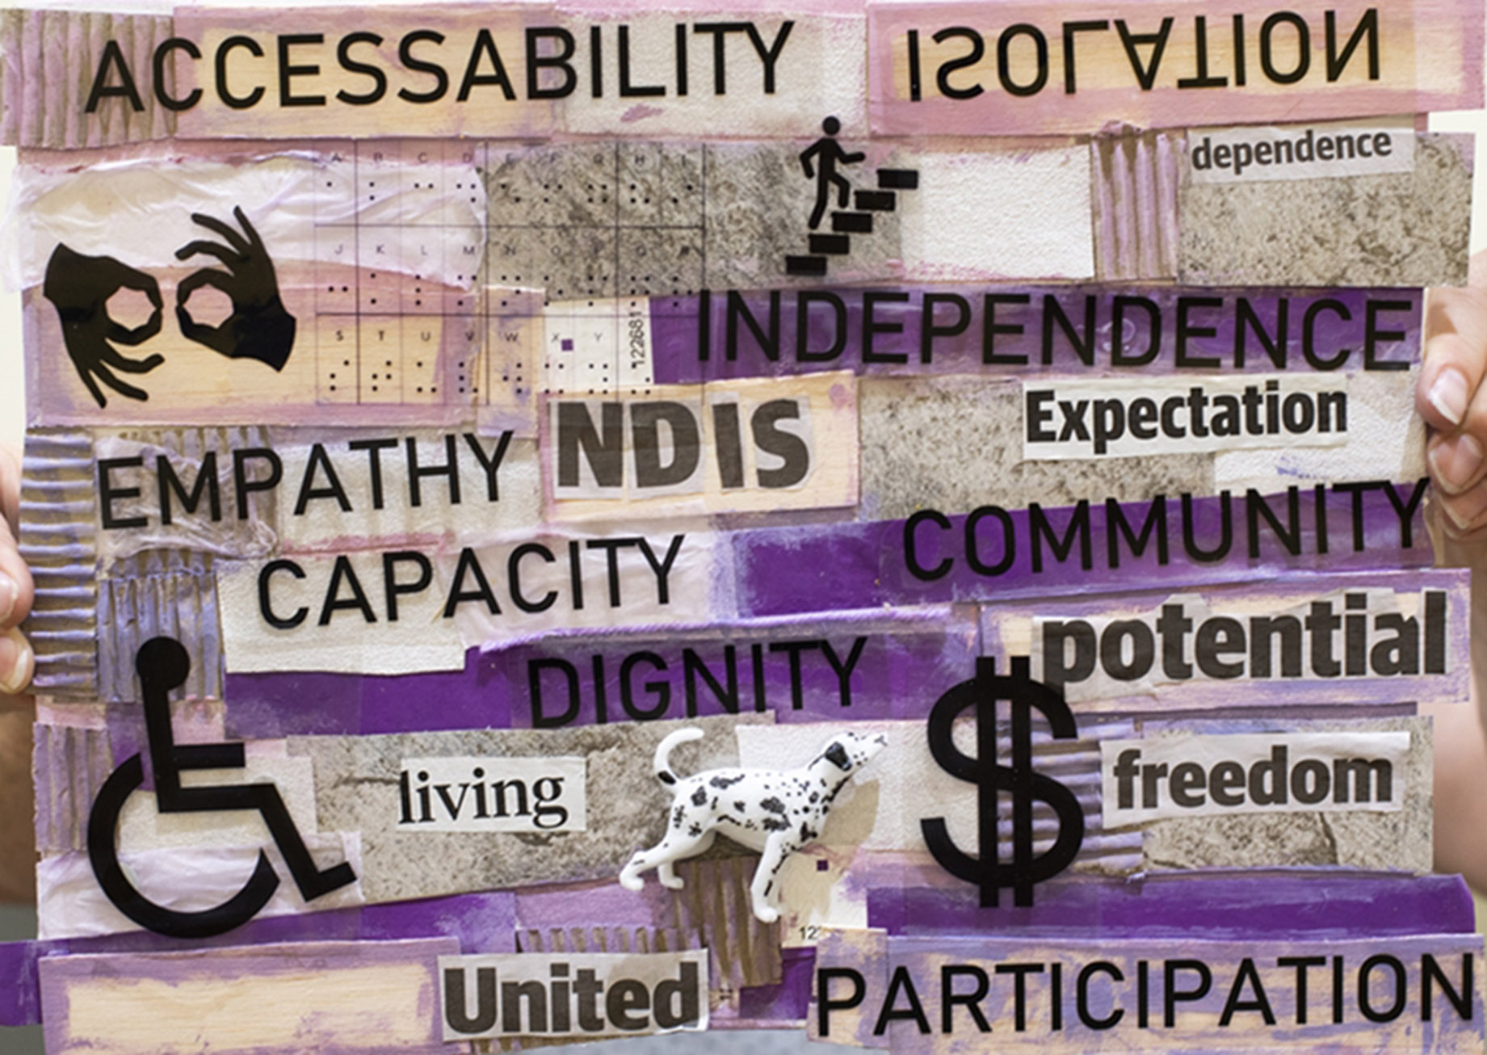

Cover: Painting by Brianna George

The artworks used in this report are by winners of the Barbara Donovan Art Competition Award at the Having a Say Conference 2020. The theme for the 2020 artworks was ‘A good life – are we there yet!’.

# Message from the Victorian Senior Practitioner, Frank Lambrick



Hello. My name is Frank Lambrick. I am the Victorian Senior Practitioner for Disability. I work with a team of people.

This is my report about our work. It is our 13th annual report. It is about what we did from July 2019 to June 2020. In the rest of the report I will just write 2019–2020.

This report is written in Plain English. We have a complex copy if you want more information.

The way that we worked this year was a little bit different from last year. Many people are now getting services from the National Disability Insurance Scheme (NDIS). The National Disability Insurance Scheme Quality and Safeguards Commission (NDIS Commission) work on the safety and quality of services. They are involved in restrictive practices that are used with people with disabilities across Australia. There are some jobs that we do and some jobs that the NDIS Commission do. I will tell you about these jobs later.

This report has five sections:

* Restrictive practices used with people with disabilities in Victoria
* Learning more about restrictive practices through special projects
* Teaching other people about supporting people who use behaviours of concern
* Working with other people to help reduce use of restrictive practices
* Making things better by writing and talking about restrictive practices.

Thank you to all the staff who work for me. Staff had to work from their home during the COVID-19 lockdown. Thank you to the families and services that work with us.

Dr Frank Lambrick signature

Dr Frank Lambrick  
Victorian Senior Practitioner

Contents

Message from the Victorian Senior Practitioner, Frank Lambrick 4

The job of the Victorian Senior Practitioner 9

Restrictive practices 11

Knowing about the restrictive practices used with people with disabilities in Victoria in 2019–2020 12

Restrictive practices in DHHS services in Victoria 14

Restrictive practices in other disability services in Victoria (not DHHS services) 15

Behaviour support plans 16

Visiting services to see if restrictive practices are being used 17

Compulsory treatment 18

Learning more about restrictive practices through special projects 20

The environmental restraint project 20

Online behaviour support planning training for behaviour support practitioners 20

Online training for authorised program officers 21

Teaching other people about supporting people who use behaviours of concern 22

Communication reports project 22

ARMIDILO-S 22

Working with other people to help reduce use of restrictive practices 23

Answering questions 23

Compulsory treatment practice workshops 23

Care team meetings for people under compulsory treatment 23

Graduate learning team project 23

Work with the Department of Education and Training 24

Making things better by writing and talking about restrictive practices 25

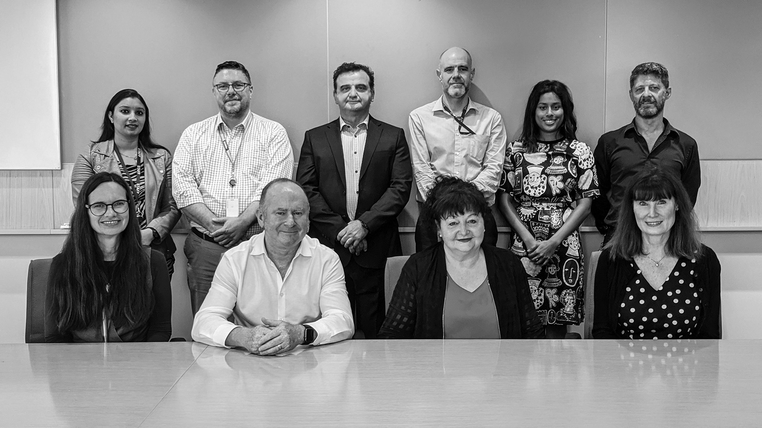

Victorian Senior Practitioner team, February 2020

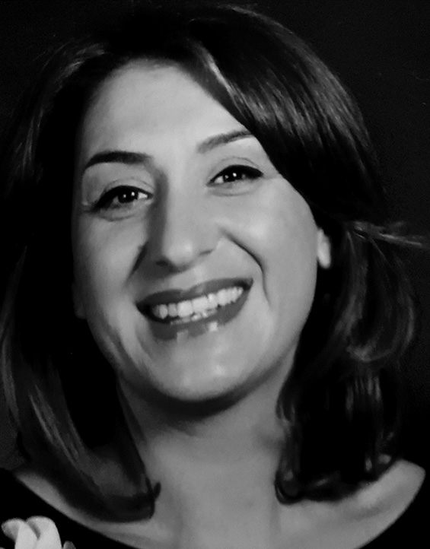 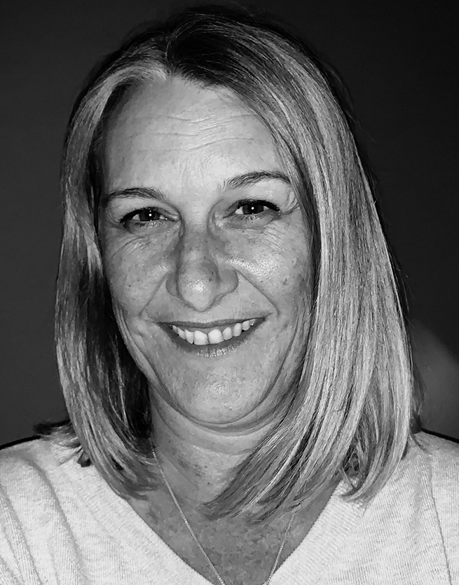

Hellen Tzanakis and Tiffany Carroll, other members of the Victorian Senior Practitioner team, 2019–2020

# The job of the Victorian Senior Practitioner

This report is about the job of the Senior Practitioner. It is about the Senior Practitioner’s work from July 2019 to June 2020.

The Senior Practitioner is a special job. The main job of the Senior Practitioner is to protect the rights of people with disabilities who have restrictive practices.

We help people who have disability services in Victoria. We help people whose disability services are paid for by the government.

The Disability Act 2006 said Victoria needed a Senior Practitioner. The Act said that the Senior Practitioner must do some special things. In 2019 there was a change in the Act. The job changed. Some jobs would be done by the NDIS Commission.

This year, the Senior Practitioner must:

* Know about the restrictive practices used with people with disabilities in Victoria
  + Know whenever restrictive practices were used on people living in group homes run by the Department of Health and Human Service
  + Say yes or no to other disability services when they ask for permission to use restrictive practices with people with disabilities
  + Give special instructions to disability services if there are worries about restrictive practices
  + Talk with the NDIS Commission
* Teach people about restrictive practices and supporting people who use behaviours of concern
* Learn more about restrictive practices by doing special projects and research.

The Senior Practitioner has an important role for people in compulsory treatment. Compulsory treatment is when the law courts have said that someone with a disability has broken the law and must have specific treatment.

Learning more is sometimes called doing research. We do a lot of important research. We have been doing this counting for longer than anyone else in the world.

We can do research on things that change and things that stay the same.

This report is about how we did these important jobs.

# Restrictive practices

|  |
| --- |
| Restrictive practices are things done to another person to stop them from doing behaviours of concern.  A **behaviour of concern** might be a behaviour like hurting yourself or hurting another person. It might be behaviours like deliberately breaking furniture.  Restrictive practices are things that restrict the rights of a person using behaviours of concern. There are a few different types of restrictive practices: chemical, mechanical, physical, and seclusion.   * **Chemical restraint** is medication given to someone just to stop them doing a behaviour. It does not include medications for health problems or mental illness. * **Mechanical restraint** is use of equipment to stop someone moving. Mechanical restraint could be a bodysuit that stops someone touching their body, or splints to stop someone moving their arm. A seatbelt and buckle guard used in a car is not a mechanical restraint. * **Physical restraint** is another person strongly holding someone to stop them from moving. It is different from helping someone gently. * **Seclusion** is locking someone in a room so they cannot get out. |

# Knowing about the restrictive practices used with people with disabilities in Victoria in 2019–2020

One of the jobs of the Senior Practitioner is knowing about restrictive practices in Victoria. This year there were some different rules for people living in services run by the Department of Health and Human Services (DHHS) and people living in other services.

In group homes run by the DHHS:

* The Authorised Program Officer decides whether a restrictive practice is allowed to be used with a person who uses behaviours of concern – this must be done at least once a year
* We are told whenever restrictive practices are used.

In services run by other disability service providers:

* We decide whether a restrictive practice is allowed to be used with a person who uses behaviours of concern – this must be done at least once a year
* The NDIS Commission are told whenever restrictive practices are used.

When services contact us, they must tell us:

* The name of the person restrained
* The person’s gender: male or female
* The person’s disability
* The type of restraint used
* The amount of restraint used.

Disability service providers must show us the person’s behaviour support plan. A behaviour support plan is a written plan. Behaviour support plans must say:

* The behaviour of concern
* What the staff will do to help the person
* The restrictive practice
* How the restrictive practice will help the person.

This part of the Annual Report is about restrictive practices, behaviour support plans, and compulsory treatment in Victoria 2019–2020.

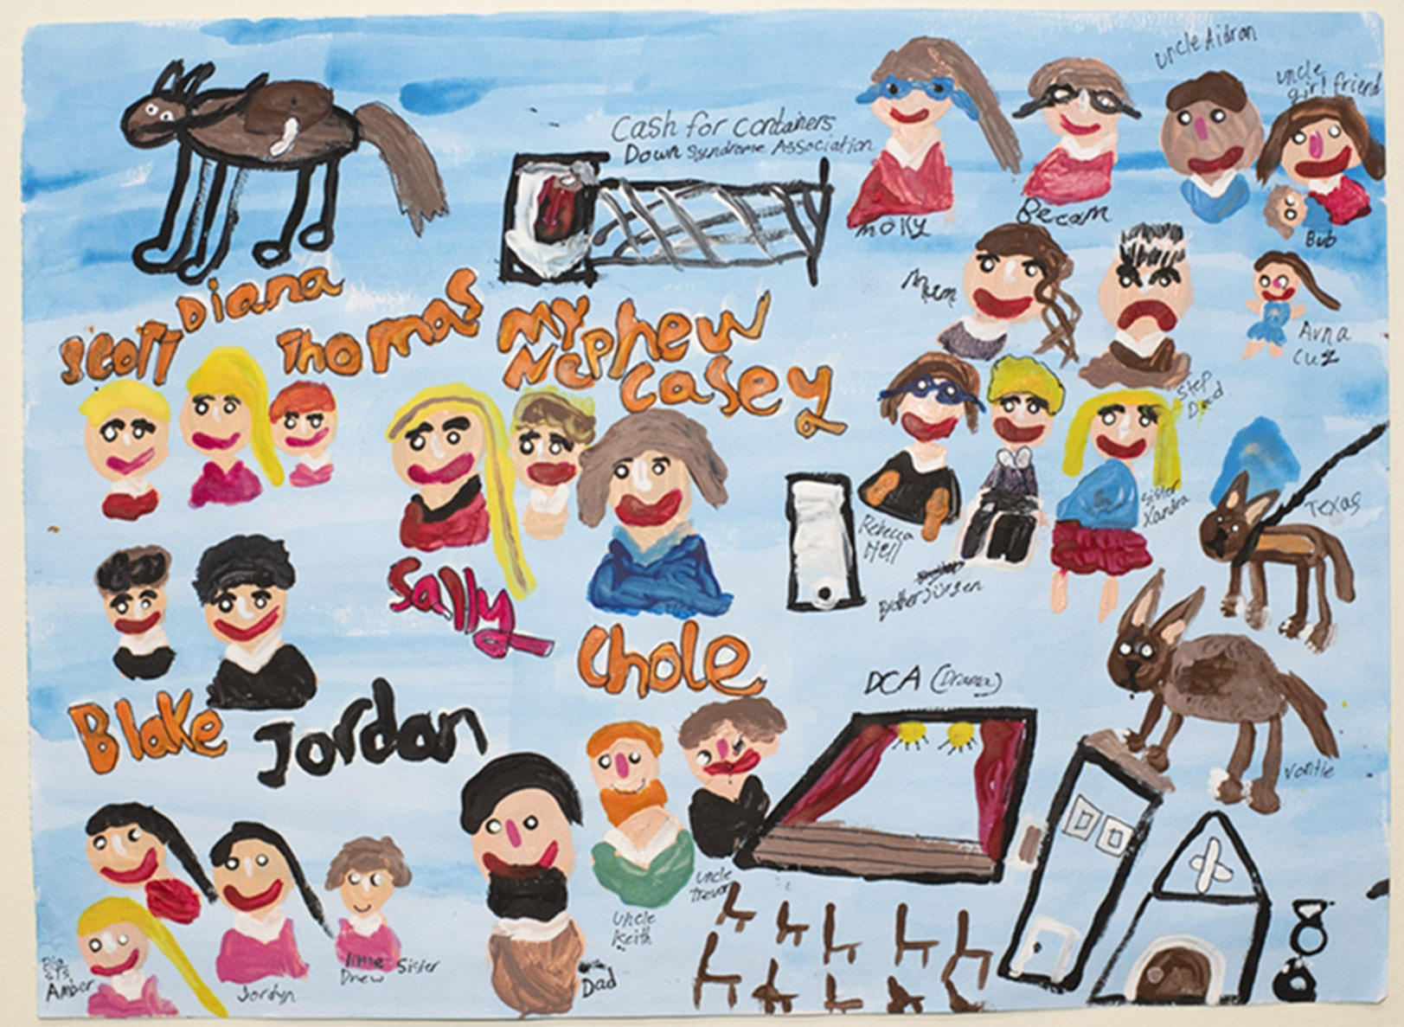

Painting by Rebecca Hell

## Restrictive practices in DHHS services in Victoria

Services run by DHHS must tell us about all the restrictive practices that they plan to use.

In past years we have compared the numbers each year. This year is different because not all service providers have to tell us when they have used the restrictive practices they planned to use. This section is just about the service providers who told us when they used restrictive practices.

### Number of people restrained

A total of 1,546 people with disabilities were restrained this year.

### Chemical restraint

Chemical restraint is the use of tablets or medicine to control someone’s behaviours of concern.

Nearly all the people with restrictive practices had chemical restraint. They were given tablets or medicine to control their behaviour every day.

Some of the people had medication for their behaviour only sometimes. This can be called PRN chemical restraint.

There were lots of different types of medications used for chemical restraint. More than half of the people who had chemical restraint took more than one type of medication.

### Mechanical restraint

Mechanical restraint is the use of bodysuits, straps, bedrails, or other things to stop a person from moving their body.

Ninety-eight people had mechanical restraints this year.

Most of the people were put in clothes that they could not take off by themselves.

### Physical restraint

Physical restraint is holding or blocking somebodies’ body with force. Physical restraint stops people from moving about.

Twenty people were physically restrained this year.

Most of the people were physically restrained once in the year.

### Seclusion

Seclusion is being locked in a room or place where you cannot get out.

Forty-nine people were secluded this year.

We will do a project on seclusion. We want to see seclusion used less.

### Types of people with restrictive practices

More males were restrained than females.

More adults were restrained than children.

Most of the people who were restrained were people with intellectual disability or autism.

## Restrictive practices in other disability services in Victoria (not DHHS services)

Disability services in Victoria must ask for permission to use restrictive practices with people who use behaviours of concern.

They must send us information and a plan for what they want to do.

Services sent us 729 requests to use restrictive practices. There was more than one request for some people. The requests were about 513 people with disability.

We said yes to 569 of the requests. We said no to 43 requests. Sometimes we said no because nobody is allowed to use the type of restrictive practice that they asked to use. Sometimes we said no because it was not really a restrictive practice. Sometimes we said no because it was a family, not a disability service, who wanted to use the restrictive practice.

Most of the requests were about using medication with a person with a disability to change their behaviour. Nearly half of the requests were to use locks on doors and cupboards to stop people from opening them. There were some requests to use mechanical and physical restrictive practices, and some requests to use seclusion.

## Behaviour support plans

A behaviour support plan is a written report about a person with a disability. It is a plan for how staff should support a person who uses behaviours of concern. It should be a plan that says that restrictive practices will only be used after all other things are tried. This is sometimes called using the least restrictive alternative.

A behaviour support plan has lots of information.

We know that support plans that are written well can help improve peoples’ lives.

We have been working to improve behaviour support plans.

The Senior Practitioner uses a special checklist called the Behaviour Support Plan – Quality Evaluation II or BSP-QEII to measure how good the behaviour support plans are.

The Senior Practitioner looked at 35 plans to check if they had the information in them.

The plans this year were better than last year. These plans are more likely to improve people’s lives.

These plans were written by NDIS registered behaviour support workers.

## Visiting services to see if restrictive practices are being used

The Senior Practitioner visited 35 places to see if restrictive practices were being used.

There were some problems in the services:

* Environmental restrictive practices were being used, like locking doors inside the house to stop people getting into kitchens and laundries.
* People did not know what some restraints were, like chemical restraints.
* Strategies for reducing restraints were written down but they were not being used.
* Restraints were being used without a behaviour support plan.
* There were missing therapist reports for using restrictive practices for ‘therapeutic practices’ (for example, strapping one hand so the person can use their other hand better).

## Compulsory treatment

The Senior Practitioner helps people who are in compulsory treatment. Compulsory treatment is a special law. It is a law that says a person must have treatment for their behaviour.

Compulsory treatment is given to some people with intellectual disabilities who are at serious risk of hurting other people. They are people who might have hurt other people before. They have been in trouble with the law.

People in compulsory treatment live in the community or residential treatment centres. There is one residential treatment centre in Victoria.

People living in the community have a supervised treatment order. These people are watched most of the time and may be in a place that has locked doors. This is sometimes called civil detention.

Some people lived part of the year in the residential treatment centre and part of the year in the community.

People in compulsory treatment have rights. The Senior Practitioner supports the rights of people in compulsory treatment who have restrictive practices. The Senior Practitioner and his team look at the treatment plans of people on compulsory treatment. We decide if the plan is good for the person.

Disability services looking after the person have to write reports. They have to say how the person is going with their treatment plan. They have to say how they are helping people have a better life.

### People on compulsory treatment in the community in 2019–2020

There were 42 people in compulsory treatment living in the community this year. There were 41 men and 1 woman.   
Twenty-eight of the people were on supervised treatment orders.

The people had hurt other people.

Twenty-two of the people on compulsory treatment had restrictive practices. Most had chemical restraint. Some had seclusion and some had physical restraint.

The Senior Practitioner looked very carefully at the restrictive practices used with people in compulsory treatment. The team looked at any changes made to a person’s treatment plan.

Big decisions about compulsory treatment are made at the Victorian Civil and Administrative Tribunal. This is sometimes called VCAT.

We had many important meetings at VCAT for people on compulsory treatment.

# Learning more about restrictive practices through special projects

This year we did three special projects.

## The environmental restraint project

We worked with a company called Nous on a project about environmental restraints.

Nous wrote us a report on measuring environmental restraints.

They wrote five important questions for service providers to measure environmental restraints. They had to think about a person with a disability when they answered the questions:

1. What room, place or item was blocked from the person?
2. Why was the person blocked from the room, place or item?
3. How was the room, place or item blocked?
4. What was the effect of the block to that person and other people?
5. When was the room, place or item was blocked, and how long?

## Online behaviour support planning training for behaviour support practitioners

We worked with other people to make training for behaviour support practitioners.

The training was written to be run on the internet.

Ten people have tried out the training. We are planning for many more people to do the training.

## Online training for authorised program officers

Authorised program officers have an important role – they are sometimes called APOs. They look at behaviour support plans and decide if a restrictive practice can be used.

Next year we will run training on the internet for APOs. We will run training so they knew the best information about supporting people who use behaviours of concern.



Painting by Kristie Newcombe

# Teaching other people about supporting people who use behaviours of concern

The Senior Practitioner thinks that learning is important for making things better. People need to learn about behaviours of concern. They need to learn about restrictive practices. They need to learn about the rights of people with disabilities.

The Senior Practitioner’s team do a lot of teaching and do a lot of special projects.

## Communication reports project

We continued to do a special project on communication reports. Many people with restrictive practices have communication difficulties. Some of the difficulties are obvious, like not being able to talk. Some difficulties are not obvious, like not understanding complex ideas.

People with communication difficulties use more behaviours of concern than people without communication difficulties.

We did a specialist communication report on one person.

## ARMIDILO-S

We taught people about using a special assessment called the ARMIDILO-S. This assessment is about the risk of people with intellectual disabilities doing sex related crimes.

# Working with other people to help reduce use of restrictive practices

The Senior Practitioner works with other services to share information, learn together, and do new projects.

Here are some of the things that the Senior Practitioner did this year.

## Answering questions

Every day people call us and email to ask questions about restrictive practices. We were contacted 1,113 times this year.

## Compulsory treatment practice workshops

The compulsory treatment team had two workshops for people working with people in compulsory treatment. People learnt new things at the workshops.

## Care team meetings for people under compulsory treatment

The compulsory treatment team have an important job in going to team meetings about people in compulsory treatment. They went to 120 meetings this year. They answer lots of questions about people under compulsory treatment with restrictive practices.

## Graduate learning team project

The Department of Health and Human Services have a team of staff who have just graduated from university. They are called the Graduate learning team.

Three people from the Graduate learning team did a project with us.

They wrote a guide called *Using restrictive practices in Victoria: Step-by-step guide for NDIS registered services*.

## Work with the Department of Education and Training

A practice leader from the Senior Practitioner finished their work with the Department of Education and Training. The Department created a new role called the Principal Behaviour Support Officer. They will help primary and secondary schools do good behaviour support in Victoria.

# Making things better by writing and talking about restrictive practices

We let people know about best ways to support people who use behaviours of concern. We let people know about restrictive practices.

We ran a big session with lots of speakers. They were all talking about helping people who use behaviours of concern and have restrictive practices.

We wrote one paper for a journal. We presented at some conferences.



Painting by David Waterhouse