Senior Practitioner report 2017–18



Cover: Painting by Tammy Smith

The artworks used in this report are by winners of the 2018 VALID Annual ‘Having a Say’ conference Art Competition sponsored by the Senior Practitioner. The theme for the 2018 artworks was ‘Community – Here I come!’.

To receive this publication in an accessible format phone 9096 8427, using the National Relay Service 13 36 77 if required, or [email the Office of Professional Practice](mailto:officeofprofessionalpractice%40dhhs.vic.gov.au?subject=) <officeofprofessionalpractice@dhhs.vic.gov.au>

Authorised and published by the Victorian Government, 1 Treasury Place, Melbourne.

© State of Victoria, Department of Health and Human Services, June 2019

Except where otherwise indicated, the images in this publication show models and illustrative settings only, and do not necessarily depict actual services, facilities or recipients of services. This publication may contain images of deceased Aboriginal and Torres Strait Islander peoples.

In this document, ‘Aboriginal’ refers to both Aboriginal and Torres Strait Islander people. ‘Indigenous’ or ‘Koori/Koorie’ is retained when part of the title of a report, program or quotation.

ISSN: 2204-7204 (online)

Available at the [Office of Professional Practice website](https://www.dhhs.vic.gov.au/office-professional-practice)   
<https://www.dhhs.vic.gov.au/office-professional-practice>

(1812020)

# Message from the Senior Practitioner



Welcome to the 11th Senior Practitioner report for 2017–18. This report describes the functions and achievements of the work of the Office during the 2017–18 financial year. Each year we review the restrictive interventions of all people who are reported to us in disability services. From our monitoring we know that in 2017–18 2,409 people were subject to restraint or seclusion at some time during this period. This is a three per cent increase since 2016–17. Most of this increase is accounted for by an increase in chemical restraint. In this report we describe restraint reduction strategies we are using in our training and research projects (see Projects to deliver evidence-informed outcomes). We continually undertake work to follow up our evaluation, seeking to find out what assistance the sector needs and what additional assistance we can provide (see Promoting best practice through professional development and Supporting best practice through advice, partnerships and consultation). Finally, we report back to the sector through evidence-informed findings (see Informing public debate and opinion).

This past year, as anticipated, has seen a significant increase in activity associated with the transition to the NDIS. Nine more Department of Health and Human Services metropolitan and rural areas rolled out into the NDIS this year, which has provided some challenges in supporting clients on compulsory treatment orders in particular. We have very much appreciated the contributions made by the Intensive Support Team, Disability Justice unit and department’s area Agency Performance staff who have worked collaboratively with us and the care teams to achieve good outcomes for our clients.

To address this increased activity, we have been able to employ two additional staff funded by the Disability and NDIS branch. We have continued to provide support to existing and new services through providing advice and education, behaviour support plan training services and targeted restrictive intervention training, as well as through the online platforms of the Restrictive Intervention Data System and the Restrictive Intervention Self Evaluation Tool in providing alerts and links to relevant information for services providers.

Overall the increases in the number of people who were subject to a restrictive intervention in 2017–18 were accounted for by increases in the numbers of people administered chemical restraint and mechanical restraint types. Our research into the use of mechanical restraint has shown that, unlike seclusion and physical restraint, disability services find it difficult to reduce mechanical restraint for several reasons, such as the nature of the behaviours of concern it is used for, particularly self-harm. People subject to this restraint also have a complexity of need, being very dependent on others for day-to-day support, having profound disabilities with complex communication support needs, and having physical disabilities and major health problems, so are often in pain. It is anticipated that the completion of phase 4 of the mechanical restraint project and the subsequent development of a practice guide in 2019 will assist service providers in addressing these issues.

The majority of people subject to chemical restraint are restrained routinely, with most also having been restrained in the previous year, so it is used in the long term. To address this issue, we developed online education modules for disability support workers and psychiatrists. We are currently completing the revision and reaccreditation process of online modules for general practitioners (GPs) to be accredited by the Royal Australian College of General Practitioners. We anticipate having this completed in 2019. We expect that if GPs undertake these modules, this will lead to a reduction in their use of routine chemical restraint in the longer term.

On a positive note, the number of people who were secluded remained the same as the previous year and the number of people who were subject to physical restraint decreased by 21 people from the previous year. This is a good news story and suggests that disability services are having an impact on reducing their use of physical restraint and seclusion. We looked at those who were physically restrained and found that, for the majority, physical restraint appears to be a one-off event, suggesting that it is being used consistently with the Act in being the least restrictive under the circumstances.

In all of this increased activity we have managed to progress work on three major projects that focus on restraint reduction: the mechanical restraint project, general practitioner modules and the roadmap project. This year we celebrated 10 years of the Disability Act 2006 and the operations of the Senior Practitioner team. The Disability Act is a unique Act that has enabled us to focus on the needs of one of the most vulnerable groups in the community. It remains the only legislation that we are aware of that mandates for research and education into restrictive interventions and compulsory treatment. Because of this, we know that some people are more likely to be subject to restrictive interventions in the long term. We also know that good-quality behaviour support plans can reduce the use of restrictive interventions.

This year we convened a panel of stakeholders to review our past research and provide advice on future research priorities. Two of these projects are currently underway – one with a focus on compulsory treatment and one focusing on chemical restraint.

We have also continued to work closely with the Disability and NDIS branch, state and territory counterparts, the National Disability Insurance Agency and the Commonwealth Department of Social Services in further progressing work around the implementation of the National quality and safeguarding framework. This work will take on a significantly greater focus over the coming year in the lead up to July 2019. The recent appointment of Dr Jeffrey Chan as the inaugural NDIS Quality and Safeguards Commission Senior Practitioner from July 2018 provides us with great reassurance given his previous establishment roles in the monitoring and oversight of restrictive practices both here and in Queensland.

I would like to take the opportunity to thank all of our staff – those who have left, those remaining and those who have joined us – for their hard work and commitment over the year. Their dedication in ensuring that the rights of people subject to restrictive interventions and compulsory treatment are protected has remained steadfast over this busy and sometimes chaotic year!

Finally, I would also like to acknowledge the contributions of our colleagues, project partners, internal and external stakeholders, disability service providers, families, carers, advocates and professionals who collaborate with us in our work. We look forward to continuing this work over the coming year with the significant changes that will take place.

Dr Frank Lambrick signature

Dr Frank Lambrick  
Senior Practitioner – Disability

Contents

Message from the Senior Practitioner 3

The role of the Senior Practitioner 7

Monitoring and evaluating practice 8

Restrictive interventions reported to the Senior Practitioner 8

The use of restrictive interventions in Victoria 8

Behaviour support plan quality evaluations 16

Restrictive intervention audit review 17

Compulsory treatment 18

Projects to deliver evidence-informed outcomes 24

Mechanical Restraint Project 24

General practitioner modules 24

The impact of the roadmap for reducing restrictive practices and behaviours of concern 25

Eleven years of the Senior Practitioner research: A review 25

Promoting best practice through professional development 27

Introduction to reporting to the Senior Practitioner about restrictive interventions for new services 27

Behaviour support plan training sessions 27

Restrictive intervention training 27

Data warehouse 27

Restrictive Intervention Self Evaluation Tool 28

Promoting Dignity Grants 28

ARMIDILO-S 29

Supporting best practice through advice, partnerships and consultation 30

Compulsory treatment practice forums 30

Compulsory treatment team newsletters 30

Care team meetings and case consultations 30

Occupational therapy students working with the Senior Practitioner 31

Recognising restrictive practices – video resource development 31

Work with the Department of Education and Training 32

Informing public debate and opinion 34

Ten years of the Disability Act 34

Publications in peer-reviewed journals 34

Conference papers 35

Invited presentations 36

References 37

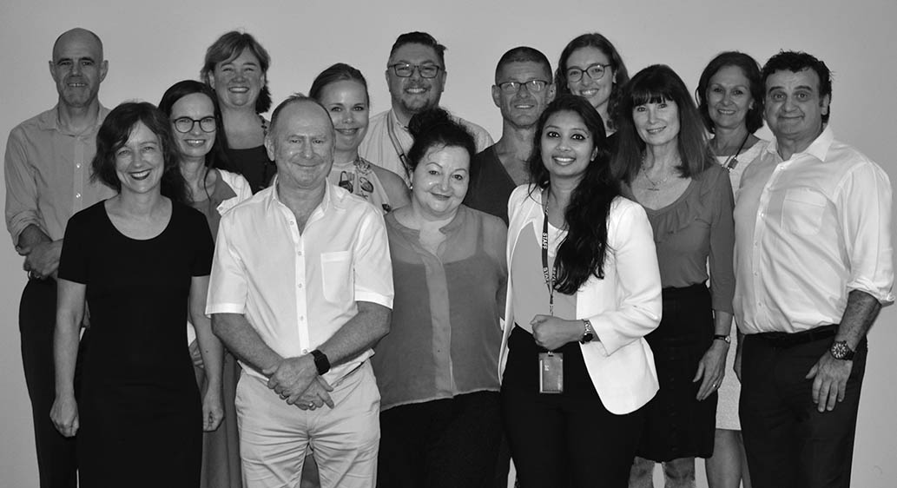

Senior Practitioner team

# The role of the Senior Practitioner

The Senior Practitioner role was established in 2006 when the Victorian Parliament enacted the Disability Act 2006 (the Act). The Senior Practitioner and his team sit within the Office of Professional Practice branch in the Children, Families, Disability and Operations Division of the Department of Health and Human Services (the department).

The Senior Practitioner is responsible for protecting the rights of people with a disability who are subject to restrictive interventions such as restraint and seclusion, and compulsory treatment, and who receive a government-funded service.

The Act requires population monitoring and reporting of people with a disability who receive a service, and who are subject to restrictive interventions or compulsory treatment.

The Act also mandates:

* development of guidelines and standards regarding restrictive intervention and compulsory treatment
* research into the use of restrictive interventions and compulsory treatment
* provision of relevant education – for example, regarding human rights and positive behaviour support – to workers involved in supporting people with a disability
* specific responsibilities of the Senior Practitioner to:
  + approve and monitor treatment plans developed for the person who is subject to compulsory treatment
  + oversee the implementation of supervised treatment orders
  + issue lawful directions to disability services on any law, policy or practice, where relevant, to a compulsory treatment order matter.

Including research and education as mandatory functions of the Senior Practitioner in the Act means it is possible to focus on what the evidence shows in Victoria, and to use this to directly inform policy and practice in disability services.

The research findings from Victoria are unique. Victoria is the only jurisdiction in the world that has collected long-term population-level data on the use of restrictive interventions and behaviour support plans over 11 years. Queensland has more recently begun collecting data that is framed by their legislative requirements.

Collecting population-level data over many years has enabled investigations into what changes over time and what factors impact on these changes. Through our research we know that people with certain characteristics tend to be subject to certain types of restraint than others without these characteristics. For example, people with autism are more likely to be restrained routinely with antipsychotic medication than people without autism.

The purpose of this report is to outline trends in the use of restrictive interventions, compulsory treatment and behaviour support planning, and to describe how our safeguarding activities have specifically improved the lives of people with a disability over the course of the year from July 2017 to June 2018.

# Monitoring and evaluating practice

A function of the Senior Practitioner is ‘to evaluate and monitor the use of restrictive interventions across disability services and to recommend improvements in practice to the Minister and the Secretary’ (Disability Act, s. 24(1)(h)). This section looks at the reported use of restrictive interventions during 2017–18 and compares this with previous years. Data on the use of chemical restraint, mechanical restraint and seclusion have been collected since 2008–09 and data on physical restraint has been collected since 2011–12.

## Restrictive interventions reported to the Senior Practitioner

Disability services must report to the Senior Practitioner about the use of four types of restrictive intervention used in their services:

* chemical restraint
* mechanical restraint
* physical restraint
* seclusion.

Every time a disability service uses a restrictive intervention, they must provide information to the Senior Practitioner that includes:

* information about the person subjected to the restrictive intervention, such as their name, gender and disability types
* the type of restrictive intervention used (chemical, mechanical, physical restraint or seclusion) and type of administration, being:
  + ‘routine’, that is, administered on an ongoing basis, for example, daily or weekly, but reported once a month, if it had been used one or more times in that month
  + ‘pro re nata’ (PRN) drug administration in accordance with and authorised within a behaviour support plan, and reported at each instance of use
  + ‘emergency’, which is restraint administered in an emergency and where there is no authorised behaviour support plan, or a restraint is not included in the authorised behaviour support plan
* a copy of the behaviour support plan that describes why the restraint or seclusion is necessary, why it is the least restrictive intervention, and how it benefited the person.

## The use of restrictive interventions in Victoria

This section of the report summarises the findings of:

* restrictive interventions reported by disability services in Victoria in 2017–18 and, where possible, compares these findings with the previous nine years
* the quality of behaviour support plans written in 2017–18 compared with the previous years of 2014–15, 2015–16 and 2016–17
* the number of people on compulsory treatment orders in 2017–18.

It should be noted that for ease of viewing, graphs only show the last seven years from 2010–11. Complete tables from 2008–09 can be requested from the Senior Practitioner.

Figure 1 shows the total number of people who were reported to be subject to a restrictive intervention each year since 2010–11.

Figure 1: Number of people subjected to a restrictive intervention, 2010–11 to 2017–18

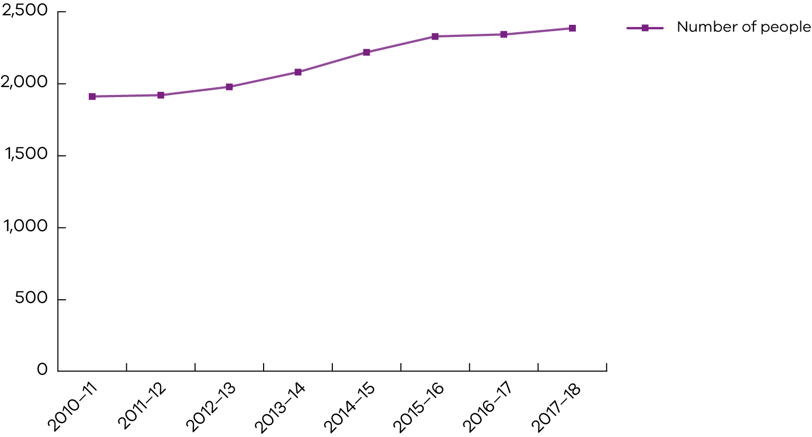

### Key findings

* In total, 2,409 people were reported as being subjected to restraint and/or seclusion in 2017–18. This number is a three per cent increase from 2016–17.
* The number of people who have been reported to be subject to restrictive interventions has been increasing since 2011–12.
* The percentage increase of people varies slightly from one financial year to the next. In 2017–18 there was a three per cent increase on the previous year where there was less than a one per cent increase.
* The upward trend in the number of people restrained between 2011–12 and 2017–18 coincided with a similar increase in the number of services reporting to the Senior Practitioner each year. The number of services reporting has been increasing each year from 736 in 2010–11 to 901 in 2017–18.

The Senior Practitioner only receives data from services that have reported restrictive interventions. Other services with no reporting of restrictive interventions are not included in the dataset. This is also true for the total numbers of people who are and are not subject to restrictive interventions, so it is not possible to evaluate whether any change in the number of services results in a change in client numbers.

Figure 2 shows the total number of people who were subject to chemical, mechanical, physical restraint and seclusion from 2010–11 to 2017–18.

Figure 2: Number of people subject to chemical, mechanical or physical restraint, or seclusion, 2010–11 to 2017–18

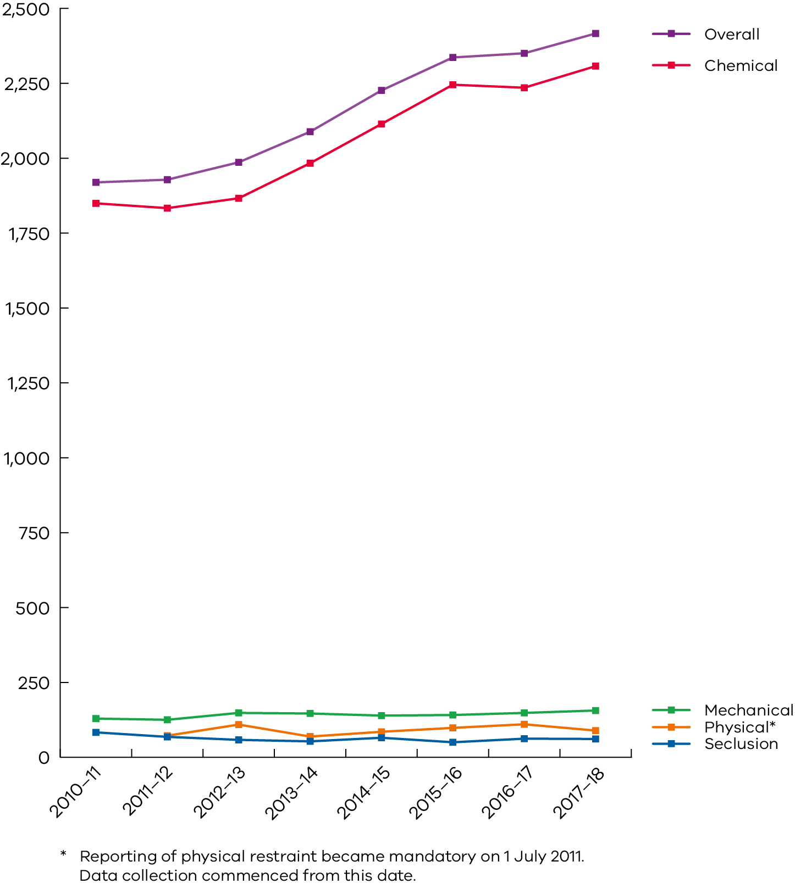

### Key findings

* Overall increases in the number of people who were subject to a restrictive intervention in 2017–18 were accounted for by increases in:
  + the number of people administered chemical restraint (72 more people in 2017–18 than 2016–17)
  + the number of people administered mechanical restraint (eight more people in 2017–18 than 2016–17).
* The number of people who were secluded decreased by one in 2017–18 from the previous year, and the number of people who were subject to physical restraint decreased by 21 in 2017–18 from the previous year.

### Chemical restraint

Chemical restraint refers to the use of medication where the primary purpose is to control a person’s behaviour and is not prescribed treatment for an underlying illness or condition. For example, stimulants are used to treat attention deficit hyperactivity disorder (ADHD) and are not categorised as chemical restraint if being used to treat ADHD. If there is no diagnosis of ADHD and a stimulant is administered, this would be an example of chemical restraint. (Section 3 of the Act provides complete definitions of all restrictive interventions.)

#### Key findings

* In 2017–18, 2,300 people or 95.5 per cent of all the people reported to be subject to a restrictive intervention were administered chemical restraint sometime during the year. This is a three per cent increase in the number of people from the previous year.
* The majority of people (89 per cent of those who were administered chemical restraint) were administered chemical restraint on a routine basis – that is, every day or on an ongoing basis.
* A total of 339 people (15 per cent of those who were administered chemical restraint) were administered chemical restraint on a PRN basis. (PRN means the medication is administered when needed by the person with a disability, as judged by support staff.)

#### Types of medications

Figure 3 shows the total number of people who were subject to different types of chemical restraint 2010–11 to 2017–18.

Figure 3: Number of people subject to different types of chemical restraint, 2010–11 to 2017–18

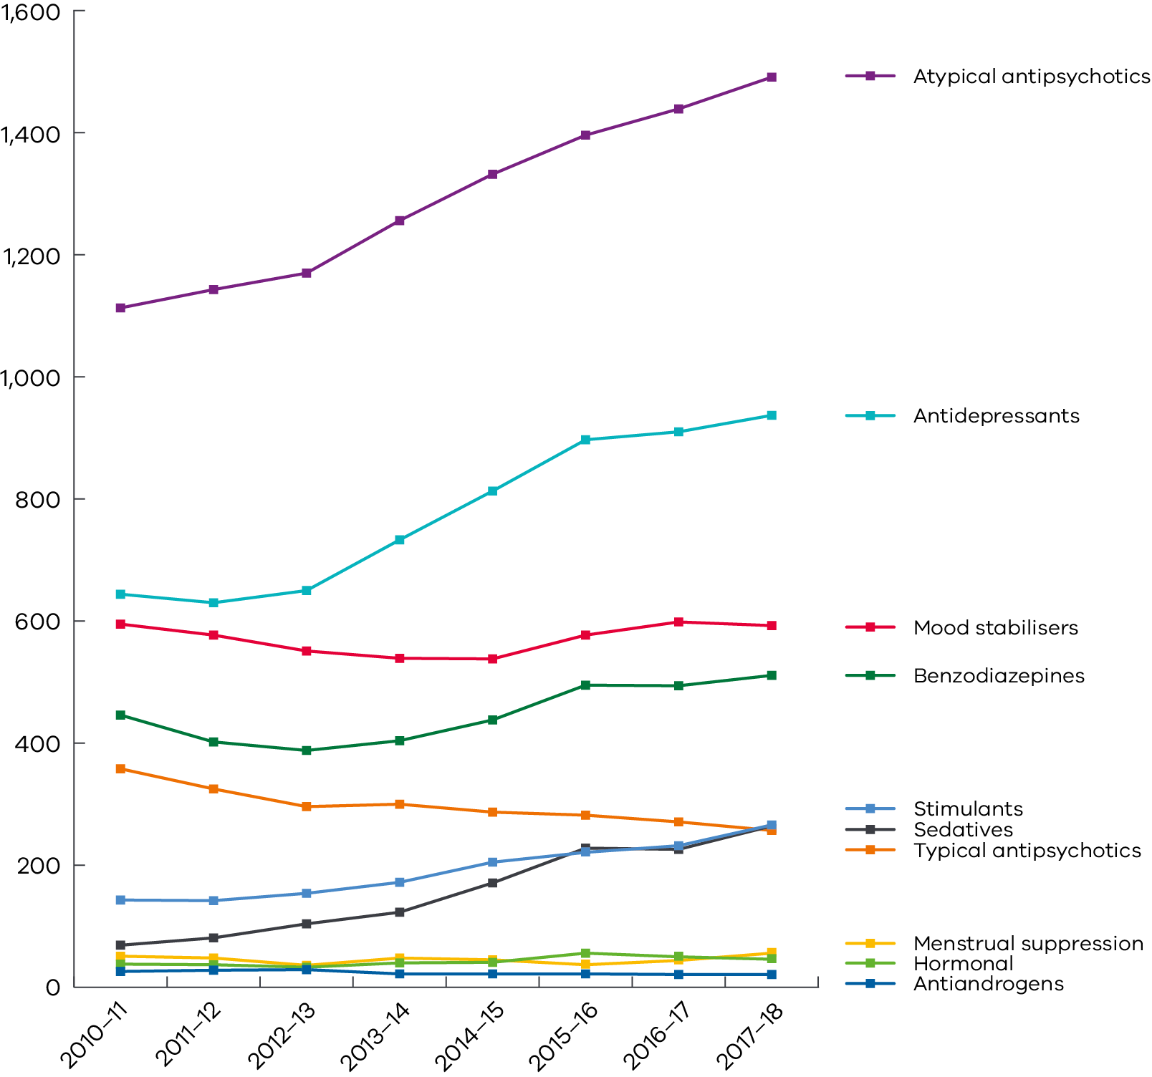

##### Key findings

Four chemical restraints were administered to the majority of people who were reported to be chemically restrained:

1. antipsychotics (71 per cent of all people who were administered chemical restraint)
2. antidepressants (41 per cent)
3. mood stabilisers (26 per cent)
4. benzodiazepines (22 per cent).

These percentages do not add to 100 per cent because 60 per cent of people reported to be chemically restrained were administered more than one chemical restraint in 2017–18 (see poly-pharmacy below).

#### Poly-pharmacy

Poly-pharmacy refers to the administration of two or more different chemical restraints that are administered simultaneously. A fairly common example of poly-pharmacy is the routine administration of two antipsychotics.

##### Key findings

* Of the 2,300 people who were chemically restrained in 2017–18, 1,381 (60 per cent) were subject to poly-pharmacy.
* Of the 60 per cent of people who were subject to poly-pharmacy:
  + six per cent were simultaneously administered up to five or more unique drugs
  + 13 per cent were simultaneously administered up to four unique drugs
  + 29 per cent were simultaneously administered up to three unique drugs
  + 52 per cent were simultaneously administered up to two unique drugs.
* The percentage of people who have been administered poly-pharmacy has remained fairly constant over the past 10 years.

### Mechanical restraint

Mechanical restraint refers to the use of a device (such as splints and bodysuits) to control a person’s movement. This excludes devices used for therapeutic purposes or to enable safe transportation in vehicles (such as a buckle guard on a seatbelt in a car).

#### Key findings

* The number of people subject to mechanical restraint has been increasing gradually from 115 people in 2008–09 to 149 people in 2017–18.
* There was a decrease in the use of mechanical restraint after introducing a mechanical restraint reduction strategy in 2013–14. However, since 2015–16 the number of people subject to mechanical restraint has been increasing.
* The majority of people who were mechanically restrained in 2017–18 were subject to restrictive clothing (51 per cent). Twenty-three per cent were restrained using straps. Less than nine per cent were subject to other mechanical restraints including splints, gloves, wheelchair brakes, helmets, cuffs and bedrails. These percentages will not add up to 100 per cent because some people were subject to more than one mechanical restraint during the year.

### Seclusion

Seclusion refers to the sole confinement of a person with a disability at any hour of the day or night in any room or area where disability services are being provided and where the person cannot exit.

#### Key findings

* The number of people reported to be subject to seclusion in 2017–18 was 54; this was one less person than in the previous year.
* Since 2008–09 the number of people subject to seclusion has declined from 98.

### Physical restraint

Physical restraint is defined by the Senior Practitioner as the use of physical force to prevent, restrict or subdue movement that is not physical guidance or physical assistance. More information about physical restraint is contained in the [Physical restraint direction paper](https://dhhs.vic.gov.au/publications/physical-restraint-direction-paper-senior-practitioner) <https://dhhs.vic.gov.au/publications/physical-restraint-direction-paper-senior-practitioner>. Physical restraint has been reported to the Senior Practitioner since July 2011.

#### Key findings

* Between 2011–12 and 2017–18, the number of people who have been reported to be physically restrained fluctuated between 62 people (in 2013–14) and 103 people (in 2016–17).
* From 2016–17 to 2017–18 there was a 20 per cent decrease in the number of people subject to physical restraint – from 103 people to 82 people.
* Between 2011–12 and 2017–18, between 15–19 people each year appear to have also been physically restrained in the preceding year. The majority of people reported in each successive year were not physically restrained in the previous year. This suggests that for the majority of people who are physically restrained, physical restraint may be a one-off event.

### Key findings about the people subject to restrictive interventions in disability services

#### Gender

* Since 2008–09 more males have been reported to be subject to restrictive interventions than females. In 2017–18 1,658 males were reported compared with 751 females.
* Since 2010–11 the number of males has increased by a higher proportion (31 per cent increase) than the number of females (16 per cent increase).
* In the last financial year (2017–18), when compared with the previous year (2016–17), the number of males increased by 3.6 per cent, while the number of females increased by 1.1 per cent.

#### Age

* Since 2008–09 more adults have been reported each year than children (that is, those aged under 18 years of age at some time during the 2017–18 financial year).
* In 2017–18, 1,884 adults were reported compared with 570 children.
* The percentage increase from 2016–17 to 2017–18 was almost the same for children and adults. That is, there were 3.5 per cent more children reported and 3.4 per cent more adults reported in 2017–18 than the previous year.
* Children show similar trends compared with the total group on different restrictive interventions. In 2017–18 there were:
  + 548 children subject to chemical restraint (five per cent increase since 2016–17)
  + 38 children subject to mechanical restraint (12 per cent increase since 2016–17)
  + 23 children subject to physical restraint (no change since 2016–17)
  + 15 children subject to seclusion (17 per cent decrease since 2016–17).

Figure 4 shows the total number of children who were subject to different types of chemical restraint 2010–11 to 2017–18.

Figure 4: Number of children subject to different types of chemical restraint, 2010–11 to 2017–18

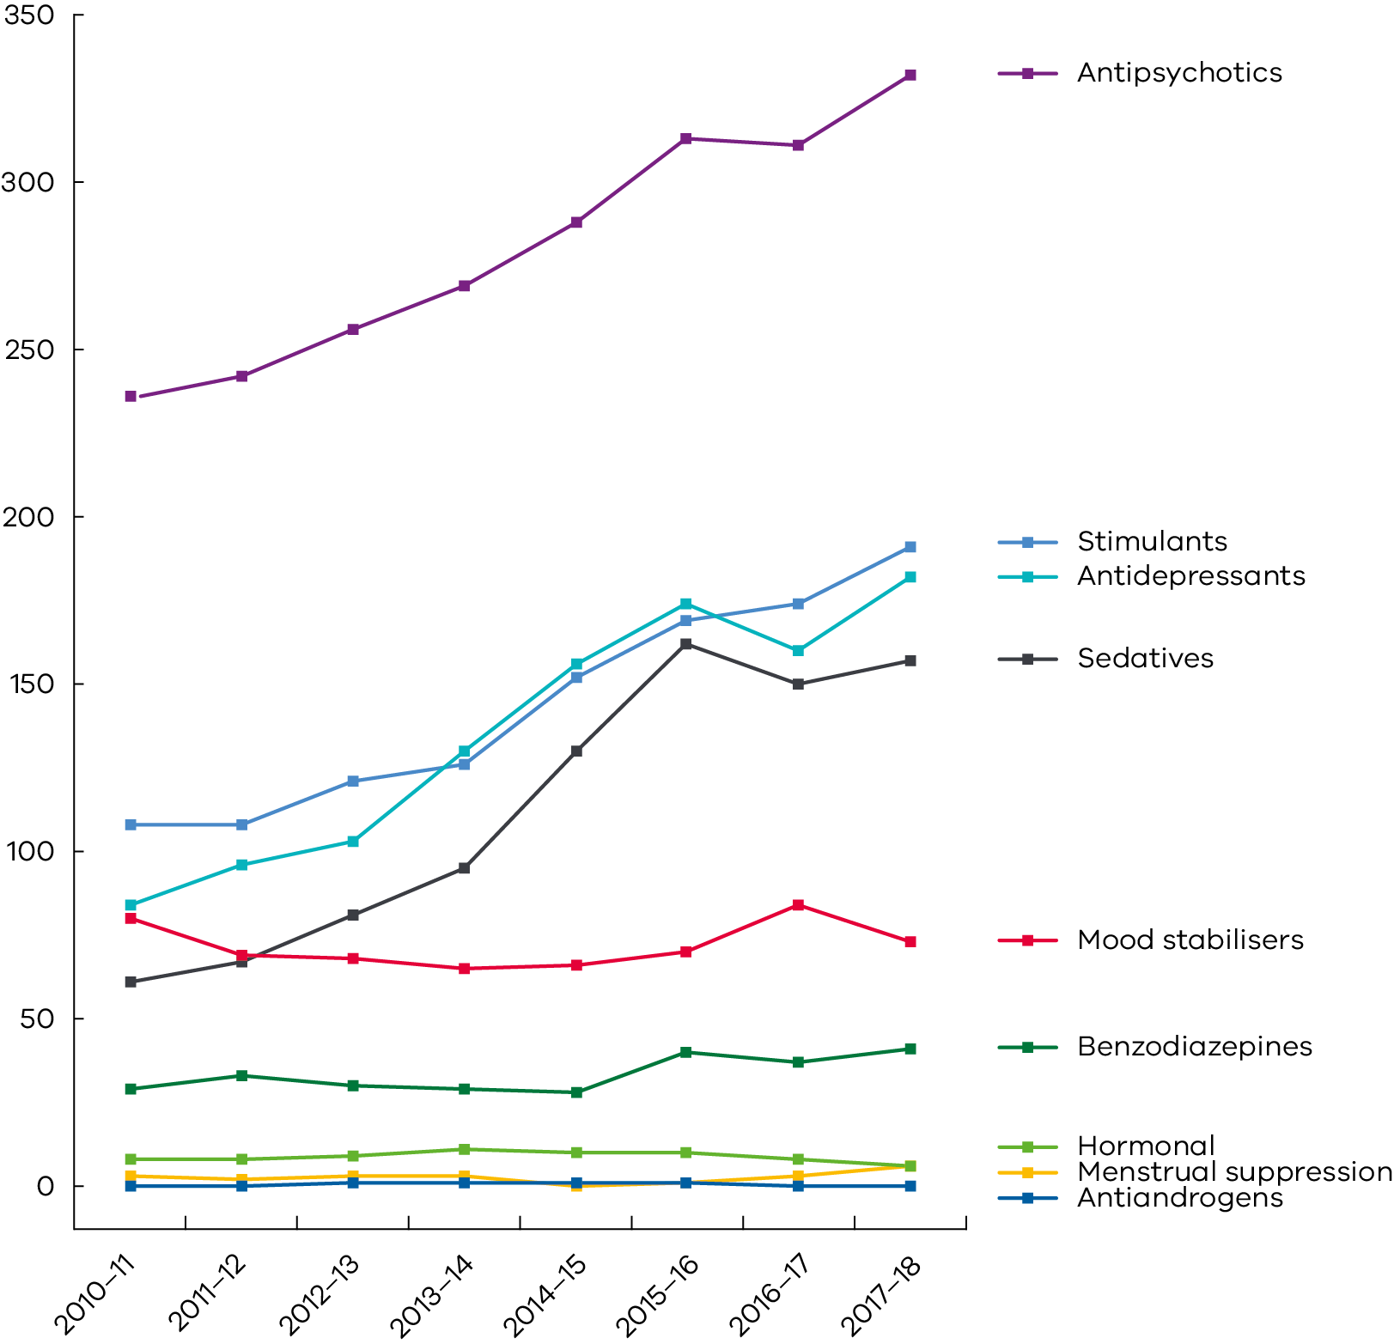

Figure 4 shows the four most commonly used chemical restraints for children are:

* antipsychotics (61 per cent of children who were administered chemical restraint)
* stimulants (35 per cent)
* antidepressants (33 per cent)
* sedatives (29 per cent).

All of the above chemical restraints show increases in the number of children over the past six years.

#### Disabilities

##### Key findings

* The majority of people who are reported to be subject to restrictive interventions in 2017–18 were reported to have an intellectual disability (89 per cent). This percentage has been decreasing slightly each year since 2008–09 when it was reported to be 96 per cent.
* In 2017–18, 50 per cent of all people reported were reported to have autism. The percentage of people with autism has been increasing steadily from 35 per cent in 2008–09.
* Since 2008–09 the percentage of people reported to have sensory, hearing, visual or psychiatric disabilities has been decreasing in each of these categories. It is not clear what accounts for such trends. However, our research has shown that some people are reported at one time and later diagnosed to have an underlying disorder (for example, a psychiatric disorder) that is treated by medications; subsequently, chemical restraint is no longer used.
* Just under one-quarter of all people have other disabilities including dual sensory, learning, neurological and physical disabilities. The proportion of people with these disabilities has not changed significantly over the past 10 years.

It should be noted that the majority of people who are reported have more than one disability, so the total of the above percentages of different disabilities is greater than 100 per cent.

## Behaviour support plan quality evaluations

Any person who is subjected to restraint and/or seclusion in disability services in Victoria must have a behaviour support plan or a treatment plan if they have a compulsory treatment order. In 2017–18 there were 2,767 behaviour support plans received by the Senior Practitioner from services.

The Senior Practitioner uses the Behavior Support Plan Quality Evaluation II tool (BSP-QE II) (Browning-Wright, Saren & Mayer 2003) to objectively assess the quality of behaviour support plans received from disability services in Victoria. Although the BSP-QE II tool was developed in the United States for children, it was validated by the Senior Practitioner for use in Victoria with adults with an intellectual disability, and was found to be a valid and reliable assessment of the quality of behaviour support plans written for adults living in Victoria (Webber et al. 2011a; 2011b). In previous work, the Senior Practitioner also found evidence that the quality of behaviour support plans is associated with reductions in restrictive intervention use (Webber et al. 2012).

### Key findings

* In 2017–18, 83 (three per cent) of the behaviour support plans received by the Senior Practitioner were assessed using the BSP-QE II.
* The average score was 12.4/24, which is unchanged from 2016–17. Figure 5 shows the average score achieved across all services from 2012–13 to 2017–18.
* Quality had been improving since 2012–13; this trend has decreased since 2015–16. The decline in average quality of behaviour support plans in the most recent year suggests there is a need for services to focus on developing high-quality plans.

Figure 5: Average BSP-QE II scores across all disability services, 2012–13 to 2017–18

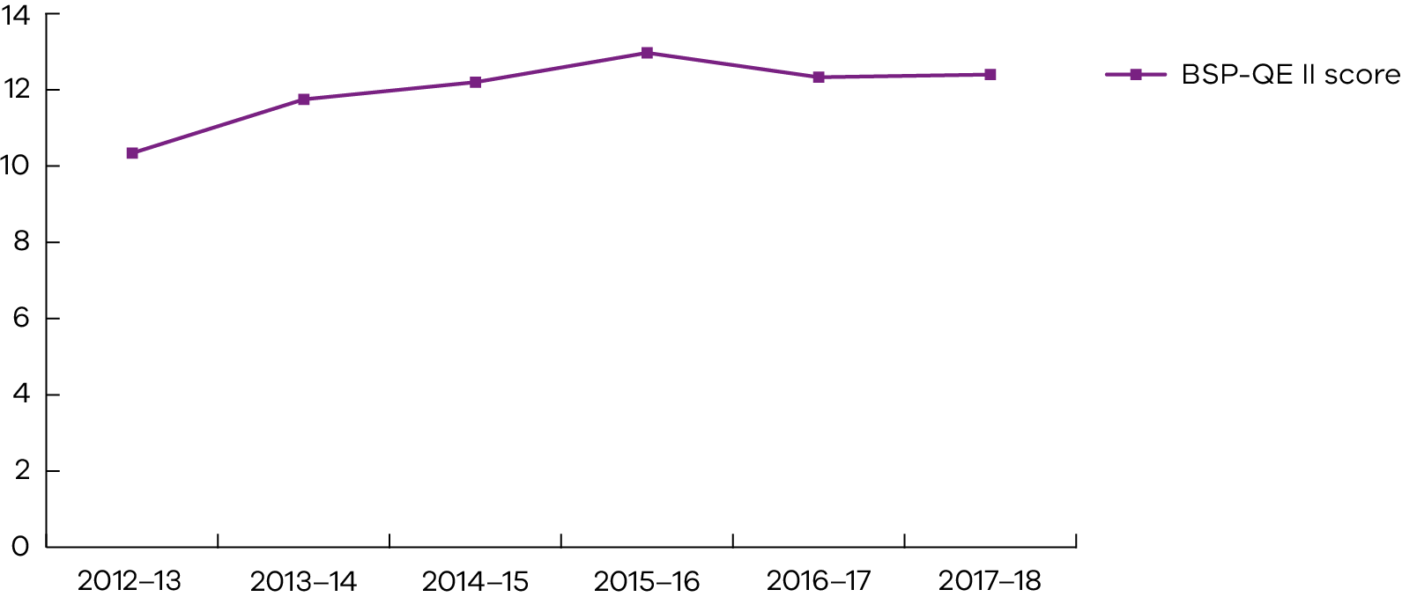

Similar to previous years, the quality review process highlighted areas of strength in planning from the sector as well as key areas where behaviour support plans could be improved.

The good news is that most plans continue to describe:

* the behaviours of concern
* the underlying triggers and the common settings where the behaviours occurred
* appropriate de-escalation strategies.

The function of the behaviours of concern, understanding trigger-setting events and functions of behaviours is essential for minimising the use of restraint and seclusion.

The bad news is that few plans described:

* clear replacement behaviours (alternative behaviours the person can use to meet the function of their behaviours of concern)
* strategies that could be used to teach and encourage effective replacement behaviours
* how the team would work together, communicate and review behavioural goals.

In sum, most plans are unlikely to result in a reduction of restrictive intervention because they do not help the person get their needs met and tend to only use reactive strategies. This means that people with poorly developed plans are likely to continue to be restrained and secluded in the long term.

## Restrictive intervention audit review

The Senior Practitioner has powers to investigate, audit and monitor the use of restrictive interventions and compulsory treatment in disability services (Disability Act, s. 27(2)(c)).

During 2017–18 the Senior Practitioner’s Integrated Health Care Team conducted audits across 28 rural and metropolitan disability services, including group homes, residential respite and day programs. Audits continue to identify and examine the use of restrictive interventions in practice.

### Key findings

This year’s audits showed several common themes including:

* high use of other restraints – this includes limiting personal choice around community access and engagement, and dietary requirements (likes and dislikes)
* a lack of knowledge regarding what other restrictive interventions refer to and how they impact on the individual as well as others using the service
* medication treatment sheets having limited information regarding the purpose of medications, making it difficult for services to decide whether a medication is considered restrictive
* a significant focus by services on identifying and correctly reporting restrictive interventions and less focus on positive and proactive solutions to reducing behaviours of concern and reducing the need for restraint
* lack of sharing of behaviour support plans with other organisations a person accesses, which is not consistent with a ‘one person, one plan’ approach
* the use of restrictive practices without an authorised behaviour support plan in place
* an improvement in disability support staff’s awareness of the need for conversations with doctors about the purpose of medication prescription and, where this was found, a reduction in the use of PRN chemical restraint in those services.

Future work in this area is being undertaken to support the sector. A revised Medication purpose form – chemical restraint for people with a disability: guide and form has been designed to:

* clarify a medication’s purpose
* create a collaborative approach to reducing chemical restraint for doctors to support service providers with their legal obligations around reporting.

These have been enthusiastically received, and support workers are reporting increased use of these among doctors.

## Compulsory treatment

Compulsory treatment means treatment of a person with an intellectual disability who is at risk of perpetrating serious violence to another person. A person may be admitted to a residential treatment facility under a court order or reside in disability residential services in the community under a supervised treatment order. In Victoria there is one disability residential treatment facility – the Intensive Residential Treatment Program at the Disability Forensic Assessment and Treatment Service (DFATS).

Part 8 of the Act allows civil detention to be provided in the community under a supervised treatment order. Detention under the Act is defined as (a) physically locking a person in any premises and (b) constantly supervising or escorting a person to prevent the person from exercising freedom of movement. This part of the Act also legislates for court-mandated detention in a residential treatment facility through orders including residential treatment orders, parole, custodial supervision orders and extended supervision orders.

### The role of the Senior Practitioner for individuals subject to compulsory treatment

The Senior Practitioner is responsible for ensuring the rights of people who are subject to compulsory treatment and restrictive interventions are protected. The Compulsory Treatment Team works for the Senior Practitioner to support these functions. The team comprises a principal practice leader, two senior practice advisers and one program adviser. The team provides practice leadership and training and attends some of the client care team meetings to provide practice advice and to monitor implementation of the treatment plan.

The authorised program officer makes an application to the Victorian Civil and Administrative Tribunal (VCAT) for a supervised treatment order or for a review of a treatment plan for those individuals at DFATS and provides a proposed treatment plan. The Senior Practitioner and the Compulsory Treatment Team review all of the documentation provided by the authorised program officer, including the treatment plan and the annual risk assessment. The treatment plan describes the treatment proposed, states how this will benefit the person, and defines the levels of detention, supervision and restrictive interventions to be overseen, with a view to move towards lesser levels of restriction, if appropriate.

The Senior Practitioner approves the treatment plan on the directions and recommendations within the treatment plan certificate issued by the Senior Practitioner for a maximum period of one year.

For people subject to custodial supervision orders under the Crimes (Mental Impairment and Unfitness to be Tried) Act 1997 at DFATS, the Senior Practitioner reviews the treatment plan and issues a treatment plan statement, which includes directions and recommendations in relation to practice.

During the life of any compulsory treatment order, implementation reports must be completed and submitted at a minimum of six-monthly intervals. The authorised program officers provide these to the Senior Practitioner and include detailed information about:

* how the person is progressing against their treatment goals
* progress on the directions of the Senior Practitioner within the treatment plan certificate
* any incident reports and data collected
* any changes in restrictive interventions
* quality of life assessments and any additional assessments that have been completed, including any implications for treatment.

The authorised program officer is responsible for implementing the treatment plan.

### Victorian Civil Administrative Tribunal hearings

A VCAT hearing is convened with the person for whom the supervised treatment order is under consideration, their legal representative, the Office of the Public Advocate, a Senior Practitioner representative, the authorised program officer and any relevant supporting staff from the person’s disability residential services present. If VCAT is satisfied that the criteria for a supervised treatment order is met they will make an order for up to one year, at which point it will be reviewed.

The treatment plan for a person subject to compulsory treatment at DFATS is reviewed by VCAT within the first six months of the person being admitted to DFATS and annually thereafter for the duration of the court order.

The Office of the Public Advocate is a party to the VCAT hearings and can make an application to VCAT directing the authorised program officer to make an application for a supervised treatment order if the office is concerned that a person is being detained unlawfully.

There were 52 VCAT hearings in relation to compulsory treatment matters held between 1 July 2017 and 30 June 2018, some of which were held in chambers. These comprised reviews for supervised treatment orders, including interim orders (which can be made until a supervised treatment order is determined), treatment plan reviews for people under compulsory treatment at DFATS, material change hearings when a variation to the plan resulting in an increase in restrictions was requested and revocation of supervised treatment orders.

The Compulsory Treatment Team attended all open hearings.

### Compulsory treatment data

There were 34 people subject to compulsory treatment during 2017–18, which is three more people than the previous year.

There have been 21 people subject to supervised treatment orders for the whole of the period between 1 July 2017 and 30 June 2018. There was one person subject to an interim supervised treatment order at the start of the financial year, which was made into a supervised treatment order during the year. Additionally there were three new supervised treatment orders and one interim supervised treatment order made during this period. Two supervised treatment orders were revoked during the year because the criteria for a supervised treatment order was no longer met.

Twenty-six people were subject to a supervised treatment order (including one interim order) at the end of the financial year. At the end of the 2017–18 year, 28 people were subject to compulsory treatment.

There were six people subject to compulsory treatment during the year at DFATS. Four people were subject to a residential treatment order for the whole of the reporting period. There was one person admitted to DFATS subject to a supervision order under the Serious Sex Offenders (Detention and Supervision) Act 2009. One person was on parole and returned to custody during 2017–18. At the end of the reporting period, there were five people subject to compulsory treatment at DFATS and six people subject to the Crimes (Mental Impairment and Unfitness to be Tried) Act; two of these individuals were granted extended leave during the period.

### Assessment orders

An authorised program officer may apply to the Senior Practitioner for an assessment order to be made in respect of a person with an intellectual disability living in a residential service. If it is necessary to detain the person to prevent a significant risk of serious harm to another person and assessments need to be undertaken to enable the urgent development of a treatment plan, the Senior Practitioner may make an assessment order once for a person, for a maximum period of 28 days. In 2017–18 no assessment orders were made, in comparison with one made in 2016–17.

### Client demographic data

Of the 34 people subject to a compulsory treatment order in 2017–18, 33 were male and one was female. There have only been four females since 2008–09 subject to compulsory treatment.

In 2017–18, the primary types of offending behaviour that resulted in people being subject to a supervised treatment order or residential treatment order included sexual violence and violence (non-sexual).

The average age of people subject to compulsory treatment in 2017–18 was 41 years, ranging from 22 to 62 years. This is a similar age profile to the previous two years. Sixteen people resided within community service organisations and 18 resided within Department of Health and Human Services accommodation, including DFATS.

### Compulsory treatment restrictive intervention data

In 2017–18, 24 out of the 34 people who were on compulsory treatment were reported to be subject to at least one type of restrictive intervention during the year (Table 1). This is two more people than the previous year. This constitutes 71 per cent of people subject to compulsory treatment in comparison with 64.5 per cent last year and 78 per cent in 2015–16.

Table 1: Number of people subject to restrictive intervention, 2015–16 to 2017–18

| Restrictive intervention | 2015–16 | 2016–17 | 2017–18 |
| --- | --- | --- | --- |
| Routine chemical restraint | 14 | 17 | 18 |
| Emergency chemical restraint | 9 | 5 | 3 |
| PRN chemical restraint | 1 | 4 | 3 |
| Seclusion | 4 | 2 | 5 |
| Physical restraint | 3 | 2 | 5 |
| **Total people subject to compulsory treatment** | **32** | **31** | **34** |

Table 2 shows the number of people subject to supervised treatment orders in the community and compulsory treatment orders at DFATS, and the different types of restrictive interventions administered in 2017–18.

Table 2: Restrictive interventions administered to people subject to orders, 2017–18

| Restrictive intervention | Supervised  treatment orders | Compulsory treatment orders at DFATS |
| --- | --- | --- |
| Routine chemical restraint | 16 | 2 |
| PRN chemical restraint | 3 | 0 |
| Emergency chemical restraint | 3 | 0 |
| Routine seclusion | 5 | 0 |
| PRN seclusion | 1 | 0 |
| Emergency seclusion | 1 | 1 |
| Emergency physical restraint | 0 | 5 |

### Material changes

A material change is a variation to a person’s treatment plan. A change cannot be made to a treatment plan unless the change is approved by the Senior Practitioner. If a material change relates to an increase in restrictions, the Senior Practitioner is unable to approve this and the authorised program officer must apply to VCAT for a variation of the plan. However, if the Senior Practitioner considers that an increase in the level of the supervision or restriction of a person who is subject to a supervised treatment order is necessary because of an emergency, the Senior Practitioner may approve a material change relating to an increase in restrictions and then must immediately apply to VCAT for a review of the variation.

During 2017–18, 20 material changes involved changes to the restrictive interventions that people were subject to, which is one fewer than the previous year. There were seven emergency material change applications to the Senior Practitioner over the financial year, whereas there were eight in the previous year. All except one of the emergency material changes were approved. The Senior Practitioner was unable to approve the application in this case due to a delay in providing notification and advised the authorised program officer to apply to VCAT. The application for emergency material changes were mainly in relation to the use of physical restraint and seclusion, and the majority of the non-emergency applications to the Senior Practitioner were in relation to medication changes.

### Revocation

The Senior Practitioner, authorised program officer or the person who is subject to the supervised treatment order can apply to VCAT to have their treatment plan reviewed, and the order can be revoked. The Senior Practitioner and VCAT must review supporting documentation before a supervised treatment order expires to determine whether or not the person continues to meet the legislative criteria for a supervised treatment order and the use of civil detention. The authorised program officer and the Senior Practitioner prepare separate submissions to VCAT to evidence how the person no longer meets all of the criteria for a supervised treatment order.

During 2017–18, two supervised treatment orders were revoked. Neither of the individuals involved continued to meet the criteria for a supervised treatment order but continued to reside in disability accommodation. The Compulsory Treatment Team remain involved for up to six months post revocation to monitor the person’s transition.

One person at DFATS was subject to a parole order and returned to custody during the reporting period.

### National Disability Insurance Scheme

Most of the clients subject to supervised treatment orders at the end of the financial year have either transitioned to the NDIS or have had a planning meeting, awaiting the outcome. Twelve of the clients have an NDIS plan, eight have been assessed and are awaiting an outcome and six have not had an assessment. In 2016–17, four of the clients subject to a supervised treatment order had transitioned to the NDIS.

Discrepancies in state-funded and Commonwealth-funded (NDIS) service provision have been managed through requesting a review of the NDIS plan, the responsible division within the department funding certain services and though the continuity of support processes within the department.

The Compulsory Treatment Team has continued to work collaboratively with the Intensive Support Team and the Disability and NDIS Branch within the department to work through processes to maximise supports for clients subject to compulsory treatment to meet their needs holistically, addressing both disability and forensic disability support needs.

### Adaptive behaviour assessments

Adaptive behaviour assessments assess the functional skills necessary for daily living. A number of standardised adaptive behaviour scales are currently available to assess an individual’s adaptive functioning, such as the Vineland III, the Adaptive Behaviour Assessment System (ABAS III) and the Scales of independent Behaviour – Revised (SIB-R).

A fundamental underlying principle of the Disability Act (5)(2)(c) states that ‘Persons with a disability have the same right as other members of the community to realise their individual capacity for physical, social, emotional and intellectual development’. To achieve this principle, it is important to maximise access to disability supports for clients subject to compulsory treatment and for these clients to have the opportunity to have their support needs effectively met through the transition to the NDIS and into the future.

A discrete piece of work that the compulsory treatment team focused on this year concerned the use of adaptive behaviour assessments with clients subject to compulsory treatment.

In reviewing the files of clients subject to compulsory treatment, it became evident that there had been a predominant focus on the individual’s risk and how that risk was managed, with significantly less attention paid to the person’s functional support needs. The Senior Practitioner considered it necessary to address the issue of having limited information about a person’s disability profile, including the person’s strengths and skill deficits. Furthermore, it is crucial for explicit adaptive behaviour information to be available to inform the NDIS support assessments. As such, the Compulsory Treatment Team requested adaptive behaviour assessments from the compulsory treatment sector, in addition to the risk and other relevant assessments.

Two of the six clients at DFATS who were subject to compulsory treatment during the year have had an adaptive behaviour assessment completed, and 11 of the 26 clients who were subject to supervised treatment orders had an adaptive behaviour assessment completed. This is an increase in the number of adaptive behaviour assessments being undertaken in the compulsory treatment sector. The tools used were the Vineland III, the ABAS III and one SIB-R. It is anticipated that all clients subject to compulsory treatment will have a formal adaptive behaviour assessment undertaken using a formal assessment for adaptive behaviour by the end of the next financial year.

The inclusion of adaptive behaviour assessments in the compulsory treatment process has introduced a significant positive outcome measure and a focus on skill building, which is important for the person with a disability in line with the principles of the Disability Act outlined above. It supports skill acquisition by providing a baseline and identifying skill deficits to target in treatment. It also helps when planning for supports by providing information about a person’s disability profile and needs.

Research shows that administering standardised measures of adaptive functioning and identified dynamic factors associated with the risk of recidivism dictate not only the levels and type of support provided but also the restrictive intervention and treatment required for this cohort of individuals. The design and implementation of treatment and support can also determine the length of time a person is subject to criminal and civil orders. A member of the Compulsory Treatment Team is currently undertaking some further work investigating the relationship between adaptive behaviour profiles and dynamic risk factors, including examining whether targeted support based on strengths and deficits related to adaptive functioning could lead to changes over time in the dynamic factors identified in a forensic assessment of risk, and vice versa.

# Projects to deliver evidence-informed outcomes

A function of the Senior Practitioner is ‘to undertake research into restrictive interventions and compulsory treatment and provide information on practice options to disability support providers’ (Disability Act, s. 24(1)(g)). This section of the report describes the major projects that were undertaken during 2017–18 to deliver evidence-informed outcomes to the sector.

## Mechanical Restraint Project

Mechanical restraint is described by the Act as material or devices that prevent a person moving freely and that are not providing treatment or helping the person be more independent. The office had seen no decrease in the number of people reported to be mechanically restrained each year from 2008 to 2013.

In response, a project was developed in 2013 to examine the use of mechanical restraint and what could be done to reduce its use.

The project had four phases:

* Phase 1 looked at the individual characteristics of those at risk of being subjected to mechanical restraint (the result of this phase was described in an article ‘Factors associated with the use of mechanical restraint in disability services’ published in the Journal of Intellectual & Developmental Disability by Webber et al. (2017a))
* Phase 2 looked at what was known and had been recommended for a group of 39 people who had been mechanically restrained over a period of years.
* Phase 3 put in place some critical assessments such as functional behaviour assessments with 10 of those people who were mechanically restrained to determine how mechanical restraint could be reduced. (A case study that describes how two service providers successfully eliminated the use of mechanical restraint was published in the journal Learning Disability Practice by Webber et al. (2017b))
* Phase 4 provided clinical support to assist services to implement strategies recommended in phase 3 to reduce the use of mechanical restraint, as well as capture facilitators and barriers for services and staffing groups to implement recommendations to reduce mechanical restraint. We want to learn more about these factors to evaluate practices surrounding the use of mechanical restraint and use these learnings to influence future work. This phase of the project will be completed in the second half of 2018.

## General practitioner modules

This project was commissioned in 2014–15 to develop online training modules for general practitioners (GPs) assessing and treating people with intellectual disabilities presenting with behaviours of concern. The purpose of the GP modules was to increase the capacity of the medical workforce to effectively assess and respond to health issues with high-quality health care and, in doing so, enhance the health and wellbeing of people with intellectual disabilities.

The Royal Australian College of General Practitioners accredited the modules, which were made freely available online for continuing professional development. A review in 2016–17 revealed that the utility and take up of the modules by GPs was poor, although the content was judged to be excellent. In response, and on advice from the Royal Australian College of General Practitioners, the Senior Practitioner commissioned Swinburne University to develop an online platform for GPs to enable a self-audit of their practice.

It is anticipated that the Royal Australian College of General Practitioners will accredit the revised modules ready for GPs to access by June 2019.

## The impact of the roadmap for reducing restrictive practices and behaviours of concern

Training in the Roadmap for achieving dignity without restraint was offered jointly by Professor Paul Ramcharan from RMIT University and National Disability Services to eight organisations between March and June 2018. The training focused on assisting disability services to reduce their use of restrictive interventions by understanding the causes of behaviours of concern.

Professor Paul Ramcharan says:

‘Behaviours of concern are often caused by difficult environments, interactions and trauma histories. A person’s behaviour of concern is often an adaptive behavioural response to a maladaptive environment. The cause of the majority of behaviours of concern is not the person or the person’s disability, but other factors in the person’s environment.’

To date the following has been completed:

* Baseline testing and training has been completed by 121 staff for 121 people with a disability who are currently reported to be subject to a restrictive intervention at some time during 2017–18.
* Each staff member developed an action plan for one person they were supporting.
* The majority of participants agreed:
  + the training was of high quality
  + the training would help them plan and target their support better
  + their use of restrictive practices would reduce as a result of implementing the training.

Next steps involve each staff member implementing their action plans in collaboration with their managers to support the person with a disability. Reassessment of baseline assessments will take place between March and May 2019 to examine the impact of training and implementation on restraint and behaviours of concern reduction. The final report is due in September 2019.

## Eleven years of the Senior Practitioner research: A review

The year 2018 marked 11 years since the Office of the Senior Practitioner undertook its first research project in 2007. The Senior Practitioner established a research review panel to review the research produced or commissioned by the office and provided advice about gaps in the literature on restrictive interventions. The panel comprised stakeholders from the department, disability service providers, universities, a person with lived experience of a disability and clinicians. The panel met on four occasions to review the research projects to date and advised on priorities for future research projects. The panel recommended three projects to be undertaken in the near future. The following two projects are currently underway:

* a project to understand the pathways to and through compulsory treatment – work towards a policy and service model to prevent imprisonment and reduce recidivism among offenders with a disability
* a project to investigate the prevalence of menstrual suppression being used as a chemical restraint and to compare the findings to world-wide best practice.



Painting by Sarah Guilfoil

# Promoting best practice through professional development

A function of the Senior Practitioner is ‘to provide education and information with respect to restrictive interventions and compulsory treatment to disability service providers’ (Disability Act, s. 24(1)(b)). This section describes various education and training opportunities that were provided to disability support providers during 2017–18.

## Introduction to reporting to the Senior Practitioner about restrictive interventions for new services

During 2017–18 the Senior Practitioner’s team provided introductory training for new services. The sessions covered the requirements under the Disability Act to report restrictive interventions. It provided information to services on chemical, mechanical and physical restraint, and seclusion, and how to register with the Restrictive Intervention Data System (RIDS) to report on restrictive interventions. During 2017–18 presentations were provided in each division in the state.

## Behaviour support plan training sessions

The RIDS behaviour support plan toolkit training is an all-day interactive session on how to develop effective behaviour support plans that will meet the requirements of the Act. The content covers the process of understanding the context in which behaviours of concern may occur for a person, and the function or purpose of that behaviour. Participants learn how to identify the best positive behaviour support interventions that would reduce the need to use a behaviour of concern, as well as how to tell if the interventions are working. The training also demonstrates how to upload the plan into the RIDS. This session was delivered 11 times during 2017–18 to 240 participants.

## Restrictive intervention training

The Integrated Health Care Team continued to provide training to services on understanding restrictive interventions and how to reduce them. Currently the team is combining audits and training to provide more focused and relevant information to services. This financial year, we have focused on meeting with advisers from Agency Performance and System Support teams to talk about the role of the Senior Practitioner and how the Integrated Health Care Team can support new organisations with our resources and training.

The Integrated Health Care Team also presented on restrictive interventions and the work of the Senior Practitioner at the following events:

* Office of the Public Advocate, Community Visitors Seminar
* National Disability Services, North Eastern Melbourne regional forum.

## Data warehouse

The Senior Practitioner has been successful in migrating the entire RIDS eBSP (electronic behaviour support plan) reporting capability into the new corporate reporting toolset. Since then the RIDS eBSP, along with its reporting capability, has been selected to be the department’s first legacy system to be migrated to an entirely cloud-based platform. The new cloud platform will bring many benefits, including a streamlined process for developing, testing and implementing new and enhanced reporting products and improved reporting performance. The migration project is nearing the end of the testing phase and the final implementation phase is to be completed in the 2018–19 financial year. For services this will mean they will have access to clear reports on their use of restrictive interventions and behaviour support plans.

## Restrictive Intervention Self Evaluation Tool

In July 2016 the Senior Practitioner’s office launched the Restrictive Intervention Self Evaluation Tool (RISET), an online tool designed to assist services to expand their knowledge and understanding of restrictive interventions and the legislative requirements of disability support services.

Key findings

* In 2017–18 the tool had 1,646 hits.
* Similar to the previous year, the majority of people using the tool appear to be seeking specific information:
  + 30 per cent chose chemical restraint
  + 10 per cent chose physical restraint
  + nine per cent chose other restrictive interventions
  + eight per cent chose seclusion
  + six per cent chose ‘Getting NDIS ready for the National Quality and Safeguarding Framework’.
* A total of 133 people (eight per cent) completed the entire tool.
* Forty-seven out of 56 people who responded to the question, How easy was the RISET to use? agreed the RISET was ‘easy to use’ or ‘moderately easy to use’.

The RISET can be found by conducting an online search for ‘RISET’.

## Promoting Dignity Grants

Since 2008 the Senior Practitioner has offered disability services small grants called Promoting Dignity Grants. They provide a chance for disability service providers to develop innovative solutions to reduce their use of restrictive interventions for a particular person or people they support who are subject to restrictive interventions. In 2017 two grants were awarded to a departmental rural area and a disability residential service provider.

In the first project, departmental area staff commissioned Dr Cadeyrn Gaskin to write a report about the components of a successful service provision to a young girl with high complex needs who had successfully been provided with services from child protection and disability services. The report describes the necessary components needed for a successful outcome for a child with high complex needs. The components include:

* understanding the history and individual needs of the child
* understanding why the child uses the behaviour of concern
* teaching the child skills to use to get their needs met safely
* all staff knowing exactly how to support the child
* coordination and communication between different services.

In the second project, a disability residential service provider wanted to improve the environment for five men they supported. Over many years the staff had removed most movable objects in the house in case the men used these objects to hurt each other. The young men had little opportunity in their house for independent living because they didn’t have access to basic things like cups, drinks and food. The staff team’s first task was to complete an inventory of all environmental restraints. They found there were 21 environmental restraints ranging from lack of access to the refrigerator to a striker door that was used to isolate one section of the house from the other section where the two most aggressive men lived. The staff were able to think of ways to reduce seven of these environmental restraints fairly quickly; for example, they provided a small refrigerator for the men so they could access drinks independently. The team has been awarded another grant for 2018 so they can continue with the project.

Posters from both of these Promoting Dignity Grant projects were on display during the 2017 Senior Practitioner Seminar.

## ARMIDILO-S

The Assessment of Risk and Manageability of Individuals with Developmental and Intellectual Limitations who Offend – Sexually (ARMIDILO-S) is a risk assessment and management tool that has been specifically developed for use with offenders with an intellectual disability.

Risk assessment and management is a central consideration for compulsory treatment when working with offenders with an intellectual disability.

The Senior Practitioner facilitates regular training sessions conducted by the principal author of the assessment, Professor Doug Boer, from the University of Canberra. ARMIDILO-S user group sessions are also facilitated by the Senior Practitioner. Two sessions were convened this year to maintain and enhance practice skills in using the assessment tool among those who attended Professor Boer’s workshops.

# Supporting best practice through advice, partnerships and consultation

A function of the Senior Practitioner is ‘to develop links and access to professionals, professional bodies and academic institutions for the purpose of facilitating knowledge and training in clinical practice for persons working with persons with a disability’ (Disability Act, s. 24(1)(f)). In this section we describe our work with our compulsory treatment stakeholders, students from universities, National Disability Services and the Department of Education and Training to facilitate knowledge and training in clinical practice.

## Compulsory treatment practice forums

The Compulsory Treatment Team ran three practice forums during the year. The membership is open to staff working with compulsory treatment clients including authorised program officers, clinicians, direct care (disability) staff and representatives from the Office of the Public Advocate and VCAT.

These forums have focused on facilitating information sharing about compulsory treatment, addressing and promoting practice, and supporting professional networking. The forums have covered a number of topics including:

* the Community Forensic Dual Disability Service’s new processes for client reviews
* the newly developed private practitioner resource list
* the RISET tool, which supports the sector when using restrictive interventions
* the importance of completing an adaptive behaviour assessment for clients in addition to a risk assessment
* the difference between functional behavioural assessments and analysis
* NDIS transition issues, specifically information about the Intensive Support Team’s role and experience with the compulsory treatment cohort and its interface with the NDIS and the new disability justice coordinator roles.

The Compulsory Treatment Team has received positive feedback from participants about these forums.

## Compulsory treatment team newsletters

Since 2015 the Compulsory Treatment Team has issued newsletters that have included practice advice, links to resources, updates on compulsory treatment forums, stakeholder issues and general information about the Office of the Senior Practitioner. Two newsletters were issued in this reporting period.

A survey conducted by the Compulsory Treatment Team has confirmed that the newsletter is beneficial to key stakeholders.

## Care team meetings and case consultations

The Compulsory Treatment Team supports the sector by engaging in case consultations and attending care team meetings for Compulsory Treatment Team clients. The team prioritises attendance at care team meetings based on the client’s presentation such as:

* the presence of significant problematic behaviour that requires intervention
* significant issues with implementing the treatment plan
* the presence of significant service gaps that affect risk management and meeting the client’s need
* multiple diagnoses that contribute to a complex presentation
* recent use of seclusion and physical restraint, when a client is noncompliant with the order, if the client is on a new order, revocation or preparation for revocation, and if the client is going through a transition period (with accommodation, support services and clinical support).

## Occupational therapy students working with the Senior Practitioner

During 2017–18 the Integrated Health Care Team hosted and supervised two Bachelor of Occupational Therapy students and two Master of Occupational Therapy Practice students from Monash University for their Participatory Community Practice unit.

The students completed two projects, both partnering with Occupational Therapy Australia – Victorian division, which looked into issues surrounding restraint reduction barriers for disability services.

The first project investigated current issues with communication pathways between occupational therapists and disability support workers. Using a survey and a focus group, students gathered information from Victorian occupational therapists currently working in the disability sector and provided recommendations to the office and Occupational Therapy Australia to reduce the challenges occupational therapists experience.

The second student project aimed to increase occupational therapists’ knowledge and awareness of restrictive interventions and behaviours of concern through developing a scenario-based learning tool to be used by practising occupational therapists and to be included in the university curriculum.

## Recognising restrictive practices – video resource development

Members of the Senior Practitioner team were involved in developing a video resource package with National Disability Services. Recognising restrictive practices is a set of short films and an accompanying guide that explores the use of restrictive practices and encourages discussion around the use of these practices.

The films show seven case examples of restrictive practices being used in everyday situations relating to:

* chemical restraint
* mechanical restraint
* physical restraint
* seclusion
* consequence control
* restricted access
* power control.

The videos can be accessed through the [National Disability Services website](https://www.nds.org.au/news/zero-tolerance-films-focus-on-restrictive-practices)   
<https://www.nds.org.au/news/zero-tolerance-films-focus-on-restrictive-practices>.



Painting by Kylie Scott

## Work with the Department of Education and Training

A dedicated Principal Practice Leader (Education) position was established in August 2015. The position was initially appointed for two years to work with the Department of Education and Training but still under the direction and guidance of the Senior Practitioner. The position was extended for a further term in 2017–18 until May 2019.

The Department of Education and Training has continued to collect data on restraint and seclusion in 2017–18, focusing on the rollout and implementation of the revised policy and guidance to reduce and eliminate restraint and seclusion in Victorian Government schools.

Two practice guides on physical restraint and seclusion were released in June 2018. These practice guides operationalise existing policy on restrictive practices in schools, support better decision making and help manage student behaviours of concern.

The Principal Practice Leader (Education) will continue to work with schools to ensure physical restraint and seclusion are only used when it is immediately required to protect the safety of a student or any other person.

Finally, Mandy Donley, who has been in this role since its inception and who previously was a long-term principal practice leader with this office, submitted her resignation in mid-June. Mandy has resigned to take up the position as the inaugural Senior Practitioner for the Australian Capital Territory. We congratulate and wish Mandy all the very best in taking on this significant role and thank her for the outstanding work she has completed not only in the Principal Practice Leader (Education) role but for all of the significant work and initiatives she has led and contributed to in her work with the Victorian Senior Practitioner team.



Mandy Donley

# Informing public debate and opinion

A function of the Senior Practitioner is ‘to provide information with respect to the rights of persons with a disability who may be subject to the use of restrictive interventions or compulsory treatment’ (Disability Act, s. 24(1)(c)). One of the main ways the Senior Practitioner shares information is through the annual Senior Practitioner Seminar. In 2017 the Senior Practitioner Seminar celebrated 10 years of the Disability Act. In this section we also list our peer-reviewed publications and conference papers that were published or presented between July 2017 and June 2018. Most of these have been written either in collaboration with our partners in universities or with our services.

## Ten years of the Disability Act

The Disability Act is quite unusual because rarely does an Act require more than monitoring of practice. Because the Disability Act mandates research and education, Victoria has led the way in providing evidence-based research that has informed the training, education, safeguarding and protecting the rights of people with a disability. The 2017 Senior Practitioner seminar, held on 4 July 2017, focused on the mandated work of the Senior Practitioner’s team from 2007 to 2017 . The event was also an opportunity to share the latest work by the Senior Practitioner as well as looking at the relationships that have been developed across the sector both within Victoria and interstate in finding ways to reduce the use of restrictive interventions.

Speakers included:

* Tracy Beaton – Director, Office of Professional Practice
* Frank Lambrick – Senior Practitioner – Disability
* Arthur Rogers – Department of Premier and Cabinet
* Laurie Harkin AM – Disability Services Commissioner
* Deputy President Genevieve Nihill and Member Brendan Hoystead – Victorian Civil and Administrative Tribunal
* Colleen Pearce – Public Advocate
* Kevin Stone – Victorian Advocacy League for Individuals with Disability (VALID)
* Paul Ramcharan – RMIT University
* Rachael McDonald – Swinburne University
* Mandy Donley – Department of Education and Training
* Members of the Senior Practitioner – Disability team including Kerrie Hancox and Katie White.

Jon Slingsby from VALID acted as the master of ceremonies for the day.

## Publications in peer-reviewed journals

Two papers were published in peer-reviewed journals in 2017–18.

Webber LS, Major K, Condello C, Hancox K 2017, ‘Providing positive behaviour support to improve a client’s quality of life’, Learning Disability Practice, 20(4): 36–41

This case study describes how two services worked together to provide good-quality positive behaviour support to eliminate the use of mechanical restraint for a 38-year-old man, James.[1] James has cerebral palsy and epilepsy among other disabilities. James has self-harmed from the age of two years, hitting his head. To stop his self-harm, mechanical restraints (splints and helmet) were used. When he began to self-harm using the mechanical restraints his carers realised they needed to find out what caused the self-harm. They found he had several serious underlying medical problems that caused pain and distress. His self-harm could be interpreted as cries for help. His carer’s ability to monitor and interpret these cries for help led to them supporting him to get his needs met. This meant they no longer needed to mechanically restrain him, with the result that mechanical restraint has not been used since October 2014.

O’Dwyer C, McVilly KR, Webber L 2017, ‘The impact of positive behavioural support training on staff and the people they support’, International Journal of Positive Behavioural Support, 7(2): 13–23

In this study, staff training in positive behaviour support was used as part of implementing policy initiatives designed to decrease the use of restrictive interventions, and increase the safety and quality of outcomes for people with a disability who show behaviours of concern. Disability staff participated in a training program based on the principles of positive behaviour support, which included elements of good practice as recommended in the BSP-QE II. Behaviour support plan quality and client outcomes were evaluated and compared with a matched control group. Evaluation outcome data showed an improvement in the behaviour support plan quality and client mental health, as well as reductions in maladaptive behaviours and restrictive intervention use. We concluded that a structured staff training intervention in positive behaviour support can meet staff training needs and result in positive client outcomes.

## Conference papers

Two conference papers were presented by occupational therapy students on placement from Monash University.

Gleeson E, McKim H 2018, The engagement of occupational therapists to enhance transdisciplinary communication in the disability sector. Occupational Therapy Australia (OTA) VIC – TAS Regional conference, Engage, Enrich, Enable, Melbourne

Occupational therapists (OTs) and disability support workers (DSW) both have a role supporting people with an intellectual disability. This project focused on investigating the issues with current communication pathways between the two professions and highlighted solutions to challenges experienced by OTs. The project employed two main methods to gather information: a survey and a focus group. Both were targeted at Victorian OTs currently working in the disability sector. The survey gathered information about the problems experienced by OTs regarding communicating with DSWs. The focus group was then subsequently held and provided a space for OTs to discuss potential solutions to the problems identified in the survey. Preliminary findings highlighted five key themes that exist surrounding current barriers to communication between OTs and DSWs: the variety of education and training of disability staff in what an OT can provide and how to follow clinical recommendations; high staff turnover of disability workers; limited opportunity for OT follow-up; referral processes being too specific and solution-based, not allowing for proper assessment and investigation by OTs; and the experience of OTs working within the NDIS.

Charles S, Curran J 2018, Restrictive practices: Reducing restrictive practices through education. Occupational Therapy Australia (OTA) VIC – TAS Regional conference, Engage, Enrich, Enable, Melbourne

This presentation provided an overview of a student project that aimed to increase OTs’ knowledge and awareness of restrictive interventions and behaviours of concern through developing a scenario-based learning tool for OTs that could be included in university curriculum. A lack of knowledge regarding behaviours of concern and their connection with restrictive practices creates a barrier to occupational engagement of people with a disability. OTs have a unique skill set to enable occupational engagement in meaningful and valuable occupations for this vulnerable population. Increasing OTs’ awareness of this pressing issue will assist the profession to uphold a client-centred approach to then assist parents, carers, teachers and disability service staff to reduce the need for and use of restrictive interventions. A scenario-based learning tool with learning objects regarding restrictive interventions was included into the Monash University curriculum for occupational therapy students.

## Invited presentations

14–15 June 2018: Roundtable on Restrictive Practices in the Northern Territory

The Northern Territory Public Guardian invited the Senior Practitioner to present on issues concerning the monitoring and oversight of the use of restrictive practices. The first presentation involved a workshop for staff from the Office of the Public Guardian. The second presentation was a keynote address to the Public Guardian, National Disability Services, the Department of Health, the Office of Disability and National Disability Insurance Agency staff for a morning roundtable discussion. The third presentation was another keynote address for an afternoon roundtable for non-government organisation service providers.

# References

Browning-Wright D, Saren D, Mayer GR 2003, The behavior support plan – quality evaluation guide, viewed 23 October 2014 at [Positive Environments, Network of Trainers website](http://www.pent.ca.gov) <http://www.pent.ca.gov>.

State Government of Victoria 2006, Disability Act 2006, at [Victorian Legislation and Parliamentary Documents website](http://www.legislation.vic.gov.au) <http://www.legislation.vic.gov.au>.

Webber LS, et al. 2011a, ‘Factors influencing quality of behaviour support plans and the impact of quality of plans on restrictive intervention use’, International Journal of Positive Behavioural Support, vol. 1, pp. 24–31.

Webber LS, et al. 2011b, ‘Assessing behaviour support plans for Australian adults with intellectual disability using the “Behaviour Support Plan Quality Evaluation II” (BSP‑QE II)’, Journal of Intellectual and Developmental Disability, vol. 36, pp. 1–5.

Webber LS, et al. 2012, ‘The impact of the quality of behaviour support plans on the use of restraint and seclusion in disability services’, International Journal of Positive Behavioural Support, vol. 2, no. 2, pp. 3–11.

Webber LS, et al. 2017a, ‘Factors associated with the use of mechanical restraint in disability services’, Journal of Intellectual and Developmental Disability, 1–5.

Webber LS, et al. 2017b, ‘[Providing positive behaviour support to improve a client’s quality of life](http://journals.rcni.com/doi/abs/10.7748/ldp.2017.e1826)’, Learning Disability Practice, 20(4): 36–41.



Painting by Sarah Veli

1. Not his real name.