Senior Practitioner report   
2017–2018

Plain English

To receive this publication in an accessible format phone   
9096 8427, using the National Relay Service 13 36 77 if required, or [email the Office of Professional Practice](mailto:officeofprofessionalpractice%40dhhs.vic.gov.au?subject=) <officeofprofessionalpractice@dhhs.vic.gov.au>

Authorised and published by the Victorian Government,   
1 Treasury Place, Melbourne.

© State of Victoria, Department of Health and Human Services, June 2019

Except where otherwise indicated, the images in this publication show models and illustrative settings only, and do not necessarily depict actual services, facilities or recipients of services. This publication may contain images of deceased Aboriginal and Torres Strait Islander peoples.

In this document, ‘Aboriginal’ refers to both Aboriginal and Torres Strait Islander people. ‘Indigenous’ or ‘Koori/Koorie’ is retained when part of the title of a report, program or quotation.

ISSN: 2204-7204 (online)

Available at the [Office of Professional Practice website](https://www.dhhs.vic.gov.au/office-professional-practice) <https://www.dhhs.vic.gov.au/office-professional-practice>

(1812020)

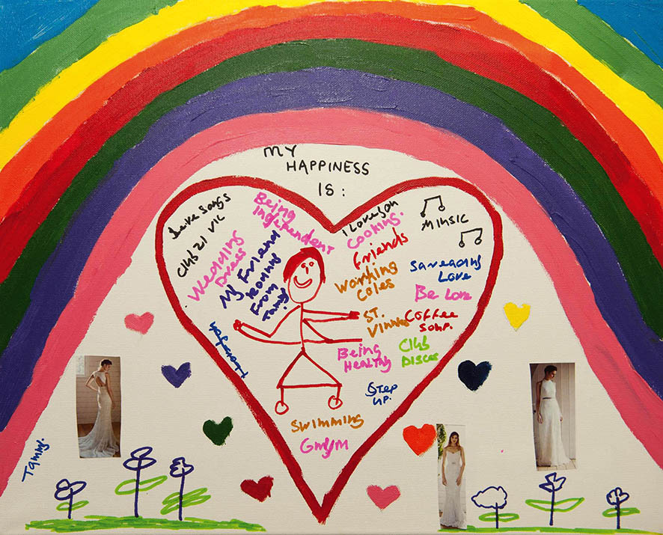

Cover: Painting by Tammy Smith

The artworks used in this report are by winners of the 2018 VALID Annual ‘Having a Say’ conference Art Competition sponsored by the Senior Practitioner. The theme for the 2018 artworks was ‘Community – Here I come!’.

# Message from the Senior Practitioner, Frank Lambrick

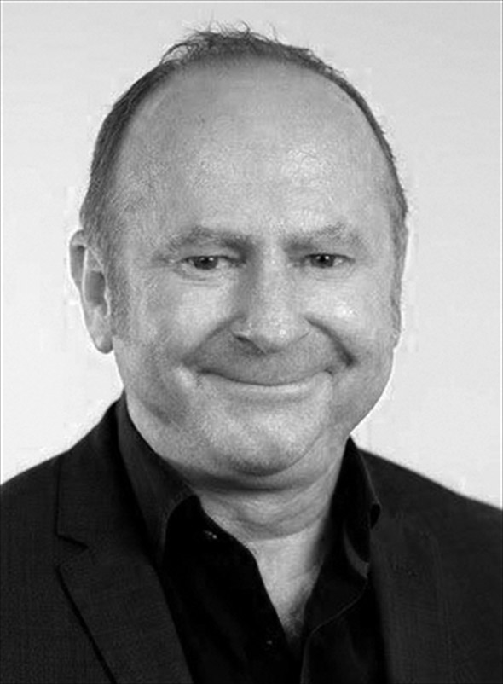

Hello. My name is Frank Lambrick. I am the Senior Practitioner for Disability. I work with a team of people.

This is my report about our work. This report is about what we did from July 2017 to June 2018. This is sometimes called an annual report. This report is written in Plain English. We have a complex copy that you can read too.

We count how many restrictive interventions happen in Victoria. We were told about 2,409 people with disabilities had restrictive interventions this year.

The job of the Senior Practitioner was first written about in the Disability Act 2006. The Disability Act is a law. It said what we must do at my Office.

We have been doing this job for 10 years. We had a celebration. We celebrated because our job reducing restrictive interventions is important.

Thank you to all the staff who work for me. Thank you to the families and services that work with us.

Dr Frank Lambrick signature

Dr Frank Lambrick  
Senior Practitioner – Disability

Contents

Message from the Senior Practitioner, Frank Lambrick 4

The job of the Senior Practitioner 8

Restrictive interventions 9

[Numbers of people with restrictive interventions   
in Victoria in 2017–2018 11](#_Toc9413209)

Restrictive interventions in Victoria 11

Behaviour support plans 13

Visiting services to see restrictive interventions 14

Compulsory treatment 15

Learning more about restrictive interventions through special projects 17

Mechanical restraint project 17

Working with doctors 17

The Roadmap project 18

Ten years of the Senior Practitioner – what have we learnt? 18

[Teaching other people about supporting people   
who use behaviours of concern 19](#_Toc9413219)

[Working with other people to help reduce use   
of restrictive interventions 21](#_Toc9413220)

Compulsory treatment practice workshops 21

Compulsory treatment newsletters 21

Care team meetings for people under compulsory treatment 21

Student projects 21

Work with the Department of Education and Training 22

Videos on restrictive interventions 22

Making things better through writing and talking about restrictive interventions 23

# The job of the Senior Practitioner

This report is about the job of the Senior Practitioner. It is about the Senior Practitioner’s work from July 2017 to June 2018.

The Senior Practitioner is a special job. The main job of the Senior Practitioner is to protect the rights of people with disabilities who have restrictive interventions.

We help people who have disability services in Victoria.

The Act said that the Senior Practitioner must do some special things.

The Senior Practitioner must:

* Learn more about restrictive interventions by doing special projects and research
* Teach people about restrictive interventions and supporting people who use behaviours of concern
* Know about the restrictive interventions used with people with disabilities in Victoria.

The Senior Practitioner has an important role for people in compulsory treatment. Compulsory treatment is when the law courts have said that someone with a disability has broken the law and must have specific treatment.

Learning more is sometimes called doing research. We do a lot of important research. We have been doing this counting for longer than anyone else in the world. We can do research on things that change and things that stay the same.

This report is about how we did these important jobs.

|  |
| --- |
| Restrictive interventions Restrictive interventions are things done to another person to stop them from doing behaviours of concern.  A behaviour of concern might be a behaviour like hurting yourself or hurting another person. It might be behaviours like deliberately breaking furniture.  Restrictive interventions are things that restrict the rights of a person using behaviours of concern. There are a few different types of restrictive interventions: chemical, mechanical, physical, and seclusion.   * Chemical restraint is medication given to someone just to stop them doing a behaviour. It does not include medications for health problems or mental illness. * Mechanical restraint is use of equipment to stop someone moving. Mechanical restraint could be a bodysuit that stops someone touching their body, or splints to stop someone moving their arm. A seatbelt and buckle guard used in a car is not a mechanical restraint. * Physical restraint is another person strongly holding someone to stop them from moving. It is different from helping someone gently. * Seclusion is locking someone in a room so they cannot get out. |

There are other things that stop the rights of people with disabilities. We are learning more about these other things.

Here are other types of restrictions:

* Stopping people from going outside without a good reason.
* Stopping people from getting food out of the fridge.

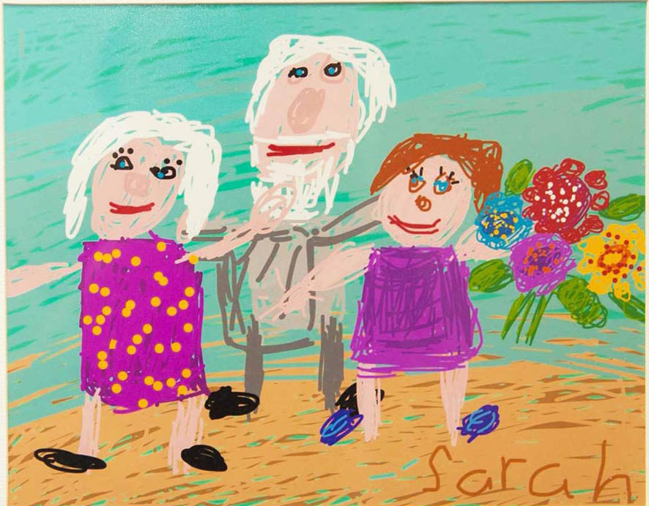

Painting by Sarah Guilfoil

# Numbers of people with restrictive interventions in Victoria in 2017–2018

One of the jobs of the Senior Practitioner is knowing about restrictive interventions in Victoria.

Disability service providers must tell us if they use any restraint with the people they support.

They must tell us:

* The name of the person restrained
* The person’s gender: male, female or other
* The person’s disability
* The type of restraint used.

Disability service providers must show us the person’s behaviour support plan. A behaviour support plan is a written plan. Behaviour support plans must say:

* The behaviour of concern
* What the staff will do to help the person
* The restrictive interventions
* How the restrictive intervention will help the person.

This part of the Annual Report is about restraint use, behaviour support plans, and compulsory treatment in Victoria July 2017 to June 2018.

## Restrictive interventions in Victoria

Disability service providers must tell us about all the restrictive interventions that they use.

### Number of people restrained

2,409 people with disabilities were restrained this year. This is more than last year.

More disability services told us about people this year.

### Chemical restraint

Chemical restraint is the use of tablets or medicine to control someone’s behaviours of concern.

Nearly all the people with restrictive interventions have chemical restraint.

This year 2,300 people were chemically restrained. They were given tablets or medicine to control their behaviour every day.

More than 300 people had medication for their behaviour only sometimes. This can be called PRN chemical restraint.

There were lots of different types of medications used for chemical restraint. More than half of the people who had chemical restraint took more than one type of medication. Many of the people with autism took more than one type of medication that affected their behaviour.

### Mechanical restraint

Mechanical restraint is the use of bodysuits, splints, or other things to stop a person from moving their body.

One hundred and forty-nine people had mechanical restraints this year. This is more people than last year.

### Seclusion

Seclusion is being locked in a room or place where you cannot get out.

Fifty-four people were secluded this year. This was less than last year.

### Physical restraint

Physical restraint is holding or blocking somebody’s body with force. Physical restraint stops people from moving about.

Eighty-two people were physically restrained this year. This is less than last year.

### Types of people with restrictive interventions

More males were restrained than females.

More adults were restrained than children

Most of the people who were restrained were people with intellectual disabilities. About half of the people had autism.

## Behaviour support plans

A behaviour support plan is a written report about a person with a disability. It is a plan for how staff should support a person who uses behaviours of concern. It should be a plan that says that restrictive interventions will only be used after all other things are tried.

A behaviour support plan has lots of information.

In 2017–2018 there were 2,767 behaviour support plans sent to us.

### Behaviour support plans that are written well

We know that support plans that are written well can help improve peoples’ lives.

We have been working to improve behaviour support plans.

The Senior Practitioner uses a special checklist called the Behaviour Support Plan - Quality Evaluation II or BSP-QEII to measure how good the behaviour support plans are.

The Senior Practitioner looked at 83 plans to check if they had the information in them.

The plans from this year scored the same as last year’s.

The things that were good in many of the plans were:

* Behaviours of concern were well described
* When and where behaviours happened was described
* Strategies for calming the person were described.

The things that were poorly written in many of the plans were:

* There were no new, better behaviours for the person to learn
* There was no plan for teams working together for the person
* There was no plan for checking if strategies were working.

Services need more training on how to write good behaviour support plans.

## Visiting services to see restrictive interventions

The Senior Practitioner visited 28 places to see if restrictive interventions were being used. We visited group homes, day services, and respite homes. We visited services in the country and cities.

There were some problems in the services:

* Other restrictive interventions were being used like stopping people from going out
* Behaviour support plans were not shared across homes and day services
* Restrictive interventions were used without behaviour support plans.

The staff are getting better at talking to doctors about chemical restraint. We wrote a new form for staff and doctors called the Medication Purpose Form. The doctor must say why a person needs medication. It is important for doctors to know if something is chemical restraint or not.

## Compulsory treatment

The Senior Practitioner also helps people who are in compulsory treatment. Compulsory treatment is a special law. It is a law that says a person must have treatment for their behaviour.

Compulsory treatment is given to some people with intellectual disabilities who are at serious risk of hurting other people. They are people who might have hurt other people before. They have been in trouble with the law.

People in compulsory treatment live in the community or residential treatment centres. There is one residential treatment centre in Victoria. People living in the community have a supervised treatment order. These people are watched most of the time and may be in a place that has locked doors.

People in compulsory treatment have rights. The Senior Practitioner supports the rights of people in compulsory treatment who have restrictive interventions. The Senior Practitioner looks at the treatment plans of people on compulsory treatment. We decide if the plan is good for the person.

Disability services looking after the person have to write reports. They have to say how the person is going with their treatment plan. They have to say how they are helping people have a better life.

### People on compulsory treatment in the community in 2017–2018

There were 34 people in compulsory treatment living in the community this year. There were 33 men and one woman.

The people had hurt other people.

Twenty-four of the people on compulsory treatment had restrictive interventions. Most had chemical restraint. Some had seclusion and some had physical restraint.

The Senior Practitioner looked very carefully at the restrictive interventions used with people in compulsory treatment. The team looked at any changes made to a person’s treatment plan.

The Senior Practitioner is also involved if a person does not need to be in compulsory treatment any more. Two people did not need to be in compulsory treatment anymore.

Most of the people in compulsory treatment joined the NDIS this year. The Senior Practitioner team worked with the person with a disability, their support team, and the NDIS.

This year we did work on assessment reports for people in compulsory treatment. The people needed assessments on what activities they could do well and what things they could not do. The assessments helped support teams know what the person needed to learn.

# Learning more about restrictive interventions through special projects

This year staff with the Senior Practitioner did four special projects.

## Mechanical restraint project

We have been doing a special project looking at mechanical restraint for five years. Mechanical restraint is using things like bodysuits, helmets, and straps to stop a person from moving.

There have been four steps in the project:

1. We looked at reports on all the people with mechanical restraints. We looked at ways that the people were the same as each other.
2. We had a closer look at 39 of the people.
3. We got special new assessments for 10 people.
4. We worked with the support teams to help them to use the recommendations in the reports.

We have nearly finished step 4.

## Working with doctors

We did more work with doctors.

We think it is important for doctors to know about behaviours of concern and restrictive interventions.

They need to know if they are prescribing medications that are restrictive interventions.

They need to know if they can do something different than restrictive interventions.

## The Roadmap project

The Roadmap for Achieving Dignity without Restraint is a special project involving many people.

More work was done on the Roadmap project this year. The Roadmap team worked with 121 staff of people who were restrained. The staff wrote action plans for each person to make their lives better.

Next year we will look for any changes for these people.

## Ten years of the Senior Practitioner – what have we learnt?

A group of people got together to look at all of the research projects that we have done.

They said we should do three more special projects.

One of the projects was about people in compulsory treatment.

One of the projects was about using medication to stop woman from having their periods.

There is another project that we might do later on.

# Teaching other people about supporting people who use behaviours of concern

The Senior Practitioner thinks that learning is important for making things better. People need to learn about behaviours of concern. They need to learn about restrictive interventions. They need to learn about the rights of people with disabilities.

The Senior Practitioner’s team do a lot of teaching. They teach a lot of different people.

Here is some of the teaching that we did:

* We taught new disability services about restrictive interventions.
* We taught 240 people about writing good behaviour support plans.
* We did special training made up for specific services.
* We used the internet to teach people about restrictive interventions using our page called the Restrictive Interventions Self Evaluation Tool (RISET).
* We taught people about using a special assessment called the ARMIDILO-S. This assessment is about the risk of people with intellectual disabilities doing sex-related crimes.

We gave money to two groups of people to do their own learning. This is called the Promoting Dignity Grants. One group helped a girl with disabilities. One group worked with five men with disabilities. The staff made changes in the house so the men had less restrictions.

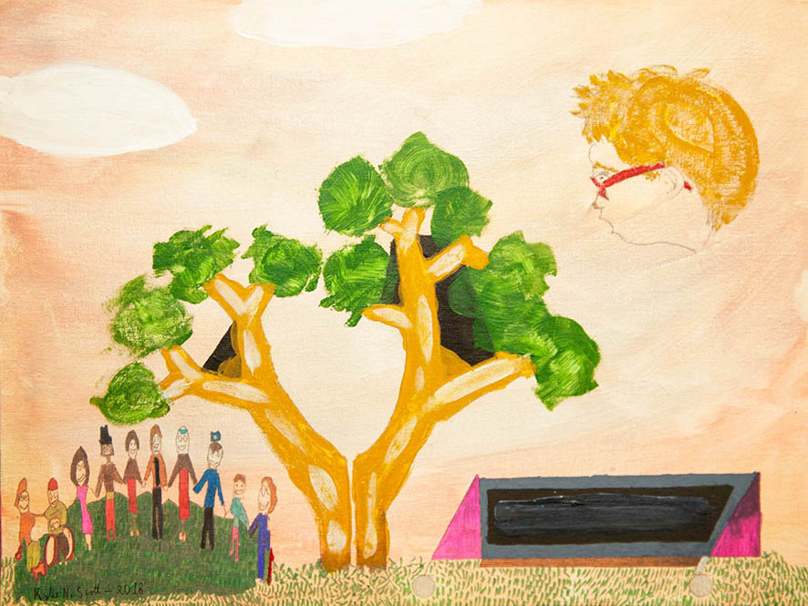

Painting by Kylie Scott

# Working with other people to help reduce use of restrictive interventions

The Senior Practitioner works with other services to share information, learn together, and do new projects.

Here are some of the things that the Senior Practitioner did this year.

## Compulsory treatment practice workshops

The compulsory treatment team had three workshops for people working with people in compulsory treatment. People learnt new things at the workshops.

## Compulsory treatment newsletters

The compulsory treatment team sent out two newsletters. The newsletters shared new information, new resources, and told people what the compulsory treatment team was doing.

## Care team meetings for people under compulsory treatment

The compulsory treatment team have an important job in going to team meetings about people in compulsory treatment. They answer lots of questions about what they law says must happen.

## Student projects

Four occupational therapy students have worked with the Senior Practitioner on projects.

## Work with the Department of Education and Training

A practice leader from the Senior Practitioner continued to work with the Department of Education and Training. The Department of Education and Training are in charge of primary and secondary schools in Victoria.

The practice leader wrote two guides for teachers. One guide was about physical restraint. The other guide was about seclusion.

## Videos on restrictive interventions

We worked with National Disabilities Services. We made some videos called Recognising Restrictive Practices. You can look at the [videos on the National Disability Service website](http://www.nds.org.au/news/zero-tolerance-films-focus-on-restrictive-practices) <http://www.nds.org.au/news/zero-tolerance-films-focus-on-restrictive-practices>.

# Making things better through writing and talking about restrictive interventions

We let people know about best ways to support people who use behaviours of concern. We let people know about restrictive interventions.

We ran a special session about the work that we have done in the last 10 years.

We wrote two papers for journals and we presented at some conferences.



Painting by Sarah Veli