Senior Practitioner report 2016–17



Cover: ‘Reach for the Stars’, painting by Sarah Guilfoil

Sometimes life is difficult.

It feels like climbing up the hill.

Obstacles like rocks

may lay in your path.

Despite it all we have to be strong.

If we try we can reach for the stars.

The artworks used in this report are by winners of the 2017 VALID Annual ‘Having a Say’ conference Art Competition sponsored by the Senior Practitioner.

To receive this publication in an accessible format phone 9096 8427, using the National Relay Service 13 36 77 if required, or [email the Office of Professional Practice](mailto:officeofprofessionalpractice@dhhs.vic.gov.au) <officeofprofessionalpractice@dhhs.vic.gov.au>

Authorised and published by the Victorian Government, 1 Treasury Place, Melbourne.

© State of Victoria, Department of Health and Human Services, April 2018

Except where otherwise indicated, the images in this publication show models and illustrative settings only, and do not necessarily depict actual services, facilities or recipients of services. This publication may contain images of deceased Aboriginal and Torres Strait Islander peoples.

In this document, ‘Aboriginal’ refers to both Aboriginal and Torres Strait Islander people. ‘Indigenous’ or ‘Koori/Koorie’ is retained when part of the title of a report, program or quotation.

ISSN: 2204-7204 (online)

Available at the [Office of Professional Practice website](https://www.dhhs.vic.gov.au/office-professional-practice) <https://www.dhhs.vic.gov.au/office-professional-practice>

(1712010)

# Message from the Senior Practitioner



In this past year, there has been significant change in the work of the Senior Practitioner team and the sector. The transition to the National Disability Insurance Scheme (NDIS) commenced on 1 July 2016 in the Barwon and North East Metropolitan Department of Health and Human Services areas, and since then, the Central Highlands and Loddon areas have also transitioned.

As a result, there has been a steady increase in work for the team in supporting and monitoring new services entering the sector, in relation to the use of restrictive practices. For the compulsory treatment team, it has led to increased work with care teams and the Department of Health and Human Services’ intensive support team, to ensure that our compulsory treatment clients have their support needs met through the NDIS and other relevant service responses. This work is absolutely critical, given the risk management issues associated with this group.

This increase in workload and the changing nature of our work has highlighted for us the importance of making sure that the resources we have developed over the years are readily accessible for existing and new services, and the importance of online platforms in facilitating this. The Restrictive Intervention Data System (RIDS) has always been a useful platform for providing alerts and links to relevant information for service providers.

This year, we launched the Restrictive Intervention Self Evaluation Tool (RISET), which provides comprehensive guidance around restrictive practices and legislative requirements. This tool has had a significant uptake since its launch and will be a valuable resource for the sector in the challenging years to come.

In 2016–17, a total of 2,328 people were reported as being subject to restrictive interventions, a number that is essentially unchanged from the previous year 2015–16. Until this year, since 2011–12, the total number who had been reported to be subject to restrictive interventions had been increasing. Similar to previous years, 95 per cent of all people were administered chemical restraint in 2016–17, hence the importance of our continued focus on the chemical restraint reduction strategy, particularly in progressing work around general practitioner education modules.

The plateauing of what had been an increasing trend in the number of people subject to restrictive practices stands in contrast to the increase in new services this year, with 49 new services registered on RIDS. We did see a levelling off on what was a progressive increase in the quality of behaviour support plans, which most likely bears reflection on this increase in new services. The use of a platform such as the RISET, and ongoing targeted training delivery and consultation, will be particular areas of focus over the coming year.

The position of principal practice leader (education) with the Department of Education and Training has continued to report directly to my role. During this year, the principal practice leader has been working with government schools to improve the management of behaviours of concern, and oversee the reduction of restraint and seclusion.

This role has produced some significant resources this year in collaboration with the sector, and has also effectively engaged staff from my team, the broader Office of Professional Practice and our divisional colleagues in systematically addressing complex student issues.

Finally, the team has been working closely with the Disability and NDIS Branch, relevant roles from other jurisdictions, the National Disability Insurance Agency (NDIA) and the Commonwealth Department of Social Services in progressing work around the development and implementation of the National Quality and Safeguarding Framework, which was released in December 2016.

In addition to this, and the work around other formal projects reported here, the team has been busy fulfilling the day-to-day roles that are frequently overlooked, but nonetheless integral to the role of Senior Practitioner, including:

* The compulsory treatment team has been attending care team meetings, reviewing treatment plans and representing the Senior Practitioner at the Victorian Civil and Administrative Tribunal (VCAT) hearings for the 31 clients subject to compulsory treatment.
* The integrated healthcare team has been consulting and liaising with service providers concerning the support of people subject to significant levels of restrictive interventions.
* The research and service development team has been providing telephone consultancy and support to a substantial proportion of the 891 services registered on RIDS.

Finally, I would like to take the opportunity to thank all of our staff – those who have left, those remaining and those who have joined us – for their dedicated commitment to their work over the year in ensuring that the rights of people with a disability who are subject to restrictive practices and compulsory treatment are protected.

I would also like to acknowledge the contributions of our colleagues, project partners, internal and external stakeholders, disability service providers, families, carers, advocates and professionals who collaborate with us in our work. We look forward to continuing these relationships over the coming year, while meeting the significant challenges that lie ahead as we continue the transition into the NDIS.

Dr Frank Lambrick

Dr Frank Lambrick  
Senior Practitioner – Disability

Contents

Message from the Senior Practitioner 3

The role of the Senior Practitioner 7

Monitoring and evaluating practice 8

Restrictive interventions reported to the Senior Practitioner 8

The use of restrictive interventions in Victoria 9

Chemical restraint 12

Mechanical restraint, physical restraint and seclusion 16

Behaviour support plan reviews 17

Restrictive intervention audit review 18

Compulsory treatment 19

Undertaking projects to deliver evidence-informed outcomes 24

The RIDS cohort study findings 24

Mechanical Restraint Project 24

Assisting services to use their data 25

Data warehouse project 26

General practitioner modules 26

The impact of the roadmap for the reduction of restrictive practices and behaviours of concern 26

Promoting best practice through professional development 28

Behaviour support plan training sessions 28

RIDS training sessions 28

Restrictive intervention training 28

Restrictive Intervention Self Evaluation Tool 28

Compulsory treatment RIDS module implementation 29

Armidilo-S 29

Supporting best practice through advice, partnerships and consultation 31

Compulsory treatment practice forums 31

Compulsory treatment team newsletters 31

Case consultations 31

Work with the Department of Education and Training 31

Occupational therapy students working with the Senior Practitioner 33

Student placements with the Senior Practitioner 33

Published resources 34

Informing public debate and opinion 35

Publications in peer-reviewed journals 35

Conference papers 35

Invited presentations 36

References 37

List of acronyms 38



‘Jellyfish Gathering’, painting by Brady Freeman

Brady’s work – whatever the basis –

is giving him voice to express his

personality, develop his skills,

grow in confidence and pride and

participate in the professional art world

as a respected artist.

# The role of the Senior Practitioner

The Senior Practitioner role was established in 2006 when the Victorian Parliament enacted the Disability Act 2006 (the Act). The Senior Practitioner and his team sit within the Office of Professional Practice branch in the Operations Division of the Department of Health and Human Services (the department).

The Senior Practitioner is responsible for protecting the rights of people with a disability who are subject to restrictive interventions such as restraint and seclusion, and compulsory treatment, and who receive a government-funded service.

The Act requires population monitoring and reporting of people with a disability who receive a service, and who are subject to restrictive interventions or compulsory treatment.

The Act also mandates:

* development of guidelines and standards regarding restrictive intervention and compulsory treatment
* research into the use of restrictive interventions and compulsory treatment
* provision of relevant education – for example, regarding human rights and positive behaviour support – to workers involved in supporting people with a disability
* specific responsibilities of the Senior Practitioner to:
  + approve and monitor treatment plans developed for the person who is subject to compulsory treatment
  + oversee the implementation of supervised treatment orders
  + issue lawful directions to the service on any law, policy or practices, where relevant, to the compulsory treatment order matter.

The inclusion of research and education as mandatory functions of the Senior Practitioner in the Act means that it is possible to focus on what the evidence shows, and to use this to directly inform policy and practice in disability services.

The research findings from Victoria are unique. Victoria is the only jurisdiction in the world that has collected population-level data on the use of restrictive interventions and behaviour support plans over ten years. Queensland has recently commenced data collection that is framed by their legislative requirements.

The collection of population-level data over years has enabled investigation into what changes over time and what factors impact on these changes.

The purpose of this report is to outline trends in the use of restrictive interventions, compulsory treatment and behaviour support planning, and to describe how our safeguarding activities have specifically improved the lives of people with a disability over the course of the year from July 2016 to June 2017.

# Monitoring and evaluating practice

A function of the Senior Practitioner is ‘to evaluate and monitor the use of restrictive interventions across disability services and to recommend improvements in practice to the Minister and Secretary’. (Disability Act s.24. (1)h)

## Restrictive interventions reported to the Senior Practitioner

Disability services must report to the Senior Practitioner about the use of four types of restrictive interventions used in their services by their staff. These include:

* chemical restraint
* mechanical restraint
* physical restraint
* seclusion.

**Chemical restraint** refers to the use of medication where the primary purpose is to control a person’s behaviour. This excludes the use of medication for treating an illness or condition.

**Mechanical restraint** refers to using a device (such as splints and bodysuits) to control a person’s movement. This excludes devices used for therapeutic purposes or to enable safe transportation (such as a buckle guard on a seatbelt in a car).

**Seclusion** refers to the sole confinement of a person with a disability at any hour of the day or night, in any room or area where disability services are being provided and where the person cannot exit. Section 3 of the Act provides complete definitions of these restrictive interventions.

Chemical restraint, mechanical restraint and seclusion have been reported to the Senior Practitioner since July 2007.

**Physical restraint** is defined by the Senior Practitioner as the use of physical force to prevent, restrict or subdue movement, which is not physical guidance or physical assistance. Further information about physical restraint is contained in the Direction on physical restraint available online. Physical restraint has been reported since July 2011.

Every time a disability service uses a restrictive intervention, they must provide information to the Senior Practitioner that includes:

* information about the person subjected to the restrictive intervention, such as their name, gender and disability types
* the type of restrictive intervention used (chemical, mechanical, physical restraint or seclusion) and type of administration being:
  + ‘routine’, that is, administered on an ongoing basis, for example, daily or weekly, but reported once a month, if it had been used one or more times in that month
  + pro re nata (PRN), as required administration in accordance with and authorised within a behaviour support plan, and reported at each instance of use
  + ‘emergency’, which is restraint administered in an emergency and where there is no authorised behaviour support plan, or a restraint is not included in the authorised behaviour support plan
* a copy of the behaviour support plan that describes why the restraint or seclusion is necessary, why it is the least restrictive intervention, and how it is of benefit to the person.

## The use of restrictive interventions in Victoria

This section of the report summarises the findings of:

* restrictive interventions reported by disability services in Victoria in 2016–17, and where possible, compares these findings with the previous eight years
* the quality of and adherence to the legislation of behaviour support plans written in 2016–17 compared with the previous years of 2014–15 and 2015–16
* the number of people on compulsory treatment orders in 2016–17.

In total, 2,328 people were reported as being subjected to restraint and/or seclusion in 2016–17. This number is essentially unchanged from the previous year 2015–16 (see Figure 1). Until this year, since 2011–12, the total number who have been reported to be subject to restrictive interventions had been increasing.

The upward trend in the number of people restrained between 2011–12 to 2015–16 coincided with a similar increase in the number of services reporting to the Senior Practitioner each year.

Specifically, the number of services reporting each year was:

* 742 in 2008–09
* 760 in 2011–12
* 842 in 2015–16
* 891 in 2016–17.

The Senior Practitioner only receives data about services that have reported restrictive interventions. Other services with no reporting of restrictive interventions are not included in the data set. This is also true for the total numbers of people who are and are not subject to restrictive interventions, so it is not possible to evaluate whether any change in the number of services results in a change in client numbers.

The vast majority of people reported as being subjected to restraint were in respite and shared supported accommodation services. Similar to the trends in total people restrained or secluded across all services, spanning 2011–12 to 2015–16, there were year‑on-year increases in the number of people reported in both service types.

That changed this year and instead, compared to 2015–16, there was no change in the number reported for shared supported accommodation, and there was a four per cent reduction in the number reported in respite services. The reduction in people reported in respite services (n=32) was mostly offset by an 18 per cent increase (n=27) in the number of people restrained within miscellaneous services (such as recreation and outreach programs).

Figure 1: Total number of people reported to be restrained and/or secluded, 2008–09 to 2016–17

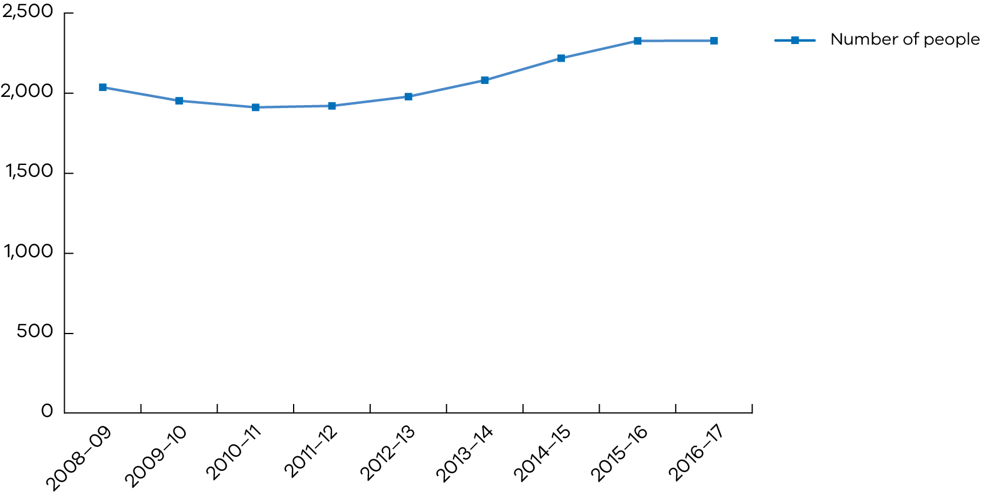

The demographic and disability characteristics of those restrained or secluded in 2016–17 were mostly stable from 2015–16 (see Figures 2–4). Around 68 per cent of those reported are male and approximately 24 per cent are children. The vast majority have some form of intellectual disability (90 per cent). There was a small increase in the proportion of people reported with autism (1.7 percentage points).

Figure 2: Number of males and females who were reported to be restrained or secluded, 2008–09 to 2016–17

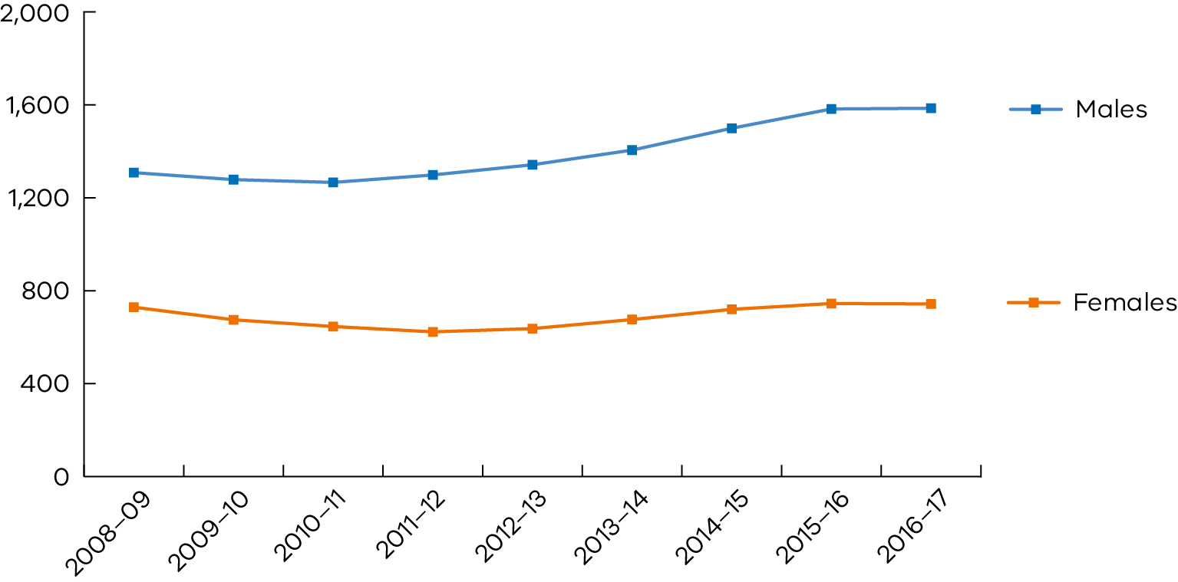

Figure 3: Number of adults and children who were reported to be restrained or secluded, 2008–09 to 2016–17

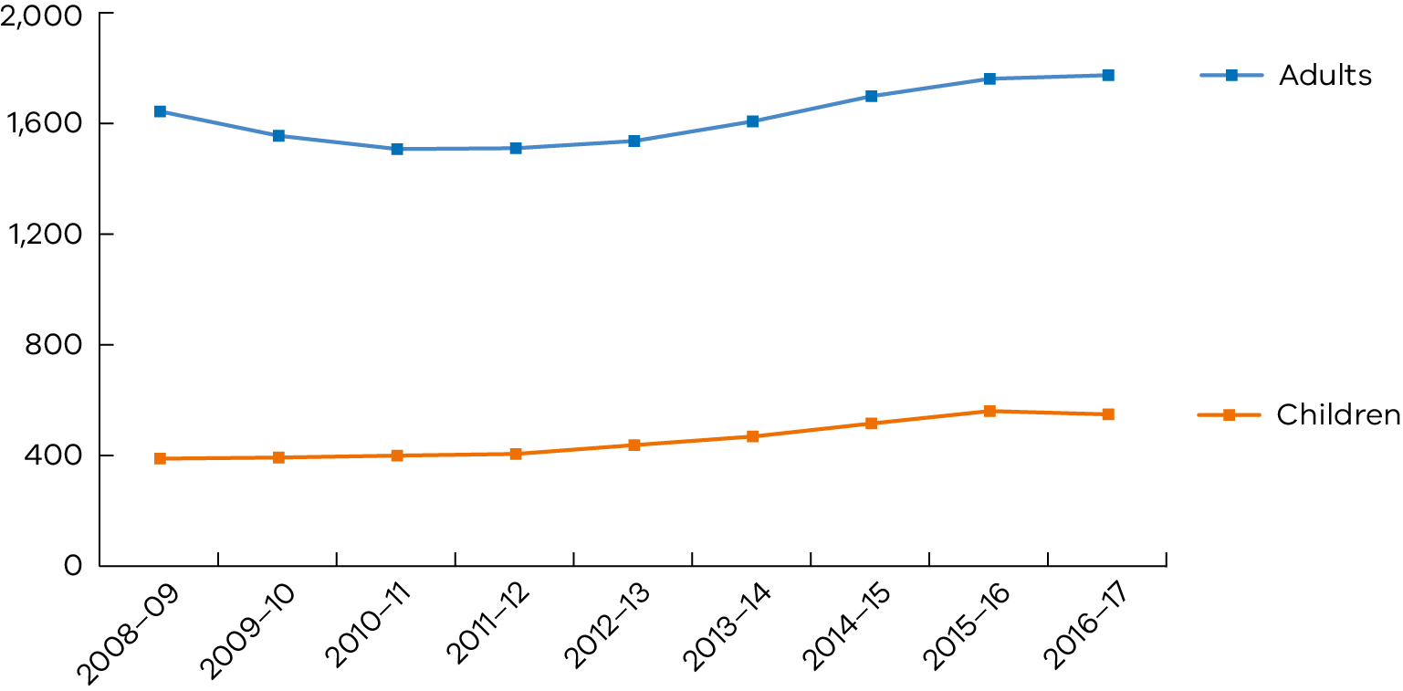

Figure 4: Disability characteristics of people who were reported to be restrained or secluded, as a proportion of all people reported, 2008–09 to 2016–17

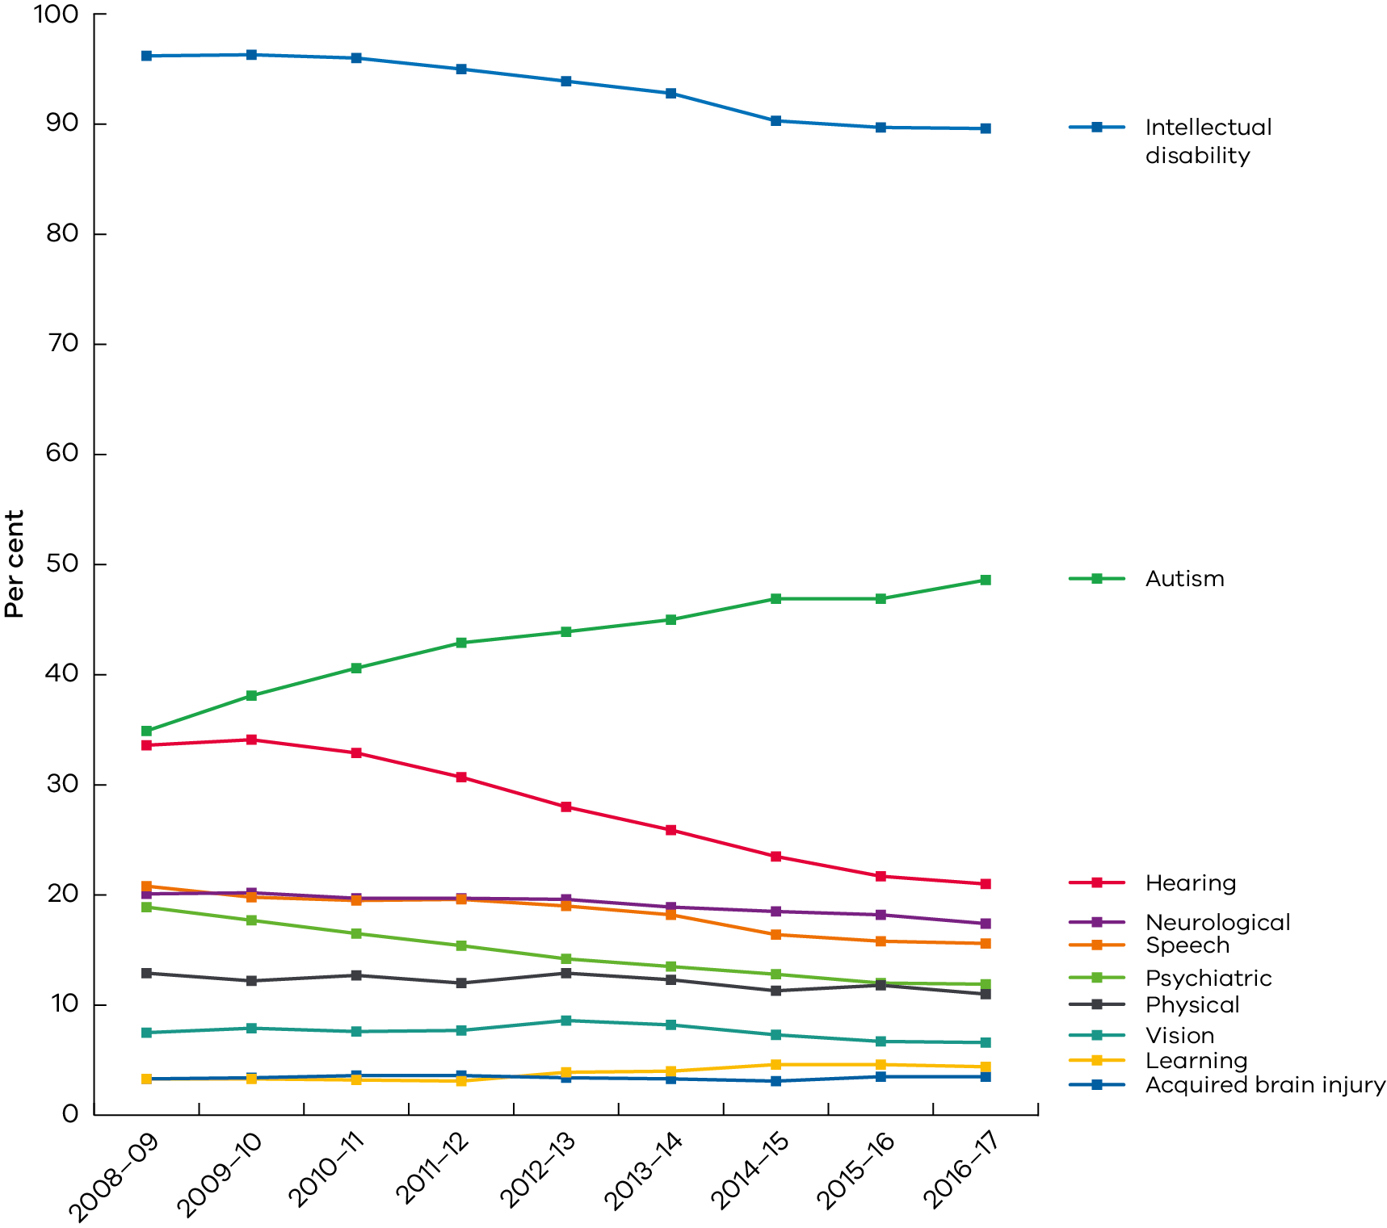

## Chemical restraint

Similar to previous years, during 2016–17, almost all people (95 per cent) who were reported to be subject to a restrictive intervention were subjected to chemical restraint. Figure 5 shows that the total number of people subjected to chemical restraint had been increasing gradually since 2011–12, although this year was stable, relative to the previous year.

Figure 5: Number of people reported to be subjected to chemical, mechanical, physical restraint and seclusion, 2008–09 to 2016–17

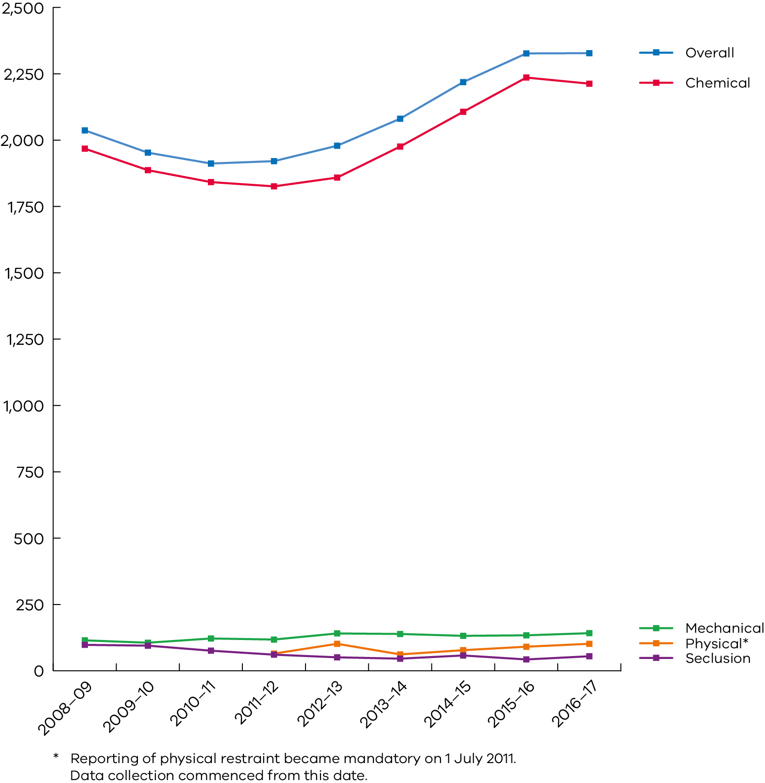

### Types of chemical restraint administration

Chemical restraint can be administered as a:

* routine medication
* PRN medication (as required or needed)
* in an emergency (not included in a behaviour support plan or there is no behaviour support plan).

Within a reporting year, it is possible for people to be administered all three types of chemical restraint.

Figure 6 shows the total number of people who were administered chemical restraint routinely, PRN and in an emergency.

In 2016–17, 91 per cent of all people who were subjected to chemical restraint were administered chemical restraint routinely, a similar proportion to previous years. A smaller proportion of people were reported for PRN (15 per cent) and emergency (43 per cent) chemical restraint. The proportion of people reported to be administered chemical restraint in an emergency increased from 18 per cent in 2011–12 to 44 per cent in 2015–16. In 2016–17, it appeared to have stabilised at 43 per cent, down by one percentage point on the previous year.

It should be noted that most of the emergency chemical restraint reported was routine chemical restraint, but was reported as an emergency due to the lack of a behaviour support plan, or a behaviour support plan being in place that did not cover a chemical restraint that was to be used.

Figure 6: Number of people reported to be subjected to PRN, routine and emergency chemical restraint, 2008–09 to 2016–17

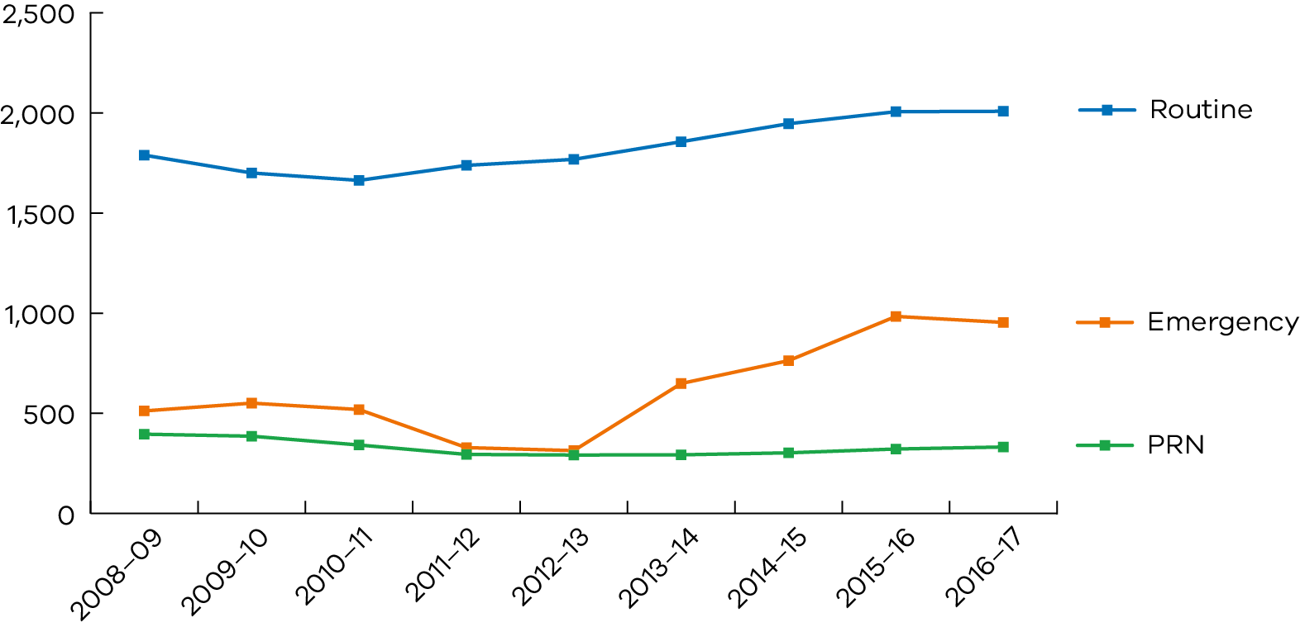

### Chemical restraint types of medications

In 2016–17, the majority of people (65 per cent) who were subjected to chemical restraint were administered atypical antipsychotics. This proportion has been stable since 2011–12, although there was a slight increase of almost two percentage points in 2016–17, compared to 2015–16.

Among those subjected to routine chemical restraint in 2016–17, a number of characteristics were associated with antipsychotic use. Specifically, children (compared to adults) were twice as likely to be restrained using antipsychotics. Similarly, those who had a hearing, intellectual or psychiatric disability were twice as likely be restrained using antipsychotics than those without those disabilities. Males, people with autism, a speech disability or a visual impairment were about 1.5 times as likely to be restrained using antipsychotics.

People with a physical disability (compared to those who do not have a physical disability) or with a learning disability (compared to those who do not have a learning disability) were about half as likely to be restrained using antipsychotics.

The proportion of people administered stimulants increased since 2011–12 from eight per cent to 10 per cent in 2015–16. This increase stabilised in the current year, where the proportion was consistent at 10 per cent. The proportion of people administered antidepressants has been increasing from 35 per cent in 2011–12 to 40 per cent in 2015–16. As was the case for stimulants, this trend stabilised in the current year at 41 per cent. The proportion of people administered benzodiazapines held stable at 22 per cent in both 2015–16 and 2016–17.

At the same time, the proportion of people administered typical antipsychotics decreased from 18 per cent in 2011–12 to 12 per cent in 2016–17.

It should be noted that in all the years shown in Figure 7, a majority of people were administered more than one type of chemical restraint over the course of the year (see Polypharmacy section below).

Figure 7: Number of people subjected to different types of chemical restraint, 2008–09 to 2016–17

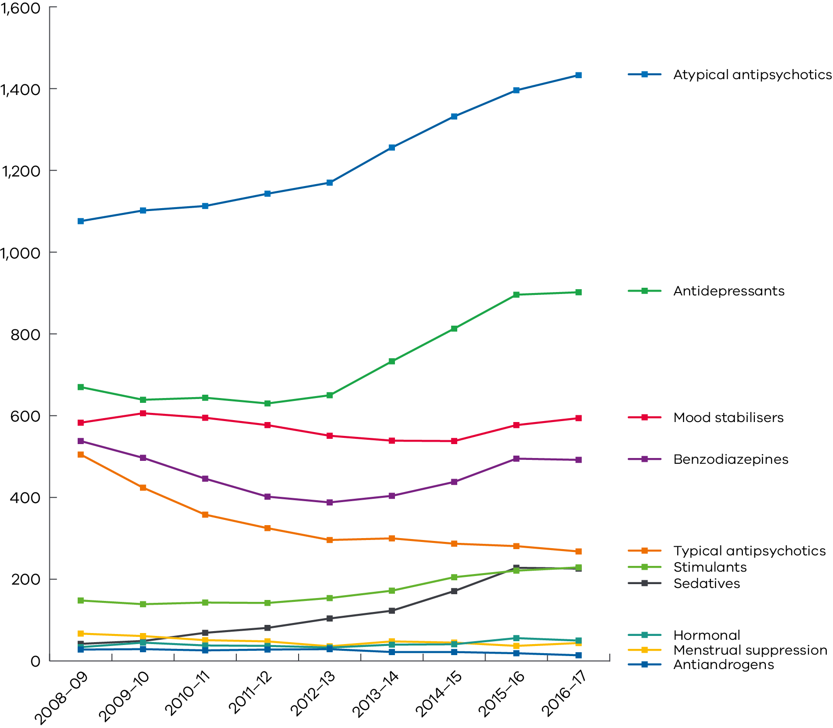

### Polypharmacy

Polypharmacy is defined as the use of two or more medications to treat the same condition (for chemical restraint, this is the simultaneous use of more than one medication for behaviours of concern).

Figure 8 shows that the proportion of people who were subjected to polypharmacy at least once within a reporting year has been relatively constant. Each year, between 63 and 68 per cent of people who were chemically restrained were simultaneously administered two or more medications to control their behaviours of concern.

Those with autism were about 1.4 times more likely to be subjected to polypharmacy than people without autism. People subjected to polypharmacy were much more likely to be administered mood stabilisers and benzodiazepines than those not subjected to polypharmacy.

Figure 8: Number of people subjected to polypharmacy compared to the number of people subjected exclusively to single chemical restraint, 2008–09 to 2016–17

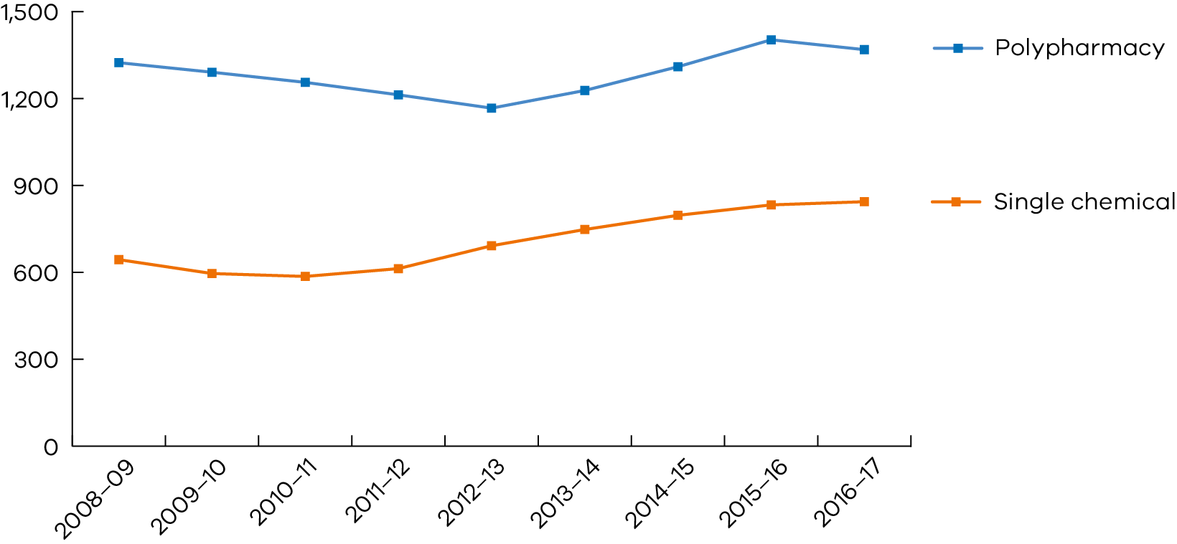

## Mechanical restraint, physical restraint and seclusion

The total number of people who were subjected to mechanical restraint, physical restraint and seclusion has increased from the previous year, as seen in Figure 9.

The number of people who were reported to be mechanically restrained had been declining since   
2012–13. This decrease was explained by the mechanical restraint reduction project that commenced in 2012–13, to examine who was at risk of mechanical restraint and what could be done to reduce the risk for those people. However, in the most recent year, mechanical restraint has increased back to the level observed in 2012–13.

Since 2011–12, the total number of people who were reported to be secluded has tended to vary, both upwards and downwards, by around 10 to 15 people per year. In the most recent year, the number of people reported to be secluded was 55.

Since 2013–14, there has been a steady increase in the number of people reported to be physically restrained of around 15 people per year. This trend continued in the most recent financial year with a total of 102 people reported, 11 more people than in 2015–16.

Figure 9: Number of people reported to be subjected to mechanical, physical restraint and seclusion, 2008–09 to 2016–17

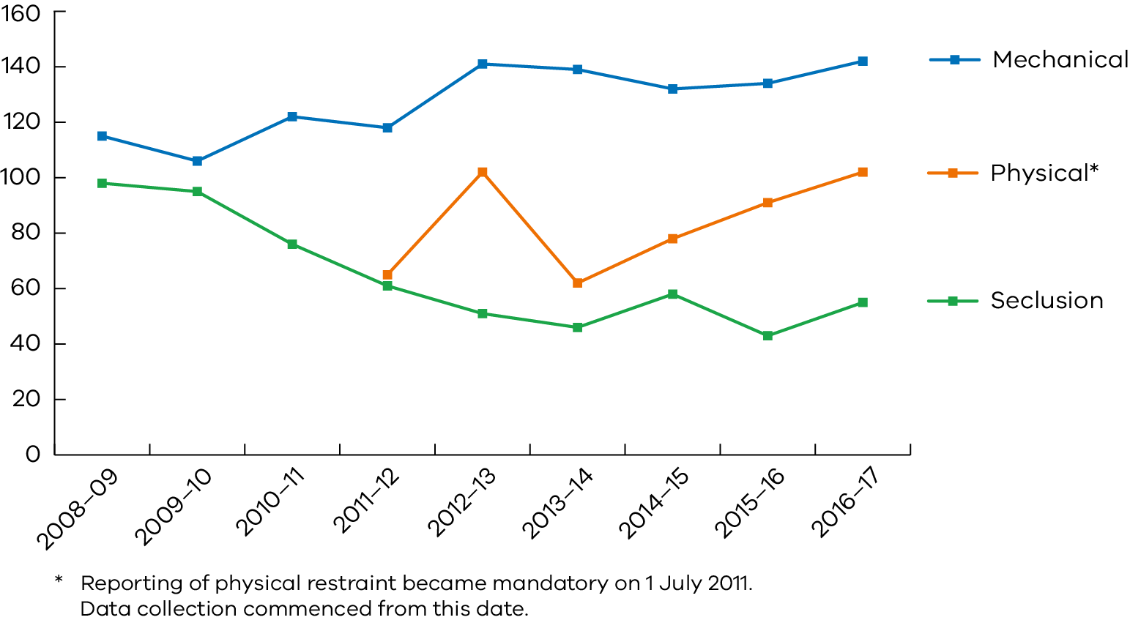

## Behaviour support plan reviews

Any person who is subjected to restraint and or seclusion in disability services in Victoria must have a behaviour support plan or a treatment plan if they have a compulsory treatment order. In 2016–17, 2,794 behaviour support plans were received by the Senior Practitioner from services.

The Senior Practitioner uses the Behaviour Support Plan Quality Evaluation tool II (BSP‑QE II) (Browning-Wright, Saren and Mayer 2003) to objectively assess the quality of behaviour support plans received from disability services in Victoria.

Although the BSP-QE II tool was developed in the United States for children, it was validated by the Senior Practitioner for use in Victoria with adults with an intellectual disability, and was found to be a valid and reliable assessment of the quality of behaviour support plans written for adults living in Victoria (Webber, McVilly, Fester and Chan 2011a; Webber, McVilly, Fester and Zazelis 2011b).

In previous work, the Senior Practitioner also found evidence that the quality of behaviour support plans is associated with reductions in restrictive intervention use (Webber, Richardson, Lambrick and Fester 2012).

### Behaviour Support Plan Quality Evaluations

In 2016–17, 88 (3 per cent) of the behaviour support plans received by the Senior Practitioner were assessed using the BSP-QE II. Figure 10 shows the average score achieved across all services from 2012–13 to 2016–17. Quality has been improving since 2012–13, although this trend has levelled off in 2016–17, given the slight decline in the quality of reviewed plans for the most recent year.

Figure 10: Average BSP-QE II scores across all services, 2012–13 to 2016–17

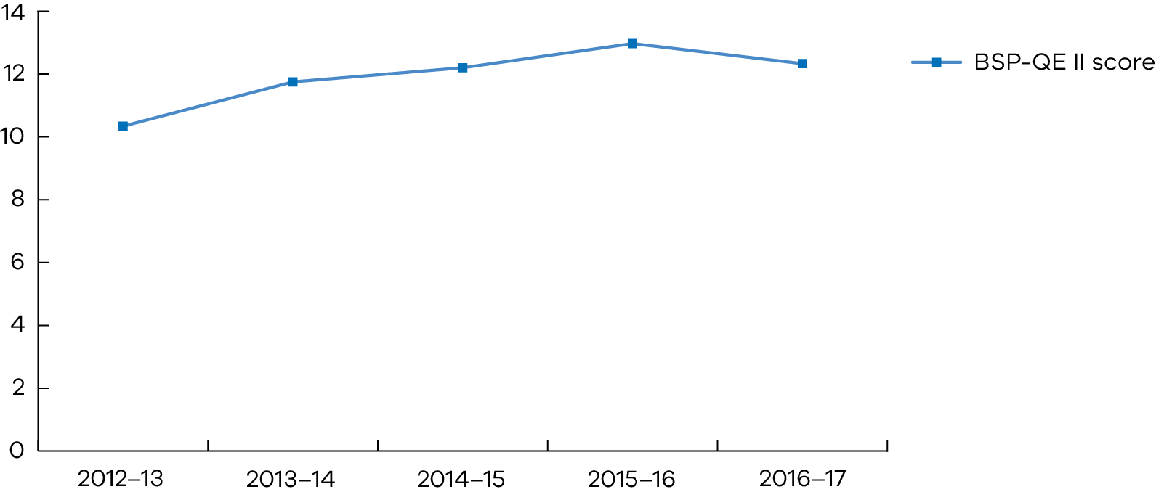

The decline in average quality of behaviour support plans in the most recent year suggests there is a need for services to receive more intensive training in behaviour support planning.

Although the average of the quality of the behaviour support plans reviewed approximates the minimum standard, similar to previous years, the review process highlighted two key areas where behaviour support plans could be improved.

Firstly, few plans articulated clear replacement behaviours (alternative behaviours the person can use to meet the function of their behaviours of concern). Related to this, few plans articulated strategies that could be used to teach and encourage effective replacement behaviours.

Secondly, most plans did not include clear processes for communication and progress review among the support team.

The review process also identified several elements where plans were consistently high in quality. Specifically, most plans clearly described the behaviours of concern, the underlying triggers, the common settings where the behaviours occurred and the function of the behaviours. Identifying key settings and triggers, as well as understanding the function of the behaviours, is essential for minimising the use of restraint and seclusion.

## Restrictive intervention audit review

The Senior Practitioner has powers to investigate, audit and monitor the use of restrictive interventions and compulsory treatment in disability services. (Disability Act 2006, s27(2)(c))

During 2016–17, the Senior Practitioner’s integrated healthcare team conducted audits across rural and metropolitan disability services, including group homes, residential respite and day programs. The rollout of the NDIS has highlighted increasing requirements for support and monitoring of restrictive practices among new services entering the disability sector.

There are 1798 sites registered on RIDS in Victoria currently, and in the last financial year, 24 sites have been audited.

These audits identified several themes including:

* people having their access to the community restricted without a formal process to determine what is needed
* behaviour support plans not being shared with involved organisations
* behaviour support plans not being authorised and restrictive practices continuing poor understanding of what a restrictive intervention is
* support staff having difficulty with medical staff when they try to confirm the purpose of medication.

Themes that were identified for new organisations under the NDIA included:

* very limited working knowledge of the Disability Act and requirements
* that some organisations have been operating in other jurisdictions and assumed the safeguards were the same in Victoria
* limited to no knowledge of what constitutes a restrictive intervention.

We have also seen some great examples of practice and client-centred care that has led to reductions in restrictive interventions. One example has been written up as a case study in the RISET as an example of both culturally sensitive practice and client-centred care.

There has also been an increase in difficulties with the interface of support workers and medical practitioners. Some medical staff have been inappropriately asking support staff to prepopulate treatment sheets and health or mental health plans with information, including the diagnosis. This isn’t the responsibility of the support worker.

Future work that is being undertaken to support the sector includes:

* a medication purpose form – for support workers to take to medical appointments to assist them in helping the medical practitioner to understand why they need to clarify the purpose of the medication. It is easy to follow and provides our contact details if there are further questions from medical staff
* updating the existing legislative audit process – authorised program officers will receive a letter from the integrated healthcare team outlining where the behaviour support plan isn’t meeting the requirements of the Act and actions that are required to address the issues. The information gathered from these audits will be used to inform behaviour support plan training.

## Compulsory treatment

Compulsory treatment means treatment of a person with an intellectual disability who is at risk of perpetrating serious violence to another person. A person may be admitted to a residential treatment facility under a court order or reside in disability residential services in the community under a supervised treatment order. In Victoria, there is one disability residential treatment facility, the Intensive Residential Treatment Program at the Disability Forensic Assessment and Treatment Service (DFATS).

Part 8 of the Act allows for provision of civil detention in the community under a supervised treatment order. Detention under the Act is defined as a) physically locking a person in any premises and b) constantly supervising or escorting a person to prevent the person from exercising freedom of movement. This part of the Act also legislates for court-mandated detention in a residential treatment facility through orders including residential treatment orders, parole, custodial supervision orders and extended supervision orders.

The Senior Practitioner is responsible for ensuring that the rights of people who are subject to compulsory treatment and restrictive interventions are protected. The compulsory treatment team work for the Senior Practitioner to support these functions. The team currently comprises a principal practice leader, two senior practice advisers and one program adviser. The team provides training and practice advice, and attends some of the care team meetings that are held for clients to monitor the implementation of the treatment plan and to provide practice advice.

Processes have been developed recently whereby the Senior Practitioner also has oversight of the treatment plans for people who are also subject to a Custodial Supervision Order under the Crimes (Mental Impairment and Unfitness to be Tried) Act 1997 (CMIA) at DFATS.

### The role of the Senior Practitioner in monitoring supervised treatment orders

The authorised program officer makes an application to VCAT. The compulsory treatment team and the Senior Practitioner review the treatment plan and supporting material, including a risk assessment provided by the authorised program officer. The Senior Practitioner approves the treatment plan on the directions and recommendations within the Treatment Plan Certificate, which is issued by the Senior Practitioner for a maximum period of one year.

A VCAT hearing is convened with the person for whom the supervised treatment order is under consideration, their family or guardian, legal representative, the Office of Public Advocate, a Senior Practitioner representative, the authorised program officer and any relevant supporting staff from the person’s disability residential services present. If VCAT is satisfied that the criteria for a supervised treatment order is fulfilled, they will make an order for up to one year, at which point it will be reviewed.

The authorised program officer is responsible for the implementation of the treatment plan. During the life of the plan, implementation reports are required at a minimum of six‑monthly intervals.

These are provided by the authorised program officer and include detailed information about how the person is progressing against:

* their treatment goals
* progress on the directions by the Senior Practitioner within the Treatment Plan Certificate
* analysis of any incident reports and data collected
* any changes in restrictive interventions
* details of a summary of quality of life
* any additional assessments that have been completed, including any implications for treatment.

In 2016–17, 31 people were subject to a compulsory treatment order. There were 32 people in 2015–16 and 33 people in 2014–15. At the end of the 2016–17 year, 28 people were subject to compulsory treatment.

### The role of the Senior Practitioner in monitoring residential treatment orders

VCAT annually reviews the treatment plans for people subject to court-mandated treatment orders, and the Senior Practitioner issues a Treatment Plan Certificate with directions and recommendations.

For people subject to other orders such as Custodial Supervision Orders under CMIA, the Senior Practitioner reviews the treatment plans and issues a Treatment Plan Statement, which includes directions and recommendations in relation to practice.



The Senior Practitioner team

### Client demographic data

All of the 31 people subject to a compulsory treatment order in 2016–17 were male. Since 2008, there have only been three females subject to compulsory treatment.

The primary types of offending behaviour that resulted in people being subject to a supervised treatment order or residential treatment order included sexual violence, violence (non-sexual), and fire-setting behaviours.

The average age of people subject to compulsory treatment in 2015–16 was 43 years, ranging from 21 to 65 years. This is a similar age profile to the previous two years. Sixteen people resided within community service organisations, 14 resided within the department’s accommodation, including DFATS, and one person transitioned from DFATS to a community services organisation during the financial year.

There were six people subject to compulsory treatment at DFATS (excluding persons subject to CMIA) during the 2016–17 financial year. In that time, two people transitioned to the community (one under a supervised treatment order) and two people were admitted to DFATS.

### Compulsory treatment restrictive intervention data

As previously mentioned, all people subject to compulsory treatment are either subject to civil detention in the community under a supervised treatment order or detained under the conditions of a Criminal Court Order. The Senior Practitioner provides oversight to ensure that, in line with Part 8 of the Act, the authorised program officer for the service or residential treatment facility has set out a proposed process for transition of the person to lower levels of supervision and, if appropriate, to living in the community without an order being required.

In addition, in 2016–17, 20 of the 31 people (64.5 per cent) who were on compulsory treatment were also reported to be subjected to further restrictive interventions during the year, compared to 78 per cent last year and 55 per cent in 2014–15.

Table 1: The number of people who were reported to be subjected to restrictive interventions

| Restrictive intervention | 2014–15  Number of people subject to CT = 33 | 2015–16  Number of people subject to CT = 32 | 2016–17  Number of people subject to CT = 31 |
| --- | --- | --- | --- |
| Routine chemical restraint | 16 | 14 | 17 |
| Emergency chemical restraint | 9 | 9 | 5 |
| PRN chemical restraint | 3 | 1 | 4 |
| Seclusion | 6 | 4 | 2 |
| Physical restraint | 8 | 3 | 2 |

### Victorian Civil Administrative Tribunal hearings

A supervised treatment order must be reviewed by VCAT at least annually. The treatment plan for a person subject to compulsory treatment at DFATS is reviewed by VCAT within the first six months of the person being admitted to DFATS and annually thereafter, for the duration of the court order.

The person subject to compulsory treatment can have legal representation at the VCAT hearing. The Office of Public Advocate is also a party to the VCAT hearings and can make an application to VCAT directing the authorised program officer to make an application for a supervised treatment order, if the office is concerned that a person is being detained unlawfully.

The compulsory treatment team attended 37 VCAT hearings during 2016–17, three less than the previous year. These comprised reviews for supervised treatment orders, treatment plan reviews for people at DFATS and material change hearings when a variation to the treatment plan was requested.

### Treatment order reviews

There were 26 supervised treatment orders made at VCAT in 2016–17, and there were six VCAT hearings to review the treatment plans for people subject to a residential treatment order at DFATS.

There were 40 treatment plan reviews, including 28-day reviews of the treatment plans for people who were admitted to DFATS, six and 12-month reviews of plans for people subjected to supervised treatment orders and interim supervised treatment orders, and one assessment order.

During 2016–17, five interim supervised treatment orders were made by VCAT, with an average length of 46 days. An authorised program officer may request that an interim supervised treatment order be made until the application for a supervised treatment order is determined.

### Assessment orders

The authorised program officer may apply to the Senior Practitioner for an assessment order to be made in respect of a person with an intellectual disability, who is residing in a residential service. If it is necessary to detain the person to prevent a significant risk of serious harm to another person, and assessments need to be undertaken to enable the urgent development of a treatment plan, the Senior Practitioner may make an assessment order once for a person, for a maximum period of 28 days. In 2016–17, one assessment order was made, whereas there was none the previous year.

### Material changes to the treatment plans

A material change is a variation to the treatment plan. A change cannot be made to a treatment plan unless the change is approved by the Senior Practitioner. If a material change relates to an increase in restrictions, the Senior Practitioner is unable to approve this and the authorised program officer must apply to VCAT for a variation of the plan.

However, if the Senior Practitioner considers that an increase in the level of the supervision or restriction of a person who is subject to a supervised treatment order is necessary because of an emergency, the Senior Practitioner may approve a material change relating to an increase in restrictions and then must immediately apply to VCAT for a review of the variation.

There have been 21 material changes during 2016–17 involving changes to the restrictive interventions that people were subject to. There were eight emergency material change applications to the Senior Practitioner over the financial year. This is half the number for the previous year. Six of these were approved. Two were not approved – one was due to a delay in the Senior Practitioner being informed about an emergency increase in restrictions and then advised the authorised program officer to apply to VCAT, and the other was not approved by the Senior Practitioner and subsequently withdrawn.

The majority of the 13 non-emergency material changes are receiving more comprehensive oversight, due to the implementation of the electronic treatment plans on the RIDS.

### Revocation

The Senior Practitioner, authorised program officer or the person who is subject to the supervised treatment order can apply to VCAT to have their treatment plan reviewed, with the supervised treatment order being revoked or allowed to expire.

Prior to the expiration of a supervised treatment order, the Senior Practitioner and VCAT must review supporting documentation to determine whether or not the person continues to meet the legislative criteria for a supervised treatment order and the use of civil detention. The authorised program officer and the Senior Practitioner prepare separate submissions to VCAT to evidence how the person no longer meets all of the criteria for a supervised treatment order.

During 2016–17, two supervised treatment orders were revoked. One person was sentenced to prison and the other no longer met the criteria for a supervised treatment order, but continued to reside in disability accommodation.

There were two residential treatment orders that ended during 2016–17. One person transitioned to a community services organisation under a supervised treatment order, while the other person transitioned successfully to live with his family in the community and had oversight from the compulsory treatment team for six months.

### People who have transitioned to the NDIS

Four of the clients subject to supervised treatment orders have transitioned to the NDIS. The compulsory treatment team has been working collaboratively with the intensive support team within the department and the NDIS branch to advocate for the complex needs of people subject to compulsory treatment.



‘Watch What You Eat’, painting by Steve Canning

Lead your life – feel think,

BE HEALTHY.

I feel healthy.

I think about being healthy.

I want the whole world to be healthy

– Everything in balance.

# Undertaking projects to deliver evidence-informed outcomes

A function of the Senior Practitioner is ‘to undertake research into restrictive interventions or compulsory treatment and provide information on practice options to disability support providers’. (Disability Act s24. (1)g)

## The RIDS cohort study findings

In this study, we examined the outcomes for a group of people who were reported to the RIDS some time in 2008–10 to find out what had happened to these people in 2013–15. Only accommodation services were included in this study, because this is the most stable group of people over time.

In 2008–10, 1,414 people were reported to the RIDS from accommodation services, and 97 per cent of these people were administered chemical restraint.

In 2013–15, 74 per cent of this group was still being reported to the RIDS. This suggests that for the majority of people, the use of restrictive interventions will be for years (at least three years).

The other 544 people were no longer reported to the RIDS. Of these, 181 were known to be deceased or to have left disability services. A survey was sent to the services regarding the outcomes for the remaining 363 people to find out why restrictive interventions had been stopped.

The results of the surveys showed that:

* 63.7 per cent of people were no longer reported because changes in behaviour support that the team put in place had helped reduce the person’s behaviours of concern, so that restrictive interventions were no longer required.
* 30.5 per cent of people were no longer reported because there was a medical reason for the person’s behaviour and the person was now being treated for some medical condition (such as anxiety).
* For 16 per cent of people, staff replied that they did not know why the restrictive intervention had been stopped.

The percentages do not add up to 100 per cent because more than one reason could be chosen for why the restrictive intervention had been stopped.

Certain factors were found to be associated with long-term use of restrictive interventions. Antipsychotic medication use in 2008–10 predicted the use of antipsychotic medications in 2013–15. Having autism or a difficulty in communicating to others also predicted the use of restrictive interventions in the long term.

Taken together, these results suggest that some people (those who are administered antipsychotic medications and those with autism or who have difficulty communicating) are at greater risk of being restrained or secluded in the long term, at least over three years, but that positive behaviour support is reducing the number of people subject to restrictive interventions. A copy of the report can be obtained by [emailing the Senior Practitioner’s team](mailto:officeofprofessionalpractice@dhhs.vic.gov.au) <officeofprofessionalpractice@dhhs.vic.gov.au>.

## Mechanical Restraint Project

Mechanical restraint is described by the Act as material or devices that prevent a person moving freely, that are not providing treatment or helping the person be more independent. The office had seen no decrease in the total number of people reported to be mechanically restrained each year from 2008 to 2013.

In response, a project was developed in 2013 to examine the use of mechanical restraint and what could be done to reduce its use.

The project had three phases, which were:

* Phase 1 – looked at the individual characteristics of those at risk of being subjected to mechanical restraint.
* Phase 2 – looked at what was known and had been recommended for a group of 39 people who had been mechanically restrained over a period of years.
* Phase 3 – put in place some critical assessments such as functional behaviour assessments with 10 of those people who were mechanically restrained, to determine how mechanical restraint could be reduced.

In the follow up to phase three of the project, the planning of phase four took place in 2016–2017.

The two objectives for phase four are to:

* provide clinical support to assist services to reduce the use of mechanical restraint
* capture facilitators and barriers for services and staffing groups to implement recommendations to reduce mechanical restraint.

We want to learn more about these factors to evaluate practices surrounding the use of mechanical restraint and use learnings to influence future work. This phase of the project will be completed in 2018.

## Assisting services to use their data

The RIDS was developed to assist the Senior Practitioner to effectively monitor and evaluate restrictive interventions used in disability services in Victoria. The RIDS enables timely collection by the Senior Practitioner of data on restrictive interventions for people with a disability, without compromising the privacy and sensitivity of the information. Research shows that using data is an key component to restrictive intervention reduction.

All services who report to the RIDS can obtain reports for their use of restrictive interventions from the RIDS, but very few services have used this reporting function. A project was undertaken with our services in 2016 to find out which particular reports would be useful and could be sent out to services on a quarterly basis.

The results of a survey showed that five reports were viewed as important by at least 50 per cent of service, which included:

* **Report 1:** People reported to be subjected to chemical restraint by calendar year – this graph is an indicator of the people who were restrained via different administration types.
* **Report 2:** People reported to be subjected to routine chemical restraint by calendar year – this graph is an indicator of the people who had a routine restraint. The emergency (multi-day) and emergency routine highlights an administration of a restraint or seclusion where it is very likely to be routine, but has been reported as emergency in the absence of a current authorised e-BSP.
* **Report 3:** Top 10 drugs by count of people who were administered the drug for chemical restraint year to date.
* **Report 4:** People reported to be subjected to PRN episodes of restraint and seclusion year to date, by times of day.
* **Report 5:** People reported to be subjected to the use of restraint and seclusion (excluding chemical routine restraint) – this graph is an indicator of the people who were restrained via different administration types.

The reports were due for release in early 2017. Due to the change in internet technology platform at the department, it has not been possible to release these reports to services, but it is expected that the reports will be available in 2018.

The Senior Practitioner will review the impact of the reports to assess the useability and usefulness of the reports to services, and to determine if any further reports should be added or removed from the suite of reports.

## Data warehouse project

The Senior Practitioner is undertaking a data warehouse project, which will enable integration and storage of data from different systems. The data warehouse will be able to address quality issues in the data collected and business rules at any stage between loading the data into the warehouse and the delivery of data.

This project will deliver high-quality data for reporting and analysis for the department and the disability sector. Other benefits will include restructuring the data so that it makes sense to people who use the data, and reduces the time taken to deliver new information products.

The data warehouse project is ongoing. It will be developed further over the coming months to take advantage of the department’s recently implemented Corporate Reporting Toolset Version 2 infrastructure. A range of new and improved information products that leverage the data warehouse will then be developed and rolled out to a variety of stakeholders.

## General practitioner modules

In 2014–15, the Senior Practitioner commissioned a project from the Centre for Developmental Disability Health Victoria at Monash University. The project was designed to develop online training modules for general practitioners (GPs) for the medical assessment and management of people with intellectual disabilities presenting with behaviours of concern.

The purpose of the GP modules was to increase the capacity of the medical workforce to effectively assess and respond to health issues, provide high-quality healthcare, and in doing so, enhance the health and wellbeing of people with intellectual disabilities. The training modules were accredited by the Royal Australian College of General Practitioners and made freely available online for continuing professional development.

In 2016–17, the Senior Practitioner commissioned a review of the GP modules by the Centre for Developmental Disability Health Victoria and Swinburne University.

The review revealed that although the content was judged to be excellent, the utility and take up of the modules by GPs was poor. In response, the Senior Practitioner commissioned Swinburne University to develop an online platform for GPs to make the modules more accessible.

The revised modules will be ready for GPs to access by the end of 2018.

## The impact of the roadmap for the reduction of restrictive practices and behaviours of concern

The Roadmap for Achieving Dignity without Restraint is a human rights-based organisational framework for reducing the use of restrictive practices and safeguarding the rights of people with disability.

Building on a pilot project undertaken in 2014, this project will work with a cross-section of disability service providers to implement the roadmap. Subsequent to promising results in the pilot project, aspects of the National Disabilities Services Zero Tolerance Framework were adopted, and further refinements were made to the Roadmap tools and training, to better drive the practice and cultural change needed to achieve best practice in behaviour support.

The project will evaluate the impact of these changes on outcomes for 150 people with disability and their staff, providing an evidence base that can help promote the wider adoption of better practice across the state.

In the context of the development of the national quality and safeguarding arrangements, there is opportunity for this project to expand nationally, as a key developmental measure for service providers seeking to minimise their use of restrictive practices. The project commenced in May 2017 and will conclude in June 2019.



‘Smile on the Dial’, painting by Tom Leembruggen

The Tri State Games Theme Nights

are lots of fun.

We receive our medals,

we dance the night away and

everyone has a ‘smile on their dial’.

# Promoting best practice through professional development

A function of the Senior Practitioner is ‘to provide education and information with respect to restrictive interventions and compulsory treatment to disability service providers’. (Disability Act s24. (1)b)

## Behaviour support plan training sessions

The RIDS behaviour support plan toolkit training is an all-day interactive session on how to develop effective behaviour support plans that will meet the requirements of the Act.

The content covers the process of understanding the context in which behaviours of concern may occur for a person, and the function or purpose of that behaviour. Participants learn how to identify the best positive behaviour support interventions that would reduce the need to use a behaviour of concern, as well as how to tell if the interventions are working. The training also demonstrates how to upload the plan into the RIDS.

This session was delivered 12 times during 2016–17 to a total of 270 participants. Results on the quality of behaviour support plans show that people who completed the training produced better quality plans than those who had not undertaken the training.

## RIDS training sessions

To support new disability staff and new services registering with the NDIS, several service-based training sessions were conducted throughout the year on how to use the RIDS, which included information on compulsory treatment (where required) and how to report using the RIDS.

The training sessions showed new services:

* how to report restrictive interventions
* compulsory treatment plans (where necessary)
* how to create behaviour support plans online using RIDS.

## Restrictive intervention training

The integrated healthcare team continued to provide training at 50 Lonsdale St, Melbourne, on understanding restrictive interventions and how to reduce them. Some thought has been given to the approach to training into the future. We will be making changes over the next year with the view to combining audits and training, to focus the information and make it more relevant.

We also recognise the importance of focusing on our relationship with local engagement officers, with the increase of new organisations into the disability sector. Into the next financial year, we will be meeting with local engagement officers to talk about our role and explore how we can support new organisations with our resources and training.

## Restrictive Intervention Self Evaluation Tool

In July 2016, the Senior Practitioner’s office launched the RISET, an online tool that supports people who are interested in restrictive interventions to find out what they are. The RISET was designed to enable services to quickly gain an improved understanding of the legislative requirements for the use of restrictive interventions.

The RISET asks questions to help people work out when a restrictive intervention occurs. One example of a question is:

How can you use physical contact when crossing the road?

|  |  |  |
| --- | --- | --- |
| If you gently hold the person’s hand and safely guide the person away from the road without using physical force: | Green traffic light | This is not a physical restraint. You are not required to make a report to the Senior Practitioner in the RIDS. |
| If you use force to keep the person safe (such as physically holding the person back from the road): | Red traffic light | This is most likely a physical restraint, which must be reported to the Senior Practitioner in the RIDS. |

As at 1 July, 2017, the RISET had received almost 3,000 hits. The majority of visitors chose to look at all the information first. Other visitors chose to look at specific information first, for example, whether melatonin was a chemical restraint. It should be noted, however, that this data refers to the number of hits received by RISET, not the number of people, as it was possible for people to return to the RISET on other occasions.

Figure 11: Number and first preference of hits received by the RISET from 2016–17

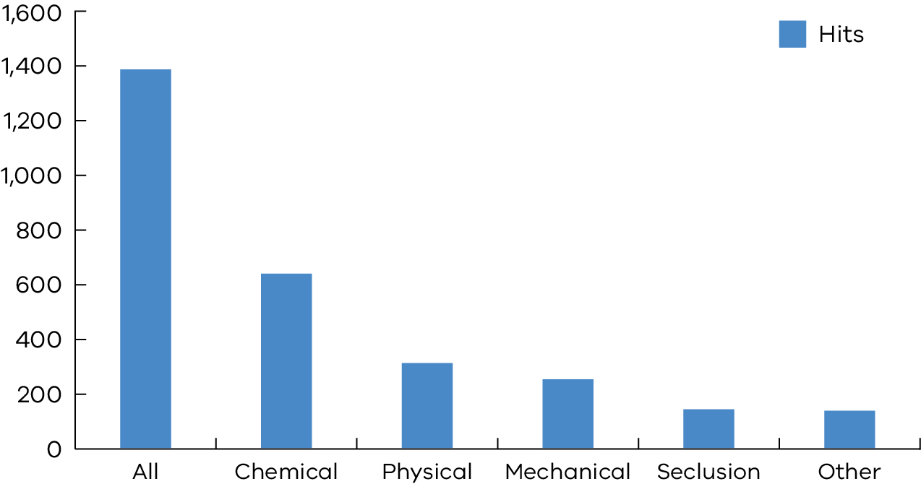

The RISET can be found by typing ‘RISET’ into a search engine’s search function.

## Compulsory treatment RIDS module implementation

The electronic treatment (e-treatment) plan was made available to the sector in April 2015. This has been successfully implemented for all those who are subject to compulsory treatment.

Training and support continues to be provided to the sector for current clients and new staff. This has facilitated greater oversight of treatment plans and the use of restrictive interventions. It is an additional safeguard for people subject to compulsory treatment. The system will continue to advance with future updates.

## Armidilo-S

The Assessment of Risk and Manageability of Individuals with Developmental and Intellectual Limitations who Offend – Sexually (ARMIDILO-S) is a risk assessment and management tool that has been specifically developed for use with this group.

Risk assessment and management is a central consideration for compulsory treatment when working with offenders with an intellectual disability.

The Senior Practitioner facilitates regular training sessions conducted by the principal author of the assessment, Professor Doug Boer, from the University of Canberra. ARMIDILO-S user group sessions are also facilitated by the Senior Practitioner. Two sessions were convened this year to maintain and enhance practice skills in the use of this assessment tool by those who attended Professor Boer’s workshops.

# Supporting best practice through advice, partnerships and consultation

A function of the Senior Practitioner is ‘to provide information with respect to the rights of individuals with a disability who may be subject to the use of restrictive interventions or compulsory treatment’. (Disability Act s24. (1)c)

## Compulsory treatment practice forums

The compulsory treatment team ran practice forums on a quarterly basis throughout the year. These are targeted for staff working with compulsory treatment matters, including authorised program officers, clinicians, direct care (disability) staff and representatives from the Office of Public Advocate and VCAT.

The purpose of these forums is to:

* facilitate information related to compulsory treatment
* address and promote practice
* support professional networking.

The intensive support team has attended the forum to explain their role in problem solving issues with people transitioning to the NDIS. The Community Forensic Dual Disability Service updated the sector about their staff changes and the intensive case reviews.

The compulsory treatment team has received positive feedback about these forums.

## Compulsory treatment team newsletters

Since 2015, the compulsory treatment team has issued a quarterly newsletter, which has included practice advice, links to resources, updates on compulsory treatment forums, stakeholder issues and general information about the office of the Senior Practitioner.

A range of stakeholders have provided positive informal feedback to the use of the newsletter as a communication strategy.

## Case consultations

The compulsory treatment team supports the sector by engaging in case consultations and attending care team meetings for compulsory treatment team clients. The compulsory treatment team has attended approximately 25 care team meetings or professional meetings per month during 2016–17.

## Work with the Department of Education and Training

A dedicated principal practice leader (education) position was established and appointed for two years last year to work with the Department of Education and Training, but still under the direction and guidance of the Senior Practitioner.

The Department of Education and Training has continued to collect data on restraint and seclusion over the last year and, in collaboration with stakeholders, has released a revised resources document to support schools to reduce and eliminate the use of restraint and seclusion.

The revised version of this document, which was previously referred to as Guidance for Responding to violent and dangerous student behaviours of concern, is now titled Policy guidance, procedures and resources for the reduction and elimination of restraint and seclusion in Victorian Government schools. The document also includes the new Principles for the reduction and elimination of restraint and seclusion in Victorian government schools.

Key changes to the document include:

* greater emphasis on and reference to the Charter of Human Rights and Responsibilities
* links to new documents such as the Child Safe Standards resources
* the inclusion of 15 Principles, initially developed by the US Department of Education and adapted for use in Victoria
* clearer definitions for restraint and the use of the Australian Psychological Society definition of seclusion, raising the threshold for its use
* removal of language such as ‘violent and dangerous’.

The new principles document provides detailed explanations of 15 principles to support school staff to manage behaviour that poses a risk to the safety of others. The Senior Practitioner endorsed this document.

These resources take important steps to support schools across Victoria to ensure that the human rights of every young Victorian are respected. They are complemented by the broader suite of professional development opportunities that are already in place to support schools to promote positive behaviour and respond to behaviours of concern.

They can be found online by searching for these titles. They sit within the broader Student Engagement and Inclusion Guidance.

The principal practice leader (education) will continue to work with schools to ensure that physical restraint and seclusion are only used when it is immediately required to protect the safety of a student or any other person.

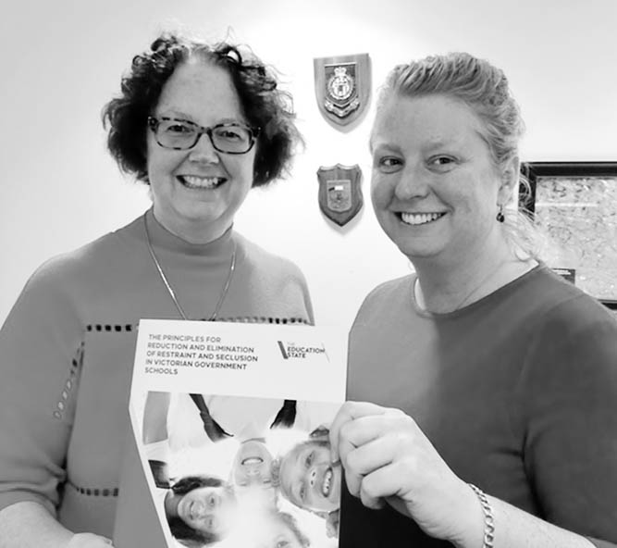

Mandy Donley, Principal Practice Leader – Education, Office of Professional Practice and Moira Buchholtz, Senior Project Officer, Inclusion, Access and Participation Branch, Department of Education and Training

## Occupational therapy students working with the Senior Practitioner

The integrated healthcare team again hosted and supervised two Bachelor of Occupational Therapy students from Monash University for their Participatory Community Practice unit. In this subject, students developed and implemented a guide for services called Reducing menstrual suppression for women with an intellectual disability in Victoria: A resource for support workers and disability services.

This resource outlines non-medical strategies to assist disability support services to support women with an intellectual disability to manage their menstruation.

The resource includes information about:

* the side effects of medication that is commonly used to suppress a women’s menstruation
* a list of alternative strategies with links to other resources
* templates to improve documentation of menstrual cycles.

A copy of the guide is available on request by [emailing the integrated healthcare team](mailto:RIquestions@dhhs.vic.gov.au) <RIquestions@dhhs.vic.gov.au>.

## Student placements with the Senior Practitioner

Many people with an intellectual disability and complex health issues suffer pain that is under-diagnosed (Baldridge & Andrasik, 2010; McGuire, Daly, & Smyth, 2010). For people who have severe neurological impairments such as cerebral palsy, pain can result from many underlying physical problems, including epilepsy, infections and gastrointestinal dysfunction (McMorris et al, 2015; Siden, Carleton, & Oberlander, 2013).

For people who are unable to communicate, behaviours of concern, such as self-injury, may be the only way they can communicate their pain and distress (Carr & Owen-DeSchryver, 2006). Restrictive practices are often used to stop the behaviours of concern, but will not address the underlying cause if the cause is pain and distress (Deshais, Fisher, Hausman & Kahng, 2015; Jennett, Hagopian, & Beaulieu, 2011).

Two projects were undertaken to gain a better understanding of this area. The first project was undertaken by a final year psychology student who spent a summer placement with the Senior Practitioner’s team in January and February 2017, to research how best to assess pain in people who are not able to communicate.

Two pain scales were researched and found to have good inter-rater reliability and useability, being:

* the Pain and Distress Scale (PADS) – designed by Shinde and his colleagues to assist healthcare professionals to diagnose and more effectively treat pain in patients with severe and profound communication difficulties (Shinde, Danov, Chen, Clary, Harper, Bodfish and Symons, 2014)
* the Non-Communicating Adult Pain Checklist (NCAPC) (Lotan, Benishvily, and Gefen, 2013).

Both assessments were trialled with two services. The service providers felt that both assessments were useful in documenting pain for a person they supported.

Pain Australia has clinics throughout Victoria and provides specific assessment of pain. These clinics can be found on the Pain Australia website.

The second project was undertaken by a graduate learning team to find a way to communicate to allied health and disability services in Victoria about pain and its assessment for people with a disability, who are not able to communicate. This project will be finished in early 2018, and the results will be presented at the Senior Practitioner Seminar 2018 and in the 2017–18 Senior Practitioner report.

## Published resources

The following resources were written in collaboration with service providers and published on the Senior Practitioner’s website. They can be found by searching for the titles.

### Wandering in people on the autism spectrum

This resource was written in 2016 in collaboration with AMAZE Autism Victoria. It is intended to provide families and carers with guidance on how to find out why their loved one wanders, and looks at some best practice strategies for reducing the risk of wandering.

Wandering in people on the autism spectrum provides information on how to access professional assistance in putting together a behaviour support plan to prevent people on the autism spectrum from wandering. It explores important considerations for the use of restrictive interventions to prevent wandering, provides measures that parents and carers can put in place to reduce the risk of harm if their family member does wander off, and provides advice on what to do if someone on the autism spectrum goes missing.

### Avoiding and responding to sexualised behaviours of concern in young people with autism and intellectual disability: a guide for disability service providers

This guide was developed by the department and the Office of Professional Practice. It is designed to provide direction to disability service providers in their support of young people with intellectual disability and autism spectrum disorder, who show sexualised behaviours of concern. The guide takes a positive approach to supporting the development of sexuality of young people with these disabilities, and uses the published evidence to outline standards for the assessment of, and intervention for, sexualised behaviours of concern.

While Avoiding and responding to sexualised behaviours of concern in young people with autism and intellectual disability: a guide for disability service providers was developed primarily for disability service providers, its application to other sectors, including schools and family homes, and use by clinical professionals, is also appropriate.

The recommendations are presented in the context of positive behaviour support, in order to maximise their practical value in improving the quality of life of young people with sexualised behaviours of concern, and in reducing those behaviours.

### Why is that locked?

This resource was created by Yooralla and the Senior Practitioner’s team in partnership. It was developed for service providers to use when they are trying to understand their reporting and monitoring requirements in relation to the use of locks.

Why is that locked? assists service providers to comply with legislative and practice requirements for disability residential services in Victoria.

# Informing public debate and opinion

A function of the Senior Practitioner is ‘to develop links and access to professional, professional bodies and academic institutions for the purpose of facilitation knowledge and training clinical practice for the purpose of facilitating knowledge and training in clinical practice for people working with individuals with a disability’. (Disability Act s24. (1)f)

## Publications in peer-reviewed journals

Baker P, et al 2016, ‘Conference report: The Seventh BILD PBS International Research and Practice Conference: Revolution or evolution? Advancing evidence-based practice in positive behaviour support’, International Journal of Positive Behavioural Support, vol. 6, no. 2, pp. 51–55.

Donley M, et al 2016, ‘Human rights, disability and restrictive interventions: Collaborative development of policy and guidance for government schools’, Journal of Intellectual Disability Research, vol. 60, no. 7–8, p. 658.

Hayward B 2017, ‘The arguments against CCTV and camera surveillance in the homes of people with disabilities to protect against abuse and neglect’, Research and Practice in Intellectual and Developmental Disabilities, vol. 4, no. 2, pp. 121–137.

Webber LS, et al 2017, Factors associated with the use of mechanical restraint in disability services, Journal of Intellectual & Developmental Disability, DOI: 10.3109/13668250.2017.1310814.

## Conference papers

Bruggemann R, Lambrick F, Nankervis K 2016, Quality and safeguards in disability services: Restrictive practices, Workshop, International Association for the Scientific Study of Intellectual Disability (IASSID) Disability Workers’ Conference, Melbourne.

Hayward B 2017, Rights of residents living in disability residential services in Victoria [and plain English version], Papers presented at the Having a Say Conference, Geelong, 8–10 Feb.

Lambrick F, Troutman C 2016, Stepping beyond risk in order to manage recidivism: A strengths-based approach, Paper, International Association of the Scientific Study of Intellectual Disability (IASSID) 15th World Congress, Global partnerships: Enhancing research policy and practice, Melbourne.

Lindsay W, Morrissey C, Lambrick F 2016, Using the PCL-R for offenders with intellectual and developmental disability, Roundtable, International Association of the Scientific Study of Intellectual Disability (IASSID) 15th World Congress, Global partnerships: Enhancing research policy and practice, Melbourne.

Webber LS 2016, Who is at risk of restrictive practices in disability services and what can be done to reduce this risk? People with Intellectual and/or Developmental Disability and Psychology Interest Group Panel discussion on restrictive practices, The Australian Psychological Society’s 2016 Congress 13–16 September.

Webber LS, Richardson B 2016, Factors associated with long-term restrictive intervention use in disability services, Symposium: The use of legislation and policy to prevent restrictive practices, International Association of the Scientific Study of Intellectual Disability (IASSID) 15th World Congress, Global partnerships: Enhancing research policy and practice, Melbourne.

Webber LS, Richardson B 2016, Increasing the quality of behaviour support plans: what works for whom? International Association of the Scientific Study of Intellectual Disability (IASSID) 15th World Congress, Global partnerships: Enhancing research policy and practice, Melbourne.

White KL 2016, Individual factors contributing to the use of mechanical restraint on people with disabilities, International Association of the Scientific Study of Intellectual Disability (IASSID) 15th World Congress, Global partnerships: Enhancing research policy and practice, Melbourne.

## Invited presentations

Lambrick F 2016, ACAP Honours Psychology Seminar, Assessment and treatment of offenders with intellectual disability, Australian Centre for Applied Psychology, 6 October 2016.

# References

Baldridge KH, Andrasik F 2010, ‘Pain assessment in people with intellectual or developmental disabilities’, The American Journal of Nursing, vol. 110, no. 12, pp. 28–35.

Browning-Wright D, Saren D, Mayer GR 2003, The behavior support plan – quality evaluation guide, viewed 23 October 2014 at [Positive Environments, Network of Trainers website](http://www.pent.ca.gov) <http://www.pent.ca.gov>.

State Government of Victoria, 2006, Disability Act 2006, at [Victorian Legislation and Parliamentary Documents website](http://www.legislation.vic.gov.au) <http://www.legislation.vic.gov.au>.

Carr EG, Owen-DeSchryver JS, 2007, ‘Physical illness, pain, and problem behavior in minimally verbal people with developmental disabilities’, Journal of Autism and Developmental Disorders, vol. 37, no. 3, pp. 413–424.

Deshais MA, et al 2015, ‘Further investigation of a rapid restraint analysis’, Journal of applied behavior analysis, vol. 48, no. 4, pp. 845–859.

Jennett H, Hagopian LP, Beaulieu L 2011, ‘Analysis of heart rate and self-injury with and without restraint in an individual with autism’, Research in Autism Spectrum Disorders, vol. 5, no. 3, pp. 1110–1118.

McGuire BE, Daly P, Smyth F 2010, ‘Chronic pain in people with an intellectual disability: under-recognised and under-treated?’, Journal of Intellectual Disability Research, vol. 54, no. 3, pp. 240–245.

McMorris C, et al 2015, ‘Chapter Five-Adults with Cerebral Palsy: Physical and Mental Health Issues and Health Service Use Patterns’, International Review of Research in Developmental Disabilities, vol. 48, pp. 115–149.

Siden HB, Carleton BC, Oberlander TF 2013, ‘Physician variability in treating pain and irritability of unknown origin in children with severe neurological impairment’, Pain Research and Management, vol. 18, no. 5, pp. 243–248.

Webber LS, et al 2011a, ‘Factors influencing quality of behaviour support plans and the impact of quality of plans on restrictive intervention use’, International Journal of Positive Behavioural Support, vol. 1, pp. 24–31.

Webber LS, et al 2011b, ‘Assessing behaviour support plans for Australian adults with intellectual disability using the “Behaviour Support Plan Quality Evaluation II” (BSP‑QE II)’, Journal of Intellectual and Developmental Disability, vol. 36, pp. 1–5.

Webber LS, et al 2012, ‘The impact of the quality of behaviour support plans on the use of restraint and seclusion in disability services’, International Journal of Positive Behavioural Support, vol. 2, no. 2, pp. 3–11.

# List of acronyms

ARMIDILO-S Assessment of Risk and Manageability of Individuals with Developmental and Intellectual Limitations who Offend – Sexually

BSP-QE II Behaviour Support Plan Quality Evaluation tool II

CMIA Crimes (Mental Impairment and Unfitness to be Tried ) Act 1997

DFATS Disability Forensic Assessment and Treatment Service

GP General practitioner

NDIA National Disability Insurance Agency

NDIS National Disability Insurance Scheme

PRN Pro re nata (as required)

RIDS Restrictive Intervention Data System

RISET Restrictive Intervention Self Evaluation Tool

the department Department of Health and Human Services

the Act Disability Act 2016

VCAT Victorian Civil and Administrative Tribunal