|  |
| --- |
| Social services regulation reform information sheet |
| September 2021 |
| OFFICIAL |

# Overview

The Department of Families, Fairness and Housing (the department) is making changes to the way that social services are regulated.

The social services regulation reform will establish a modern and fit-for-purpose regulatory framework administered by an independent regulatory body. This will better support safe service delivery and service users’ human rights, including freedom from harm, neglect and abuse. It will also provide a separation from policy design, funding models and service agreement management and strengthen the regulation of department-delivered services.

New Social Services Standards will form the foundation of the regulatory framework. These will replace the current Human Services Standards and the Accommodation and Personal Support Standards. Service users were engaged to inform the design of new standards, which focus on safe service delivery and human rights.

## Rationale for reform

### Department

Regulation plays a crucial role in reducing risks of harm to children, young people and adults who are experiencing vulnerability. Regulation obliges service providers to meet fundamental safety standards. It protects human rights by enforcing these core safety requirements and enabling timely interventions to help prevent neglect, abuse or exploitation.

### Service providers

The department has heard that while the many social services providers are currently subject to various accountability measures, these arrangements are fragmented and inefficient. The social services sector has highlighted the need for regulation reform to support its commitment to prioritising safety and to create greater efficiencies. The sector has also raised that the current accountability measures and processes are complex and burdensome.

The regulator will be independent and report directly to the Minister. These reforms will create a separation from the functions of system stewardship, policy design, funding and contract management. These roles will continue to sit with the department.

### Services users

In 2019, the department engaged a consultant to undertake a human-centred design process with service users to gain insight into their experiences accessing social services. This feedback laid the groundwork for the development of the new Social Services Standards, which are at the centre of the new framework.

## Regulator

The reforms involve the establishment of a new regulator that reports directly to the Minister. This will create a separation from the functions of system stewardship, policy design, funding and contract management. The regulator will regulate social services against the new Social Services Standards and the Worker and Carer Exclusion Scheme. The Minister will have the ability to give general directions to the regulator in relation to its functions.

## Standards

Instead of meeting the Human Service Standards or conditions as per individual funding agreements, providers will be required to meet the Social Service Standards. The development of Social Service Standards has been informed by consultation and feedback from peak bodies, providers and service users.

If an organisation doesn’t meet the standards, and there is a significant risk of harm to service users, further actions may be taken by the regulator. This could include investigation, imposing conditions, revoking registration or appointing an administrator. Your organisation will have the right to seek a review of the decisions made by the regulator.

## Registration

If providers are already registered, this registration will be transferred to the new scheme. Providers will be contacted by the regulator about their changing obligations.

Previously unregistered providers will need to meet requirements relating to the safety of services and the competence and skills of providers and staff and the suitability of premises used. Providers who have not been registered before will be phased into the new scheme.

Providers will only need to register once.

## Reporting

One of the aims of the reforms is to reduce the duplication of processes for organisations. While organisations will still have reporting requirements, the regulator will try and liaise with other organisations so it will only have to be done once. It is intended to address the administrative burden that currently requires organisations to report the same incident to multiple oversight bodies. The regulator will have mutual recognition processes to share information across relevant bodies. This might include other relevant commissions, departments and safeguarding bodies.

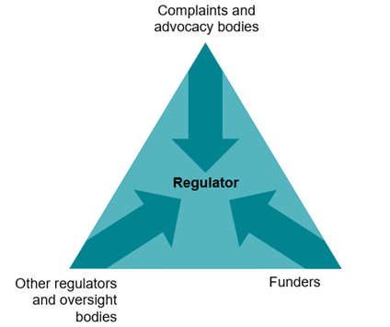

Information sharing will help protect service users and reduce duplication.

## Workers and carers

The primary focus of regulating workers will be to ensure that you have a safe workforce for clients experiencing vulnerabilities.

A new Worker and Carer Exclusion Scheme will replace the current Carers Register and independent investigations model. Conduct that places children and young people at risk of harm, including sexual, physical and emotional abuse will be considered and may lead to exclusion. The regulator will seek to streamline reporting and administrative processes through information sharing arrangements.

Service providers will ask the regulator to check a worker or carer against the excluded worker and carer database, before engaging a person to work as a worker or carer for the first time.

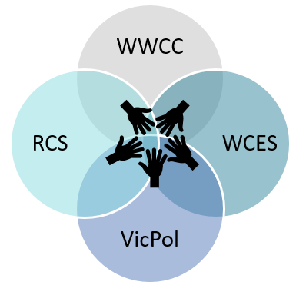

The worker and carer exclusion scheme, working with children check, police check, and reportable conduct scheme may each have a part to play in protecting those experiencing vulnerability.

# Consultation timeline

Targeted engagement on this project began in 2019, with broad engagement with sector peaks and key organisations having commenced in 2021.

Consultation on the standards and collaboration on the regulations will occur in 2022. This will align with establishment of new regulator in 2022. There will be an implementation transition period for the first group of providers in 2023, with support provided by the regulator.

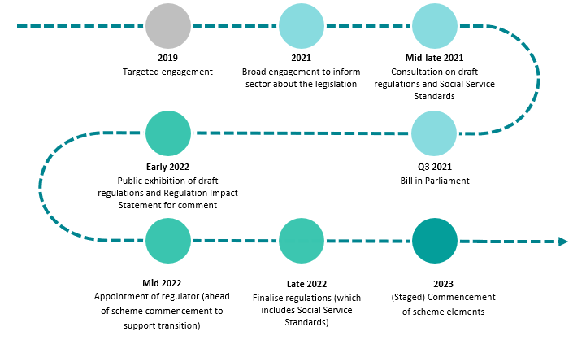

To receive this document in another format, please [email the Social Services Regulation Reform](mailto:regulationreform@dhhs.vic.gov.au) team <regulationreform@dhhs.vic.gov.au>.

Authorised and published by the Victorian Government, 1 Treasury Place, Melbourne.

© State of Victoria, Australia, Department of Families, Fairness and Housing, March 2021.

Available at [Human Services Regulator](https://www.dhhs.vic.gov.au/human-services-regulator) webpage on the department’s website

<https://www.dhhs.vic.gov.au/human-services-regulator>