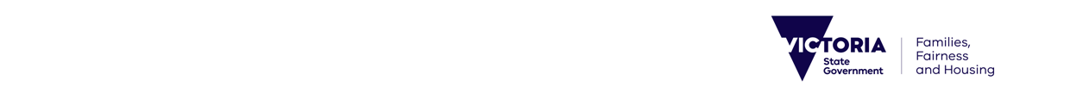Media release

Tuesday, 4 March, 2025

**CELEBRATING OUTSTANDING VICTORIANS KEEPING CHILDREN SAFE**

Victorians are being encouraged to recognise dedicated people working to make a positive difference in the lives of children, young people and families by nominating them for the 2025 Victorian Protecting Children Awards.

Department of Families, Fairness and Housing Community Operations Practice Leadership Deputy Secretary Danny O’Kellysaid the awards, which opened for nominations today, are an important way to acknowledge the outstanding efforts and dedication of Victorians who demonstrate excellence in working with children, young people and families to help ensure they are safe, supported and thriving.

The awards attracted a record number of nominations in 2024 across its 12 categories, including the Foster Carer Award and Kinship Awards. Other categories include the Minster’s Award for Excellence in Protecting Children, the Engaging Kids in School Award and the Walda Blow Aboriginal Children and Young People Award.

The Victorian Protecting Children Awards recognise achievements in both the child and family services sector and child protection, with nominations open to people working across the child and family services sector, child protection, government and academic organisations, foster, kinship and permanent carers, volunteers and community members.

Last year’s Leaving a Legacy Award recognised the late Dr Joe Tucci, former Chief Executive of the Australian Childhood Foundation,. As a registered psychologist and social worker, Dr Tucci had over 30 years of experience in child protection, working therapeutically with children, leading research into child abuse and consulting across governments and was an international leader in models of prevention and repair of childhood trauma.

Nominations for the 2025 Victorian Protecting Children Awards are open until 4 April, with finalists announced in late July. Winners will be announced at a special awards ceremony during Child Protection Week on 2 September. To find out more and to nominate visit: dffh.vic.gov.au/victorian-protecting-children-awards

**Quotes attributable to Department of Families, Fairness and Housing Community Operations Practice Leadership Deputy Secretary Danny O’Kelly**

*“These awards are a fantastic opportunity to honour the individuals, teams and groups who show excellence in their work with children, young people and families.”*

*“I’m proud to celebrate the outstanding Victorians whose crucial work makes such a positive difference to so many in our community, and I encourage people to nominate today.”*