

Department of Families, Fairness and Housing statement of direction – at a glance

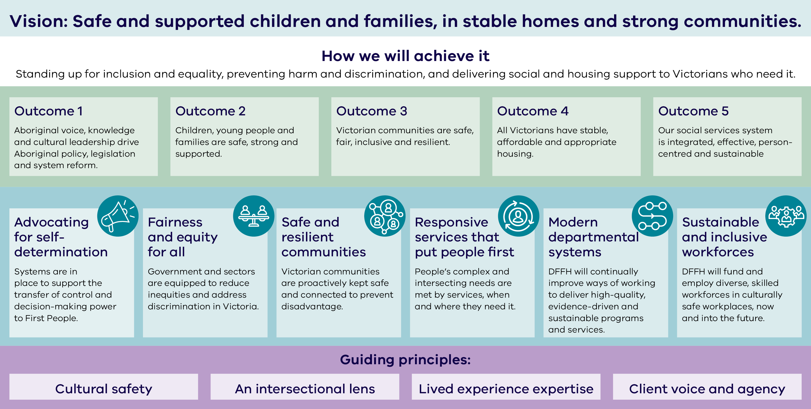

# Statement of direction

## Vision

Safe and supported children and families, in stable homes and strong communities.

## How we will achieve it

Standing up for inclusion and equality, preventing harm and discrimination, and delivering social and housing support to Victorians who need it.

## Outcomes

* Aboriginal voice, knowledge and cultural leadership drive Aboriginal policy, legislation and system reform.
* Children, young people and families are safe, strong and supported.
* Victorian communities are safe, fair, inclusive and resilient.
* All Victorians have stable, affordable and appropriate housing.
* Our social services system is integrated, effective, person-centred and sustainable

## Focus areas

**Advocating for self-determination:** Systems are in place to support the transfer of control and decision‑making power to First Peoples.

**Fairness and equity for all:** Government and sectors are equipped to reduce inequities and address discrimination in Victoria.

**Safe and resilient communities:** Victorian communities are proactively kept safe and connected to prevent disadvantage.

**Responsive services that put people first:** People’s complex and intersecting needs are met by services, when and where they need it.

**Modern departmental systems:** We will continually improve ways of working to deliver high-quality, evidence-driven and sustainable programs and services.

**Sustainable and inclusive workforces:** We will fund and employ diverse, skilled workforces in culturally safe workplaces, now and into the future.

## Guiding principles

Cultural safety, an intersectional lens, lived experience expertise, and client voice and agency.

To receive this document in another format, email Strategic Planning [strategy@dffh.vic.gov.au](mailto:strategy@dffh.vic.gov.au)

Authorised and published by the Victorian Government, 1 Treasury Place, Melbourne. © State of Victoria, Australia, Department of Families, Fairness and Housing, August 2024. (2303428) Available at [Department of Families, Fairness and Housing strategic plan](https://www.dffh.vic.gov.au/publications/dffh-strategic-plan) https://www.dffh.vic.gov.au/publications/dffh-strategic-plan.