Office of Professional Practice strategic plan   
July 2024 – June 2025

OFFICIAL

To receive this document in another format, email the Office of Professional Practice [oppdirectorate@dffh.vic.gov.au](mailto:oppdirectorate@dffh.vic.gov.au)

Authorised and published by the Victorian Government, 1 Treasury Place, Melbourne.

© State of Victoria, Australia, Department of Families, Fairness and Housing, July 2024.

In this document, ‘Aboriginal’ refers to both Aboriginal and Torres Strait Islander people.

**ISBN** 978-1-76130-605-1 (online/PDF/Word)

Available at [Office of Professional Practice strategic plan 2024-2025](https://www.dffh.vic.gov.au/publications/office-professional-practice-strategic-plan-2024-2025) https://www.dffh.vic.gov.au/publications/office-professional-practice-strategic-plan-2024-2025

(2307526)

Aboriginal acknowledgement

The Victorian Government acknowledges Victorian Aboriginal people as the First Peoples and Traditional Owners and Custodians of the land and water on which we rely.

We acknowledge and respect that Aboriginal communities are steeped in traditions and customs built on a disciplined social and cultural order that has sustained 60,000 years of existence. We recognise the intergenerational consequences of colonisation, dispossession, child removal and other discriminatory government policies. We acknowledge that the impacts and structures of colonisation still exist today.

We commit to addressing these impacts by embedding cultural safety and self-determination in all that we do. This will allow Aboriginal Victorians have decision-making power and control to determine what is best for them.

We acknowledge the ongoing leadership role of Aboriginal communities. We will continue to work in collaboration with First Peoples.

Contents

Message from the Office of Professional Practice 4

Our strategic plan 5

Our vision 5

Our mission 5

Our guiding principles 5

Our people 5

Role of the Office of Professional Practice 6

Definition of practice 6

Practice leadership 6

Statutory responsibilities 7

Advice, guidance and support 7

Contributing to reform 7

Systemic analysis and responses 8

Our practice leadership priorities in 2024–25 9

Building and promoting evidence-based practice 10

Supporting frontline workforces with expert practice advice 11

Safeguarding and continuous improvement 12

Delivering professional development for frontline workforces 13

Partnering across government to inform policy, service design and workforce development with leading practice 14

Business as usual 15

Tracking our progress and impact 16

# Message from the Office of Professional Practice

Our department works every day to help build a fairer and safer Victoria. We want all Victorians to be safe and free from discrimination and violence so they can flourish.

To achieve these aims, the department needs to work effectively. This means putting clients and communities at the centre of everything we do.

The Office of Professional Practice (OPP) helps the department do this. We guide practice in keeping with:

* contemporary, evidence-based practice frameworks and tools
* practice wisdom
* operational service delivery.

We do this to encourage practice transparency. This allows a focus on continuous improvement by learning from our mistakes and our successes. We need to support our frontline workforces to do their best work. We seek out and incorporate feedback to ensure the people we support can engage with us.

This strategic plan sets out the steps the OPP will take to further the department’s focus areas and uphold its values.

We used the experience and wisdom of our staff to develop the plan. We asked our departmental colleagues and external stakeholders what they need from us.

This plan takes place at a time of major sector reform. The communities we work with are under pressure. To be effective, we will need to listen, review and adjust the plan as things change.

It is a privilege to do our work in partnership with:

* Community Operations and Practice Leadership colleagues
* departmental stakeholders.

We will be true to our guiding principles of integrity, collaboration and leadership. We will promote a just and learning culture.

We will keep listening and learning. We will keep sharing and celebrating.

We will continue to support and enable the department to do the best work it can.

Together.

Always.

# Our strategic plan

## Our vision

The children, adults, families and communities we work with live their best lives.

We respect their rights.

Our frontline workforces are capable and confident, and we support their wellbeing.

## Our mission

The OPP works to guide and influence a consistent statewide approach to human services practice that upholds the safeguards and rights of vulnerable Victorians and is informed by contemporary evidence and leading practice.

## Our guiding principles

Our guiding principles complement the department’s values.

In delivering to this plan, we commit to **self-determination and cultural safety**. This includes:

|  |  |  |
| --- | --- | --- |
| **Integrity**  We are ethical, rigorous, evidence-informed, client-focused, effective and accountable. | **Collaboration**  We are collegiate, focused on collaborative problem solving and continuous learning. | **Leadership**  We are aspirational in our vision for practice. We are strategic, courageous and dedicated to safety and wellbeing. |

## Our people

The OPP is a team of human services specialists from varied disciplines, as well as support staff. We are a branch of the department’s Community Operations and Practice Leadership division. This helps us add value to service delivery and client outcomes. To provide the best support, we must invest in and build capability within the OPP.

We commit to:

* supporting our people to thrive at work
* delivering professional development and career opportunities to our staff
* developing greater connection across the branch
* supporting and enabling our Senior Leadership Group
* leading this strategic plan through our OPP Executive Group.

# Role of the Office of Professional Practice

The OPP exists as a branch to lead, build and promote the department’s commitment to practice expertise:

Practice expertise is at the heart of what we do: it is about how we work with people and, importantly, working in ways that support the safety and wellbeing of the people who use the department’s services, and our staff. We need to elevate the authority and leadership of practice expertise. This will improve job satisfaction for our practitioners and support career pathways across the system.[1]

## Definition of practice

We define practice as ‘the professional application of knowledge, skills, experience and professional judgement’. This is always with the aim of improved service delivery and enhanced outcomes for Victorians. Practice is about ‘how’ we work.

## Practice leadership

We provide a safeguarding function for the department. This contributes information and intelligence about:

* howservices are being delivered
* what works well
* what changes we need to make to improve outcomes.

We always do this in the spirit of continuous improvement. We set the frame for what is good practice. We support practitioners to learn from practice challenges when they arise.

Our role is to help find a way forward when it’s needed. We are a value-add to the role of operations within the department and the sector.

We aim to enable and build the department’s practice capacity by:

* evidencing our strategic and systemic role in practice leadership
* promoting examples of good practice
* using contemporary evidence to inform practice development
* improving how we support and build the capability of leaders in practice
* building collaborative approaches for how we provide support, safeguarding and continuous improvement
* embedding a learning culture that promotes professional development and capability building for frontline workforces
* engaging with external partners to improve ways of working and, at times, advocating for services for clients.

## Statutory responsibilities

We hold some statutory functions relating to:

* child protection under the *Children, Youth and Families Act* *2005* – the Chief Practitioner and Statewide Principal Practitioners are protective intervenors under s.181 of the Act
* the Victorian Senior Practitioner. The Senior Practitioner is responsible under the *Disability Act 2006* (Vic) to ensure the rights of people who are subject to restrictive practices and compulsory treatment are protected. This includes making sure the department complies with appropriate standards. This role is independent of the department.

## Advice, guidance and support

We provide a range of practice advice, guidance and support to service delivery:

* practice advice, guidance and support by specialists in child protection, children and families, Aboriginal children and families and family violence
* professional development and wellbeing for the department’s frontline workforces – child protection, housing and forensic disability
* advocating for the rights of people with disability
* developing and leading practice frameworks and approaches
* strategy and practice leadership in joint responses to child sexual and criminal exploitation, and sexual abuse
* practice leadership in housing and child protection, using themes and analysis to improve practice.

## Contributing to reform

The OPP supports the department’s ongoing reforms through a practice leadership lens. We do this both directly and indirectly.

Over the coming years, significant change will come from:

* children and families reform
* redesigning the child protection operating model
* developing an end-to-end Aboriginal children and families system
* social housing regulation review
* family violence reform including the Multi-Agency Risk Assessment and Management Framework (MARAM) and information sharing
* developing an early years strategy for Victoria
* raising the minimum age of criminal responsibility.

Recommendations also shape our work. These include from the:

* Yoorrook Justice Commission
* review of the National Disability Insurance Scheme (NDIS)
* Royal Commission into Violence, Abuse, Neglect and Exploitation of People with Disability.

The reform agenda is significant. The work also includes our contributions to state and national reform agendas. We will publish a new strategic plan each year to make sure we are focusing on the right things.

## Systemic analysis and responses

The OPP supports systemic analysis of service responses. We also accept requests and recommendations from oversight bodies. These include:

* coordinating with the Commission for Children and Young People and the Coroners Court of Victoria on the deaths of child protection clients
* offering a confidential and independent point of contact for departmental staff to report issues of client safety
* reviewing significant incidents affecting the safety of children, using the *Critical case review framework*
* researching, developing guidelines and practice standards, and providing information and education about:
  + restrictive practices
  + compulsory treatment
  + the rights of people with disability
* providing direction and recommendations about:
  + restrictive practices
  + compulsory treatment
  + behaviour support plans
  + treatment plans.

# Our practice leadership priorities in 2024–25

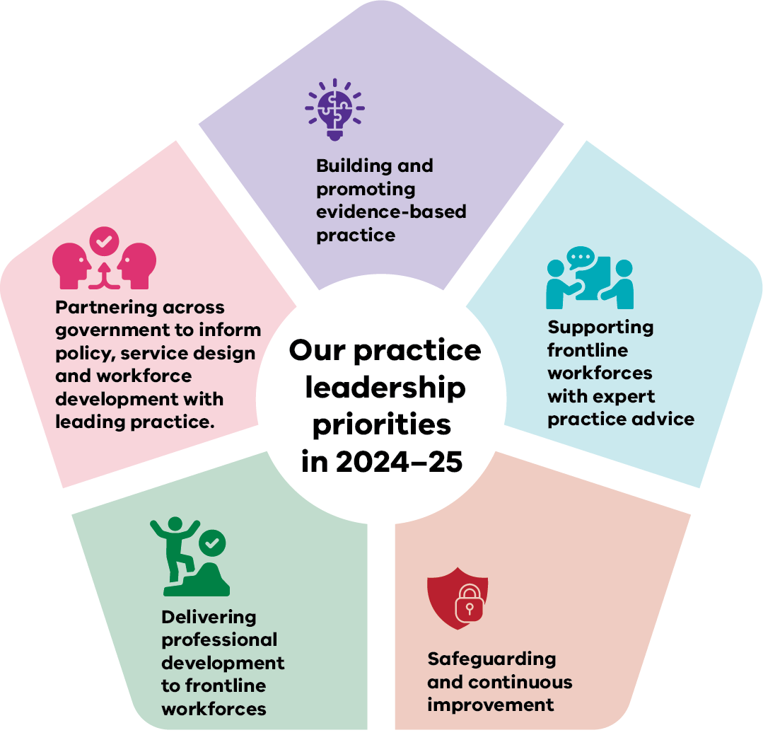

**These five priorities will guide our work from 1 July 2024 to 30 June 2025.**

**U**nder each priority are specific areas of focus and actions. We will be accountable for delivering these over the year.

## Building and promoting evidence-based practice

We will use data and evidence from research to inform our work. Data will offer guidance on qualitative measures to determine the effectiveness of our work.

Our actions are to:

### Drive and support use of contemporary evidence to inform practice

* Develop a practice approach for Child Protection.
* Continue to embed and develop the SAFER Children framework, informed by evaluation.
* Redevelop the Child Protection manual to be the contemporary practice guidance.
* Embed the *Framework for trauma-informed practice* in professional development programs and the functions of the OPP.

### Determine the effectiveness of our work

* Evaluate the Child Protection induction programs (CPP2 and Practice Induction Program).
* Monitor and report on the Child Protection *Mental health and wellbeing plan 2024–25*.
* Continue evaluating the Court Practice Advice and Support Service.

### Enhance professional development opportunities for all OPP staff

* Undertake a skills audit of OPP staff.
* Deliver a program of opportunities for knowledge dissemination across the branch.

## Supporting frontline workforces with expert practice advice

We aim to:

* provide contemporary and evidence-based advice
* share critical learnings and information
* build partnerships to provide support across the service system.

Our actions are to:

### Role model practice leadership

* Provide responsive in-reach practice support for Child Protection. (Referrals are based on request and, where identified, as needed.)
* Deliver Communities of Practice, focusing first on child sexual exploitation, family violence, children with disability. Include therapeutic specialists involved in delivering therapeutic residential care in Victoria.

### Provide timely quality practice advice, expertise and system support

* Develop clear referral pathways, guides and direction on when a referral must occur.
* Develop and launch an OPP SharePoint.
* Establish a multidisciplinary panel approach for responding to practice and client complexity.

### Enhance departmental responses to specific critical incidents

* Review the *Critical case review framework* for broader application outside the OPP as a standardised response for when significant incidents occur.
* Redevelop processes for responding to situations involving a child death. This includes initial review and preparing for requests from the Coroners Court of Victoria.
* Develop a process for sharing practice learning from:
  + deaths
  + the *Critical case review framework*
  + other case reviews.

## Safeguarding and continuous improvement

The OPP wants to champion a just and learning culture through:

* upholding safeguards
* promoting transparency in practice
* fostering continuous improvement.

Our actions are to:

### Strengthen the department’s key safeguarding reforms

* Develop a strategic joint response to child sexual and criminal exploitation, and sexual abuse. This includes intelligence and practice leadership components.
* Align policy, practice and professional development to the MARAM Framework. This includes the MARAM Adults Using Family Violence guidance, tools and training.

### Promote dissemination of systemic analyses

* Establish regular practice forums and ways of communicating.
* Develop a reflective practice approach.
* Develop refreshed child protection professional supervision operational policy, practice tools and professional development (phase 1).

### Contribute to safeguarding frameworks

* Review existing panels (High Risk Youth and Intensive Infant Response).
* Advise the Corporate and Delivery Services division on translating the Child Safe Standards into the department’s service delivery.

## Delivering professional development for frontline workforces

The OPP works with frontline workforces to promote and encourage:

* professional development
* leadership
* supervision.

Our actions are to:

### Ensure contemporary practice frameworks inform our mandatory programs

* Deliver a new Child Protection Practice Induction Program.
* Deliver Child Protection practice subjects from the curriculum framework.
* Deliver Housing learning programs that support contemporary social housing policy.
* Deliver Forensic Disability learning programs that meet NDIS accreditation and Victorian regulations.

### Build learning culture through leadership, management and supervision uplift

* Enhance the supervision skills and reflective practice frontline supervisors’ use.
* Partner with the 17 operational areas and statewide services to support local practice leadership, resources and connections with the OPP.

## Partnering across government to inform policy, service design and workforce development with leading practice

We represent the department and division in bring practice considerations to policy and strategic reform.

Our actions are to:

### Contribute to priority practice reform areas

* Deliver key government commitments for Child Protection training in response to the Yoorrook for Justice report.
* Deliver practice advice and resources to help embed Statement of Recognition legislation.
* Engage across government to address statewide practice requirements for common clients.
* Contribute to a whole-of-government response to reducing and eliminating restrictive practices.

## Business as usual

What you won’t see outlined are all our business-as-usual activities and deliverables. These are the standard functions we carry out within our operations. Our business as usual contributes to:

* our vision
* the Community Operations and Practice Leadership plan
* the department’s overarching strategic plan.

Our priorities differ from business-as-usual activities. Many of the actions and deliverables within the priorities are projects that introduce or reflect change.

Continuing to deliver on our business as usual is as much a focus as delivering on our practice leadership priorities.

# Tracking our progress and impact

We will:

* deliver this strategy, and business as usual activities, via our unit business plans
* review our progress and provide reports 3 times per year[2] to the Secretary, the Deputy Secretary Community Operations and Practice Leadership and OPP Executive Group
* provide a full report to the department’s Executive Directions Board each year (May) on our progress and impact. This will include any adjustments we need to make to our focus and approach for the year ahead.

1. Department of Families, Fairness and Housing 2022, *Final Management Structure: Evolve Program for the Department of Families, Fairness and Housing*, p 8.
2. In October/November, January/February and June.