

|  |
| --- |
| Quick Reference Card: Privacy Incident Report Form |

## DecorativePrivacy Incident Report Form

The Privacy Incident Report Form is used to capture details relating to: the privacy incident, the clients involved, the immediate risks, how the incident is being managed and contained and information relating to security and breaches.

 Using the **Privacy Incident Report** **Form** notifies the department about privacy incidents and actions taken to address immediate risks and issues.

## Access to the Privacy Incident Report Form

To access the Privacy Incident Report Form, just click on the link on the Reporting Incidents Page –

https://providers.dhhs.vic.gov.au/reporting-incidents

to be directed to the **Report a privacy incident** page.

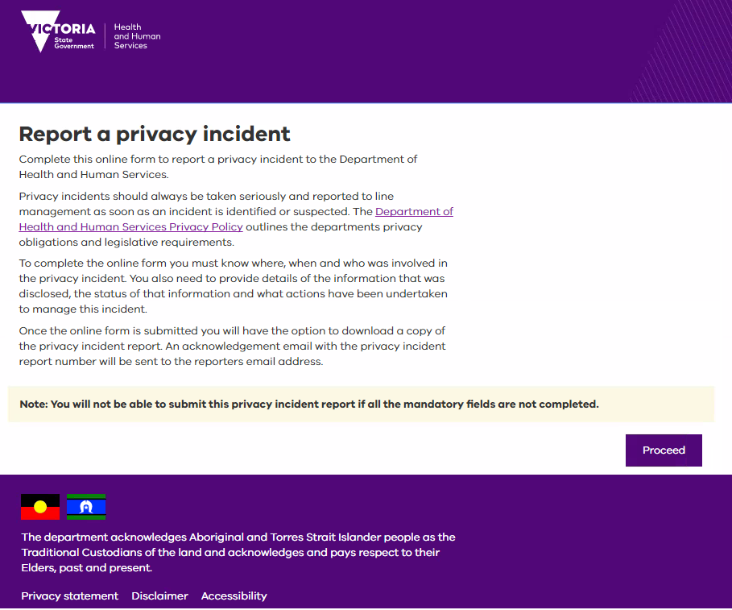

The below details key components of this page.

Policy Link – Click to open in a new browser

Proceed – Click to navigate to the Privacy Incident Form. The **Report and Contain** tab displays.

## Report and Contain Tab

|  |  |
| --- | --- |
| The **Report and Contain** tab contains all the stages to be completed before submitting the incident report to your divisional privacy officer. |  |

## Hints and Tips

The following table provides some helpful tips to assist in navigating your way through the Privacy Incident Report Form.

| Component | Description |
| --- | --- |
| Tab Key | Use the Tab key on your keyboard to navigate between the fields.  **Note**: Using this action will tab to the next component on the page, e.g. What is this? checkbox, radio button (where displayed) before moving to the next field. |
| Dropdown Lists | As you become familiar with the pre-defined dropdown lists, you can start typing and the relevant option will populate the relevant field for you, e.g. Area: South – Southern Melbourne. |
| Address Fields | When entering an address, the street name and suburb are validated against Google Maps.  **Note**: The street number isn’t validated. |
| Mandatory Fields | Mandatory fields must b filled in before you can move between stages and submit the form |
| Stage Links | Once the mandatory fields have been entered, if you need to return to the prior stage (or move to the next one), click on one of stage links at the top of the form to navigate backwards or forwards. |
| Spell Check | Any typing errors within the free text fields will display with a red squiggly line under it. |

## Where to go to for Help?

If you require any further assistance, please refer to:

1. The *Privacy Incident Report Form - User Guide for DHHS Unregistered Users* for details.
2. Contact your nearest Privacy Officer (in your division or at central office).