

|  |
| --- |
| Guidelines: Completing an External Research Application (DFFH) |
| Centre for Evaluation and Research Evidence (CERE)  Department of Health. Shared service with Department of Families, Fairness and Housing |
| OFFICIAL |

Contents

About the Centre for Evaluation and Research Evidence 1

Steps for submitting an external research application form 1

Details 2

# About the Centre for Evaluation and Research Evidence

The Centre for Evaluation and Research Evidence (CERE) reviews External Research Applications (ERAs) in terms of the Department of Families, Fairness and Housing (the department’s) capacity to support the research, alignment with strategic directions, conflicts of interest, duplication of research effort, and whether the research findings can inform service delivery and improve client outcomes.

## Steps for submitting an external research application form

1. The online accessible External Research Application (ERA) Form can be found at ERA form accessible <https://www.dffh.vic.gov.au/research-applications-external-organisations-and-individuals>.
2. Identify and contact two sponsors from the relevant program area/s to discuss and support the proposed research project. You MUST have spoken with these people and obtained their consent to act as sponsors for the proposed project prior to submitting your ERA.
3. Outline in your application clearly how your research fits with the department’s Strategic Plan and Outcomes (see below).
4. Provide a detailed description of the research project and why departmental resources (clients, staff, or data) are required. Particular attention needs to be given to the rationale for approaching vulnerable populations (e.g. children and/or young people in Out-of-Home Care) as part of the project. ERAs must outline the importance and value that the proposed research project brings to improving both practice and policy within a given program area.
5. Provide a copy of ethics approval with the ERA (e.g. from a University Human Research Ethics Committee, a Human Research Ethics Committee (HREC), or similar body), or a HREC approval for ethics exemption.
6. The research project must not commence until either your ethics approval or exemption has been received and acknowledged by the CERE.
7. Due to time constraints and limited resources within the CERE, limited correspondence will be entered into during the internal approval process. A letter will be sent to you to advise you whether the research has been approved and next steps to follow.
8. ERAs are not automatically approved.
9. Please address all correspondence and submissions to the CERE <cere@health.vic.gov.au>.

Figure 1. Summary of the ERA process.

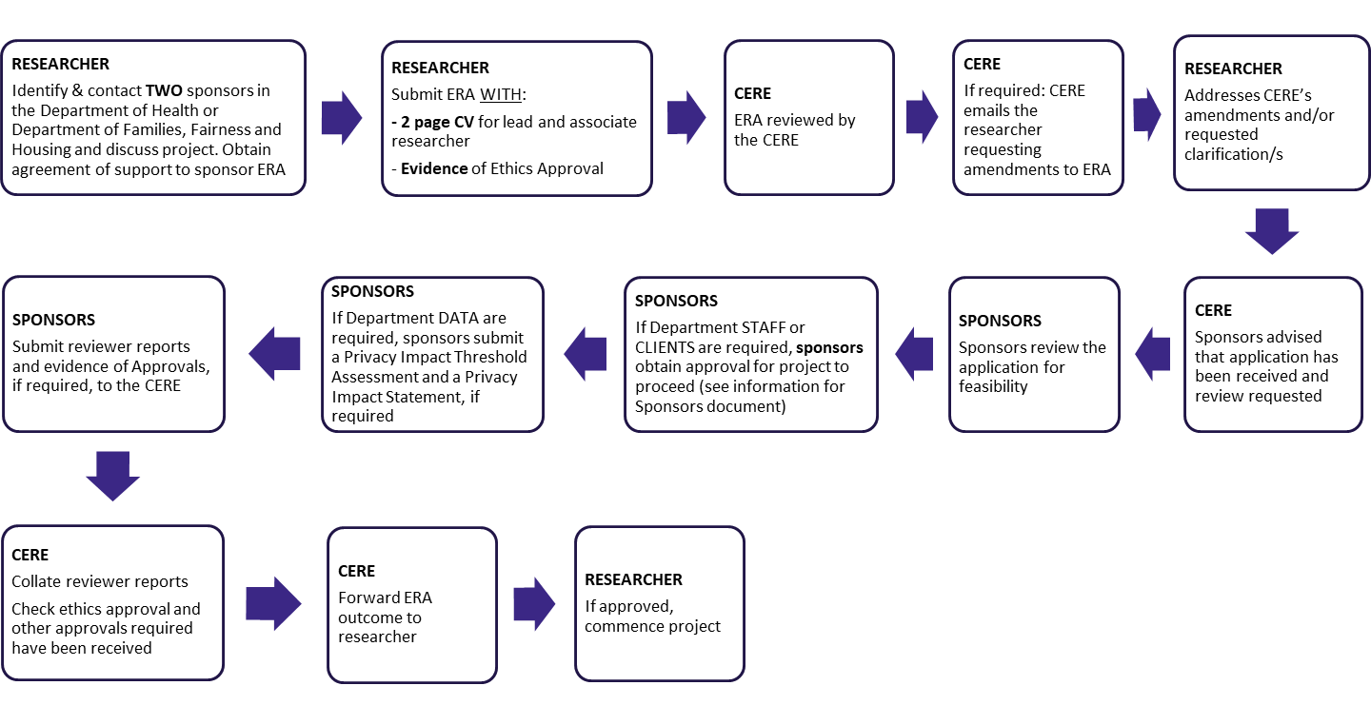

## Details

1. **External Research Application**

The accessible ERA form is available online <https://www.dffh.vic.gov.au/research-applications-external-organisations-and-individuals>. When complete, please submit this form to the CERE <cere@health.vic.gov.au>.

1. **Curriculum Vitae**

Please submit a current Curriculum Vitae for lead and associate researchers (2 CVs only, maximum of 2 pages).

1. **Sponsors**

All applicants must provide the name and contact details of two contact persons at the department when they submit the ERA. The applicant MUST have spoken with these persons before submission of the form and confirmed their support for the study.

Once your final application has been received, the sponsor’s role will be to review the application and ensure that the department can support the work, including that it is not too burdensome on the staff and clients, does not pose excessive risks to the department, or double up on research that is planned, in progress or has already been conducted.

The sponsor will, if the project is approved, be your contact person for the implementation of your research. For example, they will refer you to the appropriate people and support you to access the required staff/clients as appropriate.

1. **Department of Families, Fairness and Housing Strategic Plan and key focus areas**

In the application form, describe clearly how your research aligns with the outcomes and focus areas in the DFFH Strategic Plan <https://www.dffh.vic.gov.au/strategic-plan>.

The department's focus areas are available online <https://www.dffh.vic.gov.au/our-focus-areas>.

1. **Centre for Victorian Data Linkage and External Research Application process**

ERAs with data requests for departmental data are advised to contact the Centre for Victorian Data Linkage (CVDL) team to discuss the data requirements for their proposed research project. The CVDL supports both internal and external researchers.

In addition to this discussion, people are requested to submit an ERA (as above) and discuss the project and data requirements with the CVDL. Refer to their webpage for contact details and associated documents <https://www.health.vic.gov.au/reporting-planning-data/the-centre-for-victorian-data-linkage>.

Ensure you provide the following information about your data requirements:

* Which datasets do you want access to?
* Which datasets are to be collected, and do you require linked data?
* What are your variables of interest?
* Are you applying for identifiable information as part of your ERA?
* Have participants consented to this study (or if appropriate have justified why consent is waived)?
* What effort is required to link the data?
* What data linkage methodology is required (CVDL can assist once the project requirements are known)?
* How will the data be managed and securely stored and later destroyed?

Data collected, used, and disclosed must comply with the Health Privacy Principles and Information Privacy Principles as well as Privacy and Data Protection Act 2014 respectively.

1. **Ethics**

Research requires careful attention to ethics processes. If an ethics approval is required, researchers are requested to obtain approval from their own University HREC. Or, if required, an ethics application can be submitted to the Department of Health Human Research Ethics Committee, details about the committee and submission processes can be found here, < https://www.health.vic.gov.au/clinical-trials-and-research/department-of-health-human-research-ethics-committee>. ERAs that require ethics approval will not be approved without evidence of a HREC ethics approval letter.

Submit a copy of your ethics application with your ERA or note that it is pending and will be forwarded when available. Contact the CERE by email if you have any queries regarding this requirement.

The department accepts the approval from properly constituted ethics committees. A copy of your University ethics approval must be provided before research with department clients, staff or data can commence.

1. **Conclusion of the Research Project**

Please submit all reports and draft publications for review by the department before submitting for publication, as per approval letters.

At the completion of the research project, the department requests a presentation to departmental staff and key program stakeholders.

The CERE has a 'knowledge bank', and all project documents (i.e. reports, publications, presentations) will housed there to inform other practitioners within the department about the research and its findings.

1. **Timeframe**
   * Your application will initially be reviewed in the Centre for Evaluation and Research. We may ask you to revise your application dependent on this first review.
   * If required, before your sponsors conduct a final review of your ERA you will need to have discussed your data requirements with them. If necessary, a part of this process will involve discussions with a relevant data custodian.
   * After the above steps the final application will be sent to your sponsors to conduct a final review.
   * If clients are statutory and under Secretarial guardianship, Secretarial or Deputy Secretary (if appropriate) approval must also be sought
   * Timeframes for Sectary or Deputy Secretary review cannot be guaranteed, the minimum is two weeks.
   * A letter will be sent to you to advise you whether the research has been approved and next steps to follow from there.
   * You will be advised of the outcome at the earliest possible convenience.
   * Please do not commence the research until you receive the approval letter from the CERE and a copy of your ethics application and ethics approval (if required) has been received and acknowledged by the CERE <cere@health.vic.gov.au>.
2. **Contact**

Please send all written correspondence regarding the ERA to the CERE <cere@health.vic.gov.au>.

To receive this publication in an accessible format phone 9456 4450, using the National Relay Service (13 36 77) if required, or email the Centre for Evaluation and Research Evidence <cere@dh.vic.gov.au>.

Authorised and published by the Victorian Government, 1 Treasury Place, Melbourne.

© State of Victoria, Department of Families, Fairness and Housing, November 2021.

Available on the DFFH Research applications for external organisations and individuals webpage <https://www.dffh.vic.gov.au/research-applications-external-organisations-and-individuals>