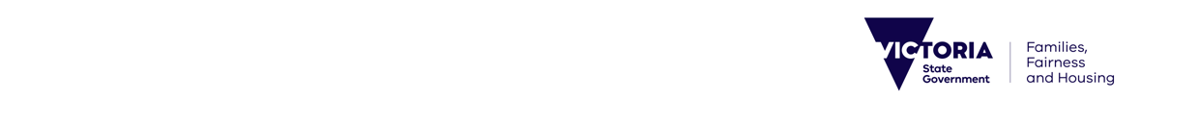Media release

Friday, 26 November, 2021

Public Housing Champions Recognised for Achievements

Victoria’s public housing staff have been recognised for their hard work and dedication to making a difference to the lives of others.

Department of Families, Fairness and Housing deputy secretary Chris Asquini has thanked the winners of the Public Housing Workforce Awards for their efforts in going above and beyond during the COVID-19 pandemic.

The annual awards aim to recognise and honour the work of the public housing workforce, who help Victorians access secure housing, sustain tenancies and live safe and happy lives.

The Western Melbourne Area Housing Teams were awarded the inaugural Outstanding Achievement and Performance – COVID response award, for rising to the challenge during the North Melbourne and Flemington estate lockdowns in July 2020.

The teams in Footscray, Ascot Vale, Carlton and North Melbourne worked with internal colleagues, health services and support agencies to deliver on-site support to residents, including food delivery, information services, the coordination of special requests, and referrals for renters.

Vanessa Sierra from the Dandenong Housing Office took out the Outstanding Performance and Leadership award, after taking on a number of leadership roles in her 26-year career at the Department of Families, Fairness and Housing, including managing the Property and Assets Team at Dandenong.

Edinha Tchong from the Footscray Housing Office won the award for Outstanding Commitment to Achieve a Positive Client Outcome for her work during the North Melbourne public housing tower lockdown, to achieve positive outcomes for residents.

And the Inner Eastern Melbourne Team won the Outstanding Collaboration award after responding to an increase in criminal and antisocial behaviour at the Alamein Avenue public housing estate in Ashburton, resulting in a significant drop in incidents.

The awards have been running since 2019 and provide an opportunity for the Public Housing workforce to be  acknowledged for their valuable work and commitment to providing housing services to Victorians.

**Quotes attributable to Department of Families, Fairness and Housing deputy secretary**   
**Chris Asquini**

‘During these challenging times, our passionate staff have worked even harder to support people in public housing and ensure their needs are met during the COVID-19 pandemic.’

‘The staff recognised today – and all our public housing staff – play an integral part in ensuring all Victorians have a safe and secure place to call home.’

‘I am incredibly proud of our Community Services Operations team members, who go above and beyond every year to assist Victorians in living their best life and achieving their dreams.’

**Media contact:** Emma Woollard | emma.woollard@dffh.vic.gov.au