Rental Report – September quarter 2009

Contents

Trends in rents 2

Rental supply trends 2

Rental affordability 3

Rental indices 3

Current rents 3

Trends by region 4

Major property types 5

Trends by suburb or town 6

Rental availability 9

New lettings 9

Active bonds 9

Turnover and length of tenancy 12

Investor finance 12
Vacancy rate 13

Rental market affordability 15

Overall trends 15

Trends by region 16

Local Government area trends 16

Methods used 17

Notes 31

1. Major data source 31

2. Rent indices methodology 31

3. Median rents 31
4. Rental report geography 32
5. Vacancy rate 32
6. Cells with no data 32
7. Spreadsheets 32
8. Tenancy duration and turnover 32

Published by the Department of Human
Services,Victorian Government, Australia.
© Copyright State of Victoria 2009
This publication is copyright, no part
may be reproduced by any process except
in accordance with the provisions of the
Copyright Act 1968.
This document may also be downloaded from:
http://www.housing.vic.gov.au
Authorised by the State Government of Victoria,
50 Lonsdale Street, Melbourne.
For further information about the
Rental Report contact Peter Leigh.
Email: peter.leigh@dhs.vic.gov.au
The Rental Report provides key statistics on the private rental market in Victoria. The major source for the statistics presented in the Rental Report is the Residential Tenancies Bond Authority which collects data on all rental bonds lodged under the Residential Tenancies Act in Victoria.
Rent indices at a glance:
 | Median Rent p.w | Quarterly Change | Annual Change
Melbourne | $320 | 0.4% | 3.9%
Regional Victoria | $220 | 0.7% | 4.6%
Victoria | $300 | 0.5% | 4.0%

Trends in rents
The latest Rental Report shows that the situation for renters in Melbourne continued to improve during the September quarter of 2009. The annual rate of increase in metropolitan rents for new lettings fell for the fifth consecutive quarter to be below the average for the past decade.
The annual percentage change in the Metropolitan Rent Index (MRI) for the September quarter (3.9 per cent) is the lowest recorded since early 2006. This rate of increase in the MRI represents a significant fall from the levels recorded only a year earlier (12.5 per cent) and is now well below the average for the 2000 to 2009 period (5.9 per cent).
The Regional Rent Index (RRI) has also shown a fall in its annual rate of increase in the September quarter. The annual rate of increase of the RRI for the September quarter (4.6 per cent) is lower than the rate of increase recorded a year ago (5.6 per cent) and also the longer term (2000-2009) average (5.3 per cent).

Rental supply trends
Across the state the total number of new lettings was 39,904 which represents an increase of 4.3 per cent compared to the same quarter of 2008. In metropolitan Melbourne there was an overall increase of 6.7 per cent in new lettings on the same quarter of last year, whereas in regional Victoria new lettings declined by 2.3 per cent.
The number of active (ie current) bonds provides an indicator of the total stock of rental accommodation based on the total number of bonds held by the RTBA at a given point in time. At September quarter 2009 the total number of active bonds held was 360,589 which represents an increase of 4.4 per cent over the same quarter of 2008.
For the September quarter 2009 the quarterly turnover rate for metropolitan Melbourne was 9.1 per cent (ie 9.1 per cent of all bonds were refunded in the quarter), which was identical to the rate of a year earlier (9.1 per cent). The turnover rate in regional Victoria is consistently higher than the Metropolitan area. In September quarter 2009 the regional turnover rate was 11.2 per cent. The trend decline in the turnover rate which had been evident since 2002 appears to have stabilised during 2009.
In the September quarter 2009 lending to investors in Victoria was $4.72 billion. This was 11.0 per cent higher than lending levels in the same quarter of 2008. The September quarter investor finance figures were the second consecutive quarterly rise in lending to residential property investors. This is a positive for the supply of rental accommodation in Victoria.
The trend metropolitan vacancy rate for the September quarter 2009 was 1.3 per cent, which was unchanged from the previous quarter and a slight increase on the level recorded in the September quarter of 2008 (1.2 per cent).

Rental Affordability
From 2006 to the first quarter of 2009 a sharp and significant decline in the availability of affordable private rental accommodation occurred in metropolitan Melbourne. This reflects the increases in the cost of renting which occurred over this period. Overall affordability levels in Melbourne have stabilised for the past two quarters in line with the levelling off in the rate of increase in rents.
At September quarter 2009 21.7 per cent of all new lettings across the state were affordable to lower income households. Across Melbourne 9.2 per cent of dwellings let in the September quarter were affordable. This figure represents a reduction in the proportion of dwellings which were affordable during the same quarter a year ago (11.1 per cent) and is in stark contrast to the availability levels of four years earlier (26.4 per cent).

Rental Indices
The Rent Indices have been developed because of strong seasonality in the rental data, especially in metropolitan areas. The share of new rental lettings accounted for by different suburbs and/or property types can show significant variation over the course of a typical year. A simple median price measure will tend to reflect those compositional shifts and be pushed higher or lower as a result. The Rent Indices control for changes from quarter to quarter in the share of new lettings between both geographic areas and property types. They are therefore a better measure for showing rental cost changes over time.

Current rents

Metropolitan
The latest Rental Report data shows that the situation for renters in Melbourne continued to improve during the September quarter of 2009. The annual rate of increase in metropolitan rents for new lettings fell for the fifth consecutive quarter to be below the average for the past decade.
The annual percentage change in the Metropolitan Rent Index (MRI) for the September quarter (3.9 per cent) is the lowest recorded since early 2006. This rate of increase in the MRI represents a significant fall from the levels recorded only a year earlier (12.5 per cent) and is now well below the average for the 2000 to 2009 period (5.9 per cent).
The September quarterly increase in the MRI was 0.4 per cent which is the lowest September quarterly increase recorded over the past five years.
Figure 1 shows trends in the MRI over the past five years. The metropolitan median rent was $320 for the September quarter 2009.

Regional Victoria
The Regional Rent Index (RRI) has also shown a fall in its annual rate of increase in the September quarter.
The annual rate of increase of the RRI for the September quarter (4.6 per cent) is lower than the rate of increase recorded a year ago (5.6 per cent) and also the longer term (2000-2009) average (5.3 per cent).
The September quarterly increase in the RRI was 0.7 per cent which is the lowest September quarterly increase recorded over the past five years.
Figure 1 shows trends in the RRI over the past five years.

Trends by region
Table 2 shows the median rents for new lettings in the September quarter by the 14 statistical regions used in this report.
Median rents in the Metropolitan region range from $270 per week for the Mornington Peninsula region to $390 for the Inner Melbourne region. In regional Victoria the highest median rent was recorded in the Barwon South West region ($245 per week).
Figure 1: Metropolitan Rent Index and Regional Rent Index — annual percent change
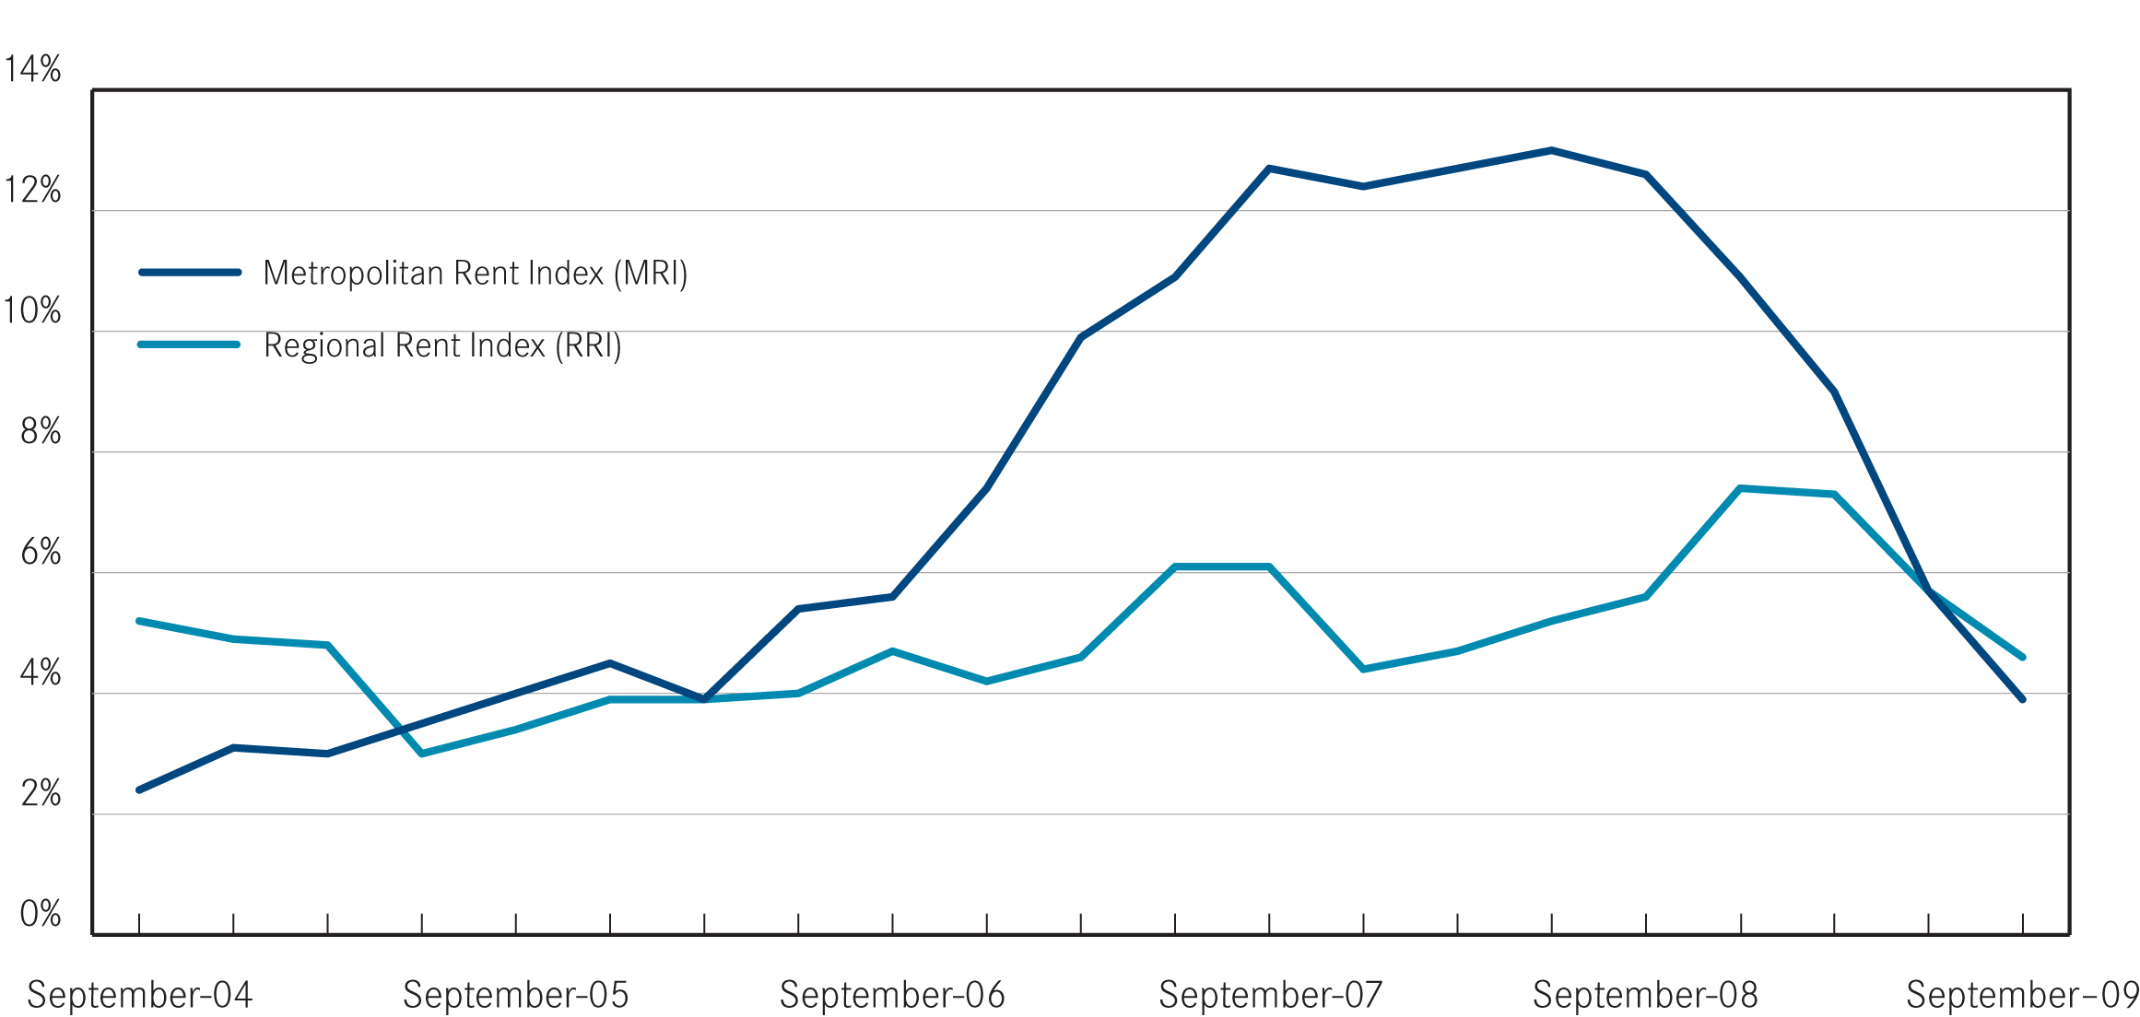

Table 1: Median rents and rent indices, September quarter 2009
 | Median  Rent p.w. | Rent Index | Quarterly Change* | Annual Change*
Melbourne | $320 | 178.7 | 0.4% | 3.9%
Regional Victoria | $220 | 167.5 | 0.7% | 4.6%
Victoria | $300 | 176.8 | 0.5% | 4.0%
*percentage change figures are calculated from relevant Rent index

Table 2: Median rents by statistical region (June quarter 2009)
Region | Median Rent p.w. | Quarterly Change | Annual Change
Inner Melbourne | $390 | 0.0% | 4.0%
Inner Eastern Melbourne | $350 | 0.0% | 0.0%
Southern Melbourne | $350 | 0.0% | 0.0%
Western Melbourne | $280 | 1.8% | 3.6%
North Western Melbourne | $310 | 0.0% | 3.3%
North Eastern Melbourne | $310 | 0.0% | 3.3%
Outer Eastern Melbourne | $300 | 0.0% | 3.4%
South Eastern Melbourne | $280 | 0.0% | 3.7%
Mornington Peninsula | $270 | 0.0% | 3.8%
Barwon-South West | $245 | 2.0% | 6.4%
Gippsland | $200 | 0.0% | 5.3%
Goulburn-Ovens-Murray | $200 | 5.0% | 5.0%
Loddon-Mallee | $210 | 0.0% | 5.0%
Central Highlands-Wimmera | $210 | 0.0% | 5.0%
The median rents for the Inner Eastern and Southern metropolitan regions showed no increase over the year to September quarter. The highest annual increase was recorded in the Inner Melbourne region (4.0 per cent). For regional Victoria the highest annual increase in rents was recorded in the Barwon South West region (6.4 per cent).

Major property types
Table 3 provides the median rents for the six major property types for metropolitan and regional Victoria.
It should be noted that these metropolitan wide medians will reflect the geographic distribution of different property types. Houses tend to be the dominant rental property form in outer metropolitan areas whereas flats are more prevalent in areas closer to the centre of Melbourne. As a result the metropolitan median for two bedroom flats ($320 per week) is higher than that for three bedroom houses ($300 per week).
For metropolitan Melbourne rents for new lettings increased by between
6.6 per cent (one bedroom flats) and 1.2 per cent (four bedroom houses) in the year to September quarter across the major property types. In regional Victoria the largest annual increase was for one bedroom flats (6.0 per cent) while four bedroom houses increased by 3.6 per cent.

Table 3: Major property types median rents, September quarter 2009
 | Median  Rent p.w | Quarterly Change* | Annual Change*
Melbourne
1 Bed Flat | $270 | -0.6% | 6.6%
2 Bed Flat | $320 | -0.3% | 4.7%
3 Bed Flat | $340 | -0.3% | 3.4%
2 Bed House | $330 | 0.2% | 2.5%
3 Bed House | $300 | 2.2% | 3.8%
4 Bed House | $360 | 0.8% | 1.2%
Regional Victoria
1 Bed Flat | $180 | 1.3% | 5.6%
2 Bed Flat | $240 | 1.5% | 3.7%
3 Bed Flat | $190 | 1.0% | 4.0%
2 Bed House | $230 | 0.6% | 4.6%
3 Bed House | $293 | 0.4% | 3.6%
4 Bed House | $270 | -0.6% | 6.6%
* percentage change figures are calculated from relevant Rent Index.

Trends by suburb or town
Figures 2 and 3 show the pattern of concentration of higher costs for private rental accommodation in the Inner Metropolitan, the inner parts of the North Western and North Eastern regions, Inner Eastern and Southern Metropolitan regions.
Table 9 shows the pattern of rental costs at a suburb and town level across Victoria. Please note that the medians in Table 9 are moving annual medians, not quarterly medians and that the annual percentage change figures are calculated from these moving annual medians.
For two bedroom flats in the metropolitan area the suburbs with the highest annual increases in moving median rents to September quarter were West Footscray (28.9 per cent), Hastings-Flinders (21.1 per cent), Sunshine (19.4 per cent), Dandenong North-Endeavour Hills (18.8 per cent), Seaford-Carrum Downs (17.5 per cent), Broadmeadows-Roxburgh Park (16.9 per cent) and Burwood-Ashburton (16.7 per cent).
For regional Victoria the towns with the highest annual increases in moving median rents for two bedroom flats to September quarter were Geelong-Newcombe (15.0 per cent), Horsham (10.3 per cent), Hamilton (9.7 per cent), Belmont - Grovedale (9.5 per cent), Newtown (9.5 per cent), Ocean Grove-Barwon Heads (9.5 per cent) and Sale-Maffra (9.4 per cent).
The highest annual increases in moving median rents for three bedroom houses were Keilor (24.1 per cent), Collingwood – Abbotsford (22.0 per cent), South Yarra (18.3 per cent) Sunshine (16.7 per cent), Prahran-Windsor (15.0 per cent), Northcote (14.3 per cent) and St Albans-Deer Park (13.9 per cent).
For regional Victoria the towns with the highest annual increases in moving median rents for three bedroom houses to September quarter were Sale – Maffra (12.5 per cent), Moe-Newborough (11.8 per cent), Mount Clear – Buninyong (11.1 per cent), Torquay (10.0 per cent), Portland (10.0 per cent), and Belmont-Grovedale (9.6 per cent).
Figure 2: Moving annual median rents for 2 bedroom flats in metropolitan Melbourne (September quarter 2009) 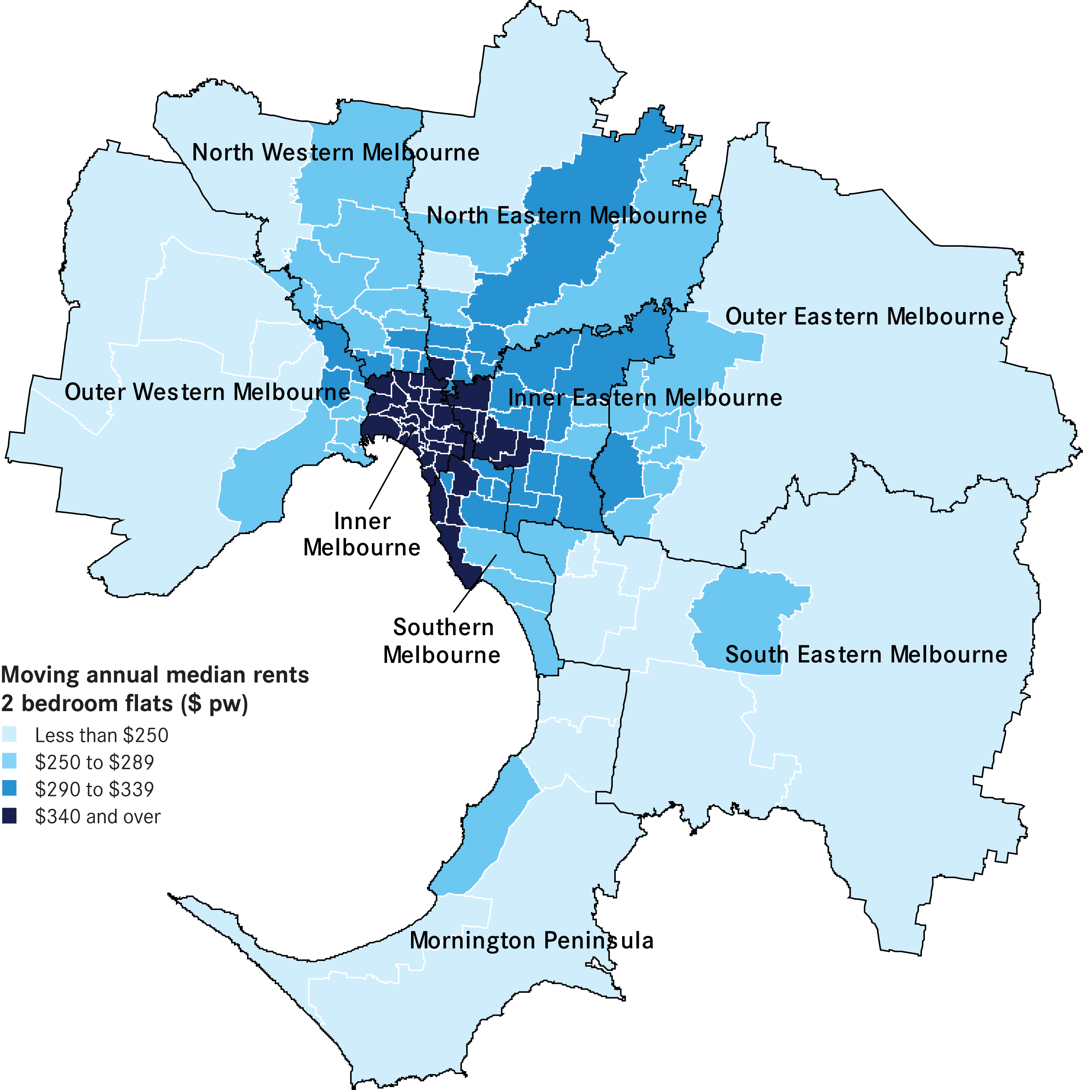
Figure 3: Moving annual median rents for 3 bedroom houses in metropolitan Melbourne (September quarter 2009)
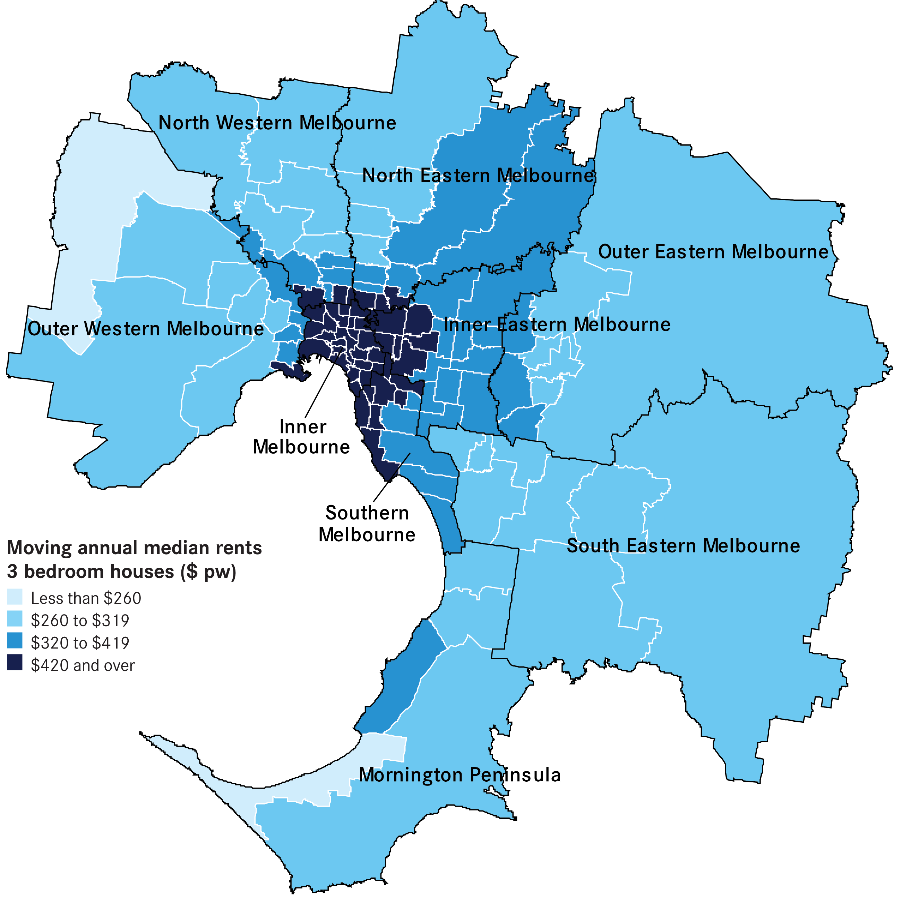

Rental availability

New Lettings
The number of new lettings provides an indicator of the overall availability of rental accommodation for a specific period. A new letting can result from two main sources: turnover in existing rental accommodation or new additions to the stock of rental accommodation.
Table 4 shows the total number of new rental lettings for the September quarter 2009. Metropolitan Melbourne accounted for 77 per cent of all new lettings in Victoria. Across the state the total number of new lettings was 39,904 which represents an increase of 4.3 per cent compared to the same quarter of 2008. In metropolitan Melbourne there was an overall increase
of 6.7 per cent in new lettings on the
same quarter of last year, whereas in regional Victoria new lettings declined by 2.3 per cent.
Table 5 lists the total number of new lettings across each of the 14 statistical regions. In the metropolitan area the only fall in new lettings over the year to September quarter was recorded in the Outer Eastern region (-1.0 per cent), while the South Eastern region experienced a significant increase (12.6 per cent).

Active Bonds
The number of active (ie current) bonds provides an indicator of the total stock of rental accommodation based on the total number of bonds held by the RTBA at a given point in time.
At September quarter 2009 the total number of active bonds held was 360,589 which represents an increase of 4.4 per cent over the same quarter of 2008.
Figure 4 shows trends in active bonds over the past five years. Over the past two quarters the rate of increase in active bond numbers has eased, but remains just above the average for the past nine years
(3.9 per cent).
Figure 5 represents a map of the number of active bonds by suburb for Metropolitan Melbourne. Suburbs with the highest supply of rental accommodation as indicated by active tenancies are the CBD and St Kilda Road precinct, Frankston, Werribee and Hoppers Crossing, St Kilda and South Yarra. This map highlights the availability of rental accommodation in some outer/fringe metropolitan suburbs
as well as the more traditional inner urban areas.
Table 4: Overall new lettings for Melbourne, non-metropolitan Victoria and Victoria (September quarter 2009)
 | Sep-09 | Sep-08 | Change
Melbourne | 30,791 | 28,869 | 6.7%
Regional Victoria | 9,111 | 9,325 | -2.3%
Victoria | 39,904 | 38,242 | 4.3%

Table 5: New lettings for statistical regions Victoria (September
quarter 2009)
 | Sep-09 | Sep-08 | Change
Inner Melbourne | 8,081 | 7,489 | 7.9%
Inner Eastern Melbourne | 3,945 | 3,716 | 6.2%
Southern Melbourne | 2,965 | 2,875 | 3.1%
Western Melbourne | 4,202 | 3,843 | 9.3%
North Western Melbourne | 2,614 | 2,490 | 5.0%
North Eastern Melbourne | 2,692 | 2,535 | 6.2%
Outer Eastern Melbourne | 1,640 | 1,657 | -1.0%
South Eastern Melbourne | 2,595 | 2,305 | 12.6%
Mornington Peninsula | 2,057 | 1,959 | 5.0%
Barwon-South West | 2,559 | 2,495 | 2.6%
Gippsland | 1,667 | 1,697 | -1.8%
Goulbourn-Ovens-Murray | 1,933 | 1,994 | -3.1%
Loddon-Mallee | 1,674 | 1,790 | -6.5%
Central Highlands-Wimmera | 1,278 | 1,349 | -5.3%

Figure 4: Total Active Residential Rental Bonds, Victoria – annual percent change
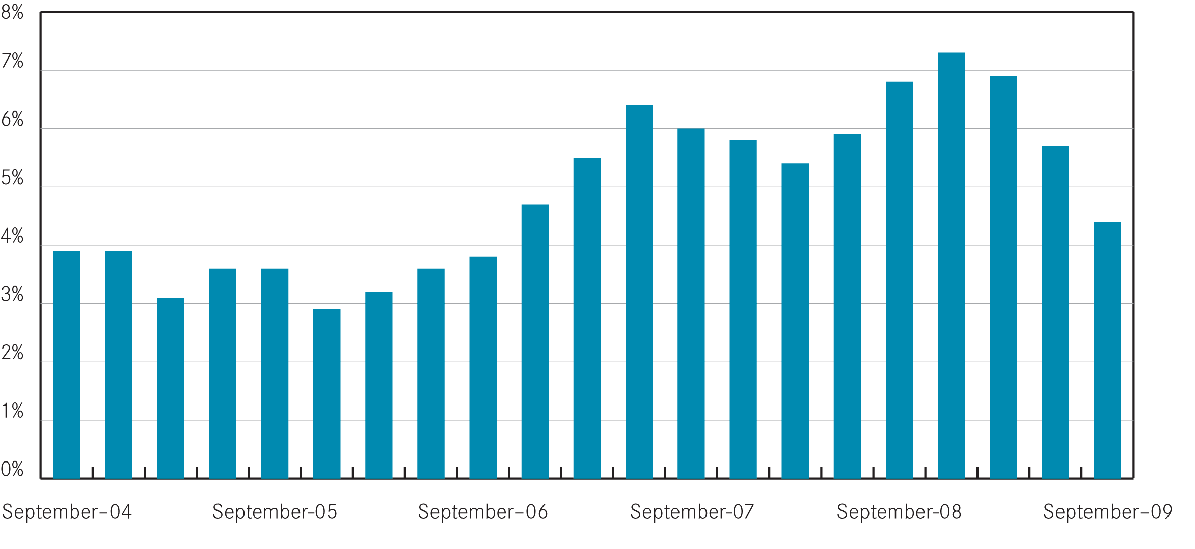
Figure 5: Number of active bonds by suburb for metropolitan Melbourne (September quarter 2009)
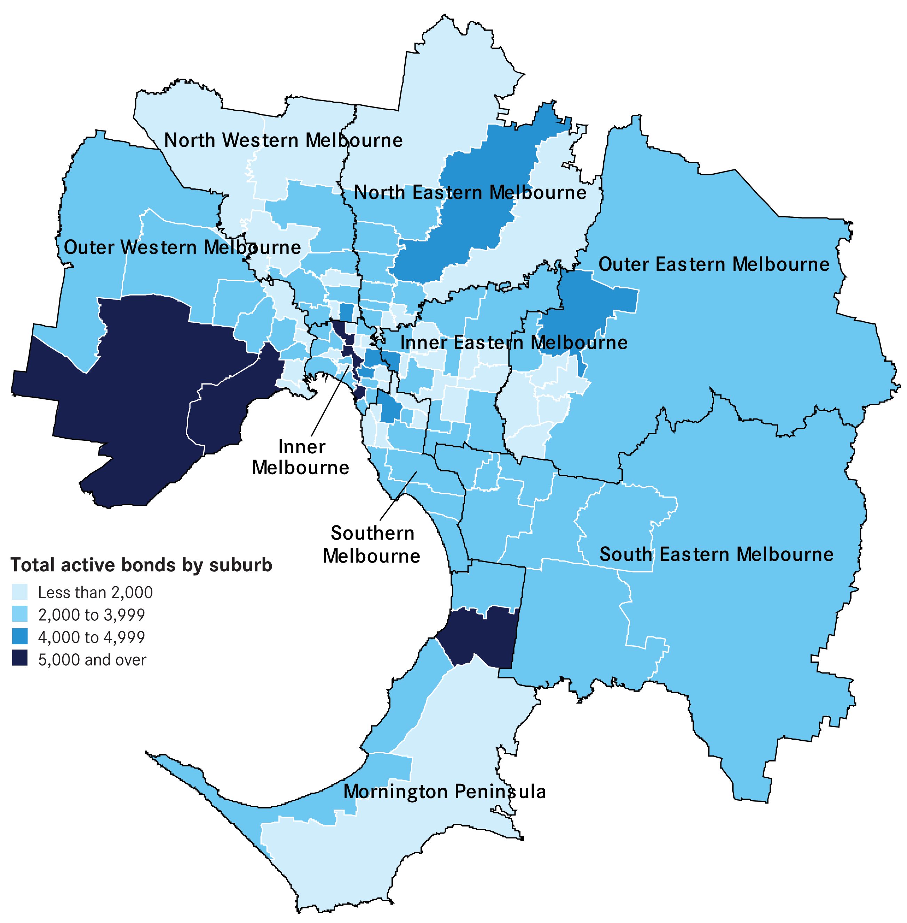

Turnover and length of tenancy
The number of bond refunds in a quarter,
if expressed as a percentage of all bonds held, can be used to provide an estimate of the ‘turnover rate’ in the rental market. The ‘turnover rate’ is an important indicator of the level of natural vacancies which are occurring in the market due to tenancies ending.
Table 6 shows statistics on turnover rate and length of tenancies (for bond refunds during the quarter) for both metropolitan Melbourne and regional Victoria. For the September quarter 2009 the quarterly turnover rate for metropolitan Melbourne was 9.1 per cent (ie 9.1 per cent of all active bonds were refunded in the quarter), which was identical to the rate of a year earlier (9.1 per cent).
The turnover rate in regional Victoria is consistently higher than the Metropolitan area. In September quarter 2009 the regional turnover rate was 11.2 per cent.
The trend decline in the turnover rate which had been evident since 2002 appears to have stabilised during 2009.
The average length of tenancy for bonds which were refunded in the September quarter 2009 was 25.0 months for Metropolitan Melbourne and 20.7 months for regional Victoria. Consistent with the longer term decline in the turnover rate, there has also been a trend increase in the average length of rental tenancies, especially in the Metropolitan area.

Table 6: Tenancy duration and turnover (September quarter 2009)
 | June-09 | June-08
Melbourne
Ave tenancy duration (months) | 25.0 | 24.8
Turnover rate | 9.1% | 9.1%
Regional Victoria
Ave tenancy duration (months) | 20.7 | 19.9
Turnover rate | 11.2% | 11.1%

Investor finance
Loan approvals for the purchase or construction of dwellings for purposes of investment (not owner-occupation) provide a measure of investor activity levels in the Victorian housing market. Figure 6 presents a summary of loan approvals for housing investment in Victoria over the past five years.
In the September quarter 2009 lending to investors in Victoria was $4.72 billion. This was 11.0 per cent higher than lending levels in the same quarter of 2008.
The September quarter investor finance figures were the second consecutive quarterly rise in lending to residential property investors. This is a positive for the supply of rental accommodation in Victoria.

Figure 6: Lending to investors in residential housing, Victoria

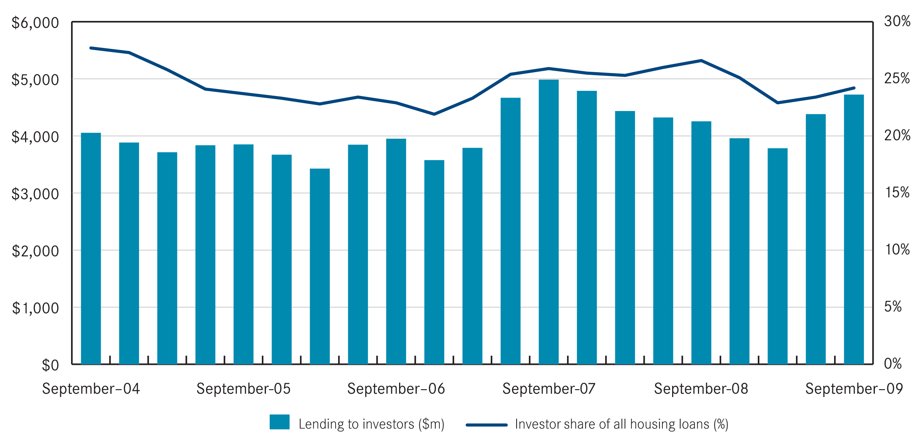
Source: Australian Bureau of Statistics Lending Finance (5671.0) & Housing Finance (5609.0)

Vacancy Rate
The rental vacancy rate is calculated by the Real Estate Institute of Australia, based on a survey of Real Estate Agents and measures the proportion of all rental properties managed by agents which are unlet at a given point in time.
The trend metropolitan vacancy rate for the September quarter 2009 was 1.3 per cent, which was no change from the previous quarter and a slight increase on the level recorded in the September quarter of 2008 (1.2 per cent).
Figure 7 shows the trend metropolitan vacancy rate over the past five years. The vacancy rate reached its lowest point in early 2008. The current vacancy rate is very low in historical terms and is indicative of an ongoing tight supply situation. The average vacancy rate for the period from 2000 to 2005 was 3.6 per cent.

Figure 7: Melbourne Rental Vacancy Rate – trend
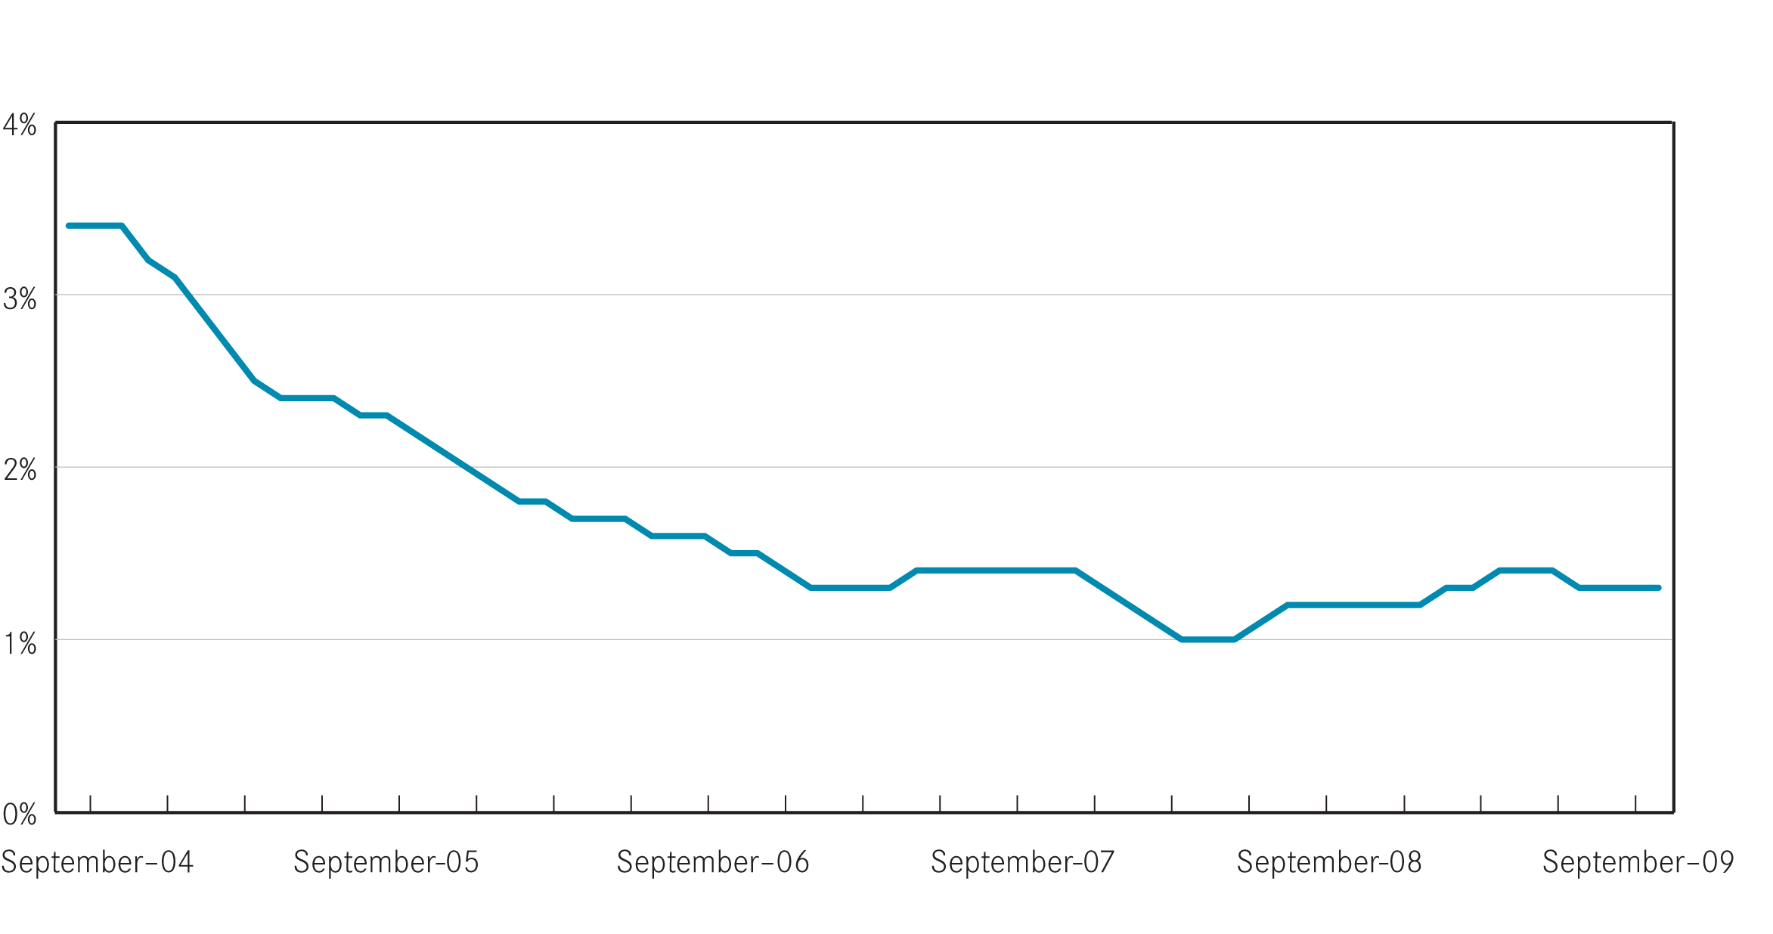

Source: Real Estate Institute of Australia, Market Facts.

Rental market affordability
This section of the Rental Report provides a summary of the affordability of rental accommodation for lower income households in Victoria. The method used in this section measures the supply of affordable new lettings based on the RTBA data used in this Report. The affordability benchmark used is that no more than 30 per cent of income is spent on rent. Lower income households are defined as those receiving Centrelink incomes.

Figure 8: Affordable rentals as percent of all rentals, Victoria
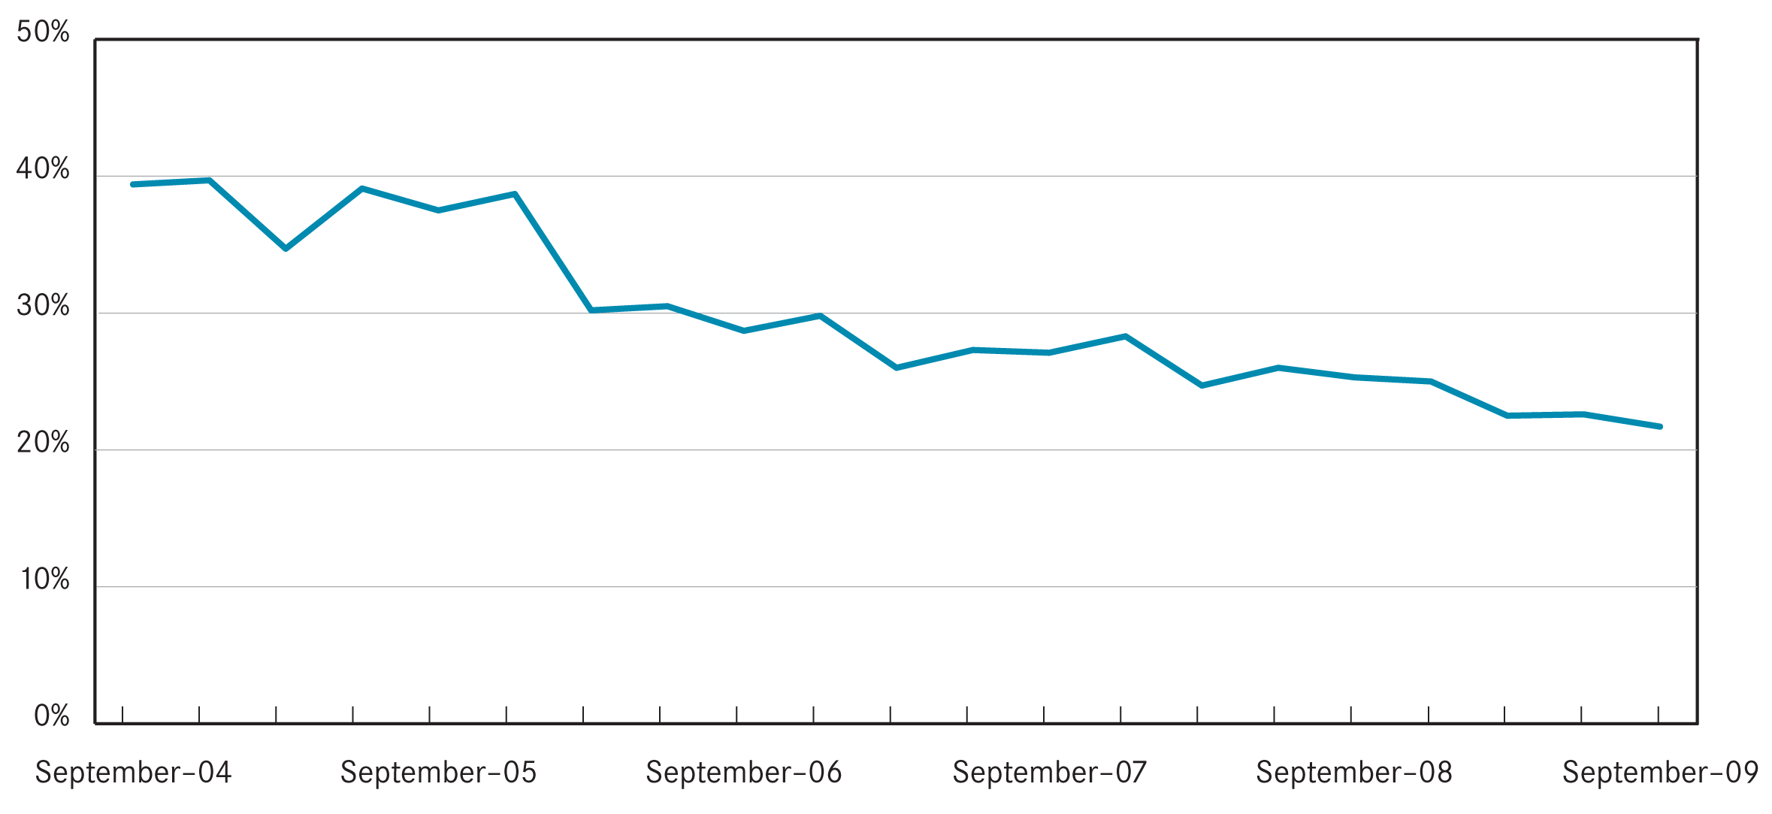

Overall trends
From 2006 to the first quarter of 2009 a sharp and significant decline in the availability of affordable private rental accommodation occurred in metropolitan Melbourne. This reflects the increases in the cost of renting which occurred over this period. Overall affordability levels in Melbourne have stabilised for the past two quarters in line with the levelling off in the rate of increase in rents.
At September quarter 2009 21.7 per cent of all new lettings across the state were affordable to lower income households. Figure 8 shows the trend in these figures over the past five years. Across Melbourne 9.2 per cent of dwellings let in the September quarter were affordable.
This figure represents a reduction in the proportion of dwellings which were affordable during the same quarter a year ago (11.1 per cent) and is in stark contrast to the availability levels of four years earlier (26.4 per cent).
In metropolitan Melbourne the availability of affordable rental lettings varies between different types of households. The rental affordability situation for different low income households is summarised in Table 7.
Due to a limited supply of affordable one bedroom dwellings, low income single person households face the most difficulties in accessing affordable rental accommodation. Across Melbourne just 1.0 per cent of one bedroom dwellings let in the September quarter were affordable to low income singles.
For a single parent with one child on Centrelink income the proportion of 2 bedroom dwellings across Melbourne which were affordable was 3.2 per cent. For larger families the supply affordable three and four bedroom dwellings is better and reflects the predominantly outer suburban location of much of this size of dwelling. A couple with two children dependant on Newstart would be able to afford 15.7 per cent of 3 bed new lettings in Melbourne in the September quarter.
Table 7: Rental affordability by indicative households on Centrelink incomes (September quarter 2009)
Household type | Singles on Newstart | Singles Parent 1 child | Couple on Newstart with 2 children | Couple on Newstart with 4 children | Total
Assumed property size | 1 bedroom | 2 bedroom | 3 bedroom | 4+ bedroom | -
Weekly income (net of RA) | $227 | $430 | $633 | $800 | -
Affordable weekly rent | $125 | $195 | $260 | $315 | -
Affordable rentals (number)
Metropolitan | 54 | 320 | 1,598 | 665 | 2,637
Regional | 304 | 1,537 | 2,996 | 590 | 5,427
State total | 358 | 1,857 | 4,594 | 1,255 | 8,064
Affordable rentals (% of total)
Metropolitan | 1.0% | 3.2% | 15.7% | 22.7% | 9.2%
Regional | 37.4% | 58.7% | 71.6% | 59.7% | 63.1%
State total | 5.6% | 14.9% | 32.0% | 32.0% | 21.7%

Trends by region
Table 8 shows the availability of affordable lettings for each of the statistical regions of Victoria. The higher cost of housing in Melbourne shows clearly in these affordability figures.
In regional terms the Western, South Eastern and Mornington Peninsula regions of metropolitan Melbourne consistently have the highest proportion of new lettings which are affordable to lower income households. In regional Victoria the Barwon South West region has the lowest availability of affordable rentals.

Local Government Area Trends
Table 11 provides data on the number of new lettings affordable to households on Centrelink incomes for all Victorian Local Government Areas.

Methods used

Fitting statutory income households to dwellings by bedroom number
These calculations show the distribution of private rental properties in Victoria affordable to households on statutory incomes by bedroom number for newly leased properties during the current quarter. It shows the number of properties by region that were affordable for different bedroom numbers, and the proportion of that municipality’s stock of those properties.
For example, if there are 100 x one bedroom properties deemed to be affordable in Port Phillip, and there are 1000 x one bedroom properties leased during that quarter, then the percentage of affordable one bedroom properties in Port Phillip during the quarter will be 10.0 per cent.

Calculating affordability – net rent method
The assessment of affordable supply is based on the number of suitably-sized properties that are within 30 per cent of income for low income households. The rental thresholds are taken from
the household incomes for whom that number of bedrooms is a minimum and may have been rounded up to the nearest $5 increment.
For one bedroom properties, we have taken the income of singles on Newstart allowance; for two bedroom properties, we have taken a single parent pensioner with one child aged under 5; for three bedroom properties we have taken a couple on Newstart with two children; and for four bedroom properties, we have taken a couple on Newstart with four children.
The method used in these calculations assumes rent assistance is fully offset against the weekly rent by subtracting rent assistance from the rent and then calculating the resulting rent as a proportion of the Centrelink income. This is the net-rent method which treats rent assistance as a housing payment, not an income supplement. Other methods are available, such as used by the Australian Institute of Health and Welfare.

Table 8: Affordable lettings for indicative households (see table 7) on Centrelink incomes (September quarter 2009)
 | 1 Bedroom |  | 2 Bedroom |  | 3 Bedroom |  | 4+ Bedroom |  | Total
Region | Number | Percent | Number | Percent | Number | Percent | Number | Percent | Number | Percent
Inner Melbourne | 9 | 0.3% | 10 | 0.3% | 7 | 0.9% | 9 | 7.8% | 35 | 0.5%
Inner Eastern Melbourne | 4 | 0.7% | 7 | 0.6% | 23 | 1.6% | 17 | 3.7% | 51 | 1.4%
Southern Melbourne | - | 0.0% | 16 | 1.3% | 8 | 0.9% | 7 | 2.7% | 31 | 1.1%
Western Melbourne | 11 | 3.1% | 70 | 8.5% | 645 | 32.4% | 356 | 45.8% | 1,082 | 27.5%
North Western Melbourne | - | 0.0% | 21 | 2.2% | 95 | 10.3% | 23 | 12.6% | 139 | 5.7%
North Eastern Melbourne | 4 | 1.1% | 23 | 2.7% | 58 | 5.4% | 27 | 12.4% | 112 | 4.4%
Outer Eastern Melbourne | 3 | 3.8% | 25 | 5.5% | 76 | 9.2% | 13 | 6.5% | 117 | 7.5%
South Eastern Melbourne | 3 | 2.0% | 54 | 9.6% | 317 | 24.5% | 131 | 29.6% | 505 | 20.6%
Mornington Peninsula | 20 | 16.7% | 94 | 18.6% | 369 | 36.1% | 82 | 29.5% | 565 | 29.3%
Metropolitan Melbourne | 54 | 1.0% | 320 | 3.2% | 1,598 | 15.7% | 665 | 22.7% | 2,637 | 9.2%
Barwon-South West | 54 | 18.8% | 234 | 33.2% | 562 | 49.2% | 111 | 42.9% | 961 | 40.1%
Gippsland | 70 | 53.0% | 342 | 70.7% | 653 | 84.5% | 123 | 69.5% | 1,188 | 75.9%
Goulbourn-Ovens-Murray | 77 | 49.4% | 406 | 69.2% | 679 | 76.7% | 136 | 63.3% | 1,298 | 70.4%
Loddon-Mallee | 56 | 44.8% | 306 | 65.2% | 636 | 78.4% | 121 | 62.4% | 1,119 | 70.0%
Central Highlands-Wimmera | 47 | 42.3% | 249 | 66.9% | 466 | 81.5% | 99 | 68.8% | 861 | 71.8%
Regional Victoria | 304 | 37.4% | 1,537 | 58.7% | 2,996 | 71.6% | 590 | 59.7% | 5,427 | 63.1%
Victoria | 358 | 5.6% | 1,857 | 14.9% | 4,594 | 32.0% | 1,255 | 32.0% | 8,064 | 21.7%

Table 9: Moving annual median rents for suburbs/towns by major property type
September Quarter 2009 | 1 Bed Flat |  |  | 2 Bed Flat |  |  | 2 Bed House |  |  | 3 Bed House
September Quarter 2009 | Count | Median | Ann % Ch | Count | Median | Ann % Ch | Count | Median | Ann % Ch | Count | Median | Ann % Ch

Inner Melbourne
Albert Park-Middle Park-West St Kilda | 256 | $295 | 5.4% | 180 | $400 | 5.3% | 84 | $493 | 14.5% | 71 | $658 | 1.2%
Armadale | 155 | $270 | 12.5% | 239 | $350 | 2.9% | 26 | $430 | -6.5% | 28 | $613 | -7.5%
Carlton North | 54 | $263 | 8.2% | 95 | $365 | 4.3% | 75 | $420 | 0.0% | 36 | $545 | 10.1%
Carlton-Parkville | 1882 | $300 | 15.4% | 617 | $425 | 9.7% | 36 | $380 | 0.0% | 33 | $600 | 3.2%
CBD-St Kilda Rd | 2441 | $355 | 4.4% | 1727 | $498 | 8.3% | 12 | $450 | nd | - | - | -
Collingwood-Abbotsford | 162 | $280 | 5.7% | 135 | $430 | 6.2% | 86 | $415 | 6.4% | 54 | $500 | 22.0%
Docklands | 352 | $415 | 9.2% | 425 | $550 | 5.8% | - | - | - | - | - | -
East Melbourne | 234 | $320 | 6.7% | 176 | $450 | 5.3% | - | - | - | 11 | $750 | nd
East St Kilda | 513 | $250 | 8.7% | 594 | $340 | 6.3% | 43 | $470 | 17.5% | 57 | $580 | 7.4%
Elwood | 494 | $280 | 9.8% | 795 | $365 | 4.3% | 29 | $480 | 6.7% | 53 | $650 | 4.8%
Fitzroy | 148 | $263 | -2.8% | 110 | $450 | 7.1% | 40 | $470 | 9.3% | 24 | $543 | -1.4%
Fitzroy North-Clifton Hill | 138 | $250 | 8.7% | 189 | $365 | 10.6% | 108 | $430 | 7.5% | 68 | $488 | 1.6%
Flemington-Kensington | 245 | $275 | 10.0% | 287 | $350 | 6.1% | 156 | $375 | 7.1% | 74 | $450 | 4.7%
North Melbourne-West Melbourne | 313 | $265 | 17.8% | 367 | $410 | 15.5% | 51 | $420 | 0.0% | 31 | $500 | -1.0%
Port Melbourne | 261 | $390 | 5.4% | 355 | $500 | 8.7% | 101 | $450 | 2.3% | 116 | $620 | 3.3%

Inner Eastern Melbourne
Balwyn | - | - | - | 152 | $330 | 10.0% | 48 | $353 | 5.2% | 235 | $430 | 2.4%
Blackburn | 35 | $230 | 15.0% | 121 | $300 | 9.1% | 39 | $310 | 3.3% | 205 | $350 | 2.9%
Box Hill | 278 | $225 | 2.3% | 410 | $300 | 5.3% | 69 | $320 | 6.7% | 229 | $370 | 5.7%
Bulleen-Templestowe-Doncaster | 42 | $230 | 5.7% | 149 | $300 | 1.7% | 28 | $310 | 8.8% | 320 | $360 | 2.9%
Burwood-Ashburton | 208 | $220 | 22.2% | 106 | $350 | 16.7% | 55 | $325 | 2.4% | 246 | $390 | 8.3%
Camberwell-Glen Iris | 174 | $250 | 17.6% | 476 | $340 | 6.3% | 59 | $381 | 5.8% | 220 | $490 | 2.1%
Canterbury-Surrey Hills-Mont Albert | 19 | $250 | -2.9% | 248 | $330 | 10.0% | 22 | $363 | 1.4% | 93 | $480 | -2.0%
Chadstone-Oakleigh | 16 | $300 | 15.4% | 198 | $319 | 11.9% | 64 | $320 | 10.3% | 191 | $360 | 4.3%
Clayton | 104 | $250 | 0.0% | 434 | $300 | 11.1% | 40 | $300 | 11.1% | 193 | $345 | 7.8%
Doncaster East-Donvale | 14 | $280 | 40.0% | 116 | $310 | 6.9% | 17 | $300 | 7.1% | 215 | $350 | 2.9%
East Hawthorn | 117 | $260 | 8.3% | 218 | $350 | 7.7% | 39 | $430 | 7.5% | 55 | $540 | 4.9%
Glen Waverley-Mulgrave | 18 | $230 | nd | 133 | $305 | 8.9% | 23 | $320 | 3.2% | 542 | $350 | 7.7%
Hawthorn | 769 | $250 | 13.6% | 643 | $360 | 9.1% | 56 | $445 | 3.5% | 76 | $578 | 9.0%
Kew | 71 | $300 | 20.0% | 414 | $345 | 7.8% | 46 | $420 | 11.3% | 158 | $470 | 4.4%
Mount Waverley | 12 | $235 | nd | 112 | $300 | 7.1% | 28 | $310 | 3.3% | 236 | $360 | 5.9%
Nunawading-Mitcham | 17 | $200 | 17.6% | 191 | $270 | 5.9% | 45 | $300 | 7.1% | 203 | $340 | 4.6%
Vermont-Forest Hill-Burwood East | - | - | - | 99 | $270 | 8.0% | 27 | $300 | 7.1% | 282 | $350 | 6.1%
Inner Eastern Melbourne | 1909 | $240 | 9.1% | 4220 | $325 | 8.3% | 705 | $335 | 4.7% | 3699 | $370 | 5.7%

September Quarter 2009 | 1 Bed Flat |  |  | 2 Bed Flat |  |  | 2 Bed House |  |  | 3 Bed House
September Quarter 2009 | Count | Count | Count | Count | Median | Ann % Ch | Count | Median | Ann % Ch | Count | Median | Ann % Ch

Southern Melbourne
Aspendale-Chelsea-Carrum | 61 | $210 | 23.5% | 417 | $265 | 6.0% | 80 | $280 | 3.7% | 262 | $338 | 5.5%
Bentleigh | 162 | $230 | 9.5% | 403 | $330 | 11.9% | 113 | $350 | 9.4% | 341 | $400 | 5.3%
Brighton | 29 | $310 | 3.3% | 198 | $400 | 9.6% | 31 | $465 | 8.1% | 116 | $663 | 6.9%
Brighton East | - | - | - | 50 | $370 | 12.1% | 36 | $390 | -2.5% | 93 | $525 | 1.9%
Carnegie | 320 | $230 | 9.5% | 279 | $320 | 10.3% | 20 | $350 | 0.0% | 52 | $435 | 3.6%
Caulfield | 317 | $230 | 7.0% | 552 | $340 | 3.0% | 60 | $400 | 8.1% | 152 | $493 | 9.4%
Cheltenham | 51 | $260 | 26.8% | 358 | $285 | 5.6% | 66 | $350 | 9.4% | 305 | $390 | 6.8%
Elsternwick | 153 | $230 | 4.5% | 211 | $330 | 3.1% | 12 | $400 | nd | 32 | $510 | 2.0%
Hampton-Beaumaris | 36 | $285 | 3.6% | 249 | $350 | 6.1% | 42 | $388 | 4.7% | 223 | $500 | 2.0%
Malvern | 112 | $270 | 12.5% | 150 | $363 | 8.2% | 17 | $415 | -3.5% | 36 | $600 | -7.7%
Malvern East | 204 | $230 | 7.0% | 214 | $330 | 6.5% | 33 | $390 | 11.4% | 96 | $463 | 0.5%
Mentone-Parkdale-Mordialloc | 235 | $220 | 10.0% | 430 | $285 | 7.5% | 29 | $350 | 14.8% | 160 | $390 | 6.8%
Murrumbeena-Hughesdale | 207 | $230 | 9.5% | 195 | $310 | 3.3% | 36 | $360 | 4.5% | 73 | $395 | 9.7%
Southern Melbourne | 1895 | $230 | 9.5% | 3706 | $320 | 6.7% | 575 | $360 | 5.9% | 1941 | $420 | 5.0%
Mentone-Parkdale-Mordialloc | 235 | $220 | 10.0% | 430 | $285 | 7.5% | 29 | $350 | 14.8% | 160 | $390 | 6.8%
Murrumbeena-Hughesdale | 207 | $230 | 9.5% | 195 | $310 | 3.3% | 36 | $360 | 4.5% | 73 | $395 | 9.7%
Southern Melbourne | 1895 | $230 | 9.5% | 3706 | $320 | 6.7% | 575 | $360 | 5.9% | 1941 | $420 | 5.0%

Outer Western Melbourne
Altona | 73 | $200 | 11.1% | 378 | $250 | 4.2% | 74 | $275 | 10.0% | 930 | $300 | 7.1%
Footscray | 277 | $195 | 0.0% | 213 | $280 | 12.0% | 93 | $320 | 6.7% | 93 | $360 | 12.5%
Keilor East-Avondale Heights | 40 | $200 | 2.6% | 170 | $295 | 9.3% | 45 | $310 | 12.7% | 273 | $320 | 6.7%
Melton | 37 | $294 | 28.7% | 97 | $195 | 8.3% | 36 | $213 | 6.3% | 637 | $230 | 7.0%
Newport-Spotswood | 71 | $195 | 14.7% | 101 | $250 | 13.6% | 82 | $340 | 13.3% | 191 | $370 | 12.1%
St Albans-Deer Park | 36 | $180 | 12.5% | 238 | $220 | 15.8% | 47 | $230 | 15.0% | 738 | $270 | 13.9%
Sunshine | 137 | $170 | 9.7% | 149 | $215 | 19.4% | 76 | $255 | 15.9% | 390 | $280 | 16.7%
Sydenham | - | - | - | 58 | $240 | 6.7% | 38 | $265 | 6.0% | 697 | $300 | 7.1%
Werribee-Hoppers Crossing | 33 | $190 | 28.8% | 335 | $217 | 11.3% | 58 | $220 | 0.0% | 1513 | $260 | 4.0%
West Footscray | 83 | $180 | 12.5% | 202 | $290 | 28.9% | 98 | $280 | 12.0% | 227 | $300 | 9.1%
Williamstown | 38 | $230 | 15.0% | 114 | $280 | 7.7% | 47 | $350 | 2.9% | 108 | $450 | 9.8%
Yarraville-Seddon | 129 | $200 | 5.3% | 201 | $280 | 12.0% | 160 | $340 | 4.6% | 233 | $370 | 5.7%
Outer Western Melbourne | 962 | $195 | 11.4% | 2256 | $245 | 11.4% | 854 | $290 | 7.4% | 6030 | $280 | 7.7%

September Quarter 2009 | 1 Bed Flat |  |  | 2 Bed Flat |  |  | 2 Bed House |  |  | 3 Bed House
September Quarter 2009 | Count | Count | Count | Count | Median | Ann % Ch | Count | Median | Ann % Ch | Count | Median | Ann % Ch

North Western Melbourne
Broadmeadows-Roxburgh Park | 28 | $175 | 9.4% | 73 | $260 | 16.9% | 32 | $260 | 8.3% | 510 | $290 | 11.5%
Brunswick | 381 | $230 | 15.0% | 433 | $310 | 10.7% | 164 | $378 | 7.9% | 117 | $450 | 9.8%
Coburg-Pascoe Vale South | 98 | $248 | 12.5% | 240 | $320 | 14.3% | 122 | $330 | 10.0% | 224 | $373 | 6.4%
Craigieburn | - | - | - | 18 | $250 | 13.6% | 12 | $275 | nd | 352 | $300 | 11.1%
East Brunswick | 72 | $250 | 8.7% | 98 | $330 | 3.1% | 24 | $383 | 6.3% | 41 | $450 | 0.0%
Essendon | 188 | $220 | 10.0% | 369 | $285 | 9.6% | 86 | $310 | 3.3% | 257 | $330 | 10.0%
Gladstone Park-Tullamarine | 22 | $215 | 28.4% | 102 | $250 | 13.6% | - | - | - | 179 | $295 | 13.5%
Keilor | - | - | - | - | - | - | - | - | - | 22 | $335 | 24.1%
Moonee Ponds-Ascot Vale | 151 | $230 | 9.5% | 319 | $310 | 6.9% | 131 | $350 | 0.0% | 172 | $420 | 7.7%
Oak Park-Glenroy-Fawkner | 47 | $195 | 13.0% | 251 | $270 | 12.5% | 100 | $280 | 12.0% | 323 | $310 | 10.7%
Pascoe Vale-Coburg North | 49 | $180 | 11.1% | 184 | $280 | 7.7% | 70 | $300 | 15.4% | 154 | $330 | 10.0%
Sunbury | - | - | - | 89 | $220 | 4.8% | 19 | $240 | 6.7% | 292 | $260 | 4.0%
West Brunswick | 240 | $230 | 15.0% | 212 | $285 | 5.6% | 34 | $340 | 5.4% | 63 | $400 | 11.1%
North Western Melbourne | 1283 | $225 | 12.5% | 2389 | $290 | 11.5% | 804 | $321 | 6.8% | 2706 | $310 | 10.7%

North Eastern Melbourne
Bundoora-Greensborough-Hurstbridge | 221 | $205 | 7.9% | 329 | $290 | 11.5% | 81 | $295 | 13.5% | 630 | $330 | 3.1%
Eltham-Research-Montmorency | 24 | $185 | 8.8% | 110 | $280 | 7.7% | 41 | $285 | 11.8% | 176 | $360 | 2.9%
Fairfield-Alphington | 200 | $240 | 17.1% | 162 | $300 | 3.4% | 25 | $380 | 8.6% | 57 | $450 | 4.7%
Heidelberg-Heidelberg West | 43 | $250 | 17.6% | 284 | $300 | 7.1% | 102 | $295 | 11.3% | 212 | $330 | 5.6%
Ivanhoe-Ivanhoe East | 51 | $250 | 13.6% | 171 | $300 | 7.1% | 24 | $360 | 12.5% | 80 | $425 | 7.6%
Mill Park-Epping | 12 | $250 | nd | 169 | $260 | 10.6% | 37 | $275 | 13.4% | 712 | $310 | 8.8%
Northcote | 194 | $240 | 20.0% | 179 | $340 | 13.3% | 128 | $410 | 7.9% | 145 | $480 | 14.3%
Preston | 167 | $210 | 13.5% | 269 | $320 | 14.3% | 129 | $305 | 2.5% | 210 | $350 | 12.9%
Reservoir | 161 | $230 | 9.5% | 446 | $270 | 8.0% | 144 | $280 | 12.0% | 302 | $300 | 7.1%
Thomastown-Lalor | 19 | $200 | 17.6% | 112 | $230 | 15.0% | 30 | $255 | 13.3% | 360 | $280 | 12.0%
Thornbury | 273 | $230 | 10.8% | 236 | $300 | 11.1% | 62 | $368 | 5.0% | 98 | $413 | 8.4%
Whittlesea | - | - | - | 19 | $230 | 15.0% | - | - | - | 123 | $310 | 3.3%
North Eastern Melbourne | 1368 | $230 | 15.0% | 2486 | $290 | 11.5% | 813 | $300 | 7.1% | 3105 | $320 | 6.7%

September Quarter 2009 | 1 Bed Flat |  |  | 2 Bed Flat |  |  | 2 Bed House |  |  | 3 Bed House
September Quarter 2009 | Count | Count | Count | Count | Median | Ann % Ch | Count | Median | Ann % Ch | Count | Median | Ann % Ch

Outer Eastern Melbourne
Bayswater | - | - | - | 151 | $250 | 8.7% | 21 | $265 | 8.2% | 144 | $300 | 7.1%
Boronia | 12 | $210 | 29.2% | 159 | $260 | 8.3% | 36 | $250 | 0.0% | 163 | $300 | 7.1%
Croydon-Lilydale | 81 | $190 | 15.2% | 443 | $250 | 4.2% | 66 | $260 | 4.0% | 599 | $310 | 8.8%
Ferntree Gully | 13 | $190 | 18.8% | 99 | $260 | 13.0% | 21 | $245 | 2.1% | 157 | $300 | 5.3%
Ringwood | 41 | $200 | 5.3% | 420 | $260 | 4.0% | 85 | $280 | 3.7% | 280 | $320 | 6.7%
Rowville | - | - | - | - | - | - | - | - | - | 210 | $325 | 3.2%
Wantirna-Scoresby | - | - | - | 65 | $300 | 15.4% | - | - | - | 268 | $323 | 7.7%
Yarra Ranges | 53 | $177 | 10.6% | 100 | $220 | 4.8% | 136 | $250 | 11.1% | 507 | $285 | 7.5%
Outer Eastern Melbourne | 219 | $190 | 11.8% | 1442 | $260 | 8.3% | 376 | $260 | 8.3% | 2328 | $310 | 6.9%

South Eastern Melbourne
Berwick | - | - | - | 90 | $250 | 8.7% | 18 | $258 | 7.3% | 417 | $300 | 7.1%
Cranbourne | - | - | - | 122 | $220 | 15.8% | 31 | $220 | 2.3% | 564 | $270 | 8.0%
Dandenong | 70 | $188 | 17.2% | 597 | $220 | 12.8% | 38 | $250 | 13.6% | 287 | $290 | 11.5%
Dandenong North-Endeavour Hills | 12 | $178 | nd | 160 | $238 | 18.8% | 25 | $240 | 20.0% | 502 | $280 | 12.0%
Narre Warren-Hampton Park | - | - | - | 134 | $231 | 8.5% | 14 | $250 | 8.7% | 856 | $280 | 12.0%
Noble Park | 127 | $180 | 20.0% | 340 | $240 | 14.3% | 26 | $235 | -2.1% | 269 | $290 | 9.4%
Pakenham | 14 | $178 | nd | 108 | $215 | 7.5% | 74 | $235 | 6.8% | 765 | $270 | 8.0%
Springvale | 88 | $180 | 16.1% | 293 | $250 | 13.6% | 38 | $250 | 8.7% | 362 | $300 | 11.1%
South Eastern Melbourne | 333 | $180 | 16.1% | 1844 | $230 | 9.5% | 264 | $240 | 6.7% | 4022 | $280 | 7.7%

Mornington Peninsula
Dromana-Portsea | 25 | $165 | 10.0% | 147 | $205 | 9.3% | 227 | $220 | 10.0% | 806 | $250 | 4.2%
Frankston | 128 | $165 | 6.5% | 558 | $220 | 10.0% | 90 | $240 | 14.3% | 888 | $275 | 10.0%
Hastings-Flinders | 12 | $178 | nd | 179 | $230 | 21.1% | 41 | $230 | 9.5% | 340 | $270 | 8.0%
Mt Eliza-Mornington-Mt Martha | 22 | $200 | 17.6% | 230 | $250 | 8.7% | 60 | $280 | 8.7% | 466 | $320 | 6.7%
Seaford-Carrum Downs | 43 | $175 | 20.7% | 242 | $235 | 17.5% | 35 | $250 | 13.6% | 571 | $270 | 8.0%
Mornington Peninsula | 230 | $170 | 9.7% | 1356 | $230 | 15.0% | 453 | $230 | 9.5% | 3071 | $270 | 8.0%

September Quarter 2009 | 1 Bed Flat |  |  | 2 Bed Flat |  |  | 2 Bed House |  |  | 3 Bed House
September Quarter 2009 | Count | Count | Count | Count | Median | Ann % Ch | Count | Median | Ann % Ch | Count | Median | Ann % Ch

Geelong
Belmont-Grovedale | 115 | $150 | 11.1% | 331 | $230 | 9.5% | 72 | $250 | 6.4% | 466 | $285 | 9.6%
Corio | 35 | $145 | 18.4% | 80 | $195 | 8.3% | 80 | $180 | 7.5% | 287 | $200 | 5.3%
Geelong-Newcombe | 130 | $160 | 14.3% | 237 | $230 | 15.0% | 122 | $240 | 9.1% | 270 | $260 | 8.3%
Herne Hill-Geelong West | 170 | $140 | 7.7% | 130 | $200 | 5.3% | 79 | $250 | 13.6% | 187 | $265 | 2.9%
Lara | 18 | $130 | 8.3% | 57 | $210 | 5.0% | 20 | $230 | -2.1% | 143 | $275 | 3.8%
Newtown | 48 | $150 | 11.1% | 108 | $230 | 9.5% | 46 | $248 | 6.5% | 120 | $298 | 5.3%
North Geelong | 59 | $140 | 16.7% | 76 | $215 | 7.5% | 49 | $215 | 7.5% | 212 | $260 | 4.0%
Geelong | 575 | $145 | 11.5% | 1019 | $220 | 10.0% | 468 | $230 | 9.5% | 1685 | $260 | 4.0%

Ballarat
Ballarat | 95 | $130 | 8.3% | 213 | $190 | 7.0% | 205 | $200 | 8.1% | 686 | $230 | 9.5%
Mount Clear-Buninyong | 17 | $125 | 4.2% | 41 | $185 | 5.7% | 20 | $200 | 11.1% | 102 | $250 | 11.1%
Sebastopol-Delacombe | 41 | $135 | 17.4% | 108 | $178 | 4.4% | 39 | $185 | 5.7% | 189 | $220 | 6.5%
Wendouree-Alfredton | 97 | $120 | 4.3% | 133 | $170 | 0.0% | 77 | $195 | 2.6% | 355 | $240 | 9.1%
Ballarat | 250 | $125 | 8.7% | 495 | $180 | 2.9% | 341 | $200 | 8.1% | 1332 | $230 | 4.5%

Bendigo
Bendigo | 59 | $135 | 8.0% | 145 | $180 | 5.9% | 72 | $210 | 5.0% | 225 | $235 | 5.6%
Flora Hill-Bendigo East | 35 | $125 | 0.0% | 287 | $185 | 2.8% | 96 | $210 | 7.7% | 408 | $240 | 4.3%
Golden Square-Kangaroo Flat | 21 | $130 | 6.1% | 95 | $185 | 2.8% | 39 | $195 | 8.3% | 249 | $230 | 4.5%
North Bendigo | 13 | $125 | 0.0% | 103 | $185 | 8.8% | 72 | $200 | 0.0% | 300 | $230 | 9.5%
Bendigo | 128 | $130 | 4.0% | 630 | $180 | 0.0% | 279 | $200 | 2.6% | 1182 | $240 | 6.7%

September Quarter 2009 | 1 Bed Flat |  |  | 2 Bed Flat |  |  | 2 Bed House |  |  | 3 Bed House
September Quarter 2009 | Count | Count | Count | Count | Median | Ann % Ch | Count | Median | Ann % Ch | Count | Median | Ann % Ch

Other Regional Centres
Bairnsdale | 23 | $140 | 7.7% | 109 | $180 | 5.9% | 44 | $195 | 8.3% | 189 | $230 | 4.5%
Benalla | 16 | $118 | 2.2% | 79 | $160 | 0.0% | 34 | $170 | 0.0% | 130 | $210 | 5.0%
Castlemaine | - | - | - | 38 | $190 | 0.0% | 49 | $200 | 3.1% | 145 | $230 | 4.5%
Echuca | 32 | $125 | 13.6% | 171 | $190 | 5.6% | 29 | $210 | 7.7% | 222 | $230 | 0.0%
Hamilton | 41 | $120 | 11.6% | 60 | $170 | 9.7% | 24 | $183 | 5.8% | 143 | $210 | 5.0%
Horsham | 37 | $110 | 18.9% | 145 | $160 | 10.3% | 40 | $165 | 3.1% | 301 | $200 | 5.3%
Mildura | 107 | $125 | 8.7% | 385 | $155 | 3.3% | 116 | $183 | 1.4% | 630 | $220 | 2.3%
Moe-Newborough | 97 | $90 | 12.5% | 127 | $120 | 9.1% | 59 | $140 | 7.7% | 168 | $190 | 11.8%
Morwell | 46 | $95 | 5.6% | 135 | $130 | 4.0% | 96 | $140 | 3.7% | 238 | $168 | 8.1%
Ocean Grove-Barwon Heads | 13 | $190 | 18.8% | 59 | $230 | 9.5% | 31 | $260 | 8.3% | 189 | $300 | 7.1%
Portland | 18 | $138 | 5.8% | 73 | $155 | -3.1% | 32 | $180 | -5.3% | 163 | $220 | 10.0%
Sale-Maffra | 77 | $120 | 9.1% | 167 | $175 | 9.4% | 65 | $180 | 5.9% | 261 | $225 | 12.5%
Seymour | 12 | $115 | 9.5% | 38 | $145 | -3.3% | 19 | $160 | -3.0% | 113 | $190 | 5.6%
Shepparton | 132 | $125 | 4.2% | 458 | $175 | 6.1% | 123 | $190 | 8.6% | 672 | $238 | 8.0%
Swan Hill | 72 | $110 | 0.0% | 120 | $190 | 5.6% | 23 | $190 | 15.9% | 164 | $220 | 4.8%
Torquay | 18 | $185 | 8.8% | 55 | $230 | 4.5% | 40 | $260 | 4.0% | 230 | $330 | 10.0%
Traralgon | 77 | $120 | 9.1% | 146 | $170 | 0.0% | 62 | $213 | 10.4% | 398 | $230 | 4.5%
Wangaratta | 59 | $125 | 4.2% | 154 | $160 | 3.2% | 44 | $185 | 0.0% | 235 | $210 | 0.0%
Warragul | 11 | $125 | -3.8% | 84 | $175 | 2.9% | 23 | $200 | 11.1% | 158 | $230 | 9.5%
Warrnambool | 98 | $130 | 3.6% | 376 | $190 | 5.6% | 93 | $235 | 6.8% | 422 | $270 | 8.0%
Wodonga | 39 | $130 | 6.1% | 387 | $185 | 2.8% | 41 | $200 | 0.0% | 457 | $250 | 4.2%
Other Regional Centres | 1027 | $120 | 9.1% | 3366 | $170 | 3.0% | 1087 | $190 | 5.6% | 5628 | $230 | 4.5%

Table 10: Median rents for local government areas, by DHS region, by major property type
September Quarter 2009 | 1 Bed Flat |  |  | 2 Bed Flat |  |  | 2 Bed House |  |  | 3 Bed House
September Quarter 2009 | Count | Count | Count | Count | Median | Ann % Ch | Count | Median | Ann % Ch | Count | Median | Ann % Ch
Colac-Otway | - | - | - | 19 | $185 | 2.8% | 15 | $190 | - | 66 | $210 | 0.0%
Corangamite | - | - | - | - | - | - | 10 | $180 | - | 44 | $200 | 5.3%
Glenelg | - | - | - | 25 | $150 | -11.8% | 15 | $155 | -17.3% | 48 | $220 | 10.0%
Greater Geelong | 154 | $150 | 7.1% | 281 | $230 | 9.5% | 129 | $235 | 6.8% | 587 | $270 | 8.0%
Moyne | - | - | - | - | - | - | - | - | - | 32 | $225 | 12.5%
Queenscliffe | - | - | - | - | - | - | - | - | - | - | - | -
Southern Grampians | - | - | - | 19 | $160 | -3.0% | - | - | - | 31 | $190 | -5.0%
Surf Coast | 12 | $185 | - | 19 | $220 | -1.1% | 20 | $243 | 2.1% | 99 | $300 | 3.4%
Warrnambool | 31 | $160 | 23.1% | 84 | $193 | 6.9% | 22 | $245 | 6.5% | 91 | $280 | 7.7%
Barwon South West | 221 | $150 | 11.1% | 457 | $220 | 10.0% | 222 | $228 | 11.0% | 1001 | $260 | 4.0%
Ararat | - | - | - | 14 | $170 | 6.3% | - | - | - | 30 | $170 | 6.3%
Ballarat | 54 | $130 | 8.3% | 125 | $180 | 2.3% | 89 | $200 | 5.3% | 301 | $230 | 2.2%
Golden Plains | - | - | - | - | - | - | - | - | - | 17 | $260 | 8.3%
Hepburn | - | - | - | - | - | - | 18 | $180 | - | 27 | $230 | 1.7%
Hindmarsh | - | - | - | - | - | - | - | - | - | 13 | $150 | 3.4%
Horsham | - | - | - | 39 | $155 | -1.6% | - | - | - | 59 | $210 | 23.5%
Moorabool | - | - | - | 12 | $193 | 10.0% | - | - | - | 36 | $250 | 4.2%
Northern Grampians | - | - | - | 16 | $120 | 9.1% | - | - | - | 34 | $160 | 10.3%
Pyrenees | - | - | - | - | - | - | - | - | - | - | - | -
West Wimmera | - | - | - | - | - | - | - | - | - | - | - | -
Yarriambiack | - | - | - | - | - | - | - | - | - | 17 | $130 | -3.7%
Grampians | 83 | $125 | 4.2% | 218 | $170 | 0.0% | 141 | $185 | 1.4% | 540 | $220 | 4.8%
Buloke | - | - | - | - | - | - | - | - | - | - | - | -
Campaspe | 14 | $110 | - | 68 | $175 | -2.8% | 14 | $165 | 3.1% | 108 | $200 | 0.0%
Central Goldfields | - | - | - | - | - | - | - | - | - | 37 | $180 | 0.0%
Gannawarra | - | - | - | - | - | - | 11 | $145 | - | 33 | $160 | 3.2%
Greater Bendigo | 33 | $135 | 3.8% | 135 | $185 | 2.8% | 67 | $205 | 7.9% | 301 | $240 | 9.1%
Loddon | - | - | - | - | - | - | - | - | - | - | - | -
Macedon Ranges | - | - | - | 16 | $228 | 7.1% | 15 | $240 | 14.3% | 84 | $270 | 8.0%
Mildura | 36 | $125 | 16.3% | 94 | $160 | 6.7% | 37 | $180 | 5.9% | 184 | $220 | 10.0%
Mount Alexander | - | - | - | - | - | - | 15 | $195 | 1.6% | 40 | $235 | 6.8%
Swan Hill | 18 | $110 | 0.0% | 24 | $190 | 11.8% | - | - | - | 54 | $215 | 7.5%
Loddon Mallee | 114 | $125 | 13.6% | 355 | $175 | 2.9% | 182 | $190 | 7.0% | 858 | $230 | 8.2%
Alpine | - | - | - | 16 | $173 | 4.5% | - | - | - | 30 | $220 | 10.0%
Benalla | - | - | - | 19 | $160 | 3.2% | 12 | $165 | - | 25 | $220 | 4.8%
Greater Shepparton | 42 | $120 | 0.0% | 121 | $170 | 3.0% | 31 | $200 | 11.1% | 175 | $230 | 4.5%
Indigo | - | - | - | - | - | - | - | - | - | 25 | $210 | -3.4%

September Quarter 2009 | 1 Bed Flat |  |  | 2 Bed Flat |  |  | 2 Bed House |  |  | 3 Bed House
September Quarter 2009 | Count | Count | Count | Count | Median | Ann % Ch | Count | Median | Ann % Ch | Count | Median | Ann % Ch
Mansfield | - | - | - | - | - | - | - | - | - | 18 | $193 | -16.3%
Mitchell | - | - | - | 16 | $193 | -3.8% | - | - | - | 70 | $240 | 6.7%
Moira | 16 | $98 | -2.5% | 39 | $170 | 6.3% | 13 | $160 | -5.9% | 91 | $200 | 0.0%
Murrindindi | - | - | - | - | - | - | - | - | - | 26 | $245 | 22.5%
Strathbogie | - | - | - | - | - | - | - | - | - | 21 | $190 | -3.8%
Towong | - | - | - | - | - | - | - | - | - | 14 | $180 | -
Wangaratta | 20 | $127 | - | 41 | $165 | 3.1% | 15 | $200 | 6.7% | 62 | $220 | 8.6%
Wodonga | 12 | $138 | 14.6% | 91 | $190 | 5.6% | 12 | $195 | -6.0% | 120 | $250 | 0.0%
Hume | 116 | $125 | 8.7% | 366 | $175 | 2.9% | 120 | $183 | 1.4% | 677 | $230 | 4.5%
Bass Coast | - | - | - | 23 | $200 | 0.0% | 29 | $190 | 10.1% | 104 | $220 | 4.8%
Baw Baw | 10 | $140 | - | 35 | $180 | 5.9% | 14 | $210 | 16.7% | 90 | $230 | 9.5%
East Gippsland | 14 | $140 | - | 62 | $170 | 3.0% | 38 | $193 | 4.1% | 118 | $220 | 0.0%
Latrobe | 53 | $100 | 11.1% | 86 | $150 | 7.1% | 58 | $155 | 6.9% | 227 | $190 | 5.6%
South Gippsland | - | - | - | 14 | $205 | 7.9% | 10 | $165 | -7.0% | 67 | $200 | 5.3%
Wellington | 19 | $120 | 9.1% | 50 | $175 | 12.9% | 30 | $165 | 1.4% | 78 | $200 | 2.6%
Gippsland | 104 | $115 | 4.5% | 270 | $170 | 6.3% | 179 | $180 | 9.1% | 684 | $215 | 7.5%
Banyule | 64 | $248 | 23.8% | 172 | $300 | 7.1% | 64 | $298 | 6.3% | 225 | $330 | 3.1%
Brimbank | 50 | $180 | 9.1% | 115 | $230 | 15.0% | 46 | $250 | 13.6% | 421 | $280 | 7.5%
Darebin | 227 | $240 | 6.7% | 308 | $290 | 3.6% | 127 | $330 | 3.1% | 207 | $350 | 0.0%
Hobsons Bay | 59 | $220 | 11.4% | 134 | $250 | 0.0% | 38 | $310 | 3.3% | 185 | $320 | 6.7%
Hume | 17 | $195 | 9.9% | 72 | $255 | 15.9% | 20 | $255 | -3.8% | 340 | $295 | 5.4%
Maribyrnong | 148 | $195 | 0.0% | 181 | $295 | 18.0% | 89 | $320 | 0.0% | 149 | $350 | 5.3%
Melbourne | 1560 | $345 | 9.5% | 1103 | $470 | 4.4% | 57 | $420 | 5.0% | 31 | $560 | 3.7%
Melton | 10 | $273 | - | 29 | $195 | 2.6% | 16 | $220 | 2.3% | 332 | $270 | 8.0%
Moonee Valley | 127 | $230 | 9.5% | 200 | $300 | 5.3% | 70 | $340 | 0.0% | 124 | $358 | 11.7%
Moreland | 212 | $240 | 9.1% | 383 | $300 | 7.1% | 139 | $330 | 3.1% | 228 | $340 | 0.0%
Nillumbik | - | - | - | 12 | $290 | 3.6% | 10 | $298 | - | 49 | $350 | -2.8%
Whittlesea | 14 | $240 | - | 78 | $255 | 2.0% | 18 | $273 | 13.5% | 292 | $308 | 2.5%
Wyndham | - | - | - | 88 | $220 | 4.8% | 21 | $220 | -4.3% | 492 | $270 | 0.0%
Yarra | 262 | $270 | 8.0% | 287 | $410 | 2.5% | 143 | $430 | 2.4% | 87 | $550 | 10.0%
North and West Metro | 2761 | $295 | 18.0% | 3162 | $335 | 8.1% | 858 | $330 | -0.2% | 3162 | $300 | 3.4%
Boroondara | 284 | $255 | 8.5% | 471 | $350 | 4.5% | 70 | $388 | 2.0% | 203 | $470 | -2.1%
Knox | - | - | - | 116 | $260 | 4.0% | 22 | $260 | 4.0% | 246 | $320 | 6.7%
Manningham | 15 | $275 | 19.6% | 69 | $310 | 3.3% | 16 | $325 | - | 139 | $360 | 1.4%
Maroondah | 16 | $205 | 2.5% | 186 | $270 | 8.0% | 27 | $270 | -3.6% | 136 | $330 | 10.0%
Monash | 43 | $295 | 5.4% | 227 | $310 | 3.3% | 48 | $315 | 5.0% | 306 | $360 | 2.9%
Whitehorse | 128 | $230 | 4.5% | 254 | $300 | 3.4% | 50 | $300 | -4.8% | 256 | $358 | 2.1%
Yarra Ranges | 27 | $180 | 5.9% | 64 | $245 | 4.3% | 33 | $260 | 8.3% | 229 | $300 | 5.3%
Eastern Metro | 521 | $245 | 11.4% | 1387 | $310 | 5.1% | 266 | $300 | 0.0% | 1515 | $350 | 6.1%
September Quarter 2009 | 1 Bed Flat |  |  | 2 Bed Flat |  |  | 2 Bed House |  |  | 3 Bed House
September Quarter 2009 | Count | Count | Count | Count | Median | Ann % Ch | Count | Median | Ann % Ch | Count | Median | Ann % Ch
Bayside | 14 | $270 | 28.6% | 171 | $355 | 1.4% | 27 | $395 | -1.3% | 140 | $525 | 1.9%
Cardinia | - | - | - | 29 | $220 | 10.0% | 21 | $230 | 3.4% | 232 | $280 | 7.7%
Casey | 11 | $190 | - | 111 | $245 | 11.4% | 18 | $250 | 12.4% | 559 | $285 | 5.6%
Frankston | 66 | $160 | 0.0% | 209 | $230 | 4.5% | 32 | $243 | 5.4% | 384 | $280 | 7.7%
Glen Eira | 413 | $240 | 6.7% | 519 | $335 | 1.5% | 55 | $375 | 1.5% | 156 | $450 | 10.8%
Greater Dandenong | 95 | $190 | 18.8% | 307 | $235 | 6.8% | 28 | $245 | -2.0% | 247 | $290 | 3.6%
Kingston | 91 | $225 | 12.5% | 330 | $280 | 5.7% | 38 | $320 | 6.7% | 197 | $360 | 2.9%
Mornington Penin'a | 17 | $195 | - | 164 | $238 | 13.1% | 88 | $230 | 7.0% | 430 | $275 | 5.8%
Port Phillip | 639 | $300 | 3.4% | 701 | $395 | 3.1% | 83 | $450 | 0.0% | 91 | $650 | 12.1%
Stonnington | 532 | $280 | 3.7% | 553 | $385 | 6.9% | 83 | $445 | -1.1% | 77 | $600 | 11.1%
Southern Metro | 1880 | $265 | 1.9% | 3094 | $325 | 1.6% | 473 | $340 | 0.0% | 2513 | $300 | 7.1%

Table 11: Affordable lettings for Local Government areas (see method note on page 17)
LGA | 1 Bedroom |  | 2 Bedroom |  | 3 Bedroom |  | 4 Bedroom |  | Total
LGA | Affordable | Percent | Affordable | Percent | Affordable | Percent | Affordable | Percent | Affordable | Percent
Alpine | 0 | 0% | 17 | 74% | 28 | 88% | 4 | 80% | 49 | 75%
Ararat | 3 | 50% | 16 | 70% | 31 | 100% | 4 | 80% | 54 | 83%
Ballarat | 28 | 42% | 136 | 59% | 267 | 78% | 53 | 60% | 484 | 67%
Banyule | 2 | 3% | 4 | 2% | 9 | 3% | 2 | 3% | 17 | 2%
Bass Coast | 0 | 0% | 41 | 56% | 123 | 80% | 22 | 76% | 186 | 70%
Baw Baw | 5 | 42% | 30 | 59% | 74 | 77% | 19 | 68% | 128 | 68%
Bayside | 0 | 0% | 0 | 0% | 0 | 0% | 0 | 0% | 0 | 0%
Benalla | 2 | 33% | 25 | 78% | 24 | 89% | 6 | 86% | 57 | 79%
Boroondara | 2 | 1% | 3 | 1% | 4 | 1% | 4 | 4% | 13 | 1%
Brimbank | 1 | 2% | 18 | 11% | 158 | 29% | 74 | 39% | 251 | 26%
Buloke | 2 | 100% | 4 | 100% | 10 | 100% | 0 | - | 16 | 100%
Campaspe | 12 | 86% | 57 | 68% | 100 | 88% | 18 | 82% | 187 | 80%
Cardinia | 1 | 13% | 12 | 22% | 97 | 38% | 50 | 48% | 160 | 38%
Casey | 0 | 0% | 4 | 3% | 159 | 25% | 62 | 22% | 225 | 21%
Central Goldfields | 2 | 50% | 16 | 89% | 39 | 100% | 2 | 100% | 59 | 94%
Colac-Otway | 2 | 25% | 22 | 65% | 67 | 94% | 5 | 83% | 96 | 81%
Corangamite | 2 | 33% | 10 | 63% | 33 | 72% | 6 | 55% | 51 | 65%
Darebin | 1 | 0% | 5 | 1% | 17 | 5% | 9 | 25% | 32 | 3%
East Gippsland | 4 | 27% | 73 | 71% | 105 | 85% | 14 | 74% | 196 | 75%
Frankston | 19 | 22% | 38 | 16% | 176 | 35% | 37 | 32% | 270 | 28%
Gannawarra | 2 | 67% | 13 | 100% | 32 | 97% | 9 | 100% | 56 | 97%
Glen Eira | 1 | 0% | 5 | 1% | 3 | 1% | 6 | 8% | 15 | 1%
Glenelg | 2 | 33% | 34 | 85% | 45 | 87% | 7 | 70% | 88 | 81%
Golden Plains | 2 | 100% | 3 | 60% | 9 | 53% | 1 | 33% | 15 | 56%
Greater Bendigo | 12 | 26% | 117 | 56% | 250 | 75% | 49 | 62% | 428 | 64%
Greater Dandenong | 1 | 1% | 36 | 10% | 60 | 17% | 18 | 35% | 115 | 14%
Greater Geelong | 30 | 15% | 86 | 20% | 296 | 44% | 65 | 45% | 477 | 33%
Greater Shepparton | 26 | 46% | 109 | 68% | 147 | 74% | 28 | 55% | 310 | 66%
Hepburn | 0 | 0% | 14 | 56% | 21 | 75% | 6 | 75% | 41 | 60%
Hindmarsh | 3 | 60% | 0 | - | 13 | 100% | 3 | 100% | 19 | 90%
Hobsons Bay | 0 | 0% | 4 | 2% | 14 | 6% | 4 | 12% | 22 | 4%
Horsham | 4 | 44% | 43 | 96% | 52 | 85% | 10 | 83% | 109 | 86%
Hume | 0 | 0% | 9 | 9% | 71 | 18% | 17 | 16% | 97 | 15%
Indigo | 4 | 36% | 13 | 72% | 26 | 81% | 8 | 73% | 51 | 71%
Kingston | 1 | 1% | 14 | 4% | 5 | 1% | 3 | 4% | 23 | 3%

LGA | 1 Bedroom |  | 2 Bedroom |  | 3 Bedroom |  | 4 Bedroom |  | Total
LGA | Affordable | Percent | Affordable | Percent | Affordable | Percent | Affordable | Percent | Affordable | Percent
Knox | 1 | 5% | 7 | 5% | 24 | 7% | 5 | 5% | 37 | 6%
Latrobe | 42 | 66% | 123 | 81% | 207 | 87% | 39 | 65% | 411 | 80%
Loddon | 0 | 0% | 3 | 100% | 9 | 100% | 3 | 100% | 15 | 94%
Macedon Ranges | 1 | 20% | 7 | 23% | 36 | 41% | 11 | 28% | 55 | 34%
Manningham | 0 | 0% | 0 | 0% | 6 | 2% | 0 | 0% | 6 | 1%
Mansfield | 0 | 0% | 4 | 57% | 19 | 100% | 4 | 100% | 27 | 87%
Maribyrnong | 10 | 6% | 6 | 2% | 12 | 6% | 1 | 4% | 29 | 4%
Maroondah | 2 | 10% | 4 | 2% | 7 | 3% | 2 | 5% | 15 | 3%
Melbourne | 3 | 0% | 4 | 0% | 5 | 2% | 7 | 16% | 19 | 1%
Melton | 0 | 0% | 19 | 39% | 192 | 47% | 92 | 47% | 303 | 45%
Mildura | 20 | 51% | 114 | 85% | 179 | 89% | 25 | 74% | 338 | 83%
Mitchell | 1 | 50% | 15 | 63% | 55 | 72% | 12 | 55% | 83 | 67%
Moira | 17 | 94% | 46 | 85% | 82 | 80% | 13 | 68% | 158 | 81%
Monash | 2 | 3% | 1 | 0% | 8 | 2% | 12 | 8% | 23 | 2%
Moonee Valley | 0 | 0% | 2 | 1% | 4 | 2% | 2 | 6% | 8 | 1%
Moorabool | 2 | 29% | 11 | 58% | 25 | 63% | 15 | 75% | 53 | 62%
Moreland | 0 | 0% | 10 | 2% | 20 | 6% | 4 | 9% | 34 | 3%
Mornington Penin'a | 1 | 3% | 56 | 22% | 193 | 37% | 45 | 28% | 295 | 30%
Mount Alexander | 0 | 0% | 13 | 52% | 33 | 83% | 8 | 80% | 54 | 68%
Moyne | 0 | 0% | 5 | 56% | 23 | 72% | 9 | 69% | 37 | 67%
Murrindindi | 0 | - | 5 | 56% | 16 | 59% | 3 | 50% | 24 | 57%
Nillumbik | 1 | 11% | 1 | 4% | 1 | 1% | 0 | 0% | 3 | 2%
Northern Grampians | 2 | 50% | 22 | 96% | 34 | 100% | 4 | 100% | 62 | 95%
Port Phillip | 3 | 0% | 2 | 0% | 0 | 0% | 0 | 0% | 5 | 0%
Pyrenees | 1 | 50% | 4 | 100% | 4 | 100% | 2 | 100% | 11 | 92%
Queenscliffe | 0 | 0% | 0 | - | 2 | 50% | 1 | 100% | 3 | 38%
South Gippsland | 5 | 63% | 12 | 50% | 67 | 93% | 11 | 73% | 95 | 80%
Southern Grampians | 7 | 64% | 20 | 71% | 30 | 94% | 5 | 50% | 62 | 77%
Stonnington | 1 | 0% | 3 | 0% | 2 | 1% | 1 | 3% | 7 | 0%
Strathbogie | 0 | 0% | 7 | 64% | 21 | 95% | 5 | 100% | 33 | 80%

LGA | 1 Bedroom |  | 2 Bedroom |  | 3 Bedroom |  | 4 Bedroom |  | Total
LGA | Affordable | Percent | Affordable | Percent | Affordable | Percent | Affordable | Percent | Affordable | Percent
Surf Coast | 1 | 4% | 7 | 17% | 18 | 17% | 2 | 6% | 28 | 13%
Swan Hill | 17 | 81% | 19 | 61% | 48 | 84% | 14 | 82% | 98 | 78%
Towong | 2 | 50% | 1 | 50% | 13 | 87% | 3 | 100% | 19 | 79%
Wangaratta | 10 | 50% | 44 | 75% | 59 | 82% | 8 | 62% | 121 | 74%
Warrnambool | 8 | 24% | 47 | 43% | 38 | 35% | 10 | 42% | 103 | 37%
Wellington | 14 | 67% | 62 | 78% | 76 | 86% | 17 | 68% | 169 | 79%
West Wimmera | 0 | - | 0 | - | 2 | 100% | 0 | - | 2 | 100%
Whitehorse | 0 | 0% | 3 | 1% | 5 | 1% | 1 | 1% | 9 | 1%
Whittlesea | 0 | 0% | 12 | 12% | 31 | 9% | 16 | 18% | 59 | 10%
Wodonga | 3 | 20% | 63 | 61% | 89 | 61% | 24 | 51% | 179 | 58%
Wyndham | 0 | 0% | 23 | 21% | 270 | 47% | 185 | 55% | 478 | 45%
Yarra | 1 | 0% | 1 | 0% | 1 | 1% | 0 | 0% | 3 | 0%
Yarra Ranges | 0 | 0% | 15 | 15% | 46 | 18% | 7 | 11% | 68 | 15%
Yarriambiack | 4 | 80% | 3 | 100% | 17 | 100% | 2 | 100% | 26 | 96%
Total | 358 | 6% | 1857 | 15% | 4594 | 32% | 1255 | 32% | 8064 | 22%

Notes

1. Major data source
The Rental Report provides the most accurate information on the private rental market in Victoria. The data come from records kept by the Residential Tenancies Bond Authority (RTBA). The RTBA is responsible for receiving, registering and refunding all bonds associated with private residential leases in Victoria.

2. Rent indices methodology
The method used to calculate the Rent Indices used in this report is based on the methodology proposed by Nalini Prasad and Anthony Richards in their paper ‘Measuring housing price growth — using stratification to improve median based measures’, Research Discussion Paper 2006-4, Reserve Bank of Australia.
The method uses stratification to control for compositional change. Two variables have been used to stratify the RTBA data; geography (suburbs for metropolitan Melbourne and LGAs for regional Victoria) and dwelling type/size (the six major property types as used in Table 3).
For each of the major property types, metropolitan suburbs were ranked by median weekly rent for the five year period 2002/03 to 2006/07. From this ranking 6 median rent based strata were derived for each property type, from least expensive to most expensive. The size of each strata was made, as far as possible, equal on the basis of the number of new lettings. This method yielded 36 strata for the metropolitan market. For regional Victoria the number of strata derived for each property type was 4, yielding a total of 24 strata.
Median rents for each of the 60 strata were produced and the arithmetic mean of the strata medians for each property type calculated. To produce aggregate metropolitan and regional figures the six dwelling type means were then weighted together (based on average number of new lettings for each property type over the past five years) and this aggregated mean converted to an index with September quarter 1999 =100.
A detailed methodology paper is available on request.

3. Median rents
The rent figures included in the Rental Report are weekly median rents. Median rents represent the mid point in the distribution of all rents. Fifty per cent of rents are higher than the median and fifty per cent are below the median.

4. Rental report geography
The Rental Report presents statistics at three main geographic levels:
• Metropolitan Melbourne and Regional Victoria
• Regions
• Suburbs and towns
The Regions used for the Rental Report are derived from the Australian Bureau of Statistics Australian Standard Geographical Classification (ASGC) Statistical Regions (ABS Ref 1216.0).
There are fourteen statistical regions in Victoria (9 metropolitan, and 5 regional). The Mornington Peninsula is a metropolitan region.
The suburbs and towns are derived from the Victorian Gazetted localities. Suburbs have been combined into synthetic suburbs where the distribution of rental properties is insufficient for regular statistical reporting of median rents for at least 2 bedroom flats or 3 bedroom houses. In combining suburbs, consideration was given to joining with adjacent suburbs of similar housing market characteristics (for example, Albert Park, Middle Park and West St Kilda have been combined into one). For towns, only those large enough to sustain regular statistical reporting have been included.
Local government areas
There are many administrative uses for housing market statistics based on local government areas, particularly local government housing strategies (tables 10 & 11).

5. Vacancy rate
The Vacancy Rate chart (source: REIV/REIA) shows a smoothed vacancy rate using the Henderson 7 term moving average. The Henderson averages are calculated by the Australian Bureau of Statistics as a form of weighted moving mean to dampen random fluctuations in the data and highlight the trend.

6. Cells with no data
Where tables have cells with no data (particularly table 9), this is because we have limited the reporting of median rents to cells with at least 10 cases to report. A blank cell, therefore, means there may have been no lettings, or fewer than 10 for that quarter.

7. Spreadsheets
Tables 1–11 are available for download in Excel format from the Office of Housing website www.housing.vic.gov.au

8. Tenancy duration and turnover
Average tenancy duration is measured (in months) from bond lodgement date to bond claim date for refunds made in the current quarter. The turnover rate is calculated based on bond refunds (moving annual total) as a % of total active bonds.

