Rental Report

March quarter 2012

Contents
Overview 2
Current rents 4
Rental availability 10
Rental market affordability 16
Notes 29

The Rental Report provides key statistics on the private rental market in Victoria. The major source for the statistics presented in the Rental Report is the Residential Tenancies Bond Authority which collects data on all rental bonds lodged under the Residential Tenancies Act 1997 (VIC).

What’s new?
In this edition of the Rental Report we have included a new table which provides information on active rental properties for local government areas. See Table 14 on page 28.

Overview

Trends in rents

In the twelve months to March 2012, the Metropolitan Rent Index (MRI) increased by 2.9 per cent. This annual rate of increase is below that of March 2011 (3.9 per cent) and well below the long term average annual increase (over the past ten years) of 5.6 per cent.

The annual change in the Regional Rent Index (RRI) to March 2012 was 4.6 per cent compared with 6.6 per cent to March 2011. The annual rate of increase in the RRI has been higher than the MRI since the June quarter 2009. The long term average annual increase of the RRI is now equal to that of the MRI.

Rent Indices at a glance
 | Median Rent p.w. | Quarterly Change* | Annual Change*
Melbourne | $350 | 0.5% | 2.9%
Regional Victoria | $260 | 2.3% | 4.6%
Victoria | $335 | 0.9% | 2.9%
* Percentage change figures are calculated from relevant Rent Index

Rental supply trends

New Lettings
Metropolitan Melbourne accounted for 80 per cent of all new lettings in Victoria. Across the state, the total number of new lettings this quarter was 53,425, an increase of 9.5 per cent over the March quarter 2011. In metropolitan Melbourne the number of new lettings increased by 11.4 per cent over the March quarter 2011. In regional Victoria the number of new lettings increased by 2.7 per cent over the March quarter 2011.

Active bonds
At the end of the March quarter 2012, the total number of active bonds held in Victoria was 426,320, an increase of 5.8 per cent on the size of the rental market in the same quarter of 2011. The average annual growth in the rental market over the last ten years is 4.7 per cent.

Turnover
The quarterly turnover rate for metropolitan Melbourne was 10.0 per cent (that is, 10.0 per cent of all bonds were refunded in the quarter), slightly below that of the March quarter 2011 (10.2 per cent). The quarterly turnover rate in regional Victoria was 10.8 per cent, again slightly below that of the March quarter 2011 (11.0 per cent).

Investor lending
Lending to residential property investors in Victoria decreased to $5.21 billion in the March quarter 2012, 6.8 per cent lower than the same quarter of 2011.

Vacancy rates
The metropolitan vacancy rate has remained steady over the past quarter. For March 2012 the trend vacancy rate was 2.2 per cent compared with 2.3 per cent in December 2011 and 1.8 per cent in March 2011. The regional vacancy rate has also remained steady over the past quarter. For March 2012 the trend vacancy rate was 1.5 per cent compared with 1.4 per cent in December 2011 and 1.3 per cent in March 2011.

Rental Affordability
Rental affordability in Victoria continues to be low and the proportion decreased further this quarter. Across the state 18.7 per cent of all new lettings were affordable, a slightly higher rate than in the March quarter 2011 (17.9 per cent).

Metropolitan Melbourne continues to register very low levels of rental affordability at 9.5 per cent, a decrease on the December quarter 2011 (10.6 per cent).

The proportion of affordable rental lettings in Regional Victoria continues to fall. In the March quarter 2012, it was 54.4 per cent, compared with 56.6 per cent in the December quarter 2011. The proportion in the March quarter was the lowest recorded since the September quarter 2002.

Current Rents

Rent Indices

Table 1 shows median rents, rent indices and changes in the rent indices at March 2012. While the Metropolitan Rent Index (MRI) continues to increase, the median rent for Melbourne has remained unchanged since December 2010 at $350 per week. Similarly, while the Regional Rent Index (RRI) continues to increase, the median rent for Regional Victoria has remained unchanged at $260 per week.

The Rent Indices are a better measure of changes in rents over time than the simple median price measure because the indices control for changes from quarter to quarter in the share of new lettings between both geographic areas and property types. (Median rents represent the mid point in the distribution of all rents with fifty per cent of rents higher than the median and fifty per cent below the median. A number of properties on the median rent can disguise overall changes in rents over time.)

Figure 1 Metropolitan Rent Index and Regional Rent Index - annual percent change
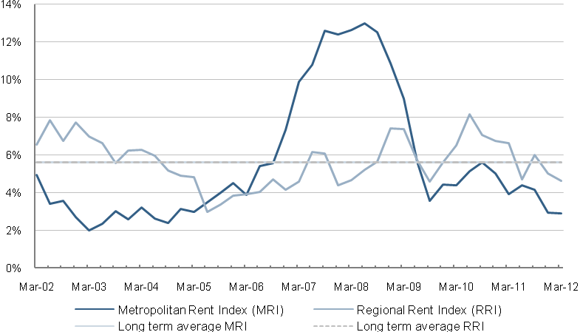

Table 1: Median rents and rent indices
 | Median Rent | Rent Index | Quarterly Change* | Annual Change*
Melbourne | $350 | 197.4 | 0.5% | 2.9%
Regional Victoria | $260 | 197.5 | 2.3% | 4.6%
Victoria | $335 | 194.9 | 0.9% | 2.9%
* Percentage change figures are calculated from relevant Rent Index

Metropolitan Rent Index
The annual increase of 2.9 per cent in the MRI to the March quarter 2012 was below that of a year ago (3.9 per cent). Over the past two years, the situation for renters has improved, with the annual increase of the MRI below the long term (10 years) average of 5.6 per cent.

The quarterly rate of increase in the MRI was 0.5 per cent, above that of the previous quarter (0.2 per cent) and the same as that of the March quarter 2011.

Regional Rent Index
The annual increase of 4.6 per cent in the RRI to the March quarter 2012 is below that of the same period last year (6.6 per cent) and below the long term average increase of 5.6 per cent. The annual rate of increase in the RRI has been above that of the MRI since June quarter 2009 and the long term average increase is now equal to that of the MRI.

Median rents by region

Table 2 shows the median rents for new lettings in the March quarter for 14 statistical regions in Victoria (9 in metropolitan Melbourne and 5 in regional Victoria).

In metropolitan Melbourne, median rents ranged from $300 per week for the Western Melbourne region to $410 for the Inner Melbourne region. In regional Victoria median rents ranged from $240 per week for the Goulburn-Ovens-Murray region to $290 per week for the Barwon-South West region.

The highest annual percentage increase in median rents in metropolitan Melbourne was in the Southern region (3.9 per cent), while Western Melbourne region has had no change in its median rent since the June quarter 2010. Notably, in the March quarter 2012, all regions except the North Western region, had zero or negative quarterly changes in median rents.

For regional Victoria, the highest annual increase was in the Loddon-Mallee region (8.3 per cent), while the lowest increase was in the Barwon-South West region (3.6 per cent)

Table 2: Median rents by statistical region
Region | Median Rent | Quarterly Change | Annual Change

Metropolitan Melbourne
Inner Melbourne | $410 | -3.5% | 2.5%
Inner Eastern Melbourne | $385 | -1.3% | 2.7%
Southern Melbourne | $395 | 0.0% | 3.9%
Western Melbourne | $300 | 0.0% | 0.0%
North Western Melbourne | $350 | 2.9% | 2.9%
North Eastern Melbourne | $340 | 0.0% | 3.0%
Outer Eastern Melbourne | $340 | 0.0% | 1.5%
South Eastern Melbourne | $310 | -3.1% | 0.0%
Mornington Peninsula | $310 | 0.0% | 3.3%

Regional Victoria
Barwon-South West | $290 | 0.0% | 3.6%
Gippsland | $250 | 1.6% | 4.2%
Goulburn-Ovens-Murray | $240 | 0.0% | 4.3%
Loddon-Mallee | $260 | 4.0% | 8.3%
Central Highlands-Wimmera | $250 | 0.0% | 4.2%
* Percentage change figures are calculated from median rents in the region

Median rents by major property types

Table 3 provides the median rents for new lettings in the March quarter 2012 for the six major property types for metropolitan Melbourne and regional Victoria as well as the quarterly and annual change in the relevant Rent Index for each property type.

In metropolitan Melbourne, the highest median rent ($390 per week) is for three bedroom flats. The lowest median rent ($295 per week) is for one bedroom flats. Annual increases in the property type Rent Index for new lettings in metropolitan Melbourne ranged from 1.2 per cent for four bedroom houses to 4.0 per cent for one bedroom flats.

In regional Victoria, the highest median rent ($350 per week) is for four bedroom houses. The lowest median rent ($150 per week) is for one bedroom flats. Annual increases in the property type Rent Index for new lettings in regional Victoria ranged from 2.3 per cent for three bedroom flats to 5.4 per cent for one bedroom flats.

Table 3: Median rents by major property types
Property Type | Median Rent | Quarterly Change* | Annual Change*

Melbourne
1 Bed Flat | $295 | 0.3% | 4.0%
2 Bed Flat | $360 | 0.3% | 2.6%
3 Bed Flat | $390 | 0.4% | 3.3%
2 Bed House | $370 | 1.2% | 3.7%
3 Bed House | $340 | 0.7% | 2.8%
4 Bed House | $380 | 0.3% | 1.2%

Regional Victoria
1 Bed Flat | $150 | 2.1% | 5.4%
2 Bed Flat | $220 | 1.8% | 3.9%
3 Bed Flat | $280 | 1.3% | 2.3%
2 Bed House | $230 | 1.7% | 4.0%
3 Bed House | $270 | 3.3% | 5.3%
4 Bed House | $350 | 0.1% | 3.1%
* Percentage change figures are calculated from relevant Rent Index

Moving annual median rents by suburb or town

Table 11 shows the moving annual median rents for suburbs and towns across Victoria by major property type. (Note that the medians in Table 11 are moving annual medians, not quarterly medians, and that the annual percentage change is calculated from these moving annual medians.)

Figure 2 and Figure 3 show the moving annual median rents in Melbourne for two bedroom flats and for three bedroom houses, respectively. They show the pattern of concentration of the highest median rents in Inner Melbourne, large portions of the Inner Eastern and Southern Melbourne regions and the inner parts of the North Western and North Eastern Melbourne regions.

Figure 2: Moving annual median rents by suburb for 2 bedroom flats
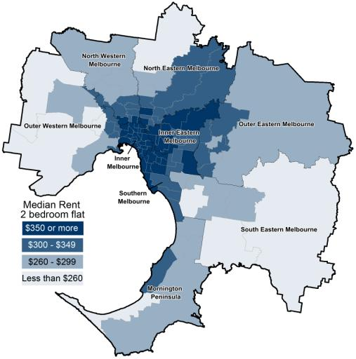
Figure 3: Moving annual median rents by suburb for 3 bedroom houses
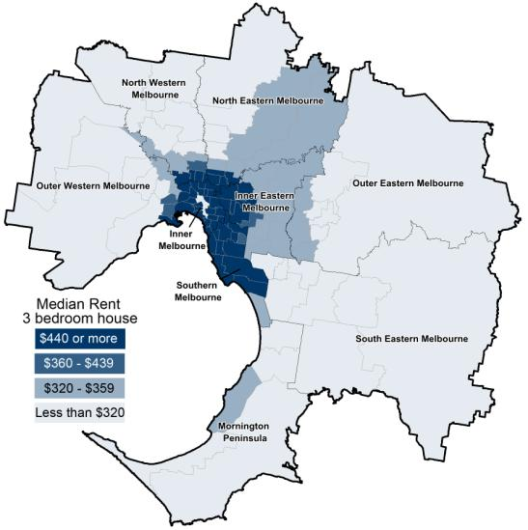

For two bedroom flats in metropolitan Melbourne, the suburbs with the highest increases in moving annual median rents to the March quarter were Fitzroy (13.3 per cent), Toorak (12.5 per cent), Footscray (10.0 per cent), North Melbourne-West Melbourne (9.8 per cent), Glen Waverley-Mulgrave (9.1 per cent) and Dromana-Portsea (8.7 per cent). Moving annual median rents for two bedroom flats decreased in Docklands (-1.5 per cent).

For regional Victoria the towns with the highest increases in moving annual median rents for two bedroom flats to the March quarter were Torquay (16.0 per cent), North Bendigo (15.0 per cent), Castlemaine (14.9 per cent), Bairnsdale (13.5 per cent) and Bendigo (10.0 per cent). Moving annual median rents for two bedroom flats decreased in Wendouree-Alfredton (-4.8 per cent) and Portland (-1.2 per cent).

The highest increases in moving annual median rents for three bedroom houses in metropolitan Melbourne to the March quarter were Port Melbourne (12.3 per cent), Kew (11.3 per cent), Elsternwick (11.3 per cent), St Kilda (10.2 per cent), Brunswick (10.0 per cent) and South Yarra (10.0 per cent). Moving annual median rents for three bedroom houses decreased in East Melbourne (-4.2 per cent), Hawthorn (-4.1 per cent), West Footscray (-1.5 per cent), Armadale
(-1.5 per cent), Heidelberg-Heidelberg West (-1.4 per cent) and Murrumbeena-Hughesdale (-1.2 per cent).

For regional Victoria, the towns with the highest increases in moving annual median rents for three bedroom houses to March quarter were Castlemaine (11.1 per cent), Horsham (9.5 per cent), Ocean Grove-Barwon Heads (9.4 per cent) and Benalla (9.1 per cent).

Where are median rents highest? Where are median rents lowest?

Table 4a provides the highest and lowest median rents in both metropolitan Melbourne and regional Victoria.

Table 4a Highest and lowest median rents in metropolitan Melbourne and regional Victoria
Where are median rents highest? |  | Where are median rents lowest?
2 bedroom flat
Melbourne
Docklands | $560 | Melton | $220
Port Melbourne | $550 | Werribee-Hoppers Crossing | $245
Fitzroy | $545 | St Albans-Deer Park | $250
Southbank | $540 | Sunshine | $250
CBD-St Kilda Rd | $520 | Whittlesea | $250
South Melbourne | $520 | Cranbourne | $250
 |  | Dromana-Portsea | $250
Regional Victoria
Torquay | $290 | Moe-Newborough | $140
Newtown | $275 | Morwell | $158
North Geelong | $270 | Portland | $168
Belmont-Grovedale | $270 | Horsham | $175
Geelong-Newcomb | $270 | Mildura | $175
Ocean Grove-Barwon Heads | $268 | Wangaratta | $175
3 Bedroom House
Melbourne
Albert Park-Middle Park-West St Kilda | $800 | Melton | $260
Toorak | $795 | Werribee-Hoppers Crossing | $280
East Melbourne | $790 | St Albans-Deer Park | $290
South Yarra | $770 | Sunshine | $300
Brighton | $750 | Dromana-Portsea | $300
Malvern | $750 | Pakenham | $300
Elwood | $750 | Sunbury | $300
 |  | Dandenong North-Endeavour Hills | $300
Regional
Torquay | $380 | Morwell | $190
Newtown | $360 | Moe-Newborough | $210
Ocean Grove-Barwon Heads | $350 | Portland | $220
Belmont-Grovedale | $340 | Horsham | $230
Herne Hill-Geelong West | $320 | Seymour | $230
Warrnambool | $320 | Swan Hill | $232

An expanded version of Table 11 containing extra property types as well as lower and upper quartile information can be found in the Rental Report March quarter 2012 data tables available for download from the Office of Housing website: www.dhs.vic.gov.au/about-the-department/documents-and-resources/research,-data-and-statistics/current-rental-report.

Rental availability

New Lettings

The number of new lettings provides an indicator of the overall availability of rental housing for a specific period. A new letting can result from two main sources: turnover in existing rental housing or new additions to the stock of rental housing.

Table 5 shows the total number of new rental lettings for the March quarter 2012. Metropolitan Melbourne accounted for 80 per cent of all new lettings in Victoria. Across the state the total number of new lettings was 53,425, an increase of 9.5 per cent on the same quarter of 2011. Metropolitan Melbourne recorded an increase of 11.4 per cent in new lettings and regional Victoria an increase of 2.7 per cent on the same quarter of last year.

Table 6 lists the total number of new lettings across each of the 14 statistical regions. All nine metropolitan regions recorded increases in the number of new lettings on the same quarter of 2011 ranging from 4.8 per cent in Inner Eastern Melbourne region to 22.9 per cent in North Eastern region.

In regional Victoria, four of the five regions had increases in new lettings since the March quarter of 2011 ranging from an increase of 2.1 per cent in the Central Highlands-Wimmera region to an increase of 5.3 per cent in the Barwon-South West region. Loddon-Mallee had no change in new lettings.

Table 5: Overall new lettings for Melbourne, regional Victoria and Victoria
 | Mar-12 | Mar-11 | Change
Metropolitan Melbourne | 42,493 | 38,147 | 11.4%
Regional Victoria | 10,932 | 10,648 | 2.7%
Victoria | 53,425 | 48,795 | 9.5%

Table 6: New lettings for statistical regions Victoria
Region | Mar-12 | Mar-11 | Change

Metropolitan Melbourne
Inner Melbourne | 11,707 | 10,823 | 8.2%
Inner Eastern Melbourne | 5,676 | 5,414 | 4.8%
Southern Melbourne | 3,807 | 3,524 | 8.0%
Western Melbourne | 5,797 | 5,072 | 14.3%
North Western Melbourne | 3,954 | 3,314 | 19.3%
North Eastern Melbourne | 4,272 | 3,476 | 22.9%
Outer Eastern Melbourne | 1,941 | 1,797 | 8.0%
South Eastern Melbourne | 3,238 | 2,853 | 13.5%
Mornington Peninsula | 2,101 | 1,874 | 12.1%

Regional Victoria
Barwon-South West | 3,065 | 2,911 | 5.3%
Gippsland | 2,047 | 2,002 | 2.2%
Goulburn-Ovens-Murray | 2,184 | 2,134 | 2.3%
Loddon-Mallee | 1,925 | 1,925 | 0.0%
Central Highlands-Wimmera | 1,711 | 1,676 | 2.1%

Active Bonds

The number of active bonds provides an indicator of the total stock of rental housing, based on the total number of bonds held by the RTBA at a given point in time.

At the end of the March quarter 2012, the total number of active bonds held in Victoria was 426,320, an increase of 5.8 per cent on the size of the rental market over the same quarter of 2011. The average annual increase in the rental market over the last ten years is 4.7 per cent. In the March quarter 2012, the annual increase in active bonds in metropolitan Melbourne (6.3 per cent) continues to be higher than for regional Victoria (4.3 per cent), a trend started in the September quarter 2009.

Figure 4 shows trends in active bonds for the past five years. While the average annual increase in the number active bonds over the past 10 years is 4.7 per cent, the average increase over the past five years has been higher (5.9 per cent) ranging from a low of 4.7 per cent in the March quarter 2010 to a high of 7.7 per cent in the December quarter 2008.

Table 14 below shows the active bonds for each local government area at March 2012 and the percentage change in active bonds. The largest numbers of active bonds in metropolitan Melbourne are in the inner municipalities of Melbourne (28,332 – 8.4 per cent of metropolitan Melbourne bonds), Port Phillip (18,778 – 5.6 per cent) and Stonnington (16,852 – 5.0 per cent). Other municipalities with large numbers of active bonds are Moreland (16,717 – 5.0 per cent), Glen Eira (16,390 – 4.9 per cent), Boroondara (15,745 – 4.7 per cent) and Darebin (14,565 - 4.3 per cent). Over the five year period to March 2012, the highest increases, however, have been in municipalities on the fringe of metropolitan Melbourne (Melton 135.3 per cent; Wyndham 116.5 per cent and Cardinia 93.3 per cent).

The largest numbers of active bonds in regional Victoria are in the municipalities of Greater Geelong (16,047 – 18 per cent of regional Victoria bonds), Ballarat (8,032 – 9.0 per cent), Greater Bendigo (7,551 – 8.5 per cent), Latrobe (5,193 – 5.8 per cent), Greater Shepparton (4,401 – 4.9 per cent) and Mildura (4,181 – 4.7 per cent). Over the past five years, the highest increases have been in the municipalities of Hindmarsh (86.0 per cent), Buloke (81.9 per cent) and Bass Coast (76.6 per cent).

Figure 5a illustrates the distribution of active bonds by suburb for metropolitan Melbourne. Figure 5b illustrates the distribution of active bonds by local government area (LGA) for regional Victoria.

Figure 4 –Total active residential bonds, Victoria - annual percent change

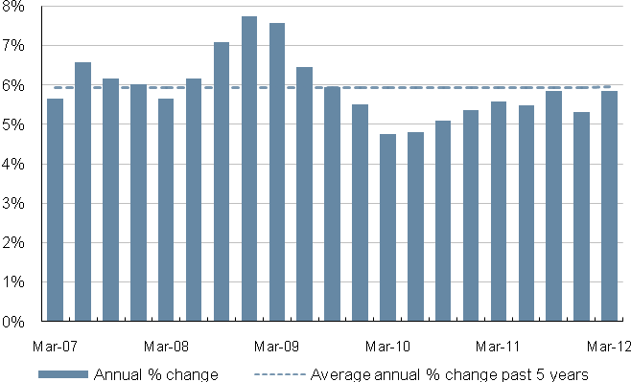

Figure 5a: Number of active bonds by suburb for metropolitan Melbourne
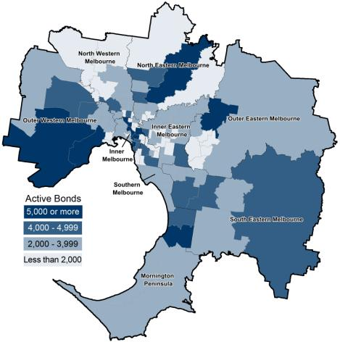

Figure 5b – Number of active bonds by Local Government Area for regional Victoria
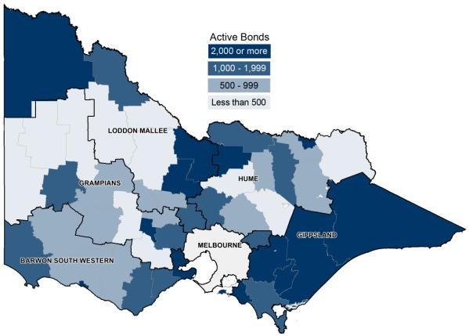

Turnover and length of tenancy

The number of bond refunds in a quarter, if expressed as a percentage of all bonds held, can be used to provide an estimate of the ‘turnover rate’ in the rental market. The ‘turnover rate’ is an important indicator of the level of natural vacancies which are occurring in the market due to tenancies ending.

Table 7 shows the turnover rate and the median and average length of tenancy (based on bond refunds during the quarter) for both metropolitan Melbourne and regional Victoria. For the March quarter 2012 the quarterly turnover rate for metropolitan Melbourne was 10.0 per cent (that is, 10.0 per cent of all bonds were refunded in the quarter), which is slightly lower than the rate of a year earlier (10.2 per cent).

The turnover rate in regional Victoria has been consistently higher than the Metropolitan area but the gap is closing. For the March quarter 2012 the regional turnover rate was 10.8 per cent, which is slightly lower than the rate of a year earlier (11 per cent).

The median length of tenancy for bonds refunded in the March quarter 2012 was 16 months for metropolitan Melbourne and 14 months for regional Victoria.

Table 8 shows the median length of tenancy and turnover by dwelling size for both metropolitan Melbourne and regional Victoria. In metropolitan Melbourne one bedroom dwellings have the lowest median length of tenancy (13 months) and the highest turnover rates (14.3 per cent). In regional Victoria, one bedroom dwellings also have the lowest median length of tenancy (13 months) and dwellings with four or more bedrooms have the highest turnover rate higher (11.8 per cent).

Table 7: Turnover and tenancy duration
 |  | Mar-12 | Mar-11
Melbourne | Turnover rate | 10.0% | 10.2%
 | Median tenancy duration | 16 months | 17 months
 | Average (mean) tenancy duration | 25 months | 25 months
Regional Victoria | Turnover rate | 10.8% | 11.0%
 | Median tenancy duration | 14 months | 14 months
 | Average (mean) tenancy duration | 22 months | 22 months
Notes:
1. Average and median duration (months) from bond lodgement date to bond claim date for refunds in that quarter
2. Bond refunds (moving annual total) as % of total active bonds
3. Median tenancy duration was first reported in September quarter 2011
Table 8: Median tenancy duration and turnover by dwelling size
 | Metropolitan Melbourne |  | Regional Victoria
 | Duration  (months) | Turnover | Duration  (months) | Turnover
1 bedroom | 13 | 14.3% | 13 | 11.0%
2 bedrooms | 18 | 9.5% | 14 | 10.7%
3 bedrooms | 18 | 8.8% | 15 | 10.6%
4+ bedrooms | 15 | 9.3% | 14 | 11.8%
All properties | 16 | 9.9% | 14 | 10.8%

Investor finance

Loan approvals for the purchase or construction of dwellings for purposes of investment (not owner-occupation) provide a measure of investor activity levels in the Victorian housing market.

In the March quarter 2012, the lending to investors in Victoria was $5.21 billion which was 27.9 per cent of the total lending for the purchase or construction of dwellings. This is 6.8 per cent lower than the level of lending to investors in the same quarter of 2011 and 7.4 per cent lower than the estimated investment in the last quarter.

Figure 6 presents a summary of lending for housing investment in Victoria over the past five years.

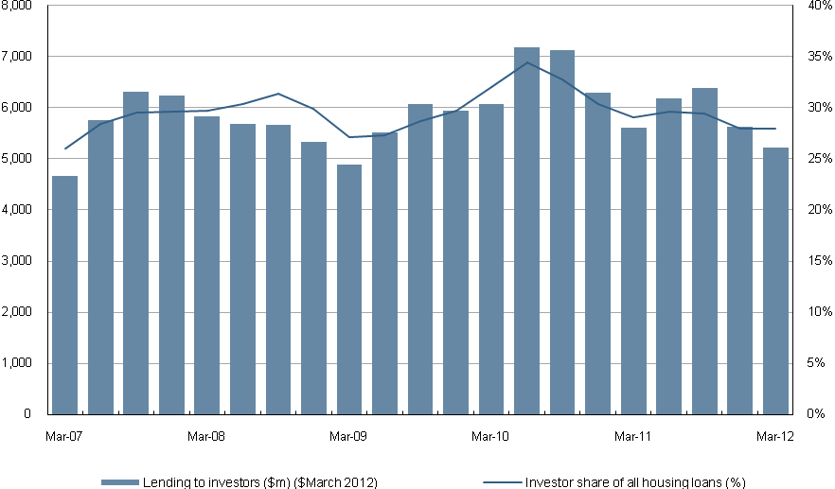
Figure 6: Lending to investors in residential housing, Victoria
Note: Lending to investors in December 2011 is an estimate - see Note 6

Vacancy Rate

Figure 7 shows the trend vacancy rate over the past five years for metropolitan Melbourne and regional Victoria. (Note: The Real Estate Institute of Australia did not collect data on vacancy rates for January 2012. For the purposes of calculating the trend vacancy rate, an average of December 2011 and February 2012 was used.)

In March 2012, the trend vacancy rate for metropolitan Melbourne was 2.2 per cent - higher than in March last year (1.8 per cent) but lower than in December 2011 (2.3 per cent). The trend vacancy rate reached its lowest point in early 2008. The current vacancy rate remains low in historical terms and is indicative of an ongoing tight supply situation. The average vacancy rate for the period January 2000 to December 2005 was 3.6 per cent but from January 2006 to the current quarter, the average vacancy rate has been 1.6 per cent.

For regional Victoria the trend vacancy rate was 1.5 per cent in March 2012, higher than in March last year (1.3 per cent) and in December 2011 (1.4 per cent). The regional Victorian rate is still below the trend metropolitan rate. From May 2005 to July 2009 regional Victoria’s trend rate was above the metropolitan rate. Since that time the regional trend rate has been on average 0.6 per cent below the metropolitan rate.

Figure 7 – Rental vacancy rate - trend
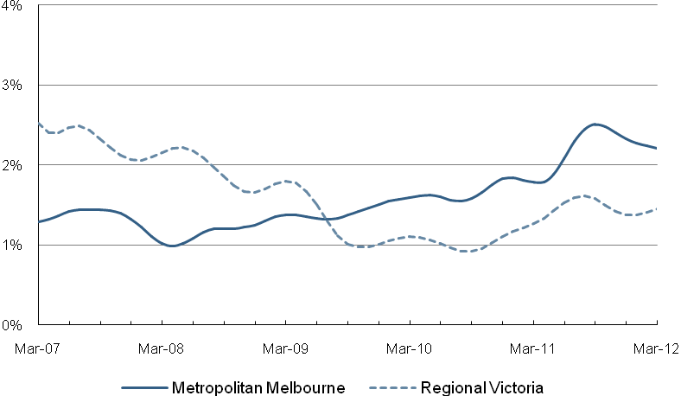

Rental Market Affordability
This section of the Rental Report provides a summary of the affordability of rental housing for lower income households in Victoria. The method used in this section measures the supply of affordable new lettings based on the RTBA data used in this Report. The affordability benchmark used is that no more than 30 per cent of gross income is spent on rent. Lower income households are defined as those receiving Centrelink incomes.

Overall trends

In the March quarter 2012, 18.7 per cent of all new lettings across the state were affordable to lower income households. Figure 8 shows the trend in these figures over the past five years for Victoria, metropolitan Melbourne and regional Victoria.

From a high in the June quarter 2006 (32.4 per cent of dwellings) to a low in the March quarter 2011 (7.4 per cent) the availability of affordable housing in metropolitan Melbourne has generally declined. While June 2011 (9.7 per cent), September 2011 (10.4 per cent) and December 2011 (10.6 per cent) showed some recovery, the availability of affordable housing in this quarter has slightly declined to 9.5 per cent.

Regional Victoria has followed a similar trend, from a high of 83.8 per cent in September quarter 2002 to a low of 55.2 per cent in March quarter 2011. In the March quarter 2012, 54.4 per cent of dwellings were affordable, below that of the same quarter in 2011 (55.2 per cent) and also the previous quarter (56.7 per cent).

In metropolitan Melbourne, the availability of affordable rental lettings varies between different types of households. The rental affordability situation for different low income households is summarised in Table 9.

Due to a limited supply of affordable one bedroom dwellings, low income single person households face the most difficulties in accessing affordable rental housing. Across Melbourne, just 0.3 per cent of one bedroom dwellings let in the March quarter were affordable to low income singles.

For a single parent with one child on Centrelink income, 2.6 per cent of two bedroom dwellings across Melbourne were affordable. For larger families, the supply of affordable three and four bedroom dwellings is better and reflects the predominantly outer suburban location of this size of dwelling. A couple on Newstart with four dependent children could afford 32.9 per cent of four bedroom new lettings in Melbourne in the March quarter up slightly from 32.5 per cent in the previous quarter.

Figure 8: Affordable rentals as percent of all rentals
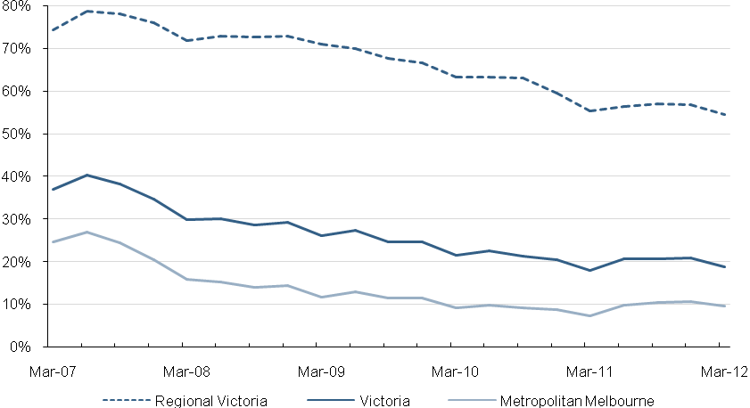

Table 9: Rental affordability by indicative households on Centrelink incomes
Household type |  | Singles on Newstart | Single Parent with 1 child | Couple on Newstart with  2 children | Couple on Newstart with  4 children | Total
Assumed property size |  | 1 bedroom | 2 bedroom | 3 bedroom | 4+ bedroom | -
Weekly income  (net of RA) |  | $243 | $494 | $709 | $912 | -
Affordable weekly rent |  | $135 | $220 | $285 | $355 | -
Affordable rentals (number) | Metropolitan Melbourne | 26 | 368 | 1,865 | 1,558 | 3,817
Affordable rentals (number) | Regional Victoria | 227 | 1,571 | 3,021 | 853 | 5,672
Affordable rentals (number) | Victoria | 253 | 1,939 | 4,886 | 2,411 | 9,489
Affordable rentals  (% of total) | Metropolitan Melbourne | 0.3% | 2.6% | 14.0% | 32.9% | 9.5%
Affordable rentals  (% of total) | Regional Victoria | 31.1% | 51.9% | 59.5% | 53.8% | 54.4%
Affordable rentals  (% of total) | Victoria | 2.8% | 11.4% | 26.6% | 38.2% | 18.7%

Trends by region

Table 10 shows the availability of affordable lettings for each of the statistical regions of Victoria. These affordability figures show the higher cost of housing in Melbourne. Western Melbourne region with 35.2 per cent has the highest proportion of affordable lettings. South Eastern (20.0 per cent) and Mornington Peninsula (19.8 per cent) regions of metropolitan Melbourne also consistently have a relatively high proportion of new lettings which are affordable to lower income households. Western Melbourne region has the highest number and proportion of three bedroom lettings (988 or 36.3 per cent) and four bedroom lettings (838 or 66.0 per cent). Western Melbourne region also has the highest number (112) of affordable two bedroom lettings.

In regional Victoria, Goulburn-Ovens-Murray region (69.7 per cent) has the highest availability of affordable lettings while the Barwon-South West region (31.0 per cent) has the lowest availability of affordable rentals.

Local Government Area Trends

Table 13 provides data on the number of new lettings affordable to households on Centrelink incomes for all Victorian Local Government Areas (LGA).

Figures 9a and 9b, drawn from Table 13, show the proportion of affordable dwellings in each LGA across metropolitan Melbourne and regional Victoria. LGAs with highest proportion of affordable dwellings in metropolitan Melbourne are Wyndham (59.1 per cent), Melton (58.7 per cent), Cardinia (40.1 per cent) and Brimbank (26.2 per cent). The LGAs with lowest proportion are Bayside, Port Phillip, Melbourne, Boroondara, Stonnington, Yarra, Moonee Valley, Glen Eira and Manningham (all with less than 2.0 per cent)

The LGAs with the highest proportion of affordable dwellings in regional Victoria are Buloke, Gannawarra, Loddon and Yarriambiack (100 per cent) and, Towong and Central Goldfields (both above 90 per cent). The LGAs with the lowest proportion of affordable dwellings are Queenscliffe (9.1 per cent), Surf Coast (11.4 per cent), Macedon Ranges (11.9%) and Greater Geelong (22.9 per cent).

Figure 9a: Affordable dwellings in metropolitan Melbourne by local government area
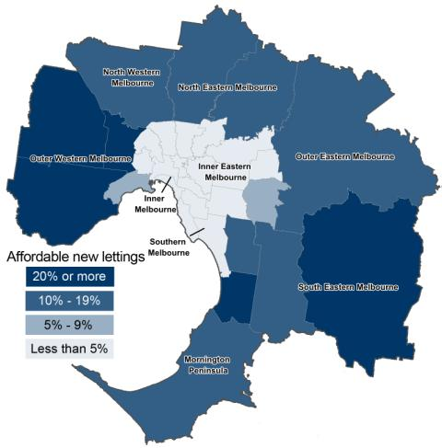

Figure 9b: Affordable dwellings in regional Victoria by local government area
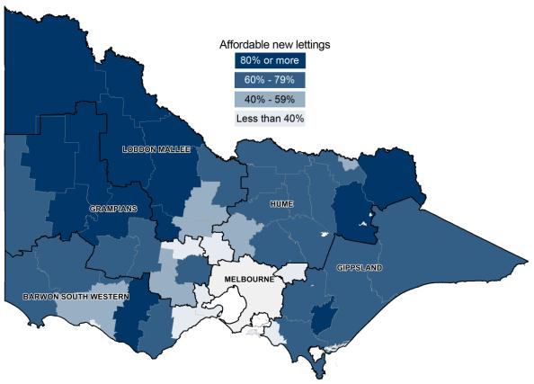

Table 10: Affordable lettings for indicative households (see table 9) on Centrelink incomes
Region | 1 Bedroom |  | 2 Bedroom |  | 3 Bedroom |  | 4+ Bedroom |  | Total
Region | Number | Percent | Number | Percent | Number | Percent | Number | Percent | Number | Percent
Inner Melbourne | 2 | 0.0% | 22 | 0.5% | 19 | 2.0% | 18 | 9.0% | 61 | 0.6%
Inner Eastern Melbourne | 4 | 0.4% | 37 | 2.1% | 43 | 2.2% | 57 | 7.5% | 141 | 2.6%
Southern Melbourne | 1 | 0.1% | 14 | 0.9% | 21 | 1.9% | 17 | 4.5% | 53 | 1.4%
Western Melbourne | 3 | 0.9% | 112 | 9.3% | 988 | 36.3% | 838 | 66.0% | 1,941 | 35.2%
North Western Melbourne | 1 | 0.2% | 18 | 1.2% | 126 | 8.8% | 96 | 26.8% | 241 | 6.4%
North Eastern Melbourne | 3 | 0.6% | 26 | 1.8% | 88 | 5.6% | 130 | 25.6% | 247 | 6.0%
Outer Eastern Melbourne | 6 | 6.8% | 34 | 6.2% | 65 | 6.8% | 43 | 14.2% | 148 | 7.8%
South Eastern Melbourne | 3 | 2.3% | 47 | 6.8% | 277 | 18.7% | 265 | 39.7% | 592 | 20.0%
Mornington Peninsula | 3 | 3.6% | 58 | 10.7% | 238 | 22.2% | 94 | 32.6% | 393 | 19.8%
Metropolitan Melbourne | 26 | 0.3% | 368 | 2.6% | 1,865 | 14.0% | 1,558 | 32.9% | 3,817 | 9.5%
Barwon-South West | 26 | 10.8% | 219 | 25.2% | 488 | 35.9% | 182 | 37.6% | 915 | 31.0%
Gippsland | 61 | 42.1% | 329 | 63.5% | 692 | 69.6% | 179 | 66.1% | 1,261 | 65.4%
Goulburn-Ovens-Murray | 53 | 42.7% | 465 | 73.0% | 741 | 73.2% | 204 | 62.4% | 1,463 | 69.7%
Loddon-Mallee | 40 | 41.7% | 300 | 56.2% | 567 | 62.1% | 131 | 53.7% | 1,038 | 58.1%
Central Highlands-Wimmera | 47 | 37.9% | 258 | 54.8% | 533 | 66.8% | 157 | 60.4% | 995 | 60.2%
Regional Victoria | 227 | 31.1% | 1,571 | 51.9% | 3,021 | 59.5% | 853 | 53.8% | 5,672 | 54.4%
Victoria | 253 | 2.8% | 1,939 | 11.4% | 4,886 | 26.6% | 2,411 | 38.2% | 9,489 | 18.7%

Table 11 – Moving annual median rents for suburbs/town by major property type
Suburb/town | 1 Bed Flat |  |  | 2 Bed Flat |  |  | 2 Bed House |  |  | 3 Bed House
Suburb/town | Count | Median | Ann % Ch | Count | Median | Ann % Ch | Count | Median | Ann % Ch | Count | Median | Ann % Ch
Inner Melbourne
Albert Park-Middle Park-West St Kilda | 271 | $330 | 4.8% | 212 | $440 | 3.5% | 111 | $550 | 3.6% | 90 | $800 | 6.7%
Armadale | 161 | $300 | 3.1% | 240 | $390 | 2.6% | 27 | $550 | 10.0% | 29 | $640 | -1.5%
Carlton North | 42 | $305 | 5.2% | 91 | $420 | 5.0% | 55 | $470 | -1.7% | 42 | $600 | 0.8%
Carlton-Parkville | 2,051 | $315 | 1.6% | 737 | $450 | 1.1% | 39 | $470 | 1.1% | 38 | $670 | 8.1%
CBD-St Kilda Rd | 2,857 | $380 | 2.7% | 2,285 | $520 | 4.0% | - | - | - | - | - | -
Collingwood-Abbotsford | 198 | $330 | 15.8% | 168 | $480 | 4.3% | 81 | $480 | 6.7% | 47 | $600 | 9.1%
Docklands | 371 | $430 | -1.1% | 535 | $560 | -1.4% | - | - | - | - | - | -
East Melbourne | 202 | $350 | -2.8% | 200 | $495 | 4.2% | 11 | $475 | nd | 12 | $790 | -4.2%
East St Kilda | 460 | $285 | 3.6% | 710 | $378 | 5.0% | 45 | $520 | 5.1% | 62 | $638 | 8.1%
Elwood | 495 | $300 | 1.7% | 819 | $400 | 1.3% | 31 | $570 | 0.9% | 64 | $750 | 8.7%
Fitzroy | 205 | $350 | 14.8% | 185 | $545 | 13.3% | 68 | $505 | 3.1% | 30 | $693 | 6.6%
Fitzroy North-Clifton Hill | 146 | $298 | 8.4% | 236 | $420 | 7.7% | 126 | $495 | 5.3% | 95 | $620 | 3.3%
Flemington-Kensington | 230 | $300 | 3.4% | 460 | $370 | 2.8% | 138 | $410 | 0.0% | 108 | $505 | 1.0%
North Melbourne-West Melbourne | 727 | $281 | 0.4% | 522 | $439 | 9.8% | 67 | $470 | 4.4% | 52 | $575 | 4.5%
Port Melbourne | 285 | $420 | 5.0% | 464 | $550 | 0.0% | 125 | $550 | 10.0% | 99 | $730 | 12.3%
Prahran-Windsor | 638 | $290 | 1.8% | 523 | $420 | 5.0% | 130 | $505 | 2.0% | 100 | $675 | 5.5%
Richmond-Burnley | 659 | $350 | 12.9% | 601 | $495 | 5.3% | 291 | $520 | 8.3% | 177 | $650 | 8.3%
South Melbourne | 187 | $395 | 1.3% | 189 | $520 | 5.1% | 88 | $500 | 0.0% | 55 | $695 | 0.0%
South Yarra | 1,306 | $340 | 6.3% | 948 | $480 | 6.7% | 87 | $540 | 8.0% | 64 | $770 | 10.0%
Southbank | 379 | $425 | 3.7% | 763 | $540 | 2.9% | - | - | - | - | - | -
St Kilda | 1,205 | $325 | 4.8% | 987 | $420 | 5.0% | 36 | $528 | 1.1% | 44 | $650 | 10.2%
Toorak | 205 | $310 | 5.1% | 293 | $450 | 12.5% | - | - | - | 42 | $795 | 3.9%
Inner Melbourne - Total | 13,280 | $340 | 4.6% | 12,168 | $470 | 4.4% | 1,573 | $500 | 4.2% | 1,256 | $650 | 8.3%
Inner Eastern Melbourne
Balwyn | - | - | - | 210 | $360 | 2.9% | 49 | $380 | 2.7% | 231 | $480 | 0.0%
Blackburn | 32 | $238 | 5.8% | 144 | $340 | 6.3% | 42 | $343 | 3.9% | 241 | $390 | 2.6%
Box Hill | 355 | $231 | -3.8% | 532 | $340 | 3.0% | 63 | $360 | 0.0% | 291 | $395 | 3.9%
Bulleen-Templestowe-Doncaster | 63 | $247 | -22.8% | 229 | $350 | 2.9% | 30 | $340 | 6.3% | 370 | $400 | 5.3%
Burwood-Ashburton | 166 | $220 | -4.3% | 152 | $375 | 7.1% | 71 | $370 | 5.7% | 299 | $400 | 0.0%
Camberwell-Glen Iris | 247 | $280 | 5.7% | 638 | $380 | 5.6% | 51 | $425 | 1.7% | 233 | $550 | 0.0%
Canterbury-Surrey Hills-Mont Albert | 22 | $265 | 3.9% | 261 | $360 | 1.7% | 35 | $375 | -3.4% | 105 | $525 | 1.0%
Chadstone-Oakleigh | 52 | $258 | -11.0% | 234 | $340 | 0.0% | 65 | $345 | 1.5% | 241 | $395 | 3.9%
Clayton | 233 | $265 | 1.9% | 494 | $330 | 6.5% | 42 | $320 | -5.9% | 219 | $360 | 0.0%
Doncaster East-Donvale | 13 | $270 | 8.0% | 113 | $350 | 2.9% | 21 | $330 | 0.0% | 231 | $395 | 5.3%
East Hawthorn | 130 | $300 | 3.4% | 285 | $380 | 2.7% | 42 | $488 | 10.9% | 60 | $600 | 2.6%
Glen Waverley-Mulgrave | 33 | $350 | 40.0% | 188 | $360 | 9.1% | 22 | $345 | -1.4% | 645 | $380 | 2.7%
Hawthorn | 1,027 | $275 | 3.8% | 777 | $390 | 2.6% | 59 | $470 | 0.0% | 106 | $650 | -4.1%
Kew | 51 | $340 | 7.9% | 425 | $380 | 5.6% | 40 | $443 | 4.2% | 168 | $590 | 11.3%
Mount Waverley | 14 | $255 | 21.4% | 114 | $340 | 3.0% | 29 | $350 | 6.1% | 290 | $395 | 3.9%
Nunawading-Mitcham | 26 | $243 | 5.7% | 229 | $315 | 5.0% | 45 | $320 | 0.0% | 227 | $370 | 1.9%
Vermont-Forest Hill-Burwood East | 16 | $245 | nd | 95 | $320 | 2.2% | 26 | $333 | 0.9% | 344 | $385 | 4.1%
Inner Eastern Melbourne - Total | 2,488 | $260 | 2.0% | 5,120 | $360 | 2.9% | 732 | $370 | 2.8% | 4,301 | $400 | 2.6%
Southern Melbourne
Aspendale-Chelsea-Carrum | 50 | $240 | 9.1% | 566 | $310 | 3.3% | 73 | $320 | 3.2% | 332 | $388 | 7.8%
Bentleigh | 165 | $250 | 4.2% | 457 | $350 | 2.9% | 124 | $395 | 6.8% | 417 | $450 | 3.4%
Brighton | 31 | $320 | 3.2% | 238 | $450 | 4.7% | 30 | $485 | -2.0% | 122 | $750 | 4.9%
Brighton East | - | - | - | 52 | $395 | 6.8% | 36 | $450 | 8.4% | 102 | $600 | 0.8%
Carnegie | 349 | $250 | 0.0% | 361 | $350 | 0.0% | 30 | $395 | 8.2% | 60 | $495 | 5.3%
Caulfield | 328 | $260 | 4.0% | 615 | $380 | 2.7% | 77 | $430 | 3.6% | 145 | $550 | 0.0%
Cheltenham | 51 | $245 | 11.4% | 454 | $325 | 1.6% | 61 | $399 | 5.0% | 327 | $445 | 6.0%
Elsternwick | 168 | $280 | 12.0% | 247 | $390 | 6.8% | 16 | $435 | -3.3% | 48 | $623 | 11.3%
Hampton-Beaumaris | 113 | $320 | -3.9% | 282 | $400 | 2.6% | 59 | $435 | 1.2% | 221 | $600 | 6.2%
Malvern | 80 | $300 | 1.7% | 145 | $395 | 3.9% | 21 | $550 | 5.8% | 40 | $750 | 9.5%
Malvern East | 311 | $255 | 4.1% | 258 | $365 | 1.4% | 29 | $440 | 10.0% | 133 | $525 | 5.0%
Mentone-Parkdale-Mordialloc | 233 | $250 | 4.2% | 465 | $330 | 5.4% | 39 | $370 | 2.8% | 169 | $450 | 0.0%
Murrumbeena-Hughesdale | 211 | $260 | 4.0% | 220 | $355 | 4.4% | 39 | $370 | -2.6% | 109 | $415 | -1.2%
Southern Melbourne - Total | 2,098 | $260 | 4.0% | 4,360 | $350 | 0.0% | 634 | $400 | 2.6% | 2,225 | $470 | 4.4%
Outer Western Melbourne
Altona | 73 | $210 | -2.3% | 506 | $280 | 1.8% | 111 | $290 | 3.6% | 1,328 | $320 | 0.0%
Footscray | 298 | $215 | 2.4% | 377 | $330 | 10.0% | 107 | $350 | 6.1% | 139 | $360 | 2.9%
Keilor East-Avondale Heights | 46 | $250 | 4.2% | 228 | $330 | 6.5% | 40 | $320 | 0.0% | 254 | $350 | 0.0%
Melton | 36 | $274 | -6.5% | 100 | $220 | 0.0% | 48 | $230 | 0.0% | 947 | $260 | 0.0%
Newport-Spotswood | 78 | $230 | 0.0% | 122 | $298 | 6.4% | 77 | $380 | 5.6% | 201 | $415 | 9.2%
St Albans-Deer Park | 41 | $200 | 0.0% | 270 | $250 | 0.0% | 56 | $258 | 3.2% | 888 | $290 | 0.0%
Sunshine | 140 | $200 | 2.6% | 230 | $250 | 4.2% | 97 | $260 | 0.0% | 560 | $300 | 1.7%
Sydenham | - | - | - | 111 | $290 | 7.4% | 35 | $295 | 5.4% | 769 | $330 | 3.1%
Werribee-Hoppers Crossing | 25 | $215 | 10.3% | 398 | $245 | 6.5% | 82 | $258 | 3.2% | 2,052 | $280 | 0.0%
West Footscray | 123 | $220 | 10.0% | 323 | $310 | 3.3% | 122 | $300 | 0.0% | 284 | $320 | -1.5%
Williamstown | 36 | $260 | 4.0% | 128 | $303 | 1.0% | 45 | $410 | 5.1% | 130 | $540 | 4.9%
Yarraville-Seddon | 150 | $220 | 4.8% | 257 | $300 | 7.1% | 165 | $380 | 4.1% | 284 | $420 | 5.5%
Outer Western Melbourne - Total | 1,055 | $215 | 4.9% | 3,050 | $280 | 3.7% | 985 | $305 | 1.7% | 7,836 | $300 | 0.0%
North Western Melbourne
Broadmeadows-Roxburgh Park | 17 | $210 | 6.1% | 106 | $290 | 3.6% | 40 | $285 | 1.8% | 625 | $320 | 3.2%
Brunswick | 490 | $276 | 6.2% | 640 | $375 | 7.1% | 169 | $440 | 10.0% | 168 | $550 | 10.0%
Coburg-Pascoe Vale South | 201 | $290 | 3.6% | 379 | $340 | 3.0% | 123 | $360 | 2.9% | 286 | $410 | 2.5%
Craigieburn | - | - | - | 39 | $280 | 0.0% | 40 | $300 | 3.4% | 556 | $320 | 0.0%
East Brunswick | 139 | $300 | 7.1% | 211 | $420 | 5.0% | 36 | $450 | 12.5% | 47 | $550 | 5.8%
Essendon | 230 | $263 | 7.3% | 534 | $320 | 3.2% | 107 | $350 | 2.9% | 290 | $375 | 4.2%
Gladstone Park-Tullamarine | 14 | $225 | -2.2% | 132 | $290 | 7.4% | - | - | - | 227 | $330 | 1.5%
Keilor | - | - | - | - | - | - | - | - | - | 23 | $360 | 7.5%
Moonee Ponds-Ascot Vale | 170 | $255 | 2.0% | 420 | $350 | 2.9% | 136 | $400 | 5.0% | 216 | $480 | 6.7%
Oak Park-Glenroy-Fawkner | 45 | $230 | 9.5% | 422 | $300 | 0.0% | 111 | $310 | 3.3% | 473 | $340 | 3.0%
Pascoe Vale-Coburg North | 48 | $186 | -7.5% | 258 | $330 | 4.8% | 85 | $330 | 3.1% | 192 | $350 | 0.0%
Sunbury | - | - | - | 96 | $265 | 6.0% | 21 | $265 | 4.7% | 358 | $300 | 3.4%
West Brunswick | 254 | $250 | 0.0% | 267 | $320 | 3.2% | 27 | $380 | -2.6% | 78 | $475 | 5.6%
North Western Melbourne - Total | 1,617 | $260 | 4.0% | 3,511 | $330 | 3.1% | 901 | $360 | 2.9% | 3,539 | $340 | 3.0%
North Eastern Melbourne
Bundoora-Greensborough-Hurstbridge | 281 | $220 | -1.3% | 462 | $320 | 3.2% | 131 | $320 | 3.2% | 856 | $350 | 0.0%
Eltham-Research-Montmorency | 27 | $210 | -2.3% | 148 | $310 | 3.3% | 35 | $340 | 6.3% | 191 | $390 | 5.4%
Fairfield-Alphington | 202 | $260 | 2.0% | 169 | $330 | 0.0% | 33 | $400 | 5.3% | 77 | $520 | 4.0%
Heidelberg-Heidelberg West | 54 | $280 | 7.7% | 294 | $340 | 6.3% | 122 | $320 | 3.2% | 268 | $350 | -1.4%
Ivanhoe-Ivanhoe East | 57 | $265 | -1.1% | 176 | $338 | 2.4% | 22 | $390 | 2.6% | 75 | $450 | 0.0%
Mill Park-Epping | 23 | $270 | 1.9% | 192 | $290 | 3.6% | 46 | $300 | 0.0% | 905 | $330 | 0.0%
Northcote | 228 | $260 | -1.1% | 270 | $400 | 5.3% | 139 | $450 | 1.1% | 155 | $570 | 7.5%
Preston | 163 | $230 | 0.0% | 447 | $350 | 6.1% | 147 | $350 | 0.0% | 272 | $400 | 5.3%
Reservoir | 185 | $270 | 5.9% | 614 | $300 | 0.0% | 180 | $310 | 3.3% | 385 | $340 | 6.3%
Thomastown-Lalor | 35 | $250 | 4.2% | 171 | $265 | 6.0% | 33 | $280 | 11.1% | 503 | $310 | 0.0%
Thornbury | 314 | $255 | 6.3% | 370 | $330 | 4.8% | 75 | $400 | 1.3% | 150 | $478 | 6.2%
Whittlesea | - | - | - | 46 | $250 | nd | - | - | - | 164 | $340 | 3.0%
North Eastern Melbourne - Total | 1,575 | $255 | 2.0% | 3,359 | $320 | 3.2% | 973 | $340 | 3.0% | 4,001 | $350 | 2.9%
Outer Eastern Melbourne
Bayswater | 24 | $195 | nd | 194 | $285 | 1.8% | 13 | $290 | 9.4% | 159 | $340 | 0.0%
Boronia | 21 | $216 | nd | 201 | $300 | 7.1% | 40 | $300 | 7.9% | 203 | $340 | 3.0%
Croydon-Lilydale | 75 | $220 | 10.0% | 430 | $300 | 7.1% | 76 | $300 | 0.0% | 769 | $350 | 2.9%
Ferntree Gully | 23 | $205 | 5.1% | 111 | $285 | 0.7% | 18 | $298 | 8.4% | 189 | $340 | 3.0%
Ringwood | 45 | $240 | 26.3% | 463 | $300 | 3.4% | 78 | $310 | 3.3% | 366 | $360 | 2.9%
Rowville | - | - | - | - | - | - | - | - | - | 209 | $375 | 4.2%
Wantirna-Scoresby | - | - | - | 60 | $320 | 1.6% | 14 | $335 | nd | 333 | $350 | 0.0%
Yarra Ranges | 63 | $200 | 0.0% | 108 | $260 | 4.0% | 154 | $280 | 3.7% | 544 | $330 | 3.1%
Outer Eastern Melbourne - Total | 262 | $205 | 2.5% | 1,577 | $300 | 5.3% | 397 | $300 | 3.4% | 2,772 | $350 | 2.9%
South Eastern Melbourne
Berwick | - | - | - | 89 | $290 | 3.6% | 38 | $310 | 3.3% | 464 | $340 | 3.0%
Cranbourne | - | - | - | 120 | $250 | 4.2% | 38 | $270 | 3.8% | 656 | $310 | 3.3%
Dandenong | 102 | $220 | 10.0% | 679 | $255 | 2.0% | 45 | $270 | -1.1% | 367 | $320 | 0.0%
Dandenong North-Endeavour Hills | 31 | $220 | 0.0% | 153 | $270 | 5.9% | 40 | $260 | 0.0% | 544 | $300 | 0.0%
Narre Warren-Hampton Park | - | - | - | 165 | $270 | 3.8% | 23 | $290 | 3.6% | 944 | $320 | 1.6%
Noble Park | 157 | $200 | 5.3% | 385 | $275 | 3.8% | 39 | $280 | 3.7% | 313 | $310 | 2.3%
Pakenham | 12 | $220 | 22.2% | 159 | $255 | 6.3% | 74 | $268 | 7.2% | 965 | $300 | 0.0%
Springvale | 81 | $207 | 3.5% | 396 | $280 | 1.4% | 40 | $293 | 2.8% | 485 | $330 | 3.1%
South Eastern Melbourne - Total | 398 | $208 | 4.0% | 2,146 | $265 | 1.9% | 337 | $280 | 3.7% | 4,738 | $320 | 3.2%
Mornington Peninsula
Dromana-Portsea | 24 | $193 | 4.3% | 175 | $250 | 8.7% | 228 | $255 | 2.0% | 837 | $300 | 3.4%
Frankston | 138 | $180 | 0.0% | 691 | $260 | 4.0% | 93 | $270 | 3.8% | 948 | $310 | 3.0%
Hastings-Flinders | 18 | $230 | 15.0% | 185 | $260 | 4.0% | 61 | $290 | 13.7% | 436 | $310 | 3.3%
Mt Eliza-Mornington-Mt Martha | 21 | $240 | 9.1% | 238 | $305 | 5.2% | 54 | $325 | 1.6% | 431 | $370 | 2.8%
Seaford-Carrum Downs | 43 | $210 | 5.0% | 283 | $275 | 5.8% | 52 | $288 | 8.7% | 772 | $310 | 3.3%
Mornington Peninsula - Total | 244 | $195 | 5.4% | 1,572 | $270 | 5.9% | 488 | $270 | 3.8% | 3,424 | $310 | 3.3%
Geelong
Belmont-Grovedale | 102 | $190 | 18.8% | 334 | $270 | 8.0% | 77 | $285 | 3.6% | 545 | $340 | 6.3%
Corio | 33 | $175 | 0.0% | 75 | $240 | 9.1% | 106 | $220 | 8.4% | 415 | $250 | 6.4%
Geelong-Newcomb | 143 | $225 | 15.4% | 257 | $270 | 1.9% | 115 | $280 | 12.0% | 393 | $300 | 3.4%
Herne Hill-Geelong West | 167 | $175 | 9.4% | 177 | $260 | 4.0% | 72 | $300 | 7.1% | 231 | $320 | 6.7%
Lara | 14 | $142 | nd | 75 | $255 | 6.3% | 16 | $268 | 0.8% | 172 | $310 | 3.3%
Newtown | 40 | $170 | 6.3% | 103 | $275 | 5.8% | 50 | $310 | 14.8% | 156 | $360 | 2.9%
North Geelong | 47 | $170 | 6.3% | 104 | $270 | 8.0% | 68 | $273 | 9.2% | 281 | $300 | 5.3%
Geelong - Total | 546 | $180 | 9.1% | 1,125 | $265 | 6.0% | 504 | $270 | 8.0% | 2,193 | $300 | 3.4%
Ballarat
Ballarat | 98 | $150 | 7.1% | 269 | $225 | 7.1% | 231 | $230 | 4.5% | 692 | $260 | 4.0%
Mount Clear-Buninyong | 14 | $150 | nd | 44 | $220 | 4.8% | 23 | $235 | 6.8% | 142 | $293 | 4.6%
Sebastopol-Delacombe | 67 | $180 | 24.1% | 146 | $210 | 6.1% | 35 | $230 | 12.2% | 260 | $260 | 8.3%
Wendouree-Alfredton | 81 | $145 | 7.4% | 124 | $200 | -4.8% | 59 | $230 | 5.5% | 410 | $275 | 5.8%
Ballarat - Total | 260 | $150 | 7.1% | 583 | $220 | 10.0% | 348 | $230 | 4.5% | 1,504 | $270 | 8.0%
Bendigo
Bendigo | 34 | $171 | 22.1% | 90 | $220 | 10.0% | 79 | $260 | 8.3% | 214 | $280 | 5.7%
Flora Hill-Bendigo East | 34 | $153 | 9.3% | 259 | $230 | 9.5% | 71 | $250 | 8.7% | 388 | $290 | 7.4%
Golden Square-Kangaroo Flat | 16 | $150 | 0.0% | 102 | $228 | 8.6% | 42 | $223 | 1.4% | 324 | $280 | 7.7%
North Bendigo | 24 | $150 | 11.1% | 123 | $230 | 15.0% | 64 | $223 | 6.2% | 313 | $270 | 8.0%
Bendigo - Total | 108 | $150 | 7.1% | 574 | $230 | 9.5% | 256 | $240 | 9.1% | 1,239 | $280 | 7.7%
Other Regional Centres
Bairnsdale | 17 | $150 | 7.1% | 75 | $210 | 13.5% | 41 | $230 | 2.2% | 181 | $270 | 8.0%
Benalla | 43 | $140 | 7.7% | 103 | $195 | 8.3% | 51 | $190 | 0.0% | 177 | $240 | 9.1%
Castlemaine | - | - | - | 40 | $247 | 14.9% | 50 | $270 | 11.1% | 118 | $300 | 11.1%
Echuca | 28 | $135 | 17.4% | 133 | $210 | 5.0% | 26 | $230 | 7.0% | 179 | $265 | 6.0%
Hamilton | 25 | $120 | 4.3% | 42 | $190 | 5.6% | 30 | $215 | 11.4% | 123 | $250 | 4.2%
Horsham | 28 | $143 | 30.0% | 151 | $175 | 2.9% | 38 | $180 | 0.0% | 296 | $230 | 9.5%
Mildura | 82 | $135 | 8.0% | 315 | $175 | 6.1% | 101 | $210 | 10.5% | 628 | $250 | 8.7%
Moe-Newborough | 83 | $110 | 10.0% | 117 | $140 | 7.7% | 63 | $170 | 6.3% | 244 | $210 | 5.0%
Morwell | 46 | $115 | 0.0% | 139 | $158 | 3.3% | 115 | $165 | 3.1% | 263 | $190 | 3.8%
Ocean Grove-Barwon Heads | 13 | $195 | 5.4% | 46 | $268 | 7.2% | 29 | $295 | 7.3% | 215 | $350 | 9.4%
Portland | 17 | $130 | 4.0% | 70 | $168 | -1.2% | 38 | $200 | 0.0% | 177 | $220 | 0.0%
Sale-Maffra | 74 | $140 | 3.7% | 145 | $200 | 8.1% | 66 | $220 | 7.3% | 276 | $250 | 4.2%
Seymour | - | - | - | 37 | $180 | 9.1% | 15 | $200 | 11.1% | 89 | $230 | 5.5%
Shepparton | 86 | $135 | 3.8% | 447 | $200 | 5.3% | 92 | $200 | 0.0% | 668 | $250 | 0.0%
Swan Hill | 65 | $120 | 0.0% | 124 | $195 | 2.6% | 28 | $188 | -1.1% | 176 | $232 | 0.9%
Torquay | 18 | $235 | 6.8% | 65 | $290 | 16.0% | 28 | $300 | 0.7% | 222 | $380 | 2.7%
Traralgon | 60 | $140 | 7.7% | 147 | $190 | 0.0% | 72 | $235 | 6.8% | 378 | $260 | 4.0%
Wangaratta | 53 | $135 | 0.0% | 156 | $175 | 2.9% | 41 | $215 | 13.2% | 237 | $240 | 4.3%
Warragul | - | - | - | 87 | $210 | 5.0% | 35 | $240 | 9.1% | 161 | $260 | 4.0%
Warrnambool | 68 | $153 | 2.0% | 379 | $230 | 0.0% | 78 | $270 | 8.0% | 464 | $320 | 6.7%
Wodonga | 53 | $150 | 0.0% | 362 | $195 | 0.0% | 51 | $220 | 0.0% | 532 | $270 | 3.8%
Other Regional Centres Total | 880 | $135 | 3.8% | 3,180 | $195 | 5.4% | 1,088 | $210 | 5.0% | 5,804 | $260 | 4.0%

Table 12 –Median rents for local government areas by DHS region, by major property type
LGA | 1 Bed Flat |  |  | 2 Bed Flat |  |  | 2 Bed House |  |  | 3 Bed House
LGA | count | Median | Ann % ch | count | Median | Ann % ch | count | Median | Ann % ch | count | Median | Ann % ch
Colac-Otway | - | - | - | 19 | $200 | 11.1% | 17 | $202 | 1.0% | 52 | $230 | -4.2%
Corangamite | - | - | - | 13 | $190 | - | - | - | - | 45 | $215 | 7.5%
Glenelg | - | - | - | 17 | $180 | 5.9% | 11 | $230 | 15.0% | 61 | $225 | 12.5%
Greater Geelong | 155 | $185 | 2.8% | 400 | $270 | 3.8% | 158 | $278 | 7.8% | 759 | $320 | 3.9%
Moyne | - | - | - | - | - | - | - | - | - | 29 | $240 | -4.0%
Queenscliffe | - | - | - | - | - | - | - | - | - | - | - | -
Southern Grampians | - | - | - | 15 | $210 | 23.5% | - | - | - | 35 | $220 | -2.2%
Surf Coast | - | - | - | 27 | $295 | 18.0% | 15 | $300 | 7.1% | 85 | $370 | 5.7%
Warrnambool | 16 | $155 | 0.0% | 104 | $230 | -2.1% | 21 | $270 | 0.0% | 121 | $320 | 3.2%
Barwon South West | 203 | $180 | 5.9% | 601 | $260 | 4.0% | 237 | $270 | 8.0% | 1,188 | $310 | 3.3%
Ararat | - | - | - | 18 | $195 | 21.9% | 16 | $190 | - | 38 | $220 | 4.8%
Ballarat | 80 | $150 | 7.1% | 167 | $220 | 4.8% | 92 | $240 | 9.1% | 430 | $270 | 3.8%
Golden Plains | - | - | - | - | - | - | - | - | - | 18 | $315 | 8.6%
Hepburn | - | - | - | - | - | - | 15 | $275 | 5.8% | 38 | $300 | 7.9%
Hindmarsh | - | - | - | - | - | - | - | - | - | 12 | $160 | -
Horsham | - | - | - | 51 | $180 | 5.9% | - | - | - | 82 | $233 | 12.0%
Moorabool | - | - | - | 27 | $225 | 12.5% | 13 | $240 | - | 57 | $280 | 0.7%
Northern Grampians | - | - | - | 10 | $130 | -3.0% | - | - | - | 25 | $190 | 5.6%
Pyrenees | - | - | - | - | - | - | - | - | - | 11 | $250 | 25.0%
West Wimmera | - | - | - | - | - | - | - | - | - | - | - | -
Yarriambiack | - | - | - | - | - | - | - | - | - | 15 | $155 | 3.3%
Grampians | 115 | $145 | 3.6% | 290 | $210 | 7.7% | 167 | $220 | 0.0% | 728 | $270 | 8.0%
Buloke | - | - | - | - | - | - | - | - | - | 12 | $150 | -
Campaspe | 11 | $150 | 27.1% | 56 | $190 | 0.0% | 10 | $200 | 2.6% | 87 | $240 | 9.1%
Central Goldfields | - | - | - | 13 | $190 | - | - | - | - | 32 | $230 | 16.2%
Gannawarra | - | - | - | - | - | - | - | - | - | 21 | $160 | 4.6%
Greater Bendigo | 37 | $152 | 8.6% | 169 | $230 | 9.5% | 67 | $245 | 6.5% | 377 | $285 | 5.6%
Loddon | - | - | - | - | - | - | - | - | - | - | - | -
Macedon Ranges | - | - | - | 25 | $270 | 22.7% | 13 | $300 | 20.0% | 57 | $340 | 6.3%
Mildura | 24 | $130 | 0.8% | 95 | $170 | 3.0% | 35 | $215 | 16.2% | 218 | $250 | 8.7%
Mount Alexander | - | - | - | 18 | $230 | 9.5% | 17 | $245 | -2.0% | 47 | $295 | 5.4%
Swan Hill | 18 | $120 | 0.0% | 36 | $190 | 0.0% | - | - | - | 47 | $230 | 5.5%
Loddon Mallee | 102 | $150 | 20.0% | 418 | $210 | 10.5% | 170 | $220 | 4.8% | 906 | $270 | 8.0%
Alpine | - | - | - | 18 | $165 | -8.3% | 17 | $210 | 13.5% | 43 | $240 | 4.3%
Benalla | 14 | $140 | 0.0% | 31 | $195 | 8.3% | 19 | $190 | -5.0% | 44 | $240 | 5.3%
Greater Shepparton | 30 | $143 | 10.0% | 122 | $200 | 5.3% | 21 | $200 | 0.0% | 195 | $250 | 0.0%
Indigo | - | - | - | 10 | $188 | - | - | - | - | 40 | $255 | 6.3%
Mansfield | - | - | - | - | - | - | - | - | - | 21 | $265 | 10.4%
Mitchell | - | - | - | 30 | $250 | 4.2% | 13 | $220 | - | 88 | $283 | 4.8%
Moira | 12 | $125 | 5.9% | 52 | $180 | 0.0% | - | - | - | 73 | $240 | 14.3%
Murrindindi | - | - | - | 13 | $170 | - | - | - | - | 35 | $260 | 4.0%
Strathbogie | - | - | - | - | - | - | - | - | - | 36 | $250 | 8.7%
Towong | - | - | - | - | - | - | - | - | - | 15 | $210 | 10.5%
Wangaratta | 18 | $143 | 2.1% | 45 | $180 | 9.1% | 12 | $218 | 17.8% | 67 | $250 | 8.7%
Wodonga | 17 | $150 | 7.1% | 85 | $200 | 2.6% | 16 | $233 | 5.9% | 142 | $277 | 4.5%
Hume | 103 | $140 | 7.7% | 420 | $195 | 5.4% | 130 | $200 | 0.0% | 799 | $260 | 4.0%
Bass Coast | - | - | - | 37 | $280 | -1.8% | 27 | $250 | -3.8% | 138 | $320 | -2.4%
Baw Baw | 10 | $140 | 3.7% | 43 | $220 | 4.8% | 26 | $230 | 0.0% | 115 | $270 | 3.8%
East Gippsland | 12 | $158 | - | 53 | $200 | 5.3% | 27 | $212 | 1.0% | 128 | $265 | 6.4%
Latrobe | 51 | $120 | 0.0% | 99 | $155 | -3.1% | 61 | $170 | -5.6% | 279 | $230 | 9.5%
South Gippsland | - | - | - | 20 | $218 | - | 15 | $210 | 5.0% | 74 | $240 | 0.0%
Wellington | 34 | $140 | -3.4% | 44 | $198 | 10.0% | 34 | $210 | 16.7% | 100 | $240 | 4.3%
Gippsland | 125 | $140 | 5.3% | 296 | $195 | 5.4% | 190 | $210 | 0.0% | 834 | $250 | 2.0%
Banyule | 183 | $220 | 0.0% | 292 | $330 | 1.5% | 77 | $340 | 9.7% | 288 | $360 | 1.4%
Brimbank | 53 | $200 | 0.0% | 176 | $260 | 4.0% | 55 | $280 | 0.0% | 528 | $300 | 0.0%
Darebin | 263 | $260 | 4.0% | 614 | $340 | 6.3% | 146 | $383 | 6.4% | 298 | $400 | 8.1%
Hobsons Bay | 58 | $240 | 4.3% | 192 | $280 | 0.0% | 46 | $350 | 0.0% | 246 | $350 | 0.6%
Hume | 10 | $215 | 19.4% | 109 | $280 | 3.7% | 23 | $290 | 0.0% | 488 | $320 | 0.0%
Maribyrnong | 186 | $218 | 1.4% | 321 | $320 | 6.7% | 125 | $360 | 2.9% | 196 | $380 | 2.7%
Melbourne | 2,976 | $330 | -2.9% | 1,951 | $509 | 3.9% | 63 | $470 | 4.4% | 74 | $588 | 1.4%
Melton | - | - | - | 45 | $250 | 8.7% | 11 | $235 | -2.1% | 347 | $280 | -1.8%
Moonee Valley | 155 | $275 | 7.8% | 421 | $350 | 2.9% | 86 | $380 | 0.0% | 191 | $405 | 3.8%
Moreland | 341 | $260 | 0.0% | 719 | $350 | 6.1% | 127 | $360 | 0.0% | 351 | $380 | 5.6%
Nillumbik | - | - | - | 23 | $300 | -3.2% | - | - | - | 97 | $350 | -2.8%
Whittlesea | 18 | $250 | - | 126 | $270 | -3.6% | 30 | $290 | -3.3% | 393 | $330 | 0.0%
Wyndham | - | - | - | 127 | $245 | 2.1% | 21 | $260 | 4.0% | 742 | $285 | 1.8%
Yarra | 463 | $335 | 11.7% | 422 | $480 | 6.7% | 176 | $500 | 4.2% | 111 | $650 | 8.3%
North and West Metro | 4,726 | $310 | 1.6% | 5,538 | $380 | 2.7% | 994 | $370 | 4.2% | 4,350 | $330 | 1.5%
Boroondara | 520 | $279 | 7.3% | 691 | $380 | 2.7% | 76 | $450 | 4.7% | 272 | $550 | 3.8%
Knox | 25 | $207 | 3.5% | 150 | $300 | 0.0% | 22 | $300 | 0.0% | 251 | $350 | 0.0%
Manningham | 17 | $270 | -22.9% | 90 | $350 | 2.9% | 11 | $370 | 10.4% | 162 | $400 | 5.3%
Maroondah | 23 | $235 | 32.8% | 224 | $300 | 3.4% | 27 | $320 | 3.2% | 199 | $360 | 0.0%
Monash | 130 | $255 | -1.9% | 335 | $350 | 4.5% | 47 | $330 | -2.9% | 380 | $385 | 1.3%
Whitehorse | 232 | $240 | 2.1% | 432 | $345 | 1.5% | 61 | $345 | -0.9% | 405 | $395 | 3.9%
Yarra Ranges | 30 | $213 | 6.5% | 62 | $288 | 2.9% | 55 | $285 | 1.8% | 254 | $340 | 0.0%
Eastern Metro | 977 | $255 | 4.1% | 1,984 | $350 | 2.9% | 299 | $340 | -1.4% | 1,923 | $380 | 1.3%
Bayside | 43 | $320 | -0.9% | 191 | $400 | 0.0% | 33 | $450 | -2.8% | 155 | $620 | 5.1%
Cardinia | - | - | - | 55 | $250 | 0.0% | 16 | $270 | 12.5% | 250 | $300 | 0.0%
Casey | - | - | - | 102 | $270 | 3.8% | 24 | $295 | 7.3% | 607 | $320 | 0.0%
Frankston | 51 | $185 | 0.0% | 268 | $265 | 1.9% | 35 | $280 | 5.7% | 425 | $310 | 0.0%
Glen Eira | 453 | $265 | 1.9% | 666 | $375 | 4.2% | 70 | $420 | 6.3% | 201 | $495 | 3.1%
Greater Dandenong | 111 | $210 | 5.0% | 391 | $265 | 1.9% | 21 | $270 | 0.0% | 285 | $320 | 3.2%
Kingston | 109 | $255 | 3.7% | 437 | $320 | 3.2% | 45 | $350 | 2.0% | 216 | $400 | 5.3%
Mornington Penin'a | 25 | $230 | 12.2% | 147 | $280 | 3.7% | 75 | $280 | 7.7% | 407 | $322 | 0.6%
Port Phillip | 709 | $330 | 1.5% | 826 | $450 | 1.1% | 113 | $540 | 2.9% | 97 | $750 | 8.2%
Stonnington | 916 | $307 | 4.8% | 744 | $429 | 2.6% | 79 | $540 | 11.8% | 109 | $630 | 0.0%
Southern Metro | 2,427 | $290 | 3.6% | 3,827 | $360 | 0.0% | 511 | $400 | 8.1% | 2,752 | $335 | 1.5%

Table 13 –Affordable lettings for local government areas
(See Note 8 on method)
LGA | 1 Bedroom |  | 2 Bedrooms |  | 3 Bedrooms |  | 4+ Bedrooms |  | Total
LGA | Count | Percent | Count | Percent | Count | Percent | Count | Percent | Count | Percent
Alpine | 1 | 33.3% | 31 | 83.8% | 42 | 89.4% | 8 | 66.7% | 82 | 82.8%
Ararat | 4 | 80.0% | 24 | 70.6% | 32 | 80.0% | 11 | 78.6% | 71 | 76.3%
Ballarat | 21 | 25.6% | 130 | 46.4% | 313 | 62.5% | 74 | 45.1% | 538 | 52.4%
Banyule | 0 | 0.0% | 7 | 1.7% | 16 | 3.5% | 7 | 6.3% | 30 | 2.6%
Bass Coast | 0 | 0.0% | 16 | 17.8% | 92 | 40.7% | 21 | 38.9% | 129 | 33.2%
Baw Baw | 5 | 45.5% | 36 | 50.7% | 90 | 70.9% | 56 | 83.6% | 187 | 67.8%
Bayside | 0 | 0.0% | 1 | 0.4% | 0 | 0.0% | 0 | 0.0% | 1 | 0.2%
Benalla | 4 | 28.6% | 43 | 86.0% | 39 | 81.3% | 8 | 88.9% | 94 | 77.7%
Boroondara | 1 | 0.2% | 5 | 0.6% | 6 | 1.4% | 1 | 0.6% | 13 | 0.7%
Brimbank | 1 | 1.7% | 45 | 18.8% | 187 | 26.9% | 74 | 41.6% | 307 | 26.2%
Buloke | 1 | 100.0% | 4 | 100.0% | 13 | 100.0% | 2 | 100.0% | 20 | 100.0%
Campaspe | 4 | 33.3% | 49 | 73.1% | 86 | 86.9% | 24 | 80.0% | 163 | 78.4%
Cardinia | 0 | 0.0% | 6 | 8.2% | 97 | 31.8% | 132 | 64.4% | 235 | 40.1%
Casey | 2 | 18.2% | 6 | 4.7% | 104 | 14.9% | 101 | 27.6% | 213 | 17.7%
Central Goldfields | 2 | 50.0% | 15 | 88.2% | 34 | 100.0% | 5 | 100.0% | 56 | 93.3%
Colac-Otway | 0 | 0.0% | 26 | 72.2% | 52 | 94.5% | 13 | 92.9% | 91 | 79.8%
Corangamite | 3 | 75.0% | 11 | 64.7% | 40 | 87.0% | 6 | 85.7% | 60 | 81.1%
Darebin | 2 | 0.7% | 8 | 1.0% | 22 | 4.8% | 10 | 14.7% | 42 | 2.6%
East Gippsland | 5 | 31.3% | 57 | 69.5% | 105 | 72.9% | 20 | 64.5% | 187 | 68.5%
Frankston | 1 | 1.9% | 34 | 10.8% | 131 | 23.4% | 52 | 39.4% | 218 | 20.6%
Gannawarra | 0 | 0.0% | 13 | 100.0% | 23 | 100.0% | 5 | 100.0% | 41 | 100.0%
Glen Eira | 0 | 0.0% | 7 | 0.9% | 3 | 0.7% | 11 | 9.2% | 21 | 1.2%
Glenelg | 2 | 33.3% | 15 | 53.6% | 56 | 86.2% | 13 | 72.2% | 86 | 73.5%
Golden Plains | 1 | 50.0% | 4 | 50.0% | 7 | 38.9% | 4 | 57.1% | 16 | 45.7%
Greater Bendigo | 4 | 10.3% | 90 | 37.8% | 216 | 51.3% | 53 | 47.7% | 363 | 44.9%
Greater Dandenong | 1 | 0.9% | 31 | 7.3% | 76 | 18.3% | 31 | 35.2% | 139 | 13.3%
Greater Geelong | 8 | 4.4% | 88 | 15.4% | 239 | 27.6% | 105 | 34.9% | 440 | 22.9%
Greater Shepparton | 14 | 43.8% | 104 | 71.2% | 165 | 76.4% | 38 | 61.3% | 321 | 70.4%
Hepburn | 0 | 0.0% | 6 | 27.3% | 13 | 33.3% | 4 | 66.7% | 23 | 32.9%
Hindmarsh | 5 | 62.5% | 2 | 100.0% | 14 | 100.0% | 1 | 100.0% | 22 | 88.0%
Hobsons Bay | 0 | 0.0% | 11 | 4.3% | 42 | 13.1% | 8 | 13.8% | 61 | 8.8%
Horsham | 6 | 85.7% | 48 | 81.4% | 75 | 85.2% | 20 | 80.0% | 149 | 83.2%
Hume | 1 | 7.1% | 2 | 1.4% | 96 | 15.9% | 87 | 41.2% | 186 | 19.1%
Indigo | 2 | 100.0% | 13 | 81.3% | 35 | 77.8% | 4 | 57.1% | 54 | 77.1%
Kingston | 0 | 0.0% | 11 | 2.2% | 10 | 2.6% | 6 | 5.0% | 27 | 2.4%
Knox | 3 | 10.7% | 10 | 5.7% | 19 | 5.4% | 14 | 10.8% | 46 | 6.7%
Latrobe | 36 | 67.9% | 144 | 88.9% | 250 | 83.1% | 47 | 66.2% | 477 | 81.3%
Loddon | 0 | 0.0% | 4 | 100.0% | 8 | 100.0% | 4 | 100.0% | 16 | 100.0%
Macedon Ranges | 1 | 14.3% | 3 | 7.3% | 9 | 12.7% | 6 | 15.0% | 19 | 11.9%
Manningham | 0 | 0.0% | 1 | 1.0% | 4 | 1.4% | 3 | 2.1% | 8 | 1.5%
Mansfield | 0 | 0.0% | 3 | 33.3% | 19 | 82.6% | 2 | 50.0% | 24 | 66.7%
Maribyrnong | 1 | 0.5% | 12 | 2.5% | 20 | 6.6% | 9 | 19.1% | 42 | 4.1%
Maroondah | 1 | 4.3% | 7 | 2.7% | 13 | 4.3% | 5 | 7.8% | 26 | 4.0%
Melbourne | 1 | 0.0% | 9 | 0.4% | 9 | 2.4% | 13 | 17.1% | 32 | 0.6%
Melton | 1 | 12.5% | 11 | 18.6% | 283 | 57.3% | 145 | 76.7% | 440 | 58.7%
Mildura | 16 | 64.0% | 121 | 90.3% | 197 | 81.7% | 40 | 78.4% | 374 | 82.9%
Mitchell | 2 | 66.7% | 19 | 43.2% | 55 | 50.9% | 40 | 72.7% | 116 | 55.2%
Moira | 9 | 75.0% | 50 | 76.9% | 66 | 77.6% | 18 | 78.3% | 143 | 77.3%
Monash | 4 | 2.9% | 20 | 5.0% | 8 | 1.2% | 28 | 10.5% | 60 | 4.0%
Moonee Valley | 0 | 0.0% | 5 | 0.9% | 7 | 2.2% | 1 | 1.8% | 13 | 1.2%
Moorabool | 1 | 16.7% | 18 | 43.9% | 37 | 60.7% | 34 | 91.9% | 90 | 62.1%
Moreland | 0 | 0.0% | 13 | 1.4% | 26 | 4.6% | 9 | 8.9% | 48 | 2.5%
Mornington Penin'a | 2 | 6.5% | 24 | 10.4% | 107 | 20.9% | 42 | 26.9% | 175 | 18.9%
Mount Alexander | 1 | 50.0% | 13 | 34.2% | 22 | 45.8% | 6 | 60.0% | 42 | 42.9%
Moyne | 1 | 100.0% | 6 | 46.2% | 23 | 69.7% | 2 | 25.0% | 32 | 58.2%
Murrindindi | 1 | 20.0% | 12 | 63.2% | 23 | 65.7% | 5 | 62.5% | 41 | 61.2%
Nillumbik | 0 | 0.0% | 2 | 5.4% | 2 | 1.5% | 54 | 34.8% | 58 | 17.3%
Northern Grampians | 4 | 66.7% | 14 | 87.5% | 24 | 92.3% | 8 | 100.0% | 50 | 89.3%
Port Phillip | 1 | 0.1% | 3 | 0.3% | 2 | 0.9% | 2 | 4.7% | 8 | 0.4%
Pyrenees | 1 | 50.0% | 6 | 85.7% | 8 | 72.7% | 3 | 100.0% | 18 | 78.3%
Queenscliffe | 0 | 0.0% | 0 | 0.0% | 0 | 0.0% | 1 | 25.0% | 1 | 9.1%
South Gippsland | 1 | 8.3% | 21 | 60.0% | 66 | 83.5% | 13 | 92.9% | 101 | 72.1%
Southern Grampians | 4 | 57.1% | 13 | 76.5% | 28 | 80.0% | 13 | 81.3% | 58 | 77.3%
Stonnington | 0 | 0.0% | 3 | 0.3% | 13 | 5.0% | 1 | 1.4% | 17 | 0.8%
Strathbogie | 1 | 50.0% | 14 | 82.4% | 29 | 78.4% | 6 | 85.7% | 50 | 79.4%
Surf Coast | 1 | 12.5% | 3 | 6.5% | 11 | 11.6% | 10 | 14.3% | 25 | 11.4%
Swan Hill | 15 | 83.3% | 37 | 82.2% | 45 | 83.3% | 10 | 62.5% | 107 | 80.5%
Towong | 3 | 100.0% | 2 | 100.0% | 14 | 93.3% | 3 | 100.0% | 22 | 95.7%
Wangaratta | 7 | 38.9% | 51 | 86.4% | 59 | 79.7% | 15 | 62.5% | 132 | 75.4%
Warrnambool | 6 | 28.6% | 53 | 40.8% | 32 | 22.1% | 15 | 39.5% | 106 | 31.7%
Wellington | 14 | 41.2% | 55 | 70.5% | 88 | 78.6% | 21 | 63.6% | 178 | 69.3%
West Wimmera | 0 | 0.0% | 1 | 100.0% | 1 | 50.0% | 0 | 0.0% | 2 | 66.7%
Whitehorse | 0 | 0.0% | 10 | 2.0% | 24 | 4.1% | 26 | 14.1% | 60 | 3.9%
Whittlesea | 1 | 4.5% | 8 | 5.0% | 48 | 9.3% | 58 | 34.3% | 115 | 13.3%
Wodonga | 5 | 27.8% | 74 | 69.8% | 109 | 60.6% | 33 | 39.8% | 221 | 57.1%
Wyndham | 0 | 0.0% | 33 | 20.5% | 454 | 51.9% | 601 | 75.9% | 1,088 | 59.1%
Yarra | 0 | 0.0% | 6 | 0.9% | 3 | 1.5% | 3 | 8.6% | 12 | 0.9%
Yarra Ranges | 2 | 5.4% | 17 | 14.2% | 34 | 11.2% | 25 | 22.9% | 78 | 13.7%
Yarriambiack | 5 | 100.0% | 9 | 100.0% | 16 | 100.0% | 2 | 100.0% | 32 | 100.0%
Total | 253 | 2.8% | 1,939 | 11.4% | 4,886 | 26.6% | 2,411 | 38.2% | 9,489 | 18.7%

Table 14 –Active bonds by local government area
Local Government Area | March  2012 | % change |  | Local Government Area | March | % change
Local Government Area | March  2012 | 1 year | 5 year | Local Government Area | 2012 | 1 year | 5 year
Alpine | 703 | 5.7% | 27.1% | Mansfield | 310 | 3.7% | 17.9%
Ararat | 603 | 8.3% | 38.6% | Maribyrnong | 8,786 | 6.7% | 41.5%
Ballarat | 8,032 | 4.6% | 31.7% | Maroondah | 6,805 | 6.1% | 21.4%
Banyule | 8,870 | 6.3% | 41.0% | Melbourne | 28,332 | 6.7% | 40.2%
Bass Coast | 2,786 | -0.5% | 76.6% | Melton | 7,133 | 12.7% | 135.3%
Baw Baw | 2,190 | 7.8% | 40.6% | Mildura | 4,181 | 4.0% | 38.8%
Bayside | 6,053 | 4.6% | 26.4% | Mitchell | 1,683 | 8.1% | 29.4%
Benalla | 918 | 5.6% | 30.8% | Moira | 1,566 | 2.5% | 38.6%
Boroondara | 15,745 | 4.4% | 24.1% | Monash | 12,959 | 3.8% | 25.5%
Brimbank | 11,485 | 7.7% | 54.1% | Moonee Valley | 9,326 | 4.0% | 20.7%
Buloke | 131 | 9.2% | 81.9% | Moorabool | 1,150 | 16.6% | 45.9%
Campaspe | 2,061 | 1.3% | 28.5% | Moreland | 16,717 | 8.0% | 34.6%
Cardinia | 4,617 | 13.3% | 93.3% | Mornington Peninsula | 9,102 | 4.2% | 27.7%
Casey | 12,358 | 7.2% | 39.1% | Mount Alexander | 795 | -1.4% | 7.0%
Central Goldfields | 631 | 4.6% | 36.6% | Moyne | 539 | 2.9% | 19.0%
Colac-Otway | 1,046 | -0.5% | 27.7% | Murrindindi | 539 | 3.5% | 15.4%
Corangamite | 616 | -1.0% | 25.5% | Nillumbik | 1,962 | 21.2% | 80.0%
Darebin | 14,565 | 5.4% | 21.2% | Northern Grampians | 619 | -0.6% | 26.1%
East Gippsland | 2,405 | 1.7% | 23.5% | Port Phillip | 18,778 | 0.2% | 2.9%
Frankston | 10,898 | 5.5% | 39.9% | Pyrenees | 167 | 15.2% | 38.0%
Gannawarra | 462 | 3.6% | 29.1% | Queenscliffe | 117 | -4.1% | -35.4%
Glen Eira | 16,390 | 3.0% | 25.5% | South Gippsland | 1,141 | 1.5% | 37.0%
Glenelg | 1,015 | 1.7% | 25.6% | Southern Grampians | 757 | 2.0% | 24.3%
Golden Plains | 300 | 2.7% | 38.9% | Stonnington | 16,852 | 4.5% | 29.5%
Greater Bendigo | 7,551 | 4.2% | 31.6% | Strathbogie | 453 | 8.9% | 37.7%
Greater Dandenong | 11,744 | 6.4% | 33.0% | Surf Coast | 1,698 | 6.3% | 40.6%
Greater Geelong | 16,047 | 6.6% | 34.5% | Swan Hill | 1,245 | 4.2% | 21.6%
Greater Shepparton | 4,401 | 4.2% | 31.2% | Towong | 233 | 7.4% | 60.7%
Hepburn | 682 | 4.1% | 27.7% | Wangaratta | 1,564 | 2.0% | 20.8%
Hindmarsh | 240 | 4.8% | 86.0% | Warrnambool | 2,700 | 2.7% | 19.5%
Hobsons Bay | 6,685 | 5.1% | 20.2% | Wellington | 2,296 | 2.7% | 29.2%
Horsham | 1,416 | 5.4% | 33.1% | West Wimmera | 71 | -12.3% | 10.9%
Hume | 7,892 | 11.1% | 52.4% | Whitehorse | 11,577 | 6.1% | 36.6%
Indigo | 678 | 2.7% | 23.9% | Whittlesea | 7,665 | 10.4% | 48.0%
Kingston | 10,818 | 6.0% | 25.0% | Wodonga | 3,236 | 7.5% | 35.2%
Knox | 7,248 | 6.4% | 25.1% | Wyndham | 12,898 | 19.0% | 116.5%
Latrobe | 5,193 | 1.4% | 27.6% | Yarra | 11,944 | 4.1% | 17.7%
Loddon | 159 | 10.4% | 38.3% | Yarra Ranges | 5,641 | 4.5% | 24.0%
Macedon Ranges | 1,528 | 3.0% | 21.1% | Yarriambiack | 223 | 2.3% | 58.2%
Manningham | 5,397 | 6.9% | 25.1% | Total | 426,319 | 5.8% | 33.0%

Notes
1. Major data source
The Rental Report provides the most accurate information on the private rental market in Victoria. The data come from records kept by the Residential Tenancies Bond Authority (RTBA). The RTBA is responsible for receiving, registering and refunding all bonds associated with private residential leases in Victoria.

2. Rent indices methodology
The Rent Indices have been developed because of strong seasonality in the rental data, especially in metropolitan areas. The share of new rental lettings, accounted for by different suburbs and/or property types, can show significant variation over the course of a typical year. A simple median price measure will tend to reflect those compositional shifts and be pushed higher or lower as a result.

The method used to calculate the Rent Indices used in this report is based on the methodology proposed by Nalini Prasad and Anthony Richards in their paper ‘Measuring housing price growth — using stratification to improve median based measures’, Research Discussion Paper 2006–4, Reserve Bank of Australia.

The method uses stratification to control for compositional change. Two variables have been used to stratify the RTBA data: geography (suburbs for metropolitan Melbourne and LGAs for regional Victoria) and dwelling type/size (the six major property types as used in Table 3).

For each of the major property types, metropolitan suburbs were ranked by median weekly rent for the five year period 2002/03 to 2006/07. From this ranking 6 median rent based strata were derived for each property type, from least expensive to most expensive. The size of each strata was made, as far as possible, equal on the basis of the number of new lettings. This method yielded 36 strata for the metropolitan market. For regional Victoria the number of strata derived for each property type was 4, yielding a total of 24 strata. Median rents for each of the 60 strata were produced and the arithmetic mean of the strata medians for each property type calculated. To produce aggregate metropolitan and regional figures the six dwelling type means were then weighted together (based on the average number of new lettings for each property type over the past five years) and this aggregated mean converted to an index with June quarter 1999 = 100.

A detailed methodology paper is available on request.

Reviewing the strata for the Metropolitan Rent Index
In the March 2011 Rental Report, the Metropolitan Rent Index (MRI) was adjusted resulting from a review of the strata on which it is based. Growth in many suburbs, predominantly on Melbourne’s fringe, along with shifts in stock composition, prompted this review of the strata. The strata were reviewed in line with the process outlined above but using the latest property and rental prices.

To avoid a sudden shift in the indices due to this change, the new index was linked to the old index back to March 2009. The change has had a small but noticeable effect on the MRI over that time. In light of this change, MRI values viewed in editions of the Rental Report between March 2009 and December 2010 will differ from those cited in the current and future editions that relate to those earlier years.

To re-reference the Metropolitan Rent Index (MRI) from the June quarter 1999 to the March quarter 2009 the index for the March quarter was divided by 100 (176.8/100 = 1.768) and all index numbers were subsequently adjusted by this figure. To then link the two index series the index number for June 2009 is the multiple of 100 and the ratio of the weighted median for June 2009 and the weighted median for March 2009 (the link period) (100 * $337/$335 = 100.6) which is then adjusted by the factor derived above (100.6*1.768 = 177.9). Note that this is equivalent to the simpler calculation of the multiple of the pre-review link period index and the ratio of the weighted median for June 2009 and the weighted median for March 2009 (176.8 * $337/$335 = 177.9).

3. Median rents
The rent figures included in the Rental Report are weekly median rents. Median rents represent the mid point in the distribution of all rents. Fifty per cent of rents are higher than the median and fifty per cent are below the median.

4. Rental report geography
The Rental Report presents statistics at four main geographic levels:
Metropolitan Melbourne and Regional Victoria
Regions
Local Government Areas, and
Suburbs and towns

The Regions used for the Rental Report are derived from the Australian Bureau of Statistics (ABS) Australian Standard Geographical Classification (ASGC) Statistical Regions (ABS Ref 1216.0). There are fourteen statistical regions in Victoria (9 metropolitan and 5 regional). The Mornington Peninsula is a metropolitan region.

Local Government Areas have been included because there are many administrative uses for housing market statistics, particularly in local government housing strategies (Tables 12 & 13).

The suburbs and towns are derived from the Victorian Gazetted localities. Suburbs have been combined into synthetic suburbs where the distribution of rental properties is insufficient for regular statistical reporting of median rents for at least two bedroom flats or three bedroom houses. In combining suburbs, consideration was given to joining with adjacent suburbs of similar housing market characteristics (for example, Albert Park, Middle Park and West St Kilda have been combined into one). For towns, only those large enough to sustain regular statistical reporting have been included.

5. Tenancy duration and turnover
Tenancy duration is measured (in months) from bond lodgement date to bond claim date for refunds made in the current quarter. The turnover rate is calculated based on bond refunds (moving annual total) as a percentage of total active bonds. Average tenancy duration is the mean. Median tenancy duration represents the mid point in the distribution of all tenancies terminated in the quarter - fifty per cent of tenancies were longer than the median and fifty per cent shorter than the median.

6. Investor finance
Figure 6 on lending to investors in residential housing in Victoria is constructed from data produced by the ABS. Lending to investors is derived from ‘Lending Finance, Australia (Cat. No. 5671.0), Table 20, Commercial Finance Commitments, Fixed Loans & Revolving Credit: State (Vic), Original’. Finance for owner-occupied housing is derived from ‘Housing Finance, Australia (Cat. No. 5609.0), Table 10b, Housing Finance Commitments (Owner Occupation), by Purpose: State, Original’. The monthly values are smoothed to dampen random fluctuations using the Henderson 13 term moving average. These values are converted into current dollars using the Consumer Price Index.

In the December quarter 2011 Rental Report, the Australian Bureau of Statistics (ABS) did not provide data for one month, December, for one component of investor finance - financial commitments to the construction of dwellings for rent/resale. This is the first time that this data has not been provided since this series began in January 1985. In this month, the ABS provided data for Australia as a whole but not for three States/Territories (Victoria, Northern Territory and the Australian Capital Territory). Data for Northern Territory and the Australian Capital Territory is regularly not provided. Where data for these two Territories only is not provided, their average proportion represents approximately 5 per cent of the Australian total. By deducting this proportion from the Australian total for December 2011, we estimate that the financial commitment to the construction of dwellings for rent/resale in Victoria was $225m.

7. Vacancy rate
The rental vacancy rate is calculated monthly by the Real Estate Institute of Australia based on a survey of real estate agents and measures the proportion of all rental properties managed by agents which are unlet at a given point in time. The Vacancy Rate chart shows a smoothed vacancy rate using the Henderson 13 term moving average. The Henderson averages are calculated by the ABS as a form of weighted moving mean to dampen random fluctuations in the data and highlight the trend.

The Real Estate Institute of Australia did not collect data on vacancy rates for January 2012. For the purposes of calculating the Henderson 13 term moving average, an average of December 2011 and February 2012 was used.

8. Rental market affordability - methods used

Fitting statutory income households to dwellings by bedroom number
These calculations show the distribution of private rental properties in Victoria affordable to households on statutory incomes by bedroom number for newly leased properties during the current quarter. It shows the number of properties by region that were affordable for different bedroom numbers, and the proportion of that municipality’s stock of those properties. For example, if there are 100 one bedroom properties deemed to be affordable in Port Phillip, and there are 1000 one bedroom properties leased during that quarter, then the percentage of affordable one bedroom properties in Port Phillip during the quarter will be 10.0 per cent.

Calculating affordability – net rent method
The assessment of affordable supply is based on the number of suitably-sized properties that are within 30 per cent of gross income for low income households. The rental thresholds are taken from the household incomes for whom that number of bedrooms is a minimum and may have been rounded up to the nearest $5 increment. For one bedroom properties, we have taken the income of singles on Newstart allowance; for two bedroom properties, we have taken a single parent pensioner with one child aged under 5; for three bedroom properties we have taken a couple on Newstart with two children; and for four bedroom properties, we have taken a couple on Newstart with four children.

The method used in these calculations assumes rent assistance is fully offset against the weekly rent by subtracting rent assistance from the rent and then calculating the resulting rent as a proportion of the Centrelink income. This is the net-rent method which treats rent assistance as a housing payment, not an income supplement. Other methods are available, such as used by the Australian Institute of Health and Welfare.

9. Cells with no data
Where tables have cells with no data (particularly Table 11), this is because we have limited the reporting of median rents to cells with at least 10 cases to report. A blank cell, therefore, means there may have been no lettings, or fewer than 10 for that quarter.

10. Spreadsheets
Tables 1–13 are available for download in Excel format from the Department of Human Services website www.dhs.vic.gov.au

Published by the Department of Human Services, Victorian Government, Australia.
March 2012
© Copyright State of Victoria 2012
This publication is copyright, no part may be reproduced by any process except in accordance with the provisions of the Copyright Act 1968.
ISBN 978-0-7311-6446-2
This document may also be downloaded from: www.dhs.vic.gov.au
Authorised by the State Government of Victoria, 50 Lonsdale Street, Melbourne.
For further information about the Rental Report contact general Housing enquiries: Housing@dhs.vic.gov.au Telephone enquiries: 1300 650 172
If you would like to receive this publication in an accessible format, please phone 1300 650 172 using the National Relay Service 13 36 77 if required.
This document is also available in PDF format on the Internet at: www.dhs.vic.gov.au/about-the-department/documents-and-resources/research,-data-and-statistics/current-rental-report

