Rental Report
December quarter 2010
The Rental Report provides key statistics on the private rental market in Victoria. The major source for the statistics presented in the Rental Report is the Residential Tenancies Bond Authority (RTBA), which collects data on all rental bonds lodged under the Residential Tenancies Act 1997 (VIC).
Published by the Department of Human Services, Victorian Government, Australia.
© Copyright State of Victoria 2011
This publication is copyright, no part may be reproduced by any process except in accordance with the provisions of the Copyright Act 1968.
This document may also be downloaded from: http://www.housing.vic.gov.au
Authorised by the State Government of Victoria, 50 Lonsdale Street, Melbourne.
For further information about the Rental Report contact Silvana Aguiar. Email: Silvana.Aguiar@dhs.vic.gov.au
Table of contents
Rental Report December quarter 2010 1
Trends in rents 1
Rental supply trends 1
Rental affordability 2
Current rents 3
Rent indices 3
Current rents 3
Rental availability 11
New lettings 11
Active bonds 12
Turnover and length of tenancy 14
Investor finance 15
Vacancy rate 16
Rental market affordability 17
Overall trends 17
Trends by region 18
Local Government area trends 19
Methods used 19
Notes 28

This page has been left blank intentionally
Rental Report December quarter 2010
Trends in rents
Over the year to December quarter 2010, the Metropolitan Rent Index (MRI) increased by 4.9 per cent, virtually the same annual rate of increase of 2009 (5.0 per cent) and half the annual increase of 2008 (10.9 per cent). This rate of increase is below the average for the past decade (5.9 per cent).
The annual percentage change in the Regional Rent Index (RRI) for the December quarter was 7.9 per cent, above that of a year ago (5.5 per cent). For the last twelve months, the annual percentage change in regional new lettings has been above the long term average of 5.5 per cent.
While the rate of increase in metropolitan Melbourne is not as high as in regional areas, there has been a trend of rising rents in all of Victoria.
Rental supply trends
New lettings
Metropolitan Melbourne accounted for 77 per cent of all new lettings in Victoria. Across the state, the total number of new lettings this quarter was 40,123, which represents an increase of 1.6 per cent over the same quarter of 2009. In metropolitan Melbourne there was an increase of 3.3 per cent in new lettings on the same quarter of last year, whereas in regional Victoria the number of new lettings declined by 3.9 per cent.
Active bonds
At December quarter 2010, the total number of active bonds held in Victoria was 393,818, which represents a growth of 5.0 per cent on the size of the rental market over the same quarter of 2009. The average annual growth in the rental market over the last five years is 5.5 per cent.
Turnover
Turnover has remained low as tenants choose to stay longer in their tenancies. The quarterly turnover rate for metropolitan Melbourne was 9.3 per cent (that is, 9.3 per cent of all bonds were refunded in the quarter). This figure has been constant for all four quarters of 2010. The turnover rate in regional Victoria was 10.3 per cent.
Investor lending
Lending to residential property investors in Victoria has slowed down but it was still strong, reaching $5.98 billion in the December quarter 2010. This was 12.7 per cent higher than lending levels in the same quarter of 2009.

Vacancy rates
The trend metropolitan vacancy rate has shown further signs of recovery, moving away from 1.6 per cent, where it had been stationed since February 2010, to 1.9 per cent in December 2010.
Rental affordability
Rental affordability in Victoria continues to move on a downward trend. Across the state 18.9 per cent of all new lettings were affordable, down from 24.6 per cent in December quarter 2009 and 40.5 per cent December 2005.
Metropolitan Melbourne continues to register record low levels of rental affordability, with only 8.0 per cent of dwellings let in the December quarter affordable to lower income households. This figure is significantly lower than one year ago (11.4 per cent) and five years ago (29.3 per cent).
Rent Indices at a glance:
 | Median Rent p.w. | Quarterly Change | Annual Change
Melbourne | $350 | 1.0% | 4.9%
Regional Victoria | $240 | 3.2% | 7.9%
Victoria | $320 | 1.3% | 5.4%

Current rents
Rent indices
The Rent Indices have been developed because of strong seasonality in the rental data, especially in metropolitan areas. The share of new rental lettings, accounted for by different suburbs and/or property types, can show significant variation over the course of a typical year. A simple median price measure will tend to reflect those compositional shifts and be pushed higher or lower as a result. The Rent Indices control for changes from quarter to quarter in the share of new lettings between both geographic areas and property types. They are, therefore, a better measure for showing rental cost changes over time.
Current rents
Metropolitan
Table 1 provides aggregate level rent indices and median rents information for the December quarter 2010.
Over the year to December quarter 2010, the Metropolitan Rent Index (MRI) stabilised with an increase of 4.9 per cent, virtually the same annual rate of increase registered in the same quarter a year ago (5.0 per cent). In comparison to previous years, the situation for renters has improved, with the annual increase of the MRI at half of that of December quarter 2008 (10.9 per cent) and also below the average for the past decade (5.9 per cent).
The quarterly rate of increase in the Metropolitan Rent Index (MRI) was 1.0 per cent, slightly above that of the previous quarter (0.7 per cent) but lower than the quarterly increase for the same quarter a year ago (2.2 per cent).
Table 1: Median rents and rent indices (Dec q 2010)
 | Median Rent | Rent Index | Quarterly Change* | Annual Change*
Melbourne | $350 | 191.6 | 1.0% | 4.9%
Regional Victoria | $240 | 185.6 | 3.2% | 7.9%
Victoria | $320 | 190.6 | 1.3% | 5.4%
* percentage change figures are calculated from relevant Rent Index.
Regional Victoria
Conditions for regional renters have deteriorated in the last eighteen months. The Regional Rent Index (RRI) has consistently increased at a rate above that of the MRI over that period.
The annual rate of increase of the RRI for the December quarter 2010 (7.9 per cent) is significantly higher than a year ago (5.5 per cent). The regional rental market remains tight, with the latest rate of increase in the RRI still above the average of the past decade (5.5 per cent).
The December quarterly increase in the RRI was 3.2 per cent.
Figure 1 shows trends in the MRI and RRI over the past five years.
Figure 1: Metropolitan Rent Index and Regional Rent Index — annual percent change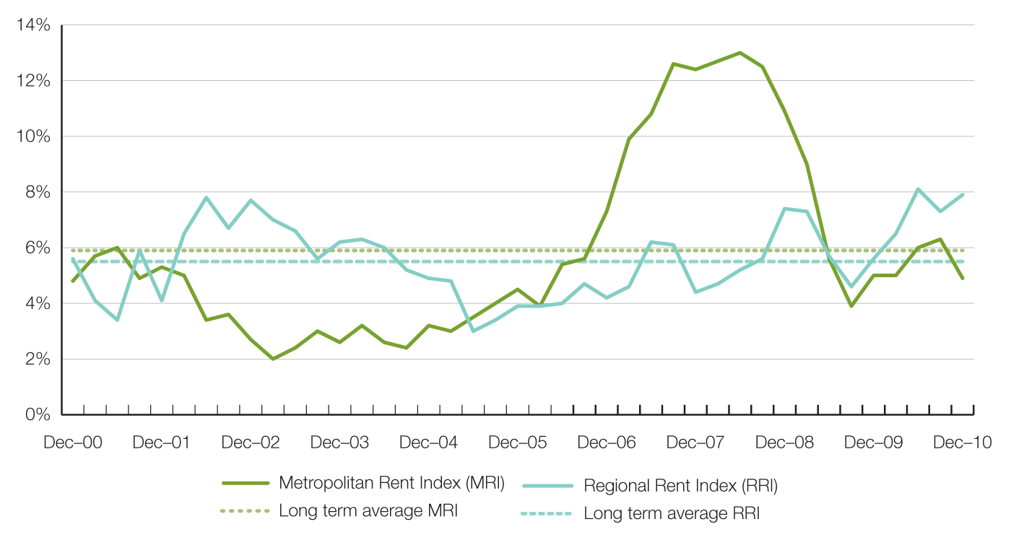
Trends by region
Table 2 shows the median rents for new lettings in the December quarter by the 14 statistical regions used in this report.
Median rents in metropolitan Melbourne range from $300 per week for the Western Melbourne region to $400 for the Inner Melbourne region. In regional Victoria the highest median rent was recorded in the Barwon South West region ($275 per week).
Mornington Peninsula recorded the highest annual percentage increase in metropolitan Melbourne at 7.1 per cent, while Inner Melbourne recorded the lowest annual increase at 2.5 per cent. There has been a gradual compositional change in property sizes in the inner metropolitan regions over the last five years and this should be taken into consideration when interpreting price changes.
For regional Victoria, the highest annual increase recorded was 11.6 per cent in the Loddon-Mallee region.
Table 2: Median rents by statistical region (Dec q 2010)
Region | Median Rent | Quarterly Change | Annual Change
Inner Melbourne | $410 | 2.5% | 2.5%
Inner Eastern Melbourne | $380 | 0.0% | 2.7%
Southern Melbourne | $380 | 0.0% | 5.6%
Western Melbourne | $300 | 0.0% | 3.4%
North Western Melbourne | $330 | 0.0% | 3.1%
North Eastern Melbourne | $330 | 0.0% | 3.1%
Outer Eastern Melbourne | $330 | 3.1% | 6.5%
South Eastern Melbourne | $305 | 1.7% | 5.2%
Mornington Peninsula | $300 | 1.7% | 7.1%
Barwon-South West | $275 | 3.8% | 10.0%
Gippsland | $230 | 0.0% | 9.5%
Goulburn-Ovens-Murray | $220 | 0.0% | 2.3%
Loddon-Mallee | $240 | 4.3% | 11.6%
Central Highlands-Wimmera | $230 | 2.0% | 4.5%

Major property types
Table 3 provides the median rents for the six major property types for metropolitan and regional Victoria.
It should be noted that these metropolitan wide medians will reflect the geographic distribution of different property types. Houses tend to be the dominant rental property form in outer metropolitan areas whereas flats are more prevalent in areas closer to the centre of Melbourne. As a result, the metropolitan median for two bedroom flats ($340 per week) is similar to that for three bedroom houses ($330 per week).
The largest annual increase in metropolitan Melbourne this quarter was 6.2 per cent for two bedroom houses, partially driven by the low levels of supply of that property type. Two bedroom houses constituted only 6 per cent of the total numbers of rental properties in metropolitan Melbourne for the quarter. Three bedroom houses recorded the lowest increase at 4.2 per cent and constituted 29 per cent of the total numbers of rental properties in the quarter.
In regional Victoria, the annual rent increases for new lettings ranged from 5.6 per cent for one bedroom flats to 9.9 per cent for three bedroom flats in the year to December quarter.
Table 3: Median rents by major property types (Dec q 2010)
 | Property Type | Median Rent | Quarterly Change* | Annual Change*
Melbourne
 | 1 Bed Flat | $290 | 1.6% | 5.0%
 | 2 Bed Flat | $340 | 0.7% | 5.2%
 | 3 Bed Flat | $370 | 1.6% | 4.6%
 | 2 Bed House | $360 | 1.4% | 6.2%
 | 3 Bed House | $330 | -0.2% | 4.2%
 | 4 Bed House | $385 | 3.3% | 4.8%
Regional Victoria
 | 1 Bed Flat | $135 | -1.7% | 5.6%
 | 2 Bed Flat | $200 | 3.7% | 8.1%
 | 3 Bed Flat | $273 | 5.8% | 9.9%
 | 2 Bed House | $210 | 2.1% | 7.2%
 | 3 Bed House | $250 | 3.1% | 8.0%
 | 4 Bed House | $330 | 4.2% | 7.5%
* percentage change figures are calculated from relevant Rent Index.
2 bedroom flats
Where are median rents highest? Where are median rents lowest?
Docklands | $560 |  | Moe-Newborough | $130
Port Melbourne | $520 |  | Morwell | $145
Southbank | $520 |  | Seymour | $160
CBD-St Kilda Rd | $500 |  | Mildura | $160
South Melbourne | $488 |  | Portland | $170
Fitzroy | $480 |  | Horsham | $170
East Melbourne | $470 |  | Wangaratta | $170
Richmond-Burnley | $460 |  | Benalla | $180
Collingwood-Abbotsford | $450 |  | Shepparton | $185
Carlton-Parkville | $445 |  | Traralgon | $185
South Yarra | $430 |  | Bairnsdale | $188

3 bedroom houses
Where are median rents highest? Where are median rents lowest?
East Melbourne | $900 |  | Morwell | $180
Toorak | $790 |  | Moe-Newborough | $200
Albert Park, Middle Park,  West St Kilda | $723 |  | Seymour | $205
South Yarra | $700 |  | Horsham | $210
Elwood | $695 |  | Portland | $218
Brighton | $695 |  | Benalla | $220
Port Melbourne | $680 |  | Corio | $230
South Melbourne | $665 |  | Hamilton | $230
Fitzroy | $650 |  | Mildura | $230
Hawthorn | $638 |  | Swan Hill | $230
Armadale | $635 |  | Wangaratta | $230
Prahran-Windsor | $600 |  | Sebastopol-Delacombe | $235
Carlton-Parkville | $600 |  | Sale-Maffra | $240
East Melbourne | $900 |  | Morwell | $180

An expanded version of Table 9 containing extra property types as well as lower and upper quartile information can be found in the Rental Report December quarter 2010 data tables available for download from the Office of Housing website www.housing.vic.gov.au.
Trends by suburb or town
Figures 2 and 3 show the pattern of concentration of higher costs for private rental accommodation in Inner Melbourne, inner parts of the North Western and North Eastern Melbourne regions, Inner Eastern and Southern Melbourne regions.
Table 9 shows the pattern of rental costs at a suburb and town level across Victoria. Note that the medians in Table 9 are moving annual medians, not quarterly medians, and that the annual percentage change figures are calculated from these moving annual medians.
For two bedroom flats in the metropolitan area the suburbs with the highest annual increases in moving annual median rents to December quarter were Melton (12.8 per cent), Sydenham (12.5 per cent), Dromana-Portsea (12.2 per cent), Mt Eliza-Mornington-Mt Martha (12.0 per cent), East Brunswick (11.8 per cent), St Albans-Deer Park (11.4 per cent), Vermont-Forest Hill-Burwood East (10.7 per cent), Bulleen-Templestowe-Doncaster (10.0 per cent) and Bayswater (10.0 per cent).
For regional Victoria the towns with the highest annual increases in moving median rents for two bedroom flats to December quarter were Lara (14.3 per cent), Bendigo (14.3 per cent), Warragul (14.3 per cent), North Geelong (13.6 per cent), Flora Hill-Bendigo East (13.5 per cent), Portland (13.3 per cent), Geelong-Newcombe (13.0 per cent), Sebastopol-Delacombe (11.1 per cent), Corio (10.5 per cent), Golden Square-Kangaroo Flat (10.5 per cent) and Warrnambool (10.0 per cent).
Figure 2: Moving annual median rents for 2 bedroom flats in metropolitan Melbourne
(Dec q 2010) 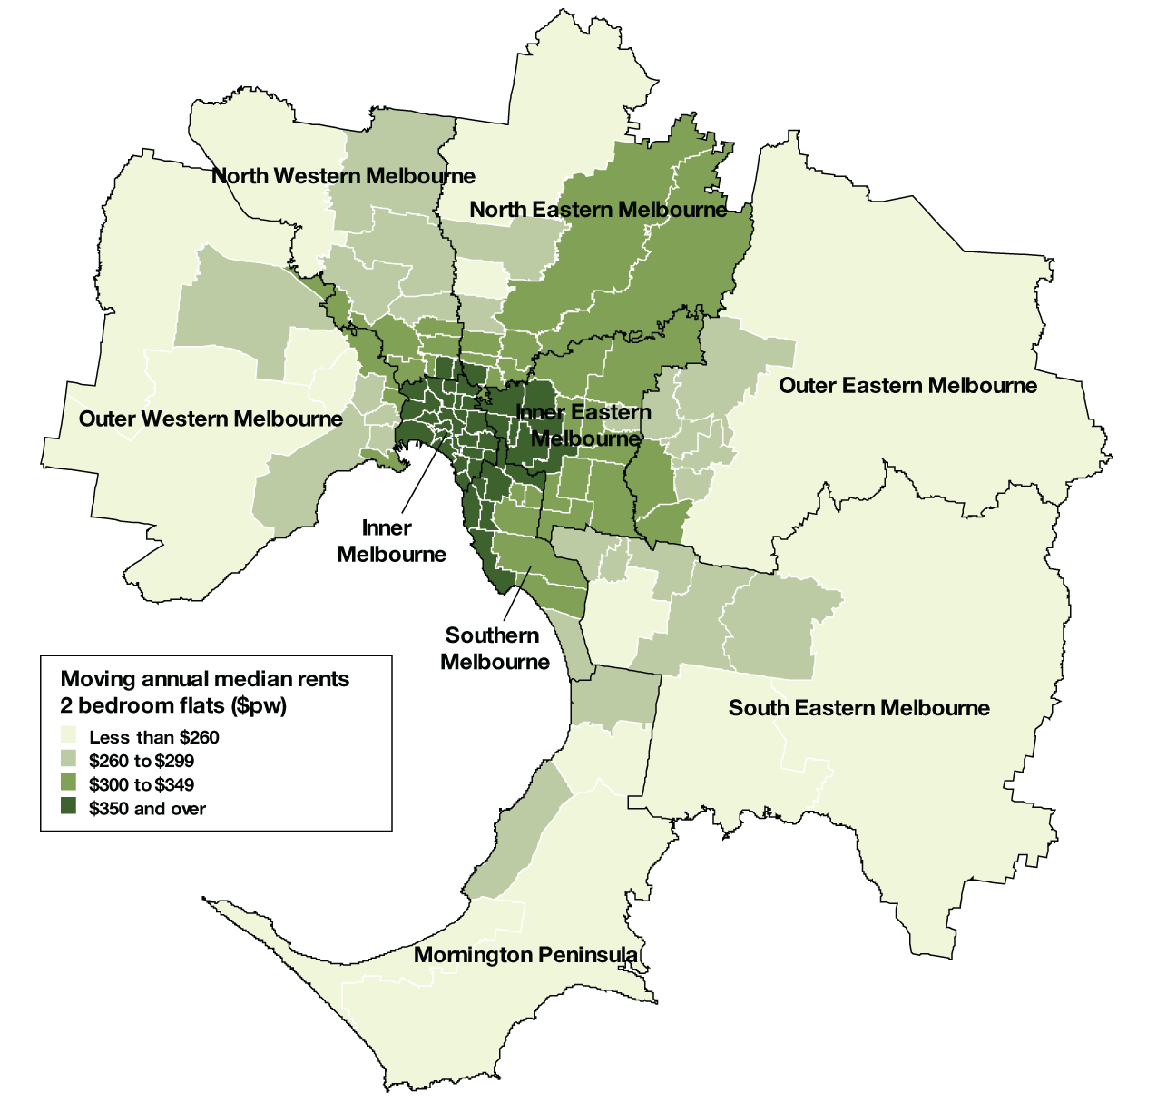

The highest annual increases in moving median rents for three bedroom houses in metropolitan Melbourne were Mentone-Parkdale-Mordialloc (15.4 per cent), West Brunswick (12.5 per cent), Fitzroy North-Clifton Hill (11.9 per cent), Albert Park-Middle Park-West St Kilda (11.2 per cent), Caulfield (11.1 per cent), Yarra Ranges (10.3 per cent), Williamstown (10.0 per cent), Bayswater (10.0 per cent), Boronia (10.0 per cent) and Berwick (10.0 per cent).
For regional Victoria, the towns with the highest annual increases in moving median rents for three bedroom houses to December quarter were Corio (15.0 per cent), Castlemaine (13.0 per cent), Herne Hill-Geelong West (12.4 per cent), Belmont-Grovedale (12.3 per cent), Warrnambool (11.1 per cent), Golden Square-Kangaroo Flat (9.6 per cent), Newtown (9.1 per cent), Ballarat, North Bendigo and Bairnsdale (all at 8.7 per cent).
Figure 3: Moving annual median rents for 3 bedroom houses in metropolitan Melbourne
(Dec q 2010) 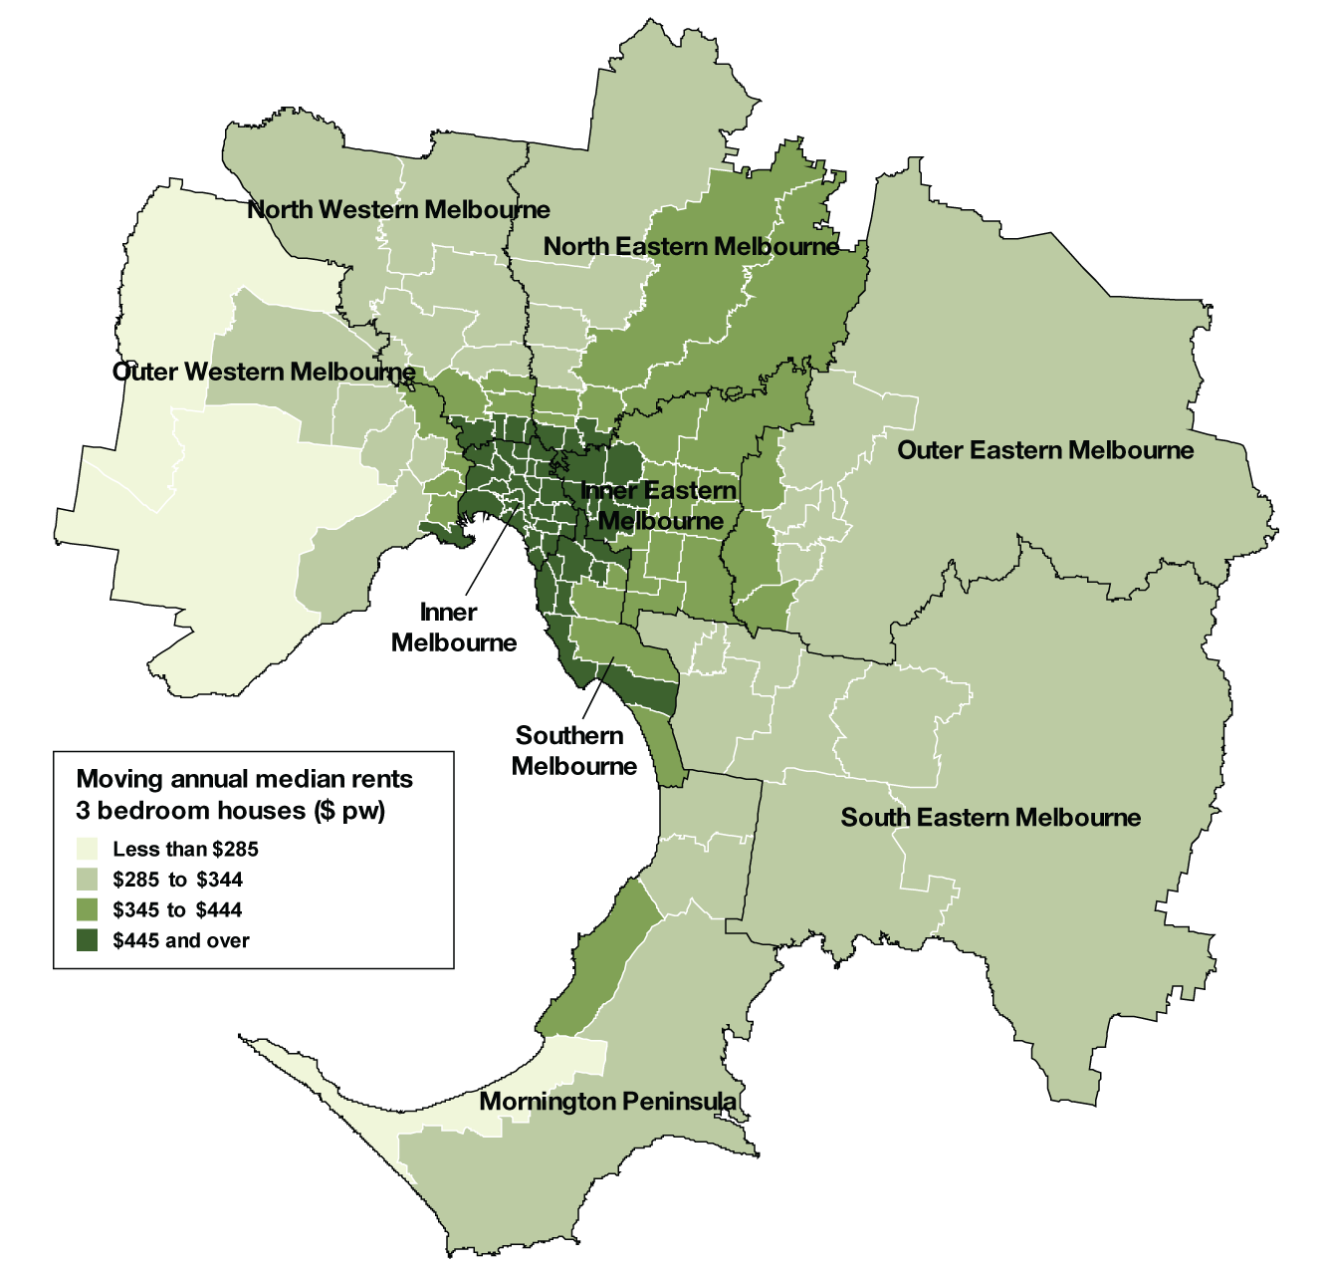

Rental availability
New lettings
The number of new lettings provides an indicator of the overall availability of rental accommodation for a specific period. A new letting can result from two main sources: turnover in existing rental accommodation or new additions to the stock of rental accommodation.
Over the last twelve months, the availability of rental dwellings across the state has improved due mainly to an increase in the numbers of new lettings in the metropolitan area. The number of new lettings in metropolitan Melbourne grew from 123,222 in 2009 to 133,339 in 2010, a total growth of seven per cent.
In contrast, the supply of rental accommodation in regional Victoria is tightening with a decline of one per cent in the number of new lettings from 2009 to 2010. This reduced number of new lettings reflects a combination of lower turnover in existing rentals as well as fewer new rental properties coming into the market.
Table 4 shows the total number of new rental lettings for the December quarter 2010. Metropolitan Melbourne accounted for 77 per cent of all new lettings in Victoria. Across the state the total number of new lettings was 40,123, which represents an increase of 1.6 per cent compared to the same quarter of 2009. Metropolitan Melbourne recorded an overall increase of 3.3 per cent in new lettings on the same quarter of last year, whereas the number of new lettings in regional Victoria declined by 3.9 per cent on the same quarter of last year.
Table 4: Overall new lettings for Melbourne, non-metropolitan Victoria, and Victoria
(Dec q 2010)
 | Dec–10 | Dec–09 | Change
Melbourne | 31,076 | 30,083 | 3.3%
Regional Victoria | 9,047 | 9,411 | -3.9%
Victoria | 40,123 | 39,494 | 1.6%

Table 5 lists the total number of new lettings across each of the 14 statistical regions. Eight of the nine metropolitan regions recorded increases in the number of new lettings compared to the same quarter of 2009. Mornington Peninsula was the only metropolitan region to register a decline in the number of new lettings in the December quarter 2010 (-5.7 per cent). North Eastern Melbourne experienced the most significant increase (8.7 per cent) followed by South Eastern Melbourne (7.0 per cent).
Table 5: New lettings for statistical regions Victoria (Dec q 2010)
 | Dec-10 | Dec-09 | Change
Inner Melbourne | 7,257 | 7,109 | 2.1%
Inner Eastern Melbourne | 4,070 | 3,943 | 3.2%
Southern Melbourne | 2,935 | 2,927 | 0.3%
Western Melbourne | 4,635 | 4,440 | 4.4%
North Western Melbourne | 2,834 | 2,713 | 4.5%
North Eastern Melbourne | 3,133 | 2,882 | 8.7%
Outer Eastern Melbourne | 1,643 | 1,574 | 4.4%
South Eastern Melbourne | 2,768 | 2,586 | 7.0%
Mornington Peninsula | 1,801 | 1,909 | -5.7%
Barwon-South West | 2,454 | 2,460 | -0.2%
Gippsland | 1,700 | 1,868 | -9.0%
Goulbourn-Ovens-Murray | 1,850 | 1,900 | -2.6%
Loddon-Mallee | 1,690 | 1,743 | -3.0%
Central Highlands-Wimmera | 1,353 | 1,440 | -6.0%
Active bonds
The number of active bonds provides an indicator of the total stock of rental accommodation, based on the total number of bonds held by the RTBA at a given point
in time.
At December quarter 2010, the total number of active bonds held in Victoria was 393,818, which represents a growth of 5.0 per cent on the size of the rental market over the same quarter of 2009. The average annual growth in the rental market over the last ten years is 4.2 per cent. The number of active bonds continued to increase at a faster rate in the metropolitan areas than in the regional areas, confirming a trend started in September quarter 2009.
Figure 4 shows trends in active bonds over the past five years. Over the past year the rate of increase in active bond numbers has climbed and remains above the average for the past ten years.
Figure 4: Total Active Residential Rental Bonds, Victoria — annual percent change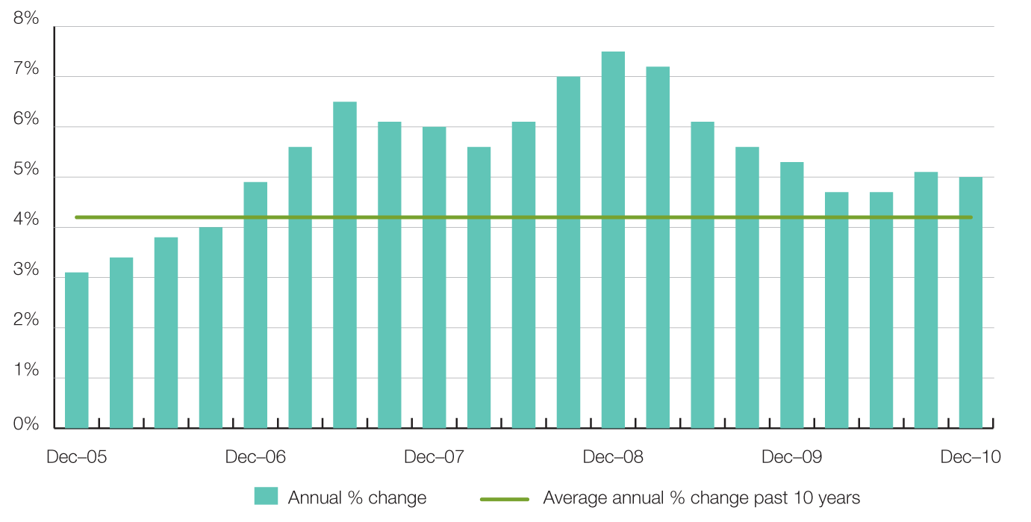

Figure 5 illustrates the distribution of active bonds by suburb for metropolitan Melbourne. Suburbs with the highest supply of rental accommodation as indicated by active tenancies are the CBD-St Kilda Road precinct, Werribee-Hoppers Crossing, Frankston, Altona, St Kilda, South Yarra, Carlton-Parkville and Croydon-Lilydale. This map highlights the availability of rental accommodation in some outer/fringe metropolitan suburbs as well as the more traditional inner urban areas.
Figure 5: Number of active bonds by suburb for metropolitan Melbourne (Dec q 2010)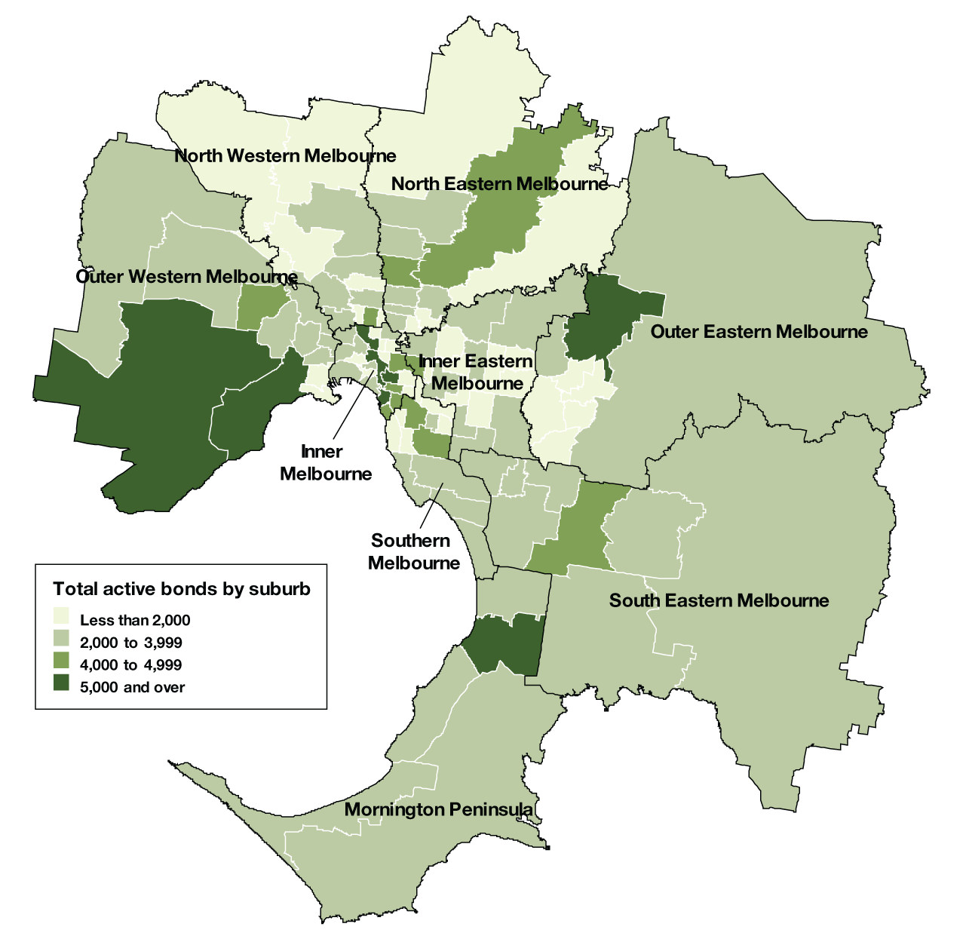
Turnover and length of tenancy
The number of bond refunds in a quarter, if expressed as a percentage of all bonds held, can be used to provide an estimate of the ‘turnover rate’ in the rental market. The ‘turnover rate’ is an important indicator of the level of natural vacancies which are occurring in the market due to tenancies ending.
Table 6 shows the turnover rate and length of tenancies (based on bond refunds during the quarter) for both metropolitan Melbourne and regional Victoria. For the December quarter 2010 the quarterly turnover rate for metropolitan Melbourne was 9.3 per cent (that is, 9.3 per cent of all bonds were refunded in the quarter), which was higher than the rate of a year earlier (9.0 per cent).
The turnover rate in regional Victoria has been consistently higher than the Metropolitan area but the gap is closing. The December quarter 2010, regional turnover rate was 10.3 per cent, which is lower than the rate of a year earlier (10.9 per cent).
The turnover rate has been quite stable throughout 2010 for both metropolitan and regional rental markets.
The average length of tenancy for bonds refunded in the December quarter 2010 was 25.5 months for metropolitan Melbourne and 21.6 months for regional Victoria, both up from respective figures in December 2009.
Table 6: Tenancy duration and turnover (Dec q 2010)
Melbourne | Dec–10 | Dec–09
Ave tenancy duration | 25.9 | 25.5
Turnover rate | 9.3% | 9.0%
Regional Victoria
Ave tenancy duration | 21.6 | 21.1
Turnover rate | 10.3% | 10.9%
Notes:
1. Ave duration (months) from bond lodgement date to bond claim date for refunds in that quarter
2. Bond refunds (moving annual total) as % of total active bonds
Investor finance
Loan approvals for the purchase or construction of dwellings for purposes of investment (not owner-occupation) provide a measure of investor activity levels in the Victorian housing market. Figure 6 presents a summary of loan approvals for housing investment in Victoria over the past five years.
In the December quarter 2010, lending to investors in Victoria was $5.98 billion which equates to 28.3 per cent of the total lending for the purchase or construction of dwellings. This was 12.7 per cent higher than the levels of lending to investors in the same quarter of 2009 but 5.9 per cent lower than last quarter.
Figure 6: Lending to investors in residential housing, Victoria
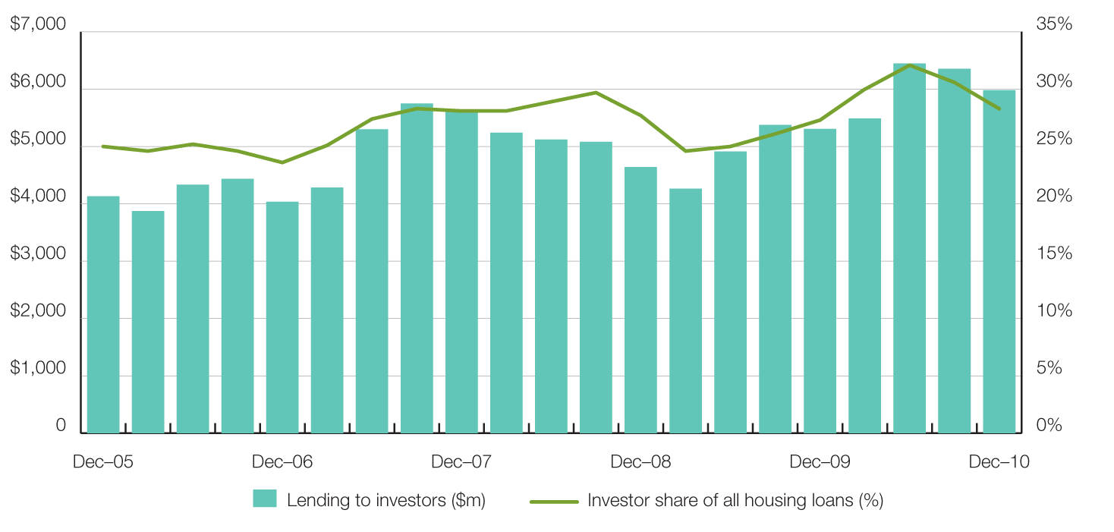
Vacancy rate
The rental vacancy rate is calculated by the Real Estate Institute of Australia based on a survey of Real Estate Agents and measures the proportion of all rental properties managed by agents which are unlet at a given point in time.
The trend metropolitan vacancy rate has shown further signs of recovery, moving away from 1.6 per cent, where it had been stationed since February 2010, to 1.9 per cent in December 2010.
Figure 7 shows the trend metropolitan vacancy rate over the past five years. The vacancy rate reached its lowest point in early 2008. The current vacancy rate remains very low in historical terms and is indicative of an ongoing tight supply situation. The average vacancy rate for the period from 2000 to 2005 was 3.6 per cent.
Regional Victoria’s vacancy rate (trend) remains at 1.0 per cent for the December quarter 2010. It has been hovering around the 1.0 per cent mark since September 2009. That was when the regional vacancy rates became tighter than in metropolitan Melbourne for the first time since May 2005.
Figure 7: Rental vacancy rate – trend
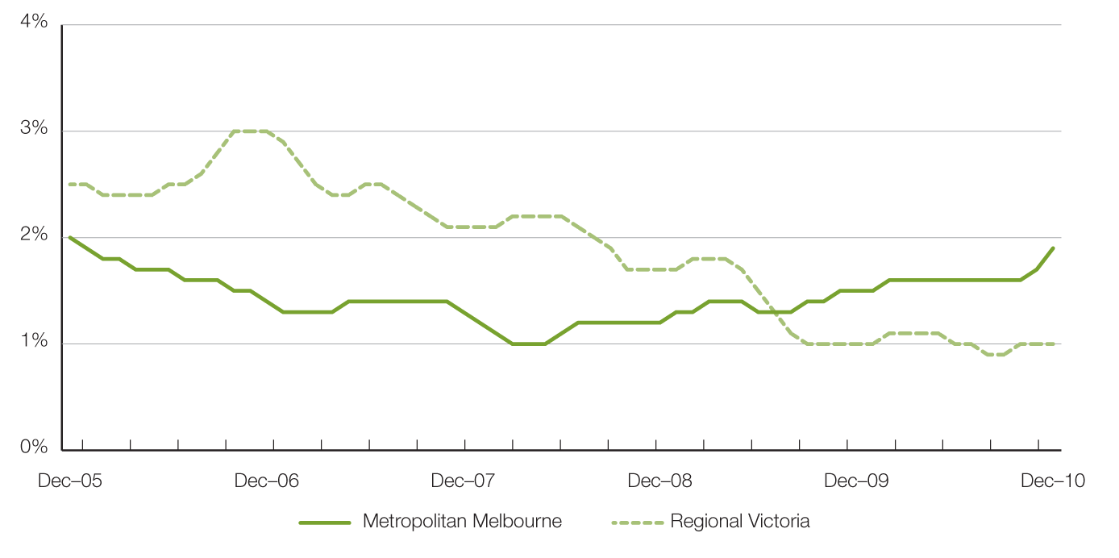
Rental market affordability
This section of the Rental Report provides a summary of the affordability of rental accommodation for lower income households in Victoria. The method used in this section measures the supply of affordable new lettings based on the RTBA data used in this Report. The affordability benchmark used is that no more than 30 per cent of gross income is spent on rent. Lower income households are defined as those receiving Centrelink incomes.
Overall trends
At December quarter 2010, 20.4 per cent of all new lettings across the state were affordable to lower income households.
The last two years has seen a decline in the availability of affordable private rental accommodation in both metropolitan Melbourne and regional areas. This reflects the increases in the cost of renting which occurred over this period.
Figure 8 shows the trend in these figures over the past five years. Across Melbourne 8.7 per cent of dwellings let in the December quarter were affordable. This figure is well below the 20.0 per cent plus figures experienced in the first half of this decade.
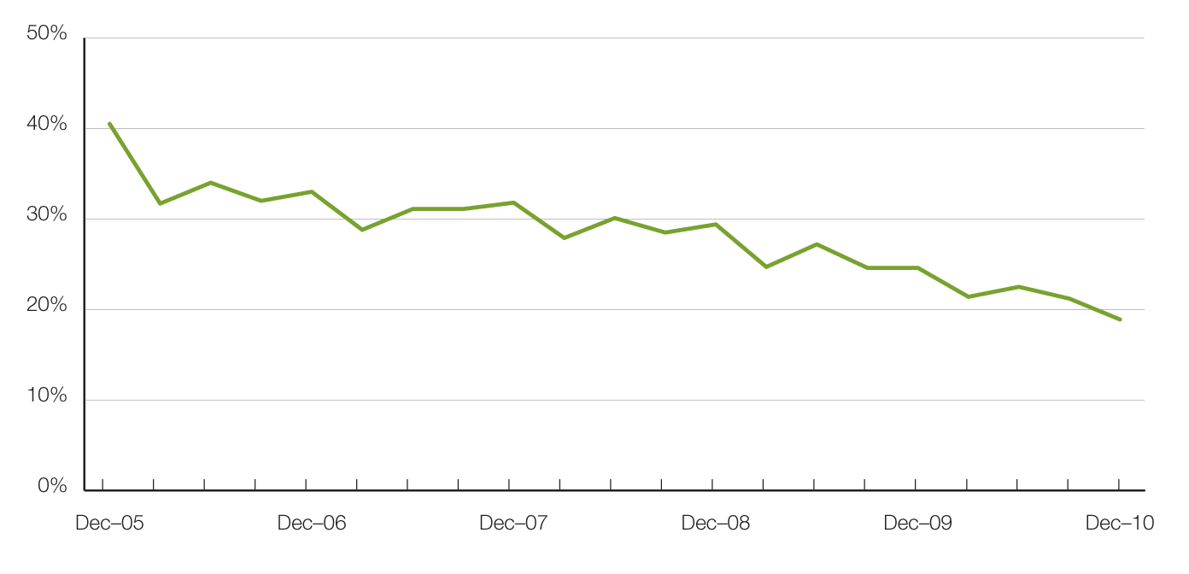
Figure 8: Affordable rentals as percent of all rentals, Victoria

In metropolitan Melbourne, the availability of affordable rental lettings varies between different types of households. The rental affordability situation for different low income households is summarised in Table 7.
Due to a limited supply of affordable one bedroom dwellings, low income single person households face the most difficulties in accessing affordable rental accommodation. Across Melbourne, just 0.5 per cent of one bedroom dwellings let in the December quarter were affordable to low income singles.
For a single parent with one child on Centrelink income, the proportion of two bedroom dwellings across Melbourne which were affordable was 2.6 per cent. For larger families, the supply of affordable three and four bedroom dwellings is better and reflects the predominantly outer suburban location of this size of dwelling. A couple on Newstart with four dependent children would be able to afford 27.3 per cent of four bedroom new lettings in Melbourne in the December quarter.

Table 7: Rental affordability by indicative households on Centrelink incomes (Dec q 2010)
Household type | Singles on Newstart | Single Parent with 1 child | Couple on Newstart with 2 children | Couple on Newstart with 4 children | Total
Assumed property size | 1 bedroom | 2 bedroom | 3 bedroom | 4+ bedroom | -
Weekly income (net of RA) | $235 | $475 | $686 | $885 | –
Affordable weekly rent | $130 | $210 | $275 | $345 | –
Affordable rentals (number)
Metropolitan | 19 | 245 | 1,163 | 848 | 2,275
Regional | 239 | 1,372 | 2,460 | 595 | 4,666
State total | 258 | 1,617 | 3,623 | 1,443 | 6,941
Affordable rentals (% of total)
Metropolitan | 0.5% | 2.7% | 11.8% | 27.3% | 8.7%
Regional | 45.2% | 55.5% | 63.5% | 59.5% | 59.2%
State total | 5.6% | 13.9% | 26.4% | 35.1% | 20.4%

Trends by region
Table 8 shows the availability of affordable lettings for each of the statistical regions of Victoria. These affordability figures show the higher cost of housing in Melbourne.
In regional terms, the Western, South Eastern and Mornington Peninsula regions
of metropolitan Melbourne consistently have the highest proportion of new lettings which are affordable to lower income households. In regional Victoria, the Barwon-South West region has the lowest availability of affordable rentals.
Table 8: Affordable lettings for indicative households (see table 7) on Centrelink incomes
(Dec q 2010)
Region | 1 Bedroom |  | 2 Bedroom |  | 3 Bedroom |  | 4+ Bedroom |  | Total
Region | Number | Percent | Number | Percent | Number | Percent | Number | Percent | Number | Percent
Inner Melbourne | 3 | 0.1% | 11 | 0.4% | 8 | 1.1% | 11 | 9.6% | 33 | 0.6%
Inner Eastern Melbourne | 5 | 1.3% | 10 | 0.8% | 23 | 1.7% | 29 | 5.9% | 67 | 1.9%
Southern Melbourne | 1 | 0.3% | 8 | 0.8% | 13 | 1.7% | 12 | 4.9% | 34 | 1.4%
Western Melbourne | 1 | 0.5% | 79 | 9.5% | 607 | 29.2% | 488 | 58.8% | 1,175 | 29.7%
North Western Melbourne | – | 0.0% | 21 | 2.4% | 70 | 7.2% | 45 | 20.8% | 136 | 5.6%
North Eastern Melbourne | 2 | 0.5% | 15 | 1.6% | 72 | 6.5% | 36 | 12.0% | 125 | 4.6%
Outer Eastern Melbourne | 3 | 4.3% | 19 | 4.7% | 31 | 4.3% | 25 | 12.3% | 78 | 5.6%
South Eastern Melbourne | 3 | 3.6% | 31 | 5.8% | 179 | 14.2% | 158 | 33.5% | 371 | 15.7%
Mornington Peninsula | 1 | 1.8% | 51 | 12.3% | 160 | 19.4% | 44 | 18.5% | 256 | 16.7%
Metropolitan Melbourne | 19 | 0.5% | 245 | 2.7% | 1,163 | 11.8% | 848 | 27.3% | 2,275 | 8.7%
Barwon-South West | 32 | 19.9% | 162 | 25.1% | 418 | 39.8% | 101 | 37.7% | 713 | 33.5%
Gippsland | 54 | 52.4% | 300 | 63.4% | 519 | 71.3% | 139 | 75.1% | 1,012 | 68.0%
Goulbourn-Ovens-Murray | 50 | 55.6% | 420 | 74.2% | 589 | 76.4% | 146 | 67.6% | 1,205 | 73.3%
Loddon-Mallee | 53 | 60.2% | 282 | 64.1% | 491 | 66.2% | 114 | 64.4% | 940 | 65.0%
Central Highlands-Wimmera | 50 | 57.5% | 208 | 59.8% | 443 | 76.1% | 95 | 61.7% | 796 | 68.0%
Regional Victoria | 239 | 45.2% | 1,372 | 55.5% | 2,460 | 63.5% | 595 | 59.5% | 4,666 | 59.2%
Victoria | 258 | 5.6% | 1,617 | 13.9% | 3,623 | 26.4% | 1,443 | 35.1% | 6,941 | 20.4%

Local Government area trends
Table 11 provides data on the number of new lettings affordable to households on Centrelink incomes for all Victorian Local Government Areas (LGA).
Methods used
Fitting statutory income households to dwellings by bedroom number
These calculations show the distribution of private rental properties in Victoria affordable to households on statutory incomes by bedroom number for newly leased properties during the current quarter. It shows the number of properties by region that were affordable for different bedroom numbers, and the proportion of that municipality’s stock of those properties.
For example, if there are 100 one bedroom properties deemed to be affordable in Port Phillip, and there are 1000 one bedroom properties leased during that quarter, then the percentage of affordable one bedroom properties in Port Phillip during the quarter will be 10.0 per cent.
Calculating affordability – net rent method
The assessment of affordable supply is based on the number of suitably-sized properties that are within 30 per cent of gross income for low income households. The rental thresholds are taken from the household incomes for whom that number of bedrooms is a minimum and may have been rounded up to the nearest $5 increment. For one bedroom properties, we have taken the income of singles on Newstart allowance; for two bedroom properties, we have taken a single parent pensioner with one child aged under 5; for three bedroom properties we have taken a couple on Newstart with two children; and for four bedroom properties, we have taken a couple on Newstart with four children.
The method used in these calculations assumes rent assistance is fully offset against the weekly rent by subtracting rent assistance from the rent and then calculating the resulting rent as a proportion of the Centrelink income.
This is the net-rent method which treats rent assistance as a housing payment, not an income supplement. Other methods are available, such as used by the Australian Institute of Health and Welfare.

Table 9: Moving annual median rents for suburbs/towns by major property type
 | 1 Bed Flat |  |  | 2 Bed Flat |  |  | 2 Bed House |  |  | 3 Bed House
 | Count | Median | Ann % Ch | Count | Median | Ann % Ch | Count | Median | Ann % Ch | Count | Median | Ann % Ch
Inner Melbourne
Albert Park-Middle Park-West St Kilda | 274 | $300 | 1.7% | 204 | $420 | 5.0% | 88 | $525 | 5.0% | 72 | $723 | 11.2%
Armadale | 154 | $290 | 7.4% | 270 | $375 | 7.1% | 33 | $496 | 7.8% | 36 | $635 | -2.3%
Carlton North | 61 | $295 | 11.3% | 90 | $390 | 5.4% | 77 | $470 | 9.3% | 54 | $598 | 5.3%
Carlton-Parkville | 1,666 | $305 | 1.7% | 636 | $445 | 4.7% | 43 | $450 | 12.5% | 46 | $600 | -7.7%
CBD-St Kilda Rd | 2,521 | $370 | 2.8% | 2,076 | $500 | 0.0% | - | - | - | - | - | -
Collingwood-Abbotsford | 198 | $280 | 0.0% | 152 | $450 | 2.3% | 100 | $450 | 7.1% | 59 | $550 | 8.9%
Docklands | 356 | $418 | -0.6% | 504 | $560 | 1.8% | - | - | - | - | - | -
East Melbourne | 251 | $350 | 6.1% | 215 | $470 | 4.4% | - | - | - | 17 | $900 | nd
East St Kilda | 434 | $270 | 8.0% | 717 | $360 | 5.9% | 54 | $486 | 4.6% | 57 | $590 | 2.6%
Elwood | 517 | $290 | 3.6% | 891 | $385 | 4.1% | 24 | $530 | 6.5% | 65 | $695 | 6.9%
Fitzroy | 155 | $300 | 7.1% | 131 | $480 | 6.7% | 67 | $475 | -2.6% | 25 | $650 | 8.3%
Fitzroy North-Clifton Hill | 144 | $270 | 3.8% | 181 | $390 | 8.3% | 132 | $460 | 5.7% | 84 | $588 | 11.9%
Flemington-Kensington | 240 | $290 | 7.4% | 469 | $360 | 0.0% | 153 | $400 | 5.3% | 101 | $480 | 6.7%
North Melbourne-West Melbourne | 384 | $280 | 5.7% | 575 | $375 | -8.5% | 42 | $438 | 4.2% | 49 | $550 | 7.8%
Port Melbourne | 325 | $400 | 2.6% | 465 | $520 | 4.0% | 81 | $490 | 8.9% | 97 | $680 | 6.3%
Prahran-Windsor | 693 | $286 | 5.9% | 514 | $395 | 3.9% | 138 | $483 | 7.2% | 89 | $600 | 0.0%
Richmond-Burnley | 578 | $300 | 1.7% | 510 | $460 | 4.5% | 322 | $470 | 4.4% | 186 | $590 | 7.3%
South Melbourne | 191 | $390 | 3.3% | 190 | $488 | 3.7% | 65 | $491 | 9.1% | 30 | $665 | 9.9%
South Yarra | 1,053 | $320 | 6.7% | 950 | $430 | 2.4% | 99 | $500 | 4.2% | 59 | $700 | 3.7%
Southbank | 404 | $410 | -2.4% | 659 | $520 | 4.0% | - | - | - | - | - | -
St Kilda | 1,234 | $308 | 4.2% | 949 | $395 | 1.3% | 41 | $495 | 7.6% | 38 | $580 | -2.9%
Toorak | 225 | $290 | 1.8% | 241 | $400 | 2.6% | 12 | $488 | -11.4% | 31 | $790 | -8.7%
Inner Melbourne — Total | 12,058 | $322 | 2.2% | 11,589 | $445 | 3.5% | 1,582 | $470 | 6.8% | 1,197 | $600 | 3.4%
Inner Eastern Melbourne
Balwyn | 12 | $263 | nd | 186 | $350 | 5.7% | 60 | $373 | 5.7% | 210 | $470 | 9.3%
Blackburn | 32 | $220 | -2.2% | 128 | $310 | 3.3% | 31 | $340 | 9.7% | 233 | $370 | 5.7%
Box Hill | 245 | $235 | 4.4% | 450 | $320 | 6.7% | 74 | $360 | 13.4% | 256 | $385 | 2.7%
Bulleen-Templestowe-Doncaster | 40 | $253 | 8.6% | 162 | $330 | 10.0% | 24 | $325 | 1.6% | 364 | $380 | 5.6%
Burwood-Ashburton | 137 | $225 | 2.3% | 122 | $350 | 0.0% | 63 | $350 | 6.1% | 253 | $400 | 3.2%
Camberwell-Glen Iris | 173 | $250 | 0.0% | 502 | $355 | 4.4% | 56 | $410 | 7.0% | 233 | $530 | 6.0%
Canterbury-Surrey Hills-Mont Albert | 12 | $243 | -12.5% | 275 | $350 | 2.2% | 27 | $380 | 8.6% | 108 | $500 | 7.5%
Chadstone-Oakleigh | 57 | $290 | -3.3% | 238 | $330 | 6.5% | 62 | $340 | 3.0% | 222 | $380 | 5.6%
Clayton | 260 | $260 | 0.0% | 553 | $300 | 0.0% | 49 | $340 | 13.3% | 201 | $350 | 0.0%
Doncaster East-Donvale | 19 | $250 | -7.4% | 125 | $340 | 6.3% | 25 | $330 | 5.6% | 244 | $370 | 5.7%
East Hawthorn | 119 | $290 | 7.4% | 211 | $370 | 5.7% | 41 | $430 | -1.1% | 59 | $540 | -1.8%
Glen Waverley-Mulgrave | 12 | $243 | -3.0% | 129 | $325 | 1.6% | 17 | $350 | 9.4% | 591 | $368 | 5.1%
Hawthorn | 779 | $260 | 4.0% | 759 | $370 | 2.8% | 58 | $480 | 10.3% | 88 | $638 | 9.9%
Kew | 55 | $300 | -9.1% | 418 | $360 | 2.9% | 52 | $420 | 5.0% | 144 | $525 | 7.1%
Mount Waverley | - | - | - | 113 | $320 | 5.6% | 19 | $330 | 3.1% | 244 | $380 | 4.1%
Nunawading-Mitcham | 24 | $233 | 16.3% | 224 | $295 | 5.4% | 48 | $320 | 6.7% | 232 | $360 | 2.9%
Vermont-Forest Hill-Burwood East | - | - | - | 84 | $310 | 10.7% | 31 | $330 | 10.0% | 300 | $370 | 5.7%
Inner Eastern Melbourne — Total | 1,991 | $250 | 4.2% | 4,679 | $340 | 3.0% | 737 | $360 | 5.9% | 3,982 | $390 | 4.0%
Southern Melbourne
Aspendale-Chelsea-Carrum | 43 | $220 | 2.3% | 460 | $295 | 9.3% | 62 | $300 | 5.3% | 290 | $360 | 5.9%
Bentleigh | 150 | $240 | 4.3% | 425 | $340 | 3.0% | 135 | $365 | 4.3% | 396 | $430 | 3.6%
Brighton | 35 | $320 | 1.6% | 191 | $420 | 5.3% | 29 | $480 | 3.8% | 108 | $695 | 3.0%
Brighton East | - | - | - | 49 | $390 | 5.4% | 29 | $425 | 7.6% | 90 | $578 | 9.0%
Carnegie | 291 | $245 | 6.5% | 334 | $340 | 3.0% | 21 | $360 | 2.9% | 70 | $460 | 2.2%
Caulfield | 304 | $250 | 8.7% | 558 | $360 | 4.3% | 71 | $410 | 2.5% | 151 | $550 | 11.1%
Cheltenham | 65 | $225 | -13.5% | 368 | $310 | 6.9% | 85 | $370 | 5.7% | 338 | $415 | 7.8%
Elsternwick | 154 | $250 | 8.7% | 214 | $355 | 4.4% | 16 | $430 | nd | 51 | $560 | 1.8%
Hampton-Beaumaris | 35 | $320 | 9.4% | 295 | $380 | 7.8% | 52 | $423 | -0.6% | 198 | $565 | 6.6%
Malvern | 77 | $285 | 3.6% | 147 | $380 | 4.1% | 22 | $500 | 18.3% | 34 | $598 | -3.2%
Malvern East | 237 | $240 | 2.1% | 243 | $350 | 4.5% | 36 | $400 | 1.3% | 117 | $480 | 6.7%
Mentone-Parkdale-Mordialloc | 203 | $235 | 6.8% | 396 | $310 | 6.9% | 42 | $360 | 3.6% | 153 | $450 | 15.4%
Murrumbeena-Hughesdale | 211 | $250 | 6.4% | 226 | $343 | 8.7% | 21 | $375 | 0.7% | 85 | $400 | 1.3%
Southern Melbourne — Total | 1,809 | $245 | 6.5% | 3,906 | $340 | 6.3% | 621 | $380 | 5.6% | 2,081 | $450 | 4.9%
Outer Western Melbourne
Altona | 72 | $210 | 5.0% | 444 | $270 | 8.0% | 85 | $280 | 0.0% | 1,111 | $320 | 4.9%
Footscray | 277 | $200 | 2.6% | 354 | $300 | 6.2% | 102 | $330 | 3.1% | 142 | $350 | -2.8%
Keilor East-Avondale Heights | 42 | $220 | 10.0% | 199 | $300 | 1.7% | 38 | $315 | 3.3% | 281 | $350 | 6.1%
Melton | 24 | $284 | -3.6% | 115 | $220 | 12.8% | 34 | $228 | 8.3% | 796 | $250 | 4.2%
Newport-Spotswood | 64 | $230 | 17.9% | 134 | $280 | 7.7% | 71 | $350 | 9.4% | 177 | $380 | 2.7%
St Albans-Deer Park | 43 | $200 | 11.1% | 225 | $245 | 11.4% | 71 | $250 | 8.7% | 865 | $285 | 5.6%
Sunshine | 135 | $190 | 8.6% | 203 | $230 | 4.5% | 74 | $260 | 4.0% | 529 | $290 | 3.6%
Sydenham | - | - | - | 52 | $270 | 12.5% | 38 | $280 | 3.7% | 904 | $320 | 6.7%
Werribee-Hoppers Crossing | 33 | $195 | -7.1% | 332 | $230 | 4.5% | 87 | $240 | 9.1% | 1,741 | $275 | 5.6%
West Footscray | 137 | $195 | 5.4% | 204 | $290 | 0.0% | 112 | $293 | 4.5% | 272 | $320 | 3.2%
Williamstown | 41 | $250 | 4.2% | 124 | $300 | 0.0% | 51 | $390 | 11.4% | 126 | $495 | 10.0%
Yarraville-Seddon | 113 | $220 | 12.8% | 234 | $285 | 1.8% | 195 | $360 | 2.9% | 285 | $395 | 3.9%
Outer Western Melbourne — Total | 984 | $200 | 2.6% | 2,620 | $265 | 6.0% | 958 | $300 | 3.4% | 7,229 | $295 | 5.4%
North Western Melbourne
Broadmeadows-Roxburgh Park | 25 | $200 | 11.1% | 96 | $280 | 7.7% | 27 | $280 | 3.7% | 559 | $310 | 3.3%
Brunswick | 389 | $254 | 5.8% | 520 | $350 | 9.4% | 178 | $400 | 5.3% | 142 | $480 | 6.7%
Coburg-Pascoe Vale South | 114 | $270 | 8.0% | 262 | $320 | -3.0% | 133 | $350 | 6.1% | 268 | $398 | 4.6%
Craigieburn | - | - | - | 27 | $270 | nd | 23 | $295 | 5.4% | 414 | $320 | 6.7%
East Brunswick | 88 | $250 | 0.0% | 132 | $380 | 11.8% | 46 | $400 | 1.9% | 51 | $495 | 4.8%
Essendon | 229 | $240 | 4.3% | 479 | $300 | 1.7% | 87 | $340 | 6.3% | 274 | $350 | 6.1%
Gladstone Park-Tullamarine | 18 | $230 | 7.0% | 97 | $270 | 3.8% | - | - | - | 199 | $320 | 6.7%
Keilor | - | - | - | - | - | - | - | - | - | 33 | $330 | 3.1%
Moonee Ponds-Ascot Vale | 166 | $243 | 3.2% | 355 | $330 | 4.8% | 135 | $381 | 5.8% | 189 | $445 | 6.0%
Oak Park-Glenroy-Fawkner | 38 | $210 | 5.0% | 353 | $290 | 7.4% | 80 | $298 | 6.3% | 412 | $330 | 4.8%
Pascoe Vale-Coburg North | 46 | $198 | 10.0% | 250 | $305 | 5.2% | 88 | $320 | 6.7% | 155 | $350 | 6.1%
Sunbury | - | - | - | 79 | $250 | 8.7% | 20 | $255 | 6.3% | 326 | $290 | 9.4%
West Brunswick | 240 | $240 | 4.3% | 268 | $300 | 3.4% | 34 | $388 | 13.6% | 50 | $450 | 12.5%
North Western Melbourne — Total | 1,362 | $240 | 4.3% | 2,922 | $310 | 3.3% | 859 | $350 | 6.1% | 3,072 | $330 | 3.1%
North Eastern Melbourne
Bundoora-Greensborough-Hurstbridge | 292 | $230 | 12.2% | 384 | $300 | 3.4% | 104 | $300 | 1.7% | 712 | $350 | 6.1%
Eltham-Research-Montmorency | 19 | $230 | 27.8% | 156 | $300 | 7.1% | 31 | $300 | 0.0% | 175 | $370 | 2.8%
Fairfield-Alphington | 193 | $250 | 4.2% | 164 | $323 | 7.5% | 28 | $375 | -5.1% | 72 | $500 | 7.9%
Heidelberg-Heidelberg West | 33 | $250 | -2.9% | 280 | $320 | 6.7% | 110 | $310 | 6.0% | 266 | $350 | 2.9%
Ivanhoe-Ivanhoe East | 49 | $260 | 4.0% | 220 | $320 | 3.2% | 31 | $390 | 8.3% | 99 | $460 | 4.5%
Mill Park-Epping | 14 | $265 | 6.0% | 146 | $275 | 5.8% | 38 | $290 | 3.8% | 859 | $330 | 6.5%
Northcote | 248 | $260 | 8.3% | 215 | $360 | 7.5% | 133 | $435 | 4.2% | 158 | $520 | 8.3%
Preston | 173 | $230 | 9.5% | 365 | $330 | 0.0% | 132 | $350 | 9.4% | 247 | $380 | 8.6%
Reservoir | 174 | $250 | 4.2% | 532 | $290 | 5.5% | 170 | $300 | 5.4% | 396 | $320 | 4.9%
Thomastown-Lalor | 26 | $240 | 20.0% | 117 | $250 | 4.2% | 31 | $250 | -3.8% | 447 | $300 | 3.4%
Thornbury | 319 | $240 | 4.3% | 274 | $320 | 6.7% | 92 | $395 | 7.5% | 127 | $435 | 8.5%
Whittlesea | - | - | - | - | - | - | 12 | $290 | nd | 128 | $330 | 3.1%
North Eastern Melbourne — Total | 1,545 | $250 | 8.7% | 2,863 | $300 | 3.4% | 912 | $330 | 10.0% | 3,686 | $340 | 6.3%
Outer Eastern Melbourne
Bayswater | - | - | - | 187 | $275 | 10.0% | 14 | $260 | -3.7% | 138 | $330 | 10.0%
Boronia | - | - | - | 167 | $280 | 7.7% | 43 | $270 | 8.0% | 194 | $330 | 10.0%
Croydon-Lilydale | 63 | $200 | 5.3% | 443 | $275 | 5.8% | 73 | $295 | 9.3% | 738 | $330 | 3.1%
Ferntree Gully | 16 | $188 | 1.4% | 93 | $270 | 3.8% | 17 | $280 | 7.7% | 175 | $330 | 6.5%
Ringwood | 32 | $215 | 7.5% | 431 | $290 | 9.4% | 67 | $300 | 5.1% | 339 | $350 | 6.1%
Rowville | - | - | - | - | - | - | - | - | - | 226 | $360 | 9.1%
Wantirna-Scoresby | - | - | - | 62 | $310 | 3.3% | 12 | $330 | nd | 288 | $350 | 7.7%
Yarra Ranges | 66 | $188 | 7.1% | 101 | $240 | 4.3% | 146 | $260 | 4.0% | 509 | $320 | 10.3%
Outer Eastern Melbourne — Total | 208 | $200 | 5.3% | 1,491 | $280 | 7.7% | 376 | $280 | 5.7% | 2,607 | $335 | 6.3%
South Eastern Melbourne
Berwick | - | - | - | 74 | $273 | 6.9% | 27 | $300 | 14.3% | 480 | $330 | 10.0%
Cranbourne | - | - | - | 111 | $240 | 9.1% | 26 | $260 | 15.6% | 653 | $300 | 9.1%
Dandenong | 55 | $200 | 5.3% | 568 | $250 | 8.7% | 44 | $273 | 9.0% | 335 | $310 | 5.1%
Dandenong North-Endeavour Hills | - | - | - | 176 | $260 | 8.3% | 40 | $260 | 4.0% | 580 | $300 | 7.1%
Narre Warren-Hampton Park | - | - | - | 146 | $260 | 8.3% | 17 | $270 | 8.0% | 908 | $310 | 8.8%
Noble Park | 104 | $190 | 2.7% | 358 | $260 | 4.0% | 29 | $260 | 4.0% | 277 | $300 | 3.4%
Pakenham | 17 | $190 | 5.6% | 134 | $240 | 9.1% | 71 | $250 | 8.7% | 842 | $290 | 7.4%
Springvale | 71 | $190 | 5.6% | 324 | $270 | 8.0% | 53 | $277 | 10.8% | 450 | $320 | 3.2%
South Eastern Melbourne — Total | 278 | $200 | 8.1% | 1,891 | $255 | 8.5% | 307 | $260 | 4.0% | 4,525 | $300 | 6.8%
Mornington Peninsula
Dromana-Portsea | 26 | $200 | 19.4% | 151 | $230 | 12.2% | 205 | $240 | 9.1% | 753 | $280 | 7.7%
Frankston | 152 | $180 | 9.1% | 676 | $250 | 8.7% | 103 | $260 | 6.1% | 943 | $300 | 7.1%
Hastings-Flinders | 15 | $200 | 2.6% | 163 | $250 | 7.3% | 49 | $255 | 6.3% | 390 | $290 | 7.4%
Mt Eliza-Mornington-Mt Martha | 15 | $195 | -2.5% | 238 | $280 | 12.0% | 67 | $320 | 14.3% | 429 | $350 | 7.7%
Seaford-Carrum Downs | 35 | $185 | 5.7% | 224 | $260 | 8.3% | 35 | $265 | 10.4% | 643 | $300 | 8.1%
Mornington Peninsula — Total | 243 | $180 | 5.9% | 1,452 | $250 | 8.2% | 459 | $255 | 10.9% | 3,158 | $300 | 7.1%
Geelong
Belmont-Grovedale | 104 | $160 | 6.7% | 304 | $248 | 5.3% | 72 | $270 | 8.0% | 524 | $320 | 12.3%
Corio | 38 | $175 | 25.0% | 65 | $210 | 10.5% | 89 | $200 | 6.7% | 385 | $230 | 15.0%
Geelong-Newcombe | 101 | $190 | 18.8% | 258 | $260 | 13.0% | 115 | $250 | 5.3% | 321 | $280 | 7.7%
Herne Hill-Geelong West | 138 | $160 | 6.7% | 149 | $240 | 9.1% | 74 | $275 | 10.0% | 224 | $295 | 12.4%
Lara | - | - | - | 70 | $240 | 14.3% | 24 | $260 | 15.6% | 148 | $295 | 5.4%
Newtown | 56 | $150 | 0.0% | 101 | $255 | 8.5% | 41 | $280 | 12.0% | 121 | $330 | 9.1%
North Geelong | 51 | $160 | 14.3% | 106 | $250 | 13.6% | 52 | $250 | 13.6% | 246 | $280 | 7.7%
Geelong — Total | 498 | $160 | 6.7% | 1,053 | $250 | 13.6% | 467 | $250 | 8.7% | 1,969 | $285 | 7.5%
Ballarat
Ballarat | 87 | $135 | 3.8% | 273 | $200 | 5.3% | 190 | $220 | 10.0% | 690 | $250 | 8.7%
Mount Clear-Buninyong | - | - | - | 51 | $200 | 5.3% | 15 | $200 | 5.3% | 82 | $265 | 6.0%
Sebastopol-Delacombe | 67 | $150 | 1.7% | 107 | $200 | 11.1% | 39 | $195 | 2.6% | 223 | $235 | 2.2%
Wendouree-Alfredton | 84 | $130 | 6.1% | 126 | $195 | 8.3% | 62 | $218 | 8.8% | 362 | $260 | 8.3%
Ballarat — Total | 248 | $135 | 3.8% | 557 | $200 | 11.1% | 306 | $210 | 7.7% | 1,357 | $250 | 6.4%
Bendigo
Bendigo | 49 | $140 | -6.7% | 102 | $200 | 14.3% | 73 | $230 | 9.5% | 213 | $260 | 8.3%
Flora Hill-Bendigo East | 34 | $135 | 3.8% | 277 | $210 | 13.5% | 71 | $230 | 4.5% | 401 | $260 | 4.0%
Golden Square-Kangaroo Flat | 22 | $145 | 3.6% | 106 | $210 | 10.5% | 47 | $217 | 11.3% | 286 | $258 | 9.6%
North Bendigo | 14 | $135 | nd | 112 | $190 | 2.7% | 63 | $200 | 0.0% | 300 | $250 | 8.7%
Bendigo — Total | 119 | $140 | 3.7% | 597 | $200 | 8.1% | 254 | $220 | 7.3% | 1,200 | $260 | 8.3%
Other Regional Centres
Bairnsdale | 16 | $140 | 0.0% | 84 | $188 | 4.2% | 42 | $210 | 7.7% | 165 | $250 | 8.7%
Benalla | 31 | $130 | 4.0% | 86 | $180 | 5.9% | 43 | $170 | 0.0% | 144 | $220 | 4.8%
Castlemaine | - | - | - | 46 | $210 | 5.0% | 55 | $235 | 17.5% | 135 | $260 | 13.0%
Echuca | 28 | $115 | -11.5% | 159 | $195 | 0.0% | 33 | $210 | 2.4% | 198 | $250 | 6.4%
Hamilton | 31 | $120 | 0.0% | 64 | $190 | 5.6% | 32 | $200 | 11.1% | 122 | $230 | 4.5%
Horsham | 34 | $113 | 2.3% | 148 | $170 | 6.3% | 52 | $180 | 12.5% | 314 | $210 | 0.0%
Mildura | 65 | $125 | 0.0% | 356 | $160 | 0.0% | 131 | $189 | 2.2% | 658 | $230 | 4.5%
Moe-Newborough | 83 | $100 | 11.1% | 123 | $130 | 4.0% | 69 | $160 | 6.7% | 191 | $200 | 5.3%
Morwell | 59 | $110 | 10.0% | 149 | $145 | 3.6% | 105 | $155 | 6.9% | 234 | $180 | 5.9%
Ocean Grove-Barwon Heads | 16 | $183 | -3.9% | 48 | $245 | 2.1% | 40 | $280 | 7.7% | 182 | $320 | 6.7%
Portland | 18 | $123 | -2.0% | 81 | $170 | 13.3% | 24 | $195 | 8.3% | 226 | $218 | 3.6%
Sale-Maffra | 79 | $135 | 12.5% | 163 | $190 | 8.6% | 72 | $200 | 11.1% | 261 | $240 | 4.3%
Seymour | 14 | $111 | -3.6% | 37 | $160 | 6.7% | 11 | $180 | 10.8% | 94 | $205 | 5.1%
Shepparton | 92 | $130 | 0.0% | 395 | $185 | 5.7% | 114 | $200 | 5.3% | 662 | $250 | 4.2%
Swan Hill | 77 | $115 | 4.5% | 124 | $195 | 2.6% | 34 | $190 | -2.6% | 169 | $230 | 4.5%
Torquay | 16 | $210 | 13.5% | 66 | $248 | 7.6% | 29 | $280 | 12.0% | 207 | $350 | 2.9%
Traralgon | 79 | $120 | 0.0% | 144 | $185 | 5.7% | 93 | $220 | -1.1% | 393 | $245 | 6.5%
Wangaratta | 43 | $135 | 6.1% | 165 | $170 | 6.3% | 50 | $190 | 2.7% | 221 | $230 | 4.5%
Warragul | - | - | - | 72 | $200 | 14.3% | 31 | $220 | 10.0% | 167 | $250 | 6.4%
Warrnambool | 68 | $155 | 12.7% | 306 | $220 | 10.0% | 86 | $250 | 4.2% | 416 | $300 | 11.1%
Wodonga | 54 | $140 | 7.7% | 361 | $190 | 0.0% | 43 | $220 | 7.3% | 486 | $260 | 4.0%
Other Regional Centres — Total | 914 | $125 | 4.2% | 3,177 | $180 | 2.9% | 1,189 | $200 | 5.3% | 5,645 | $245 | 6.5%
Table 10: Median rents for local government areas, by DHS region, by major property type
 | 1 Bed Flat |  |  | 2 Bed Flat |  |  | 2 Bed House |  |  | 3 Bed House
 | Count | Median | Ann % Ch | Count | Median | Ann % Ch | Count | Median | Ann % Ch | Count | _{Median} | Ann % Ch
Colac-Otway | 12 | $150 | - | 17 | $190 | 5.6% | 20 | $210 | 5.0% | 47 | $220 | -2.2%
Corangamite | - | - | - | - | - | - | 13 | $175 | - | 29 | $200 | 2.6%
Glenelg | - | - | - | 27 | $180 | 24.1% | 10 | $193 | - | 62 | $215 | 7.5%
Greater Geelong | 115 | $170 | 13.3% | 277 | $255 | 8.5% | 132 | $260 | 8.3% | 627 | $300 | 11.1%
Moyne | - | - | - | - | - | - | - | - | - | 32 | $260 | 0.0%
Queenscliffe | - | - | - | - | - | - | - | - | - | - | - | -
Southern Grampians | - | - | - | 13 | $195 | 14.7% | - | - | - | 25 | $185 | -15.9%
Surf Coast | - | - | - | 17 | $300 | 25.0% | 13 | $310 | 10.7% | 74 | $360 | 9.1%
Warrnambool | 20 | $160 | -3.0% | 85 | $250 | 13.6% | 22 | $250 | -2.9% | 107 | $300 | 5.3%
Barwon South West | 166 | $160 | 6.7% | 450 | $245 | 6.5% | 219 | $250 | 8.7% | 1,005 | $290 | 9.4%
Ararat | - | - | - | 11 | $160 | -4.5% | - | - | - | 28 | $178 | 4.4%
Ballarat | 52 | $130 | 0.0% | 154 | $210 | 10.5% | 74 | $220 | 15.8% | 333 | $255 | 6.3%
Golden Plains | - | - | - | - | - | - | - | - | - | 20 | $263 | -
Hepburn | - | - | - | - | - | - | 13 | $250 | 14.9% | 28 | $250 | 4.2%
Hindmarsh | - | - | - | - | - | - | - | - | - | 14 | $148 | 5.4%
Horsham | - | - | - | 35 | $180 | 20.0% | 16 | $183 | 14.1% | 72 | $205 | -6.8%
Moorabool | - | - | - | 12 | $218 | - | - | - | - | 36 | $275 | 10.0%
Northern Grampians | - | - | - | 11 | $130 | 8.3% | - | - | - | 35 | $170 | 3.0%
Pyrenees | - | - | - | - | - | - | - | - | - | - | - | -
West Wimmera | - | - | - | - | - | - | - | - | - | - | - | -
Yarriambiack | - | - | - | - | - | - | - | - | - | 11 | $150 | 7.1%
Grampians | 84 | $130 | 4.0% | 235 | $200 | 11.1% | 127 | $205 | 7.9% | 588 | $240 | 4.3%
Buloke | - | - | - | - | - | - | - | - | - | - | - | -
Campaspe | - | - | - | 63 | $190 | 5.6% | 17 | $175 | -2.8% | 83 | $210 | -4.5%
Central Goldfields | - | - | - | 13 | $170 | 20.1% | - | - | - | 27 | $200 | 11.1%
Gannawarra | - | - | - | - | - | - | - | - | - | 31 | $155 | 3.3%
Greater Bendigo | 28 | $140 | 0.0% | 140 | $210 | 7.7% | 56 | $230 | 12.2% | 317 | $270 | 12.5%
Loddon | - | - | - | - | - | - | - | - | - | - | - | -
Macedon Ranges | - | - | - | 25 | $230 | 4.5% | 16 | $265 | 23.3% | 71 | $325 | 16.1%
Mildura | 21 | $110 | -10.2% | 91 | $160 | 0.0% | 30 | $180 | -1.4% | 197 | $230 | 7.0%
Mount Alexander | - | - | - | - | - | - | 20 | $238 | 13.1% | 45 | $260 | 13.0%
Swan Hill | 24 | $120 | 14.3% | 34 | $183 | 0.0% | - | - | - | 55 | $220 | 10.0%
Loddon Mallee | 97 | $125 | 0.0% | 382 | $190 | 5.6% | 162 | $200 | 5.3% | 840 | $250 | 8.7%
Alpine | - | - | - | 22 | $173 | -1.4% | 19 | $175 | - | 35 | $210 | -4.5%
Benalla | - | - | - | 18 | $180 | 5.9% | 13 | $185 | 12.1% | 33 | $230 | 13.3%
Greater Shepparton | 24 | $135 | -3.6% | 98 | $193 | 6.9% | 38 | $200 | 14.3% | 175 | $240 | 0.0%
Indigo | - | - | - | - | - | - | 11 | $190 | - | 30 | $230 | -8.0%
Mansfield | - | - | - | - | - | - | - | - | - | 14 | $250 | 4.2%
Mitchell | - | - | - | 24 | $235 | 8.0% | 10 | $200 | 0.0% | 72 | $276 | 15.0%
Moira | - | - | - | 44 | $180 | 5.9% | 13 | $205 | 24.2% | 79 | $235 | 6.8%
Murrindindi | - | - | - | 11 | $154 | - | - | - | - | 18 | $225 | 2.3%
Strathbogie | - | - | - | - | - | - | - | - | - | 19 | $250 | 25.0%
Towong | - | - | - | - | - | - | - | - | - | - | - | -
Wangaratta | 10 | $133 | - | 43 | $170 | 3.0% | 14 | $183 | -6.4% | 56 | $240 | 9.1%
Wodonga | - | - | - | 76 | $195 | 2.6% | 16 | $213 | 0.0% | 115 | $260 | 4.0%
Hume | 81 | $130 | 0.0% | 353 | $185 | 2.8% | 153 | $195 | 6.8% | 654 | $245 | 6.5%
Bass Coast | - | - | - | 32 | $283 | 25.6% | 26 | $300 | 50.0% | 113 | $300 | 21.2%
Baw Baw | - | - | - | 35 | $210 | 20.0% | 24 | $215 | 7.5% | 85 | $260 | 8.3%
East Gippsland | - | - | - | 44 | $185 | 12.1% | 36 | $205 | 10.8% | 87 | $245 | 6.5%
Latrobe | 53 | $120 | 14.3% | 103 | $150 | -6.3% | 77 | $173 | 8.1% | 233 | $210 | 7.7%
South Gippsland | - | - | - | 16 | $220 | 7.3% | - | - | - | 70 | $223 | 8.5%
Wellington | 14 | $130 | 2.4% | 49 | $185 | 5.7% | 26 | $203 | 14.1% | 96 | $220 | 0.0%
Gippsland | 87 | $125 | 4.2% | 279 | $185 | 8.8% | 196 | $200 | 11.1% | 684 | $240 | 9.1%
Banyule | 51 | $250 | 2.0% | 211 | $310 | 5.1% | 62 | $315 | 5.0% | 253 | $360 | 5.9%
Brimbank | 38 | $193 | 4.1% | 134 | $250 | 13.6% | 33 | $260 | 4.0% | 486 | $300 | 3.8%
Darebin | 269 | $250 | 8.7% | 401 | $320 | 6.7% | 140 | $373 | 9.6% | 250 | $370 | 5.7%
Hobsons Bay | 46 | $245 | 16.7% | 152 | $280 | 7.7% | 44 | $350 | 14.8% | 209 | $330 | 0.0%
Hume | 11 | $190 | -2.6% | 68 | $270 | 3.8% | 20 | $280 | 3.7% | 398 | $310 | 3.3%
Maribyrnong | 121 | $210 | 7.7% | 206 | $300 | 7.1% | 108 | $330 | 3.1% | 183 | $360 | 5.9%
Melbourne | 982 | $370 | 5.7% | 1,081 | $490 | 2.1% | 78 | $450 | 7.8% | 51 | $550 | 0.0%
Melton | - | - | - | 38 | $230 | 16.5% | 12 | $240 | 3.2% | 366 | $285 | 4.6%
Moonee Valley | 119 | $240 | 0.0% | 315 | $340 | 7.9% | 59 | $380 | 2.7% | 133 | $371 | 3.1%
Moreland | 240 | $250 | 8.7% | 434 | $320 | 6.7% | 143 | $350 | 6.1% | 272 | $365 | 1.4%
Nillumbik | - | - | - | 16 | $318 | 5.8% | - | - | - | 46 | $380 | 8.6%
Whittlesea | 14 | $240 | - | 73 | $270 | 3.8% | 21 | $300 | 11.1% | 389 | $320 | 3.2%
Wyndham | - | - | - | 98 | $240 | 9.1% | 25 | $250 | 0.0% | 535 | $280 | 3.7%
Yarra | 276 | $290 | -1.7% | 240 | $445 | 9.9% | 156 | $475 | 5.6% | 78 | $580 | 5.5%
North and West Metro | 2,183 | $295 | 1.7% | 3,467 | $350 | 6.1% | 906 | $360 | 8.3% | 3,649 | $320 | 3.2%
Boroondara | 232 | $285 | 7.5% | 505 | $365 | 4.3% | 75 | $410 | 5.1% | 209 | $530 | 7.6%
Knox | 15 | $220 | - | 115 | $290 | 7.4% | 29 | $290 | 6.4% | 258 | $350 | 9.4%
Manningham | 13 | $295 | 25.5% | 61 | $340 | 6.3% | 10 | $320 | 0.0% | 150 | $380 | 3.4%
Maroondah | 14 | $208 | -5.7% | 180 | $290 | 7.4% | 23 | $320 | 8.5% | 132 | $350 | 6.1%
Monash | 77 | $255 | 1.0% | 254 | $330 | 6.5% | 39 | $350 | 10.2% | 306 | $375 | 4.2%
Whitehorse | 71 | $230 | 2.2% | 323 | $320 | 3.2% | 52 | $350 | 13.8% | 300 | $380 | 1.3%
Yarra Ranges | 28 | $200 | 11.1% | 61 | $275 | 5.8% | 32 | $278 | 4.7% | 216 | $340 | 9.7%
Eastern Metro | 450 | $260 | 8.3% | 1,499 | $330 | 6.5% | 260 | $345 | 13.9% | 1,571 | $370 | 5.7%
Bayside | 25 | $310 | 3.3% | 160 | $400 | 8.0% | 32 | $423 | 4.3% | 119 | $550 | -2.7%
Cardinia | - | - | - | 39 | $240 | 6.7% | 18 | $253 | 9.8% | 223 | $300 | 7.1%
Casey | - | - | - | 102 | $260 | 4.0% | 29 | $270 | 8.0% | 604 | $310 | 6.9%
Frankston | 48 | $200 | 17.6% | 217 | $260 | 8.1% | 27 | $260 | 4.0% | 364 | $310 | 10.7%
Glen Eira | 321 | $250 | 4.2% | 505 | $360 | 5.9% | 78 | $408 | 8.7% | 164 | $453 | 0.6%
Greater Dandenong | 70 | $200 | 5.3% | 283 | $250 | 4.2% | 33 | $270 | 8.0% | 300 | $310 | 3.3%
Kingston | 70 | $240 | 4.3% | 340 | $300 | 3.4% | 44 | $340 | 13.3% | 221 | $390 | 8.3%
Mornington Penin'a | 10 | $193 | -8.3% | 127 | $265 | 10.4% | 74 | $263 | 14.1% | 350 | $315 | 12.5%
Port Phillip | 598 | $320 | 5.6% | 646 | $413 | 4.4% | 70 | $533 | 7.6% | 89 | $650 | 3.2%
Stonnington | 491 | $300 | 1.7% | 541 | $400 | 2.6% | 65 | $480 | 4.3% | 87 | $600 | -4.0%
Southern Metro | 1,641 | $290 | 5.5% | 2,960 | $350 | 6.1% | 470 | $360 | 4.3% | 2,521 | $321 | 7.0%

Table 11: Affordable lettings for Local Government areas (see method note on page 18)
 | 1 Bedroom |  | 2 Bedrooms |  | 3 Bedrooms |  | 4+ Bedrooms |  | Total
 | Count | Percent | Count | Percent | Count | Percent | Count | Percent | Count | Percent
Alpine | 2 | 50.0% | 33 | 84.6% | 30 | 88% | 6 | 75% | 71 | 84%
Ararat | 2 | 100.0% | 14 | 82.4% | 25 | 96% | 3 | 75% | 44 | 90%
Ballarat | 27 | 55.1% | 119 | 52.2% | 246 | 70% | 51 | 50% | 443 | 60%
Banyule | 0 | 0.0% | 1 | 0.4% | 9 | 3% | 6 | 8% | 16 | 2%
Bass Coast | 0 | 0.0% | 15 | 19.7% | 62 | 40% | 13 | 37% | 90 | 33%
Baw Baw | 4 | 36.4% | 30 | 51.7% | 60 | 71% | 38 | 86% | 132 | 67%
Bayside | 0 | 0.0% | 0 | 0.0% | 1 | 1% | 2 | 2% | 3 | 1%
Benalla | 4 | 50.0% | 27 | 87.1% | 30 | 91% | 6 | 86% | 67 | 85%
Boroondara | 2 | 0.9% | 2 | 0.4% | 1 | 0% | 1 | 1% | 6 | 1%
Brimbank | 0 | 0.0% | 30 | 18.9% | 141 | 23% | 83 | 58% | 254 | 27%
Buloke | 6 | 100.0% | 4 | 100.0% | 4 | 100% | 2 | 100% | 16 | 100%
Campaspe | 7 | 77.8% | 58 | 73.4% | 75 | 87% | 19 | 90% | 159 | 82%
Cardinia | 0 | 0.0% | 7 | 12.5% | 60 | 25% | 58 | 55% | 125 | 31%
Casey | 1 | 14.3% | 3 | 2.4% | 67 | 11% | 72 | 27% | 143 | 14%
Central Goldfields | 2 | 66.7% | 20 | 90.9% | 26 | 96% | 5 | 100% | 53 | 93%
Colac-Otway | 3 | 27.3% | 20 | 58.8% | 43 | 88% | 5 | 83% | 71 | 71%
Corangamite | 1 | 100.0% | 16 | 88.9% | 21 | 88% | 5 | 83% | 43 | 88%
Darebin | 2 | 0.8% | 8 | 1.6% | 12 | 4% | 13 | 23% | 35 | 3%
East Gippsland | 4 | 44.4% | 53 | 68.8% | 63 | 70% | 11 | 79% | 131 | 69%
Frankston | 1 | 2.2% | 26 | 11.3% | 79 | 18% | 19 | 18% | 125 | 15%
Gannawarra | 1 | 100.0% | 12 | 100.0% | 30 | 100% | 3 | 100% | 46 | 100%
Glen Eira | 1 | 0.3% | 0 | 0.0% | 2 | 1% | 4 | 5% | 7 | 1%
Glenelg | 3 | 75.0% | 28 | 82.4% | 55 | 83% | 6 | 75% | 92 | 82%
Golden Plains | 0 | 0.0% | 2 | 50.0% | 10 | 59% | 3 | 60% | 15 | 56%
Greater Bendigo | 7 | 24.1% | 92 | 50.0% | 178 | 55% | 48 | 60% | 325 | 53%
Greater Dandenong | 2 | 2.8% | 16 | 5.2% | 49 | 14% | 28 | 33% | 95 | 12%
Greater Geelong | 14 | 12.4% | 46 | 11.8% | 197 | 31% | 63 | 39% | 320 | 24%
Greater Shepparton | 8 | 36.4% | 91 | 71.1% | 137 | 76% | 30 | 64% | 266 | 70%
Hepburn | 2 | 22.2% | 3 | 16.7% | 23 | 82% | 1 | 100% | 29 | 52%
Hindmarsh | 4 | 100.0% | 4 | 100.0% | 12 | 100% | 0 | 0% | 20 | 100%
Hobsons Bay | 0 | 0.0% | 5 | 2.8% | 13 | 5% | 17 | 40% | 35 | 7%
Horsham | 4 | 50.0% | 41 | 89.1% | 64 | 88% | 6 | 86% | 115 | 86%
Hume | 0 | 0.0% | 9 | 9.9% | 55 | 13% | 33 | 27% | 97 | 15%
Indigo | 1 | 100.0% | 18 | 94.7% | 26 | 87% | 9 | 100% | 54 | 92%
Kingston | 0 | 0.0% | 13 | 3.6% | 13 | 4% | 4 | 4% | 30 | 4%
Knox | 0 | 0.0% | 6 | 4.2% | 9 | 3% | 10 | 11% | 25 | 5%
Latrobe | 37 | 68.5% | 142 | 85.0% | 193 | 84% | 43 | 80% | 415 | 82%
Loddon | 0 | 0.0% | 1 | 100.0% | 9 | 100% | 1 | 100% | 11 | 100%
Macedon Ranges | 1 | 33.3% | 7 | 17.9% | 8 | 12% | 11 | 38% | 27 | 20%
Manningham | 0 | 0.0% | 0 | 0.0% | 7 | 3% | 5 | 6% | 12 | 3%
Mansfield | 0 | 0.0% | 6 | 66.7% | 12 | 80% | 7 | 88% | 25 | 78%
Maribyrnong | 1 | 0.8% | 7 | 2.2% | 20 | 9% | 4 | 14% | 32 | 5%
Maroondah | 1 | 7.1% | 4 | 2.2% | 5 | 3% | 5 | 10% | 15 | 3%
Melbourne | 0 | 0.0% | 5 | 0.4% | 2 | 1% | 3 | 7% | 10 | 0%
Melton | 0 | 0.0% | 20 | 38.5% | 186 | 46% | 139 | 68% | 345 | 52%
Mildura | 19 | 100.0% | 107 | 94.7% | 162 | 87% | 22 | 71% | 310 | 89%
Mitchell | 4 | 80.0% | 15 | 45.5% | 36 | 51% | 15 | 50% | 70 | 50%
Moira | 9 | 100.0% | 45 | 83.3% | 70 | 80% | 12 | 86% | 136 | 82%
Monash | 2 | 2.5% | 6 | 2.2% | 11 | 2% | 20 | 11% | 39 | 4%
Moonee Valley | 0 | 0.0% | 2 | 0.6% | 4 | 2% | 4 | 12% | 10 | 1%
Moorabool | 2 | 33.3% | 6 | 42.9% | 17 | 50% | 17 | 77% | 42 | 55%
Moreland | 0 | 0.0% | 10 | 1.8% | 10 | 3% | 10 | 16% | 30 | 2%
Mornington Penin'a | 0 | 0.0% | 25 | 13.4% | 81 | 21% | 25 | 19% | 131 | 18%
Mount Alexander | 0 | 0.0% | 9 | 34.6% | 27 | 61% | 7 | 70% | 43 | 52%
Moyne | 1 | 100.0% | 3 | 25.0% | 24 | 75% | 5 | 56% | 33 | 61%
Murrindindi | 0 | 0.0% | 11 | 64.7% | 18 | 100% | 4 | 80% | 33 | 75%
Nillumbik | 0 | 0.0% | 0 | 0.0% | 1 | 2% | 1 | 2% | 2 | 1%
Northern Grampians | 4 | 100.0% | 16 | 100.0% | 35 | 100% | 8 | 100% | 63 | 100%
Port Phillip | 1 | 0.2% | 1 | 0.1% | 0 | 0% | 6 | 22% | 8 | 1%
Pyrenees | 2 | 100.0% | 0 | 0.0% | 5 | 100% | 4 | 100% | 11 | 100%
Queenscliffe | 0 | 0.0% | 0 | 0.0% | 1 | 50% | 0 | 0% | 1 | 25%
South Gippsland | 2 | 66.7% | 9 | 40.9% | 62 | 90% | 17 | 94% | 90 | 80%
Southern Grampians | 2 | 40.0% | 11 | 73.3% | 21 | 81% | 4 | 50% | 38 | 70%
Stonnington | 1 | 0.2% | 2 | 0.3% | 3 | 2% | 0 | 0% | 6 | 0%
Strathbogie | 1 | 50.0% | 4 | 40.0% | 13 | 72% | 5 | 100% | 23 | 66%
Surf Coast | 1 | 16.7% | 2 | 7.1% | 12 | 15% | 3 | 9% | 18 | 12%
Swan Hill | 17 | 70.8% | 30 | 76.9% | 47 | 85% | 15 | 94% | 109 | 81%
Towong | 6 | 100.0% | 2 | 100.0% | 7 | 88% | 1 | 100% | 16 | 94%
Wangaratta | 5 | 55.6% | 51 | 91.1% | 50 | 85% | 7 | 64% | 113 | 84%
Warrnambool | 7 | 38.9% | 33 | 30.3% | 34 | 31% | 7 | 24% | 81 | 31%
Wellington | 7 | 41.2% | 50 | 69.4% | 78 | 79% | 17 | 85% | 152 | 73%
West Wimmera | 0 | 0.0% | 0 | 0.0% | 5 | 100% | 2 | 100% | 7 | 100%
Whitehorse | 1 | 1.4% | 2 | 0.6% | 4 | 1% | 5 | 5% | 12 | 1%
Whittlesea | 0 | 0.0% | 6 | 6.7% | 50 | 12% | 16 | 14% | 72 | 11%
Wodonga | 3 | 27.3% | 59 | 66.3% | 85 | 65% | 25 | 50% | 172 | 61%
Wyndham | 0 | 0.0% | 18 | 16.2% | 248 | 44% | 242 | 59% | 508 | 47%
Yarra | 1 | 0.4% | 3 | 0.7% | 3 | 2% | 2 | 10% | 9 | 1%
Yarra Ranges | 2 | 5.1% | 10 | 11.9% | 18 | 7% | 10 | 15% | 40 | 9%
Yarriambiack | 3 | 100.0% | 5 | 100.0% | 11 | 100% | 3 | 100% | 22 | 100%
Total | 258 | 5.6% | 1,617 | 13.9% | 3,623 | 26% | 1,442 | 35% | 6,940 | 20%

Notes
1. Major data source
The Rental Report provides the most accurate information on the private rental market in Victoria. The data come from records kept by the Residential Tenancies Bond Authority (RTBA). The RTBA is responsible for receiving, registering and refunding all bonds associated with private residential leases in Victoria.
2. Rent indices methodology
The method used to calculate the Rent Indices used in this report is based on the methodology proposed by Nalini Prasad and Anthony Richards in their paper ‘Measuring housing price growth — using stratification to improve median based measures’, Research Discussion Paper 2006-4, Reserve Bank of Australia.
The method uses stratification to control for compositional change. Two variables have been used to stratify the RTBA data; geography (suburbs for metropolitan Melbourne and LGAs for regional Victoria) and dwelling type/size (the six major property types as used in Table 3).
For each of the major property types, metropolitan suburbs were ranked by median weekly rent for the five year period 2002/03 to 2006/07. From this ranking 6 median rent based strata were derived for each property type, from least expensive to most expensive. The size of each strata was made, as far as possible, equal on the basis of the number of new lettings. This method yielded 36 strata for the metropolitan market. For regional Victoria the number of strata derived for
each property type was 4, yielding a total of 24 strata.
Median rents for each of the 60 strata were produced and the arithmetic mean of the strata medians for each property type calculated. To produce aggregate metropolitan and regional figures the six dwelling type means were then weighted together (based on the average number of new lettings for each property type over the past five years) and this aggregated mean converted to an index with June quarter 1999 =100.
A detailed methodology paper is available on request.
3. Median rents
The rent figures included in the Rental Report are weekly median rents. Median rents represent the mid point in the distribution of all rents. Fifty per cent of rents are higher than the median and fifty per cent are below the median.
4. Rental report geography
The Rental Report presents statistics at three main geographic levels:
• Metropolitan Melbourne and Regional Victoria
• Regions
• Suburbs and towns
The Regions used for the Rental Report are derived from the Australian Bureau of Statistics Australian Standard Geographical Classification (ASGC) Statistical Regions (ABS Ref 1216.0). There are fourteen statistical regions in Victoria (9 metropolitan, and 5 regional). The Mornington Peninsula is a metropolitan region.
The suburbs and towns are derived from the Victorian Gazetted localities. Suburbs have been combined into synthetic suburbs where the distribution of rental properties is insufficient for regular statistical reporting of median rents for at least 2 bedroom flats or 3 bedroom houses. In combining suburbs, consideration was given to joining with adjacent suburbs of similar housing market characteristics (for example, Albert Park, Middle Park and West St Kilda have been combined into one). For towns, only those large enough to sustain regular statistical reporting have been included.
Local government areas
There are many administrative uses for housing market statistics based on local government areas, particularly local government housing strategies (tables 10 & 11).
5. Vacancy rate
The Vacancy Rate chart (source: REIV/REIA) shows a smoothed vacancy rate using the Henderson 7 term moving average. The Henderson averages are calculated by the Australian Bureau of Statistics as a form of weighted moving mean to dampen random fluctuations in the data and highlight the trend.
6. Cells with no data
Where tables have cells with no data (particularly table 9), this is because we have limited the reporting of median rents to cells with at least 10 cases to report. A blank cell, therefore, means there may have been no lettings, or fewer than 10 for that quarter.
7. Spreadsheets
Tables 1–11 are available for download in Excel format from the Office of Housing website www.housing.vic.gov.au
8. Tenancy duration and turnover
Average tenancy duration is measured (in months) from bond lodgement date to bond claim date for refunds made in the current quarter. The turnover rate is calculated based on bond refunds (moving annual total) as a % of total active bonds.

