Rental Report
December quarter 2009

The Rental Report provides key statistics on the private rental market
in Victoria. The major source for the statistics presented in the Rental
Report is the Residential Tenancies Bond Authority which collects data
on all rental bonds lodged under the Residential Tenancies Act in Victoria.

Published by the Department of Human Services, Victorian Government, Australia.
© Copyright State of Victoria 2010 This publication is copyright, no part may be reproduced by any process except in accordance with the provisions of the Copyright Act 1968.
This document may also be downloaded from:
http://www.housing.vic.gov.au
Authorised by the State Government of Victoria, 50 Lonsdale Street, Melbourne.
For further information about the Rental Report contact Ronald Aspin.
Email: ronald.aspin@dhs.vic.gov.au

Contents
Rental supply trends 3
Rental Affordability 4
Rental Indices 5
Current rents 5
New Lettings 10
Active Bonds 11
Turnover and length of tenancy 11
Investor finance 13
Vacancy Rate 14
Overall trends 15
Trends by region 16
Local Government Area Trends 16
Methods used 16
1. Major data source 28
3. Median rents 28
4. Rental report geography 28
5. Vacancy rate 29
6. Cells with no data 29
7. Spreadsheets 29
8. Tenancy duration and turnover 29

December quarter overview
Rent Indices at a glance:
 | Median Rent | Quarterly Change | Annual Change
Melbourne | $330 | 2.2% | 5.0%
Regional Victoria | $225 | 2.6% | 5.6%
Victoria | $300 | 2.3% | 5.1%
Trends in rents
Latest figures from the Rental Report show rent increases were above those of the previous quarter. Nonetheless, the rental market in Melbourne is significantly better for renters than the situation which prevailed during 2007 and 2008.
The annual percentage change in the Metropolitan Rent Index (MRI) for the December quarter 2009 (5.0 per cent) is higher than that recorded in September quarter (3.9 per cent), but well below that of the same quarter in 2008 (10.9 per cent).
The current rate of increase in the MRI is below the long term average of the past decade (5.9 per cent).
The Regional Rent Index (RRI) is currently increasing at a rate above that of the MRI. The annual rate of increase of the RRI for the December quarter 2009 (5.6%) is higher than the rate of increase recorded last quarter (4.6%) but well below the increases for the same quarter of 2008 (7.4%). The latest rate of increase in the RRI is slightly above the average for the past decade (5.3%) for the RRI.
Rental supply trends
Metropolitan Melbourne accounted for 77 per cent of all new lettings in Victoria. Across the state the total number of new lettings was 37,713 which represents an increase of 3.6 per cent compared to the same quarter of 2008. In metropolitan Melbourne there was an overall increase of 5.9 per cent in new lettings on the same quarter of last year, whereas in regional Victoria new lettings declined by 3.3 per cent.
The number of active (ie current) bonds provides an indicator of the total stock of rental accommodation based on the total number of bonds held by the RTBA at a given point in time. At December quarter 2009 the total number of active bonds held was 368,565 which represents an increase of 4.0 per cent over the same quarter of 2008.
For the December quarter 2009 the quarterly turnover rate for metropolitan Melbourne was 9.2 per cent (ie 9.2 per cent of all bonds were refunded in the quarter), which was higher than the rate of a year earlier (8.8 per cent).
The turnover rate in regional Victoria is consistently higher than the Metropolitan area. In December quarter 2009 the regional turnover rate was 11.1 per cent.
Over the past three quarters a slight upward trend in the turnover rate has been evident in both metropolitan and regional areas. This is a positive factor for availability of rental accommodation and may be a factor behind the easing vacancy rate.
In the December quarter 2009 lending to investors in Victoria was $4.76 billion. This was 19.4 per cent higher than lending levels in the same quarter of 2008. The December quarter investor finance figures were the third consecutive quarterly rise in lending to residential property investors. This is a positive for the supply of rental accommodation in Victoria.
The trend metropolitan vacancy rate for the December quarter 2009 was 1.5 per cent, higher than the level recorded a year earlier (1.2 per cent). Since early 2008 the metropolitan vacancy rate has shown a gradual but consistent upward trend.
Rental Affordability
From 2006 to the first quarter of 2009 a sharp and significant decline in the availability of affordable private rental accommodation occurred in metropolitan Melbourne. This reflects the increases in the cost of renting which occurred over this period. Overall affordability levels in Melbourne have stabilised for the past few quarters in line with the levelling off in the rate of increase in rents.
At December quarter 2009 21.8 per cent of all new lettings across the state were affordable to lower income households. Across Melbourne 8.8 per cent of dwellings let in the December quarter were affordable. This figure represents a reduction in the proportion of dwellings which were affordable during the same quarter a year ago (10.6 per cent) and is in stark contrast to the availability levels of four years earlier (27.5 per cent).

Current rents
Rental Indices
The Rent Indices have been developed because of strong seasonality in the rental data, especially in metropolitan areas. The share of new rental lettings accounted for by different suburbs and/or property types can show significant variation over the course of a typical year. A simple median price measure will tend to reflect those compositional shifts and be pushed higher or lower as a result. The Rent Indices control for changes from quarter to quarter in the share of new lettings between both geographic areas and property types. They are therefore a better measure for showing rental cost changes over time.
Current rents
Metropolitan
Latest figures from the Rental Report show rent increases were above those of the previous quarter. Nonetheless, the rental market in Melbourne is significantly better for renters than the situation which prevailed during 2007 and 2008.
The annual percentage change in the Metropolitan Rent Index (MRI) for the December quarter 2009 (5.0 per cent) is higher than that recorded in September quarter (3.9 per cent), but well below that of the same quarter in 2008 (10.9 per cent). The current rate of increase in the MRI is below the long term average of the past decade (5.9 per cent).
The December quarterly increase in the MRI was 2.2 per cent which is the highest quarterly increase since September quarter of 2008.
Figure 1 shows trends in the MRI over the past five years. The metropolitan median rent was $330 for the December quarter 2009.
Regional Victoria
The Regional Rent Index (RRI) is currently increasing at a rate above that of the MRI.
The annual rate of increase of the RRI for the December quarter 2009 (5.6%) is higher than the rate of increase recorded last quarter (4.6%) but well below the increases for the same quarter of 2008 (7.4%). The latest rate of increase in the RRI is slightly above the average for the past decade (5.3%) for the RRI.
The December quarterly increase in the RRI was 2.6%. Figure 1 shows trends in the RRI over the past five years.
Trends by region
Table 2 shows the median rents for new lettings in the December quarter by the 14 statistical regions used in this report.
Median rents in the Metropolitan region range from $280 per week for the Mornington Peninsula region to $400 for the Inner Melbourne region. In regional Victoria the highest median rent was recorded in the Barwon South West region ($255 per week).

Figure 1: Metropolitan Rent Index and Regional Rent Index — annual percent change
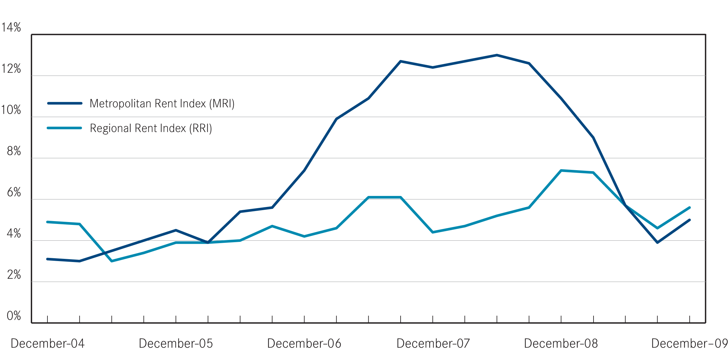
Table 1: Median rents and rent indices (December quarter 2009)
 | Median Rent | Rent Index | Quarterly Change* | Annual Change*
Melbourne | $330 | 182.7 | 2.2% | 5.0%
Regional Victoria | $225 | 172.0 | 2.6% | 5.6%
Victoria | $300 | 180.8 | 2.3% | 5.1%
*percentage change figures are calculated from relevant Rent Index

Table 2: Median rents by statistical region (December quarter 2009)
Region | Median Rent | Quarterly Change | Annual Change
Inner Melbourne | $400 | 2.6% | 5.3%
Inner Eastern Melbourne | $367 | 4.9% | 4.9%
Southern Melbourne | $360 | 2.9% | 2.9%
Western Melbourne | $290 | 1.8% | 3.6%
North Western Melbourne | $320 | 3.2% | 6.7%
North Eastern Melbourne | $320 | 3.2% | 6.7%
Outer Eastern Melbourne | $310 | 3.3% | 6.9%
South Eastern Melbourne | $290 | 3.6% | 4.3%
Mornington Peninsula | $280 | 3.7% | 7.7%
Barwon-South West | $255 | 2.0% | 6.3%
Gippsland | $210 | 5.0% | 7.7%
Goulburn-Ovens-Murray | $215 | 2.4% | 7.5%
Loddon-Mallee | $215 | 2.4% | 2.4%
Central Highlands-Wimmera | $220 | 4.8% | 4.8%

The highest annual increase was recorded in the Mornington Peninsula region (7.7 per cent). For regional Victoria the highest annual increase in rents was recorded in the Gippsland region (7.7 per cent).
Major property types
Table 3 provides the median rents for the six major property types for metropolitan and regional Victoria.
It should be noted that these metropolitan wide medians will reflect the geographic distribution of different property types. Houses tend to be the dominant rental property form in outer metropolitan areas whereas flats are more prevalent in areas closer to the centre of Melbourne. As a result the metropolitan median for two bedroom flats ($320 per week) is the same as that for three bedroom houses ($320 per week).
For metropolitan Melbourne rents for new lettings showed no change for 2 bedroom houses but increased by 7.7 per cent for one bedroom flats in the year to December quarter. In regional Victoria the largest annual increase was for four bedroom houses (7.1 per cent) while two bedroom houses increased by 2.6 per cent.
Trends by suburb or town
Figures 2 and 3 show the pattern of concentration of higher costs for private rental accommodation in the Inner Metropolitan region, the inner parts of the North Western and North Eastern regions, Inner Eastern region and Southern Metropolitan region.
Table 9 shows the pattern of rental costs at a suburb and town level across Victoria.
Please note that the medians in Table 9 are moving annual medians, not quarterly medians and that the annual percentage change figures are calculated from these moving annual medians.
Table 3: Major property types median rents (December quarter 2009)
 | Property Type | Median Rent | Quarterly Change* | Annual Change*
Melbourne
 | 1 Bed Flat | $280 | 1.8% | 7.7%
 | 2 Bed Flat | $320 | 0.0% | 3.2%
 | 3 Bed Flat | $360 | 2.9% | 5.9%
 | 2 Bed House | $330 | 1.5% | 0.0%
 | 3 Bed House | $320 | 3.2% | 6.7%
 | 4 Bed House | $370 | 2.8% | 1.4%
Regional Victoria
 | 1 Bed Flat | $130 | 0.0% | 4.0%
 | 2 Bed Flat | $185 | 2.8% | 5.7%
 | 3 Bed Flat | $250 | 0.0% | 4.2%
 | 2 Bed House | $195 | 2.6% | 2.6%
 | 3 Bed House | $240 | 4.3% | 6.7%
 | 4 Bed House | $300 | 1.7% | 7.1%
*percentage change figures are calculated from relevant Rent Index

For two bedroom flats in the metropolitan area the suburbs with the highest annual increases in moving median rents to December quarter were Sunshine (18.9 per cent), Whittlesea (18.8 per cent), Preston (17.9 per cent), Hastings – Flinders (16.5 per cent), West Footscray (16.0 per cent), Coburg – Pascoe Vale South (15.8 per cent ) and Williamstown (15.4 per cent).

For regional Victoria the towns with the highest annual increases in moving median rents for two bedroom flats to December quarter were Hamilton (20.0 per cent), Morwell (16.7 per cent), Moe – Newborough (13.6 per cent), Herne Hill – Geelong West (12.8 per cent), Warrnambool (11.1 per cent) and North Geelong (10.0 per cent).

Figure 2: Moving annual median rents for 2 bedroom flats in metropolitan Melbourne (December quarter 2009)
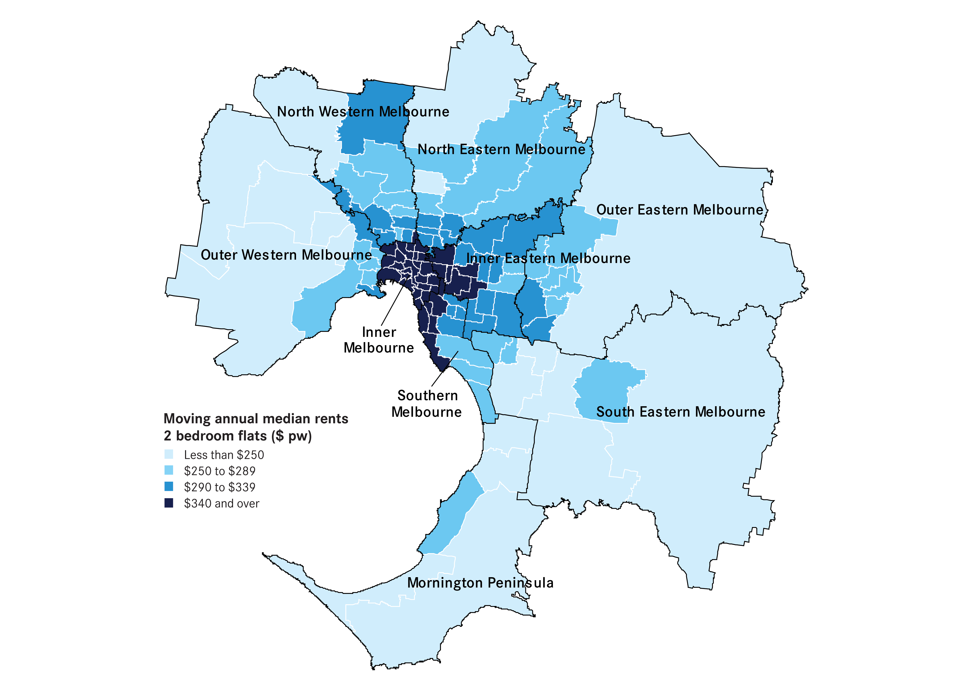

The highest annual increases in moving median rents for three bedroom houses were Toorak (23.6 per cent), Keilor (18.5 per cent), Elsternwick (15.8 per cent), Carlton North (13.5 per cent), South Yarra (12.5 per cent), Sunshine (12.0 per cent) and Fitzroy North – Clifton Hill (11.7 per cent).
For regional Victoria the towns with the highest annual increases in moving median rents for three bedroom houses to December quarter were Moe – Newborough (11.8 per cent), Horsham (10.5 per cent), Hamilton (10.0 per cent), Sebastapol – Delacombe (9.5 per cent), Sale – Maffra (9.5 per cent) and Seymour (8.3 per cent).

Figure 3: Moving annual median rents for 3 bedroom houses in metropolitan Melbourne (December quarter 2009)
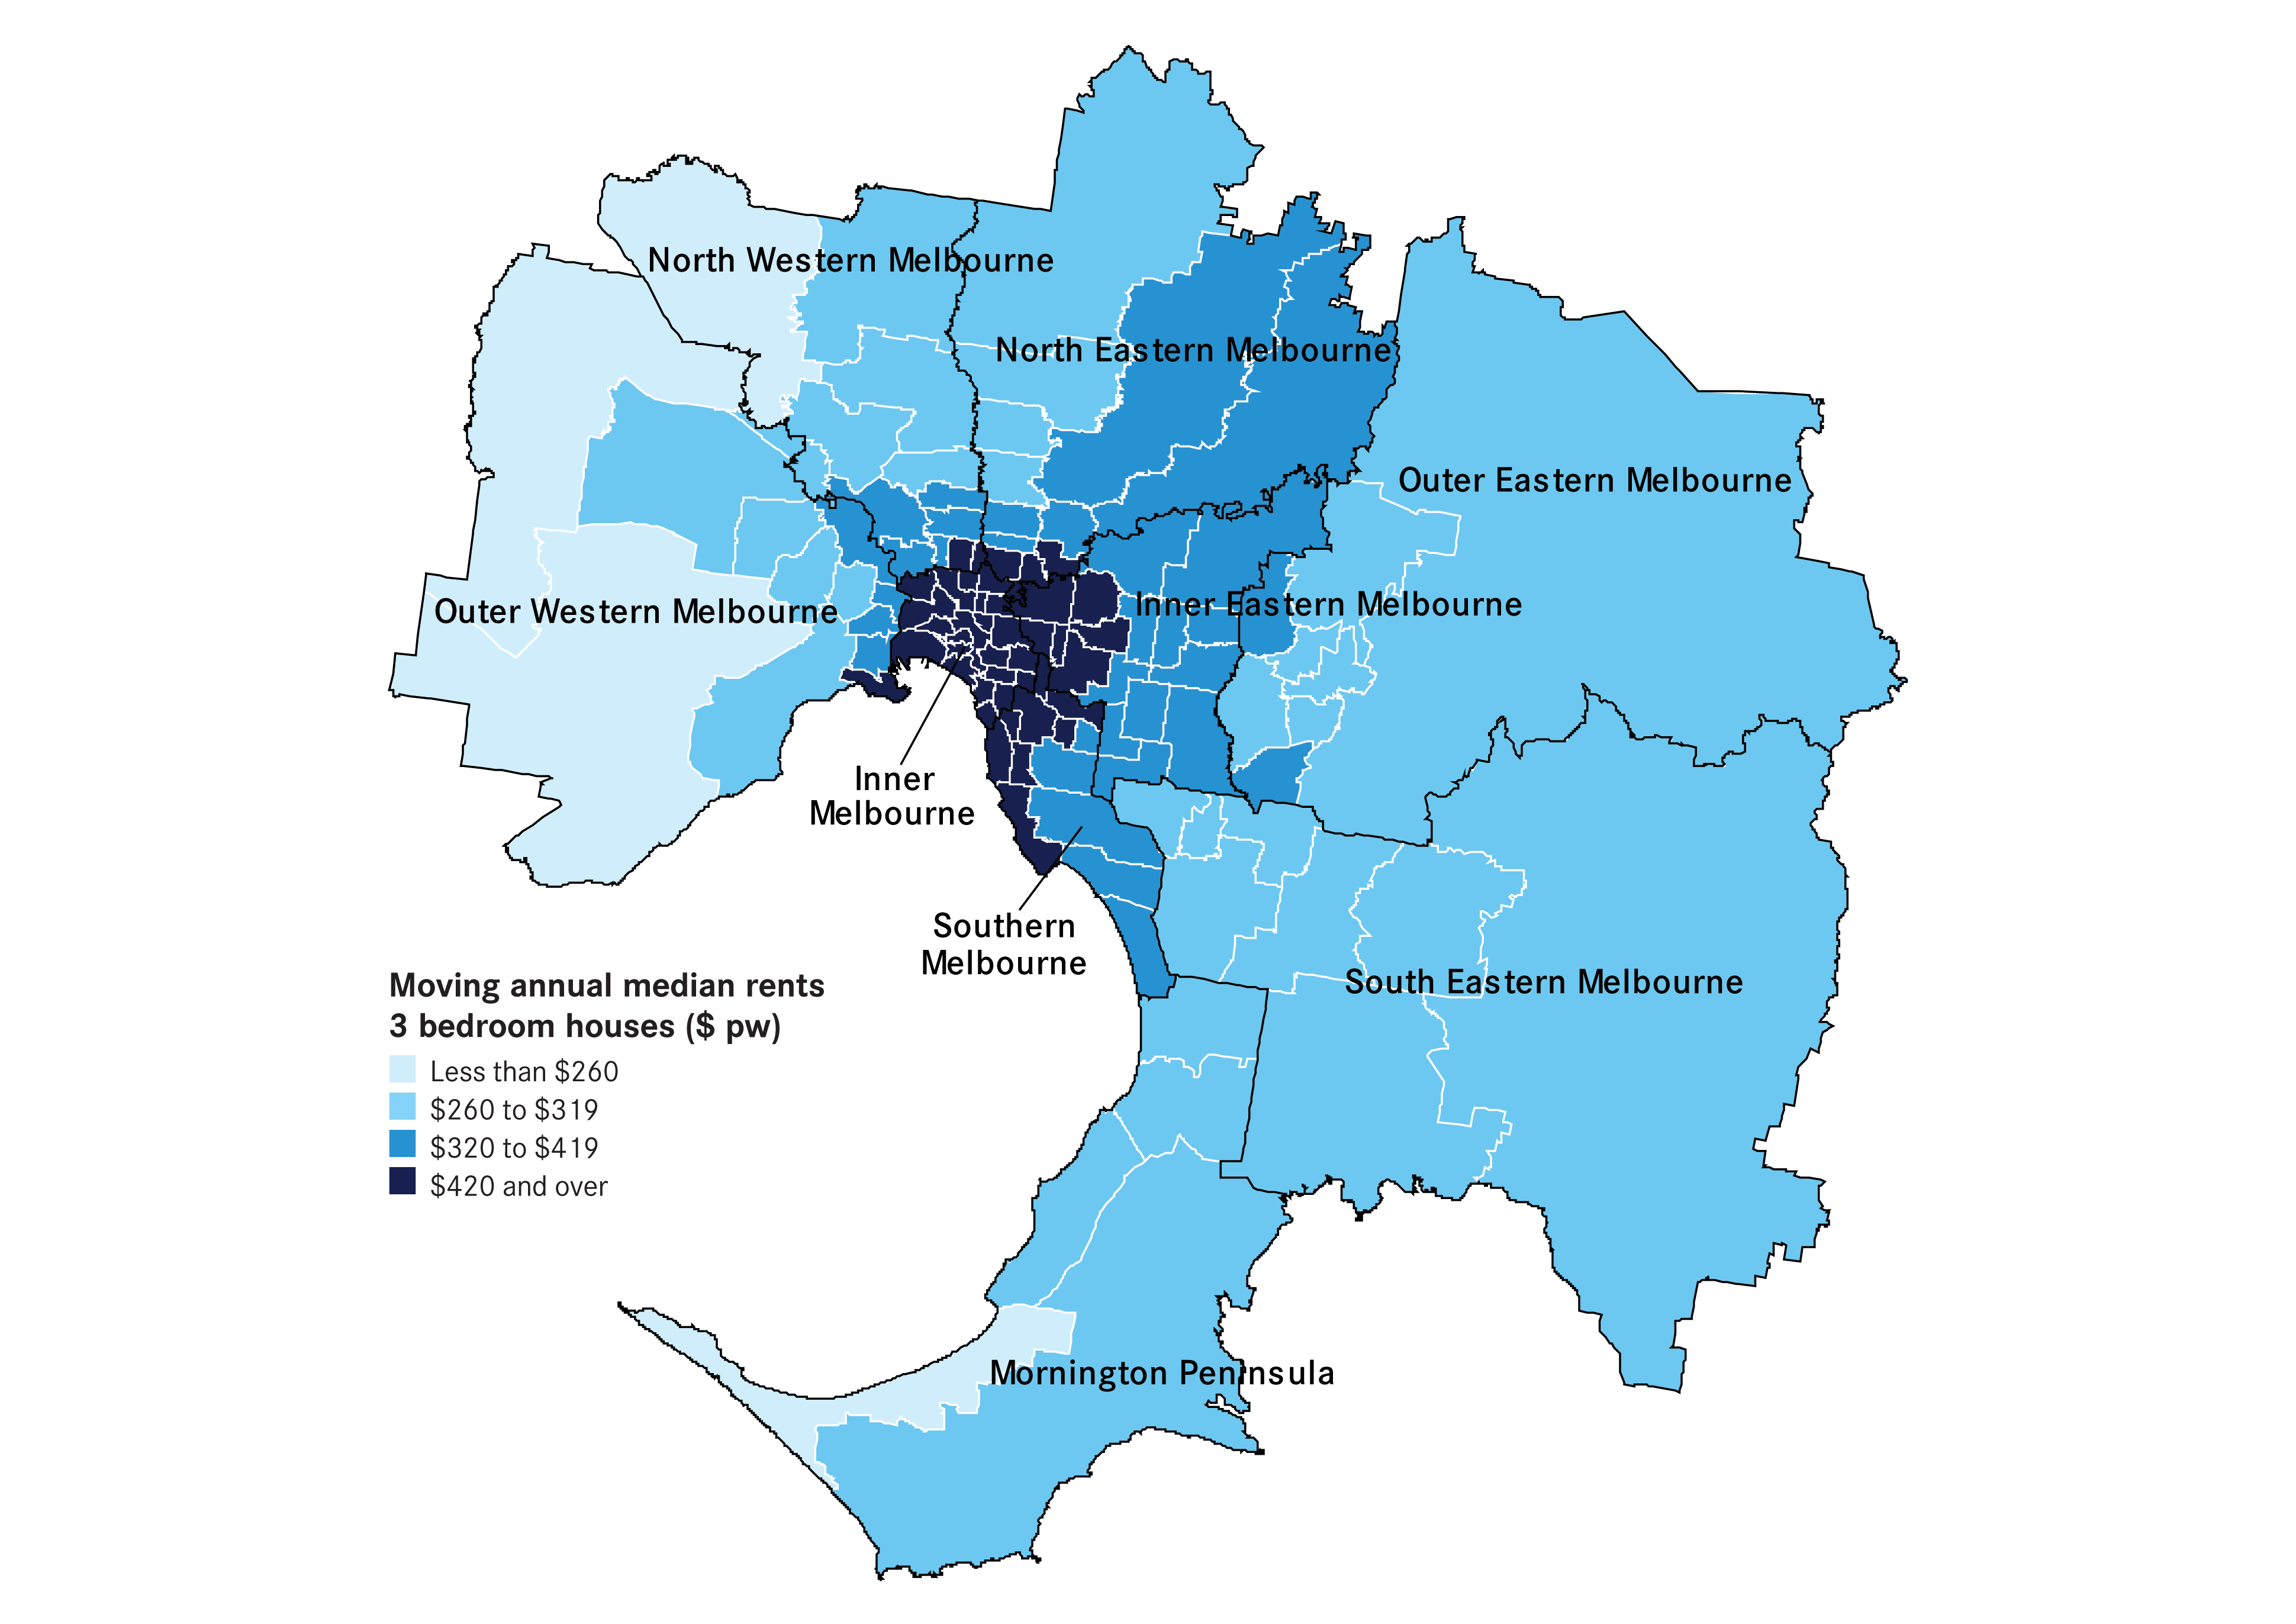

Rental availability
New Lettings
The number of new lettings provides an indicator of the overall availability of rental accommodation for a specific period. A new letting can result from two main sources: turnover in existing rental accommodation or new additions to the stock of rental accommodation.
Table 4 shows the total number of new rental lettings for the December quarter 2009. Metropolitan Melbourne accounted for 77 per cent of all new lettings in Victoria. Across the state the total number of new lettings was 37,713 which represents an increase of 3.6 per cent compared to the same quarter of 2008. In metropolitan Melbourne there was an overall increase of 5.9 per cent in new lettings on the same quarter of last year, whereas in regional Victoria new lettings declined by 3.3 per cent.
Table 5 lists the total number of new lettings across each of the 14 statistical regions. Seven of the nine metropolitan regions recorded increases in the number of new lettings compared to the same quarter of 2008. In the metropolitan area the largest fall in new lettings over the year to December quarter was recorded in the Outer Eastern region (-7.0 per cent), while the North Eastern region experienced significant increase (12.1 per cent).
Table 4: Overall new lettings for Melbourne, non-metropolitan Victoria and Victoria (December quarter 2009)
 | Dec-09 | Dec-08 | Change
Melbourne | 28,858 | 27,257 | 5.9%
Regional Victoria | 8,855 | 9,160 | -3.3%
Victoria | 37,713 | 36,417 | 3.6%
Table 5: New lettings for statistical regions Victoria (December quarter 2009)
 | Dec-09 | Dec-08 | Change
Inner Melbourne | 6,780 | 6,359 | 6.6%
Inner Eastern Melbourne | 3,784 | 3,663 | 3.3%
Southern Melbourne | 2,820 | 2,735 | 3.1%
Western Melbourne | 4,239 | 3,795 | 11.7%
North Western Melbourne | 2,602 | 2,400 | 8.4%
North Eastern Melbourne | 2,770 | 2,470 | 12.1%
Outer Eastern Melbourne | 1,520 | 1,634 | -7.0%
South Eastern Melbourne | 2,494 | 2,342 | 6.5%
Mornington Peninsula | 1,849 | 1,859 | -0.5%
Barwon-South West | 2,327 | 2,390 | -2.6%
Gippsland | 1,770 | 1,624 | 9.0%
Goulbourn-Ovens-Murray | 1,784 | 1,984 | -10.1%
Loddon-Mallee | 1,610 | 1,800 | -10.6%
Central Highlands-Wimmera | 1,364 | 1,362 | 0.1%

Active Bonds
The number of active (ie current) bonds provides an indicator of the total stock of rental accommodation based on the total number of bonds held by the RTBA at a given point in time.
At December quarter 2009 the total number of active bonds held was 368,565 which represents an increase of 4.0 per cent over the same quarter of 2008.
Figure 4 shows trends in active bonds over the past five years. Over the past year the
rate of increase in active bond numbers has eased, but currently is very close to the average for the past nine years (4.1 per cent).
Figure 4: Total Active Residential Rental Bonds, Victoria – annual percent change
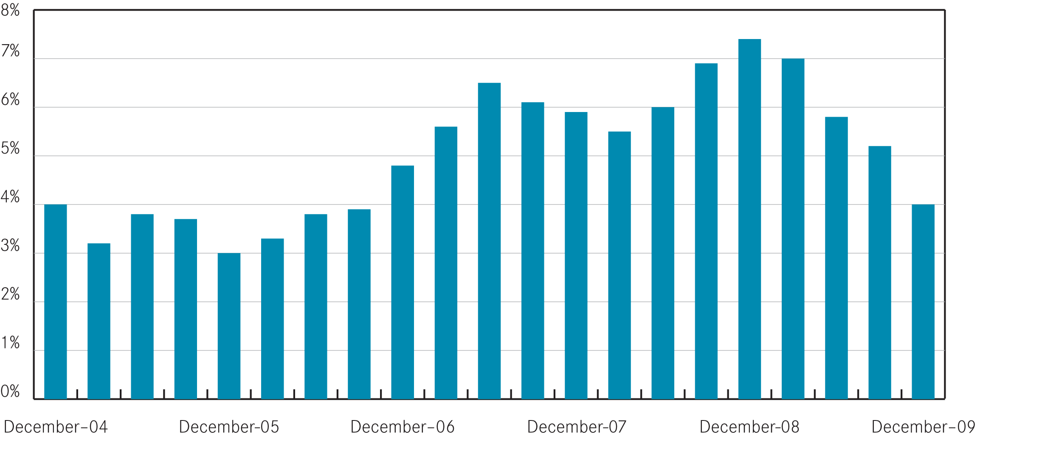
Figure 5 represents a map of the number of active bonds by suburb for Metropolitan
Melbourne. Suburbs with the highest supply of rental accommodation as indicated by active tenancies are the CBD and St Kilda Road precinct, Frankston, Werribee and Hoppers Crossing, St Kilda and South Yarra. This map highlights the availability of rental accommodation in some outer/fringe metropolitan suburbs as well as the more traditional inner urban areas.
Turnover and length of tenancy
The number of bond refunds in a quarter, if expressed as a percentage of all bonds held, can be used to provide an estimate of the ‘turnover rate’ in the rental market.
The ‘turnover rate’ is an important indicator of the level of natural vacancies which are occurring in the market due to tenancies ending.
Table 6 shows statistics on turnover rate and length of tenancies (for bond refunds during the quarter) for both metropolitan Melbourne and regional Victoria. For the December quarter 2009 the quarterly turnover rate for metropolitan Melbourne was 9.2 per cent (ie 9.2 per cent of all bonds were refunded in the quarter), which was higher than the rate of a year earlier (8.8 per cent).

Figure 5: Number of active bonds by suburb for metropolitan Melbourne (December quarter 2009)
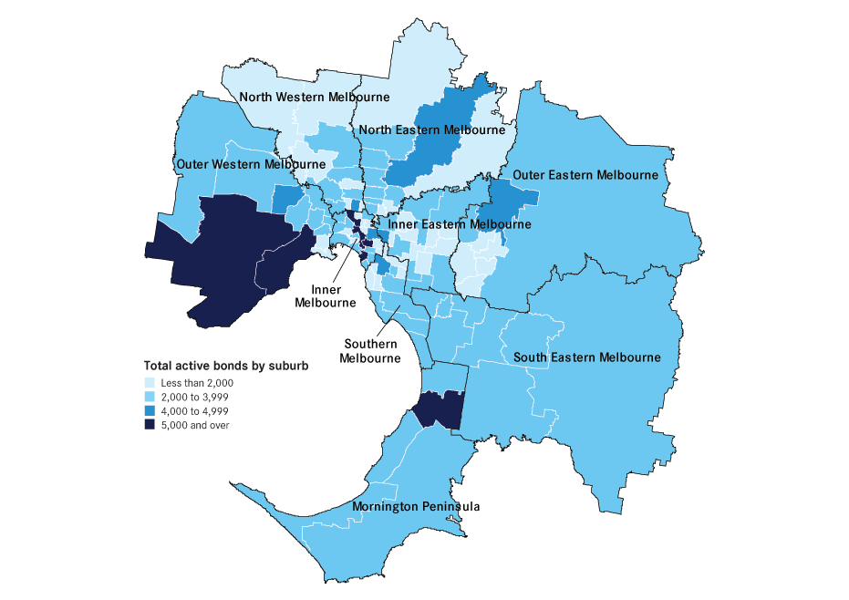
The turnover rate in regional Victoria is consistently higher than the Metropolitan area. In December quarter 2009 the regional turnover rate was 11.1 per cent.
Over the past three quarters a slight upward trend in the turnover rate has been evident in both metropolitan and regional areas. This is a positive factor for availability of rental accommodation and may be a factor behind the easing vacancy rate.
The average length of tenancy for bonds which were refunded in the December quarter 2009 was 25.5 months for Metropolitan Melbourne and 20.9 months for regional Victoria.
Table 6: Tenancy duration and turnover (December quarter 2009)
 | Dec-09 | Dec-08
Melbourne
Ave tenancy duration | 25.5 | 25.0
Turnover rate | 9.2% | 8.8%
Regional Victoria
Ave tenancy duration | 20.9 | 19.8
Turnover rate | 11.1% | 10.8%
Notes:
1. Ave duration (months) from bond lodgement date to bond claim date for refunds in that quarter
2. Bond refunds (moving annual total) as % of total active bonds

Investor finance
Loan approvals for the purchase or construction of dwellings for purposes of investment (not owner-occupation) provide a measure of investor activity levels in the Victorian housing market.
Figure 6 presents a summary of loan approvals for housing investment in
Victoria over the past five years.
In the December quarter 2009 lending to investors in Victoria was $4.76 billion. This
was 19.4 per cent higher than lending levels in the same quarter of 2008.
The December quarter investor finance figures were the third consecutive quarterly rise in lending to residential property investors. This is a positive for the supply of rental accommodation in Victoria.

Figure 6: Lending to investors in residential housing, Victoria
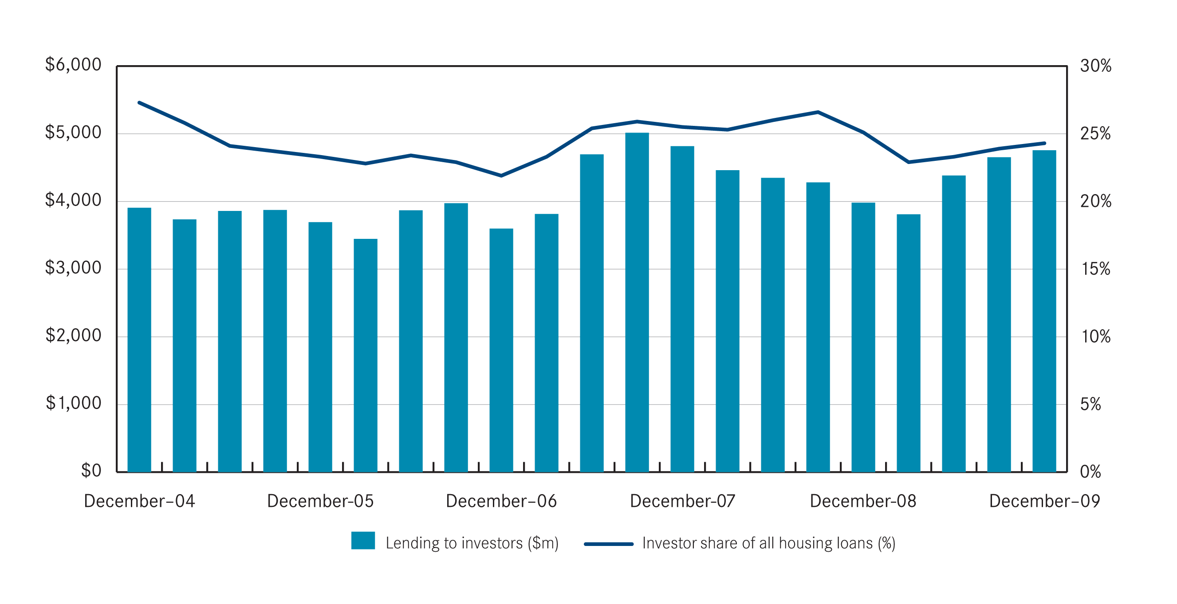
Source: Australian Bureau of Statistics Lending Finance (5671.0) & Housing Finance (5609.0)

Vacancy Rate
The rental vacancy rate is calculated by the Real Estate Institute of Australia, based on a survey of Real Estate Agents and measures the proportion of all rental properties managed by agents which are unlet at a given point in time.
The trend metropolitan vacancy rate for the December quarter 2009 was 1.5 per cent, higher than the level recorded a year earlier (1.2 per cent). Since early 2008 the metropolitan vacancy rate has shown a gradual but consistent upward trend.
Figure 7 shows the trend metropolitan vacancy rate over the past five years. The vacancy rate reached its lowest point in early 2008. The current vacancy rate is very low in historical terms and is indicative of an ongoing tight supply situation. The average vacancy rate for the period from 2000 to 2005 was 3.6 per cent.

Figure 7: Melbourne Rental Vacancy Rate – trend
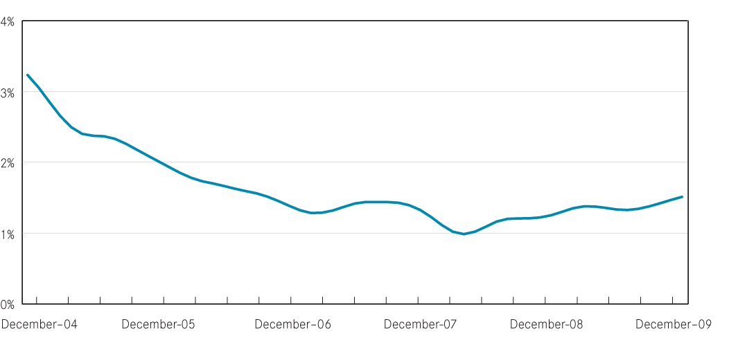

Rental market affordability
This section of the Rental Report provides a summary of the affordability of rental accommodation for lower income households in Victoria. The method used in this section measures the supply of affordable new lettings based on the RTBA data used in this Report. The affordability benchmark used is that no more than 30 per cent of income is spent on rent. Lower income households are defined as those receiving Centrelink incomes.
Overall trends
From 2006 to the first quarter of 2009 a sharp and significant decline in the availability of affordable private rental accommodation occurred in metropolitan Melbourne. This reflects the increases in the cost of renting which occurred over this period. Overall affordability levels in Melbourne have stabilised for the past few quarters in line with the levelling off in the rate of increase in rents.
At December quarter 2009 21.8 per cent of all new lettings across the state were affordable to lower income households. Figure 8 shows the trend in these figures over the past five years. Across Melbourne 8.8 per cent of dwellings let in the December quarter were affordable.

Figure 8: Affordable rentals as percent of all rentals, Victoria
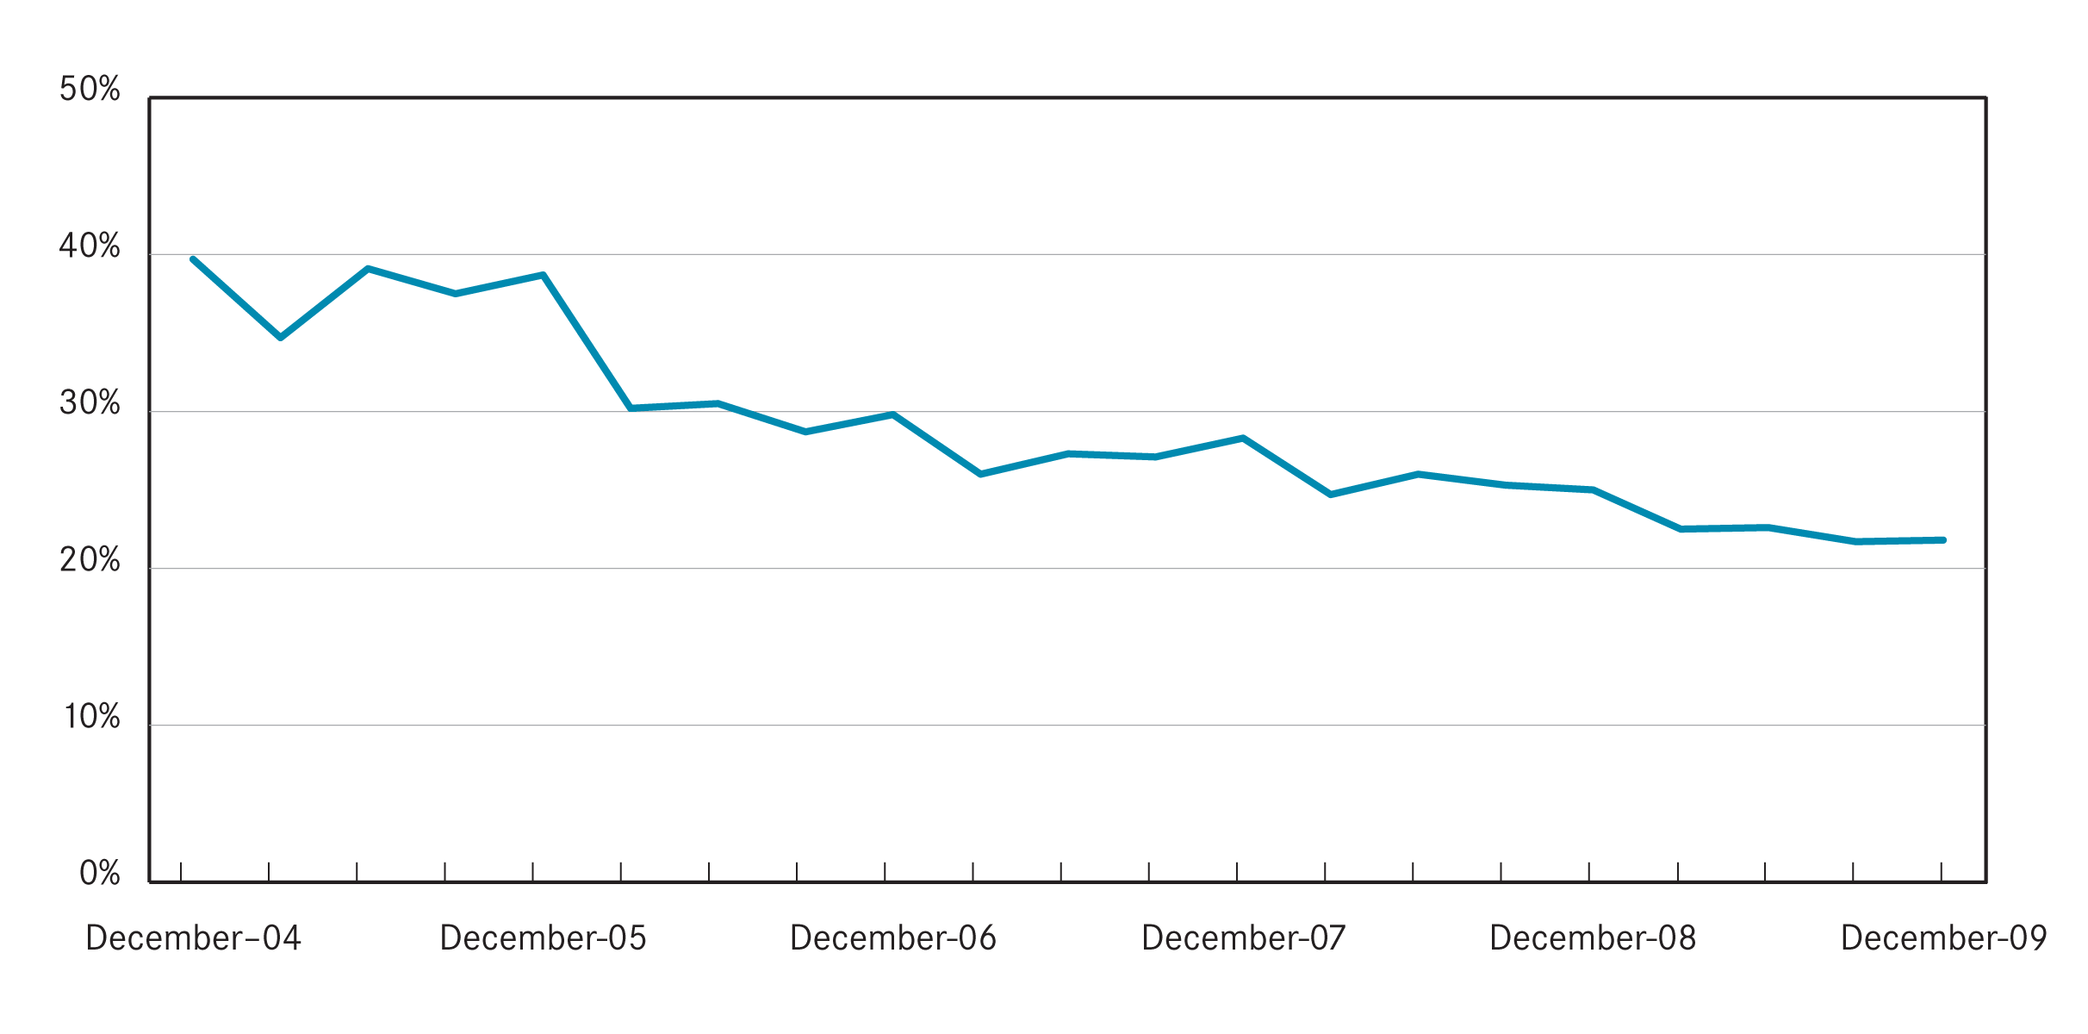
This figure represents a reduction in the proportion of dwellings which were affordable during the same quarter a year ago (10.6 per cent) and is in stark contrast to the availability levels of four years earlier (27.5 per cent).
In metropolitan Melbourne the availability of affordable rental lettings varies between different types of households. The rental affordability situation for different low income households is summarized in Table 7.
Due to a limited supply of affordable one bedroom dwellings, low income single person households face the most difficulties in accessing affordable rental accommodation. Across Melbourne just 0.5 per cent of one bedroom dwellings let in the December quarter were affordable to low income singles.
For a single parent with one child on Centrelink income, the proportion of 2 bedroom dwellings across Melbourne which were affordable was 3.7 per cent.
For larger families the supply of affordable three and four bedroom dwellings is better and reflects the predominantly outer suburban location of much of this size of dwelling.
A couple with two children dependant on Newstart would be able to afford 12.8 per cent of 3 bed new lettings in Melbourne in the December quarter.
Table 7: Rental affordability by indicative households on Centrelink incomes (December quarter 2009)
Household type | Singles on Newstart | Single Parent with 1 child | Couple on Newstart with 2 children | Couple on Newstart with 4 children | Total
Assumed property size | 1 bedroom | 2 bedroom | 3 bedroom | 4+ bedroom | -
Weekly income (net of RA) | $228 | $433 | $635 | $803 | -
Affordable weekly rent | $125 | $200 | $260 | $320 | -
Affordable rentals (number)
Metropolitan | 21 | 326 | 1,187 | 672 | 2,206
Regional | 259 | 1,436 | 2,667 | 598 | 4,960
State total | 280 | 1,762 | 3,854 | 1,270 | 7,166
Affordable rentals (% of total)
Metropolitan | 0.5% | 3.7% | 12.8% | 24.8% | 8.8%
Regional | 39.2% | 61.1% | 69.4% | 59.4% | 63.1%
State total | 5.7% | 15.9% | 29.4% | 34.2% | 21.8%

Trends by region
Table 8 shows the availability of affordable lettings for each of the statistical regions of Victoria. The higher cost of housing in Melbourne shows clearly in these affordability figures.
In regional terms the Western, South Eastern and Mornington Peninsula regions of metropolitan Melbourne consistently have the highest proportion of new lettings which are affordable to lower income households. In regional Victoria the Barwon South West region has the lowest availability of affordable rentals.
Local Government Area Trends
Table 11 provides data on the number of new lettings affordable to households on Centrelink incomes for all Victorian Local Government Areas.
Methods used
Fitting statutory income households to dwellings by bedroom number
These calculations show the distribution of private rental properties in Victoria affordable to households on statutory incomes by bedroom number for newly leased properties during the current quarter. It shows the number of properties by region that were affordable for different bedroom numbers, and the proportion of that municipality’s stock of those properties.
For example, if there are 100 x one bedroom properties deemed to be affordable in Port Phillip, and there are 1000 x one bedroom properties leased during that quarter, then the percentage of affordable one bedroom properties in Port Phillip during the quarter will be 10.0 per cent.
Calculating affordability – net rent method
The assessment of affordable supply is based on the number of suitably-sized properties that are within 30 per cent of income for low income households. The rental thresholds are taken from the household incomes for whom that number of bedrooms is a minimum and may have been rounded up to the nearest $5 increment.
For one bedroom properties, we have taken the income of singles on Newstart allowance; for two bedroom properties, we have taken a single parent pensioner with one child aged under 5; for three bedroom properties we have taken a couple on Newstart with two children; and for four bedroom properties, we have taken a couple on Newstart with four children.
The method used in these calculations assumes rent assistance is fully offset against the weekly rent by subtracting rent assistance from the rent and then calculating the resulting rent as a proportion of the Centrelink income.
This is the net-rent method which treats rent assistance as a housing payment, not an income supplement. Other methods are available, such as used by the Australian institute of Health and Welfare.
Table 8: Affordable lettings for indicative households (see table 7) on Centrelink incomes (December quarter 2009)

Dec-09
Region | 1 Bedroom |  | 2 Bedroom |  | 3 Bedroom |  | 4+ Bedroom |  | Total
Region | Number | Percent | Number | Percent | Number | Percent | Number | Percent | Number | Percent
Inner Melbourne | - | 0.0% | 12 | 0.5% | 11 | 1.5% | 3 | 2.6% | 26 | 0.4%
Inner Eastern Melbourne | 1 | 0.3% | 9 | 0.8% | ₁₄ | 1.1% | 12 | 2.6% | 36 | 1.1%
Southern Melbourne | 5 | 1.1% | 17 | 1.7% | 12 | 1.6% | 5 | 2.5% | 39 | 1.6%
Western Melbourne | 4 | 1.9% | 103 | 13.2% | 563 | 28.8% | 392 | 54.9% | 1,062 | 29.0%
North Western Melbourne | 2 | 0.6% | 16 | 1.8% | 66 | 7.7% | 27 | 15.3% | 111 | 4.9%
North Eastern Melbourne | 2 | 0.7% | 19 | 2.2% | 52 | 5.1% | 20 | 8.6% | 93 | 3.8%
Outer Eastern Melbourne | - | 0.0% | 16 | 4.1% | 38 | 5.4% | 11 | 6.9% | 65 | 4.9%
South Eastern Melbourne | 3 | 2.7% | 57 | 10.8% | 195 | 17.6% | 141 | 35.4% | 396 | 18.4%
Mornington Peninsula | 4 | 4.0% | 77 | 18.0% | 236 | 27.9% | 61 | 24.9% | 378 | 23.3%
Metropolitan Melbourne | 21 | 0.5% | 326 | 3.7% | 1,187 | 12.8% | 672 | 24.8% | 2,206 | 8.8%
Barwon-South West | 44 | 21.2% | 202 | 33.5% | 470 | 48.6% | 109 | 44.5% | 825 | 40.8%
Gippsland | 72 | 56.3% | 333 | 72.4% | 598 | 74.8% | 132 | 68.8% | 1,135 | 71.9%
Goulbourn-Ovens-Murray | 43 | 38.7% | 397 | 74.1% | 567 | 75.3% | 144 | 64.6% | 1,151 | 70.9%
Loddon-Mallee | 45 | 46.4% | 292 | 69.2% | 568 | 77.6% | 108 | 60.3% | 1,013 | 70.8%
Central Highlands-Wimmera | 55 | 47.4% | 212 | 64.4% | 464 | 78.5% | 105 | 62.9% | 836 | 69.5%
Regional Victoria | 259 | 39.2% | 1,436 | 61.1% | 2,667 | 69.4% | 598 | 59.4% | 4,960 | 63.1%
Victoria | 280 | 5.7% | 1,762 | 15.9% | 3,854 | 29.4% | 1,270 | 34.2% | 7,166 | 21.8%

Table 9: Moving annual median rents for suburbs/towns by major property type
Dec-09 |  | 1 Bed Flat |  |  | 2 Bed Flat |  |  | 2 Bed House |  |  | 3 Bed House
 |  | Count | Median | Ann % Ch | Count | Median | Ann % Ch | Count | Median | Ann % Ch | Count | Median | Ann % Ch
Inner Melbourne
 | Albert Park-Middle Park-West  St Kilda | 253 | $295 | 1.7% | 180 | $400 | 0.0% | 86 | $500 | 11.1% | 75 | $650 | -1.5%
 | Armadale | 151 | $270 | 8.0% | 257 | $350 | 2.9% | 27 | $460 | 7.0% | 25 | $650 | 0.0%
 | Carlton North | 52 | $265 | 6.0% | 109 | $370 | 5.7% | 73 | $430 | 2.4% | 38 | $568 | 13.5%
 | Carlton-Parkville | 1899 | $300 | 15.4% | 620 | $425 | 6.9% | 43 | $400 | 5.3% | 33 | $650 | 8.3%
 | CBD-St Kilda Rd | 2546 | $360 | 4.0% | 1747 | $500 | 5.3% | - | - | - | - | - | -
 | Collingwood-Abbotsford | 159 | $280 | 5.7% | 142 | $440 | 4.8% | 91 | $420 | 5.0% | 43 | $505 | 6.3%
 | Docklands | 355 | $420 | 7.7% | 438 | $550 | 3.8% | - | - | - | - | - | -
 | East Melbourne | 239 | $330 | 3.1% | 191 | $450 | 2.3% | - | - | - | - | - | -
 | East St Kilda | 493 | $250 | 6.4% | 615 | $340 | 4.6% | 44 | $465 | 10.7% | 58 | $575 | 8.5%
 | Elwood | 542 | $280 | 7.7% | 814 | $370 | 5.7% | 34 | $498 | 11.8% | 54 | $650 | 0.0%
 | Fitzroy | 173 | $280 | 3.7% | 116 | $450 | 2.3% | 44 | $488 | 10.8% | 26 | $600 | 9.1%
 | Fitzroy North-Clifton Hill | 148 | $260 | 13.0% | 189 | $360 | 2.9% | 109 | $435 | 6.1% | 73 | $525 | 11.7%
 | Flemington-Kensington | 246 | $270 | 3.8% | 288 | $360 | 5.9% | 142 | $380 | 8.6% | 73 | $450 | 4.7%
 | North Melbourne-West Melbourne | 319 | $265 | 15.2% | 358 | $410 | 12.3% | 50 | $420 | 0.0% | 39 | $510 | 1.0%
 | Port Melbourne | 281 | $390 | 4.0% | 365 | $500 | 4.7% | 98 | $450 | 0.0% | 110 | $640 | 6.7%
 | Prahran-Windsor | 567 | $270 | 2.9% | 442 | $380 | 4.1% | 121 | $450 | 7.1% | 81 | $600 | 9.1%
 | Richmond-Burnley | 533 | $295 | 3.5% | 441 | $440 | 4.8% | 292 | $450 | 7.1% | 176 | $550 | 5.8%
 | South Melbourne | 178 | $378 | 7.9% | 175 | $470 | 4.4% | 65 | $450 | 2.9% | 41 | $605 | 3.9%
 | South Yarra | 877 | $300 | 7.1% | 789 | $420 | 7.7% | 87 | $480 | 1.1% | 59 | $675 | 12.5%
 | Southbank | 343 | $420 | 5.3% | 660 | $500 | 4.2% | - | - | - | - | - | -
 | St Kilda | 1171 | $295 | 7.3% | 918 | $390 | 8.3% | 32 | $460 | 7.0% | 30 | $598 | 3.9%
 | Toorak | 218 | $285 | 9.6% | 217 | $390 | 5.4% | 14 | $550 | 7.3% | 32 | $865 | 23.6%
 | Inner Melbourne | 11743 | $315 | 8.6% | 10071 | $430 | 7.5% | 1467 | $440 | 4.8% | 1078 | $580 | 5.5%
Inner Eastern Melbourne
 | Balwyn | - | - | - | 167 | $331 | 6.8% | 54 | $353 | 2.2% | 250 | $430 | 2.4%
 | Blackburn | 41 | $225 | 12.5% | 125 | $300 | 4.3% | 29 | $310 | 0.0% | 206 | $350 | 0.0%
 | Box Hill | 289 | $225 | 2.3% | 408 | $300 | 3.4% | 74 | $318 | 5.8% | 221 | $375 | 4.2%
 | Bulleen-Templestowe-Doncaster | 40 | $233 | 5.7% | 160 | $300 | 0.0% | 32 | $320 | 14.3% | 322 | $360 | 2.9%
 | Burwood-Ashburton | 215 | $220 | 15.8% | 108 | $350 | 9.4% | 60 | $330 | 3.1% | 246 | $388 | 2.0%
 | Camberwell-Glen Iris | 177 | $250 | 13.6% | 485 | $340 | 4.5% | 62 | $383 | 0.8% | 219 | $500 | 3.1%
 | Canterbury-Surrey Hills-Mont Albert | 17 | $277 | 13.5% | 252 | $343 | 8.7% | 25 | $350 | -4.1% | 93 | $465 | -6.1%
 | Chadstone-Oakleigh | 14 | $300 | 7.1% | 207 | $310 | 3.3% | 64 | $330 | 10.9% | 204 | $360 | 2.9%
 | Clayton | 111 | $260 | -1.0% | 441 | $300 | 7.1% | 39 | $300 | 1.7% | 192 | $350 | 9.4%
 | Doncaster East-Donvale | 18 | $270 | 35.0% | 119 | $320 | 8.5% | 22 | $313 | 8.7% | 208 | $350 | 0.7%
 | East Hawthorn | 123 | $270 | 12.5% | 216 | $350 | 2.9% | 28 | $435 | 4.8% | 60 | $550 | 7.8%
 | Glen Waverley-Mulgrave | 17 | $250 | 31.6% | 142 | $320 | 10.3% | 21 | $320 | 1.6% | 567 | $350 | 6.1%
 | Hawthorn | 770 | $250 | 8.7% | 646 | $360 | 5.9% | 52 | $435 | -1.1% | 83 | $580 | 1.6%
 | Kew | 71 | $330 | 32.0% | 405 | $350 | 6.1% | 46 | $400 | 0.0% | 149 | $490 | 6.5%
 | Mount Waverley | 17 | $230 | nd | 108 | $303 | 8.2% | 27 | $320 | 6.7% | 227 | $365 | 4.3%
 | Nunawading-Mitcham | 20 | $200 | 17.6% | 197 | $280 | 8.7% | 45 | $300 | 3.4% | 200 | $350 | 6.1%
 | Vermont-Forest Hill-Burwood East | - | - | - | 105 | $280 | 12.0% | 22 | $300 | 2.6% | 273 | $350 | 2.9%
 | Inner Eastern Melbourne | 1955 | $240 | 6.7% | 4291 | $330 | 6.5% | 702 | $340 | 6.3% | 3720 | $375 | 5.6%
Southern Melbourne
 | Aspendale-Chelsea-Carrum | 59 | $215 | 19.4% | 430 | $270 | 3.8% | 81 | $285 | 1.8% | 276 | $340 | 3.8%
 | Bentleigh | 169 | $230 | 7.0% | 410 | $330 | 10.0% | 109 | $350 | 6.1% | 354 | $415 | 7.8%
 | Brighton | 36 | $315 | 3.3% | 199 | $399 | 5.0% | 30 | $463 | 2.8% | 111 | $675 | 8.9%
 | Brighton East | - | - | - | 39 | $370 | 5.7% | 34 | $395 | -1.3% | 93 | $530 | 6.0%
 | Carnegie | 337 | $230 | 4.5% | 282 | $330 | 10.0% | 23 | $350 | 1.4% | 55 | $450 | 10.4%
 | Caulfield | 312 | $230 | 4.5% | 545 | $345 | 4.5% | 66 | $400 | 5.3% | 162 | $495 | 10.0%
 | Cheltenham | 56 | $260 | 23.8% | 364 | $290 | 3.6% | 74 | $350 | 2.9% | 326 | $385 | 1.3%
 | Elsternwick | 148 | $230 | 0.0% | 202 | $340 | 3.0% | - | - | - | 34 | $550 | 15.8%
 | Hampton-Beaumaris | 38 | $293 | 4.5% | 240 | $353 | 3.7% | 37 | $425 | 11.8% | 231 | $530 | 6.5%
 | Malvern | 103 | $275 | 3.8% | 150 | $365 | 7.4% | 14 | $423 | -15.5% | 48 | $618 | -5.0%
 | Malvern East | 187 | $235 | 6.8% | 207 | $335 | 4.7% | 31 | $395 | 8.2% | 104 | $450 | -5.8%
 | Mentone-Parkdale-Mordialloc | 243 | $220 | 10.0% | 433 | $290 | 7.4% | 40 | $348 | 8.6% | 150 | $390 | 0.0%
 | Murrumbeena-Hughesdale | 210 | $235 | 9.3% | 203 | $315 | 5.0% | 32 | $373 | 6.4% | 87 | $395 | 6.8%
 | Southern Melbourne | 1904 | $230 | 4.5% | 3704 | $320 | 6.7% | 581 | $360 | 2.9% | 2031 | $429 | 7.3%
Outer Western Melbourne
 | Altona | 71 | $200 | 11.1% | 375 | $250 | 4.2% | 92 | $280 | 9.8% | 951 | $305 | 5.2%
 | Footscray | 285 | $195 | 0.0% | 212 | $283 | 8.7% | 98 | $320 | 6.7% | 89 | $360 | 9.1%
 | Keilor East-Avondale Heights | 40 | $200 | 0.0% | 179 | $295 | 7.3% | 38 | $305 | 8.9% | 264 | $330 | 10.0%
 | Melton | 35 | $294 | 28.5% | 87 | $195 | 8.3% | 43 | $210 | 5.0% | 659 | $240 | 9.1%
 | Newport-Spotswood | 73 | $195 | 8.3% | 110 | $260 | 10.6% | 79 | $320 | 0.0% | 184 | $370 | 5.0%
 | St Albans-Deer Park | 37 | $180 | 9.1% | 220 | $220 | 10.0% | 55 | $230 | 15.0% | 787 | $270 | 8.0%
 | Sunshine | 136 | $175 | 9.4% | 162 | $220 | 18.9% | 77 | $250 | 8.7% | 391 | $280 | 12.0%
 | Sydenham | - | - | - | 52 | $240 | 4.3% | 42 | $270 | 8.0% | 785 | $300 | 7.1%
 | Werribee-Hoppers Crossing | 33 | $210 | 44.8% | 333 | $220 | 10.0% | 68 | $220 | -3.3% | 1574 | $261 | 4.2%
 | West Footscray | 88 | $185 | 8.8% | 219 | $290 | 16.0% | 100 | $280 | 7.7% | 253 | $310 | 10.7%
 | Williamstown | 41 | $240 | 20.0% | 113 | $300 | 15.4% | 48 | $350 | 2.9% | 119 | $450 | 7.1%
 | Yarraville-Seddon | 138 | $195 | 0.0% | 200 | $280 | 9.8% | 165 | $350 | 6.1% | 234 | $380 | 5.6%
 | Outer Western Melbourne | 986 | $195 | 8.3% | 2262 | $250 | 8.7% | 905 | $290 | 3.6% | 6290 | $280 | 5.7%
North Western Melbourne
 | Broadmeadows-Roxburgh Park | 29 | $180 | 12.5% | 72 | $260 | 13.0% | 30 | $270 | 8.0% | 490 | $300 | 11.1%
 | Brunswick | 384 | $240 | 20.0% | 492 | $320 | 10.3% | 162 | $380 | 8.6% | 123 | $450 | 7.1%
 | Coburg-Pascoe Vale South | 106 | $250 | 13.6% | 257 | $330 | 15.8% | 133 | $330 | 10.0% | 234 | $380 | 8.6%
 | Craigieburn | - | - | - | - | - | - | 17 | $280 | nd | 370 | $300 | 7.1%
 | East Brunswick | 68 | $250 | 8.7% | 105 | $340 | 3.0% | 24 | $393 | 9.0% | 50 | $473 | 5.0%
 | Essendon | 198 | $230 | 15.0% | 383 | $295 | 9.3% | 75 | $320 | 3.2% | 235 | $330 | 6.5%
 | Gladstone Park-Tullamarine | 26 | $215 | 21.1% | 122 | $260 | 13.0% | - | - | - | 173 | $300 | 9.1%
 | Keilor | - | - | - | - | - | - | - | - | - | 23 | $320 | 18.5%
 | Moonee Ponds-Ascot Vale | 153 | $235 | 6.8% | 325 | $315 | 5.0% | 135 | $360 | 2.9% | 165 | $420 | 5.0%
 | Oak Park-Glenroy-Fawkner | 46 | $200 | 11.1% | 280 | $270 | 8.0% | 99 | $280 | 7.7% | 339 | $315 | 6.8%
 | Pascoe Vale-Coburg North | 44 | $180 | 9.1% | 182 | $290 | 10.5% | 65 | $300 | 1.7% | 160 | $330 | 3.1%
 | Sunbury | - | - | - | 90 | $230 | 4.5% | 21 | $240 | 4.3% | 298 | $265 | 6.0%
 | West Brunswick | 235 | $230 | 9.5% | 226 | $290 | 3.6% | 31 | $341 | 3.3% | 63 | $400 | 1.3%
 | North Western Melbourne | 1297 | $230 | 15.0% | 2544 | $300 | 11.1% | 801 | $330 | 6.5% | 2723 | $320 | 6.7%
North Eastern Melbourne
 | Bundoora-Greensborough-Hurstbridge | 223 | $205 | 7.3% | 344 | $290 | 7.4% | 87 | $295 | 9.3% | 650 | $330 | 3.1%
 | Eltham-Research-Montmorency | 23 | $180 | 5.9% | 110 | $280 | 1.8% | 36 | $300 | 20.0% | 176 | $360 | 2.9%
 | Fairfield-Alphington | 207 | $240 | 12.7% | 153 | $300 | 3.4% | 23 | $395 | 12.9% | 46 | $464 | 5.9%
 | Heidelberg-Heidelberg West | 38 | $258 | 12.0% | 292 | $300 | 3.4% | 104 | $293 | 4.5% | 225 | $340 | 6.3%
 | Ivanhoe-Ivanhoe East | 61 | $250 | 9.9% | 168 | $310 | 6.9% | 27 | $360 | 2.9% | 82 | $440 | 10.0%
 | Mill Park-Epping | 13 | $250 | nd | 159 | $260 | 4.0% | 40 | $280 | 7.5% | 714 | $310 | 3.3%
 | Northcote | 211 | $240 | 14.3% | 193 | $335 | 8.1% | 132 | $418 | 8.4% | 150 | $480 | 6.7%
 | Preston | 162 | $210 | 10.5% | 291 | $330 | 17.9% | 137 | $320 | 6.7% | 226 | $350 | 6.1%
 | Reservoir | 158 | $240 | 9.1% | 456 | $275 | 7.8% | 156 | $285 | 9.4% | 308 | $305 | 8.9%
 | Thomastown-Lalor | 21 | $200 | nd | 112 | $240 | 11.6% | 29 | $260 | 13.0% | 384 | $290 | 11.5%
 | Thornbury | 265 | $230 | 4.5% | 279 | $300 | 7.1% | 60 | $368 | 4.9% | 109 | $401 | 2.8%
 | Whittlesea | - | - | - | 18 | $238 | 18.8% | - | - | - | 122 | $320 | 6.7%
 | North Eastern Melbourne | 1385 | $230 | 9.5% | 2575 | $290 | 5.5% | 841 | $300 | 3.4% | 3192 | $320 | 3.2%
Outer Eastern Melbourne
 | Bayswater | - | - | - | 152 | $250 | 4.2% | 18 | $270 | 5.9% | 135 | $300 | 1.7%
 | Boronia | 11 | $200 | 14.3% | 159 | $260 | 4.0% | 31 | $250 | 0.0% | 173 | $300 | 5.3%
 | Croydon-Lilydale | 84 | $190 | 15.2% | 404 | $260 | 6.1% | 71 | $270 | 8.0% | 617 | $320 | 8.5%
 | Ferntree Gully | 11 | $185 | 15.6% | 97 | $260 | 8.3% | 21 | $260 | 8.3% | 152 | $310 | 6.9%
 | Ringwood | 41 | $200 | 0.0% | 417 | $265 | 6.0% | 80 | $285 | 3.8% | 289 | $330 | 10.0%
 | Rowville | - | - | - | - | - | - | - | - | - | 215 | $330 | 3.1%
 | Wantirna-Scoresby | 11 | $230 | nd | 66 | $300 | 7.1% | - | - | - | 264 | $325 | 4.8%
 | Yarra Ranges | 63 | $175 | 6.1% | 111 | $230 | 9.5% | 131 | $250 | 4.2% | 484 | $290 | 7.4%
 | Outer Eastern Melbourne | 229 | $190 | 11.8% | 1412 | $260 | 4.0% | 365 | $265 | 6.0% | 2329 | $315 | 6.8%
South Eastern Melbourne
 | Berwick | - | - | - | 85 | $255 | 8.5% | 20 | $263 | 7.1% | 444 | $300 | 5.3%
 | Cranbourne | - | - | - | 111 | $220 | 11.4% | 36 | $225 | 2.3% | 537 | $275 | 5.8%
 | Dandenong | 70 | $190 | 11.8% | 629 | $230 | 15.0% | 36 | $250 | 9.2% | 285 | $295 | 9.3%
 | Dandenong North-Endeavour Hills | 13 | $185 | nd | 166 | $240 | 14.3% | 32 | $250 | 13.6% | 554 | $280 | 7.7%
 | Narre Warren-Hampton Park | 11 | $190 | nd | 133 | $240 | 9.1% | 19 | $250 | 8.7% | 866 | $285 | 9.6%
 | Noble Park | 132 | $185 | 19.4% | 360 | $250 | 13.6% | 27 | $250 | 4.2% | 258 | $290 | 7.4%
 | Pakenham | 19 | $180 | nd | 120 | $220 | 10.0% | 67 | $230 | 4.5% | 782 | $270 | 3.8%
 | Springvale | 102 | $180 | 8.1% | 285 | $250 | 8.7% | 38 | $250 | 2.0% | 367 | $310 | 10.7%
 | South Eastern Melbourne | 362 | $185 | 15.6% | 1889 | $235 | 11.9% | 275 | $250 | 8.7% | 4093 | $281 | 6.0%
Mornington Peninsula
 | Dromana-Portsea | 30 | $168 | 4.7% | 153 | $205 | 4.3% | 228 | $220 | 10.0% | 793 | $260 | 4.0%
 | Frankston | 146 | $165 | 3.1% | 584 | $230 | 9.5% | 91 | $245 | 11.4% | 900 | $280 | 7.7%
 | Hastings-Flinders | 13 | $195 | nd | 178 | $233 | 16.5% | 47 | $240 | 11.6% | 348 | $270 | 8.0%
 | Mt Eliza-Mornington-Mt Martha | 23 | $200 | 8.1% | 227 | $250 | 4.2% | 50 | $280 | 5.7% | 460 | $325 | 8.2%
 | Seaford-Carrum Downs | 45 | $175 | 16.7% | 231 | $240 | 11.6% | 37 | $240 | 0.0% | 576 | $278 | 8.8%
 | Mornington Peninsula | 257 | $170 | 6.3% | 1373 | $231 | 10.0% | 453 | $230 | 4.5% | 3077 | $280 | 7.7%
Geelong
 | Belmont-Grovedale | 114 | $150 | 7.1% | 340 | $235 | 6.8% | 80 | $250 | 2.0% | 471 | $285 | 5.6%
 | Corio | 32 | $140 | -6.7% | 80 | $190 | 0.0% | 82 | $188 | 7.1% | 301 | $200 | 5.3%
 | Geelong-Newcombe | 135 | $160 | 0.0% | 205 | $230 | 9.5% | 108 | $238 | 3.3% | 282 | $260 | 4.0%
 | Herne Hill-Geelong West | 172 | $150 | 15.4% | 139 | $220 | 12.8% | 75 | $250 | 8.7% | 196 | $263 | 1.0%
 | Lara | 16 | $133 | 10.4% | 58 | $210 | 1.2% | 19 | $225 | -4.3% | 149 | $280 | 3.7%
 | Newtown | 51 | $150 | 5.3% | 109 | $235 | 6.8% | 51 | $250 | 5.3% | 122 | $303 | 8.0%
 | North Geelong | 60 | $140 | 7.7% | 84 | $220 | 10.0% | 48 | $220 | 10.0% | 211 | $260 | 4.0%
 | Geelong | 580 | $150 | 11.1% | 1015 | $220 | 4.8% | 463 | $230 | 4.5% | 1732 | $265 | 6.0%
Ballarat
 | Ballarat | 103 | $130 | 8.3% | 226 | $190 | 5.6% | 193 | $200 | 5.3% | 698 | $230 | 4.5%
 | Mount Clear-Buninyong | 12 | $130 | 8.3% | 39 | $190 | 7.0% | 23 | $190 | 2.7% | 104 | $250 | 6.4%
 | Sebastopol-Delacombe | 54 | $148 | 22.9% | 110 | $180 | 2.9% | 44 | $190 | 5.6% | 204 | $230 | 9.5%
 | Wendouree-Alfredton | 102 | $123 | 6.5% | 126 | $180 | 5.9% | 77 | $200 | 2.6% | 357 | $240 | 6.7%
 | Ballarat | 271 | $130 | 8.3% | 501 | $180 | 2.9% | 337 | $195 | 2.6% | 1363 | $235 | 6.8%
Bendigo
 | Bendigo | 52 | $150 | 15.4% | 113 | $175 | 0.0% | 65 | $210 | 3.7% | 232 | $240 | 4.3%
 | Flora Hill-Bendigo East | 30 | $130 | 4.0% | 307 | $185 | 2.8% | 85 | $220 | 12.8% | 391 | $250 | 6.4%
 | Golden Square-Kangaroo Flat | 26 | $140 | 16.7% | 86 | $190 | 5.6% | 41 | $195 | 2.6% | 252 | $235 | 6.8%
 | North Bendigo | - | - | - | 111 | $185 | 8.8% | 73 | $200 | 0.0% | 300 | $230 | 4.5%
 | Bendigo | 117 | $135 | 8.0% | 617 | $185 | 2.8% | 264 | $205 | 2.5% | 1175 | $240 | 4.3%
Other Regional Centres
 | Bairnsdale | 28 | $140 | 7.7% | 102 | $180 | 5.9% | 47 | $195 | 2.6% | 182 | $230 | 4.5%
 | Benalla | 18 | $125 | 11.1% | 85 | $170 | 6.3% | 41 | $170 | 0.0% | 129 | $210 | 5.0%
 | Castlemaine | - | - | - | 30 | $200 | 8.1% | 45 | $200 | 2.6% | 144 | $230 | 0.0%
 | Echuca | 27 | $130 | 13.0% | 156 | $195 | 5.4% | 36 | $205 | 2.5% | 218 | $235 | 2.2%
 | Hamilton | 31 | $120 | 14.3% | 57 | $180 | 20.0% | 29 | $180 | 0.0% | 136 | $220 | 10.0%
 | Horsham | 37 | $110 | 15.8% | 147 | $160 | 6.7% | 47 | $160 | -3.0% | 291 | $210 | 10.5%
 | Mildura | 95 | $125 | 4.2% | 367 | $160 | 6.7% | 119 | $185 | 0.0% | 638 | $220 | 2.3%
 | Moe-Newborough | 107 | $90 | 5.9% | 125 | $125 | 13.6% | 58 | $150 | 15.4% | 158 | $190 | 11.8%
 | Morwell | 47 | $100 | 11.1% | 139 | $140 | 16.7% | 97 | $145 | 7.4% | 244 | $170 | 6.3%
 | Ocean Grove-Barwon Heads | 15 | $190 | 18.8% | 70 | $240 | 9.1% | 32 | $260 | 4.0% | 202 | $300 | 5.3%
 | Portland | 22 | $125 | -16.7% | 68 | $150 | -9.1% | 31 | $180 | -6.5% | 160 | $210 | 0.0%
 | Sale-Maffra | 81 | $120 | 0.0% | 160 | $175 | 6.1% | 68 | $180 | 0.0% | 280 | $230 | 9.5%
 | Seymour | 12 | $115 | 9.5% | 35 | $150 | 0.0% | 18 | $163 | 0.0% | 109 | $195 | 8.3%
 | Shepparton | 132 | $130 | 8.3% | 468 | $175 | 6.1% | 120 | $190 | 5.6% | 634 | $240 | 6.7%
 | Swan Hill | 73 | $110 | 0.0% | 113 | $190 | 2.7% | 20 | $195 | 18.2% | 155 | $220 | 4.8%
 | Torquay | 16 | $185 | 1.4% | 53 | $230 | 3.4% | 39 | $250 | 0.0% | 228 | $340 | 6.3%
 | Traralgon | 86 | $120 | 7.6% | 156 | $175 | 2.9% | 72 | $223 | 17.1% | 393 | $230 | 0.0%
 | Wangaratta | 52 | $127 | 6.0% | 162 | $160 | 3.2% | 43 | $185 | -2.6% | 237 | $220 | 4.8%
 | Warragul | 12 | $128 | -1.9% | 79 | $175 | 2.9% | 23 | $200 | 8.1% | 163 | $235 | 6.8%
 | Warrnambool | 96 | $138 | 10.0% | 346 | $200 | 11.1% | 83 | $240 | 9.1% | 388 | $270 | 3.8%
 | Wodonga | 45 | $130 | 0.0% | 370 | $190 | 5.6% | 44 | $205 | 2.5% | 432 | $250 | 4.2%
 | Other Regional Centres | 1035 | $120 | 7.1% | 3288 | $175 | 6.1% | 1112 | $190 | 5.6% | 5521 | $230 | 4.5%

Table 10: Median rents for local government areas, by DHS region, by major property type
December Quarter 2009 | 1 Bed Flat |  |  | 2 Bed Flat |  |  | 2 Bed House |  |  | 3 Bed House
 | Count | Median | Ann % Ch | Count | Median | Ann % Ch | Count | Median | Ann % Ch | Count | Median | Ann % Ch
Colac-Otway | - | - | - | 20 | $180 | 7.5% | 13 | $200 | 8.1% | 58 | $225 | 7.1%
Corangamite | - | - | - | - | - | - | - | - | - | 40 | $195 | 9.9%
Glenelg | - | - | - | 15 | $145 | -10.8% | - | - | - | 57 | $200 | -4.8%
Greater Geelong | 147 | $150 | 3.4% | 262 | $235 | 6.8% | 151 | $240 | 6.7% | 573 | $270 | 1.9%
Moyne | - | - | - | - | - | - | 11 | $190 | 8.6% | 22 | $260 | 20.4%
Queenscliffe | - | - | - | - | - | - | - | - | - | - | - | -
Southern Grampians | - | - | - | 10 | $170 | 6.3% | - | - | - | 30 | $220 | 10.0%
Surf Coast | - | - | - | 16 | $240 | 0.0% | 11 | $280 | 7.7% | 77 | $330 | 0.0%
Warrnambool | 11 | $165 | 65.0% | 69 | $220 | 15.8% | 16 | $258 | 7.3% | 80 | $285 | 5.6%
Barwon South West | 182 | $150 | 7.1% | 408 | $230 | 15.0% | 221 | $230 | 4.5% | 940 | $265 | 3.9%
Ararat | - | - | - | 12 | $168 | 19.6% | - | - | - | 30 | $170 | 1.5%
Ballarat | 70 | $130 | 8.3% | 129 | $190 | 5.6% | 79 | $190 | -2.6% | 327 | $240 | 4.3%
Golden Plains | - | - | - | - | - | - | - | - | - | - | - | -
Hepburn | - | - | - | - | - | - | 16 | $218 | 11.5% | 22 | $240 | 14.3%
Hindmarsh | - | - | - | - | - | - | - | - | - | 11 | $140 | 5.7%
Horsham | - | - | - | 35 | $150 | -1.6% | 15 | $160 | -9.9% | 75 | $220 | 22.2%
Moorabool | - | - | - | - | - | - | - | - | - | 48 | $250 | 8.7%
Northern Grampians | - | - | - | 11 | $120 | 20.0% | - | - | - | 35 | $165 | -2.9%
Pyrenees | - | - | - | - | - | - | - | - | - | - | - | -
West Wimmera | - | - | - | - | - | - | - | - | - | - | - | -
Yarriambiack | - | - | - | - | - | - | - | - | - | 18 | $140 | 0.0%
Grampians | 101 | $125 | 4.2% | 205 | $180 | 5.9% | 133 | $190 | 2.7% | 578 | $230 | 4.5%
Buloke | - | - | - | - | - | - | - | - | - | - | - | -
Campaspe | - | - | - | 62 | $180 | 1.4% | 19 | $180 | 9.1% | 89 | $220 | 6.0%
Central Goldfields | - | - | - | 10 | $142 | - | 11 | $150 | - | 33 | $180 | 2.9%
Gannawarra | - | - | - | - | - | - | - | - | - | 23 | $150 | 0.0%
Greater Bendigo | 34 | $140 | 12.0% | 148 | $195 | 8.3% | 61 | $205 | 2.5% | 299 | $240 | 4.3%
Loddon | - | - | - | - | - | - | - | - | - | 10 | $150 | -
Macedon Ranges | - | - | - | 18 | $220 | 10.0% | 10 | $215 | 3.6% | 68 | $280 | 9.8%
Mildura | 20 | $123 | -2.0% | 74 | $160 | 6.7% | 34 | $183 | -1.4% | 193 | $215 | 1.2%
Mount Alexander | - | - | - | - | - | - | 14 | $210 | 10.5% | 35 | $230 | 4.5%
Swan Hill | 21 | $105 | -8.7% | 24 | $183 | 1.4% | - | - | - | 49 | $200 | 2.6%
Loddon Mallee | 95 | $125 | 4.2% | 349 | $180 | 5.3% | 163 | $190 | 0.0% | 804 | $230 | 4.5%
Alpine | - | - | - | 19 | $175 | 12.9% | - | - | - | 35 | $220 | 10.0%
Benalla | - | - | - | 20 | $170 | 6.3% | 15 | $165 | - | 35 | $203 | -3.3%
Greater Shepparton | 29 | $140 | 16.7% | 112 | $180 | 2.9% | 21 | $175 | -2.8% | 172 | $240 | 4.3%
Indigo | - | - | - | - | - | - | - | - | - | 25 | $250 | 13.6%
Mansfield | - | - | - | - | - | - | - | - | - | 14 | $240 | 9.1%
Mitchell | - | - | - | 24 | $218 | 26.1% | 11 | $200 | 17.6% | 76 | $240 | 0.0%
Moira | 12 | $100 | 5.3% | 53 | $170 | 6.3% | 13 | $165 | 0.0% | 79 | $220 | 10.0%
Murrindindi | - | - | - | - | - | - | - | - | - | 20 | $220 | 0.0%
Strathbogie | - | - | - | - | - | - | - | - | - | 13 | $200 | 1.3%
Towong | - | - | - | - | - | - | - | - | - | - | - | -
Wangaratta | - | - | - | 35 | $165 | 3.1% | 10 | $195 | -1.3% | 61 | $220 | 4.8%
Wodonga | 12 | $138 | - | 71 | $190 | 5.6% | 10 | $213 | - | 91 | $250 | 0.0%
Hume | 86 | $130 | 13.0% | 359 | $180 | 5.9% | 110 | $183 | 1.4% | 630 | $230 | 4.5%
Bass Coast | - | - | - | 22 | $225 | 55.2% | 44 | $200 | 9.6% | 124 | $248 | 12.5%
Baw Baw | 11 | $120 | - | 27 | $175 | -2.8% | 16 | $200 | 0.0% | 113 | $240 | 4.3%
East Gippsland | 19 | $135 | 3.8% | 35 | $165 | -2.9% | 31 | $185 | 1.4% | 107 | $230 | 7.0%
Latrobe | 57 | $105 | 2.4% | 117 | $160 | 28.0% | 59 | $160 | 14.3% | 224 | $195 | 5.4%
South Gippsland | - | - | - | 18 | $205 | 13.9% | 20 | $170 | -4.2% | 59 | $205 | 2.5%
Wellington | 18 | $127 | 3.7% | 36 | $175 | 2.9% | 30 | $178 | -1.4% | 105 | $220 | 4.8%
Gippsland | 112 | $120 | 6.0% | 255 | $170 | 6.3% | 200 | $180 | 2.9% | 732 | $220 | 4.8%
Banyule | 47 | $245 | 6.5% | 219 | $295 | -1.7% | 64 | $300 | 0.0% | 220 | $340 | 3.0%
Brimbank | 46 | $185 | 8.8% | 111 | $220 | 4.8% | 39 | $250 | -1.0% | 456 | $289 | 7.0%
Darebin | 209 | $230 | 4.5% | 350 | $300 | 7.1% | 130 | $340 | 3.0% | 234 | $350 | 0.0%
Hobsons Bay | 31 | $210 | 5.0% | 139 | $260 | 4.0% | 54 | $305 | -4.7% | 198 | $330 | 10.0%
Hume | 12 | $195 | - | 78 | $260 | 13.0% | 21 | $270 | 3.8% | 292 | $300 | 7.1%
Maribyrnong | 104 | $195 | 2.6% | 191 | $280 | 0.0% | 103 | $320 | 6.7% | 167 | $340 | -2.9%
Melbourne | 1029 | $350 | 2.3% | 914 | $480 | 4.3% | 62 | $418 | 4.4% | 47 | $550 | 7.8%
Melton | - | - | - | 22 | $198 | 6.8% | 22 | $233 | -7.0% | 324 | $273 | 9.0%
Moonee Valley | 135 | $240 | 6.7% | 221 | $315 | 5.0% | 53 | $370 | 12.1% | 135 | $360 | 4.3%
Moreland | 196 | $230 | 15.0% | 440 | $300 | 7.1% | 119 | $330 | 0.0% | 254 | $360 | 2.9%
Nillumbik | - | - | - | 13 | $300 | 3.4% | - | - | - | 54 | $350 | 0.0%
Whittlesea | - | - | - | 61 | $260 | 4.0% | 20 | $270 | 5.9% | 288 | $310 | 3.3%
Wyndham | - | - | - | 77 | $220 | 4.8% | 25 | $250 | - | 487 | $270 | 1.9%
Yarra | 285 | $295 | 11.3% | 222 | $405 | 1.3% | 136 | $450 | 4.7% | 98 | $550 | 10.0%
North and West Metro | 2114 | $290 | 11.5% | 3058 | $330 | 6.5% | 854 | $333 | 0.8% | 3254 | $310 | 3.3%
Boroondara | 219 | $265 | 1.0% | 473 | $350 | 0.0% | 57 | $390 | -7.1% | 202 | $493 | 4.8%
Knox | - | - | - | 92 | $270 | 8.0% | 16 | $273 | 13.5% | 214 | $320 | 3.2%
Manningham | 12 | $235 | 2.2% | 75 | $320 | 6.7% | 19 | $320 | 10.3% | 122 | $368 | 5.0%
Maroondah | 14 | $220 | 0.0% | 178 | $270 | 8.0% | 26 | $295 | 9.3% | 139 | $330 | 6.5%
Monash | 34 | $253 | 5.2% | 229 | $310 | 3.3% | 30 | $318 | 0.8% | 298 | $360 | 2.9%
Whitehorse | 79 | $225 | 2.3% | 246 | $310 | 6.9% | 56 | $308 | 2.5% | 272 | $375 | 7.1%
Yarra Ranges | 38 | $180 | 5.9% | 62 | $260 | 8.3% | 42 | $265 | 6.0% | 200 | $310 | 6.9%
Eastern Metro | 400 | $240 | 0.0% | 1355 | $310 | 3.3% | 246 | $303 | 1.0% | 1447 | $350 | 2.9%
Bayside | 27 | $300 | 7.1% | 133 | $370 | 4.2% | 39 | $405 | 6.6% | 128 | $565 | 14.1%
Cardinia | - | - | - | 38 | $225 | 12.5% | 13 | $230 | -2.1% | 217 | $280 | 3.7%
Casey | - | - | - | 90 | $250 | 13.6% | 27 | $250 | 8.7% | 525 | $290 | 7.4%
Frankston | 53 | $170 | 3.0% | 222 | $241 | 6.9% | 32 | $250 | 4.2% | 376 | $280 | 5.7%
Glen Eira | 345 | $240 | 6.7% | 486 | $340 | 5.3% | 66 | $375 | 0.7% | 175 | $450 | 8.4%
Greater Dandenong | 66 | $190 | 5.6% | 317 | $240 | 9.1% | 26 | $250 | 13.6% | 236 | $300 | 3.4%
Kingston | 86 | $230 | 12.2% | 294 | $290 | 6.4% | 53 | $300 | 1.7% | 206 | $360 | 0.0%
Mornington Penin'a | 18 | $210 | 23.5% | 127 | $240 | 4.3% | 77 | $230 | 0.0% | 373 | $280 | 5.7%
Port Phillip | 636 | $303 | 2.7% | 610 | $395 | 2.6% | 75 | $495 | 5.3% | 79 | $630 | 2.4%
Stonnington | 465 | $295 | 9.3% | 502 | $390 | 8.3% | 67 | $460 | 7.0% | 99 | $625 | 4.2%
Southern Metro | 1711 | $275 | 5.8% | 2819 | $330 | 3.1% | 475 | $345 | -1.4% | 2414 | $300 | 3.4%

Table 11: Affordable lettings for Local Government areas (see method note on page 17)
LGA | 1 Bedroom |  | 2 Bedroom |  | 3 Bedroom |  | 4 Bedroom |  | Total
LGA | Affordable | Percent | Affordable | Percent | Affordable | Percent | Affordable | Percent | Affordable | Percent
Alpine | 0 | 0% | 25 | 86% | 28 | 82% | 9 | 82% | 62 | 81%
Ararat | 6 | 100% | 17 | 100% | 28 | 97% | 7 | 88% | 58 | 97%
Ballarat | 28 | 36% | 117 | 56% | 258 | 74% | 48 | 51% | 451 | 62%
Banyule | 0 | 0% | 0 | 0% | 7 | 3% | 6 | 9% | 13 | 2%
Bass Coast | 0 | 0% | 39 | 50% | 107 | 65% | 18 | 56% | 164 | 59%
Baw Baw | 7 | 58% | 28 | 62% | 84 | 68% | 29 | 83% | 148 | 69%
Bayside | 0 | 0% | 1 | 1% | 1 | 1% | 1 | 1% | 3 | 1%
Benalla | 3 | 50% | 26 | 84% | 34 | 92% | 8 | 100% | 71 | 87%
Boroondara | 0 | 0% | 3 | 1% | 2 | 1% | 1 | 1% | 6 | 1%
Brimbank | 2 | 4% | 42 | 30% | 138 | 25% | 72 | 49% | 254 | 28%
Buloke | 0 | - | 2 | 100% | 5 | 100% | 1 | 100% | 8 | 100%
Campaspe | 4 | 44% | 56 | 73% | 79 | 87% | 20 | 83% | 159 | 79%
Cardinia | 0 | 0% | 9 | 17% | 72 | 33% | 61 | 59% | 142 | 37%
Casey | 0 | 0% | 11 | 10% | 91 | 16% | 73 | 31% | 175 | 19%
Central Goldfields | 3 | 100% | 21 | 100% | 36 | 100% | 5 | 100% | 65 | 100%
Colac-Otway | 3 | 38% | 20 | 63% | 46 | 79% | 4 | 80% | 73 | 71%
Corangamite | 2 | 33% | 11 | 69% | 33 | 80% | 9 | 82% | 55 | 74%
Darebin | 1 | 0% | 13 | 3% | 14 | 5% | 5 | 12% | 33 | 3%
East Gippsland | 7 | 39% | 52 | 80% | 84 | 74% | 16 | 76% | 159 | 73%
Frankston | 3 | 5% | 39 | 16% | 112 | 26% | 32 | 31% | 186 | 22%
Gannawarra | 1 | 100% | 10 | 100% | 25 | 100% | 1 | 100% | 37 | 100%
Glen Eira | 5 | 2% | 6 | 1% | 5 | 2% | 1 | 2% | 17 | 1%
Glenelg | 6 | 67% | 20 | 95% | 51 | 85% | 7 | 78% | 84 | 85%
Golden Plains | 1 | 50% | 2 | 50% | 4 | 80% | 8 | 80% | 15 | 71%
Greater Bendigo | 10 | 24% | 115 | 57% | 209 | 70% | 43 | 57% | 377 | 61%
Greater Dandenong | 3 | 4% | 36 | 11% | 30 | 10% | 7 | 14% | 76 | 10%
Greater Geelong | 25 | 16% | 91 | 23% | 249 | 43% | 55 | 42% | 420 | 33%
Greater Shepparton | 10 | 28% | 97 | 75% | 121 | 69% | 25 | 61% | 253 | 66%
Hepburn | 1 | 17% | 6 | 30% | 12 | 63% | 4 | 67% | 23 | 45%
Hindmarsh | 2 | 67% | 1 | 100% | 11 | 100% | 2 | 100% | 16 | 94%
Hobsons Bay | 0 | 0% | 5 | 3% | 14 | 6% | 8 | 23% | 27 | 5%
Horsham | 8 | 100% | 43 | 90% | 58 | 79% | 5 | 63% | 114 | 83%
Hume | 0 | 0% | 4 | 4% | 44 | 13% | 21 | 21% | 69 | 12%
Indigo | 3 | 43% | 12 | 92% | 16 | 70% | 8 | 67% | 39 | 71%
Kingston | 0 | 0% | 11 | 3% | 8 | 3% | 2 | 3% | 21 | 3%
Knox | 0 | 0% | 3 | 3% | 9 | 3% | 5 | 7% | 17 | 4%
Latrobe | 46 | 73% | 139 | 83% | 181 | 81% | 30 | 61% | 396 | 79%
Loddon | 1 | 100% | 3 | 100% | 9 | 100% | 1 | 100% | 14 | 100%
Macedon Ranges | 0 | 0% | 9 | 36% | 23 | 35% | 10 | 26% | 42 | 31%
Manningham | 0 | 0% | 0 | 0% | 1 | 1% | 1 | 1% | 2 | 1%
Mansfield | 0 | 0% | 6 | 75% | 18 | 100% | 2 | 100% | 26 | 90%
Maribyrnong | 2 | 2% | 8 | 3% | 20 | 9% | 3 | 11% | 33 | 5%
Maroondah | 0 | 0% | 5 | 3% | 9 | 4% | 1 | 3% | 15 | 3%
Melbourne | 0 | 0% | 7 | 1% | 4 | 2% | 2 | 5% | 13 | 1%
Melton | 0 | 0% | 18 | 41% | 166 | 45% | 108 | 66% | 292 | 50%
Mildura | 12 | 52% | 99 | 91% | 184 | 90% | 31 | 84% | 326 | 87%
Mitchell | 7 | 70% | 16 | 48% | 55 | 67% | 18 | 55% | 96 | 61%
Moira | 10 | 83% | 53 | 83% | 64 | 80% | 11 | 55% | 138 | 78%
Monash | 1 | 3% | 4 | 2% | 5 | 1% | 3 | 2% | 13 | 1%
Moonee Valley | 1 | 1% | 1 | 0% | 9 | 4% | 2 | 7% | 13 | 2%
Moorabool | 1 | 17% | 8 | 53% | 40 | 74% | 26 | 72% | 75 | 68%
Moreland | 1 | 1% | 11 | 2% | 15 | 4% | 3 | 6% | 30 | 3%
Mornington Penin'a | 1 | 3% | 38 | 20% | 124 | 29% | 29 | 21% | 192 | 24%
Mount Alexander | 0 | 0% | 10 | 45% | 28 | 82% | 7 | 88% | 45 | 69%
Moyne | 0 | - | 8 | 47% | 12 | 55% | 4 | 50% | 24 | 51%
Murrindindi | 0 | 0% | 10 | 100% | 14 | 82% | 4 | 80% | 28 | 82%
Nillumbik | 0 | 0% | 0 | 0% | 3 | 4% | 0 | 0% | 3 | 2%
Northern Grampians | 7 | 100% | 15 | 100% | 33 | 97% | 9 | 100% | 64 | 98%
Port Phillip | 0 | 0% | 2 | 0% | 2 | 1% | 0 | 0% | 4 | 0%
Pyrenees | 0 | 0% | 3 | 100% | 3 | 100% | 1 | 100% | 7 | 88%
Queenscliffe | 0 | - | 0 | 0% | 0 | 0% | 0 | - | 0 | 0%
South Gippsland | 3 | 43% | 24 | 63% | 53 | 90% | 13 | 81% | 93 | 78%
Southern Grampians | 4 | 100% | 14 | 88% | 26 | 90% | 9 | 100% | 53 | 91%
Stonnington | 0 | 0% | 0 | 0% | 2 | 1% | 1 | 4% | 3 | 0%
Strathbogie | 0 | 0% | 9 | 90% | 12 | 92% | 1 | 50% | 22 | 81%
Surf Coast | 0 | 0% | 6 | 25% | 16 | 19% | 7 | 17% | 29 | 18%
Swan Hill | 18 | 82% | 23 | 82% | 49 | 91% | 9 | 82% | 99 | 86%
Towong | 1 | 100% | 2 | 100% | 8 | 73% | 4 | 67% | 15 | 75%
Wangaratta | 2 | 25% | 35 | 73% | 54 | 84% | 11 | 73% | 102 | 76%
Warrnambool | 3 | 25% | 30 | 36% | 32 | 37% | 6 | 32% | 71 | 36%
Wellington | 9 | 39% | 50 | 76% | 85 | 77% | 26 | 67% | 170 | 71%
West Wimmera | 0 | - | 0 | - | 4 | 100% | 0 | - | 4 | 100%
Whitehorse | 0 | 0% | 3 | 1% | 6 | 2% | 7 | 7% | 16 | 2%
Whittlesea | 1 | 14% | 6 | 7% | 28 | 8% | 9 | 12% | 44 | 9%
Wodonga | 3 | 21% | 50 | 61% | 64 | 60% | 23 | 52% | 140 | 57%
Wyndham | 0 | 0% | 30 | 33% | 224 | 41% | 202 | 59% | 456 | 45%
Yarra | 0 | 0% | 2 | 1% | 3 | 2% | 1 | 4% | 6 | 1%
Yarra Ranges | 0 | 0% | 9 | 9% | 24 | 11% | 5 | 10% | 38 | 9%
Yarriambiack | 2 | 100% | 2 | 100% | 17 | 100% | 3 | 100% | 24 | 100%
Total | 280 | 6% | 1762 | 16% | 3854 | 29% | 1270 | 34% | 7166 | 22%

Notes
1. Major data source
The Rental Report provides the most accurate information on the private rental market in Victoria. The data come from records kept by the Residential Tenancies Bond Authority (RTBA). The RTBA is responsible for receiving, registering and refunding all bonds associated with private residential leases in Victoria.
2. Rent indices methodology
The method used to calculate the Rent Indices used in this report is based on the methodology proposed by Nalini Prasad and Anthony Richards in their paper ‘Measuring housing price growth — using stratification to improve median based measures’, Research Discussion Paper 2006-4, Reserve Bank of Australia.
The method uses stratification to control for compositional change. Two variables have been used to stratify the RTBA data; geography (suburbs for metropolitan Melbourne and LGAs for regional Victoria) and dwelling type/size (the six major property types as used in Table 3).
For each of the major property types, metropolitan suburbs were ranked by median weekly rent for the five year period 2002/03 to 2006/07. From this ranking 6 median rent based strata were derived for each property type, from least expensive to most expensive. The size of each strata was made, as far as possible, equal on the basis of the number of new lettings. This method yielded 36 strata for the metropolitan market. For regional Victoria the number of strata derived for each property type was 4, yielding a total of 24 strata.
Median rents for each of the 60 strata were produced and the arithmetic mean of the strata medians for each property type calculated. To produce aggregate metropolitan and regional figures the six dwelling type means were then weighted together (based on average number of new lettings for each property type over the past five years) and this aggregated mean converted to an index with September quarter 1999 =100.
A detailed methodology paper is available on request.
3. Median rents
The rent figures included in the Rental Report are weekly median rents. Median rents represent the mid point in the distribution of all rents. Fifty per cent of rents are higher than the median and fifty per cent are below the median.
4. Rental report geography
The Rental Report presents statistics at three main geographic levels:
- Metropolitan Melbourne and Regional Victoria
- Regions
- Suburbs and towns
The Regions used for the Rental Report are derived from the Australian Bureau of Statistics Australian Standard Geographical Classification (ASGC) Statistical Regions (ABS Ref 1216.0). There are fourteen statistical regions in Victoria (9 metropolitan, and 5 regional). The Mornington Peninsula is a metropolitan region.

The suburbs and towns are derived from the Victorian Gazetted localities. Suburbs have been combined into synthetic suburbs where the distribution of rental properties is insufficient for regular statistical reporting of median rents for at least 2 bedroom flats or 3 bedroom houses. In combining suburbs, consideration was given to joining with adjacent suburbs of similar housing market characteristics (for example, Albert Park, Middle Park and West St Kilda have been combined into one). For towns, only those large enough to sustain regular statistical reporting have been included.
Local government areas
There are many administrative uses for housing market statistics based on local government areas, particularly local government housing strategies (tables 10 & 11).
5. Vacancy rate
The Vacancy Rate chart (source: REIV/REIA) shows a smoothed vacancy rate using the Henderson 7 term moving average. The Henderson averages are calculated by the Australian Bureau of Statistics as a form of weighted moving mean to dampen random fluctuations in the data and highlight the trend.
6. Cells with no data
Where tables have cells with no data (particularly table 9), this is because we have limited the reporting of median rents to cells with at least 10 cases to report. A blank cell, therefore, means there may have been no lettings, or fewer than 10 for that quarter.
7. Spreadsheets
Tables 1–11 are available for download in Excel format from the Office of Housing website www.housing.vic.gov.au
8. Tenancy duration and turnover
Average tenancy duration is measured (in months) from bond lodgement date to bond claim date for refunds made in the current quarter. The turnover rate is calculated based on bond refunds (moving annual total) as a % of total active bonds.

