

|  |
| --- |
| Process 9: Extended leave – RTO clients |
| Compulsory treatment – Senior Practitioner |
|  |

Contents

Acronyms 1

Extended leave for RTO clients 1

Application process 1

Figure 1: How to apply for extended leave for RTO clients 3

# Acronyms

* APO: Authorised Program Officer
* RTF: Residential treatment facility
* RTO: Residential treatment order
* SP: Senior Practitioner
* VCAT: Victorian Administrative and Civil Tribunal

# Extended leave for RTO clients

A person on a residential treatment order (RTO) may apply for extended leave under section162 of the *Disability Act 2006* for a period of not more than 12 months (and subject to any conditions of the court that made the RTO) to enable the person to be reintegrated within the community.

Applications for extended leave can be made and granted more than once – see s162(6) of the Act.

## Application process

### Step 1: Outline intention for extended leave application

Within the existing VCAT-approved treatment plan, outline the intention that an application for extended leave be developed.

This should be done in the ‘reduction plan’ section of the existing treatment plan and form part of the ‘transition plan’.

### Step 2: Determine where the person will transition to

Determine where the person will be transitioning to and identify the receiving service.

### Step 3: Prepare treatment plan with receiving service

In collaboration with the receiving service, prepare a treatment plan outlining what you will do when the person is with the receiving service to reduce the risk the person poses to others. This should be based on your assessments and specifically look at reintegrating the person into the community. A good plan will help with the application to the courts for extended leave.

The treatment plan should contain provisions for suspending the leave, including under what conditions this would occur and under what conditions the suspension would be lifted. Refer to s164.

### Step 4: APO of receiving service approves plan

The APO from the receiving service signs that they approve of and will implement the plan.

### Step 5: APO from RTF approves plan

The APO from the RTF signs approval of the plan and acknowledges that they will implement any suspension or revocation of extended leave.

### Step 6: Submit treatment plan to SP

Submit the treatment plan to the SP for a certificate of approval.

### Step 7: Submit treatment plan to court

Submit the treatment plan to the court that made the RTO as part of the application for extended leave.

**Note:** While an order is in force, the APO must apply to VCAT for review of the treatment plan, in line with s154. The plan remains subject to SP approval and directions.

Figure 1: How to apply for extended leave for RTO clients

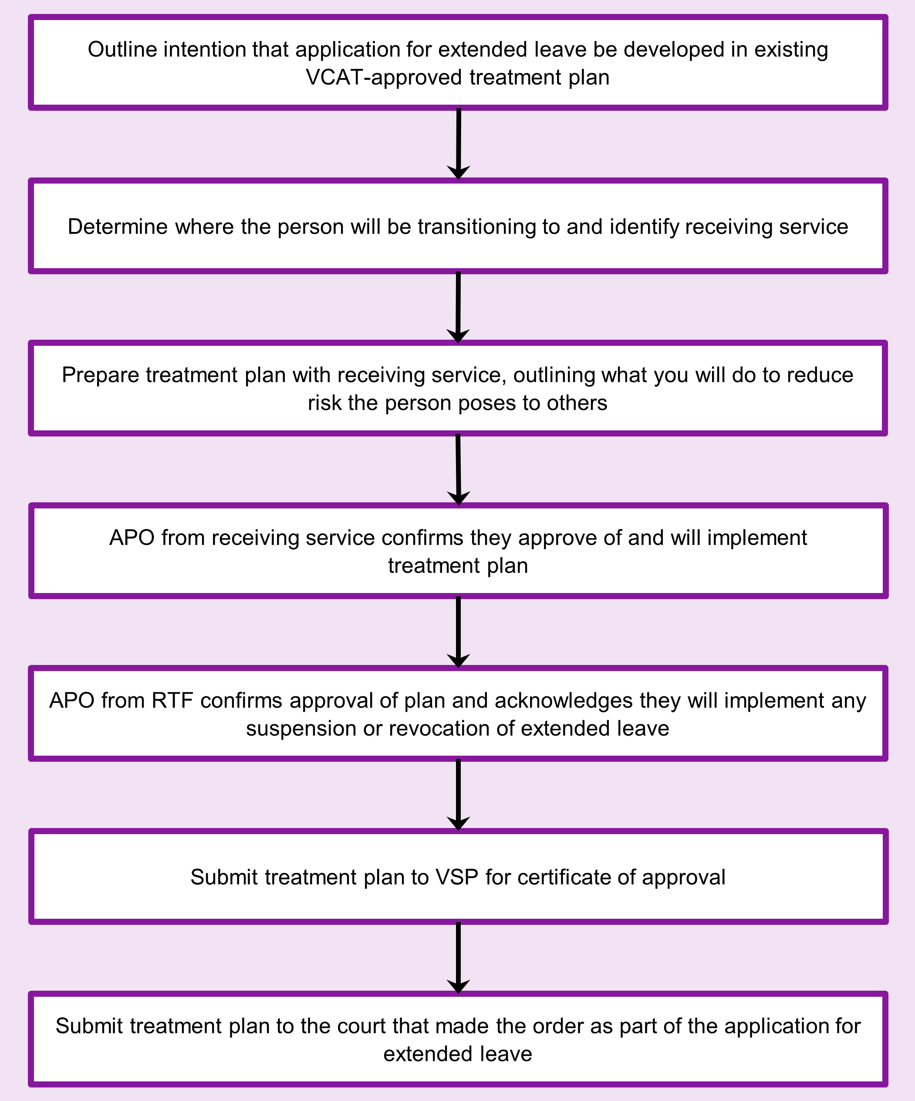

To receive this document in another format phone 03 9096 8427, using the National Relay Service 13 36 77 if required, or [email the Senior Practitioner](mailto:VictorianSeniorPractitioner@dffh.vic.gov.au) <VictorianSeniorPractitioner@dffh.vic.gov.au>.

Authorised and published by the Victorian Government, 1 Treasury Place, Melbourne.

© State of Victoria, Australia, Department of Families, Fairness and Housing, April 2021.

Available on the [DHHS website’s Senior Practitioner page](https://www.dhhs.vic.gov.au/victorian-senior-practitioner) <https://www.dhhs.vic.gov.au/victorian-senior-practitioner>.