

|  |
| --- |
| Process 8: Apply for a treatment plan review – RTF clients |
| Compulsory treatment – Senior Practitioner |
|  |

Contents

Acronyms 1

Treatment plan review for RTF clients 1

Application process 1

Figure 1: How to apply for a review of a treatment plan – RTF clients 3

# Acronyms

* APO: Authorised Program Officer
* RIDS: Restrictive Intervention Data System
* RTF: Residential treatment facility
* SP: Senior Practitioner
* VCAT: Victorian Administrative and Civil Tribunal

# Treatment plan review for RTF clients

## Application process

### Step 1: Person is admitted to residential treatment facility

The person is admitted to a residential treatment facility (RTF).

### Step 2: Develop treatment plan within 28 days of admission

A treatment plan must be developed within 28 days of admission – refer to s153(1) of the *Disability Act 2006*.

This plan must be lodged with the Senior Practitioner (SP) for approval **within two days** of its development.

A copy of the plan must be given to the person with an explanation of how they can seek a review. The person can seek a VCAT review of this plan anytime (see s155).

The plan must be reviewed by the VCAT within six months of admission – or 12 months if client is admitted under s152(2)(d) – and then reviewed again at intervals of not more than 12 months while the order that enabled the admission to the RTF is in place. Refer to s154(1).

**Note**: Treatment plans for residents admitted under s152(2)(c) do not require a VCAT review but the same processes for other RTF clients apply for SP oversight.

### Step 3: Develop revised treatment plan for SP approval

Prepare a revised treatment plan for SP approval before the end of the six (or 12) months.

Ensure that any previous VCAT or VPS directions have been addressed and that any materials referenced in the plan are attached. The outcomes of assessments and implications for treatment identified in the initial treatment plan should be addressed or considered in the revised plan.

Include an implementation report to advise on progress since admission or last review date.

### Step 4: APO applies to VCAT for s155 review of treatment plan

Access the online VCAT application on the [VCAT website’s Apply for an order under the Disability Act page](https://www.vcat.vic.gov.au/disability-act/apply-for-an-order-under-the-disability-act) <https://www.vcat.vic.gov.au/disability-act/apply-for-an-order-under-the-disability-act>.

Alternatively, use the form on the [DHHS website’s Senior Practitioner page](https://www.dhhs.vic.gov.au/victorian-senior-practitioner) <https://www.dhhs.vic.gov.au/victorian-senior-practitioner>.

### Step 5: APO complies with dates

If VCAT makes directions specifying when the treatment plan must be filed, the APO must comply with these dates.

The APO ensures SP is given the treatment plan and supporting materials by the date directed in the VCAT order to ensure SP has enough time to consider the plan and provide a certificate.

### Step 6: Print online application and upload to RIDS

Print the online application and upload to RIDS.

### Step 7: Support the person to access legal representation

Support the person to access legal representation. Ensure their legal representative has access to all materials that will be relied on at the VCAT hearing.

### Step 8: APO attends hearing

The APO attends the hearing with the person, their legal representative and any supporting people that will speak to the application.

### Step 9: APO gives SP track changes version of plan

After the VCAT hearing. the APO gives SP a track changes version of the plan showing:

* any variations made to the treatment plan during the VCAT hearing – refer to sections 155(3)(b) and 154(3)(b)
* variations to the plan that were agreed by the parties during the VCAT hearing with VCAT’s approval.

Figure 1: How to apply for a review of a treatment plan – RTF clients

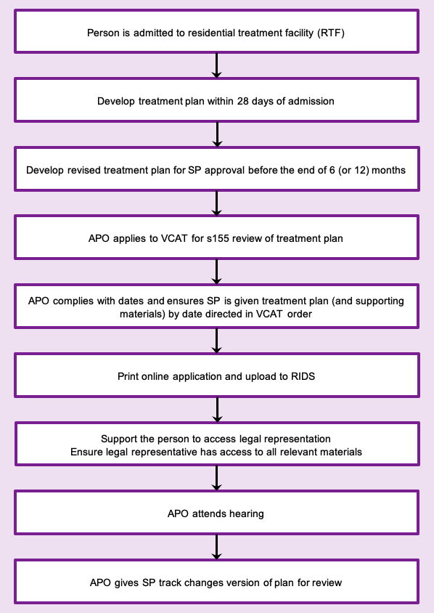

To receive this document in another format phone 03 9096 8427, using the National Relay Service 13 36 77 if required, or [email the Senior Practitioner](mailto:VictorianSeniorPractitioner@dffh.vic.gov.au) <VictorianSeniorPractitioner@dffh.vic.gov.au>.

Authorised and published by the Victorian Government, 1 Treasury Place, Melbourne.

© State of Victoria, Australia, Department of Families, Fairness and Housing, April 2021.

Available on the [DHHS website’s Senior Practitioner page](https://www.dhhs.vic.gov.au/victorian-senior-practitioner) <https://www.dhhs.vic.gov.au/victorian-senior-practitioner>.