

|  |
| --- |
| Process 7: Develop a treatment plan – RTF clients |
| Compulsory treatment – Senior Practitioner |
|  |

Contents

Acronyms 1

Treatment plans for RTF clients 1

Process 2

Figure 1: How to develop a treatment plan for RTF clients 3

# Acronyms

* APO: Authorised Program Officer
* RIDS: Restrictive Intervention Data System
* RTF: Residential treatment facility
* SP: Senior Practitioner
* VCAT: Victorian Administrative and Civil Tribunal

# Treatment plans for RTF clients

A treatment plan must be developed within 28 days of a person being admitted to a residential treatment facility (long term rehabilitation program and intensive residential treatment program) – see section 153(1) of the *Disability Act 2006*.

Within two days of developing the plan, the APO submits the plan to the Senior Practitioner (SP) for approval – refer to s153 (3)(b).

This applies to any person admitted to an RTF under s152(2)(a to f).

The plan must be reviewed within six months of admission by VCAT and then at intervals of not more than 12 months while the order that enabled the admission to the RTF is in place– see s154(1), specifically s154(1)(a) and s154(1)(b).

For those admitted under s152(2)(d), the plan is reviewed every 12 months.

For people admitted under s152(2)(c), VCAT approval is not currently required; however, the Senior Practitioner will review the treatment plan and provide a treatment plan statement.

## Process

### Step 1: Gather your evidence

Identify and review all relevant assessments and documentation to inform the completion of the plan. This should include information of behaviours of concern and a recent risk assessment.

Where possible this should include reports from varied allied health professionals including speech, sensory, neuropsychological and occupational health assessments.

#### Things to consider

Consider what assessment work is required over the life of the plan and what the key priorities are for the person and the care team. Include information on all restrictive practices and consider supervised leave of absence (SLOA) and unsupervised leave of absence (ULOA). The person’s goals and interests should be incorporated into the plan.

Make sure that all legislative criteria are addressed and contained within the plan. – refer to s 153(2).

Make sure that all reports, assessments and policies that have informed the plan, or are referenced within the plan are attached to the plan.

### Step 2: Prepare treatment plan within 28 days of admission

Prepare a treatment plan, outlining what treatment will be provided over the period to reduce the risk the person poses to others, based on current information, benefit to the person, any restrictive practices to be used, process for leave of absence and transition process. Refer to s 153(2) of the Act.

### Step 3: APO signs approval of plan

The APO signs approval of the plan.

The APO organises for the plan to be uploaded to RIDS.

### Step 4: APO submits treatment plan via RIDS within 28 days of admission

The SP requires a treatment plan to be submitted within 28 days of the person being admitted to an RTF under an order.

### Step 5: If needed, APO makes changes and resubmits via RIDS

If necessary, the APO makes required changes and resubmits the plan to SP using RIDS.

### Step 6: SP provides treatment certificate

The SP will provide a treatment certificate (or statement) approving the plan and make any relevant directions, including required dates for implementation reports.

### Step 7: Is a VCAT review needed?

* **No**: Clients in an RTF under s152(2)(c) do not need a VCAT review. Update the treatment plan and submit this to SP for review and a treatment plan statement within six months of admission and then in intervals of not more than 12 months for the life of the order.
* **Yes**: APO applies to VCAT for review of the plan within six months of being admitted – or within 12 months for those admitted under s152(2)(d). Follow the process for applying for a treatment plan review.

Figure 1: How to develop a treatment plan for RTF clients

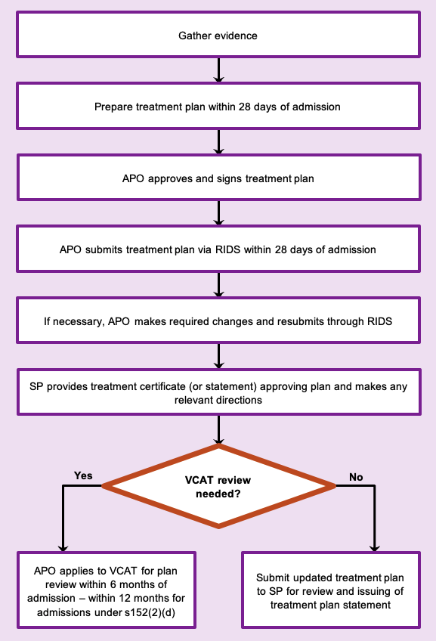

To receive this document in another format phone 03 9096 8427, using the National Relay Service 13 36 77 if required, or [email the Senior Practitioner](mailto:VictorianSeniorPractitioner@dffh.vic.gov.au) <VictorianSeniorPractitioner@dffh.vic.gov.au>.

Authorised and published by the Victorian Government, 1 Treasury Place, Melbourne.

© State of Victoria, Australia, Department of Families, Fairness and Housing, April 2021.

Available on the [DHHS website’s Senior Practitioner page](https://www.dhhs.vic.gov.au/victorian-senior-practitioner) <https://www.dhhs.vic.gov.au/victorian-senior-practitioner>.