

|  |
| --- |
| Process 6: Develop a revised treatment plan – existing clients |
| Compulsory treatment – Senior Practitioner |
| OFFICIAL |

Contents

Acronyms 1

Revise treatment plans 1

Process 1

Figure 1: How to revise a treatment plan 3

# Acronyms

* APO: Authorised Program Officer
* RIDS: Restrictive Intervention Data System
* SP: Senior Practitioner
* STO: Supervised treatment order
* VCAT: Victorian Administrative and Civil Tribunal

# Revise treatment plans

## Process

### Step 1: Gather your evidence

Consider whether a further supervised treatment order (STO) is needed and if the criteria for a STO continues to be met.

An up-to-date risk assessment is required to inform any application for a STO. If there is not a current one, arrange for one to be conducted by suitably qualified clinician before making an application.

Identify and review all relevant assessments and documentation to inform the STO application. This should include:

* frequency, intensity and duration of behaviours of concern
* the client’s response to staff intervention when warning signs to behaviours of concern are shown
* level and frequency of supervision
* level and frequency of restrictive practices
* clinical opinion
* reports from varied allied health professionals including speech, sensory, neuropsychological and occupational health assessments where available.

Also consider:

* progress against goals in the last treatment plan
* progress through step downs
* barriers to implementation and how these will be addressed, or treatment goals amended to reflect this.

### Step 2: Talk to the Compulsory Treatment team

Talk to a member of the Compulsory Treatment team as early as possible.

Discussions should be at least 75 days before an order expires to allow enough time for any further assessments to be conducted and reports made available. Problems getting an updated risk assessment should be raised with the Compulsory Treatment team as soon as issues occur.

### Step 3: Does the person still meet the STO criteria?

* **No**: Apply to VCAT for a revocation of the STO. **[process ends]**
* **Yes**: Go to **Step 4: Prepare a treatment plan**.

Talk to the care team and the Compulsory Treatment team to determine if the person still meets the STO criteria. Refer to criteria outlined in s191(6) of the *Disability Act 2006*.

### Step 4: Prepare a treatment plan

Prepare a treatment plan, outlining what you will do over the life of the plan to reduce the risk the person poses to others based on your assessments. This should include barriers to steps down and implementation, and progress of the previous plan.

Give the Compulsory Treatment Team the details of all support providers associated with the plan and the proposed accommodation address before submitting the application**.**

### Step 5: Complete and document all SP and VCAT directions

Make sure that all directions in the existing SP certificate of approval and VCAT order have been actioned and documented. This can be done within implementation reports.

### Step 6: Address all legislative criteria in the revised plan

Make sure that all legislative criteria are addressed in the revised plan. Refer to the treatment plan guide and s191(6) criteria for what is required in a treatment plan. The treatment plan acts as an NDIS behaviour support plan if written by an NDIS registered behaviour support practitioner and if the behaviours of concern section is completed.

Make sure that all reports, assessments and policies that have informed the plan, or are referenced within the plan, are attached to the plan.

### Step 7: APO approves plan and applies to VCAT for review

The APO signs approval of the plan and makes an application to VCAT for review of the plan. This can be done on the [VCAT website](https://www.vcat.vic.gov.au) <https://www.vcat.vic.gov.au> or using the form available on the [DHHS website’s Senior Practitioner page](https://www.dhhs.vic.gov.au/victorian-senior-practitioner) <https://www.dhhs.vic.gov.au/victorian-senior-practitioner>.

### Step 8: VCAT issues directions order

VCAT issues a directions order and notice of hearing.

### Step 9: Upload documents to RIDS

Upload documents to RIDS by the date directed by the VCAT.

### Step 10: SP issues certificate

SP issues a certificate in line with VCAT’s directions order.

Figure : How to revise a treatment plan

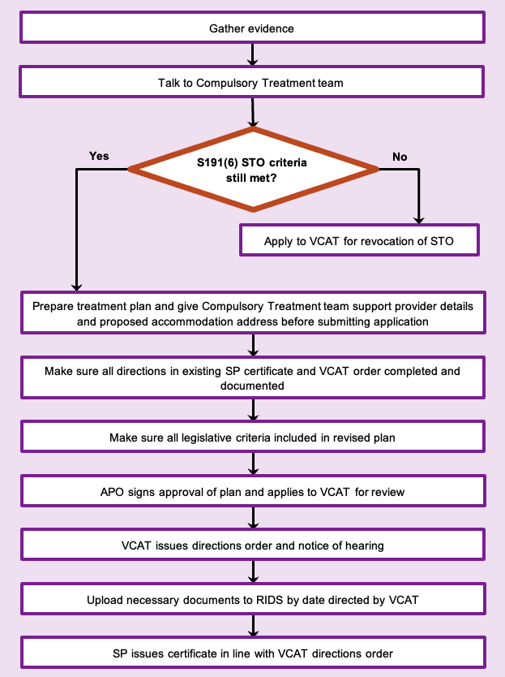

To receive this document in another format phone 03 9096 8427, using the National Relay Service 13 36 77 if required, or [email the Senior Practitioner](mailto:VictorianSeniorPractitioner@dffh.vic.gov.au) <VictorianSeniorPractitioner@dffh.vic.gov.au>.

Authorised and published by the Victorian Government, 1 Treasury Place, Melbourne.

© State of Victoria, Australia, Department of Families, Fairness and Housing, April 2021.

Available on the [DHHS website’s Senior Practitioner page](https://www.dhhs.vic.gov.au/victorian-senior-practitioner) <https://www.dhhs.vic.gov.au/victorian-senior-practitioner>.