

|  |
| --- |
| Process 5: Develop a treatment plan – new clients |
| Compulsory treatment – Senior Practitioner |
|  |

Contents

Acronyms 1

Treatment plans for new clients 1

Process 1

Figure 1: How to develop a treatment plan 4

# Acronyms

* APO: Authorised Program Officer
* OPA: Office of the Public Advocate
* RIDS: Restrictive Intervention Data System
* SDA: Specialist disability accommodation
* SP: Senior Practitioner
* STO: Supervised treatment order
* VCAT: Victorian Administrative and Civil Tribunal

# Treatment plans for new clients

## Process

### Step 1: Gather your evidence

An up-to-date risk assessment is required to inform the application for a supervised treatment order (STO). If there is not a current assessment, arrange for one to be conducted by a suitably qualified clinician before making an application.

Identify and review all relevant assessments and documentation to inform the STO application. This should include

* frequency, intensity and duration of behaviours of concern
* the client’s response to staff intervention when warning signs to behaviours of concern are shown
* level and frequency of supervision
* level and frequency of restrictive practices
* clinical opinion
* reports from varied allied health professionals, including speech, sensory, neuropsychological and occupational health assessments where available.

### Step 2: Talk to the Compulsory Treatment team

Talk to a member of the Compulsory Treatment team as early as possible to allow enough time for any further assessments to be conducted and reports made available. Consideration for an application for an assessment order may occur here.

### Step 3: Does the person meet the criteria for a supervised treatment order?

* **No**: Develop a behaviour support plan or get an NDIS behaviour support plan to manage any behaviours of concern or restrictive practices. **[process ends]**
* **Yes**: Go to **Step 4: Prepare treatment plan**.

Refer to s191(1) and (6) of the *Disability Act 2006* for disability service providers applying for STOs and 191(1A) and (6) for registered NDIS providers applying for STOs for SDA residents.

### Step 4: Prepare treatment plan

Prepare a treatment plan, outlining what you will do over the life of the plan to reduce the risk the person poses to others based on your assessments. A treatment plan guide is available from the Compulsory Treatment team.

### Step 5: Address all legislative criteria in plan and attach supporting material

Make sure that all legislative criteria are addressed within the revised plan. See s191(6) and (7) criteria and what is required in a treatment plan.

Make sure all reports, assessments and policies that have informed the plan, or are referenced within the plan, are attached to the plan. The treatment plan is considered an NDIS behaviour support plan if it is written by an NDIS registered behaviour support practitioner.

Give the Compulsory Treatment team details of all support providers associated with the plan and the proposed accommodation address to ensure the STO accommodation criteria is met before the application is submitted.

### Step 6: APO approves plan

The APO approves and signs the plan.

### Step 7: APO submits the treatment plan to the SP for approval

To apply to VCAT for a STO, you need a treatment plan that has been approved by the SP and a treatment plan certificate issued by the SP.

### Step 8: SP reviews treatment plan and issues certificate

The SP will review the submission and issue a treatment plan certificate with relevant directions.

### Step 9: APO applies to VCAT for STO

The APO makes an application to VCAT for a STO using the online application form once a treatment plan certificate is received.

This can be done on the [VCAT website](https://www.vcat.vic.gov.au) <https://www.vcat.vic.gov.au> or using the form available on the [DHHS website’s Senior Practitioner page](https://www.dhhs.vic.gov.au/victorian-senior-practitioner) <https://www.dhhs.vic.gov.au/victorian-senior-practitioner>.

Attach the application to the person’s file on RIDS along with supporting documentation.

### Step 10: Inform the person, legal representative and OPA of STO application

Inform the person who will be subject to the STO, their legal representative and the Office of Public Advocate that an application is being made.

Contact the Office of the SP for contact details.

### Step 11: VCAT issues directions

Once VCAT receives an application, it will issue a directions order and a notice of hearing to all relevant parties.

Figure 1: How to develop a treatment plan

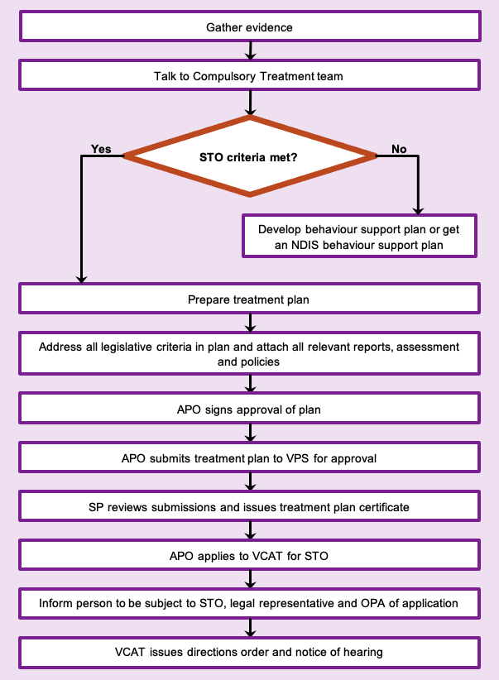

To receive this document in another format phone 03 9096 8427, using the National Relay Service 13 36 77 if required, or [email the Senior Practitioner](mailto:VictorianSeniorPractitioner@dffh.vic.gov.au) <VictorianSeniorPractitioner@dffh.vic.gov.au>.

Authorised and published by the Victorian Government, 1 Treasury Place, Melbourne.

© State of Victoria, Australia, Department of Families, Fairness and Housing, April 2021.

Available on the [DHHS website’s Senior Practitioner page](https://www.dhhs.vic.gov.au/victorian-senior-practitioner) <https://www.dhhs.vic.gov.au/victorian-senior-practitioner>.