

|  |
| --- |
| Process 3: Apply for an interim STO – new clients |
| Compulsory treatment – Senior Practitioner |
| OFFICIAL |

Contents

Acronyms 1

Interim supervised treatment orders 1

Application process 2

Figure 1: Interim STO process 4

# Acronyms

* APO: Authorised Program Officer
* BSP: Behaviour support plan
* NDIS: National Disability Insurance Scheme
* OPA: Office of the Public Advocate
* SDA: Specialist disability accommodation
* SP: Senior Practitioner
* STO: Supervised treatment order
* VCAT: Victorian Administrative and Civil Tribunal

# Interim supervised treatment orders

An interim supervised treatment order (section 192 of the *Disability Act 2006*) can only be made:

* if an application for a supervised treatment order has been made under s191
* if the APO has requested VCAT make an interim supervised treatment order having effect until the application for a supervised treatment order can be determined at a VCAT hearing

VCAT can only make an order if satisfied that the criteria for people living in residential services[1] or for SDA residents living in SDA-enrolled dwellings under an SDA residency agreement[2] are met and that the person must be detained to ensure compliance with the treatment plan and prevent a significant risk of serious harm to another person until the STO application is determined.

## Application process

### Step 1: Develop treatment plan and submit to SP for approval

Develop a treatment plan and submit to SP for approval.

### Step 2: Apply to VCAT for a STO under s191

* Apply under s 191(1) if you are a disability service provider and the client lives in a residential service.
* Apply under s 191(1A) if you are a registered NDIS provider and the client is an SDA resident living in an SDA-enrolled dwelling under an SDA residency agreement.

### Step 3: Talk to Compulsory Treatment team to determine if you need to detain the person

Talk to a member of the Compulsory Treatment team to determine if you need to detain the person to prevent a significant risk of serious harm to another person while you wait for the STO application to be determined by VCAT.

### Step 4: Does the person need to be detained?

* **No**: go to**Step 5a: Do not detain the person**.
* **Yes**: go to **Step 5b: APO contacts VCAT and makes s192 application**.

### Step 5a: Do not detain the person

Do not detain the person – wait for the application for a STO to be heard.

### Step 6a: Develop a behaviour support plan

Develop a behaviour support plan (refer to the BSP toolkit) if any restrictive practices are in place or arrange for an NDIS behaviour support practitioner to prepare one for all NDIS participants. **[Process ends]**

### Step 5b: APO contacts VCAT and makes s192 application

The APO contacts the VCAT (on 1300 01 8228) and makes an application:

* selecting s192 option
* stating the date that the application under s191 was made
* listing the dates of the treatment plan and the treatment plan certificate in the summary box.

Provide VCAT with all materials to support the application.

In most cases, the application for an interim STO is made at the same time as the application for a STO using the same form. This is done by requesting that an interim STO is considered by VCAT until a STO can be determined.

### Step 6b: Explain to the person that an application for an interim STO is being made

Explain to the person that an application for an interim STO is being made and help them access legal representation.

### Step 7b: Upload all relevant materials to RIDS

Upload all relevant materials (including the application form) to RIDS.

### Step 8b: Notify the person’s legal representation and the OPA

Notify the person’s legal representation and OPA.

Ensure that all parties have all relevant materials that will be relied on to make a decision on an interim STO.

Figure : Interim STO process

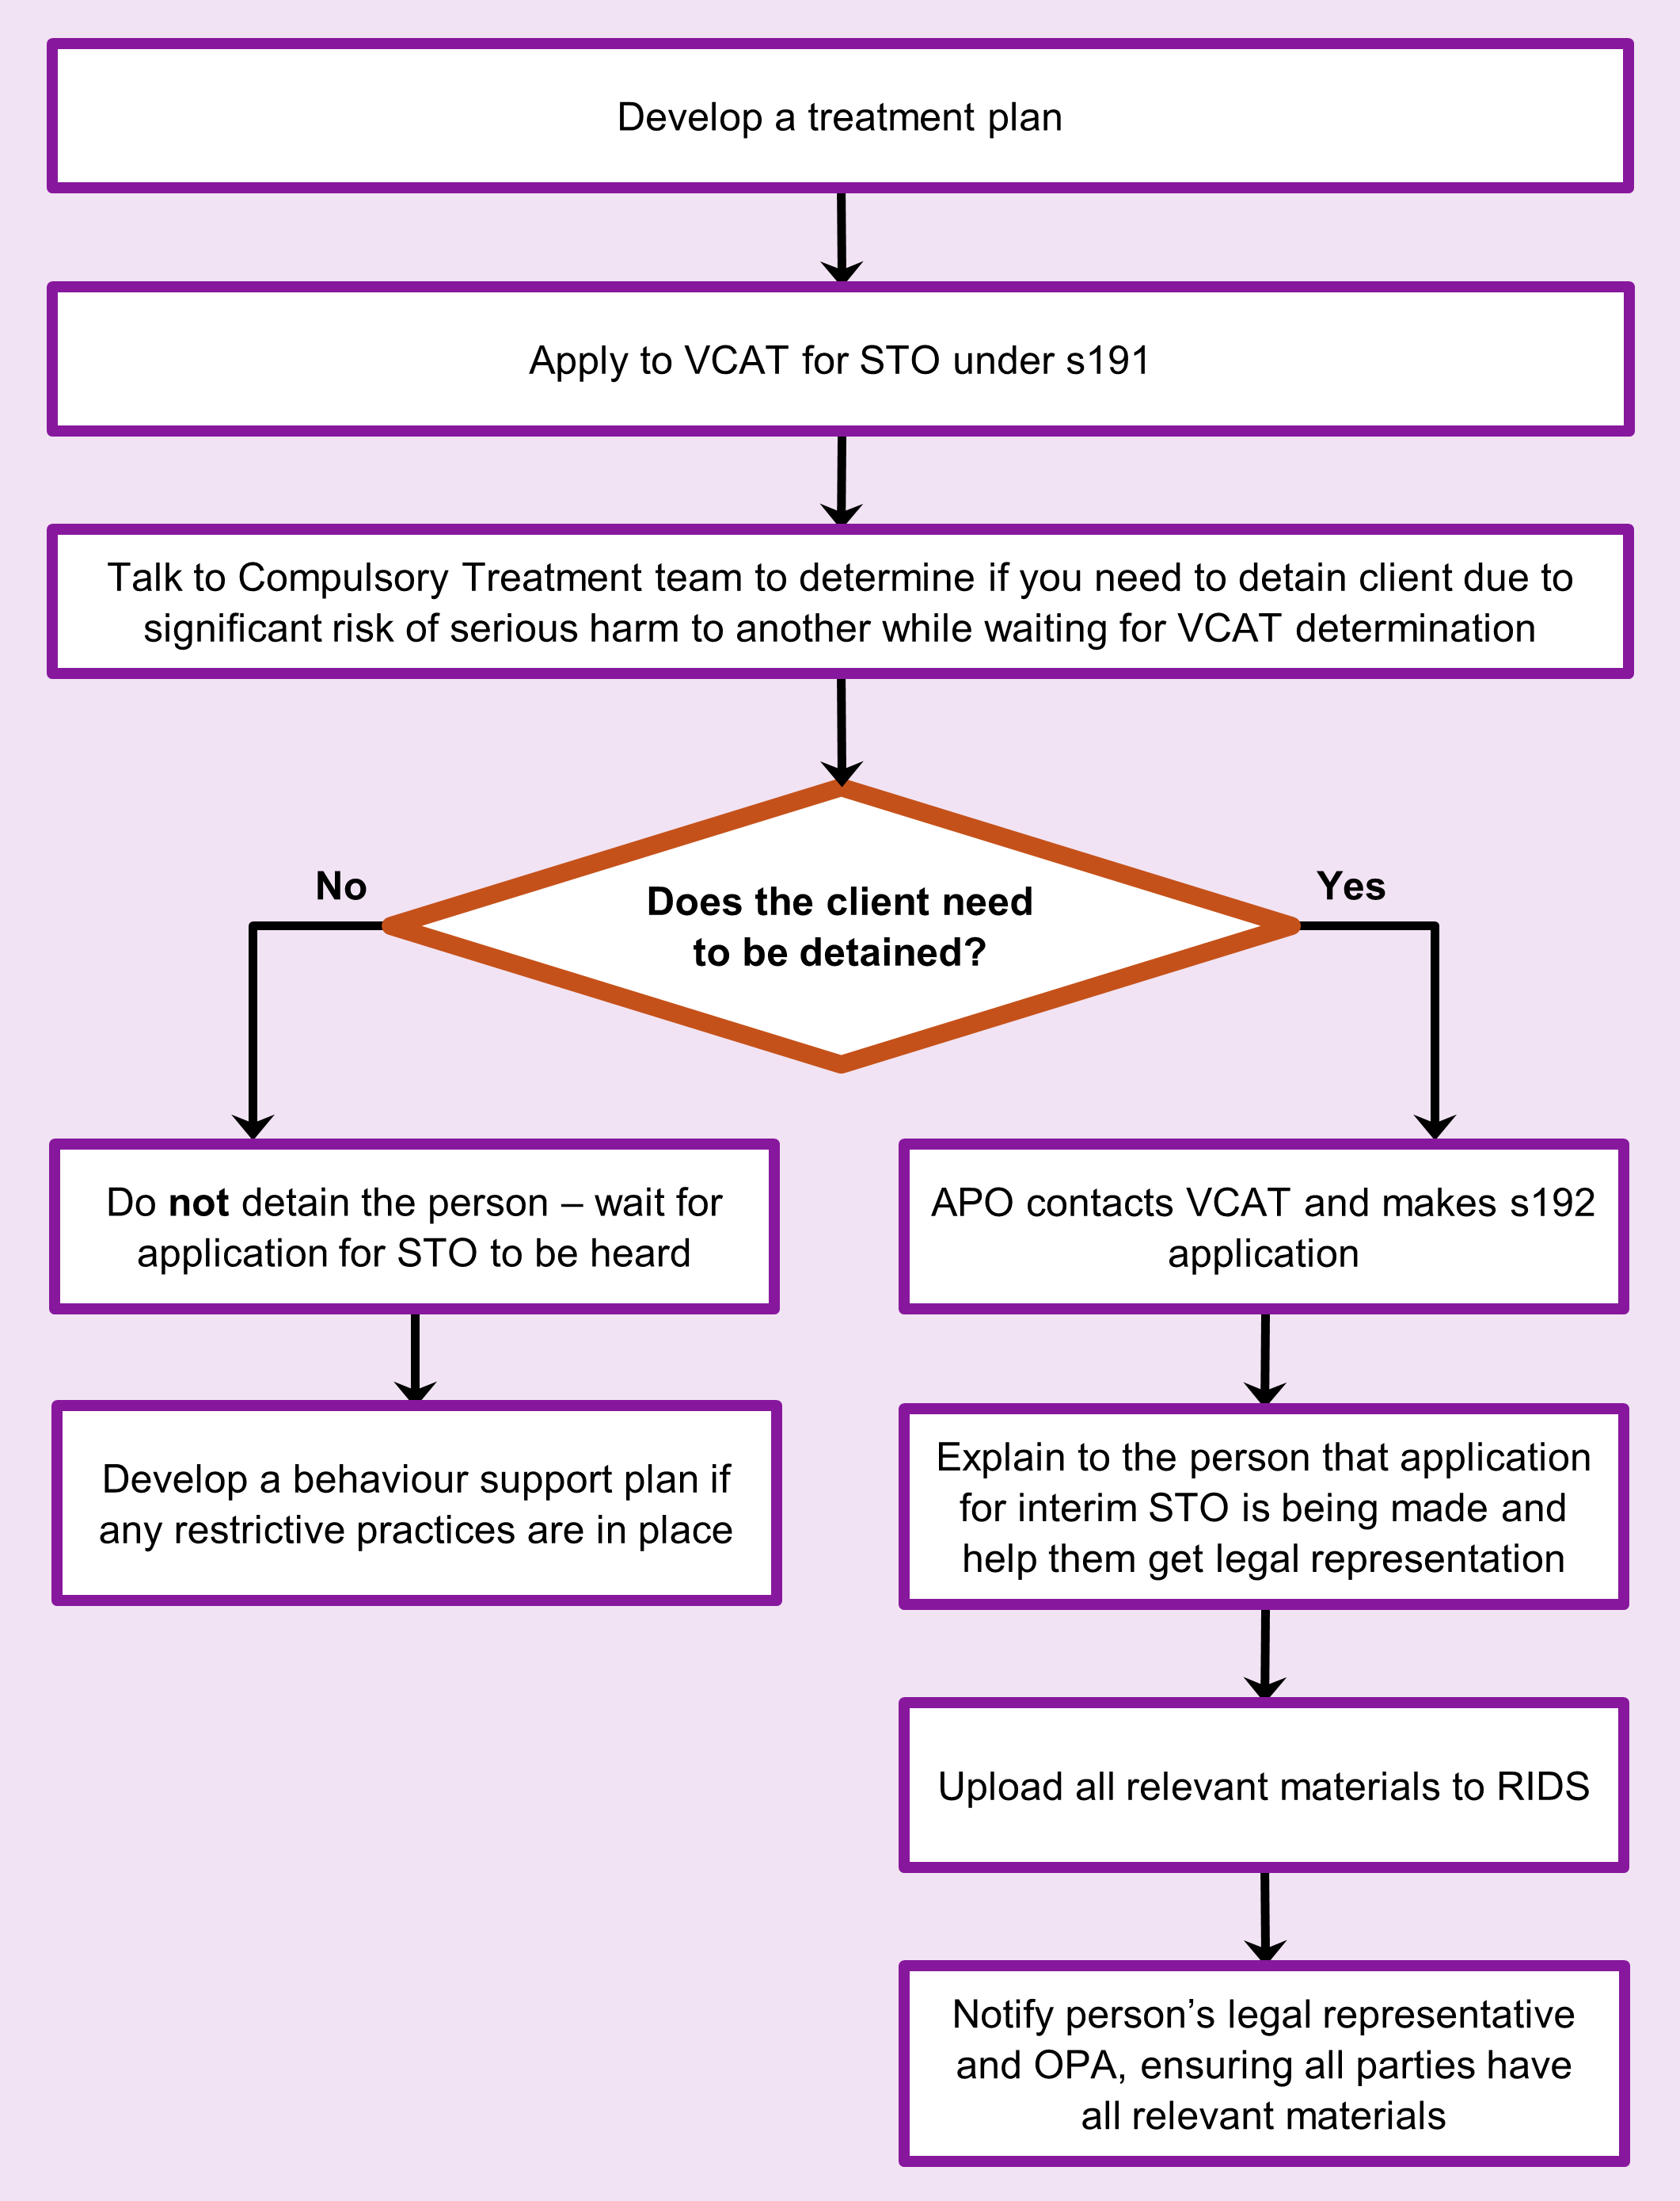

To receive this document in another format phone 03 9096 8427, using the National Relay Service 13 36 77 if required, or [email the Senior Practitioner](mailto:VictorianSeniorPractitioner@dffh.vic.gov.au) <VictorianSeniorPractitioner@dffh.vic.gov.au>.

Authorised and published by the Victorian Government, 1 Treasury Place, Melbourne.

© State of Victoria, Australia, Department of Families, Fairness and Housing, April 2021.

Available on the [DHHS website’s Senior Practitioner page](https://www.dhhs.vic.gov.au/victorian-senior-practitioner) <https://www.dhhs.vic.gov.au/victorian-senior-practitioner>.

1. s191(1) (a to c)
2. s191(1A)(a to d)