

|  |
| --- |
| Process 11: Implementation reports |
| Compulsory treatment – Senior Practitioner |
| OFFICIAL |

Contents

Acronyms 1

Implementation reports 1

Process 1

Figure 1: Implementation reports process 2

# Acronyms

* APO: Authorised Program Officer
* RIDS: Restrictive Intervention Data System
* VCAT: Victorian Administrative and Civil Tribunal
* SP: Senior Practitioner

# Implementation reports

Authorised Program Officers (APOs) must give the Senior Practitioner (SP) implementation reports of treatment plans.

Receiving and reviewing implementation reports is essential to enable the SP to fulfil its legal requirements to supervise the implementation of treatment plans.

Implementation reports are due to the SP at intervals of no more than six months or at intervals directed by the SP. Dates that implementation reports are due are outlined in treatment plan certificates.

## Process

### Step 1: Check when implementation report is due

Check the treatment plan certificate relating to the current VCAT-approved treatment plan for when the next implementation report is due.

### Step 2: Report progress of directions

Report on progress of any directions made by the SP or VCAT.

### Step 3: Report on any data or other evidence

Report on any data and other evidence that informs your support of the person.

The data and information provided should directly relate to the amount of restriction or supervision that the person is subject to and the progress towards achieving identified treatment goals. Consider any barriers to implementing the treatment plan and progress through identified step downs.

For more information on the content of implementation reports, refer to the *Implementation report practice guide* or talk to a member of the Compulsory Treatment team.

### Step 4: Submit implementation report by due date

Submit the implementation report in RIDS on or before the due date.

**Note**: Attachments cannot be directly attached to the implementation report. Instead, they can be attached to the relevant treatment plan in RIDS. Make a note of any attachments in the implementation report.

Figure : Implementation reports process

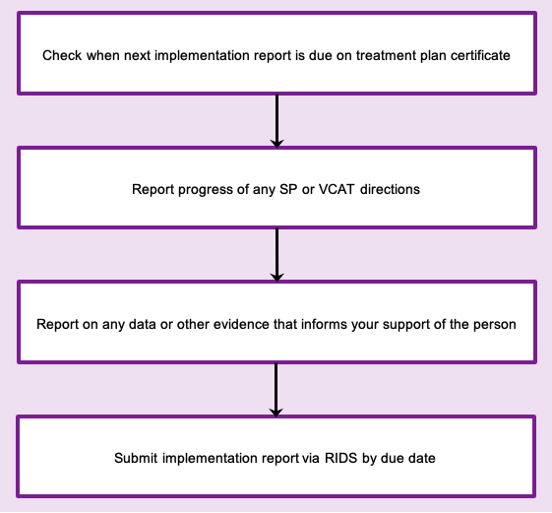

To receive this document in another format phone 03 9096 8427, using the National Relay Service 13 36 77 if required, or [email the Senior Practitioner](mailto:VictorianSeniorPractitioner@dffh.vic.gov.au) <VictorianSeniorPractitioner@dffh.vic.gov.au>.

Authorised and published by the Victorian Government, 1 Treasury Place, Melbourne.

© State of Victoria, Australia, Department of Families, Fairness and Housing, April 2021.

Available on the [DHHS website’s Senior Practitioner page](https://www.dhhs.vic.gov.au/victorian-senior-practitioner) <https://www.dhhs.vic.gov.au/victorian-senior-practitioner>.