

|  |
| --- |
| Process 1: Assessment orders |
| Compulsory treatment – Senior Practitioner |
| OFFICIAL |

Contents

Acronyms 1

Assessment orders 1

Application process 2

Figure 1: How to apply for an assessment order 4

Timeline for an assessment order 5

Figure 2: Assessment order timeline 6

# Acronyms

* AO: Assessment order
* APO: Authorised Program Officer
* OPA: Office of the Public Advocate
* SDA: Specialist disability accommodation
* SP: Senior Practitioner
* STO: Supervised treatment order
* VCAT: Victorian Administrative and Civil Tribunal

# Assessment orders

Assessment orders are orders made by the Senior Practitioner (SP) under s199 of the *Disability Act 2006* that allow a disability service provider or a registered NDIS provider to detain a person. This includes

* physically locking a person in any premises
* constantly supervising or escorting a person to prevent the person from exercising freedom of movement.

An assessment order can only be applied and granted if:

* the person has an intellectual disability
* the person is receiving residential services or is an SDA resident under an SDA residency agreement
* it is necessary to detain the person to prevent a significant and imminent risk of serious harm to another person, and
* an assessment needs to be undertaken to enable the urgent development of a treatment plan for the purpose of making an application for a supervised treatment order.

An assessment order lasts for 28 days, cannot be extended or renewed, and can only occur once per client.

## Application process

### Step 1: Talk to Compulsory Treatment team

Talk to a member of the compulsory treatment team as early as possible to determine if you need to apply for an assessment order.

### Step 2: Assessment order criteria met?

Does the person meet the criteria for an assessment order (section 199 of the Disability Act)?

* **No**: Detention is not necessary – detention to end immediately (the person may need a behaviour support plan or an NDIS behaviour support plan). **[process ends]**
* **Yes**: Go to **Step 3: APO emails SP to apply for AO**.

### Step 3: APO emails SP to apply for AO

The APO applies to the SP via email for an order to be made. This application should include the reason for the application and any relevant background information.

### Step 4: SP approves order

Assessment order approved by SP, which may specify conditions.

### Step 5a: APO gets assessments and implements any SP directions

The APO gets assessments and implements any directions from the SP. They may apply to VCAT requesting a hearing date for an STO close to expiry of AO or detention ceased if STO unnecessary

### Step 5b: SP writes to the person within 72 hours

The SP writes to the person within 72 hours outlining the assessment order details and why they are satisfied that the criteria for an assessment order have been met.

The SP will also:

* tell the person how they can apply for a review
* notify the Office of the Public Advocate and the NDIS Commission (if a registered NDIS provider obtained the AO) that the order has been made.

### Step 6: APO and SP consider if STO is needed

The APO, in consultation with the SP, considers if a STO will be necessary.

### Step 7: APO submits treatment plan at least 7 days before AO expires

If an STO is needed, the APO submits a treatment plan **at least seven days before** the AO expires.

### Step 8: APO files application for new STO.

The APO files a section 191 application for a new STO – s191(1) for disability service providers and s191(1A) for registered NDIS providers. The APO must:

* file the s191 application and a treatment plan (NDIS behaviour support plan for NDIS participants living in SDA, if written by a registered NDIS behaviour support practitioner), any supporting materials and treatment plan certificate
* ensure OPA, the person and their legal representative are notified.

### Step 9: Talk to VCAT to determine if interim STO is needed

Talk to VCAT to determine if an application for an interim supervised treatment order under s192 will be needed. For example, if the STO application is not able to be heard within the 28 days of the assessment order and it is necessary to detain the person.

Figure : How to apply for an assessment order

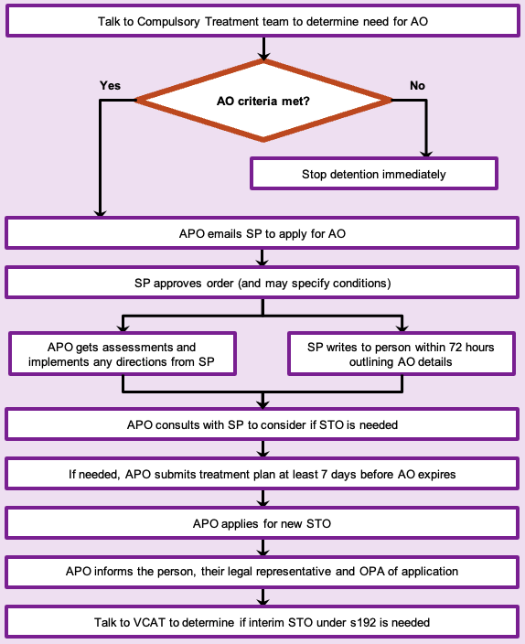

## Timeline for an assessment order

### Day 1

The assessment order starts on the day the SP approves the order. The order is for 28 days only.

### Days 1 to 14

* Get assessments
* Begin draft treatment plan in anticipation of applying for a STO.
* Consult with the Compulsory Treatment team as needed about developing the plan.

If you are unsure if you wish to apply for a STO, it is better to have a treatment plan prepared as this will need to be approved by the SP to apply for a STO.

### Days 14 to 20

* Finalise the plan, focusing on treatment goals and details of restrictive practices and step-down planning.
* Consider key recommendations from gathered assessments.
* Consult with the Compulsory Treatment team as needed about completing the plan.

### Day 21

* APO signs finalised treatment plan
* Submit signed treatment plan and any supporting materials to the SP for approval no later than day 21 (seven days before the assessment order expires).

### Day 25

* SP provides a treatment certificate no later than day 25 of the order
* Once certificate of approval is obtained, make an application for a supervised treatment order with VCAT
* If you do not get a hearing date before the order expires, make an application for an interim supervised treatment order.

### Day 28

Assessment order expires.

Figure : Assessment order timeline

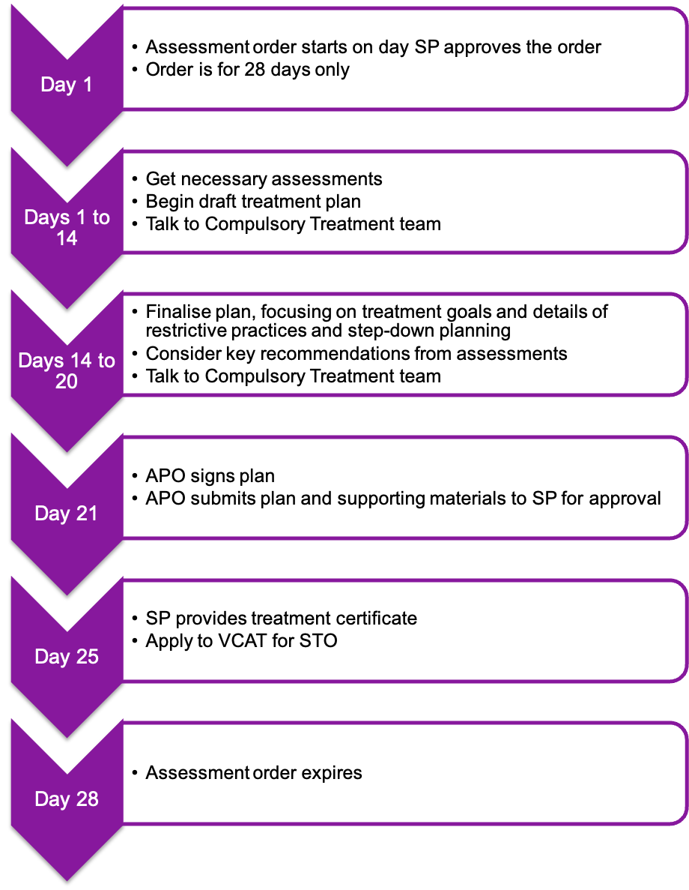

To receive this document in another format phone 03 9096 8427, using the National Relay Service 13 36 77 if required, or [email the Senior Practitioner](mailto:VictorianSeniorPractitioner@dffh.vic.gov.au) <VictorianSeniorPractitioner@dffh.vic.gov.au>.

Authorised and published by the Victorian Government, 1 Treasury Place, Melbourne.

© State of Victoria, Australia, Department of Families, Fairness and Housing, April 2021.

Available on the [DHHS website’s Senior Practitioner page](https://www.dhhs.vic.gov.au/victorian-senior-practitioner) <https://www.dhhs.vic.gov.au/victorian-senior-practitioner>.