

|  |
| --- |
| Positive practice framework  A guide for behaviour support practitioners |



**Cover image: ‘People’, painting by Brady Freeman, one of the winners of the 2016   
VALID Annual ‘Having a Say’ conference Art Competition sponsored by the Senior   
Practitioner, Office of Professional Practice**

To receive this publication in an accessible format phone 03 9096 8427 using the National Relay Service 13 36 77 if required, or [email the Office of Professional Practice](mailto:officeofprofessionalpractice@dhhs.vic.gov.au) <[officeofprofessionalpractice@dhhs.vic.gov.au](mailto:officeofprofessionalpractice@dhhs.vic.gov.au)>.

Authorised and published by the Victorian Government, 1 Treasury Place, Melbourne.

© State of Victoria, Department of Health and Human Services, January 2018.

Where the term ‘Aboriginal’ is used it refers to both Aboriginal and Torres Strait Islander people. Indigenous is retained when it is part of the title of a report, program or quotation.

ISBN 978-1-76069-235-3 (pdf/online)

Available from the <https://www.dhhs.vic.gov.au/victorian-senior-practitioner>

(1801029)

**Disclaimer**

This *Positive practice framework* (‘the framework’) has been prepared as a practice reference resource only. It is not a comprehensive or binding statement of the obligations of practitioners or disability service providers in relation to their work and should not be relied upon as such. The Department of Health and Human Services will endeavour to update this document from time to time as the need arises but does not warrant that it will always be up to date. The Department of Health and Human Services and the State of Victoria disclaim all liability for any loss or damage suffered by any individual or organisation as a result of use of the framework or reliance on any information it contains, including loss or damage arising from any claims made by a third party.

Contents

Executive summary 6

Part A: About the *Positive practice framework* 7

1 Purpose 7

2 Format of the practice strategies 8

3 Definitions 8

Part B: Positive behaviour support 12

4 Positive behaviour support 12

5 Self-directed approaches 13

Part C: Context for the practice model 14

6 Effective services 14

7 Ethical services 14

Part D: About the practice model 15

8 Goals 16

Part E: Practice model standards 17

9 About the standards 17

Part F: Principles 18

10 About the principles 18

Part G: Practice model: practice pathway 20

Part H: Practice strategies 21

11 Introductory comments 21

12 Format of the practice strategies 21

13 Referral 23

14 Behavioural assessment 25

15 Contemporary interventions 36

16 Inclusive support 47

17 Review and exit 54

Part I: Effective governance 56

18 Policy and standards 56

19 Clinical leadership 58

20 Promoting good practice 59

21 Behaviour support practitioners as scientists 59

Part J: Appendices 60

Appendix 1: Disability Services policy and legislation 60

Appendix 2: Social model of disability 60

Appendix 3: International Classification of Functioning, Disability and Health 61

Appendix 4: Human rights 61

Appendix 5: Human Services Standards 62

Appendix 6: Advocacy 62

Appendix 7: MacArthur Treatment Competence Study 62

Appendix 8: Referral information 63

Appendix 9: Risk assessment 64

Appendix 10: Health screening 65

Appendix 11: Mental health screening tools 65

Appendix 12: Risk assessment tools 68

Appendix 13: Communication assessment tools 70

Appendix 14: Sensory processing problem resource 70

Appendix 15: Phenotype information 70

Appendix 16: Context tools 71

Appendix 17: Adaptive behaviour scales 73

Appendix 18: Quality of life scales 74

Appendix 19: Is functional assessment an effective and ethical approach? 76

Appendix 20: Measures of behaviour 76

Appendix 21: Functional assessment tools 77

Appendix 22: Formulation 79

Appendix 23: Systematic observation tools 79

Appendix 24: Mediator analysis 85

Appendix 25: Standards for a positive behaviour support plan 89

Appendix 26: Contextual fit 90

Appendix 27: Goal setting 90

Appendix 28: Quality of life 90

Appendix 29: Is relying on environmental strategies alone adequate? 91

Appendix 30: Sensory environments 91

Appendix 31: Active support 91

Appendix 32: Is skills building effective and ethical? 92

Appendix 33: Are cognitive-behavioural strategies an effective and ethical approach? 92

Appendix 34: Teach skills resources 93

Appendix 35: Social skills resources 93

Appendix 36: Speech and communication resources 94

Appendix 37: Attachment and trauma resources 94

Appendix 38: Behavioural and family systems interventions 96

Appendix 39: Social stories resources 96

Appendix 40: Mindfulness techniques 97

Appendix 41: Punishment 97

Appendix 42: Reinforcement schedule resources 97

Appendix 43: Counterintuitive strategies 98

Appendix 44: Planned immediate responses resources 98

Appendix 45: Occupational health and safety resources 99

Appendix 46: System constraints to implementation 99

Appendix 47: Constructive systems change 99

Appendix 48: Positive working relationships 100

Appendix 49: National disability strategy 100

Appendix 50: Children and adolescents 100

Appendix 51: Aboriginal and Torres Strait Islander people 101

Appendix 52: Culturally and linguistically diverse backgrounds 101

Appendix 53: Strategies for attitudinal change 101

Appendix 54: Collaboration 101

Appendix 55: Self-care 103

Appendix 56: Supervision 103

Appendix 57: Training 104

Appendix 58: Collective leadership model 104

Appendix 59: Managing behaviours training 105

Appendix 60: Review 106

Appendix 61: Advocacy for individuals 106

Appendix 62: Feedback 106

Appendix 63: Outcome and process measures 107

Appendix 64: Professional development 107

Appendix 65: Australian Health Practitioner Regulation Agency 108

Appendix 66: Community of practice 108

Appendix 67: Assumptions about behaviour 108

Appendix 68: Qualitative, quantitative and econometric measures 108

Appendix 69: Outcome measures 109

Part K: References 110

# Executive summary

The Department of Health and Human Services funds a range of services for children, adolescents and adults with disability, according to legislative requirements under the *Disability Act 2006*. These services are delivered by the department, community service organisations and private practitioners.

More recently, the National Disability Insurance Scheme (NDIS) was established under the *National Disability Insurance Act 2013*. Under the NDIS, funding is provided to participants to purchase a range of supports aimed at increasing their independence, inclusion and social and economic participation. Behaviour support within the NDIS results in a plan to limit the likelihood of behaviours of concern developing and/or increasing. The plan will assist a participant, their family and supporters to identify and address behaviours of concern through specific positive behaviour support strategies.

The Positive practice framework (PPF), first established in 2011, is an online resource for behaviour support practitioners. It presents a practice model that brings together current research, knowledge and practice strategies and reflects the legislative requirements of the Disability Act. The PPF operationalises positive behaviour support and promotes a person-centred approach to responding to people with emerging or presenting behaviours of concern. It relies on a comprehensive assessment and analysis of the meaning of behaviour for the person within a whole-of-life context and provides for a person with disability to exercise their human rights in an appropriate manner and to live in, be included in and participate in the community.

Evidence and a set of practice principles underpin the PPF practice model to ensure the integrity of the model over future revisions and to guide ethical and effective practice. In addition to presenting a practice model, the PPF also supports practitioners to exercise professional judgement within an organisational context and complements professional supervision and development. The PPF assists practitioners to promote and inform people about their role and the services they provide.

The revised PPF is aligned with the objectives and principles of both the Disability Actand the National Disability Insurance Act. The content of the PPF includes: background information and context; an overview of the practice model and principles; numerous practice pathway strategies and advice; standards and supporting templates; and references. The practice pathway has been designed to assist practitioners to implement the practice model and offers practice advice about key stages of the practice pathway such as assessment, intervention, support and review.

# About the Positive practice framework

## Purpose

The Positive practice framework (PPF) is an online resource for behaviour support practitioners. It presents a practice model that brings together current research, knowledge and practice strategies and reflects the legislative requirements of the Disability Act 2006.

In addition to ensuring the practice model is underpinned by evidence, a set of practice principles were developed in consultation with stakeholders to ensure the integrity of the model over future revisions and to guide ethical and effective practice.

Behaviour support practitioners are specialists, preferably with tertiary qualifications in relevant disciplines such as nursing, psychology, special education, speech pathology, occupational therapy or social work, and/or staff with relevant behavioural training and experience. Behaviour support managers are responsible for managing multidisciplinary teams.

To manage and prevent behaviours of concern, behaviour support practitioners:

* conduct comprehensive assessments relevant to the person’s presenting needs and circumstances
* develop and implement evidence-based behaviour support programs, which might be delivered in the form of multisystemic interventions and/or individual therapy
* deliver training and consultation to staff and carers based on contemporary practice and professional standards
* promote environments that support and maintain positive behaviour.

The goals of the PPF are to ensure behaviour support practitioners:

* deliver evidence-based services that are consistent with a contemporary human rights approach to supporting people with disability
* demonstrate accountability to the person with disability, their support network and the disability service system
* deliver consistent standards of services statewide while taking into account local and individual client circumstances.

## Format of the practice strategies

The PPF presents background information/context, standards, principles, an overview of the practice model, key practice strategies and advice and supporting references/templates.

Each phase of the practice pathway contains hyperlinks that take the reader to additional supporting information including templates, suggested assessment/planning tools and additional advice.

The practice strategies are presented in the following format.

Practice strategy

|  |  |
| --- | --- |
| Component | Description |
| Task | The task required of the section of the Positive practice framework |
| Process | The method for achieving the task |
| Outcomes | The outcome to be achieved by the behaviour support practitioner (practice strategies) or the behaviour support manager (quality assurance) |
| Standard | The standard to be supervised by the behaviour support manager |
| Sample proforma | Where applicable |

The PPF should be read in conjunction with Disability Services policy and legislation (Appendix 1).

The PPF:

* promotes a positive approach to responding to people with emerging or presenting behaviours of concern that reflects best practice and is person-centred and outcome-focused
* relies on a comprehensive assessment and analysis of the meaning of behaviour for the person within a whole-of-life context
* provides for a person with disability to exercise their human rights in an appropriate way and to live in, be included in and participate in the community.

## Definitions

### Disability

Disability is not simply a quality or attribute inherent in an individual person that requires treatment or cure. Rather, disability comes about as a consequence of the complex interaction between biological, psychological and social factors, including physical, economic and attitudinal barriers to participation at home, in education, at work or in the community generally (McVilly & Newell 2007).

A key principle of positive behaviour support is that it is a non-categorical process; that is, strategies, interventions and decisions are not based on any particular category of behaviour, impairment or disability. Therefore, the framework aligns itself with a social model definition of disability (Appendix 2), which is supported by the World Health Organization (WHO) International Classification of Functioning Disability and Health (Appendix 3) and the United Nations (UN) *Convention on the Rights of Persons with Disabilities* (Appendix 4). The process must address ethical issues and priorities (managing risk, duty of care to provide effective interventions and prevention of abuse) as outlined in the Victorian *Charter of Human Rights and Responsibilities* (Appendix 4) and the *UN Convention on the Rights of Persons with Disabilities* (Appendix 4).

The WHO International Classification of Functioning, Disability and Health is a biopsychosocial framework that informs the PPF. It covers:

* body functioning associated with the integrity of the person’s body structures and functions (including the nervous system and cognitive functioning)
* activities and participation known to affect health and wellbeing (including communication, learning, domestic activity and social and community participation)
* environmental factors that can facilitate or impede the person realising their full potential (including physical, social and political factors).

Figure 1 presents a diagrammatic representation of factors that predispose, precipitate or maintain mental ill-health and/or behaviours of concern.

Figure 1: Factors that predispose, precipitate or maintain mental ill-health and/or behaviours of concern

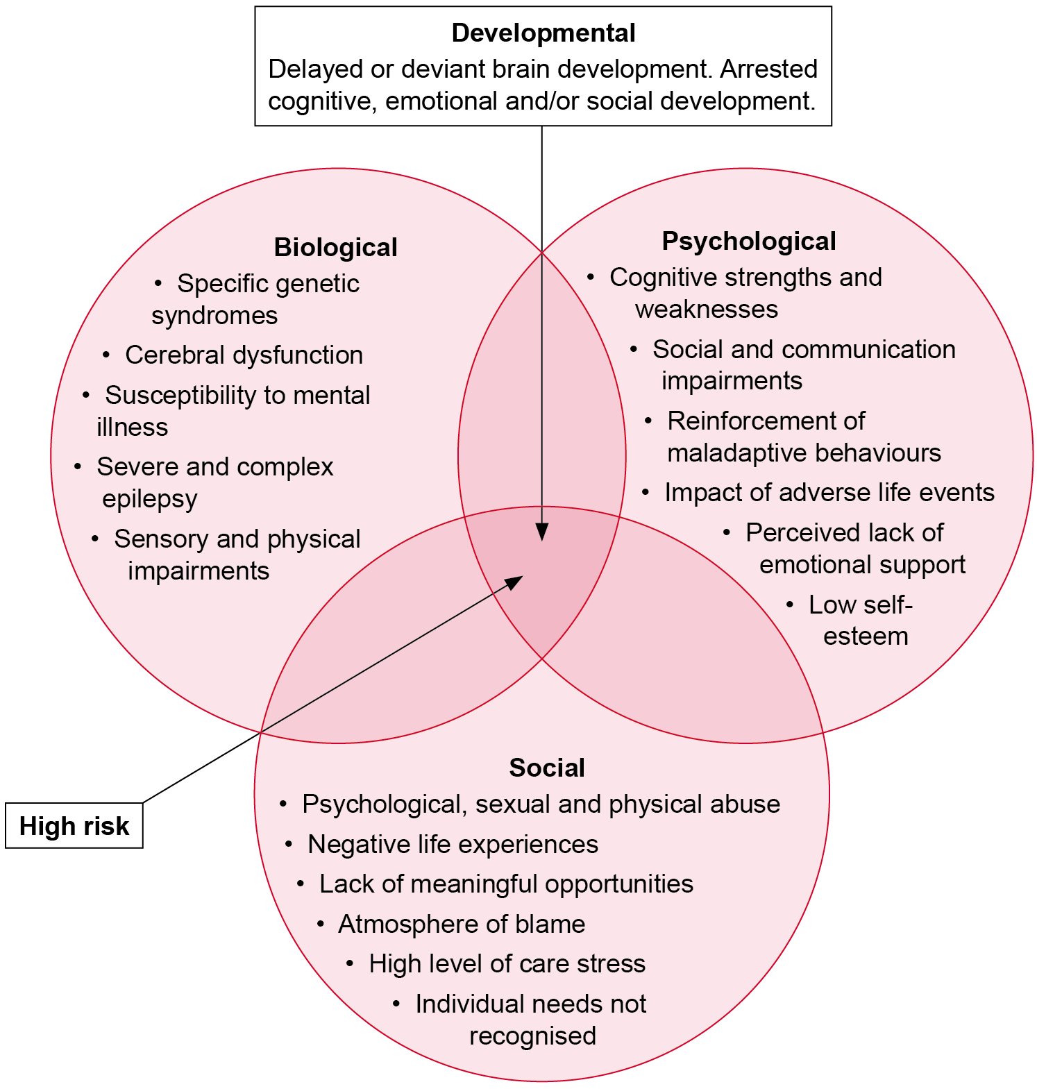

Adapted from: Holland & Jacobson (2001) (cited in McVilly 2002).

### Behaviours of concern

Behaviours of concern are socially constructed, an outcome of the person–environment interaction. Therefore, such behaviours are a ‘challenge’ to service systems.

Reinforcing the social model of disability, behaviours of concern may be a reaction to an inappropriate environment or a method of communicating a lack of autonomy, lack of stimulation, frustration at not being understood, or overstimulation. A more inclusive social model definition incorporates intrinsic factors such as the nature and severity of impairment and contextual factors such as the attitudes of others, the extent to which the environment is enabling or disabling and wider critical social and economic issues. Behaviours of concern may represent ‘protest or resistance’ when the environmental responses are neglectful, socially/morally unacceptable, abusive or restrictive, particularly when human rights are violated. In other words, it is system attitudes, practices and structures that are disabling, not necessarily facets of the person.

For the purpose of this document, behaviours of concern are defined as (McVilly 2002):

Any behaviour that is a barrier to a person participating in and contributing to their community (including both active and passive behaviours) that undermines, directly or indirectly, a person’s rights, dignity or quality of life, and poses a risk to the health and safety of a person and those with whom they live or work.

This definition of behaviour of concern has been adopted by the Australasian Society for the Study of Intellectual Disability and the Australian Psychological Society (Budiselik et al. 2010).

This definition is:

* tangible – behaviours can be observed and measured
* dynamic – social and interactive elements are identified.

The definition guides practitioners in addressing person factors, environmental factors and human rights.

Positive behaviour support can be defined as ‘a multifaceted approach that builds from functional behavioural assessment of problem behaviour and generates a support plan that is both comprehensive and educative’ (Morris & Horner 2016, p. 425).

Foundational components of positive behaviour support include (Morris & Horner 2016):

* functional behaviour analysis
* antecedent manipulations based on assessment
* teaching strategies
* altering contingent reinforcement to emphasise the positive and reduce or remove the aversive.

Dunlap et al. (2009) have identified four core features of positive behaviour support:

* application of research-validated behavioural science
* integration of multiple intervention elements to provide ecologically valid, practical support
* commitment to substantive, durable lifestyle outcomes
* implementation of support within organisational systems that facilitate sustained effects.

Central to all definitions is the application of behavioural science, the goal of improving quality of life, and the need for systems change (Grey, Lydon & Healy 2016).

### Scope of services

Behaviour support broadly includes the following:

* An intervention that is provided directly with the person, or via carers or staff. This form of service delivery requires assessment, intervention and support strategies. These strategies may be delivered simultaneously rather than sequentially.
* Consultation and skills building that is designed to build systemic capacity. This form of service delivery involves the application of clinical knowledge and skills to enhance service policy and procedures as well as the knowledge and skills of those who provide direct support to people with disability.

The Department of Health and Human Services is registered with the National Disability Insurance Agency (NDIA) to provide behaviour support. Under the National Disability Insurance Scheme (NDIS), funding is provided to participants to purchase a range of supports aimed at increasing their independence, inclusion and social and economic participation. Participants with funding allocated in their plan for behaviour support may choose to access services that provide behaviour support to NDIS participants, specifically in the ‘Improved Relationships’ category (3.11), in which specialised assessment is delivered where the client need is unclear or complex, or requires long-term or intensive supports to address behaviours of concern.

# Positive behaviour support

## Positive behaviour support

Positive behaviour support is both a philosophy of practice and a term to denote a range of individual and multisystemic interventions designed to effect change in people’s behaviour and ultimately their quality of life. Positive behaviour support is the approach that underpins this framework.

Positive behaviour support is applicable to all people; it has been applied to provide support to children and adults, to provide support and intervention for people with and without disability and for people in a range of settings. It is applicable to all people with behaviours of concern, regardless of cognitive functioning or disability.

Positive behaviour support recognises that all people, regardless of their behaviour, are endowed with basic human rights and that any assessment, intervention or support should be respectful of those human rights and foster the exercise and experience of those rights. Positive behaviour support recognises that all human behaviour serves a purpose, including those behaviours that are deemed to be behaviours of concern. In order to bring about adaptive change, it is first important to understand the purpose of their existing behaviours, their aspirations and the range of knowledge and skills they already have. In order to develop effective behaviour change strategies it is important to understand the context in which any behaviours of concern occur and the environments in which the person lives and needs to learn to use more adaptive behaviours.

Positive behaviour support includes the following key aspects:

* It has been defined as: ‘an applied science that uses educational methods to expand an individual’s behaviour repertoire and systems change methods to redesign an individual’s living environment to first enhance the individual’s quality of life and, second, to minimise his or her problem behaviour’ (Carr et al. 2002, p. 4).
* It is an empirical approach that, in practice, (a) is based on scientific principles; (b) is subjected to formal research validation tests; and (c) collects and applies data (Dunlap et al. 2008).
* It expects behaviour support practitioners to be scientist-practitioners (applying research to solve problems with clients).

Positive behaviour support is based on a functional assessment and is focused on positive behaviour and improved quality of life. It begins with person-centred planning, leads to an individualised service based on effective and ethical practice and produces outcomes that address the person’s wants and needs.

Positive behaviour support is implemented in a partnership approach with the person, their carers and their support network and staff who work collaboratively to:

* identify behaviours of concern and goals of intervention
* gather information to identify the factors surrounding the behaviour
* generate, implement and evaluate the intervention.

Positive behaviour support utilises systemic, environmental, educational and other therapeutic strategies to prevent the occurrence of behaviours of concern by:

* engaging systems changes to redesign a person’s living environment (such as making choices, modifying the setting or restructuring curricula)
* teaching, strengthening and expanding a person’s behavioural repertoire to prevent recurrence of behaviours of concern (such as communication and self-management skills).

Positive behaviour support is (Carr 2007, p. 3):

… a great and worthy idea predicated on the notion that creating a life of quality and purpose, embedded in and made possible by a supportive environment, should be the focus of our efforts as professionals. Our chief concern is not with a problem behaviour and certainly not with problem people, but rather with problem contexts ... we must give [people with disability] and their loved ones the support they need to challenge and reconstruct systems that serve bureaucratic needs rather than human needs.

## Self-directed approaches

Positive behaviour support is self-directed with particular values, strategies and procedures.

Values include:

* person-centred planning in supporting the perspective, specific needs and goals of the person (rather than staff values)
* self-determination in supporting autonomy to make informed choices or best-interest decision making by those who know and love the person
* wraparound processes in developing positive behaviour support plans that are needs-driven and strengths-based rather than service-driven and deficits-based.

Self-directed strategies aim to:

* place the person in the centre of service design and decision making
* provide individualised supports to the person
* empower the person to achieve his or her own wishes, preferences and aspirations.

Planning procedures:

* help the person work out what he or she wants in their life
* clarify the support needs for the person to pursue his or her aspirations
* bring together people who have a part to play in supporting joint problem solving
* energise and motivate the person
* help direct and shape the contributions made from service agencies to ensure plans are based on what is important to the person from their perspective and so more effectively help people meet their goals
* show service agencies how they can adjust their activities at both the operational and strategic levels in order to better support people to achieve their goals.

Self-directed approaches are enhanced by providing flexibility, greater control and better outcomes for Victorians with disability.

# Context for the practice model

People with disability require a strong set of professional ethical standards and values to underpin behaviour support and practice principles to protect them against abuse, neglect and disempowerment.

Poorly conducted or limited behaviour support can, at best, result in ineffective intervention and support strategies and can, at worst, cause harm to people with disabilities and their carers.

Best practice strategies are both:

* effective – they work
* ethical – they are the right thing to do.

Positive behaviour support is a blend of values about the rights of people with disability and the practical science of learning and behaviour change (Morris & Horner 2016). However, Grey et al. (2016) warned against positive behaviour support becoming exclusively values-driven to the detriment of technology drawn from non-aversive applied behaviour analysis. That is, behaviour support practitioners need to have a thorough grounding in both the philosophical and technological aspects of positive behaviour support so that ethical value and empiricism can be merged to avoid ‘services adopting the lexicon of positive behaviour support but not its core practices’ (Grey et al. 2016, p. 263).

Positive behaviour support is a problem-solving framework that embodies research-based practices (Morris & Horner 2016).

## Effective services

Extensive literature searches and meta-analyses have shown that assessments and interventions based on the psychological principles derived from learning theory have been most successful in responding to behaviours of concern. Learning theory includes behavioural assessment and both behavioural and cognitive-behavioural strategies. Effective services are enhanced through a combination of structured staff education, staff coaching conducted in the workplace and the development of organisational policy and procedure. This research informs the PPF. However, behaviour support practitioners must be cautious in applying contemporary approaches to groups of people with specific disabilities. That is, behaviour support practitioners must understand the empirical literature and which assessment, interventions and contexts are appropriately applied to particular client groups.

Positive behaviour support is an empirical approach that relies on valid and reliable data to support its practices and the science of behaviour that determines that much of human behaviour is learned and affected by environmental factors and, therefore, can be changed as the environment is changed (Morris & Horner 2016). In a short time, positive behaviour support has developed a compelling database demonstrating the validity of function-based assessment and comprehensive intervention (Morris & Horner 2016).

## Ethical services

Good ethical practice relies on regular clinical supervision. Each practitioner is responsible for ensuring they are aware of their ethical obligations as contained in professional codes of conduct and legislation as it applies to them. The British Psychological Society notes that professionals ought to be alert to their personal values, the practitioner–client power imbalance and the potential for erroneous assessments and interventions.

Practitioners also need to be cognisant of guidelines for support staff who work directly with people with disabilities (McVilly & Newell 2007).

# About the practice model

To ensure an effective and ethical approach, a model grounded in positive behaviour support is provided so that behaviour support practitioners know what they are doing and why they are doing it.

The PPF is a resource that behaviour support practitioners can use to promote the services they provide and inform people about the model for service delivery. The model underpinning behaviour support is positive behaviour support. Positive behaviour support is applicable to all people with behaviours of concern, regardless of cognitive functioning or disability.

The PPF guides behaviour support. The framework is based on positive behaviour support. Behaviour support practitioners are supported by practice principles. In turn, these practice principles will determine the person–environment interaction to engage person change and environment change. Quality assurance will ensure behaviour support practitioners deliver effective and ethical services that meet industry standards.

Figure 2 presents a diagrammatical representation of the behaviour support practice model.

Figure 2: Behaviour support practice model

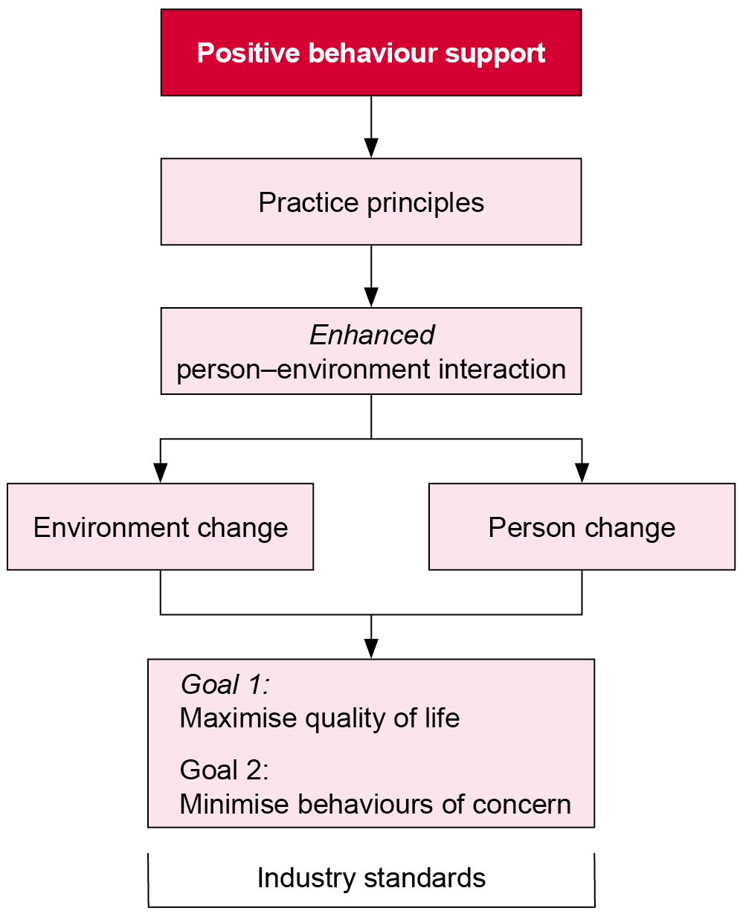

In summary, the practice model is (1) grounded in positive behaviour support, (2) guided by practice principles that will determine the person–environment interaction to engage person change and environment change and (3) supported by quality assurance in line with industry standards. This practice model supports delivery of effective and ethical services.

## Goals

The primary goal of positive behaviour support is to maximise quality of life (Goal 1) and minimise behaviours of concern (Goal 2). Positive behaviour support aims to illuminate understanding of the meaning and purpose of behaviour from the individual’s viewpoint, rather than eliminate behaviour by simply extinguishing it (Weiss & Knoster 2008). The question is: What can go right in this person’s life? rather than What impairments or disabilities are causing this person’s problems?

### Goal 1: Maximise quality of life

This framework explores how to maximise a person’s quality of life. Outcome success maximises quality of life in participating and contributing to the community and realised rights and dignity. Quality of life is multidimensional and includes satisfaction in family life, employment, community inclusion, supported living, social relationships and so on. Quality of life is described as the central ‘dependent variable’ and, although the range of dependent variables addressed is being expanded, positive behaviour support relies on its behavioural roots to insist on careful measurement and evaluation to determine the effectiveness of an intervention (Dunlap et al. 2008). Impediments to quality of life include behaviours of concern, skills deficits and dysfunctional systems (Carr 2007).

Proactive behaviour support strategies include changing the environment, teaching skills and implementing short-term behaviour change strategies. These strategies are long-term and aim to prevent the problem from occurring through a supportive environment. These strategies may include support through consultation and skills building to support both the person and their environment.

If a person’s needs are met (rather than problem behaviours managed) then their quality of life will improve (Goal 1) and this will help reduce or eliminate behaviours of concern (Goal 2).

### Goal 2: Minimise behaviours of concern

This framework also addresses how to minimise behaviours of concern. Outcome success minimises behaviours of concern in reducing the intensity, frequency and/or duration of the risk posed to the person and others, beginning with the least restrictive alternative.

Reactive behaviour support strategies are immediate response strategies to achieve rapid and safe control over high-risk behaviours (including both passive and active behaviours). These strategies feature clear and well-rehearsed reactive plans that identify triggers and behavioural indicators to diffuse and de-escalate the situation if necessary. However, to minimise behaviours of concern is a necessary, but not a sufficient, condition for change.

# Practice model standards

## About the standards

Practice should meet relevant standards.

The department’s Human Services Standards (Appendix 5) and independent review process seek to ensure that people experience the same quality of service no matter which service provider they access.

The standards aim to:

* embed and promote rights for people accessing services
* assure the community that service providers are providing services that meet clients’ needs
* develop a common and systemic approach to quality review processes
* build greater transparency in quality requirements between the department, service providers, clients and the community
* enable service providers to select an independent review body from an approved panel that meets their requirements and expectations
* foster a culture of continuous quality improvement that is embedded in everyday practice and supports the meaningful participation of people in giving feedback about the services they require and the quality of services they receive
* reduce red tape to help ensure service providers have more time and resources to provide services by reducing the number of quality reviews they are required to undertake.

# Principles

## About the principles

Practice principles specify the values that practitioners should strive for in delivering an effective and ethical approach. Practice principles ensure that any future revisions will uphold the integrity of the PPF. Practice principles based on positive behaviour support complement the industry standards.

Seven principles of positive behaviour support are espoused (Table 1).

Table 1: The seven principles of positive behaviour support

| No. | Principle | Description |
| --- | --- | --- |
| 1. | Values-driven | Positive behaviour support starts with the person-centred values of the person receiving support, their advocates, and those who will deliver support in order to improve the person’s quality of life. Quality of life is made up of six domains – material wellbeing, health and safety, social wellbeing, emotional/affective wellbeing, leisure and recreation, and personal wellbeing (Dunlap et al. 2010). Quality of life is achieved through increasing the likelihood of successful opportunities in education, employment and the community, as well as improved health and social wellbeing of the person and their stakeholders. Support includes instructional methodology for teaching, strengthening and expanding prosocial behavioural repertoires. That is, if the person’s needs are met, then quality of life will be improved and behaviours of concern will be reduced or eliminated. |
| 2. | Behaviour-based | Positive behaviour support is founded on applied behaviour analysis, which evaluates the antecedents and consequences associated with behaviour and identifies when behaviours of concern are likely to occur and what events are likely to lead to recurrence. Positive behaviour support technology then establishes a direct connection between the results of a functional behaviour analysis and the positive behaviour support plan developed. |
| 3. | Comprehensive in scope | Positive behaviour support not only solves the problem in a dramatic moment but also prevents the moment, teaches skills to redirect the moment, defuses the moment, prevents the moment from repeating, and defines the data system that makes all this understandable to all stakeholders. Intervention therefore requires multiple elements and outcomes, so it needs to be comprehensive in scope, format and function.  Comprehensive interventions:   * target all behaviours of concern, not some of them * are always based on a functional behavioural assessment * are applied throughout the entire day * combine multiple procedures to target different behaviours of concern, motivations, antecedents and setting events * exemplify a contextual fit aligned with the values, skills and resources of the implementers and work for all individuals in that context. |
| 4. | Educative | Positive behaviour support teaches adaptive skills and positive behaviours to replace behaviours of concern and to navigate current and future environments. Positive behaviour support directly teaches individuals prosocial and adaptive ways of obtaining the outcomes that are currently achieved through maladaptive behaviours of concern. To teach replacement behaviours, the function of the behaviours of concern needs to be identified.  Positive behaviour support teaches the person a specific set of replacement behaviours that:   * are socially acceptable * produce the same effect (obtain desired items/activities or avoid aversive situations) as the behaviours of concern * are more efficient than the behaviours of concern (requires less time, effort or repetition). |
| 5. | Effective environmental design | Positive behaviour support recognises that behaviours of concern are less likely in effective environments, drawing from systems analysis, ecological psychology, environmental psychology and community psychology.  Positive behaviour support parallels such ecological paradigms through:   * dealing with analysis that is larger than the individual and focuses on systemic change * ecological validity, which is paramount with mediators (parents, teachers, supervisors) in all settings (home, school, work, community) over long periods of time * research as a collaborative process between researchers, practitioners and stakeholders. |
| 6. | Accountability | Positive behaviour support is an empirical approach that relies on valid and reliable data.  The functional behaviour analysis develops a hypothesis about the when, where and why of behaviours of concern and so collects data on the:   * context and triggers of the behaviours of concern * intensity, duration and form of the behaviours of concern * events that follow and maintain the behaviours of concern.   Data collection identifies the impact of positive behaviour support on the behaviours of concern as well as improvements in the person’s quality of life, with stakeholders meeting regularly to make data-based decisions and prioritise implementation.  Fidelity of implementation determines whether the positive behaviour support plan has been implemented as designed. |
| 7. | Safety | Positive behaviour support aims to protect the safety of all as part of the positive behaviour support plan that distinguishes between emergency procedures and proactive programming.  A positive behaviour support plan that details avoidance or ignoring of behaviours of concern is considered insufficient and unethical. |

Adapted from: Morris & Horner 2016.

In summary, the framework promotes a holistic and multidisciplinary approach incorporating a comprehensive behavioural assessment and implementation of multicomponent interventions in supporting the person, their carers and staff.

# Practice model: practice pathway

The following section presents the practice pathway.

Intervention to the client or via carers or staff include assessment, intervention and support strategies.

System consultation and system skills building includes support strategies.

Figure 3 presents a diagrammatic representation of the interface of the behaviour support pathway and goals.

Figure 3: Interface of the behaviour support pathway and goals

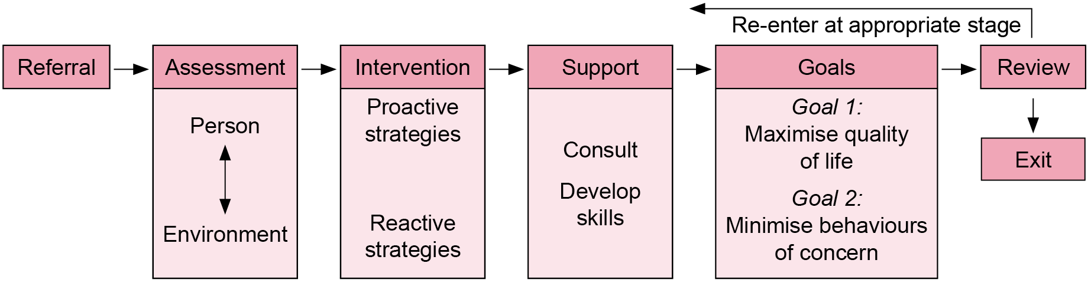

# Practice strategies

## Introductory comments

The PPF requires multicomponent assessment and intervention approaches that include skills replacement supplemented by environmental and systems change.

These strategies can be applicable to all people with behaviours of concern, regardless of cognitive functioning or disability. Examples include the ABI Behaviour Consultancy in Victoria, which describes a framework for people with an acquired brain injury and behaviours of concern, including on-site assessment of the environment, behaviour-focused intervention and engagement of the client, staff and family in the change process (Kelly & Parry 2008). It also describes helpful practices for maintaining a safe environment and improving wellbeing, competence, sensitivities, motivation and so on for people with autism spectrum disorder and behaviours of concern (Clements & Zarkowski 2000).

Several good practice guidelines for professionals have been released. In the United Kingdom, the British Psychological Society published clinical guidelines (Ball, Bush & Emerson 2004) with a revised version that includes psychiatrists and speech and language therapists (Banks et al. 2007). In the United States, the Association for Positive Behavior Support developed standards of practice as a ‘work in progress’ (Anderson, Brown & Scheurmann 2007). While these guidelines focus on people with an intellectual disability, the professional standards are supplemented throughout the PPF with additional resources. The Professional Association of Nurses in Developmental Disability Areas (Aust.) Inc. (PANDA 2010) has released a position statement containing statements about nursing to support people with a developmental/intellectual disability and their families. The Australian Psychological Society published a practice guide to promote, protect and ensure the full and equal enjoyment of human rights and fundamental freedoms by people with disabilities and to promote respect for their inherent dignity (Budiselik et al. 2010). That is, the Australian Psychological Society guidelines are broader than intellectual disability and are based on the WHO definition of disability – that it results in impairment in communication, mobility and/or self-care. The Australian Psychological Society guidelines are designed for all health professionals to foster interdisciplinary collaboration and support systemic improvements.

These guidelines establish best practice standards. Practice strategies presented in the PPF reflect these standards.

## Format of the practice strategies

Key practice strategies are presented in the following format:

Practice strategy

|  |  |
| --- | --- |
| Component | Description |
| Task | The task required of the section of the Positive practice framework |
| Process | The method for achieving the task |
| Outcomes | The outcome to be achieved (practice strategies and quality assurance) |
| Standard | The industry standard to be supervised by the behaviour support manager |
| Sample proforma | Where applicable |

The practice strategies also identify the relevant practice principles where applicable.

Key practice strategies and supporting advice are presented for the following:

* referral
* engaging the person
* managing referrals
* assessing risk.

Behavioural assessment

* Gather information about the
  + - person
    - environment
    - person–environment interaction.
* Develop an initial formulation.
* Undertake systematic observation.
* Undertake a reformulation.
* Conduct a systems analysis.
* Provide an assessment report.

Contemporary interventions

* Positive behaviour support plans
* Maximise quality of life (Goal 1)
* Environment change strategies
* Skills building
* Short-term strategies
* Planned immediate responses
* Minimise behaviours of concern (Goal 2)
* Environment change strategies
* Skills-building strategies
* Short-term strategies
* Planned immediate responses

Inclusive support

* The person: beyond diagnoses
* Children and adolescents
* Aboriginal and Torres Strait Islander people
* Culturally and linguistically diverse backgrounds
* Carers and staff: values and skills
* Support through consultation
* Support through skills building

Review and exit

* Review
* Exit planning

## Referral

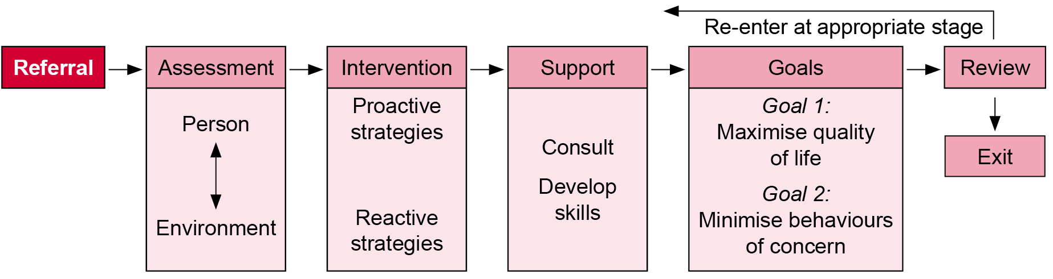

Practice principle

|  |
| --- |
| *See:*  *No. 1 Values-driven* |

### Engage the person

Practice strategy

| Component | Description |
| --- | --- |
| Task | Engage the person. |
| Process | Practitioner:  Supports active engagement of the person (or guardian as appropriate) in service delivery. |
| Outcomes | The person (and guardian if appropriate) is engaged, is making informed choices at key decision-making points and is aware that they can withdraw consent at any time.  Note:It is preferable that if consent is withdrawn, the person (or guardian as appropriate) understands what is in their best interest. |
| Standard | **Refer to** Appendix 5. |

Although the person (or guardian) has consented to receiving behaviour intervention services, the person still needs to be actively engaged in service delivery. Feedback from people with a dual diagnosis indicates that they should be involved in planning their own behavioural strategies (see Office of the Senior Practitioner 2010).

Advocacy (Appendix 6) ensures the human and legal rights of people with disabilities are promoted and protected so that people with disabilities can fully participate in the community. Via the Office for Disability, Disability Advocacy Program (Appendix 6) funds are provided to a range of disability advocacy and self-advocacy organisations. These organisations strongly support advocacy to:

* address discrimination
* empower individuals through information, support and knowledge of their rights
* promote community education
* increase the quality of life of individuals and their families
* make services accountable
* address inequities in service provision.

Advocacy can occur through self-advocacy or through individual, systemic, citizen or group advocacy. One role of an advocate can be to assist the person with disability to make choices.

To make choices, the person needs to have the motivation and capacity (‘the will and the way’ (Birgden 2004)). Four elements found to be necessary to consent to treatment are the capacity to: (1) understand – to understand relevant information, (2) appreciate – to appreciate the nature of the situation, (3) reason – to rationally manipulate information to weigh the costs and benefits of various treatment choices and (4) communicate – to state a choice. The MacArthur Treatment Competence Study (Appendix 7) empirically compared the decision-making capacity of hospitalised individuals with mental illness against those with physical illness and found that those with psychiatric diagnoses could make informed choices. The approach provides gradual and simple disclosure, or ‘teaches’ the person information in order to maximise informed choices. This approach could be modified for people with disabilities other than mental illness.

### Manage referrals

Practice strategy

| Component | Description |
| --- | --- |
| Task | Allocate referrals. |
| Process | The behaviour support practitioner/manager:   * considers preliminary referral information (Appendix 8) to ensure the definition of behaviours of concern is met * considers the frequency, duration and intensity of behaviours (McVilly 2002, p. 46) to assist prioritisation (note that forensic clients may engage in high-intensity but low-frequency behaviours such as sexual offending, violent offending and arson) * discusses referral with a referral provider * manages expectations regarding the outcome of the referral.   Provide written feedback to the referral provider (usually the intake worker or case manager) whether the referral is rejected (with a referral to an appropriate service) or accepted (and the anticipated timeframe for service). |
| Outcomes | Timely and documented referral outcome |
| Standard | **Refer to** Appendix 5. |

### Assess risk

Practice strategy

| Component | Description |
| --- | --- |
| Task | Undertake a risk assessment. |
| Process | Behaviour support practitioner:   * conducts a risk assessment screen (Appendix 9) that identifies any immediate areas of risk of harm to self or others, the nature of the risk inherent in the behaviour of concern and the degree of risk to self * establishes the level of risk to determine any action that needs to be taken in order to develop protective factors and reduce or remove the possibility that harm will occur * considers the person’s capacity to assess particular risks and to make their own judgements regarding the ‘dignity of risk’ (to self). |
| Outcomes | An immediate risk assessment screen has been undertaken and documented to identify any potential serious risk to self or others. |
| Standard | **Refer to** Appendix 5. |
| Sample methods | For an overview of risk assessment see Clinical risk assessment in people with an intellectual disability on the Office of the Senior Practitioner website <http://www.dhs.vic.gov.au/about-the-department/documents-and-resources/reports-publications/clinical-risk-assessment-in-people-with-intellectual-disability> |

## Behavioural assessment

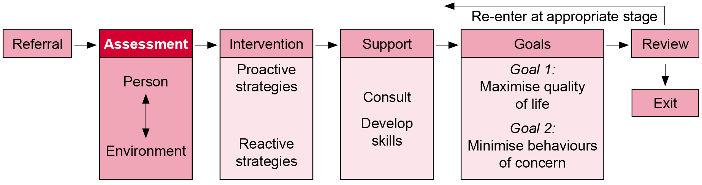

Practice principles

|  |
| --- |
| *See:*  *No. 2 Behaviour-based*  *No. 5 Effective environmental design*  *No. 6 Accountability* |

Practice strategy

| Component | Description |
| --- | --- |
| Task | Provide a behaviour support assessment report. |
| Process | Behaviour support practitioner conducts an assessment of the person and their environment if intervention is required:   1. Gather information. 2. Develop an initial formulation. 3. Undertake systematic observation. 4. Undertake a reformulation. 5. Conduct a system analysis. 6. Provide a behaviour support assessment report.   A behaviour support assessment report is provided for intervention with the person or via staff. |
| Outcomes | A comprehensive behaviour support assessment report is completed that includes:   * presentation * background to referral * history of the individual * categorical findings of the assessment, formulation and opinion. |
| Standard | **Refer to** Appendix 5. |

Behavioural assessment determines why the behaviour of concern occurs. Assessment should be comprehensive and consistent with international best practice standards and determined on the basis of the person’s presenting circumstances.

A person-centred assessment aims to understand the meaning of the behaviour of concern. Assessment is therefore fundamental to intervention, whether directly with the client or via observation or information obtained from carers and staff.

The WHO International Classification of Functioning, Disability and Health emphasises function rather than diagnosis. While special factors and skills related to sensory impairment, autism, acquired brain injury and so on are considered important, it is the response to each person, their life history and personal choices and abilities that matters. Note that few assessment tools have been developed and normed for use with individuals with specific disabilities but are provided where available in the framework.

The process of assessment and formulation is appropriate for all people with behaviours of concern, regardless of cognitive functioning or diagnosis. Assessment is an ongoing process in which reassessment may be necessary if major life changes occur. Assessment requires a planned, systematic and hypothesis-driven approach to understanding behaviours of concern. A hypothesis is the proposed explanation for the behaviour.

Hypothesis testing involves systematically collecting the relevant information about a person. It begins with a pre-assessment and then progresses towards more comprehensive information gathering about the person, their environment and the behaviour(s) of concern. Following this, an initial formulation must be conducted that involves generating a preliminary hypothesis about the causal links between the information gathered and how this relates to the behaviour of concern. Once this process has been completed, direct observation must be conducted, following which, reformulation may need to occur. Finally, the assessment process must involve an analysis of the system or environment in which the intervention is to take place.

Assessments based on good practice aim to achieve the following:

* Identify specific questions for the assessment to answer.
* Listen and ask questions: Why are you doing this? Why do you think he or she is doing this? Why is this happening? What are you doing in response to this?
* Use diverse user-friendly and validated assessment tools that consider contextual factors.
* Develop initial hypotheses (formulations) about the causal mechanisms and functions of the identified behaviour.
* Undertake direct observation to refute or confirm hypotheses.
* Identify who will act on the information provided by the assessment.
* Expand the process to include stakeholders in a broad range of settings.
* Utilise multicomponent, multidisciplinary and multiagency approaches.
* Develop a positive behaviour support plan that maximises quality of life (Goal 1) and minimises behaviours of concern (Goal 2).

Assessment is not a linear process and may on occasion be simultaneous or cyclical (that is, an intervention may begin while an assessment is being conducted). However, a comprehensive assessment should always be completed in order to guide further reformulation and subsequent practices for intervention with the person or via carers or staff.

Behavioural assessment in positive behaviour support is made up of a:

* functional behaviour analysis
* functional analysis
* comprehensive behavioural assessment.

Functional behaviour analysis

Positive behaviour support assumes that there is a functional relationship between the person and repeated patterns of environmental variables, as the result of antecedent events and reinforcing consequences, and that behaviours of concern can be predicted and managed once a functional relationship has been established (Morris & Horner 2016). That is, the foundation of positive behaviour support includes functional assessment and functional analysis. Functional behaviour analysis (FBA) identifies variables that reliably predict and maintain behaviours of concern and what function they serve for the person exhibiting them. Behaviours of concern communicate a function – either something the person wants (items, activities or attention) or something the person is trying to avoid (an unpleasant or demanding situation). The FBA serves to determine the conditions within which behaviours of concern are likely to occur so that the environment can be modified – what the purpose, intent, function and motivation of the behaviours of concern is. Common triggers to behaviours of concern are frustration, under-stimulation and boredom, and over-stimulation from environmental cues. Of note: ‘There is now wide and compelling literature documenting that if behaviour support is consistent with functional assessment, the effectiveness of the intervention increases’ (Morris & Horner 2016, p. 422).

There are three methods (‘potential reinforcers’) to conducting a functional assessment (Miltenberger et al. 2016):

1. Indirect assessment – an interview or questionnaire with caregivers and a file review to gather initial information on the behaviours of concern. The behaviour support practitioner develops hypotheses about the functions of the behaviour – antecedents and consequences (although a functional analysis is required to demonstrate experimental control and to confirm the hypothesised function). Research outcomes regarding relying on indirect assessment alone is mixed, and indirect assessment should not be considered the sole method of data collection.
2. Direct assessment – direct observation and data collection through setting-triggers-action-results (STAR) analysis of the behaviour to identify highly specific or idiosyncratic environmental variables (under supervision of the behaviour support practitioners, parents, teachers and others can also gather this information). Data can be collected through narrative recording (descriptions of each behavioural incident), checklist recording (the observer completes a checklist every time the behaviour occurs), interval recording (the observer identifies target behaviours to be recorded), structured descriptive assessment (identifying environmental–behaviour relationships), and scatter plots (uninterrupted observation of the behaviours of concern across multiple consecutive time intervals to determine when behaviours of concern are most likely to occur.
3. Functional analysis – experimentally manipulating environmental variables to check the reliability of steps 1 and 2. Rather than a hypothesis, the functional analysis confirms a relationship. For example, one or more test conditions, and one or more control conditions, are established by manipulating a potential reinforcer (attention, tangible item, escape) delivered on a continuous reinforcement schedule following every instance of behaviour to see if it increases behaviour. In the control condition, that reinforcer is not delivered if the behaviours of concern occur. Alternatively, a condition is presented to evoke the behaviour, such as deprivation of attention or triggering escape. In a control condition, non-contingent attention would be provided, or the absence of an aversive activity or the presence of an easy task regarding escape. Another method is that the discriminative stimulus is manipulated to establish a unique test and control discriminative stimulus for each condition.

A typical FBA is made up of four experimental conditions – three that test potential reinforcers (social positive reinforcement, social negative reinforcement and being alone) and a control condition (play). The goal of functional analysis is to understand the four possible reinforcement contingencies (Miltenberger et al. 2016), listed in Table 2.

Table 2: Reinforcement contingencies

| Reinforcement | Positive | Negative |
| --- | --- | --- |
| **Social reinforcement**  Delivered by a person | A person provides attention, an activity or tangible item that strengthens behaviours of concern or desirable behaviour.  Test: If behaviours of concern escalate when ignored. | A person removes an unpleasant stimulus that strengthens behaviours of concern or desirable behaviour.  Test: If behaviours of concern escalate to avoid or escape the person. |
| **Automatic reinforcement**  Delivered by the environment | A response directly acts on the environment that strengthens behaviours of concern or desirable behaviour.  Test: If behaviours of concern escalate when the person is left alone with no stimulation (for example, stereotypy and self-injury). | A response directly acts on the environment to terminate an aversive stimulus – avoidance or escape – that strengthens behaviours of concern or desirable behaviour.  Test: If behaviours of concern escalate to avoid or escape the environment. |

There are further variations of the functional analysis that are briefly summarised here (Miltenberger et al. 2016):

* Multi-element – exposing the person to a number of brief (10–15-second) test conditions and a control condition with different antecedent events and programmed consequences that are rapidly alternated with the differential rates of responding graphed.
* Brief multi-element – exposing the person to two to four conditions of 5–10 minutes with 1–2 minute breaks, followed by a contingency reversal phase.
* Single-test – if a comprehensive interview and direct assessment has been conducted and a function hypothesised, one test condition is compared with one control condition.

There are several other methods that can be used in a functional analysis (Miltenberger et al. 2016):

* Attention condition – attention occurs at every instance of the behaviours of concern with moderately preferred items.
* Tangible condition – preferred items are selected on the probability that their removal will result in behaviours of concern and contingent delivery will reinforce behaviour.
* Escape condition – tasks presented in the least-to-most prompting sequence. Compliance results in brief praise and behaviours of concern result in a 30-second break from the task.
* Alone condition – test for automatic reinforcement. The person is left alone and observed surreptitiously within a room without stimulation. If behaviours of concern are maintained by automatic reinforcement, then high rates of behaviours of concern can be expected when alone.
* Control condition – an enriched environment in which there are no demands with continuous access to preferred items and non-contingent attention is provided every 30 seconds, with an expectation of low or zero behaviours of concern.
* Extended alone – a series of alone (or ignore) sessions conducted. If the behaviour is maintained by automatic reinforcement, responding will persist in the alone sessions. If the behaviour is maintained by social reinforcement, extinction will lead to a decrease as the person progresses through the alone sessions.
* Trial-based – embeds discrete trials into natural routines rather than analogue settings with the percentage of trials in each condition in which the behaviours of concern occurred.
* Latency – as the dependent measure when the behaviour occurs at low rates or when the behaviours of concern pose a risk to self and others.
* Precursor analysis – when a single behaviour of concern can result in harm to self or others, analysis can consider the contingencies to behaviours of concern and then contingencies for the precursor behaviours to check whether they serve the same function.

Interpretation of the functional analysis compares the test and control conditions, with the rate or percentage of intervals with behaviours of concern graphed on the *y*-axis and the number of sessions on the *x*-axis (Miltenberger et al. 2016).

Behaviour imaging

Behaviour imaging applies remote and recorded direct observations, which is a more recent method that has been developed, particularly in relation to diagnosing autism spectrum disorder. Behavior Capture™ by Caring Technologies is a Behavior Imaging® app used to capture and upload video evidence from natural environments securely to the online service Behavior Connect or AssessmentView™. In Behavior Connect the user can annotate video including tagging the moment in time by adding a label and comment directly to the video. Behavior Connect allows multiple authorised users to securely collaborate on a person in natural settings. Users can better analyse their progress and programs while using the system to support and train staff and caregivers. AssessmentView allows multiple authorised users to securely access the collected data. More information can be found at the [Behavior Imaging website](https://www.behaviorimaging.com) <https://www.behaviorimaging.com>.

Comprehensive behavioural assessment

An overlooked feature of positive behaviour support is that functional assessment procedures that determine the purposes of the behaviours of concern are only a constituent part of a *thorough comprehensive behavioural assessment* (Grey et al. 2016). A comprehensive behavioural assessment should be integral to the assessment process in that it serves a number of key functions – a full biopsychosocial assessment for the person concerned (cognitive ability, communication, motivation/preferences, environment, life story and medical examination) to identify the mismatch between the impairment and the environment of the person concerned. In other words, a clear narrative or description of how an intellectual disability affects the person, and how that disability interacts with identified barriers in the environment to result in behaviours of concern, which in itself sets up even more barriers for the person. The environmental failure to adapt to the needs of the person may result in behaviours of concern that have a purposeful outcome for the person engaging in such behaviour. A full behavioural assessment must identify the functional ability of the person *and* the environmental context of the person. Rather than focus on the behaviours of concern, behaviour support practitioners should consider underlying deficiencies such as poor environmental conditions or a lack of functional alternative skills (Grey et al. 2016 citing Carr et al. 1999).

From a positive behaviour support perspective, the term ‘environment’ is not just the physical environment but is also the interpersonal environment, the internal environment of the person, their daily structure, the extent of meaningful activity, and the value of that activity to the person. That is, an assessment encompasses both antecedent–behaviour–consequence observation charts and setting events – social context, personal context, the presence or absence of others or activities, the time of day – which all affect how the person reacts to an antecedent event (STAR charts).

Figure 4 presents a diagrammatic overview of the assessment process.

Figure 4: Overview of the assessment process

This figure shows the following stages in the assessment process:
Stage 1: Information gathering of person, environment and person-environment interaction
Stage 2: Initial formulation
Stage 3: Direct observation
Stage 4: Reformulation
Stage 5: Assessment

### Gather information

Assessment must determine the best intervention to maximise quality of life (Goal 1) and minimise behaviours of concern (Goal 2). The aim is to develop the person’s ‘story’ regarding their past, present and future life.

The WHO International Classification of Functioning, Disability and Health is a biopsychosocial framework that informs the PPF. Information gathering is therefore required of the:

* person
* environment
* person–environment interaction.

#### The person

The WHO International Classification of Functioning, Disability and Health identifies health and health-related domains in terms of body functioning (the integrity of the person’s body structures and functions including cognitive functioning). Behaviours of concern are often a function of health-related domains. Assessment must rule out any issues regarding person factors that restrain the capacity of the person to maximise their quality of life and minimise their behaviours of concern.

The following areas must be considered regarding strengths and obstacles to improving quality of life. The method of gathering information regarding the person is through file searches, direct observation and assessment tools (noting that some tools require minimum standards of education and training). Many of the assessment tools can also be used as pre- and post-measures. The tools are suggestions only, and behaviour support practitioner supervision and training should ensure that the appropriate assessment tools are selected and applied to the appropriate client group. That is, not every area needs to be assessed. Note that diagnoses or types of behaviour are explored within this section.

| Domain | Relevant diagnoses and behaviours |
| --- | --- |
| Medical and organic factors (including medical examinations)  Health screening resources (Appendix 10) | * Headaches and migraine * Physical problems (discomfort, pain, malaise, physiological disturbance) * Cerebrovascular and epilepsy-related events * Eyesight problems * Gut-related and dental pain * Urinary tract infections and prostatism * Bone and joint pain * Neoplasms (tumours or growths) * Wounds and fractures * Hormonal changes such as puberty * Current medications * Syndrome-specific health complications |
| Psychiatric, psychological and neuropsychological factors  Mental health screening tools (Appendix 11) | * Psychiatric symptoms including personality disorders and some ‘philias’ * Atypical or secondary presentation of a mental health problem * Diagnostic overshadowing – the tendency to attribute behavioural patterns to a pre-existing disability and so failure to identify psychiatric symptoms * Underlying cognitive abilities, deficits and preferences * Problems in thinking – problem solving, tightly focused attention, binary thinking, mental/behavioural stuttering (perseveration) * Interaction between mental health problems and behavioural processes * Iatrogenic effect of medication * Trauma such as bereavement, parental rejection, relationship difficulties, poor self-esteem, isolation * Consequence of neuropsychological disorders such as Gilles de la Tourette’s syndrome, attention deficit with hyperactivity disorder and dementia * Personality features influenced by genetics, acquired brain injury or experiences of the early environment such as attachment problems, neglect and abuse * Acquired brain injury – verbal aggression, physical aggression, inappropriate social behaviours, lack of initiation, inappropriate sexual behaviour, wandering/absconding and perseveration |
| Risk assessment  Risk assessment tools (Appendix 12) | * Risk assessment must be conducted for behaviours that pose a serious risk to self or others so that risk may be managed * Risk assessment can be determined through clinical judgement or actuarial assessments or structured clinical judgements * Structured clinical judgement is preferable:   + assesses the intensity of intervention and support required   + assesses dynamic risk factors to be monitored   + re-evaluates dynamic risk factors * Risk assessment requires validated or trialled tools * A risk assessment must be based on a file review and staff/carer interviews and preferably includes an interview with the person * Risk assessment should also consider:   + protective factors such as specific abilities, likes/interests, strengths, motivations   + contextual factors such as the skills and abilities of staff and carers   + any organisational policy, procedures or resources that are inconsistent with the safe and dignified support of the person |
| Communication problems  Communication assessment tools (Appendix 13) | * Communication difficulties such as hearing loss, unclear communication, insufficient vocabulary or means of expression and difficulties understanding others * Difficulties in understanding social information * Difficulties in understanding language – comprehension, hearing difficulties, slowness of processing, developing more generalised ideas * Difficulties in self-expression – awareness of the need to communicate and difficulties in means of communication * Communication environment (including communication partners) * How communication is utilised in daily life |
| Sensory processing problems  Sensory processing problem resources (Appendix 14) | * Seeking significant deep pressure or strong tactile responses such as biting self, banging head, throwing body against wall * Sensory seeking or high levels of arousal as a way to calm down * Sensory processing difficulties resulting in sensitivity to smell, taste, texture of surroundings such as at home or school affecting behaviour * Personal sensations – problems with sensory modulation and physical and emotional wellbeing |
| Phenotype-related disorders  Phenotype information (Appendix 15) | * Self-injurious behaviours linked to particular syndromes such as Lesch-Nyhan syndrome resulting in hand and lip biting * Usually very serious regarding risks to the person and carers * Can be long-term and highly resistant to behaviour change |

#### The environment

The WHO International Classification of Functioning, Disability and Health identifies health and health-related domains in terms of activity and participation (that affect health and wellbeing) and environmental factors (that impede or facilitate the person realising their full potential). Behaviours of concern are mediated by interpersonal, organisational and environmental settings. Assessment must determine the capacity of the environment to maximise quality of life and minimise behaviours of concern.

The following areas must be considered regarding strengths and obstacles to improving quality of life. Many of the assessment tools can be used as pre- and post-measures. The tools are suggestions only, and behaviour support practitioner supervision and training should ensure that the appropriate assessment tools are selected and applied.

| Domain | Factors |
| --- | --- |
| Physical setting  Context tools (Appendix 16) | * Size, crowding, privacy * Comfort (heat, light, noise) * Location and home environment * Visitors and others (visitors, access to community and safety) |
| Interpersonal and organisational setting  Context tools (Appendix 16) | * Relationships with staff/carers/co-clients/friends * Behaviour of staff/carers/co-clients/friends * Effects of behaviours of concern on staff/carers/co-clients/friends * Structure – structured vs unstructured, groups vs individual, routines and practices * Amount and quality of social interaction * Staff/carer attitudes – expectations, beliefs and responses * Staff/carer skills and turnover * Level of resources available * Organisational/familial culture * Quality of management/leadership |
| Adaptive behaviour  Adaptive behaviour scales (Appendix 17) | * Physical/motor abilities * Personal care * Domestic, community and vocational skills * Social and communication skills * Sexual behaviours * Activities that are therapeutic (age-appropriate, purposeful, engaged) rather than anti-therapeutic (age-inappropriate, non-adaptive, disruptive) |
| Quality of life  Quality of life scales (Appendix 18) | * Independence – attaining and maintaining maximum independence * Participation – attaining and maintaining full inclusion and participation in all aspects of life * Ability – attaining and maintaining full physical, mental, social and vocational ability * Choice – how preference and choice is expressed and how reinforcers may be used to motivate change and teach new skills * Quality of life measured through daily routine, schedules and social interaction:   + material wellbeing   + health and safety   + social wellbeing   + emotional wellbeing   + leisure and recreation opportunities   + autonomy |

#### Person–environment interaction

The WHO International Classification of Functioning, Disability and Health identifies health and health-related domains in terms of body functioning, activity and participation and environmental factors.

Behaviours of concern are the result of an interaction between the person and their environment; they cannot be separated. Is functional assessment an effective and ethical approach (Appendix 19)? Yes, and therefore a functional assessment of the person–environment interaction is essential for intervention with the person or via carers or staff.

The Australian Psychological Society describes functional assessment as three interrelated processes:

* identifies and objectively defines a target behaviour
  + - initially obtained from the referral process
* describes the relationship between the occurrence (and non-occurrence) of the target behaviour and identifies environmental events or bio-behavioural states
  + - obtained from assessment of environment and person factors
* generates hypotheses concerning
  + - events that precede the occurrence of the behaviour
    - contingencies maintaining the behaviour
    - topography of the behaviour (described in this section).

Based on the person and environment information gathering, the following steps are required in a functional assessment.

| Step | Task |
| --- | --- |
| Define the behaviour  Measures of behaviour (Appendix 20) | What is the behaviour of concern?  Develop a clear, observable and measurable operational description of the identified behaviour of concern that includes:   * form of behaviour – category * frequency of behaviour – how often * intensity of behaviour – how serious for self and others. |
| Determine antecedents  Functional assessment tools (Appendix 21) | What triggers the behaviour of concern?  These are the predictors of behaviour in the immediate or past immediate environment and can also be in the person’s physical setting, social setting, activities, scheduling factors, degree of independence, degree of participation, social interaction or degree of choice. |
| Determine setting events  Functional assessment tools (Appendix 21) | Where does the interaction happen?  Setting events are antecedent events that are removed in time and place from the occurrence of the behaviour but are functionally related to the behaviour because of their powerful influences.  The setting events ‘set the scene’ for any triggers that may occur. |
| Determine consequences  Functional assessment tools (Appendix 21) | What happened just after the behaviour?  This forms an analysis of what supports the problem behaviour and why the identified variables are reinforcing the likelihood of the behaviour occurring. |
| Determine protective factors  Functional assessment tools (Appendix 21)  Quality of life scales (Appendix 18) | What are the person’s strengths?  Determine the person’s preferences, interests and preferred or valued activities and dislikes to identify reinforcers that may be used to motivate change and teach new skills.  Determine friendships and other social relationships to integrate into community activities and supports.  Determine physical, social and psychological wellbeing and a sense of ‘home’. |

### Develop an initial formulation

A formulation is a hypothesis about the nature of the behaviours of concern – their causal or functional relationship between variables and events and the behaviour. Formulation applies to all people with behaviours of concern, regardless of cognitive functioning or disability. In contrast to a diagnosis, a formulation ‘tells the person’s story’. The formulation must be a collaborative effort between the behaviour support practitioner, the person and staff and carers from the relevant settings.

When undertaking a formulation, note that it is rare for a person’s behaviour to be explained by a single cause. The behaviour of concern may have originally had a single function but is likely to have escalated to numerous biopsychosocial functions requiring multicomponent intervention.

Ensure that the formulation is adequately documented for future reference and revision.

Figure 5 presents a diagrammatic representation of a formulation template.

Figure 5: Formulation template

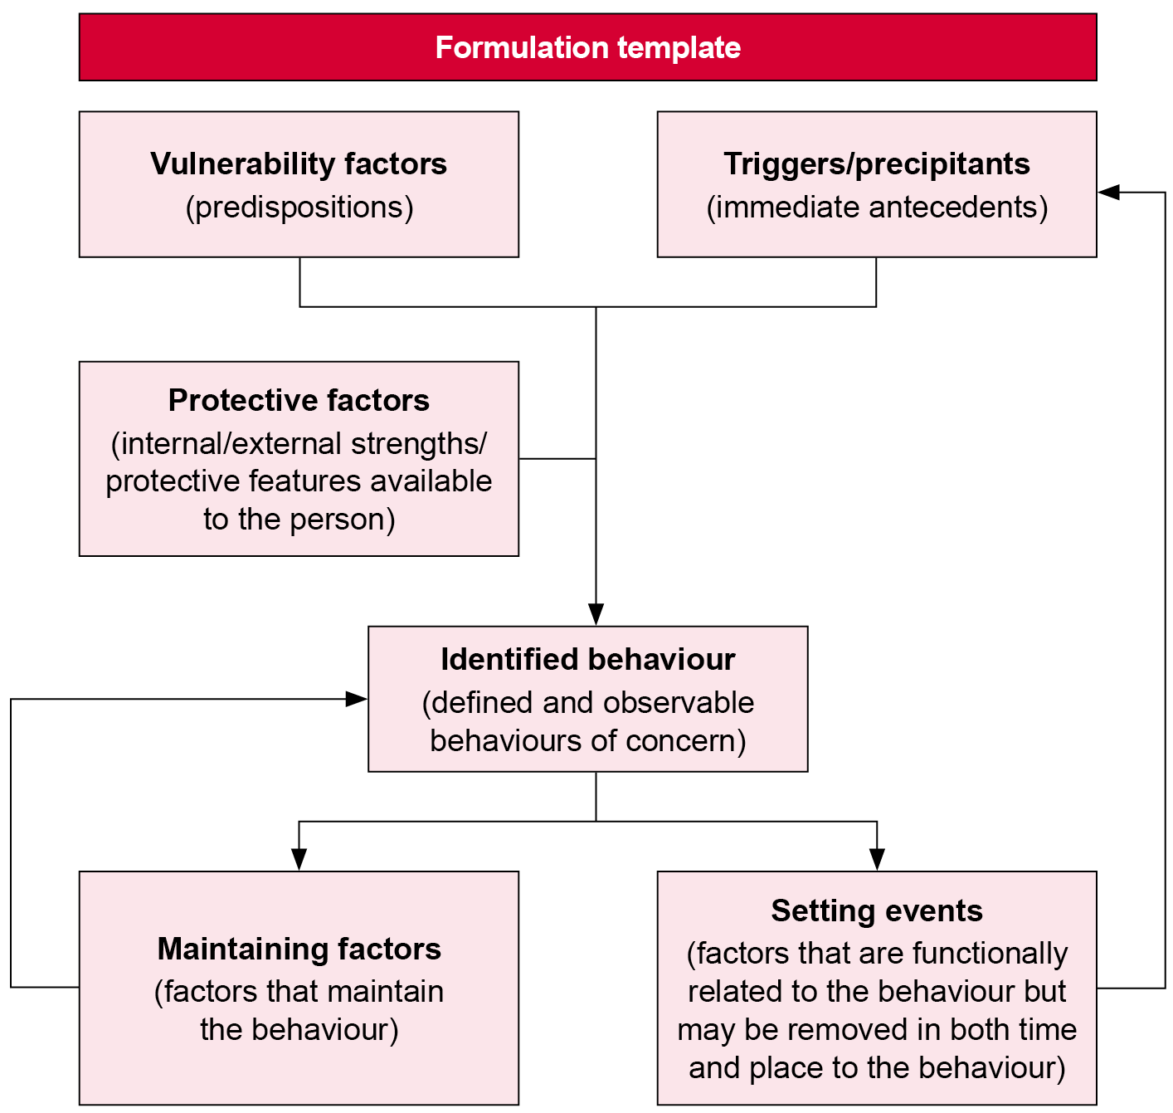

The assessment of the person, their environment and the person–environment interaction should form the basis of the formulation (Appendix 22).

### Undertake systematic observation

Systematic observation generates information about the behaviour by counting and recording defined behaviours in a given setting to confirm or refute an initial hypothesis. A number of useful systematic observational tools (Appendix 23) are suggested.

### Undertake a reformulation

Following direct observation, the initial hypothesis is either verified or refuted with a reformulation. Additional information may be drawn from the assessment process by considering common results across the datasets. A reformulation will help to further guide the behaviour support practitioner’s thinking, inform future observations and assessment needs and contribute to the development of a positive behaviour support plan, as well as guide the evaluation of its effectiveness.

### Conduct a system analysis

Given that interventions will usually be carried out by a person’s carers (as mediators), a mediator analysis (Appendix 24) should be conducted to assess the person’s strengths and needs. The aim is to achieve the contextual fit between the behavioural intervention plan and the environment (see Goodness of Fit Survey in Appendix 24).

### Provide a behaviour support assessment report

Provide a behaviour support assessment report that summarises the findings.

## Contemporary interventions

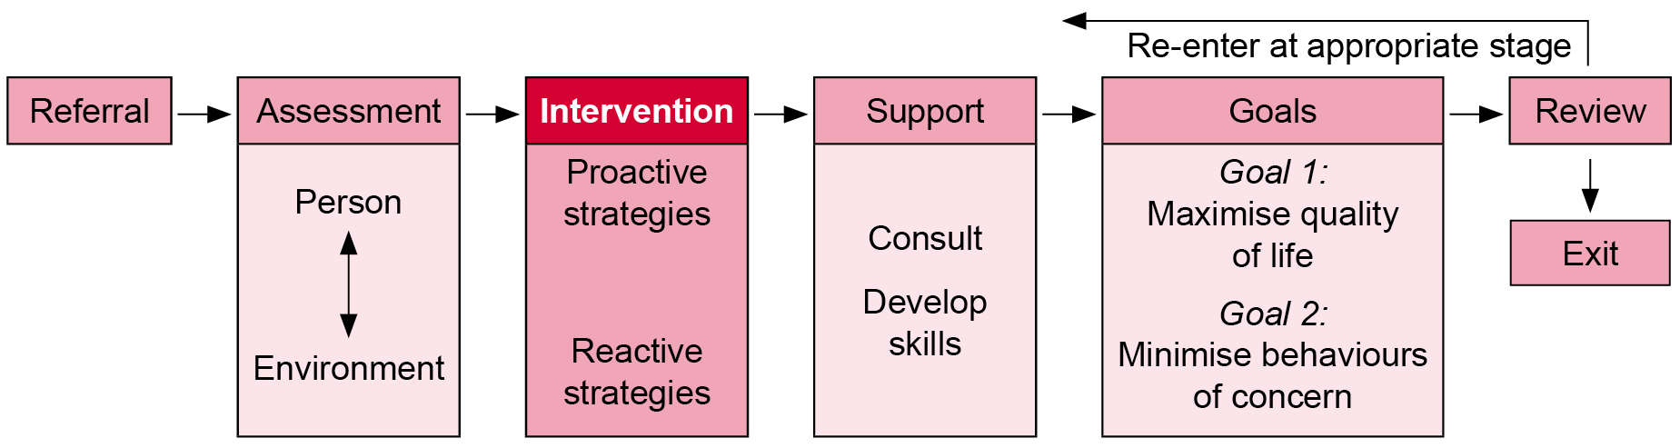

Practice principles

|  |
| --- |
| *See:*  *No. 1 Values-driven*  *No. 3 Comprehensive in scope*  *No. 4 Educative*  *No. 5 Effective environmental design*  *No. 7 Safety* |

Practice strategy

| Component | Description |
| --- | --- |
| Task | Deliver contemporary intervention strategies. |
| Process | Behaviour support practitioner:   * develops intervention strategies based on a formulation, relying on proactive strategies if intervention is required  1. proactive strategies    1. environment change    2. skills building    3. short-term change 2. reactive strategies (if necessary). |
| Outcomes | A documented positive behaviour support plan that:   * maximises quality of life * minimises behaviours of concern. |
| Standard | **Refer to** Appendix 5. |

Contemporary intervention determines what services are provided. Intervention should be comprehensive and consistent with international best practice standards and determined on the basis of the person’s presenting circumstances.

The WHO International Classification of Functioning, Disability and Health is a biopsychosocial framework that informs the PPF. Intervention is therefore required to address the:

* person
* environment
* person–environment interaction.

Positive behaviour support encompasses the range (and combination) of intervention strategies and modalities. These could include, but need not be limited to, behavioural, cognitive, cognitive-behavioural, insight and mindfulness-based approaches, together with pharmacological interventions. While in some circumstances strategies can be effectively implemented by a sole practitioner, it is more usual and typically more effective when a multidisciplinary team approach is employed, depending on the person’s presenting circumstances and the experience of the behaviour support practitioners involved.

There must be a direct link between assessment and intervention implementation. Good practice in assessment results in an intervention plan that has a contextual fit between the person and their environment. That is, the intervention needs to meet the values and characteristics of the person and their family, including their social, cultural and organisational environment, as well as the resources and constraints of that environment.

Positive behaviour support continues to have an equal focus on preventive and proactive strategies as well as intervention strategies to reduce behaviours of concern (Morris & Horner 2016).

### Positive behaviour support plans

Behaviour support practitioners must articulate intervention strategies through a positive behaviour support plan that meets the needs of the person with disability. A positive behaviour support plan has primarily a proactive focus followed by a reactive focus if required. Behaviour support practitioners must actively supervise carers and staff implementing the positive behaviour support plan (Reid & Parsons 2002).

The positive behaviour support plan is developed in collaboration with the person and staff/carers to maximise the likelihood that the interventions will be implemented consistently across all environments. The minimum standards (Appendix 25) for positive behaviour support plans are clearly stated by the Australian Psychological Society.

The positive behaviour support plan should be developed as part of a multicomponent, multidisciplinary and multiagency collaboration. The positive behaviour support plan ensures a contextual fit (Appendix 26) within the collaborative team.

A positive behaviour support plan should involve goal setting (Appendix 27) that aims to enhance self-efficacy or gradual mastery of skills.

The following interventions emphasise proactive and reactive change strategies to maximise quality of life (Goal 1) and minimise behaviours of concern (Goal 2). This model can be used to track behaviour support practitioner services regarding environment change and skills building and intervention in short-term and planned immediate response strategies.

To reflect the biopsychosocial model, the contemporary intervention section suggests the following structure for ease of application. These interventions apply to all people with behaviours of concern, regardless of cognitive functioning or disability. The following structure is an adapted version of the department’s [Positive behaviour support: Getting it right from the start resource](http://www.dhs.vic.gov.au/about-the-department/documents-and-resources/reports-publications/positive-behaviour-support-getting-it-right-from-the-start) <http://www.dhs.vic.gov.au/about-the-department/documents-and-resources/reports-publications/positive-behaviour-support-getting-it-right-from-the-start> and has been extended to include cognitive-behavioural interventions. In other words, any strategies can be included in the structure, as long as they are effective and ethical. Impediments to quality of life include behaviours of concern, skills deficits and dysfunctional systems (Carr 2007).

Positive behaviour support plans typically involve environmental accommodations, direct interventions, skills teaching and reactive strategies (Grey et al. 2016).

Support teams use FBA data to design positive behaviour support plans for each targeted behaviour and relevant setting. Positive behaviour support plans include explicit instructions for clearly defined target behaviours and precise procedural descriptions to:

* develop replacement behaviours
* appropriately reinforce replacement behaviours
* redesign the antecedent environment to prevent reoccurrences of behaviours of concern
* appropriately respond to displays of behaviours of concern
* collect evaluation data to plan effectiveness and implementation fidelity.

The Senior Practitioner – Disability provides a behaviour support planning toolkit <http://www.dhs.vic.gov.au/about-the-department/documents-and-resources/policies,-guidelines-and-legislation/behaviour-support-planning-practice-guide-senior-practitioner> that provides the rationale for good-quality plans, useful assessment tools and forms, and guidelines for writing a behaviour support plan.

Figure 6 presents proactive support strategies and reactive support strategies to maximise quality of life (Goal 1) and to minimise behaviours of concern (Goal 2). The table in the figure is an adaptation of LaVigna and Willis’ (2005) multi-element model with the addition of Carr’s (2007) impediments to quality of life (behaviours of concern, skills deficits and dysfunctional systems) and WHO’s biopsychosocial approach.

Figure 6: Support strategies

| **Support** | **Intervention** |
| --- | --- |

| Proactive  support strategies | | | Reactive support strategies |
| --- | --- | --- | --- |
| Environment change | Skills building | Short-term change | Planned immediate response |
| Social strategies for dysfunctional systems   * Physical setting * Interpersonal and organisational setting * Quality of life | Psychological strategies for skills deficits   * Behavioural   + teach skills   + social skills * Speech and communication * Cognitive-behavioural * Attachment and trauma * Family intervention * Social stories * Mindfulness techniques | Biological strategies for behaviours of concern   * Reinforcement schedules * De-escalating strategies * Counterintuitive strategies * Biomedical responses | * Develop reactive plans that avoid restrictive practices * Use stimulus change or removal * Provide swift diversion techniques * Reduce or increase arousal * Teach staff to ethically manage risk |

The recommended strategies are overlapping; they are not discrete. Behaviour support practitioner supervision should ensure that the appropriate intervention techniques are selected and applied for the appropriate purpose to the appropriate client group.

### Proactive support strategies

Maximising a person’s quality of life requires designing and delivering interventions that address the interaction between the internal capacities of the person and the external opportunities in the environment. Primary prevention is preferable because it identifies and develops the skills a person needs to function independently in important natural settings to improve their quality of life; these strategies are maintained and generalise in the long term and are also more socially valid and acceptable for carers and staff. Human rights include the right to access services such as appropriate education, employment, leisure activities and accommodation.

Behaviour change strategies aimed at improving quality of life (Appendix 28) include environment change, skills building and short-term change strategies, based on the functional assessment conducted for intervention with the person or via their carers or staff.

#### Environment change strategies

| Proactive  support strategies | | | **Reactive support strategies** |
| --- | --- | --- | --- |
| Environment change | Skills building | Short-term change | Planned immediate response |

Environment change strategies focus on ordinary opportunities and experiences that people without a disability take for granted such as living with the people they choose, doing valued and meaningful activities, joining a club with like-minded others and owning objects and equipment based on their interests. An enriched environment reduces the likelihood of stereotypic behaviours, self-injury and noncompliance. See Is relying on environmental strategies alone adequate (Appendix 29)?

Environmental strategies are central to the principle of overcoming behavioural problems by adapting the environment to the needs and characteristics of the person (Grey et al. 2016). Identifying the necessary environmental strategies can only occur through a sound understanding of the person, including a comprehensive behavioural assessment.

Environment change strategies include capacity building in carers and staff and capacity building in the person.

| Domain | Considerations |
| --- | --- |
| Physical setting  Sensory environments (Appendix 30) | * Consider changes to settings (accommodation, respite, day support, educational and/or employment). * Suggest changes to the person’s placement or setting altogether. * Recommend a sturdy yet attractive living environment (reinforced walls, unbreakable windows). * Suggest ways to manage the environment (such as noise, crowding, smells, temperature) and remove dangerous objects (such as knives and loose/heavy furniture). * Sensory approaches include positive sight, sound, smell and touch. * Develop alternative environments to promote comfort for sensory-seeking or sensory-avoiding people such as aromatherapy, medicine balls and massage. * Ensure an autism-friendly environment – acoustic modifications, lighting options and sensory-based activities and spaces. * Enhance auditory and visual stimulation or manage auditory or visual over-stimulation (such as ear phones, heavy blankets, sensory boards and vibrating cushions). * Ensure age-appropriate and contextually appropriate furnishings and decor. |
| Interpersonal and organisational setting | * Alter or eliminate identified setting events. * Modify antecedent triggers – modify activities, modify instructions and routines, provide choice and control, apply pre-correction and errorless learning. * Manage the organisation – create clear expectations and engage the person/carer/staff in change. * Create a supportive environment with collaborative relationships between the person/carer/staff/co-clients. * Support staff/carer attitudes towards and knowledge of the behaviour. * Support an appropriate staff work culture and staffing levels. * Improve the quality of interpersonal interactions. * Develop predictable routines (such as devising a daily schedule in a format that the person can understand). * Modify daily demands across settings so the person can successfully complete tasks. * Provide low-arousal techniques such as moderate interaction styles and minimise demands and situations of potential conflict. * Assist communication partners to use more appropriate and portable augmentative and alternative communication systems and promote environments that facilitate good communication. * Apply family systems theory when participation of the familial or care system is indicated (although ensure that the expectations of intervention are agreed). * Create a supportive environment that builds collaborative relationships between individuals and agencies. * Engage in multiagency approaches such as disability services and mental health services for people with dual diagnosis. |
| Quality of life  Active support (Appendix 31) | * Provide choice-making opportunities in everyday living such as collaborating on routines, meal options, social activities, room layouts and privacy. * Provide choices that are age-appropriate and contextually appropriate. * Provide active support to engage in a range of everyday meaningful activities. Enhance appropriate activity levels and community access. * Address issues regarding attachment and trauma. * Support autonomy and ensure that ‘programs’ do not override a person’s immediate human needs. |

#### Skills-building strategies

| Proactive  support strategies | | | **Reactive support strategies** |
| --- | --- | --- | --- |
| Environment change | Skills building | Short-term change | Planned immediate response |

Skills-building is at the core of positive behaviour support to enhance the person’s ability to exert control over their own environment and over their own life (Grey et al. 2016). The end goal is to help develop a sense of mastery – to meaningfully choose options, to meaningfully engage, and to have a better quality of life. Skill teaching includes targeting functionally equivalent skills, general skills and coping and tolerance skills to provide alternative socially acceptable means of gaining the same outcome or goal. Effective skill teaching relies on operant psychology but with less emphasis on trying to change the individual through behaviour modification (Grey et al. 2016).

Skills building is a critical but under-emphasised aspect of managing behaviours of concern. Skills-building strategies teach individuals to replace the problem behaviour with a desired behaviour so the person can achieve the goals they are seeking to obtain quality of life. Is skills building effective and ethical (Appendix 32)? Yes, skills replacement strategies are more effective than changing antecedents or contingencies, and multicomponent strategies containing a skills replacement element based on the results of a functional analysis are considered the most effective. In children and adolescents, skills training for destructive, self-injurious, stereotypic and inappropriate social behaviour is particularly effective.

Behaviours of concern may be a means of communicating human needs. Interventions should include strategies/procedures/steps to ensure consistency in teaching the alternative behaviour as well as building general skills. The behavioural or cognitive-behavioural strategies must be matched to the person’s learning style (including limited understanding of time and contingencies, poor concentration span and memory, impaired problem-solving skills and a degree of egocentricity) and must be provided in the context of the person–environment interaction. Note that skills replacement training is often carried out less consistently than other strategies.

The core behaviour support intervention approaches are behavioural strategies that can be supplemented with cognitive-behavioural strategies under certain circumstances. Engaging in interventions outside core behavioural interventions is best delivered in collaboration with specialist agencies (such as family therapists, acquired brain injury services, medical management of psychiatric diagnoses and forensic practitioners). Are cognitive-behavioural strategies an effective and ethical approach (Appendix 33)? The Australian Psychological Society has summarised an increasing number of cognitive-behavioural programs, primarily manualised anger management programs and some depression programs. Cognitive-behavioural strategies include accessible information, experiential tasks such as role-plays, flip charts with thought bubbles and ensuring repetition, practice and support between sessions and after therapy.

Ethical and effective cognitive-behavioural intervention requires that:

* the person has adequate cognitive skills
* the person has adequate communication skills
* the person can tolerate distressing emotional states
* the environment reinforces new skills
* the environment supports self-regulation
* the environment supports self-determination.

Behaviours of concern is an interpersonal issue requiring skills building in social skills. Skills building includes behavioural strategies supplemented by cognitive-behavioural interventions when appropriate.

Behavioural strategies (required)

| Behavioural strategy | Description |
| --- | --- |
| Teach skills  Teach skills resources (Appendix 34) | * Teach regularly and often. * Teach by: ask → instruct → prompt → show → guide (use task analysis). * Instructional methods address problems proactively (such as pre-instruction, modelling, rehearsal, social stories, incidental teaching, use of peer/buddy, meeting sensory needs, direct instruction and verbal, physical or visual prompting). * Teach appropriate alternative behaviours that serves the same function or meets the same need as the behaviour of concern. * Increase the rate of pre-existing positive behaviours that serve the same function, which then increases general positive behaviour. * Benefits to the person should be maximised (positive feedback) and costs to the person minimised (punishment). * Apply reinforcement: specifically stated, contingently given, immediate, frequently given, desired by the person and varied with choice. * Apply reinforcements – physical, verbal, activity-based, tangible (tokens/points/ stars/privileges). * Provide active support (Appendix 31) to learn new skills because motor patterns are laid down more effectively with active ‘doing’ rather than passive ‘receiving’. * Active support is implemented through a combination of structured staff education, staff coaching in the workplace and organisational policy and procedure. |
| Social skills  Social skills resources (Appendix 35) | * Teach cued relaxation. * Provide intensive interaction (Appendix 35) to facilitate social interaction and communication through interactive games, engaging staff, interactions flowing in time, responding to initiations as significant communications, and contingent responding in following the person’s lead. * Take into account the person’s stage of psycho-social development regarding cognition, attachment and communication. * Address sex education and human relations. |
| Speech and communication  Speech and communication resources (Appendix 36) | * Provide speech and communication aids. * Provide ecologically valid communication training embedded into everyday support. * Develop a personal communication dictionary. * Teach alternative communication skills to replace behaviours with a functionally equivalent communicative response (such as avoiding a demand by signalling the term ‘break’). |

Cognitive-behavioural strategies (supplementary)

| Cognitive-behavioural strategy | Description |
| --- | --- |
| Are cognitive-behavioural strategies an effective and ethical approach? | * See Appendix 33. |
| Attachment and trauma  Attachment and trauma resources (Appendix 37) | * The consequences of abuse and other traumatic experiences can be devastating. * Children with behavioural problems and intellectual disability are at risk of neglect, physical abuse or sexual abuse. * Attachment is a human need because it provides safety. * Attachments can be secure (or healthy) or insecure (avoidant, anxious or fearful). * Disruption of normal development in children may be detrimental to establishing healthy attachments over a lifetime, leading to behaviours of concern. * The impact of trauma and attachment problems may result in poor cognitive problem solving and emotion regulation. * The appropriate response is for carers and staff to provide a safe, predictable and supportive environment and to encourage sensory and movement activities (such as going for a walk or doing puzzles). |
| Family intervention  Behavioural and family systems interventions (Appendix 38) | * Behavioural interventions can be limited in family settings if a mediator analysis is not conducted. What happens if a family refuses to implement a comprehensive behavioural program? How is a family to progress when dealing with insecure attachment, grief, marital conflict and neglect? How can the special needs of all family members be addressed when attempting to ameliorate behaviours of concern? * While behavioural analysis determines the communication function of the behaviour, family analysis determines where the family is ‘stuck’ in its lifecycle, which serves to protect or distract them from challenges; both approaches determine the function of the behaviour. * While behavioural intervention advocates some change while preserving homeostasis, family intervention advocates a more radical change to interrelationships. * Up until 2003 there were only 11 published studies regarding family therapy directed at a person with disability. * Stepping Stones Triple P is a successful behavioural intervention program for preschoolers with disability and behaviours of concern. |
| Social stories  Social stories resources (Appendix 39) | * Social stories are described as a situation, skill or concept in terms of relevant social cues, perspectives and common responses in a specifically defined style and format (more information is available from Carol Gray’s website <https://carolgraysocialstories.com>). * Social stories depict a character that the person may identify with and describes his/her behaviours, thoughts and feelings while they try to accomplish the behavioural goals identiﬁed in the story. * The goal of a social story is to share accurate social information in a simple, patient and reassuring manner; half of all social stories developed should affirm something that the person does well. The goal of a social story is to improve the person’s understanding of events and expectations, not to change their behaviour. * Social stories have been used to decrease fear and aggression, introduce changes in routine, teach academic skills and teach appropriate social behaviour in children, adolescents and adults with autism spectrum disorder. * Note that little empirical evidence is available to validate its use and that using a sole intervention to address speciﬁc social deﬁcits misses the complex and unique needs of people with autism spectrum disorder. Social stories have been found to have questionable effectiveness and may be better suited to addressing inappropriate behaviour than teaching social skills. |
| Mindfulness techniques  Mindfulness techniques resources (Appendix 40) | * Mindfulness techniques are a form of cognitive-behavioural intervention. * Mindfulness training leads to a clear, calm mind focused in the present and awareness of both the external environment (such as the behaviour) and what is occurring in the person’s internal environment (as a consequence of aggressive behaviour). * Mindfulness can be applied to people with disability and with carers and staff. * Mindfulness training:   + determines triggers to verbal or physical aggression   + meditates – place the soles of the feet on the floor, breathe normally, think of what led to feeling angry, shift focus to the feet and wait until calm   + helps the person walk away from the situation without anger. * However, this technique is yet to be subject to systematic research. |

#### Short-term change strategies

| Proactive  support strategies | | | **Reactive support strategies** |
| --- | --- | --- | --- |
| Environment change | Skills building | Short-term change | Planned immediate response |

Short-term change strategies shape more adaptive behaviours to achieve quality of life. Are short-term strategies effective and ethical? Yes, if they are based on reinforcement, not punishment (Appendix 41).

Short-term change strategies

| Short-term change strategy | Description |
| --- | --- |
| Reinforcement schedules  Reinforcement schedule resources (Appendix 42) | * Non-contingent reinforcement * Antecedent control * Instructional control strategies * Stimulus satiation * Differential reinforcement of:   + alternative behaviour   + incompatible behaviour   + zero rates of behaviour   + lower rates of behaviour * Extinction |
| De-escalating strategies | * Distraction * Diversion to a reinforcing/compelling event (strategic capitulation) * Verbal commands to reassure or calm the person * Verbal commands to stop the identified behaviour |
| Counterintuitive strategies (Appendix 43) | Apply strategies that are counter to control and dominance of behaviour to avoid situations that would otherwise lead to restrictive practices.   * Maintain a high density of non-contingent reinforcement. * Avoid natural consequences. * Do not ignore behaviours under certain conditions. * Do not punish. |
| Biomedical responses | * Medication adjustment * Dietary changes |

### Reactive support strategies

Planned immediate response strategies focus on early intervention for when the behaviour is about to occur. These strategies are clear and well-rehearsed reactive plans that identify triggers and behavioural indicators with an aim to diffuse or de-escalate the severity of the situation. Reactive methods are primarily used to address the communication function embedded in the behaviour of concern and to interrupt the behaviour to protect the person and/or others. These strategies are not intended to affect or reduce the problem behaviour in the long term. Immediate response strategies must aim to be least restrictive (not restricting opportunity, choice and participation in the life of the community) and least intrusive (do not intimidate, ignore, override or directly negate the needs, intentions and feelings of the person by simply further disempowering or subjugating the individual). Human rights include the right to not be subjected to unlawful restrictive practice.

Behaviour change strategies aimed at managing behaviours of concern require planned immediate responses.

Before applying reactive strategies as a last resort, alternative proactive strategies should be considered.

The Senior Practitioner – Disability has considered the use of restrictive practices and provided recommendations <http://www.dhs.vic.gov.au/about-the-department/documents-and-resources/reports-publications/experiences-of-restrictive-practices-report> to promote positive supports along a rights-based approach and considered alternatives to seclusion, the use of sensory-focused activities <http://www.dhs.vic.gov.au/about-the-department/documents-and-resources/reports-publications/positive-solutions-in-practice,-guides-and-advice> to reduce restraint and seclusion, and alternatives to restrictive interventions.

#### Planned immediate responses

|  |  |  |  |
| --- | --- | --- | --- |
| **Proactive  support strategies** | | | Reactive support strategies |
| Environment change | Skills building | Short-term change | Planned immediate response |

| Strategy | Description |
| --- | --- |
| Planned immediate responses  Planned immediate responses resources (Appendix 44) | * Develop reactive plans that avoid restrictive practices. * Use stimulus change or removal. * Provide swift diversion techniques. * Reduce or increase arousal. * Teach staff to ethically manage risk. |

In summary, the Australian Psychological Society indicates that, following development of a positive behaviour support plan, the behaviour support practitioner should be able to answer the following questions (Horner et al. 2000):

* Is there a good understanding of the problem?
* What needs to be done differently?
* Are you organised for success?
* How will the plan be monitored and reviewed?

### Occupational health and safety

The Department of Health and Human Services is committed to ensuring the health and safety of its employees and to, wherever possible, improving the health and safety of its workplaces; it expects its funded agencies to do the same. A number of occupational health and safety resources (Appendix 45) have been developed to assist staff in ensuring their practices are consistent with the requirements of relevant legislation.

In Victoria the Occupational Health and Safety Act 2004 (OHS Act) is the cornerstone of legislative and administrative measures to improve occupational health and safety. The OHS Act outlines employers’ responsibilities in ensuring a safe and healthy workplace. Section 21(1) of the OHS Act states, ‘An employer must, so far as is reasonably practicable, provide and maintain for employees of the employer a working environment that is safe and without risks to health’. This includes providing information, training and supervision that enables employees to perform their role in a way that is safe and without risk to health.

The obligations of employees are outlined in s. 25(1) of the OHS Act. These include:

* taking reasonable care of their own health and safety
* taking reasonable care for the health and safety of those who may be affected by the employee’s acts or omissions at a workplace
* cooperating with their employer with respect to any action taken by the employer to comply with a requirement imposed by or under the OHS Act or regulations.

When undertaking assessments and identifying intervention strategies for a client’s positive behaviour support plan, practitioners must be mindful of obligations under health and safety legislation. This includes ensuring health and safety risks for carers, support staff or to others are considered.

For a person living in a department-managed accommodation service, practitioners must also be aware of the consultation processes outlined in s. 35 of the OHS Act that prescribe the circumstances under which the employer (Department of Health and Human Services management) must consult in relation to a range of health and safety-related activities. Consultation should occur, in conjunction with the appropriate manager, with departmental employees (Disability Accommodation Services staff) and their health and safety representative prior to finalising any strategies in a positive behaviour support plan. Further information relating to departmental responsibilities for clients living in Disability Accommodation Services regarding occupational health and safety issues can be found in section 3.1 and 3.4 of the *Residential services practice manual* (Appendix 45). Community service organisations may have consultative processes that differ from those used by the department; it is the responsibility of the community service organisation to discuss these with the behaviour support practitioner.

## Inclusive support

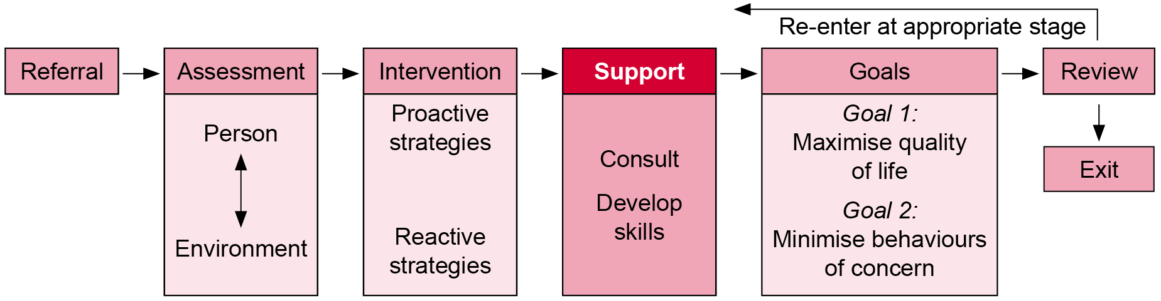

Practice principles

|  |
| --- |
| *See:*  *No. 1 Values-driven*  *No. 6 Accountability*  *No. 7 Safety* |

Practice strategy

| Component | Description |
| --- | --- |
| Task | Deliver support that is inclusive. |
| Process | Behaviour support practitioner:   * works in partnership to create an innovative, flexible system, whether intervention with the person or via carers or staff * provides capacity building to individuals, organisations and the community * maintains skills and capacity to respond to the diverse behaviour support needs of people with disability. |
| Outcomes | Support strategies provided:   1. Address the unique needs of the person. 2. Provide consultation and skills building to staff and carers. |
| Industry standards | **Refer to** Appendix 5. |

Inclusive support determines how services are provided. Support should be comprehensive and consistent with international best practice standards and be determined on the basis of the person’s presenting circumstances.

The positive behaviour support plan must be actively implemented by carers and staff. The importance of carers and staff in carrying out positive behaviour support plans cannot be underestimated, and difficulties in implementation should not reflect negatively on them. As positive behaviour support plans are not always carried out in accordance with a scientist-practitioner approach, what are the system constraints to implementation (Appendix 46)?

Support provides capacity building, whether direct intervention or consultancy is provided. Capacity building enhances the ability of people, organisations, institutions and communities to effectively respond to and manage their changing circumstances.

A person-centred approach cannot substitute for quality leadership, effective and efficient resources, skilled and motivated staff, service development or system changes requiring cultural and organisational change. The primary goal of maximised quality of life is realised if the environment supports person-centred goals and is well organised and if interventions are delivered by well-trained staff. In positive behaviour support, inclusive support enhances skills and constructive systems change (Appendix 47) procedures to create competencies to promote quality of life.

Inclusive support addresses the individual and unique needs of the person and capacity building assists staff and carers to understand and respond to behaviours of concern. The Australian Psychological Society notes that behaviours of concern can be complex, so working in a multidisciplinary team is considered most effective to provide a richer understanding, ensure no duplication, minimise unnecessary intrusion and ensure all treatment approaches are complementary and add value. Therefore, positive behaviour support requires a multiagency approach because: behaviours of concern have detrimental effects on the person and individuals who interact with them; there are varied and multiple social, physical and staffing responsibilities that must be fulfilled; and intervention and support is not the responsibility of one person or a small group of people (Reid & Parsons 2002).

The clearest common factor regarding successful outcomes is a positive working relationship (Appendix 48) between key players through mutual respect and trust.

### The person: beyond diagnoses

Behaviour support practitioners must demonstrate competence in considering unique needs when designing and implementing interventions for the person.

Behavioural assessment and contemporary intervention needs to take into consideration the unique needs of the person, carers and staff. The *2010–2020 National disability strategy* (Appendix 49) supports a person-centred approach – policies, programs and services for people with disability responding to the needs and wishes of each individual. The strategy recognises that not all people with disability are alike. People with disability have specific needs, priorities and perspectives based on their personal circumstances, including the type and level of support required, education, sex, race, age, sexuality, ethnic or cultural background and multiple disadvantages. The strategy takes an approach that is comprehensive while recognising the different needs, perspectives and interests of people with disability. Recognising the diversity of experiences of people with disability underpins the outcome areas of the strategy.

While there are clear state government policy directions regarding inclusive support, the available literature regarding behavioural assessment and contemporary intervention with the person with diverse needs (other than children and adolescents) is sparse. The following are tips for behaviour support practitioners not based on diagnosis or disability. Research and evaluation in these areas is strongly encouraged.

#### Children and adolescents

* Children with disability are first and foremost children.
* Improving health and development outcomes for children and young people is a joint responsibility of parents, carers and government on behalf of the community.
* Guidelines derived from managing behaviours of concern in adults need to be carefully implemented.
* The education system is a crucial setting, and application of positive behaviour support varies across schools.
  + - Behaviour management, including the manual handling/touching of students and the use of restrictive practices and punishment, varies across schools.
    - School systems in Australia are starting to utilise this training since it is considered to be safer, more respectful of the person and fits well with a human rights focus.
* Emphasise the normal rhythms of the child’s life.
* Explore parenting models that the family may use and ensure that interventions support them (such as the Sleepwise program for children with an intellectual disability or autism spectrum disorder, which explores parenting style and their values base and then develops an intervention within the family’s framework).
* Behaviour support practitioners must apply appropriate policies and practices to children and adolescents (Appendix 50).

#### Aboriginal and Torres Strait Islander people

* Aboriginal and Torres Strait Islander people are the most disadvantaged members of the Australian community, with disability at approximately twice the rate of the general population.
* Disability results from multiple barriers in the Aboriginal community, as well as the wider community, which results in double disadvantage. The National Indigenous reform agreement has resolved to address the needs of Aboriginal people with disability.
* A significantly larger number of Aboriginal and Torres Strait Islander people have a disability but are not accessing disability services, particularly if services are not culturally responsive. Services can be inclusive by employing Aboriginal staff, providing staff training and ensuring the availability of Aboriginal advocates.
* Be mindful of the worldview of Aboriginal and Torres Strait Islander people in which individuals with disability are seen to still have roles and responsibilities within the kinship system. Aboriginal families consider themselves to be supportive and accepting of family members with disability.

Behaviour support practitioners must apply appropriate policies and practices to Aboriginal and Torres Strait Islander people (Appendix 51) in:

* addressing social inclusion
* improving outcomes for Aboriginal and Torres Strait Islander people
* recognising Aboriginal and Torres Strait Islander people as vulnerable
* increasing access through appropriate service delivery arrangements.

#### Culturally and linguistically diverse backgrounds

* Positive behaviour support emphasises cultural diversity in conceptualising behaviours of concern relative to the cultural context (cultural relativism).
* Barriers to access include: lack of accessible information; communication difficulties; cultural sensitivities; reluctance to acknowledge a disability; need for counselling and referral to appropriate disability support agencies; need for translated information; need for plans to include long-term issues; importance of carer support groups; lack of professional interpreters; and scarcity of services in regional centres.
* ‘Disability’ is socially constructed, so may differ between cultures, and religious and cultural beliefs may view disability positively or negatively.
* Language problems can be a barrier when working with carers, with some languages not having terms for ‘disability’.
* Culture and ethnicity can strongly influence the expression of behaviours (and symptoms) and the way the behaviours are interpreted by staff.
* Culturally appropriate services designed and implemented in consultation with people with culturally and linguistically diverse backgrounds and disabilities are essential to accessible service delivery and basic human rights.
* Structured assessment processes may be invalid in terms of cultural bias and normative data.
* At school, children and adolescents from culturally and linguistically diverse backgrounds may be over-represented as having a disability.
* The socially determined position of men and women in a particular society may have an impact on differences in gender.
* A competent bilingual professional should be present to facilitate the process. Interpretation should be planned and the interpreters be ‘matched’ to their clients.
* Train staff in issues relating to cultural sensitivity and effectiveness.
* Consider the family’s history because some families may have experienced significant transitions in relation to emigration and/or experiences of war.

Behaviour support practitioners must apply appropriate policies and practices to people from culturally and linguistically diverse backgrounds (Appendix 52) in:

* understanding people and their needs
* encouraging participation in decision making
* providing culturally relevant and accessible information
* ensuring a culturally diverse workforce
* using language services to be effective
* meeting the specific needs of different communities
* promoting the benefits of a culturally diverse Victoria.

### Carers and staff: values and skills

The PPF requires that carers and staff are develop values and skills that enhance positive behaviour support. There are two primary reasons why implementation of positive behaviour support plans fail: (1) carers and staff do not know how to implement the strategies; or (2) carers and staff do not wish to implement the strategies (Reid & Parsons 2002).

Behaviour support practitioners need to support ‘the will and the way’ in carers and staff to implement positive behaviour support plans (Birgden 2004). Attitudinal change is considered a precursor of behaviour change; emerging theory of organisational change argues that cognitive or attitudinal change is required for cultural change. The problem with organisational change management has been the focus on behavioural change (how to do things differently) as opposed to cognitive change (how to think differently about how to do things). It is expected that carers and staff constantly examine their core beliefs and assumptions to make sense of organisational change and to resolve conflict inherent in accepting change (that is, cognitive dissonance). This process is described by Porporino (2001) as ‘sensemaking’ or an ongoing process of adjustment and receptivity to change that is both emotional and cognitive, and therefore attitudinal. The cognitive schemata about change that carers and staff develop will lead them to either accept or reject change for very personalised reasons. Therefore, relying on a skills-based approach assumes that carers and staff are motivated to change.

Effective strategies for attitudinal change (Appendix 53) include persuasive communication strategies and active participation techniques.

Behaviour support practitioners engage in collaboration (Appendix 54). Collaboration with ‘inter-professional’ teams should occur with carers as equal partners, highlighting the focus on stakeholder participation, mutual education and capacity building that supports systems change (Carr et al. 2002). Behaviour support practitioners understand the importance of developing collaborative relationships (Appendix 54) with the person, carers and staff. Partnership models include family partnership approaches and collaborating with carers in natural settings.

Behaviour support practitioners provide consultation and skills building to carers and staff. Staff and carers require both emotional support (through good teamwork, supervision, debriefing and counselling) and technical support (through skills building in care and treatment).

#### Support through consultation

Consultation occurs with carers and staff who support individuals with behaviours of concern. Consultation provides advice and assistance in the planning and development of support services to prevent, reduce or minimise the likelihood of developing behaviours of concern (Jenkins 2006). The consultation is specific to the particular environment and may include a service review, supporting a non-government organisation, or regional planning. Consultation may be assisted by referring to specialist services available in other agencies.

Positive behaviour support plans are rarely effective if carer or staff implementation and the person’s response to the strategies are not systematically monitored. Effective monitoring requires ensuring that carers and staff know they will be observed, are informed of the purpose, are treated respectfully in the process and receive feedback as soon as possible (Reid & Parsons 2002).

Based on positive behaviour support, consultation needs to focus on the quality of the environment and what supports it offers to:

* work alongside carers and staff to model and implement interventions
* highlight incremental successes
* facilitate problem-solving approaches to unforeseen circumstances
* facilitate supportive social networks
* be available to assist
* encourage positive behaviour support.

Behaviours of concern may require numerous intervention approaches that can cause significant stress to the person, carers and staff. Carers and staff may therefore experience a range of strong and negative emotional reactions that may lead to restrictive practices and reduced wellbeing. Positive behaviour support endeavours to ensure a contextual fit between the positive behaviour support plan and the resources and wellbeing of those who put it in place. Self-care (Appendix 55) is also important because the work involves an intense focus on the needs of others; self-care leads to less fatigue, a greater ability to enjoy life, less emotional overload and burnout and less ‘compassion fatigue’ (Allen 2009). Mindfulness-based interventions allow carers to develop mechanisms to cope with stress.

#### Support through skills building

The PPF recognises that carers and staff are critical mediating factors in effective and ethical support (NDTi 2007) (Appendix 56). The attitudes and motivations are crucial; carers and staff need to view the person in a positive light, and this will have a direct effect on the quality of their interaction with them. The most successful services are those where staff are willing to learn and take advice from others and look to wider community resources for opportunities and relationships. In other words, the staff are committed to the person and do not give up on the person when ‘the going gets tough’. Behaviour support practitioners need to provide ongoing support to staff who are directly engaged with the person and nurture such organisational strengths. In particular, carers and staff need to be actively assisted in implementing positive behaviour support plans (Reid & Parsons 2002).

There is a difference between learning and training. Whichever term is used, learning and/or training requires developing knowledge and skills that are supported by experientially based application that reinforces the competency of the learner. Learning is the acquisition of knowledge through observation, discussion and testing of knowledge. *Training* (Appendix 57) takes the learning through to the on-the-job application of the learning. Optimum learning takes place when the person is able to apply the theory to practice and observe change in the workplace. The development of skills requires that the person providing the learning has significant and substantial practice experience in the area of behaviours of concern and familiarity with communication with people with disability in order to ensure a strong knowledge base and credibility. The approach to skill development should de-emphasise formats that rely on ‘lectures’ and instead favour real-life settings such as schools, community residences and worksites, to produce staff competence. Carers and staff should develop an understanding of how a given intervention is contextualised within the broader infrastructure (knowledge of administrative issues, mechanisms for funding, mission statements and interagency collaboration) and provided with the opportunity to rehearse and practice the strategies.

Positive behaviour support has been contrasted with applied behaviour analysis in that positive behaviour support has moved away from the ‘expert-based’ model towards person-centred planning involving a range of stakeholders such as family, direct care staff, teachers and other professionals (MacDonald 2016). This approach represents a shift away from a sole reliance on professionals to bring about direct change in the lives of people with intellectual disability and behaviours of concern (Grey et al. 2016, citing MacDonald & McGill 2013). A team approach is almost always applied (Grey et al. 2016). A number of evaluations to date have also demonstrated that staff, including direct care staff, can be trained successfully in positive behaviour support (see Grey et al. 2016).

Models of training using coaching that have improved on fidelity (programs delivered as designed) include individualised training by an expert after an initial workshop followed either by side-by-side coaching in which the trainee receives in-vivo feedback during skill implementation or supervisory coaching in which the trainee is observed initially and receives feedback after the observation (Kretlow & Bartholomew 2010).

Various models of training have been proposed (Table 3).

Table 3: Models of training

| Authors | Objectives | Format |
| --- | --- | --- |
| Anderson et al. (1993); Anderson et al. (1996); Anderson and Freeman (2000) | * Change lives of service users (improved lifestyles as well as reduced behaviour) * Improve skills and knowledge of staff (proactive strategies, multi-component approaches, sees behaviour change in context of a good life, recognises need for long-term support, not quick fixes) * Adjust agencies and systems (adopted into organisational policies training to be prioritised proactively rather than crisis led resulting in flexible support options involving inter-agency and family collaboration) | * Ensure sustainability and develop local expertise via a trainer-the-trainer model * Target multiple audiences to create systems of comprehensive support across all of the person’s environment * Use a case-study approach * Intersperse teaching with periods of practice in the service setting, along with coaching and mentoring * Provide a comprehensive curriculum (values, functional analysis, positive behaviour support planning, skills building, reinforcement, emergency management, evaluation and systems issues) * Facilitate the development of positive behaviour support communities via ongoing implementation of positive behaviour support at the local level, and multiple levels of training, dependent on roles |
| Dunlap and Hieneman (2000) | * Build enduring capacity to provide effective positive behaviour support * Ensure lifestyle changes for those with behaviours of concern * Change systems to promote positive behaviour support * Improve collaborative working including community building and networking | * Multidisciplinary collaboration in a range of settings * Case study to apply learning to an actual person * Dynamic training process with practical application and formal learning * Comprehensive training addressing various topics (for example, collective goals, building teams, FBA, designing positive behaviour support plans, implementing strategies, evaluation and infusing positive behaviour support into systems) |
| LaVigna et al. (2002) | * Deliver competency-based assessment and multi-element behaviour support plans * Provide skills, materials and procedures to deliver positive behaviour support in workplaces * Teach positive behaviour support interventions with consistency and accuracy, and to utilise ongoing quality improvement systems * Improve support to integrate practices into ordinary work and living and to be able to achieve durability | * Two weeks of intensive training and practice * Hands-on implementation of positive behaviour support, with supervised field-based practice assignments, practice exercises, writing assignments and feedback sessions * Carry out FBA and develop multi-element plans with both proactive and reactive strategies * Implement person-centred, community-based behaviour analysis approaches * Learn about evaluation |
| Carr et al. (2002) | * Utilise a range of stakeholders, not just professionals * Ensure collaboration with stakeholders and between agencies * Ensure capacity building of stakeholders leading to system change | * Creative use of technology * On-site education * Real-life problem solving, in context, within sufficient time duration * Learning how to use interventions within systems and how to integrate with broader infrastructures and networks |

Adapted from: MacDonald 2016.

MacDonald (2016) suggested four key features of staff training:

1. Function-based, with multi-element support planning – positive behaviour support training teaches that it must be based on FBA and an understanding of why behaviour occurs in specific contexts and environments. This leads to a range of proactive and reactive strategies, with the major focus on proactive strategies. Within the proactive, there must be a focus on both stimulus-based intervention (changing the physical and social environment, such as manipulation of setting events) and reinforcement-based interventions (addressing behavioural deficiencies via skills teaching and reinforcement plans, which more strongly reinforce appropriate behaviours than behaviours of concern).
2. Person-specific with a long-term focus on improving quality of life – positive behaviour support training encourages participants to complete training with a specific individual in mind. The training is modular, with breaks in between sessions to apply the learning in practice and has a clear focus on improving quality of life for individuals in addition to reducing the severity and frequency of behaviours of concern.
3. Involvement of stakeholders – positive behaviour support training is the primary means to make positive behaviour support more widespread in natural settings, including family carers and direct care staff to understand and participate in a collaborative process that fits with their values and makes sense to their life experience; learning how to implement positive behaviour support in real life settings and the ‘contextual fit’ (the congruence between the positive behaviour support interventions and the context in which they will be implemented).
4. Systems changes and organisational focus – positive behaviour support is a whole-systems approach; the central independent variable in positive behaviour support is systems change resulting in improved outcomes in terms of reduced behaviours of concern and quality of life. Behavioural intervention skills need to be supplemented by organisational changes to ensure whole-system commitment and widespread implementation. Periodic service review is a quality assurance system that supports positive behaviour support (see BSP QE II at section 18.2).

#### Parent training

Parents should also have access to evidence-based training in positive behaviour support.

Hieneman and Fefer (2017) have conceptualised parent training to:

* ensure enhanced quality of life
* engage all relevant family members
* conduct structured, comprehensive assessments
* develop support strategies and interventions
* monitor fidelity and outcomes
* provide tiered programs.

The format applied is:

1. lifestyle enhancement – to ensure social validity for parents by enhancing quality of life, engaging support teams, using a multi-tiered approach
2. assessment-based intervention – assess contexts and functions and make data-based decisions
3. comprehensive interventions – proactive, teaching and management strategies and implementing the positive behaviour support plan.

Skills building can utilise a collective leadership model (Appendix 58) that involves a group of staff harnessing the available skills, experience and resources to work together in their communities. The group is led by a team leader (depending upon the setting) and includes an embedded behaviour support practitioner who ensures service delivery based on the PPF. Activities such as communities of practice and active learning can further enhance learning.

Staff and carers are to receive managing behaviours training (Appendix 59).

## Review and exit

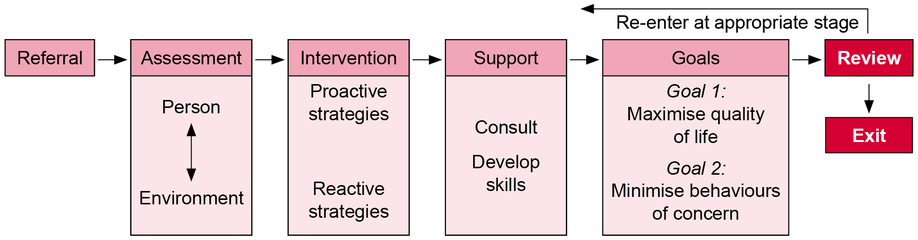

Practice strategy

| Component | Description |
| --- | --- |
| Task | Undertake a review and exit planning. |
| Process | Behaviour support practitioner:   * summarises the interventions and measures the effectiveness of behaviour support within the context of achievement towards Goal 1 and Goal 2, ongoing system support and in consultation with the person (and/or their carer) * determines when the review and exit planning should occur. |
| Outcomes | Timely and effective review and exit planning for people occurs. |
| Industry standard | **Refer to** Appendix 5. |

### Review

Behaviour support practitioners are ethically obliged to determine the outcome success of Goal 1 and Goal 2. The functional assessment and positive behaviour support plan ensures this.

Review (Appendix 60) is the measurement of change to determine the impact or effectiveness of interventions. Outcome success should be determined by: reduced barriers to participation; realisation of the person’s rights, dignity and quality of life; and improved health and safety of the person and others. Review of the referral occurs when Goal 1 (maximise quality of life) and Goal 2 (minimise behaviours of concern) are met.

Very little guidance regarding structured consumer feedback appears to be available. The Victorian Advocacy League for Individuals with Disability Inc. (VALID) (Appendix 61) strongly supports advocacy and has developed the Having a say resource manual for people with an intellectual disability.

Feedback (Appendix 62) communicates the information about the process and the effectiveness of the intervention. Hudson et al. (1995) conducted a three-year outcome study on eight behaviour support teams established in Victoria between 1991 and 1993. The authors found that of 134 completed interventions, there was a good rate of success in reducing or eliminating behaviours of concern, improved skills acquisition and satisfaction expressed by carers.

### Exit planning

The choice of exit criteria depend on the agreed definition of behaviours of concern and the goals of intervention. A re-evaluation of dynamic risk factors may be required.

Once agreed goals have been achieved, the focus shifts to maintaining the change. Planning for the end of the intervention begins as part of the initial engagement and assessment process and should be reflected in the positive behaviour support plan. Throughout the practice pathway the behaviour support practitioner should be preparing the person, their family, carers and significant others for the eventual cessation of service.

After the review process (Appendix 60) is completed and it is agreed that the exit criteria as reflected in the positive behaviour support plan has been met, the referral is closed and the service ends. This does not preclude re-referral at a later stage should the person’s circumstances change.

# Effective governance

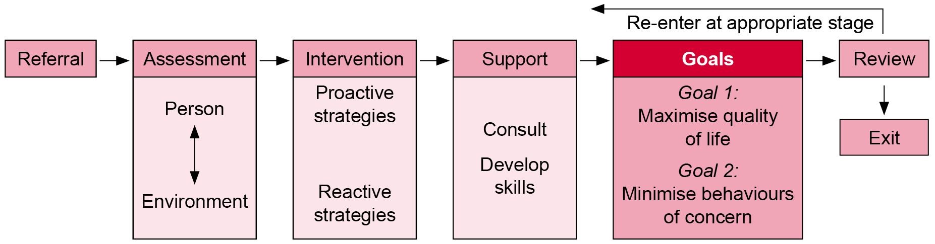

Governance is a system through which organisations ensure they are accountable for continuously improving the quality of their services and safeguarding high standards. It includes corporate functions, strategic direction, managing risk, improving performance and ensuring compliance with standards and statutory requirements.

Clinical governance occurs within a broader context of broader governance role of organisations.

For the purpose of behaviour support ‘clinical governance’ is the system by which managers, practitioners and staff share responsibility and accountability for quality, continuously improving, minimising risks and fostering an environment of excellence.

## Policy and standards

Victorian Government legislation, policy and standards guide monitoring of performance. During Victoria’s transition the NDIS, existing quality and safeguarding arrangements continue to apply.

### Department of Health and Human Services standards

The department’s Human Services Standards and independent review process seek to ensure that people experience the same quality of service no matter which service provider they access.

The standards are summarised as:

* **Empowerment**: People’s rights are promoted and upheld.
* **Access and engagement**: People’s right to access transparent, equitable and integrated services is promoted and upheld.
* **Wellbeing**: People’s right to wellbeing and safety is promoted and upheld.
* **Participation**: People’s right to choice, decision making and to actively participate as a valued member of their chosen community is promoted and upheld.

### Behaviour support services performance framework: individual and organisational outcomes measures

Positive behaviour support is an applied science, and behaviour support practitioners function as scientist-practitioners. As practitioners they supervise organisational outcome measures to ensure process standards. As scientists they supervise individual outcome measures to ensure outcome standards.

A performance framework identifying individual and organisational outcome measures will be considered to assist practitioners to monitor performance within the context of the practice model.

1. Individual outcome measures – the influence and impact on the political, social, cultural, economic and physical wellbeing of people with disability and the areas of life that are important to them (Goal 1 and Goal 2 of the PPF) = outcome measures (Appendix 63).
2. Organisational outcome measures – the organisational systems and processes that are good practice and are required to ensure better outcomes for people with disability (the PPF) = process measures (Appendix 63).

Practice principles

|  |
| --- |
| See:  No. 5 Effective environmental design  No. 6 Accountability |

Positive behaviour support conceptualises the environment as the independent variable and the person’s behaviour as the dependent variable (Morris & Horner 2016).

The quality of positive behaviour support plans can be determined at the organisational level.

The Behaviour Support Plan Quality Evaluation tool (BSP QE II) can be applied to monitor and improve the quality of support provided in accommodation and day-support services and for adults with behaviours of concern (McVilly et al. 2013a; McVilly et al. 2013b).

The Senior Practitioner – Disability provides a behaviour support planning toolkit <http://www.dhs.vic.gov.au/about-the-department/documents-and-resources/policies,-guidelines-and-legislation/behaviour-support-planning-practice-guide-senior-practitioner> that includes the BSP QE II at Section 4 (‘Useful assessment tools and forms’).

Practice strategy

| Component | Description |
| --- | --- |
| Task | Ensure effective governance. |
| Process | 1. Governance is supported through:    * professional development – competency-based orientation and training (to address training needs)    * clinical supervision – at least fortnightly supervision to ensure practice outcomes (to reinforce training)    * peer support meetings – regular multidisciplinary meetings (to provide group supervision and reinforce training). 2. Monitoring and evaluation is undertaken against:    * the PPF    * process and outcome standards. |
| Outcomes | 1. Adherence to process standards (delivery of practice in line with the PPF) 2. Adherence to outcome standards (meeting Goals 1 and 2 of the PPF) |
| Standards | **Refer to** Appendix 5 **and** behaviour support **individual and organisational outcome measures** (outcome and process measures) (Appendix 63). |

Figure 7 presents a diagrammatic representation of behaviour support process and outcome measures to achieve the goals of maximising quality of life (Goal 1) and minimising behaviours of concern (Goal 2).

Figure 7: Behaviour support process and outcome measures

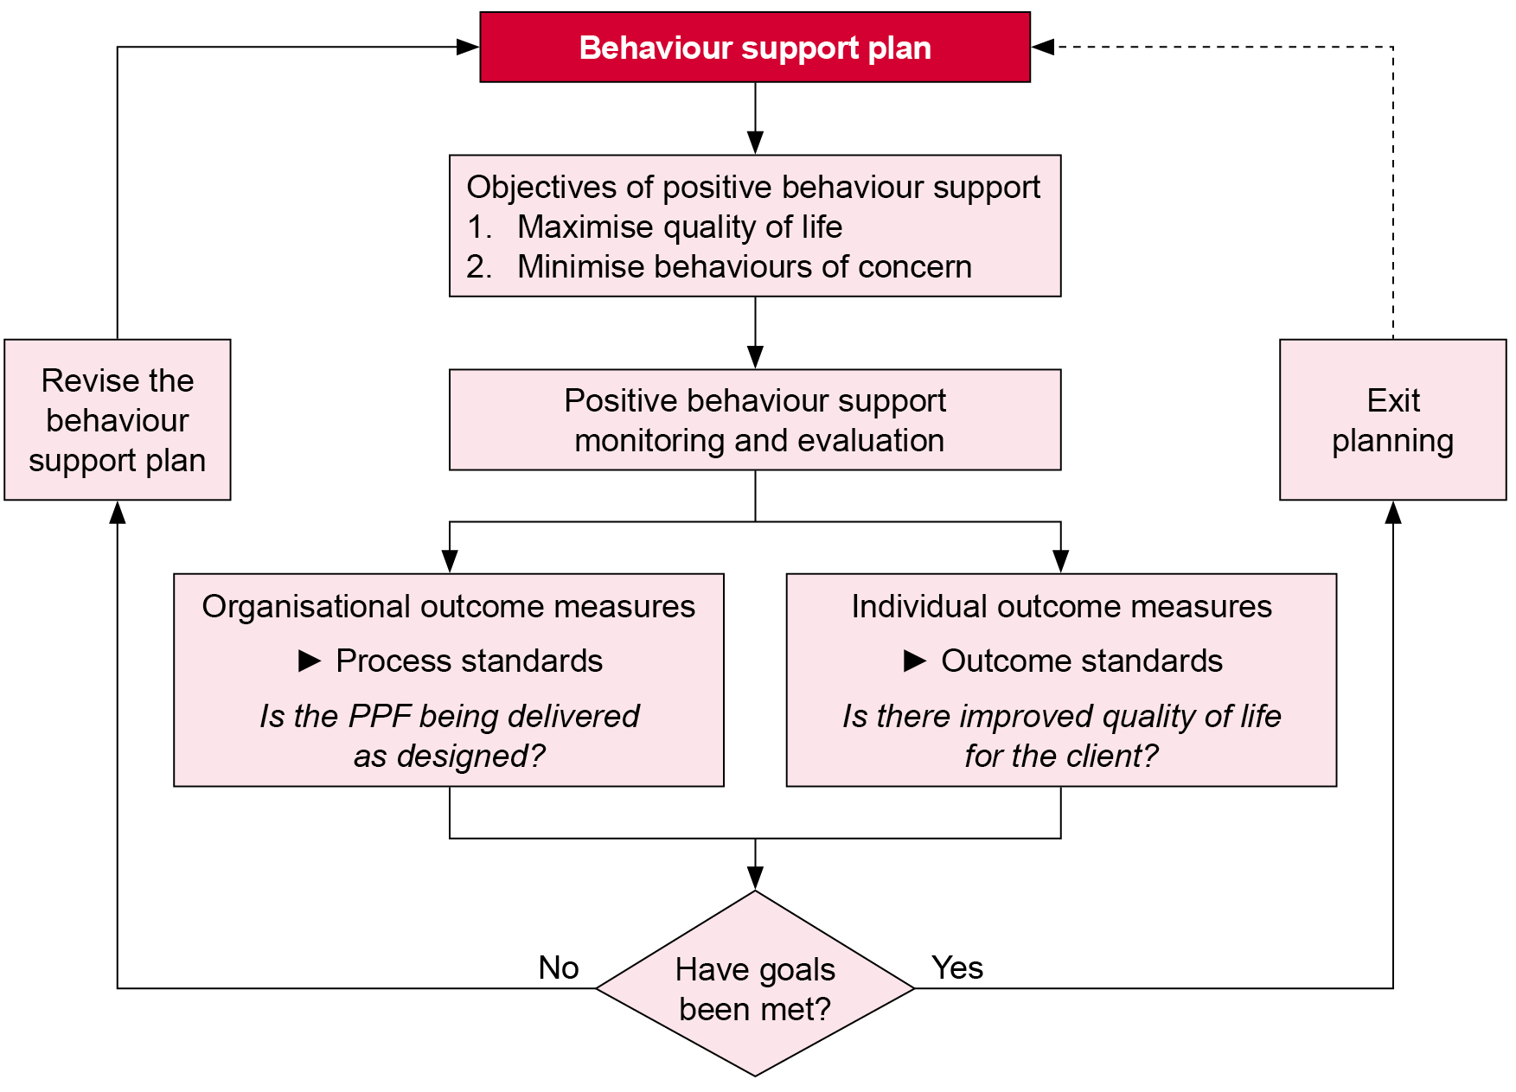

## Clinical leadership

Successful clinical leaders act as change agents who support carers and staff to effectively implement programs by ensuring a contextual fit between the person and their environment. Change agents have: professional credibility; intimate knowledge of the agency and its staff; the support of the senior agency officials and direct care staff; professional orientation and values compatible with the agency’s mandate and goals; and a history of successful program implementation in the agency’s program area. They continue until there are clear performance indices that management and staff are able to use to maintain the delivery of the program with a reasonable degree of competence (Gendreau, Goggin & Smith 2002).

Effective change agents employ:

* persuasion
* motivational interviewing techniques (such as empathy, discrepancy, non-confrontational responses,   
  self-efficacy support)
* authority (but do not use threats)
* reinforcement (such as praise)
* modelling
* systemic problem solving
* advocacy/brokerage.

Strong clinical leadership requires ongoing professional development (Appendix 64) regarding positive behaviour support.

The Australian Health Practitioner Regulation Agency (AHPRA) (Appendix 65) was established in July 2010 and is responsible for the registration and accreditation of 10 health professions across Australia, including psychology, occupational therapy and nursing (but not speech pathology). Psychologists are required to engage in a program of continuing professional development to develop the required personal qualities (values and attitudes) and maintain, improve and broaden their knowledge, expertise and competence (skills). A minimum standard per year for psychologists is 30 hours of continuing professional development and 10 hours of individual or group peer supervision, for occupational therapists 30 hours of continuing professional development, and for nurses 20 hours of continuing professional development.

## Promoting good practice

Professional practice can be enhanced by a community of practice (Appendix 66).

The Australasian Society for the Study of Intellectual Disability (ASSID), following a five-year consultation across Australia and New Zealand, published the Australasian code of ethics for direct support professionals (McVilly & Newell 2007). This document outlines a range of principles to consider in the design and delivery of contemporary disability services. These principles include:

* professional competence
* evidence-based practice
* professional conduct
* self-care and the care of colleagues
* collaboration
* accountability
* consent
* confidentiality
* relationships
* person rights
* advocacy
* skills development and lifelong learning.

In addition to professional codes, this document can be used to frame standards for clinical supervision.

## Behaviour support practitioners as scientists

Positive behaviour support emphasises the role of staff as intervening directly with individuals with behaviours of concern. These professionals should possess the skills to both understand and alter rates of behaviours of concern.

Practitioners should function as scientists and adhere to basic assumptions about behaviour (Appendix 67).

Practitioners should gather data regarding efficacy. Positive behaviour support applies a problem-solving approach using systematic data collection to evaluate and guide intervention and support in determining efficacy in maximising quality of life (Goal 1) and minimising behaviours of concern (Goal 2). These data include qualitative, quantitative and econometric measures (Appendix 68).

Behaviour support practitioners determine whether outcome success (Appendix 69) is achieved.

# Appendices

1. Disability Services policy and legislation

Return to Section 2

Disability Act

The *Disability Act 2006* (Vic) establishes the compliance framework for quality assurance. It identifies the standards and performance measures and mandates compliance and the authority for the Department of Health and Human Services to monitor and take action in cases of noncompliance.

[Disability Act 2006 page on the department’s website](https://services.dhhs.vic.gov.au/disability-act-2006) <https://services.dhhs.vic.gov.au/disability-act-2006>

The *Disability Amendment Act 2012* came into operation on 1 July 2012. It makes minor changes to the *Disability Act 2006*.

Return to Section 3.1

National Disability Insurance Scheme Act

The *National Disability Insurance Scheme Act 2013* provides for the NDIS to deliver reasonable and necessary supports to persons with disability. The NDIA planner is responsible for identifying that the participant requires behavioural intervention services under the reasonable and necessary supports (s. 34) of the Act.

[Legislation page on the NDIS website](https://www.ndis.gov.au/about-us/governance/legislation) <https://www.ndis.gov.au/about-us/governance/legislation>

Return to Section 3.1

1. Social model of disability

A social model definition of disability

There are various current definitions. In the United Kingdom, disability tends to be seen as a social construct, created by the environment rather than individual attributes and requiring social change; society disables individuals with impairments, which results in unnecessary isolation and exclusion from full participation. In the United States, disability tends to be seen as the experience of discrimination and segregation through sensory, attitudinal, cognitive, physical and economic barriers, similar to other oppressed minority groups. Either way, society needs to include all people regardless of their individual differences.

Resource

Mitra S 2006, ‘The capability approach and disability’, Journal of Disability Policy Studies, 16(4), 236–247.

Return to Section 3.1

1. International Classification of Functioning, Disability and Health

In 2001 the World Health Organization endorsed the International Classification of Functioning, Disability and Health (ICF). The ICF classifies health and health-related domains in terms of body functioning, activity/participation and environmental factors. The emphasis is on function rather than the aetiology of condition or disease, and the definition is relevant across cultures, age groups and genders. The ICF therefore ‘mainstreams’ the experience of disability as a universal human experience and so integrates the medical and social model of disability.

[International Classification of Functioning, Disability and Health page on the World Health Organization website](http://www.who.int/classifications/icf/en) <http://www.who.int/classifications/icf/en>

Resource

Mitra S 2006, ‘The capability approach and disability’, Journal of Disability Policy Studies, 16(4), 236–247 – see p. 239 for a simple diagram of the ICF.

Return to Section 3.1

1. Human rights

Convention on the Rights of Persons with Disabilities

The United Nations *Convention on the Rights of Persons with Disabilities* adopts a social model of disability in defining it as interactive – impairments interacting with various social barriers may hinder a person’s full and effective participation in society on an equal basis with others.

Human rights goals of habilitation and rehabilitation (s. 26) incorporate three goals:

* attain and maintain full inclusion and participation in all aspects of life
* attain and maintain maximum independence
* attain and maintain full physical, mental, social and vocational ability.

[Convention on the Rights of Persons with Disabilities page on the United Nations website](https://www.un.org/development/desa/disabilities/convention-on-the-rights-of-persons-with-disabilities.html) <https://www.un.org/development/desa/disabilities/convention-on-the-rights-of-persons-with-disabilities.html>

Return to Section 3.1

Victorian Charter of Human Rights and Responsibilities

The Victorian *Charter of Human Rights and Responsibilities Act 2006* is a law that protects the human rights of all people in Victoria. The Charter complements other laws – such as equal opportunity legislation – by setting out a familiar list of 20 rights that assist all people to live with freedom, respect, equality and dignity.

The Charter places obligations on public authorities such as the department to act in a way that is compatible with the human rights contained in the Charter and to give relevant human rights proper consideration when making decisions.

[Victoria’s Charter of Human Rights and Responsibilities page on the Victorian Equal Opportunity & Human Rights Commission website](https://www.humanrightscommission.vic.gov.au/human-rights/the-charter) <https://www.humanrightscommission.vic.gov.au/human-rights/the-charter>

Return to Section 3.1

National Disability Insurance Scheme Act

Section 3 of the *National Disability Insurance Scheme Act 2013* gives effect to Australia’s obligations to the *Convention on the Rights of Persons with Disabilities* and to certain obligations that Australia has as a party to international human rights laws.

Return to Section 3.1

1. Human Services Standards

The Department of Health and Human Services’ Human Services Standards represent a single set of service quality standards for department-funded service providers and department-managed services. The standards comprise the department’s four service delivery standards – empowerment, access and engagement, wellbeing, and participation – and the governance and management standards of a department-endorsed independent review body.

[Human Services Standards page on the department’s website](https://dhhs.vic.gov.au/publications/human-services-standards) <https://dhhs.vic.gov.au/publications/human-services-standards>

Return to Section 9 | Return to Section 13.1 | Return to Section 13.2 | Return to Section 13.3 | Return to Section 14 | Return to Section 15 | Return to Section 16 | Return to Section 17 | Return to Section 18.2

1. Advocacy

Advocacy resources

The Disability Action Resource Unit

The Disability Action Resource Unit (DARU) is a statewide service established to resource the disability advocacy sector in Victoria. The DARU website contains an advocacy resource map where you can search for advocacy services and organisations by region.

[Disability Action Resource Unit website](http://www.daru.org.au) <http://www.daru.org.au>

Office for Disability

The Office for Disability also provides further information on advocacy services in Victoria and a list of funded organisations.

[Office for Disability website](https://www.dhhs.vic.gov.au/office-disability) <https://www.dhhs.vic.gov.au/office-disability>

Return to Section 13.1

1. MacArthur Treatment Competence Study

The MacArthur Competence Assessment Tool – Treatment (MacCAT-T) is a clinical tool. The MacCAT-T assesses understanding, appreciation and reasoning. Understanding determines the patient’s ability to paraphrase what has been disclosed about the disorder, the recommended treatment and the treatment’s risks and benefits. Appreciation explores whether the patient fails to appreciate the disorder and that treatment may have some benefit, based on delusional or otherwise distorted perceptions. Reasoning rechecks the patient’s first choice and reasoning including a no-treatment option, generating consequences, final choice and logical consistency of choice.

Resources

Appelbaum PS, Grisso T 1995, ‘The MacArthur Treatment Competence Study I: Mental illness and competence to consent to treatment’, Law and Human Behavior, 19(2), 105–126.

Grisso T, Appelbaum PS 1996, Values and limits of the MacArthur Treatment Competence Study, Psychology, Public Policy and Law, 2(1), 167–181.

Grisso T, Appelbaum PS, Hill-Fotouhi C 1997, ‘The MacCAT-T: A clinical tool to assess patients’ capacities to make treatment decisions’, Psychiatric Services, 48(11), 1415–1419.

Grisso T, Appelbaum PS, Mulvey EP, Fletcher K 1995, ‘The MacArthur Treatment Competence Study II: measures of abilities related to competence to consent to treatment’, Law and Human Behavior, 19(2), 127–148.

Birgden A 2004, ‘Therapeutic jurisprudence and responsivity: finding the will and the way in offender rehabilitation’, Crime, Psychology & Law, 10(3), 283–296.

Return to Section 13.1

1. Referral information

Preliminary referral information includes:

* file search
* residential, day/community services and respite arrangements
* weekly structure of the person including their residential, day/community, respite and social/leisure arrangements
* intellectual functioning
* adaptive behaviour
* existing diagnoses
* involvement of other professionals
* previous and current assessments and interventions
* recent changes in circumstances
* stakeholder’s perception of the person’s needs and behaviours of concern
* ensuring that fundamental human rights are in place – a safe living environment, adequate social and community access, regular activities and respect from staff and other providers.

Resource

Special Projects Team: Directorate of Learning Disability Services, Bro Morgannwg NHS Trust 2010, A hitchhiker’s guide for the specialist behaviour team (operational guidance), GIG CYRMU, Wales.

| Frequency | Low intensity of behaviour | High intensity of behaviour |
| --- | --- | --- |
| Low frequency of behaviour | Most commonly overlooked yet have potential over time to adversely affect the health, wellbeing and quality of life of the person and those supporting them | Can cause fear and apprehension among family and support staff and give rise to unnecessarily restrictive practices ‘just in case’ the behaviour occurs |
| High frequency of behaviour | Commonly regarded as ‘nuisance’ behaviours that are often tolerated and subsequently rarely addressed effectively, potentially resulting in or contributing towards more serious behaviours | Most commonly recognised as behaviours of concern |

Return to Section 13.2

1. Risk assessment

Risk assessment screen

Clinical indicators for risk of aggression in people with disability include:

* male, aged 15–34 years
* aggression as the single most form of behaviour of concern
* aggression is persistent over time (past behaviour is a predictor)
* mental health problems
* co-occurrence of self-injury and other behaviours of concern
* life events – losses and changes, physical and sexual abuse, bereavement, service transitions
* impaired receptive and expressive communication skills
* poor impulse or anger control
* failure to recognise emotional cues.

Environmental risk factors can be further divided between immediate situational and system-level factors (although the following information is based on institutions with general population individuals):

1. Situational risk factors:
   * + crowded and hot environment
     + few structured activities in place
     + inconsistent approaches by carers
     + violent cues present – accessible weapons and aggressive behaviour modelled by carers
     + purposeful aggressive behaviour
     + pressure from peers to be violent
     + authoritarian, rejecting carers
     + aversive demands presented by carers.
2. System-level risk factors:
   * + inexperienced staff
     + high usage of temporary staff
     + expectations of violence.

Risk assessment should include strategies to prevent escalation:

* Describe precisely the frequency, duration and intensity of the behaviour.
* Indicate who and what is at risk.
* Identify any behavioural precursors that may escalate the risk.
* Identify any aspects of the environment associated with increased likelihood of risk.
* Determine risk to self and others.
* Consider existing risk management strategies.

Resource

Allen D 2002, Devising individualised risk management plans. In: D. Allen (ed.), Ethical approaches to physical interventions: responding to challenging behaviour in people with intellectual disabilities, 71–88, BILD Publications, Glasgow.

Return to Section 13.3

1. Health screening

Health screening resources

IASSID health guidelines for adults with an intellectual disability:

[Health guidelines for adults with an intellectual disability [PDF download from IASSID website]](https://www.iassidd.org/uploads/legacy/pdf/healthguidelines.pdf) <https://www.iassidd.org/uploads/legacy/pdf/healthguidelines.pdf>

Comprehensive Health Assessment Program

The Comprehensive Health Assessment Program (CHAP) is a system for providing comprehensive medical histories for patients with disabilities. The information is stored in one central location, completed by the patient with their carers and practitioners. Further information on the CHAP in the context of client residential health plans can be found in part 5 of the Residential services practice manual at <https://das.dhhs.vic.gov.au/residential-services-practice-manual>

Return to Section 14.1.1

1. Mental health screening tools

Psychiatric Assessment Schedules for Adults with Developmental Disabilities checklist (PAS-ADD) (revised)

Purpose: A 25-item questionnaire designed to collect data on an individual’s mental health. The PAS-ADD may be used by families and care staff and aims to assist them to decide whether further assessment of an individual’s mental health may be warranted (in other words, identifying individuals at risk). The checklist produces three scores relating to: affective or neurotic disorder; possible organic condition (including dementia); and psychotic disorder. It is also suitable for exploring conditions in autism spectrum disorder.

[PAS-ADD website](http://www.pas-add.com) <http://www.pas-add.com>

Moss S 2002, The mini PAS-ADD interview pack, Pavilion, Brighton.

Reiss Screen for Maladaptive Behaviour

Purpose: A psychiatric screening interview to be used with individuals with intellectual disability that may be administered by carers or family. The test consists of 36 items identifying symptoms of psychiatric disorder screened in three ways (severity of challenging behaviour, diagnosis, and rare but significant symptoms such as suicidal behaviour). A ‘positive’ result may indicate that the person needs to referred for further professional evaluation.

[Reiss Screen for Maladaptive Behavior web page](http://www.reiss-screen.com/shortform.htm) <http://www.reiss-screen.com/shortform.htm>

Havercamp S, Reiss S 1997, ‘The Reiss screen for maladaptive behaviour: confirmatory factor analysis’, Behaviour Research and Therapy, 35, 967–971.

Psychopathology Instrument for Mentally Retarded Adults (PIMRA)

Purpose: Contains 56 items that are distributed across eight clinical scales including schizophrenia, affective disorder, psychosexual disorder, adjustment disorder, anxiety disorder, somatoform disorder, personality disorder and inappropriate adjustment. The instrument consists of two structured interview schedules: ‘self’ (an interview with the person) and ‘other’ (interview with the carer/staff).

Matson J 1988,The Psychopathology Inventory for Mentally Retarded Adults (PIMRA) manual, International Diagnostic Systems, Orland Park, PL.

Developmental Behaviour Checklist (Adult version) (DBC-A)

Purpose: An instrument for assessing behavioural and emotional problems of adults with developmental and intellectual disabilities. The assessment provides an overall measure of behavioural/emotional disturbance and categories of disturbance across six dimensions (disruptive, self-absorbed, communication disturbance, anxiety/antisocial, social relating and depressive).

Mohr C, Tonge B, Einfeld SL 2005, ‘The development of a new measure for the assessment of psychopathology in adults with intellectual disability’, Journal of Intellectual Disability Research, 49, 469–480.

Glasgow Depression Scale for People with a Learning Disability (GDS-LD)

Purpose: A 20-item scale used for screening, monitoring progress and appraising outcomes for people with intellectual disability who may have a depressive illness.

Cuthill FM, Espie CA, Cooper SA 2003, ‘Development and psychometric properties of the Glasgow Depression Scale for People with Learning Disabilities’, British Journal of Psychiatry, 182(4): 347–353.

Glasgow Anxiety Scale for People with Intellectual Disability (GAS-ID)

Purpose: A self-rating scale to measure anxiety symptoms in people with mild intellectual disability. The scale includes cognitive, behavioural and somatic symptoms associated with anxiety disorders. It is not intended as a diagnostic tool but may be used to indicate that further assessment is required by a mental health professional.

Mindham J, Espie CA 2003, ‘Glasgow Scale for People with an Intellectual Disability (GAS-ID): development and psychometric properties of a new measure for use with people with a mild intellectual disability’, Journal of Intellectual Disability Research, 47(1), 22–30.

Centre for Developmental Disability Health Victoria, Depression in Adults with Intellectual Disability, Checklist for carers

Purpose: The depression checklist is for use by carers, in particular paid support staff. It is intended to be completed on behalf of adults who are unable to report their own feelings or symptoms because of a severe communication impairment.

The checklist is not a diagnostic tool; it provides information for use by a medical or mental health practitioner in screening for possible depression or related disorders in adults who are unable to self-report. The checklist is not a substitute for a clinical assessment. Health professionals are responsible for conducting individual clinical assessments. The information obtained by a carer who knows an individual well may assist the health professional in this clinical assessment.

There is a short registration process to access the checklist, which can be accessed here:

Centre for Developmental Disability Health Victoria, Depression in Adults with Intellectual Disability, Checklist for carers <http://www.cddh.monash.org/research/depression>

Further resources

Deb S, Matthews T, Holt G, Bouras N 2001, Practice guidelines for the assessment and diagnosis of mental health problems in adults with intellectual disability, Pavilion, Brighton.

Smith P, McCarthy G 1996, ‘The development of a semi-structured interview to investigate the attachment related experiences of adults with learning disabilities’,British Journal of Learning Disabilities, 24, 154–160.

Guerin S, Dodd P, Tyrell J, McEvoy J, Buckley S, Hillery J 2009, ‘An initial assessment of the psychometric properties of the Complicated Grief Questionnaire for People with Intellectual Disabilities (CGQ-ID)’, Research in Developmental Disabilities, 30, 1258–1267.

*More specific tools regarding dementia in Down syndrome, anxiety, depression and other conditions are described by the Australian Psychological Society in Appendix A (see source below) and indicate areas that may require further specialist assessment.*

Budiselik M, Davies M, Geba E, Hagiliassis N, Hudson A, McVilly K, Meyer K, Tucker M, Webber L, Lovelock H, Mathews R, Forsyth C, Gold R 2010, Evidence-based psychological interventions that reduce the need for restrictive practices in the disability sector: a practice guide for psychologists, Australian Psychological Society, Melbourne.

Return to Section 14.1.1

NADD – National Association for Persons with Developmental Disabilities and Mental Health Needs

NADD is the leading North American body for providing professionals, educators, policymakers and families with education, training and information on mental health issues relating to people with intellectual or developmental disabilities.

[NADD website](http://thenadd.org) <http://thenadd.org>

Acquired brain injury

Acquired brain injury requires an assessment as part of a comprehensive protocol that includes:

* the cause of the brain injury – historical accounts, neuropsychological assessments and discharge summaries
* cognitive strengths and deficits
* time post-injury
* a pre-morbid personality profile
* current comorbidities
* the current accommodation setting
* existing psychosocial supports
* risk factors.

Kelly G, Parry A 2008, ‘Managing challenging behaviour of people with acquired brain injury in community settings: The first 7 years of a specialist clinical service’, Brain Impairment, 9(3),   
293–304.

Overt Aggression Scale Modified for Neurorehabilitation (OAS-MNR)

Purpose: Derived from use with psychiatric populations, the scale allows for: (1) objective recordings of aggressive behaviour; (2) frequency of aggressive behaviour; (3) severity of aggressive behaviour on a four-point Likert scale; (4) clear verbal descriptions of aggression weighting to enhance reliability and validity; and (5) observer recordings of efforts to manage aggressive behaviour.

Alderman N, Davies JA, Jones C, McDonnel P 1999, ‘Case study: reduction of severe aggressive behaviour in acquired brain injury: case studies illustrating clinical sue of the OAS-MNR in the management of challenging behaviours’, Brian Injury, 13(9), 669–704.

Yudofsky SC, Silver JM, Jackson W, et al. 1986, ‘The Overt Aggression Scale for the objective rating of verbal and physical aggression’, American Journal of Psychiatry, 143, 35–39.

Return to Section 14.1.1

1. Risk assessment tools

Risk of self-harm requires a comprehensive assessment and functional behaviour analysis.

In terms of harm to others, the Senior Practitioner – Disability provides an overview of issues surrounding the use of risk assessment and management approaches with offenders with intellectual disability. The guide has been developed for senior disability managers and specialist services staff.

Clinical risk assessment in people with an intellectual disability <http://www.dhs.vic.gov.au/about-the-department/documents-and-resources/reports-publications/clinical-risk-assessment-in-people-with-intellectual-disability>

In terms of harm to others, an assessment tool is under development in Sussex, UK: Positive Behaviour Support Team (New) Matrix Assessment: Sussex Partnership NHS Foundation Trust (2009). The assessment occurs prior to a functional behaviour analysis and considers:

1. Wellbeing – the effects of the behaviour of concern on the physical and psychological wellbeing of the individual and those with whom they come into contact (physical injury, psychological distress, chemical intervention and mechanical intervention).
2. Quality of life – the impact of the behaviour of concern on the quality of life of the individual and that of the people with whom they have contact, across a range of areas (restricted environment, service breakdown, social networks, skills development and positive image).

While this tool is unpublished, it provides an example of areas to consider when conducting a functional behaviour analysis.

Assessment of Risk and Manageability of Intellectually Disabled Individuals who Offend (General version): ARMADILO-G

For forensic populations, the ARMADILO-G assesses the risk and risk manageability for offending behaviour including violent, challenging and sexual behaviour in offenders with intellectual disability. It is primarily based on a review of the client file and interviews with significant others; the person doesn’t necessarily need to be interviewed. The manual provides key questions and a scoring key for 24 domains such as goal setting, compliance with supervision and treatment, pro-criminal attitudes, self-efficacy, relationships, mental health, employment, communication, attitude towards the client, and changes in access to various risk and supports. At 2017 the tool was subject to initial validation and is currently available from Dr Matt Frize via <[matthew.frize@facs.nsw.gov.au](mailto:matthew.frize@facs.nsw.gov.au)>.

Boer DP, Frize MCJ, Lambrick F, Lindsay WR, McVilly K, Haaven J 2014, Assessment of Risk and Manageability of Individuals with Developmental and Intellectual Limitations who Offend: (General version), NSW Department of Human Services, Sydney.

Assessment of Risk and Manageability of Intellectually Disabled IndividuaLs who Offend – Sexually: ARMIDILO-S

The ARMIDILO-S is a similar tool combining the SVR-20 and the Static-99. It determines: stable client items (such as supervision and treatment compliance, sexual preoccupation, impulsivity, mental health and unique lifestyle considerations); stable environment items (such as attitudes towards the client, communication among support people, consistency of supervision, unique considerations such as staff modelling); acute client items (such as changes in supervision, treatment, sexual drive and coping strategies); and acute environmental items (changes in social relationships, victim access, social relationships, situational changes and unique considerations). At 2017 the tool, research support and associated materials are available at the [ARMIDILO website](http://www.armidilo.net) <http://www.armidilo.net>.

Boer D, Haaven J, Lambrick F, Lindsay WR, McVilly K, Frize MCJ 2013, Assessment of Risk and Manageability of Individuals with Developmental and Intellectual Limitations who Offend – Sexually (ARMIDILO-S), NSW Department of Human Services, Sydney.

Dynamic Risk Assessment and Management System (DRAMS)

This tool anticipates the likelihood of a person being involved in a serious incident so that additional supports can be put in place or a program temporarily suspended.

Administration: 31 items administered collaboratively with the person in an understandable format using traffic-light pictorial cues as the rating scale. The Victorian Senior Practitioner – Disability trialled the tool in 2009 and it is widely used among service providers involved in the use of compulsory treatment in Victoria.

Lindsay WR, Murphy L, Smith G, et al. 2004, ‘The Dynamic Risk Assessment and Management System: an assessment of immediate risk of violence for individuals with offending and challenging behaviour’, Journal of Applied Research in Intellectual Disabilities, 17(4), 267–274.

Steptoe LR, Lindsay WR, Murphy L, Young SJ 2008, ‘Construct validity, reliability and predictive validity of the dynamic risk assessment and management system (DRAMS) in offenders with intellectual disability’, Legal and Criminological Psychology, 13, 309–321.

For a detailed plan for conducting risk assessments see:

Allen D 2002, Devising individualised risk management plans, In: D. Allen (ed.), Ethical approaches to physical interventions: responding to challenging behaviour in people with intellectual disabilities, 71–88, BILD Publications, Glasgow.

A range of risk assessment tools and offence-related behaviour/attitude scales are provided at:

Office of the Senior Practitioner 2010, Strengths needs risks and goals (SNRG) report: a user’s guide, Community Justice Program: Department of Ageing Disability and Home Care, Sydney.

Resources

Office of the Senior Practitioner 2009, Positive solutions in practice: clinical risk assessment and risk management in people with an intellectual disability, Victorian Government Department of Human Services, Melbourne.

The Kinsella approach considers and seeks to balance the dimensions of ‘personal safety’ and ‘personal happiness’: [Paradigm website](http://www.paradigm-uk.org) <http://www.paradigm-uk.org>.

Banks R, Bush A, Baker P, Bradshaw J, Carpenter P, Shoumitro D, Joyce T, Mansell J, Xenitidis K 2007, Challenging behaviour: a unified approach: Clinical services for supporting people with learning disabilities who are at risk of receiving abusive or restrictive practices. Royal College of Psychiatrists, British Psychological Society and Royal College of Speech and Language Therapists, London.

Lindsay WR, Beail N 2004, ‘Risk assessment: actuarial prediction and clinical judgement of offending incidents and behaviour for intellectual disability services’, Journal of Applied Research in Intellectual Disabilities, 17(4), 229–234.

Quinsey VL 2004, Risk assessment and management in community settings. In: WR Lindsay, JL Taylor and P Sturmey (eds), Offenders with developmental disabilities, John Wiley and Sons, West Sussex.

Sellars C 2002, Risk assessment with people with learning disabilities, British Psychological Society, Blackwell, Leicester, UK.

Return to Section 14.1.1

1. Communication assessment tools

Functional Assessment of Comprehension Skills (FACS)

Purpose: Assesses communication interactions in everyday contexts and the role of communication in the managing behaviours of concern.

Ulliana L, Mitchell R 1998, F.A.C.S: Functional assessment comprehension skills, The Autistic Association of New South Wales, Forestville.

Checklist of Communication Competencies (Triple C)

Purpose: Designed to sensitise communication partners to potentially communicative behaviours and identify communication strategies to support the person with behaviours of concern. The Triple C assesses both pre-intentional (reflexive, reactive and proactive) and intentional (informal, formal and referential) speech.

Bloomberg K, West D 1997, Triple C: Checklist of communication competencies for adults with severe and multiple disabilities, SCOPE, Melbourne.

Reynell Developmental Language Scales: Comprehension and Expressive Language Scales III

Purpose: A 62-item test that was constructed to reflect knowledge of language impairment and structural and lexical development in children’s language. The RDLS III assesses the comprehension of spoken language (comprehension scale) and the use of spoken language (expressive scale).

Edwards S, Garman M, Hughes AM, Letts C, Sinka I 1997, Reynell developmental language scales: Comprehension and expressive language scales III, Nelson, Berkshire.

FCP-R Functional Communication Profile – Revised (FCP-R)

Purpose: Assesses the communication skills in people with developmental and acquired delays across 11 areas: sensory, attentiveness, receptive language, expressive language, pragmatic/social, speech, voice, oral, fluency and non-oral communication. The FCP-R evaluates the person’s ability, severity of impairment, mode of communication, degree of independence versus assistance or prompting and overall skills.

Administration: Approximately 45–90 minutes.

Kleiman L 2003, FCP-R Functional Communication Profile – Revised, Lingui Systems, USA.

Return to Section 14.1.1

1. Sensory processing problem resource

Clements J, Zarkowski E 2000, Behavioural concerns and autism spectrum disorder: explanations and strategies for change, Jessica Kingsley Publishers, London.

Return to Section 14.1.1

1. Phenotype information

Currently recommended assessment, intervention and support practices are provided   
on the [Syndrome Sheets page of the Society for the Study of Behavioural Phenotypes Website](http://www.ssbp.org.uk/syndromes.html) <http://www.ssbp.org.uk/syndromes.html>.

Return to Section 14.1.1

1. Context tools

Contextual Assessment Inventory (CAI)

Purpose: The CAI filters contextual variables to guide the direction of subsequent assessment. A detailed interview schedule is designed to provide a systematic appraisal of a number of contextual variables (setting events) that may contribute to behaviours of concern. The inventory contains 93 statements describing possible contextual variables, and the statements are spread over four categories: social/cultural (subcategories of negative interactions and disappointments); nature of task or activity (subcategories factors related to tasks or activities and daily routines); physical (subcategories uncomfortable environment and changes in the environment); and biological (subcategories medication, illness and physiological stress).

Respondents rate on a five-point Likert scale how likely it is that the person would display behaviours of concern in response to the situation described in each item. Items rated as 4 or 5 are identified as potentially significant and requiring further analysis (such as via direct observation methods).

Administration: The CAI takes approximately 25 minutes to complete, and reliability is improved when the interviewer completes a separate inventory for each behaviour identified.

McAtee M, Carr EG, Schulte C 2004, ‘A contextual assessment inventory for problem behaviour: initial development’, Journal of Positive Behavior Interventions, 6(3), 148–165.

The Stress Survey Schedule for individuals with autism and pervasive developmental disabilities

Purpose: A tool used to increase awareness if environmental stressors that affect people with autism spectrum disorder. The schedule may be used to determine a person’s needs and develop interventions that aim to modify stress reactions as well as a communication tool for staff and parents to increase their awareness of stressful situations.

Groden J, Diller A, Bausman M, Velicer W, Norman G, Cautela J 2001, ‘The development of a Stress Survey Schedule for persons with autism and other developmental disabilities’, Journal of Autism and Developmental Disorders, 31(2), 207–217.

Emotional Reactions to Challenging Behaviours Scale (ERCBS)

Purpose: Designed to assess carer stress (in the form of typical emotional reactions experienced by carers as part of their work) in response to behaviours of concern. The ERCBS consists of 23 emotional reactions that carers have said they experience when they work with people with behaviours of concern. Respondents are asked to rate how they typically feel in a given situation by considering each emotion separately and rating on a five-point Likert scale that assesses both negative and positive emotional responses.

Administration: The scale is to be completed within the first six weeks of involvement and at discharge/closure for pre- and post-evaluation.

Mitchell G, Hastings RP 1998, ‘Learning disability care staff emotional reactions to aggressive challenging behaviours: development of a measurement tool’, British Journal of Clinical Psychology, 37, 441–449.

Emotional Reactions to Behaviours of Concern Scale

Instructions:

Below is a list of emotions that caregivers have said they experience when they have to work with people who display behaviours of concern. We want to know how you typically feel in this situation when working with [INSERT NAME]. Think of your own recent experiences of behaviours of concern displayed by [INSERT NAME]. Consider each of the emotional reactions and select the responses next to each item that best describes how you feel when working with [INSERT NAME].

For each time, tick the box that is most relevant for you. For example, if there have only been a few occasions when you have felt ‘shocked’ by [INSERT NAME] behaviour then tick the ‘yes, but infrequently’ box.

| Emotion | No, never | Yes, but infrequently | Yes, frequently | Yes, very frequently |
| --- | --- | --- | --- | --- |
| 1. Shocked | 0 | 1 | 2 | 3 |
| 2. Confident | 0 | 1 | 2 | 3 |
| 3. Guilty | 0 | 1 | 2 | 3 |
| 4. Hopeless | 0 | 1 | 2 | 3 |
| 5. Comfortable | 0 | 1 | 2 | 3 |
| 6. Afraid | 0 | 1 | 2 | 3 |
| 7. Angry | 0 | 1 | 2 | 3 |
| 8. Invigorated | 0 | 1 | 2 | 3 |
| 9. Incompetent | 0 | 1 | 2 | 3 |
| 10. Happy | 0 | 1 | 2 | 3 |
| 11. Frustrated | 0 | 1 | 2 | 3 |
| 12. Helpless | 0 | 1 | 2 | 3 |
| 13. Self-assured | 0 | 1 | 2 | 3 |
| 14. Disgusted | 0 | 1 | 2 | 3 |
| 15. Relaxed | 0 | 1 | 2 | 3 |
| 16. Resigned | 0 | 1 | 2 | 3 |
| 17. Frightened | 0 | 1 | 2 | 3 |
| 18. Cheerful | 0 | 1 | 2 | 3 |
| 19. Humiliated | 0 | 1 | 2 | 3 |
| 20. Betrayed | 0 | 1 | 2 | 3 |
| 21. Sad | 0 | 1 | 2 | 3 |
| 22. Excited | 0 | 1 | 2 | 3 |
| 23. Nervous | 0 | 1 | 2 | 3 |

Adapted from: Special Projects Team: Directorate of Learning Disability Services, Bro Morgannwg NHS Trust 2010, A hitchhiker’s guide for the specialist behaviour team (operational guidance), GIG CYRMU, Wales.

Return to Section 14.1.2

1. Adaptive behaviour scales

Adaptive Behaviour Scale (ABS) – Residential and Community, Second Edition (ABS-RC 2)

Purpose: Designed to provide an assessment of a person’s strengths and needs in relation to adaptive skills. The assessment consists of two parts, although Part One is used most frequently due to Part Two being deemed unreliable (Special Projects Team 2010). Part One consists of 10 categories: independent functioning; physical development; economic activity; language development; numbers and time; domestic activity; prevocational/vocational activity; self-direction; responsibility; and socialisation.

Nihira K, Leland H, Lambert N 1993, Adaptive Behaviour Scale – Residential and Community: Second Edition (ABS – RC:2), The American Association on Mental Retardation, Texas.

Vineland Adaptive Behaviour Scales, Third Edition (Vineland-3)

Purpose: A measure of adaptive behaviour from birth to adulthood. The domains are: communication, daily living skills, socialisation, motor skills (optional) and maladaptive behaviour (optional). The updated Vineland-3 assists in identifying a person’s strengths and weaknesses, with less room for error. Depending on the purpose of the evaluation, there is a choice between a longer version (comprehensive) or a new, briefer one (domain-level). Six new instruments are available to help you collect the information you need most. Adaptive behaviour can be assessed in individuals with intellectual and developmental disabilities, ADHD, acquired brain injury, hearing impairment and dementia/Alzheimer’s disease.

[Vineland-3 flyer [PDF download from Pearson Clinical website]](ttp://images.pearsonclinical.com/images/Assets/vineland-3/Vineland-3-Flyer.pdf) <http://images.pearsonclinical.com/images/Assets/vineland-3/Vineland-3-Flyer.pdf>

Adaptive Behaviour Assessment System, Third Edition (ABAS-3)

Purpose: Provides a complete assessment of adaptive skills across the life span. The ABAS-3 assesses 11 skill areas in conceptual, social and practical adaptive domains. The ABAS-3 is useful for evaluating those with developmental delays, autism spectrum disorder, intellectual disability, learning disabilities, neuropsychological disorders and sensory or physical impairments. The behaviour rating scale is typically completed by parent, caregiver and/or teacher, but there is also a self-rating option for adults.

Harrison PL, Oakland T 2015, *Adaptive Behaviour Assessment System* (3rd edition), Pearson Assessment Minneapolis, MN.

Scales of Independence Behaviour – Revised (SIB-R)

Purpose: A comprehensive measure of adaptive and problem behaviours that assesses functional independence and adaptive functioning across school, home, employment and the community. The instrument has been designed to provide for individual evaluation, program planning, selection, placement and to assess service needs. The SIB-R yields two scale scores: the adaptive behaviour full scale score and the problem behaviour scale score. Different rating systems are used for the two scales: the adaptive behaviour items (the extent to which the individual performs a task completely and independently) and the problem behaviour scale (the frequency and severity of each behaviour). A support scale score is based on information obtained from the other two scales and indicates an approximate level of support that the person may need in order to be independent in a number of areas.

Bruininks R, Woodcock R, Weatherman R, Hill B 1997, Scales of Independent Behaviour – Revised, Riverside Publishing, Rolling Meadows, IL.

Comprehensive Test of Adaptive Behaviour – Revised (CTAB-R)

Purpose: Developed to assess self-help skills, home living skills, independent living skills, social skills, sensory and motor skills, and academic and language concepts. The CTAB-R also yields a composite total score.

Adams GL 1999, Comprehensive Test of Adaptive Behaviour – Revised, Educational Achievement Systems Seattle, WA.

Autism Spectrum Screening Questionnaire (ASSQ)

Purpose: A 27-item checklist for assessing symptoms characteristic of Asperger’s syndrome and other high-functioning autism spectrum disorders in children and adolescents with normal intelligence or mild intellectual disability. It is scored on a three-point scale and covers areas such as social interaction, communication problems, restricted and repetitive behaviour and motor clumsiness. The ASSQ is not intended for diagnostic use but as a screen for a comprehensive assessment.

[Ehlers S](http://www.ncbi.nlm.nih.gov/pubmed?term=%22Ehlers%20S%22%5BAuthor%5D), [Gillberg C](http://www.ncbi.nlm.nih.gov/pubmed?term=%22Gillberg%20C%22%5BAuthor%5D), [Wing LJ](http://www.ncbi.nlm.nih.gov/pubmed?term=%22Wing%20L%22%5BAuthor%5D) 1999,‘A screening questionnaire for Asperger syndrome and other high-functioning autism spectrum disorders in school age children’, Journal of Autism and Developmental Disorders, 29(2)*,* 129–41.

The Inventory for Client and Agency Planning (ICAP)

Purpose: Measures adaptive (motor, social and communication, personal living and community living skills) and maladaptive behaviour (internalised, externalised, asocial and general). The ICAP also enables the gathering of additional information (such as demographic characteristics, diagnoses, residential placement and social/leisure activities). This information, in addition to a generated total service score made up of a combined measure of adaptive and maladaptive behaviour, is used to indicate the overall need for care, supervision or training required.

Bruininks R, Hill B, Weatherman R, Woodcock R 1986, ICAP inventory for client and agency planning, DLM Teaching Resources Park Allen, TX.

Return to Section 14.1.2

1. Quality of life scales

Classification and Assessment of Support Needs (I-CAN)

Purpose: Assesses and describes the supports needed to achieve person-centred goals. The I-CAN is a web-based assessment tool that is scored automatically and generates a report online, with cost estimation and needs comparison functionality. The assessment utilises a semi-structured group interview format, with domains across health and wellbeing (including physical health, mental and emotional health, and behaviour of concern) and activities and participation (including communication, self-care and domestic life, interpersonal interactions and relationships, community, and social and civic life).

Arnold SRC, Riches VC, Parmenter TR, Llewellyn G, Chan J, Hindmarsh G 2009, I-CAN: Instrument for the classification and assessment of support needs, instruction manual V4.2. Centre for Disability Studies, Faculty of Medicine, University of Sydney, Australia.

[I-CAN website](https://i-can.org.au/) [<https://i-can.org.au>](http://www.i-can.org.au/)

The Personal Wellbeing Index- Intellectual Disability (PWI-ID)

Purpose: Developed by Deakin University. The scale is made up of eight items that address the following quality of life domains: standard of living, health, life achievement, personal relationships, personal safety, community-connectedness, future security, and spirituality-religion. The scale is to be administered with the client and takes approximately 10-20 minutes. The scale has demonstrated good reliability and validity.

Cummins RA, Lau ALD 2005, *Personal Wellbeing Index – Intellectual Disability (English): 3rd edition*, School of Psychology, Deakin University, Melbourne.

Reiss Profile for Human Needs (Intellectual Disabilities version) (RMP-ID)

Purpose: The Reiss Profile of Human Needs assesses 12 human needs and holistically focuses on the individual. It is recommended for all individuals with an intellectual disability from the ages of 12 years onwards.

Administration: 10 minutes.

Reiss S 2010, Human needs and intellectual disabilities: Applications for person-centred planning, dual diagnosis and crisis intervention, see the [IDS Publishing website](http://www.idspublishing.com) <http://www.idspublishing.com>.

Guernsey Community Participation and Leisure Assessment (GCPLA)

Purpose: Gathers information about the quantity and quality of community-based activities, contacts and leisure activities. The GCPLA identifies 53 potential activities or contacts that the person may access, divided into six categories: services; public transport; indoor leisure; sport and recreation; social; and facilities/amenities. Each activity is operationally defined to indicate frequency of contact or participation and level of support required by the person to participate.

Baker P 2000, ‘Measurement of community participation and use of leisure by service users with intellectual disabilities: The Guernsey Community Participation and Leisure Assessment (GCPLA)’, Journal of Applied Research in Intellectual Disabilities, 13(3), 169–185.

The Life Experiences Checklist (LEC)

Purpose:Used to explore the person’s quality of life. The LEC consists of five categories each (home, leisure, relationships, freedom and opportunities) containing 10 items. The score for each category is then totalled and an overall score is obtained. The scores for each of the categories can then be compared with percentages of the general population participating in the specific life experiences.

Ager A 1990, Life Experiences Checklist: manual, nferNelson, Berkshire.

The Mood, Interest and Pleasure Questionnaire (MIPQ)

Purpose: A 25-item questionnaire that draws on proxies to evaluate the subjective wellbeing of people with profound and multiple disabilities over a two-week period. The MIPQ is considered a valid and reliable instrument. An adapted version (Petry et al. 2010) assesses ‘positive mood’ (nine items), ‘interest’ (seven items) and ‘negative mood’ (seven items).

Petry K, Kuppens S, Vos P, Maes B 2010, ‘Psychometric evaluation of the Dutch version of the Mood, Interest and Pleasure Questionnaire (MIPQ)’, Research in Developmental Disabilities, 31, 1652–1658.

Ross E, Oliver C 2003, ‘Preliminary analysis of the psychometric properties of the Mood, Interest & Pleasure Questionnaire (MIPQ) for adults with severe and profound learning disabilities’, British Journal of Clinical Psychology, 42, 81.

Vos P, de Cock P, Petry K, Van Den Noortgate W, Maes B 2010, ,What makes them feel like they do? Investigating the subjective well-being in people with severe and profound disabilities’, Research in Developmental Disabilities, 31, 1623–1632.

Return to Section 14.1.2 | Return to Section 14.1.3

1. Is functional assessment an effective and ethical approach?

Three meta-analyses have found that functional assessment explains behaviours of concern and contribute to more powerful interventions for children and adults with intellectual disability and will improve the likelihood of success for people with autism spectrum disorder.

Resources

Campbell JM 2003, ‘Efficacy of behavioural interventions for reducing problem behaviour in persons with autism: a quantitative synthesis of single-subject research’, Research in Developmental Disabilities, 24, 120–138.

Didden R, Korzilius H, van Oorsouw W, Sturmey P 2006, ‘Behavioural treatment of challenging behaviours in individuals with mild mental retardation: meta-analysis of single-subject research’, American Journal on Mental Retardation, 111, 290–298.

Harvey ST, Boer D, Meyer LH, Evans IM 2009, ‘Updating a meta-analysis of intervention research with challenging behaviour: treatment validity and standards of practice’, Journal of Intellectual and Developmental Disability, 34, 67–80.

McClean B, Grey I 2012, ‘An evaluation of an intervention sequence outline in positive behaviour support for people with autism and severe escape-motivated challenging behaviour’, *Journal of Intellectual & Developmental Disability, 37*, 209–220.

Return to Section 14.1.3

1. Measures of behaviour

Form of behaviour

Internalised behaviours include:

* withdrawn or inattentive behaviours (such as appearing shy, easily distracted, fearful, lacking motivation, constantly tired, psychiatric diagnoses)
* repetitive and unusual behaviours that impede daily activities (such as pacing, sucking fingers or objects, rocking, twirling)
* self-injurious behaviours that have the potential to cause the person harm (such as head banging, pulling/pulling out own hair, picking at skin, hitting self)
* disruptive behaviour that interfere with the activities of other people (such as teasing, yelling, interrupting, clinging)
* being destructive to property and objects (such as hitting, throwing, burning)
* being hurtful to others in causing physical or psychological harm (such as hitting, kicking, verbally abusing, punching).

Externalised behaviours include:

* being uncooperative and behaviours that involve a refusal to comply with reasonable requests (such as performing chores, taking it in turns in a group situation, adhering to the law)
* offensive behaviours that offend, embarrass or upset others who observe/hear them (such as swearing, public masturbation, inappropriate social touching, spitting, child sex offences).

Frequency of behaviour

* Never or rarely
* Less than once a month
* 1–3 times per month
* 1–6 times per week
* 1–10 times per day
* 1 or more times per hour

Intensity of behaviour

* Not serious / not a problem
* Slightly serious / a mild problem
* Moderately serious / a moderate problem
* Very serious / a severe problem
* Extremely serious / a critical problem

McVilly KR 2002, Positive behaviour support for people with intellectual disability: evidence-based practice, promoting quality of life, Australian Society for the Study of Intellectual Disability Inc., Rosanna.

Return to Section 14.1.3

1. Functional assessment tools

Functional Assessment Interview (FAI)

Purpose:Comprehensive schedule designed to identify key variables that affect a person’s behaviour. The FAI has 11 major sections: descriptions and topographies of behaviours; ecological/setting events; antecedent events (setting events and discriminative stimuli); maintaining consequences; efficiency of behaviours; functional alternatives to challenging behaviours; the person’s primary communication skills; approaches that should and should not be used when supporting the person; possible positive reinforcers; the history of behaviours; and previous intervention strategies. Section 12 provides an opportunity for a formulation to be constructed.

Administration time:Approximately 45–90 minutes, although may take longer depending on the number and complexity of the behaviours identified.

O’Neill R, Horner RH, Albin RW, Storey K, Sprague JR 1997, Functional analysis and program development for problem behaviour, Brookes/Cole Pacific Grove, CA.

[Functional behavioral assessment interview form [PDF download from the Kansas Institute for Positive Behavior Support website]](http://www.kipbs.org/new_kipbs/fsi/files/Functional%20Assessment%20Interview.pdf) <http://www.kipbs.org/new_kipbs/fsi/files/Functional%20Assessment%20  
Interview.pdf>

The Setting > Triggers > Actions > Results (STAR) method

Purpose:Represents a further development of the ABC method while incorporating ecological assessment (setting events) to understand the context to the behaviour of concern. The six components of the STAR method are:

* date
* time
* setting – What happened immediately before the incident? Where? Who was there? What was happening?
* triggers – What occurred immediately prior to the incident?
* actions – What did the person do? What was the incident?
* response – What happened as a consequence of the incident?

Zarkowska E, Clements J 1994, Problem behaviour and people with severe learning disabilities: the STAR approach (2nd edn), Chapman and Hall, London.

Office of the Senior Practitioner 2007, Positive solutions in practice: getting it right from the start: Star chart form, Victorian Government Department of Human Services, Melbourne.

| Setting | Triggers | Actions | Results |
| --- | --- | --- | --- |
| Describe where the incident took place or where the person had been.  What were the expectations/plans at the time?  What happened in the lead up (physically, socially and so on)? | Describe who was there and what they were or were not doing at the time that the incident occurred. | Describe precisely what happened. What did the behaviour look like? Sound like? Feel like?  Write it out like stage direction for a play so someone who has never seen it could act it out accurately. | Describe the outcome. What did the person do? What did others do? How did the situation or expectations change from how it was before the incident? |

Motivation Assessment Scale (MAS)

Purpose:Develops an understanding of the variables that maintain behaviours of concern. Respondents (family member or staff) rate the likelihood of a specific behaviour occurring in 16 antecedent conditions by completing a seven-point Likert-type scale. The antecedent conditions are organised into four motivational categories that suggest the possible motivation underlying the person’s behaviour: sensory stimulation, social contact, access to tangible items, and avoidance of demands.

Administration:Quick assessment to administer. Reliability is improved when a separate MAS is completed for each specific behaviour identified and when behaviours are high frequency.

Durand V, Crimmins D 1992, The Motivation Assessment Scale (MAS): Administration guide. Monaco and Associates, Topeka, KS. [Applied Behavioral Solutions, LLC website](http://appliedbehavioralsolutionsllc.com) <http://appliedbehavioralsolutionsllc.com>

Aberrant Behaviour Checklist (ABC)

Purpose:A 58-item checklist that examines a person’s behaviour over the preceding four weeks and takes into account the frequency and severity of the behaviours of concern and the severity of the challenge on both the individual and their carers. There are five domains of concern: irritability, lethargy, stereotypy, hyperactivity and inappropriate speech.

Administration time: Approximately 10 minutes.

Aman MG, Singh NN, Stewart AW, Field CJ 1985, ‘The Aberrant Behaviour Checklist: A behaviour rating scale for the assessment of treatment effects’, American Journal of Mental Deficiency, 89(5), 485–491.

Functional assessment samples

Samples of a functional assessment can be found at:

Carr EG 2007, ‘The expanding vision of positive behaviour support: research perspectives on happiness, helpfulness, hopefulness’, Journal of Positive Behavior Interventions, 9(1), 3–14.

Office of the Senior Practitioner 2007, [*Positive solutions in practice: Getting it right from the start: Functional Behaviour Assessment Form*](http://www.dhs.vic.gov.au/about-the-department/documents-and-resources/reports-publications/getting-it-right-from-the-start-value-of-good-assessment), Victorian Government Department of Human Services, Melbourne. <http://www.dhs.vic.gov.au/about-the-department/documents-and-resources/reports-publications/getting-it-right-from-the-start-value-of-good-assessment>.

Office of the Senior Practitioner 2007, *Understanding the function of behaviour: A practice guide*, Statewide Behaviour Intervention Service: Department of Ageing, Disability and Home Care, Sydney. Available at the [Behaviour suppport policy and practice manual page on the New South Wales Ageing, Disability and Home Care website](https://www.adhc.nsw.gov.au/sp/delivering_disability_services/behaviour_support_services/behaviour_support_policy_and_practice_manual) <https://www.adhc.nsw.gov.au/sp/delivering_disability_services/  
behaviour_support_services/behaviour_support_policy_and_practice_manual>.

Additional resource

Special Projects Team: Directorate of Learning Disability Services, Bro Morgannwg NHS Trust 2010, A hitchhiker’s guide for the specialist behaviour team (operational guidance), GIG CYRMU, Wales.

Return to Section 14.1.3

1. Formulation

Features of a formulation are based on the functional assessment:

* identified behaviour 🡪 systematic observation, interviews and questionnaires
* vulnerabilities factors that predispose behaviours of concern 🡪 person assessment
* maintaining factors that serve to reinforce the behaviour 🡪 assessment of consequences
* setting events that are temporally distant and idiosyncratic antecedent events that relate to the problem behaviour 🡪 assessment of setting events
* triggers/precipitants to the behaviour 🡪 assessment of antecedent factors
* protective factors may be internal (specific abilities, likes/interests, strengths, motivations) or external (supportive relationships with carers or staff) that may act as buffers between the existing vulnerabilities of the person and behaviours of behaviour 🡪 ecological analysis.

Ensure the formulation is adequately documented for future reference and revision.

Resources

Emerson E, Cummings R, Barrett S, Hughes H, McCool C, Toogood A 1988, ‘Challenging behaviour and community services: Who are the people who challenge services?’, Mental Handicap, 16, 16–19.

An example of a detailed formulation for offending behaviour can be found at:

Office of the Senior Practitioner 2010, Strengths needs risks and goals (SNRG) Report: A user’s guide, Community Justice Program: Department of Ageing Disability and Home Care, Sydney.

Return to Section 14.2

1. Systematic observation tools

Scatterplots

Purpose: Record the patterns of incidents of target behaviours that may occur around specific times and can be of use when verifying hypotheses around time-based patterns. Scatterplots are used to record the timeslots in the day during which the specific behaviours either occur or do not occur. Continuous observation is required, which are then recorded onto a grid with columns (split into hour or half-hour cells) for up to seven days; when the target behaviour occurs during a particular time-slot, the cell is ticked/shaded. Separate codes may be assigned for each behaviour, although it should be noted that scatterplots do not record the frequency of the behaviour, only that it has occurred within a given time period.

For an example:

[Scatter plot activity example [PDF download from the Kansas Institute for Positive Behavior Support website]](http://www.kipbs.org/new_kipbs/fsi/files/ScatterPlotActivityExample.pdf) <http://www.kipbs.org/new_kipbs/fsi/files/ScatterPlotActivityExample.pdf>

For a template:

[Scatter plot assessment tool [PDF download from the Kansas Institute for Positive Behavior Support website]](http://www.kipbs.org/new_kipbs/fsi/files/scatterplot-abc%20analysis.pdf) <http://www.kipbs.org/new_kipbs/fsi/files/scatterplot-abc%20analysis.pdf>

Behaviour Monitoring Form (BMF)

Purpose:These forms are completed by carers or family following a behavioural incident in order to provide comprehensive information about the circumstances surrounding specific incidents; they may be continuously administered. The BMF gathers information surrounding the date, location, day, time and duration of the incident, individuals present, setting events, antecedents, behaviours, consequences, reactive strategy used and its effectiveness, medication, severity of the behaviour and the confidence of the carer to manage the situation.

Special Projects Team: Directorate of Learning Disability Services, Bro Morgannwg NHS Trust 2010, A hitchhiker’s guide for the specialist behaviour team (operational guidance), GIG CYRMU, Wales.

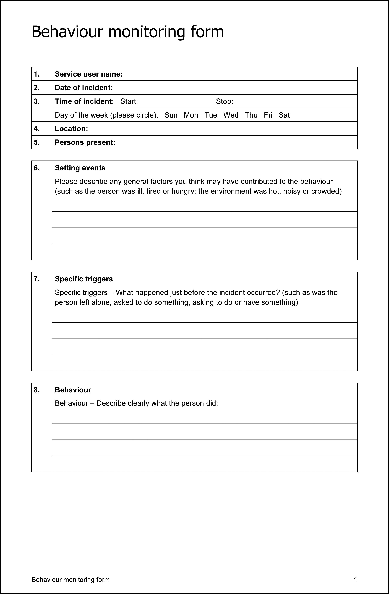

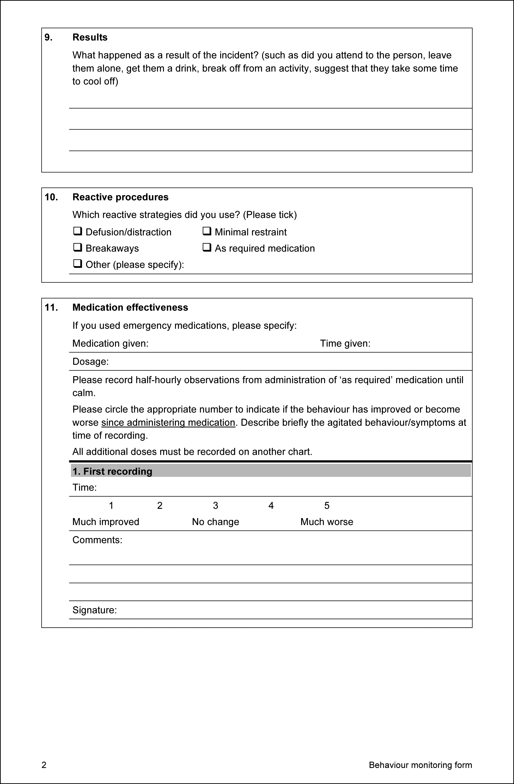

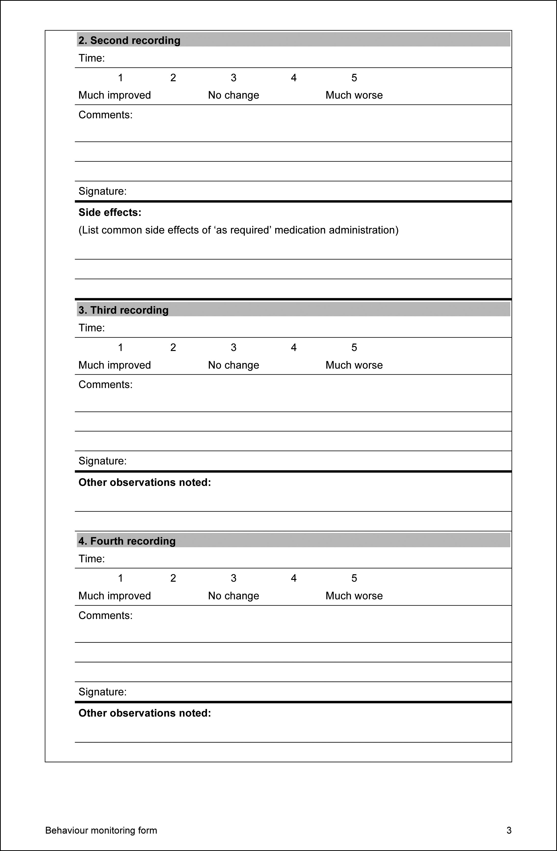

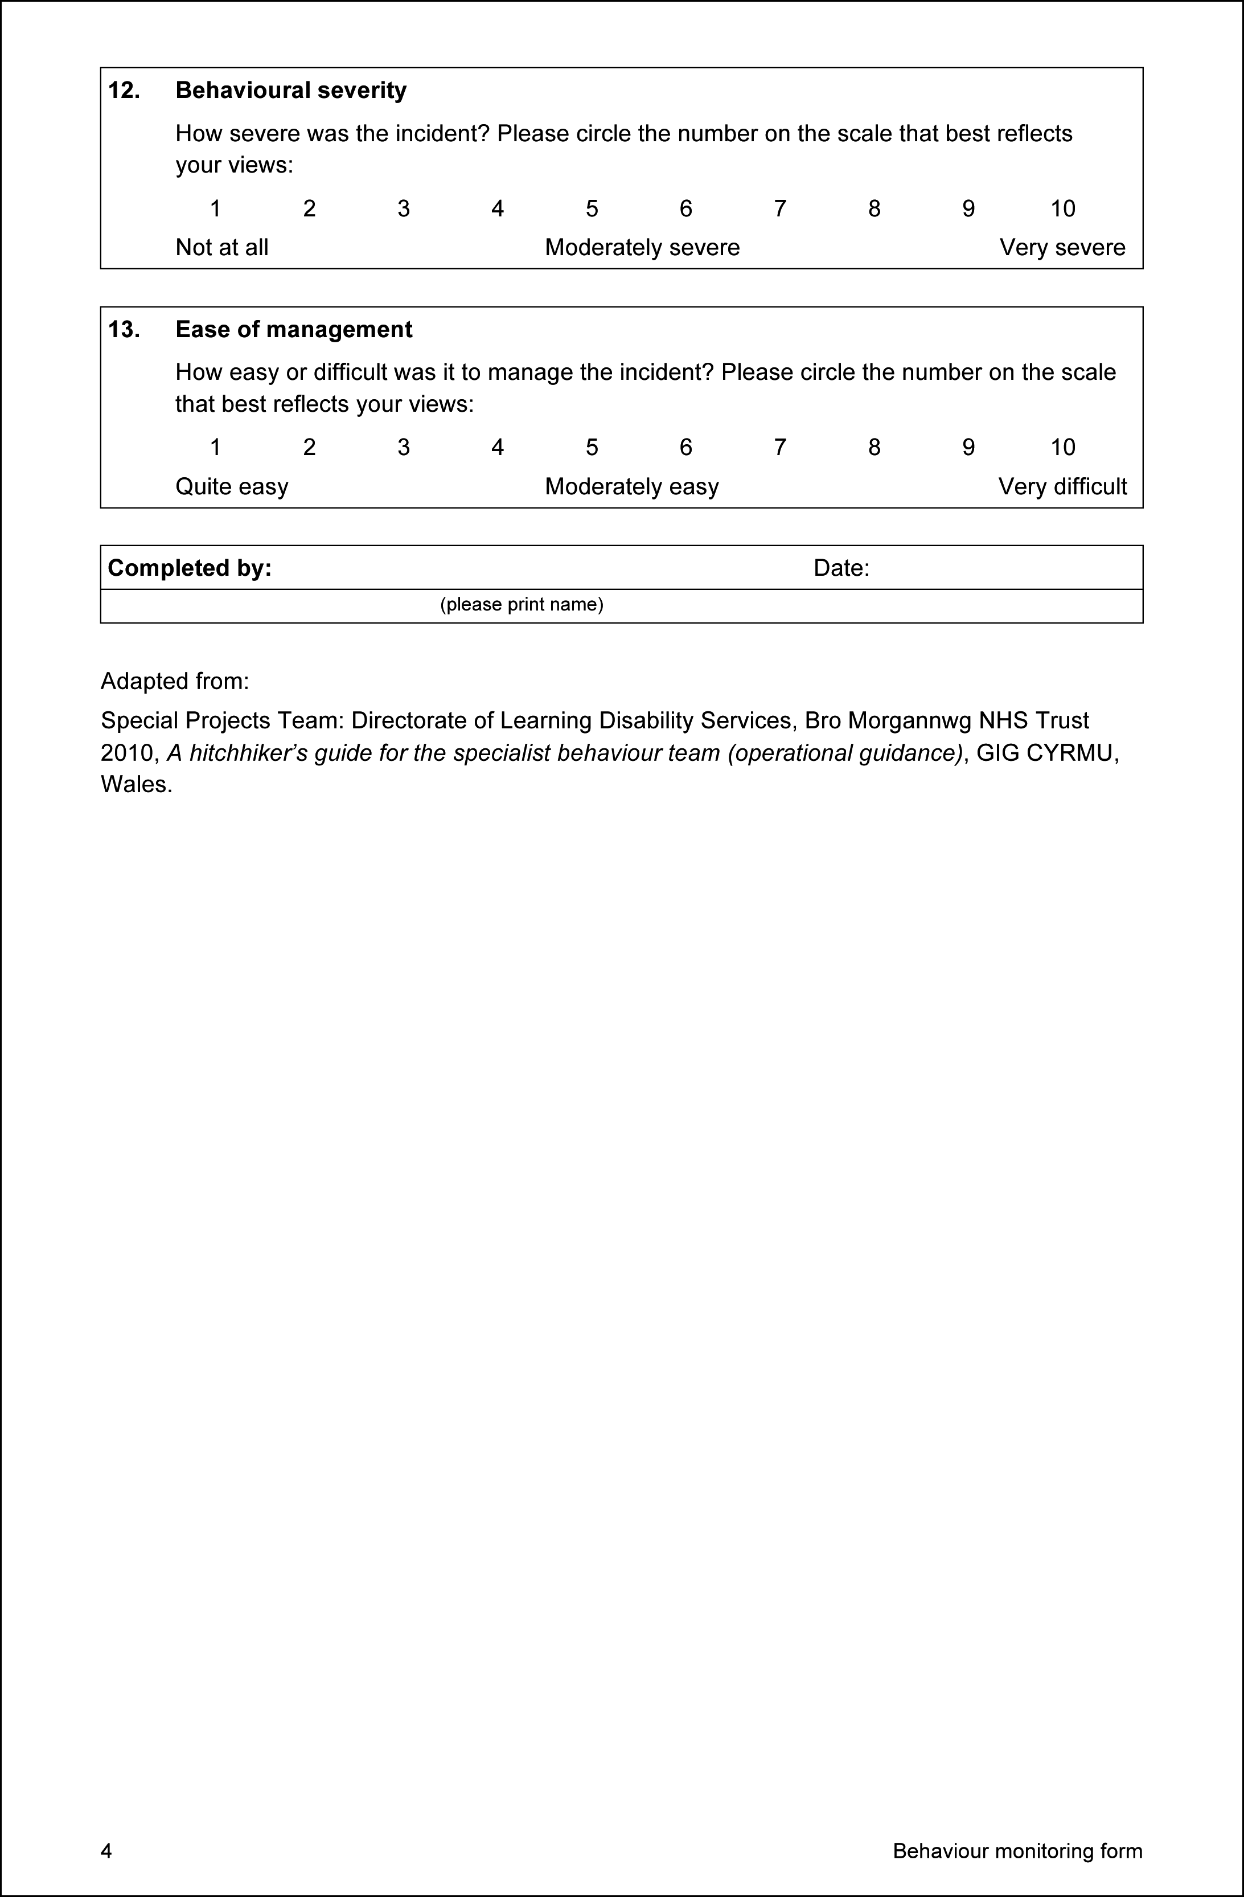

Momentary time sampling (MTS)

Purpose: May be used for behaviour that occurs at high rates and involves continuous observation over a specified length of time (such as 20 minutes). MTS requires that target behaviours are decided prior to beginning observation and assigned codes. The target behaviours are then entered into an observation grid and observations are made at regular intervals (such as every 20 seconds) throughout the observation period. With MTS, observation should continue regardless of whether or not the behaviour actually occurs. If the behaviour occurs at the precise point that the designated interval (such as 20, 40 or 60 seconds) occurs, the code is entered in the appropriate grid; no code is entered if the behaviour occurs outside of the time-designated interval.

Special Projects Team: Directorate of Learning Disability Services, Bro Morgannwg NHS Trust 2010, A hitchhiker’s guide for the specialist behaviour team (operational guidance), GIG CYRMU, Wales.

Return to Section 14.3

1. Mediator analysis

Behavioural interventions will usually be carried out by a person’s usual carers (‘mediators’) rather than by external ‘experts’ and are likely to be more effective when implemented in this way. A critical part of behavioural assessment involves assessing the strengths and needs of mediators, as this will, in turn, affect the success of the intervention. Designing complex intervention plans that are beyond the skills or resources of mediators will fail.

The following questions are helpful starting points in conducting a mediator analysis:

* Who will be implementing the plan?
* How many people will be involved?
* What are their characteristic strengths?
* How are they managed/organised/supervised?
* Have they been involved in the functional analysis?
* What previous training in behavioural approaches (proactive and reactive) have they had?
* What are their current beliefs about why the person engages in the behaviour of concern?
* What are their general attitudes towards the person?
* How motivated are they in relation to the intervention?
* Are there any particular people who will be crucial to the intervention’s success?
* Do they have experience of behavioural recording?
* What emotional supports are available to them?
* What key constraints (such as time, environment or sickness) may affect the intervention?
* What critical routines exist in the setting and must be maintained throughout the intervention process (set routines and activities around which the intervention must be able to accommodate)?

It is useful to try to summarise the results of a mediator analysis into strengths and needs. System strengths can be capitalised on in terms of introducing a behavioural intervention, whereas any identified needs should be highlighted in an action plan that would need to be implemented prior to introducing the intervention if its impact is to be maximised. The key objective here is to achieve the best possible contextual fit between the positive behaviour support plan and the environment in which it is designed to operate. This can be done using a goodness of fit assessment (see Appendix D in the resource listed below: Goodness of Fit Survey).

Adapted from:

Special Projects Team: Directorate of Learning Disability Services, Bro Morgannwg NHS Trust 2010, A hitchhiker’s guide for the specialist behaviour team (operational guidance), GIG CYRMU, Wales.

Return to Section 14.5

Goodness of fit

It is important to achieve a goodness of fit between the contents of an intervention plan and the characteristics of the settings and the mediators. The Goodness of Fit Survey has been adapted for use in staffed settings. The survey tool should first be completed by individual staff members when the positive behaviour support plan is first finalised; it should then be completed at regular intervals or at any point that major revisions are made. Any areas where there is poor goodness of fit need to be considered and addressed. If there is a general consensus that the fit is poor, then it is likely that the positive behaviour support plan will need to be adjusted or aspects of the environment changed. However, if only one or two people report a poor goodness of fit, then it is possible that additional training or workplace support may be required for those individuals.

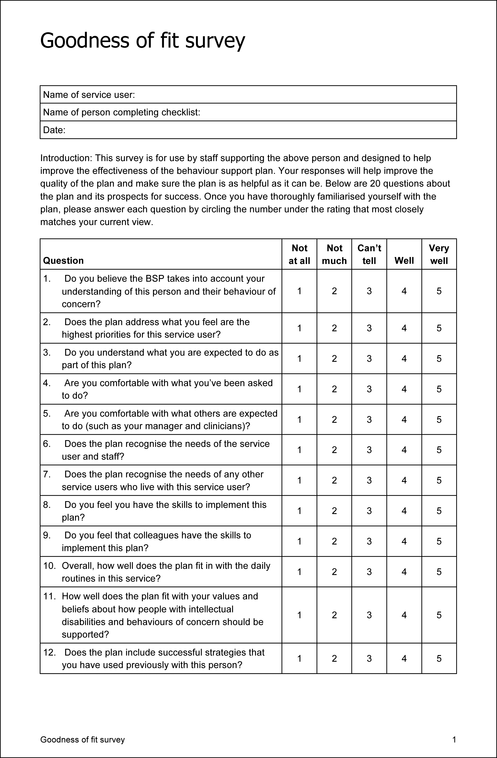

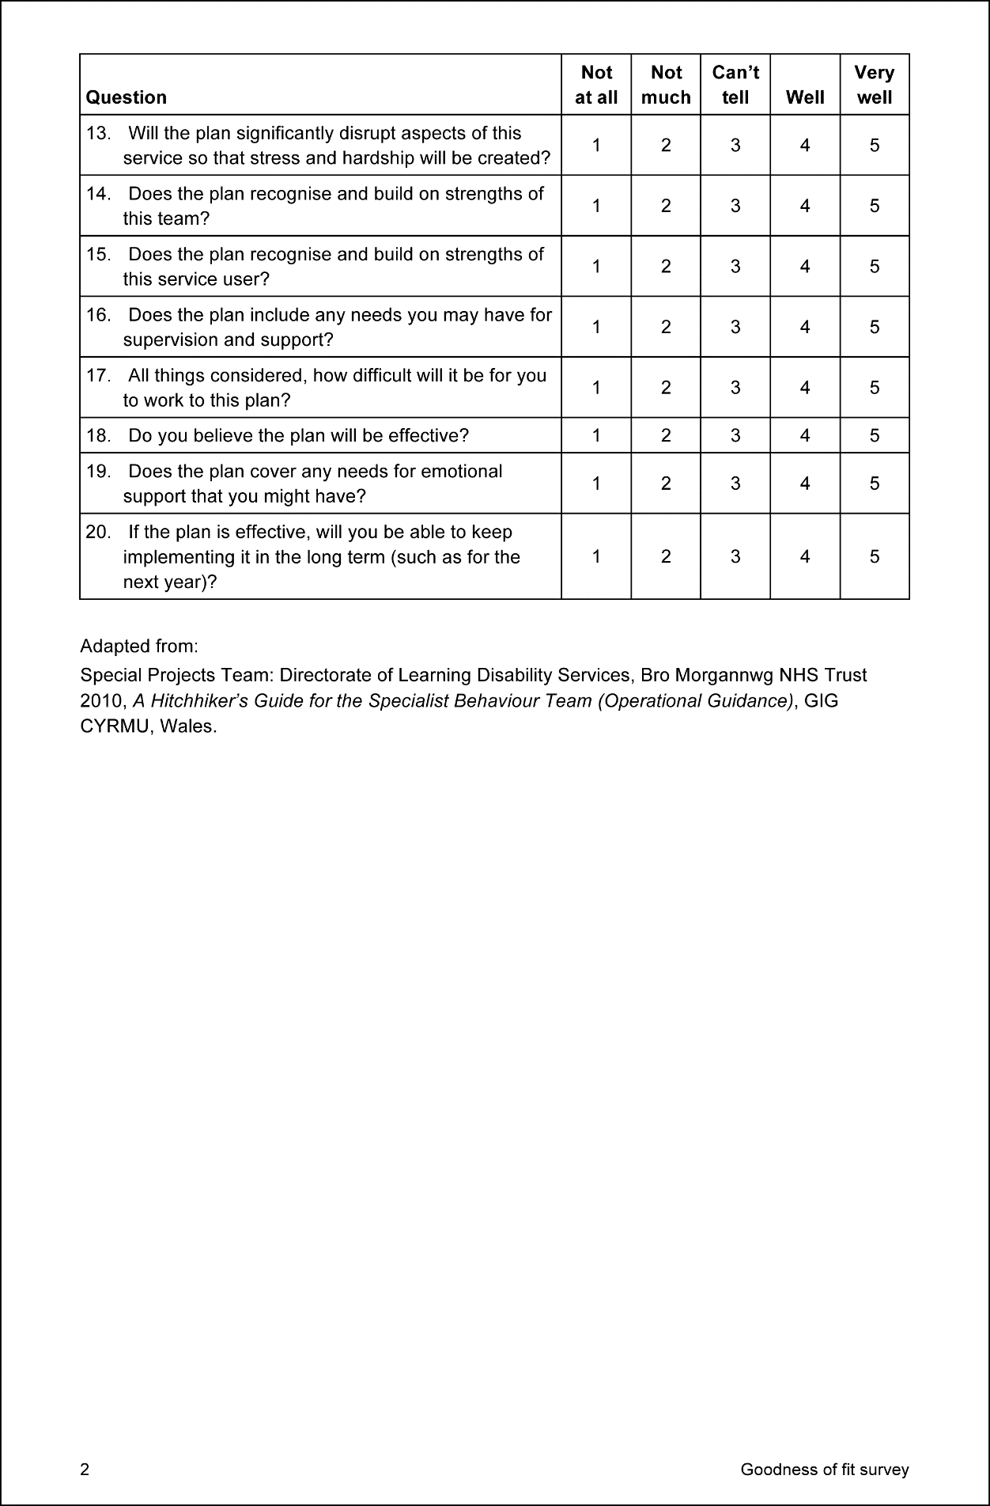

Return to Section 14.5

1. Standards for a positive behaviour support plan

Minimum standards

Minimum standards for a positive behaviour support plan (Budiselik et al. 2010, Appendix B, p. 43):

* Plans should be formulated in plain language and any technical terms should be explained in lay terms.
* The identified behaviour(s) should be operationally defined and the topography should be detailed (form, intensity, frequency and duration).
* The hypothesised function(s) of each behaviour, based on a documented functional assessment, should be outlined.
* Predictors and setting events should be described in detail (for example, places, activities, people and personal circumstances such as health status or social incidents), together with strategies to minimise their occurrence or diffuse their impact.
* The person’s preferred circumstances and needs should be outlined (provide details of the circumstances under which the behaviour is known not to occur because the person’s needs are met and they are happy).
* Environmental (social, physical, organisational and procedural) strategies should be detailed. These should include strategies to explicitly enhance the person’s quality of life and wellbeing.
* Educational strategies should be described, together with details of associated reward and reinforcement programs designed to enhance the development of alternative, more adaptive behaviours.
* The goals of the behaviour support plan should be outlined, as should the review/evaluation timeline and procedures (including data collection processes and timelines). Details of the circumstances under which the review process might be brought forward should also be included.
* Communication strategies should be detailed, providing a clear explanation of the person’s receptive and expressive communication skills and the strategies (including any augmentative or alternative communication techniques, aids or devices) that those who provide support should be using.
* Crisis management procedures (Carr et al. 1994) should be specified.
* The educational and other support needs of those expected to implement the plan should be outlined.
* Team coordination, communication and responsibility protocols should be detailed and include contact options for short-term consultations and clarification of the plan.
* Any legal requirements, such as details of the consent process and the necessity for guardianship, or others’ approvals for particular procedures, should be documented.

Resources

Budiselik M, Davies M, Geba E, Hagiliassis N, Hudson A, McVilly K, Meyer K, Tucker M, Webber L, Lovelock H, Mathews R, Forsyth C, Gold R 2010, Evidence-based psychological interventions that reduce the need for restrictive practices in the disability sector: a practice guide for psychologists, Australian Psychological Society, Melbourne.

Carr EG, Levin L, McConnachie G, Carlson JI, Kemp DC, Smith CC 1994, Communication-based intervention for problem behaviour: a user’s guide for producing positive change, Paul H Brookes Publishing Company, Baltimore.

Webber LS, McVilly K, Fester T, Zazelis T 2011, ‘Assessing behaviour support plans for Australian adults with intellectual disability using the ‘Behavior Support Plan Quality Evaluation II’ (BSP-QE II)’, Journal of Intellectual and Developmental Disabilit*y*, 36, 1–5.

Return to Section 15.1

1. Contextual fit

Contextual fit attends to:

* the values and goals of the team
* the current and desired routines within various settings
* the skills and buy-in of the people delivering the plan
* administrative support.

Anderson J, Brown F, Scheurmann B 2007, [APBS standards of practice: individual level](http://apbs.org/standards-of-practice.html), see <http://apbs.org/standards-of-practice.html>.

Return to Section 15.1

1. Goal setting

Behaviour change occurs through building self-efficacy and mastery of new skills, which requires the following.

* Goals are clear plans of action – expressed as behaviours the person/carer/staff intend to do, not wishful thinking or good intentions or desirable outcomes.
* Goals are realistically challenging – not too hard and not too easy.
* Goals incorporate the person’s interests – the goal is genuinely interesting.
* Goals conform to the person’s values – consider diverse cultures and beliefs.
* Goals have verifiable outcomes – the person can see the goals that are being achieved.
* Goals depend on the person’s own efforts – only set what is under the person’s control.
* Goals should be achieved reasonably soon – closer goals (or sub-goals) are stronger motivators than distant goals.
* Goals are set with the person – goal setting is the beginning of successful behaviour change and must respect the autonomy of the person.

Montgomery B 2010, [The keys to successful behaviour change](http://www.psychology.org.au/publications/inpsych/behaviour), InPsych, see <http://www.psychology.org.au/publications/inpsych/behaviour>.

Return to Section 15.1

1. Quality of life

Improving quality of life requires attention to:

* achieve the person’s dreams
* meet health and physiological needs
* promote all aspects of self-determination
* improve active, successful participation in inclusive school, work, home and community settings
* promote social interactions, relationships and enhanced social networks
* increase fun and success in life
* improve leisure, relaxation and recreational activities throughout the day.

Anderson J, Brown F, Scheurmann B 2007, [APBS standards of practice: individual level](http://apbs.org/standards-of-practice.html), see <http://apbs.org/standards-of-practice.html><http://apbs.org/standards-of-practice.html>.

Return to Section 15.2

1. Is relying on environmental strategies alone adequate?

A meta-analysis of 142 articles regarding 316 individuals under the age of 21 years, published between 1988 and 2006, found that no studies used systems change as the sole intervention, most likely reflecting clinical perspectives that systems change is a context for intervention rather than an intervention itself.

Harvey ST, Boer D, Meyer LH, Evans IM 2009, ‘Updating a meta-analysis of intervention research with challenging behaviour: treatment validity and standards of practice’, Journal of Intellectual and Developmental Disability, 34, 67–80.

Return to Section 15.2.1

1. Sensory environments

Sensory environments are described by the Victorian Senior Practitioner – Disability at:

Office of the Senior Practitioner 2012, Positive solutions in practice: using sensory focused activities to help reduce restraint and seclusion, Victorian Government Department of Human Services, Melbourne, see <http://www.dhs.vic.gov.au/__data/assets/pdf_file/0010/846136/Positive-solutions-in-practice-using-sensory-focused-activities-senior-practitioner-0913.pdf>.

Autism-friendly environment

[Tips for an autism-friendly environment](http://www.autism.org.uk/professionals/others/architects/autism-friendly-design.aspx) have been published by the UK National Autistic Society at <http://www.autism.org.uk/professionals/others/architects/autism-friendly-design.aspx>.

Hayward B, Saunders K 2010, Designing environments for autism spectrum disorders: an introduction to the available evidence, poster presented at the 45th ASSID Australasian Conference, Brisbane, Queensland, 29 September – 1 October 2010 (a copy can be provided upon request).

Clements J, Zarkowski E 2000, Behavioural concerns and autism spectrum disorder: explanations and strategies for change, Jessica Kingsley Publishers, London.

Return to Section 15.2.1

1. Active support

Active support applies systematic techniques to provide support for engagement in meaningful daily activity utilising structured staff education, staff coaching and organisational policy and procedure. This approach results in new skills, improved mental health and positive changes in behaviour. Active support is effective for behaviour that is self-injurious, stereotypical or severely withdrawn.

Budiselik M, Davies M, Geba E, Hagiliassis N, Hudson A, McVilly K, Meyer K, Tucker M, Webber L, Lovelock H, Mathews R, Forsyth C, Gold R 2010, Evidence-based psychological interventions that reduce the need for restrictive practices in the disability sector: a practice guide for psychologists, Australian Psychological Society, Melbourne.

Clement T, Bigby C 2008, Implementing person-centred active support in a group home for people with profound intellectual disabilities: issues for house supervisors and their managers, State Government of Victoria, Melbourne.

Jones E, Felce D, Lowe K, Bowley C, Pagler J, Strong G, Gallagher B, Kurowska K 2001, ‘Evaluation of the dissemination of active support training and training trainers’, Journal of Applied Research in Intellectual Disabilities, 14, 79–99.

Mansell J, Elliot T, Beadle-Brown J, Ashman B, MacDonald S 2002, ‘Engagement in meaningful activity and “active support” of people with intellectual disabilities in residential care’, Research in Developmental Disabilities, 23, 342–352.

Return to Section 15.2.1 | Return to Section 15.2.2

1. Is skills building effective and ethical?

A meta-analysis of 142 articles regarding 316 individuals under the age of 21 years, published between 1988 and 2006, found that skills building resulted in consistently higher effect sizes and may be more effective when combined with antecedent and system change approaches.

Harvey ST, Boer D, Meyer LH, Evans IM 2009, ‘Updating a meta-analysis of intervention research with challenging behaviour: treatment validity and standards of practice’, Journal of Intellectual and Developmental Disability, 34, 67–80.

Return to Section 15.2.2

1. Are cognitive-behavioural strategies an effective and ethical approach?

The Royal College of Psychiatrists indicated in 2004 that cognitive-behavioural interventions had promising, albeit limited, effectiveness. The Australian Psychological Society suggests adapted cognitive-behavioural strategies in Appendix C of:

Budiselik M, Davies M, Geba E, Hagiliassis N, Hudson A, McVilly K, Meyer K, Tucker M, Webber L, Lovelock H, Mathews R, Forsyth C, Gold R 2010, Evidence-based psychological interventions that reduce the need for restrictive practices in the disability sector: a practice guide for psychologists, Australian Psychological Society, Melbourne.

In managing behaviours of concern, cognitive-behavioural treatment may broaden the choice of available therapies but does little to improve the overall outcome. However, cognitive-behavioural interventions may be more appropriate for deterring offending such as sex offending and addressing emotional problems and have been shown to be effective for depression.

McGillvray JA, McCabe MP, Kershaw MM 2008, ‘Depression in people with intellectual disability: an evaluation of a staff-administered treatment program’, Research in Developmental Disabilities, 29, 524–536.

Willner P 2005, ‘The effectiveness of psychotherapeutic interventions for people with learning disabilities: a critical overview’, Journal of Intellectual Disability Research, 49 (Part I), 73–85.

As a cautionary note, a review of 80 articles published between 1980 and 2005 about children and some adults with intellectual disability found that behavioural interventions were more effective than cognitive-behavioural interventions such as anger management.

Didden R, Korzilius H, van Oorsouw W, Sturmey P 2006, ‘Behavioural treatment of challenging behaviours in individuals with mild mental retardation: meta-analysis of single-subject research’, American Journal on Mental Retardation, 111, 290–298.

Return to Section 15.2.2 (1st link) | Return to Section 15.2.2 (2nd link)

1. Teach skills resources

Teaching functional skills to people with severe disabilities involves identifying activities that:

* someone else would otherwise have to do for the person
* the person is more likely to perform
* a person can perform as paid employment
* provides a person something wanted or allows a person to avoid something unwanted without behaviours of concern.

Resources

Reid DH, Parsons MB 2002, Working with staff to overcome challenging behaviour among people who have severe disabilities: A guide for getting support plans carried out: Volume I: Behaviour analysis applications in developmental disabilities series, Habilitative Management Consultants, Inc., Morganton, NC.

Webber LS, McVilly K, Fester T, Zazelis T 2011, ‘Assessing behaviour support plans for Australian adults with intellectual disability using the ‘Behavior Support Plan Quality Evaluation II’ (BSP-QE II)’, Journal of Intellectual and Developmental Disability, 36, 1–5 (a copy can be provided upon request).

Oorsouw W, Embregts P, Bosman A, Jahoda A 2010, ‘**Training staff to manage challenging behaviour’,** Journal of Applied Research in Intellectual Disabilities, 23(2), 192–196.

Windley D, Chapman, M 2010, ‘Support workers within learning/intellectual disability services: perception of their role, training and support needs’, British Journal of Learning Disabilities, 38(4), 310–318.

Crickmore D 2009, ‘Education and training for learning disability practice: key messages from contemporary literature’, Journal of Intellectual Disabilities, 13(4), 291–304.

Woodward P, Halls S 2009, ‘Staff training in the mental health needs of people with learning disabilities in the UK’, Advances in Mental Health and Learning Disability, 3(2),15–19.

Return to Section 15.2.2

1. Social skills resources

Intensive interaction

Intensive interaction is effective for people with severe to profound intellectual, physical or sensory disability and may be effective for people with autism spectrum disorder. It teaches fundamental skills for social interaction and communication through: (1) the creation of mutual pleasure and interactive games; (2) staff adjustment of their personal behaviours in order to become more engaging and meaningful for the person; (3) interactions flowing in time with pauses, repetitions and blended rhythms; (4) the use of intentionality – responding to the person’s behaviours as if they were initiations with communicative significance; and (5) the use of contingent responding: following the person’s lead and sharing control of the activity.

Budiselik, M, Davies, M, Geba, E, Hagiliassis, N, Hudson, A, McVilly, K, Meyer, K, Tucker, M, Webber, L, Lovelock, H, Mathews, R, Forsyth, C and Gold, R 2010, Evidence-based psychological interventions that reduce the need for restrictive practices in the disability sector: a practice guide for psychologists, Australian Psychological Society, Melbourne.

Return to Section 15.2.2

1. Speech and communication resources

Functional communication training

This is a positive behaviour support intervention designed to reduce behaviours of concern by replacing them with meaningful or functional communication using words, gestures or alternative communication systems (such as the Picture Exchange Communication System).

[Image Search – Picture Exchange Communication System](https://images.search.yahoo.com/search/images;_ylt=AwrBT_3762VZktAAh3FXNyoA;_ylu=X3oDMTByMjB0aG5zBGNvbG8DYmYxBHBvcwMxBHZ0aWQDBHNlYwNzYw--?p=exchange+communication+system&fr=aaplw) <https://images.search.yahoo.com/search/images;_ylt=AwrBT_3762VZktAAh3FXNyoA;_ylu=X3oDMTByMjB0aG5zBGNvbG8DYmYxBHBvcwMxBHZ0aWQDBHNlYwNzYw--?p=exchange+communication+system&fr=aaplw>

Functional communication training for children – [Centre on the Social and Emotional Foundations for Early Learning website](http://csefel.vanderbilt.edu) <http://csefel.vanderbilt.edu>

Functional communication training for children with autism spectrum disorder:

[Functional Communication Training page on the Association for Science in Autism Treatment website](https://www.asatonline.org/for-parents/learn-more-about-specific-treatments/applied-behavior-analysis-aba/aba-techniques/functional-communication-training-fct) <https://www.asatonline.org/for-parents/learn-more-about-specific-treatments/applied-behavior-analysis-aba/aba-techniques/functional-communication-training-fct>

Durand VM 2002, Severe behaviour problems: a functional communication training approach (Treatment manual for practitioners), Guilford Press, New York.

Durand VM, Moskowitz L 2016, ‘Functional communication training: thirty years of treating challenging behaviour’, *Topics in Early Childhood Special Education, 35*(2), 116–126.

Neitzel J 2010, ‘Positive behaviour supports for children and youth with autism spectrum disorder’, Preventing School Failure, 54(4), 247–255.

SCOPE Communication Resource Centre

This is part of the Communication Access Network in Victoria for people with complex communication needs (such as Children’s Aided Language Tools, COMPIC pictographs).

[Information and Resources Hub on the SCOPE website](https://www.scopeaust.org.au/information-resources-hub) <https://www.scopeaust.org.au/information-resources-hub>

Return to Section 15.2.2

1. Attachment and trauma resources

Clients with cognitive impairments are at significantly greater risk of abuse and neglect than the general population (Marcal & Trifoso 2017). Trauma histories result in behaviours of concern because the person may be unaware of their stress responses or sensory needs, which can lead to inappropriate self-soothing (Chandler 2008). In trauma-informed care, education and skills training based on client strengths are used as the building blocks for change, usually through cognitive behavioural treatment and dialectical behavioural skills training. The aim is to have clients feel less vulnerable and more in control, leading to less use of restraint and seclusion (Chandler 2008). Trauma-informed systems emphasise individual choice through empowerment models that are collaborative, strengths-based and culturally-sensitive, and aim to minimise re-traumatisation (Chandler 2008). An example of a combined positive behaviour support and trauma-informed care approach utilises calming the limbic system and enhancing positive rewarding relational experiences to create new experiences and decrease trauma-related associations over time (Raftl, Rudman & Roberts 2017).

The Senior Practitioner – Disability provides general information on attachment and trauma in individuals with intellectual disability to ensure awareness.

Attachment and trauma in people with an intellectual disability <http://www.dhs.vic.gov.au/about-the-department/documents-and-resources/reports-publications/attachment-and-trauma-in-people-with-an-intellectual-disability>

Attachment and trauma resources

Office of the Senior Practitioner 2008, Positive solutions in practice: attachment and trauma in people with intellectual disability, Victorian Government Department of Human Services, Melbourne.

Other resources

Chandler G 2008, ‘From traditional inpatient to trauma-informed treatment: transferring control from staff to patient’ *Journal of the American Psychiatric Nurses Association, 14,* 363-371.

Clegg J, Sheard C 2002, ‘Challenging behaviour and insecure attachment’, Journal of Intellectual Disability Research, 46(6),503–506.

Doyle C, Mitchell D 2003, ‘Post-traumatic stress disorder and people with learning disabilities’, Journal of Learning Disabilities, 7, 23–33.

Hollins S, Sinason V 2000, ‘Psychotherapy, learning disabilities and trauma: new perspectives’, British Journal of Psychiatry, 176, 32–36.

Hudson CJ, Pilek E 1990, ‘PTSD in the retarded’, Hospital and Community Psychiatry, 41, 97.

Janssen CGC, Schuengel C, Stolk J 2002, ‘Understanding challenging behaviour in people with severe and profound intellectual disability: a stress-attachment model’, Journal of Intellectual Disability Research, 46(6), 445–453.

Johnson D 2001, ‘Trauma, dissociation and learning disability’, Clinical Psychology Forum, 147, 18–21.

Marcal S, Trifoso S 2017, [*A trauma-informed toolkit for providers in the field of intellectual disabilities & developmental disabilities*](http://www.acesconnection.com/fileSendAction/fcType/0/fcOid/468137553002812476/filePointer/468137553002812517/fodoid/468137553002812512/IDD%20TOOLKIT%20%20CFDS%20HEARTS%20NETWORK%205-28%20FinalR2.pdf)*,* Centre for Disability Services, New York, viewed 23 November 2017 <http://www.acesconnection.com/fileSendAction/fcType/0/fcOid/468137553002812476/filePointer/468137553002812517/fodoid/468137553002812512/IDD%20TOOLKIT%20%20CFDS%20HEARTS%20NETWORK%205-28%20FinalR2.pdf>.

McCarthy J 2001, ‘Post-traumatic stress disorder in people with learning disability’, Advances in Psychiatric Treatment, 7, 163–169.

Mitchell A, Clegg J, Furniss F 2006, ‘Exploring the meaning of trauma with adults with intellectual disabilities’, Journal of Applied Research in Intellectual Disabilities, 19, 131–142.

Newman E, Christopher SR, Berry JO 2000, ‘Developmental disabilities, trauma exposure and post-traumatic stress disorder’, Trauma, Violence and Abuse, 1, 154–170.

Raftl GC, Rudman ER, Roberts N 2017, Integration of a neuro-developmental, attachment and trauma-informed (NATI) approach and positive behaviour support: towards a framework for trauma-informed positive behaviour support (TIPBS), SAL Consulting.

Rutgers AH, Bakermans-Kranenburg MJ, Van IJzendoorn MH, Berckelaer-Onnes IA 2004, ‘Autism and attachment: a meta-analytic review’, Journal of Child Psychology and Psychiatry, 45, 1123–1134.

Sterkenburg PS, Janssen CGC, Schuengel C 2008, ‘The effect of an attachment-based behaviour therapy for children with visual and severe intellectual disabilities’, Journal of Applied Research in Intellectual Disabilities, 21, 126–135.

Return to Section 15.2.2

1. Behavioural and family systems interventions

Four stages of intervention are presented to integrate contemporary behavioural and systemic orientations to facilitate action in families to address behaviours of concern:

1. standard behavioural assessment
2. mediator analysis (family assessment)
3. family therapy (if required)
4. behavioural intervention.

Rhodes, P 2003, ‘Behavioural and family systems interventions in developmental disability: towards a contemporary and integrative approach’, Journal of Intellectual & Developmental Disability, 28(1), 51–64.

For preschoolers, the Stepping Stones Triple P is an adapted version of the Triple P Positive Parenting Program, combining behavioural family intervention and parent management training. Stepping Stones Triple 3 has been found in a randomised clinical trial to have fewer child behaviour problems reported by mothers and independent observers, improved maternal and paternal parenting style and decreased maternal stress at six-month follow-up.

Roberts C, Mazzucchelli T, Studman L, Sander MR 2006, ‘Behavioural family intervention for children with developmental disabilities and behavioural problems’, Journal of Clinical Child and Adolescent Psychology, 35(2), 180–193.

Sanders MR, Markie-Dadds C, Turner KMT 1998, Practitioner’s manual for enhanced Triple P, Families International, Brisbane.

Sanders MR, Mazzucchelli TG, Studman LJ 2003, Practitioner’s manual for standard Stepping Stones Triple P, Triple P International, Brisbane.

Sanders MR, Mazzucchelli TG, Studman LJ 2003, *Stepping Stones Triple P family workbook*, Triple P International, Brisbane.

Sanders MR, Mazzucchelli TG, Studman LJ 2004, ‘Stepping Stones Triple P: the theoretical basis and development of an evidenced-based positive parenting program for families with a child who has a disability’, Journal of Intellectual and Developmental Disability, 29, 265–285.

Return to Section 15.2.2

1. Social stories resources

Chan JM, O’Reilly MF, Lang RB, Boutot EM, White PJ, Pierce N, Baker S 2010, ‘Evaluation of a Social Stories™ intervention implemented by pre-service teachers for students with autism in general education settings’, Research in Autism Spectrum Disorders, 20.

Kalyva E, Agalioti I 2009, ‘Can social stories enhance the interpersonal conﬂict resolution skills of children with LD?’ Research in Developmental Disabilities, 30, 192–20.

Kokina A, Kern L 2010, ‘Social Story™ interventions for students with autism spectrum disorders: a meta-analysis’, Journal of Autism and Developmental Disorders, 40(7), 812–826.

O’Connor E 2009, ‘The use of Social Story DVDs to reduce anxiety levels: a case study of a child with autism and learning disabilities’, Support for Learning, 24(3), 133–136.

Tarnai B, Wolfe PS 2008, ‘Social stories for sexuality education for persons with autism / pervasive developmental disorder’, Sexuality and Disability, 26(1), 29–36.

Return to Section 15.2.2

1. Mindfulness techniques

The Senior Practitioner – Disability provides information in mindfulness as an alternative to restrictive practices.

Positive solutions in practice <http://www.dhs.vic.gov.au/about-the-department/documents-and-resources/reports-publications/positive-solutions-in-practice,-guides-and-advice>

Resources

Budiselik M, Davies M, Geba E, Hagiliassis N, Hudson A, McVilly K, Meyer K, Tucker M, Webber L, Lovelock H, Mathews R, Forsyth C, Gold R 2010, Evidence-based psychological interventions that reduce the need for restrictive practices in the disability sector: a practice guide for psychologists, Australian Psychological Society, Melbourne.

Office of the Senior Practitioner 2007, Positive solutions in practice: Mindfulness: Issue No. 1, Victorian Government Department of Human Services, Melbourne.

Singh NN, Lancioni GE, Winton ASW, Adkins AD, Singh J, Singh AN 2007, ‘Mindfulness training assists individuals with moderate mental retardation to maintain their community placements’, Behavior Modification, 31(6), 800–814.

Return to Section 15.2.2

1. Punishment

Punishment-based strategies such as response cost (such as removal of possessions or limiting rights as a consequence to specific behaviours), exclusory time-out/seclusion and overcorrection are ineffective, inconsistent with contemporary clinical practice and may be inconsistent with what is legally permitted. Therefore the Australian Psychological Society does not recommend punishment-based strategies.

Resources

Budiselik M, Davies M, Geba E, Hagiliassis N, Hudson A, McVilly K, Meyer K, Tucker M, Webber L, Lovelock H, Mathews R, Forsyth C, Gold R 2010, Evidence-based psychological interventions that reduce the need for restrictive practices in the disability sector: A practice guide for psychologists, Australian Psychological Society, Melbourne.

Sanson A, Montgomery B, Gault U, Gridley H, Thomson D 1995, Punishment & behaviour change: An APS position paper, Australian Psychological Society, Melbourne.

Return to Section 15.2.3

1. Reinforcement schedule resources

Altering contingency arrangements to ensure the environment provides maintaining consequences for appropriate behaviours are followed by maintaining consequences to build or strengthen (through reinforcement contingencies) appropriate skills for the person so they can live a life of their choosing (Grey et al. 2016).

Based on information regarding antecedents and consequences of behaviour derived from the functional assessment, there are three methods of functional treatment (Miltenberger et al. 2016):

1. Extinction – withholding the reinforcer that previously maintained a response and so weakening the contingency between the behaviour and reinforcer until the behaviour ceases.
2. Functional reinforcement – deliver a reinforcer after an alternative behaviour, or the absence of the behaviours of concern, while withholding the reinforcer for the behaviours of concern. The desired behaviour should increase and replace the behaviours of concern. An example of how teachers can apply behavioural logs using tokens, behavioural report cards and Check In/Check Out is provided by Krach, McKreery, Wilcox and Focaracci (2017), and the same strategies could be applied by parents.
3. Antecedent manipulations – manipulate antecedent events that that evoke the behaviours of concern or to increase the effort for behaviours of concern (or rather, if they occur naturally in the environment).

Reinforcement inventory for adults

Willis TJ, LaVigna GW, Donnellan AM 1993, Behaviour assessment guide, Institute of Applied Behaviour Analysis, Los Angeles, CA.

Anderson J, Brown F, Scheurmann B 2007, [APBS standards of practice: individual level](http://apbs.org/standards-of-practice.html), see <http://apbs.org/standards-of-practice.html>.

Return to Section 15.2.3

1. Counterintuitive strategies

Apply strategies that are counter to control and dominance of behaviour to avoid situations that would otherwise lead to restrictive practices.

* Provide high-density non-contingent reinforcement – maintain a routine and enjoyable activities as long as they are not contingent on the behaviour of concern (that is, it does not give rise to an event) and there is a short time delay between the behaviour and the preferred event.
* Avoid using natural consequences if the person is less likely to learn because the consequence in itself can become the setting or trigger for further behaviours of concern.
* Do not ignore behaviours of concern unless it is certain that the only function is to gain attention; behaviours generally have numerous functions.
* Remove punishments because aversive situations act as setting events to further escalate behaviours of concern; diversion to a more compelling activity or even ‘strategic capitulation’ in providing the person with what they want until a more appropriate time can be found to teach skills.

LaVigna GW, Willis TJ 2009, Counter-intuitive strategies for crisis management within a non-aversive framework. In: D. Allen (ed.), Ethical approaches to physical interventions: responding to challenging behaviour in people with intellectual disabilities, 89–103, BILD Publications Glasgow.

Return to Section 15.2.3

1. Planned immediate responses resources

Hewitt O, Keeling N, Pearce M 2016, ‘Training a family in physical interventions as part of a positive behaviour support intervention for challenging behaviour’, *British Journal of Learning Disabilities, 44*(2), 159–166.

LaVigna GW, Willis TJ 2009, Counter-intuitive strategies for crisis management within a non-aversive framework. In: D Allen (ed.), Ethical approaches to physical interventions: responding to challenging behaviour in people with intellectual disabilities, 89–103, BILD Publications, Glasgow.

Return to Section 15.3.1

1. Occupational health and safety resources

Occupational Health and Safety Act 2004

To view a copy of the [Occupational Health and Safety Act](http://www.austlii.edu.au/au/legis/vic/consol_act/ohasa2004273/) go to <http://www.austlii.edu.au/au/legis/vic/consol_act/ohasa2004273>.

Occupational Violence Risk Assessment and Management Tool (OVRAMT)

The OVRAMT is a tool designed to prevent occupational violence caused by residents. It identifies triggers and causes of occupational violence and solutions to eliminate or control risks. Further information on OVRAMT can be located at Part 3 of <http://www.dhs.vic.gov.au/about-the-department/documents-and-resources/reports-publications/residential-services-practice-manual>.

Residential services practice manual

To view a copy of the Residential services practice manual go to <https://das.dhhs.vic.gov.au/residential-services-practice-manual>.

Return to Section 15.4

1. System constraints to implementation

Numerous explanations can be offered:

* Settings do not have the necessary resources.
* Plans are not implemented as designed by carers and staff.
* Preparation is insufficient for carers and staff.
* Supervision and clinical support for carers and staff is lacking.

Reid DH, Parsons MB 2002, Working with staff to overcome challenging behaviour among people who have severe disabilities: a guide for getting support plans carried out: Volume I: Behaviour analysis applications in developmental disabilities series, Habilitative Management Consultants, Inc., Morganton, NC.

Return to Section 16

1. Constructive systems change

Constructive system change to sustain evidence-based procedures among staff and carers includes:

* vision – a common set of goals that consider cultural and personal values
* skills – knowledge and expertise by all supports to solve real-life problems
* incentives – responsive to social and emotional needs and motivation in staff and carers
* resources – time, money and material necessities are feasible
* action plans – defined roles and responsibilities.

Carr EG 2007, ‘The expanding vision of Positive Behaviour Support: research perspectives on happiness, helpfulness, hopefulness’, Journal of Positive Behavior Interventions, 9(1), 3–14.

Additional resources

Carr EG, Dunlap G, Horner RH, Koegel RL, Turnbull AP, Sailor W, Anderson JL, Albin RW, Koegel LK, Fox L 2002, ‘Positive behaviour support: evolution of an applied science’, Journal of Positive Behavior Interventions, 4(1), 4–16.

Mansell J 2007, Services for people with learning disabilities and challenging behaviour or mental health needs, The Mansell report (revised), HMSO, Department of Health, London.

Return to Section 16

1. Positive working relationships

The National Development Team for Inclusion (NDTi) developed a how-to guide for disability commissioners to turn evidence-based expectations into practical commissioning actions. The NDTi did so by analysing locations that have made good progress in supporting people with behaviours of concern. The NDTi found that the clearest common factor across all sites making progress was the strength of positive relationships between key players. These relationships helped to encourage, build and then sustain the capacity and capability needed to deliver services. People from different organisations and from different parts of the same organisation demonstrated: respect to one another; trust in particular areas of expertise and responsibility; and a ‘no blame’ culture. Consequently, agreement on how to move forward was achieved.

National Development Team for Inclusion 2007, How-to guide for commissioners of service for people with learning disabilities who challenge services, NDTi, Bath.

[National Development Team for Inclusion website](https://www.ndti.org.uk) <https://www.ndti.org.uk>

Return to Section 16

1. National disability strategy

The *National disability strategy 2010–2020* provides a 10-year national policy framework for improving life for Australians with disability, their families and carers. It represents a commitment by all levels of government, industry and the community to a unified, national approach to policy and program development. This new approach aims to address the challenges faced by people with disability, both now and into the future.

[National Disability Strategy 2010–2020 page on the Australian Government Department of Social Services website](https://www.dss.gov.au/our-responsibilities/disability-and-carers/publications-articles/policy-research/national-disability-strategy-2010-2020) <https://www.dss.gov.au/our-responsibilities/disability-and-carers/publications-articles/policy-research/national-disability-strategy-2010-2020>

Return to Section 16.1

1. Children and adolescents

[Disability Standards for Education 2005 – Australian Government Department of Education and Training website](https://www.education.gov.au/disability-standards-education-2005) <https://www.education.gov.au/disability-standards-education-2005>

[Autism – Helping Children with Autism program – Australian Government Department of Health website](http://www.health.gov.au/internet/main/publishing.nsf/Content/autism-children) <http://www.health.gov.au/internet/main/publishing.nsf/Content/autism-children>

[National plan to reduce violence against women and their children 2010–2022 – Australian Government Department of Social Services website](https://www.dss.gov.au/women/programs-services/reducing-violence/the-national-plan-to-reduce-violence-against-women-and-their-children-2010-2022) <https://www.dss.gov.au/women/programs-services/reducing-violence/the-national-plan-to-reduce-violence-against-women-and-their-children-2010-2022>

Return to Section 16.1.1

1. Aboriginal and Torres Strait Islander people

Council of Australian Governments 2012, [Indigenous reform agreement (closing the gap)](http://www.federalfinancialrelations.gov.au/content/npa/health/_archive/indigenous-reform/national-agreement_sept_12.pdf) <http://www.federalfinancialrelations.gov.au/content/npa/health/_archive/indigenous-reform/national-agreement_sept_12.pdf>

Disability Services 2011, [Enabling choice for Aboriginal people living with disability – promoting access and inclusion](https://dhhs.vic.gov.au/publications/enabling-choice-for-aboriginal-people-living-with-disability) <https://dhhs.vic.gov.au/publications/enabling-choice-for-aboriginal-people-living-with-disability>

Stopher K, D’Antoine H 2008, [Aboriginal people with disability: unique approaches to people with unique needs](http://www.disability.wa.gov.au/Global/Publications/About%20us/Count%20me%20in/Research/aboriginal-people-with-disability.pdf), Disability WA, Perth <http://www.disability.wa.gov.au/Global/Publications/About%20us/  
Count%20me%20in/Research/aboriginal-people-with-disability.pdf>

Return to Section 16.1.2

1. Culturally and linguistically diverse backgrounds

Further information on working with people from culturally and linguistically diverse backgrounds can be found via the DARU website:

[Inclusive consultation and communication with people with a disability [PDF download from the DARU website]](http://www.daru.org.au/wp/wp-content/uploads/2013/05/Inclusive-Consultation-and-Communication-with-People-with-a-Disability_04.pdf) <http://www.daru.org.au/wp/wp-content/uploads/2013/05/Inclusive-Consultation-and-Communication-with-People-with-a-Disability_04.pdf>

Selepak L 2008, [Challenges facing people with disabilities from culturally and linguistically diverse (CaLD) backgrounds: Monograph](http://www.disability.wa.gov.au/Global/Publications/About%20us/Count%20me%20in/Research/cald.pdf), Disability WA, Perth <http://www.disability.wa.gov.au/Global/Publications/About%20us/Count%20me%20in/Research/cald.pdf>

Return to Section 16.1.3

1. Strategies for attitudinal change

Active participation strategies include personal contact and role-playing to so that a situation can be viewed from another’s perspective and increase the likelihood that carers and staff will perceive the new information as relevant.

Persuasive communication strategies are designed to provide new information for the person to assimilate. Important characteristics are the source or change agent (trustworthy, expert, high status, attractive and credible), the message (such as a two-sided argument, argument presented towards the end of the presentation, ‘unusualness’ in type of communication) and the audience (such as persuasibility and open-mindedness). Failure to provide a message that is attended to be comprehended and accepted will inhibit attitudinal change.

Fishbein M, Ajzen I 1975, Belief, attitude, intention and behaviour: an introduction to theory and research, Addison-Wesley, Massachusetts.

Return to Section 16.2

1. Collaboration

Behaviour support practitioners:

* understand and respect the importance of collaboration in providing effective positive behaviour support
* use skills needed for successful collaboration, including the ability to
  + - communicate clearly
    - establish rapport
    - be flexible and open
    - support the viewpoints of others
    - learn from others
    - incorporate new ideas within a personal framework
    - manage conflict.

Return to Section 16.2

Collaborative relationships

Behaviour support practitioners establish a collaborative relationship to:

* ensure a ‘no blame’ culture
* develop a decision-making partnership
* utilise a structured approach
  + - practical hands-on activities and models direct work with the person
    - plain language
    - simple reports and written documentation
    - ready access to direction and debriefing, particularly if threatening behaviour occurs
* demonstrate skill in
  + - communication
    - rapport
    - flexibility and openness
    - support of alternative viewpoints
    - learning from others
    - incorporating new ideas
    - managing conflict.

Return to Section 16.2

Collaborative teams

Behaviour support practitioners establish collaborative teams based on:

* facilitation
* coaching
* mediation
* consensus building
* meeting management
* team roles and responsibilities
* advocate for resources to carry out team decisions.

Anderson, J, Brown, F and Scheurmann, B 2007, [APBS standards of practice: individual level](http://www.apbs.org/files/apbs_standards_of_practice.pdf), see <http://www.apbs.org/files/apbs_standards_of_practice.pdf>.

References

Albin RW, Dunlap G, Lucyshyn JM 2002, Collaborative research with families on positive behaviour support. In: JM Lucyshyn, G Dunlap, RW Albin (eds), Families and positive behaviour support: addressing problem behaviour in family contexts, PH Brookes, Baltimore.

Bartlett C, Bunning K 1997, ‘The importance of communication partnerships: a study to investigate the communicative exchanges between staff and adults with learning disabilities’, British Journal of Learning Disabilities, 25, 148–153.

Bryer F, undated, *Positive behavioural support for Australian schools: resources and challenges for buildings school capacity.* Children and behaviour: A strength-based approach to education: Griffith University.

Carr EG, Dunlap G, Horner RH, Koegel RL, Turnbull AP, Sailor W, Anderson JL, Albin RW, Koegel LK, Fox, L 2002, ‘Positive behaviour support: evolution of an applied science’, Journal of Positive Behavior Interventions, 4(1), 4–16.

Davis H, Day C, Bidmead C 2002, Parent adviser training manual, Psychological Corporation, London.

Department of Education and Training 2018, [*School-Wide Positive Behaviour Support*](http://www.education.vic.gov.au/school/teachers/management/improvement/Pages/swpbs.aspx), Victorian Government, Melbourne, see <http://www.education.vic.gov.au/school/teachers/management/improvement/Pages/swpbs.aspx>.

Marshall JK, Mirenda P 2002, ‘Parent–professional collaboration for positive behaviour support in the home’, Focus on Autism and Other Developmental Disabilities, 17(4), 216–228.

Minke KM, Anderson KJ 2005, ‘Family-school collaboration and positive behaviour support’, Journal of Positive Behavior Interventions, 7(3), 181–185.

Return to Section 16.2

1. Self-care

The Australian Psychological Society website and some psychology registration board websites provide self-care resources for clinicians:

[Psychologist self-care web resources page on the Australian Psychological Society website](http://www.psychology.org.au/practitioner/resources/self-care) <http://www.psychology.org.au/practitioner/resources/self-care>

Allen D 2009, Ethical approaches to physical interventions: Vol. 2, BILD, Kidderminister.

Return to Section 16.2.1

1. Supervision

National Development Team for Inclusion 2007, How-to guide for commissioners of service for people with learning disabilities who challenge services, NDTi, Bath.

[National Development Team for Inclusion website](https://www.ndti.org.uk) <https://www.ndti.org.uk>

Supervision of staff implementing positive behaviour support plans requires:

* specifying expected staff duties
* training staff in performance skills constituting duties
* observing staff performing the duties at work
* providing positive support for adequate staff performance
* implementing corrective action for inadequate staff performance.

Reid DH, Parsons MB 2002, Working with staff to overcome challenging behaviour among people who have severe disabilities: A guide for getting support plans carried out: Volume I: Behaviour analysis applications in developmental disabilities series, Habilitative Management Consultants, Inc., Morganton, NC.

Return to Section 16.2.2

1. Training

Competency-based training requires:

1. describing the rationale and skills to be taught
2. providing a succinct written description of the skills to be taught
3. demonstrating how to perform the skill
4. observing carer/staff performing each skill
5. providing feedback regarding proficiency
6. repeating 3–5 until proficiency is demonstrated for each skill.

Reid DH, Parsons MB 2002, Working with staff to overcome challenging behaviour among people who have severe disabilities: A guide for getting support plans carried out: Volume I: Behaviour analysis applications in developmental disabilities series, Habilitative Management Consultants, Inc., Morganton, NC.

Other resources

Carr EG, Dunlap G, Horner RH, Koegel RL, Turnbull AP, Sailor W, Anderson JL, Albin RW, Koegel LK, Fox L 2002, ‘Positive behaviour support: evolution of an applied science’, Journal of Positive Behavior Interventions, 4(1), 4–16.

Commerce Clearing House 1997, CCH management manual, CCH International: The Information Professionals, Sydney.

Return to Section 16.2.2

1. Collective leadership model

Create a participatory process that:

* defines roles and responsibilities
* defines expectations for all staff
* formalises collaborative decision-making and planning processes
* fosters a feedback culture
* maintains transparent distribution of resources
* facilitates communication across all stakeholders.

Lancaster SJ 2010, Disability accommodation services: proposed model for individuals with an autism spectrum disorder: Draft for discussion, Disability Services Division, Department of Human Services, Melbourne.

Return to Section 16.2.2

1. Managing behaviours training

* Use a calm voice and speak slowly.
* Use open questions.
* Do not sound accusatory or threatening.
* Genuinely acknowledge the feelings of the person in a way that they understand.
* Provide positive feedback.
* Be patient and honest.
* Negotiate (rather than adopting a ‘win at all cost’ approach).
* Moderate eye contact to maintain visual communication but without causing anxiety.
* Keep facial expression serious but calm, and avoid the expression of anger or fear.
* Adopt an open physical posture (such as avoid crossing arms and adopting an accusatory or domineering stance).
* Avoid physical contact with the person unless this is absolutely necessary or known to provide comfort and reassurance.
* Manage personal space – keep distant, stand off to the side, be on the same level as the person, ensure there is a clear exit path and remain calm and safe.

Budiselik M, Davies M, Geba E, Hagiliassis N, Hudson A, McVilly K, Meyer K, Tucker M, Webber L, Lovelock H, Mathews R, Forsyth C, Gold R 2010, Evidence-based psychological interventions that reduce the need for restrictive practices in the disability sector: a practice guide for psychologists, Australian Psychological Society, Melbourne.

Blackburn R 2006, Physical interventions and autism: a service users’ perspective. In: S Paley, J Brooke (eds), Good practice in physical interventions, BILD, Kidderminster.

McVilly K 2009, [What do psychologists need to know about working with people with disability?](https://www.psychology.org.au/inpsych/psychologists_disability) InPsych, see <https://www.psychology.org.au/inpsych/psychologists_disability>.

Using a cognitive-behavioural framework for carer and staff training in low-arousal approaches includes the following:

* Reduce potential points of conflict by decreasing staff demands and requests.
* Adopt verbal and non-verbal strategies that avoid potentially rousing triggers (direct eye contact, touch, aggressive posture and stances).
* Explore staff beliefs about behaviour management.
* Provide emotional support to staff.

McDonnell A, Waters T, Jones D 2002, Low arousal approaches in the management of challenging behaviours. In: D Allen (ed.), Ethical approaches to physical interventions: responding to challenging behaviour in people with intellectual disabilities, 104–113, BILD Publications, Glasgow.

Additional information

Some states have adopted non-violent intervention training to address the need for careful and safe management of specific types of behaviours of concern.

[Resources – Crisis Prevention Institute, Inc. website](http://resources.crisisprevention.com/CPI-Help.html?code=ITM002DT&src=Pay-Per-Click&utm_source=bing&utm_medium=cpc&utm_campaign=US%2FCAN%20NCI%20Branded%20Discovery%20(Search)&utm_term=%2Bcrisis%20%2Bprevention&utm_content=Crisis%20Prevention) <http://resources.crisisprevention.com/CPI-Help.html?code=ITM002DT&src=Pay-Per-Click&utm_source=bing&utm_medium=cpc&utm_campaign=US%2FCAN%20NCI%20Branded%20Discovery%20(Search)&utm_term=%2Bcrisis%20%2Bprevention&utm_content=Crisis%20Prevention>

Department of Health 2001, Planning with people: towards person-centred approaches; guidance for implementation groups, Department of Health, London.

Newman I, Emerson E 1991, ‘Specialised treatment units for people with challenging behaviours’, Mental Handicap, 19(3), 113–119.

Mansell J, Beadle-Brown J, Ashman B and Ockendon J 2005, Person-centred active support: a multi-media training resource for staff to enable participation, inclusion and choice for people with learning disabilities, Pavilion, Brighton.

Carr EG, Horner RH, Turnbull AP, et al. 1999, Positive behaviour support for people with developmental disabilities: a research synthesis, American Association on Mental Retardation, Washington.

Foundation for People with Learning Disabilities 2000, Choice discovered: a training resource pack, Foundation for People with Learning Disabilities, London.

[Disability Professionals Australasia website](https://www.ndp.org.au) <https://www.ndp.org.au>.

Return to Section 16.2.2

1. Review

According to the British Psychological Society, good practice guidelines regarding review include:

* routinely evaluating interventions for effectiveness
* repeating baseline measures to evaluate change
* evaluating the specific impact of the intervention (such as reduction in anger)
* evaluating generalisability to other settings
* follow-up evaluation over time.

Ball T, Bush A, Emerson E 2004, Psychological interventions for challenging behaviours shown by people with learning disabilities: clinical practice guidelines, British Psychological Society, London.

Return to Section 17.1 | Return to Section 17.2

1. Advocacy for individuals

Victorian Advocacy League for Individuals with Disability Inc.

[Victorian Advocacy League for Individuals with Disability Inc. website](https://www.valid.org.au) <https://www.valid.org.au>

Return to Section 17.1

1. Feedback

According to the British Psychological Society, good practice guidelines regarding feedback include:

* doing so at post-assessment, if there is a major revision of the positive behaviour support plan, at   
  post-intervention and at exit
* providing it to the person, individuals involved in the assessment and treatment, the referral source and significant others
* meeting requirements of ethical codes regarding confidentiality
* elicited feedback regarding own behaviour support practitioner performance.

Ball T, Bush A, Emerson E 2004, Psychological interventions for challenging behaviours shown by people with learning disabilities: clinical practice guidelines, British Psychological Society, London.

Hudson A, Patrick W, Jauernig R, Radler G 1995, ‘Regionally based teams for the treatment of challenging behaviour: a three-year outcome study’, Behaviour Change, 12(4), 209–15.

Return to Section 17.1

1. Outcome and process measures

Outcome measures

Outcome standards are the measure of an agency’s success in meeting goals and objectives. For example, the standard for participation could be that the person has attended 20 per cent more community-based activities than at baseline.

Process measures

Process standards hold an agency accountable for completing the necessary tasks to reach its goals and objectives. For example, behaviour support practitioners attend fortnightly supervision meetings.

Together, outcome and process measures can be the basis for:

* performance monitoring
* supervisory and managerial actions to improve and maintain performance
* staff training.

Adapted from: LaVigna GW, Willis TJ, Shaull JF, Abedi M, Sweitzer M 1994, The periodic service review: a total quality assurance system for human services and education, Paul H Brookes Publishing Co., London.

Return to Section 18.2

1. Professional development

* Pursue continuing education and in-service training.
* Consult peer-reviewed journals and current publications to stay abreast of emerging research, trends and national models of support.
* Attend national, regional, state and local conferences.
* Seek out collaboration, support and/or assistance when faced with challenges outside of one’s expertise.
* Seek out collaboration, support and/or assistance when intended outcomes are not achieved in a timely manner.
* Seek out knowledge from a variety of empirically based fields – education, behavioural and social sciences and biomedical sciences.

Anderson J, Brown F, Scheurmann B 2007, [APBS standards of practice: individual level](http://apbs.org/standards-of-practice.html), see <http://apbs.org/standards-of-practice.html>.

Additional references

Freeman R, Smith C, Zarcone J, Kimbrough P, Tieghi-Benet M, Wickham D, Reese M, Hine K 2006, ‘Building a statewide plan for embedding positive behaviour support in human service organizations’, Journal of Positive Behavior Interventions, 7(2), 109–119.

Lowe K, Jones E, Allen D, Davies D, James W, Doyle T, Andrew J, Kaye N, Jones S, Brophy S, Moore K 2007, ‘Staff training in positive behaviour support: impact on knowledge and attitudes’, Journal of Applied Research in Intellectual Disabilities, 20, 30–40.

Luiselli JK, Bass JD, Whitcomb SA 2010, ‘Teaching applied behaviour analysis knowledge competencies to direct-care service providers: outcome assessment and social validation of a training program’, Behavior Modification, 34(5), 403–414.

Return to Section 19

1. Australian Health Practitioner Regulation Agency

Australian Health Practitioner Regulation Agency

[Australian Health Practitioner Regulation Agency website](https://www.ahpra.gov.au) <https://www.ahpra.gov.au>

Return to Section 19

1. Community of practice

Communities of practice include people who engage in a process of collective learning through:

* a domain – shared interest
* a community – joint activities and discussions, helping each other and sharing information
* a practice – practitioners with shared resources – experiences, stories, tools, solving recurring problems.

[Introduction to communities of practice – Wenger-Trayner website](http://wenger-trayner.com/introduction-to-communities-of-practice) <http://wenger-trayner.com/introduction-to-communities-of-practice>

Return to Section 20

1. Assumptions about behaviour

Assumptions about behaviour include the following.

* Problem behaviour serves a function.
* Positive strategies are effective in addressing behaviours of concern.
* When positive behaviour intervention strategies fail, additional functional assessment is required to develop more effective positive behaviour support strategies.
* Features of the environmental context affect behaviour.
* Reduction of problem behaviour is an important, but not the sole, outcome of successful intervention; effective positive behaviour support results in improvements in quality of life, acquisition of valued skills and access to valued activities.

Anderson J, Brown F, Scheurmann B 2007, [APBS standards of practice: individual level](http://apbs.org/standards-of-practice.html), <http://apbs.org/standards-of-practice.html>.

Return to Section 21

1. Qualitative, quantitative and econometric measures

Qualitative measures are used to generate hypotheses to answer the ‘why and how’ questions regarding the person. Conclusions are therefore informative guesses. Single-case research design is a method supported by positive behaviour support.

Quantitative measures are used to test hypotheses systematically and empirically. Quantitative measures can be used as both intermediate measures of change and outcome measures. Quantitative measures can be selected from the range of assessment tools provided in the Positive practice framework.

Econometric measures include quantitative and qualitative measures of cost-benefit and cost-effectiveness.

LaVigna GW, Willis TJ, Shaull JF, Abedi M, Sweitzer M 1994, The periodic service review: a total quality assurance system for human services and education, Paul H Brookes Publishing Co., London.

Return to Section 21

1. Outcome measures

As described in the Standards for Disability Services in Victoria:

* individuality – each individual has goals, wants, aspirations and support needs and makes decisions and choices about their life
* capacity – each individual’s abilities and potential are identified and encouraged
* participation – each individual is able to be part of his or her community
* citizenship – each individual has rights and responsibilities as a member of the community
* leadership – each individual has the opportunity to inform the way that supports are provided.

Return to Section 21

# References

Allen D 2009, Ethical approaches to physical interventions: Vol. 2, BILD, Kidderminister.

Anderson J, Brown F, Scheurmann, B 2007, [*APBS standards of practice: individual level*](http://www.apbs.org/about_APBS.htm#standards_of_practice), viewed 27 November 2017, <http://www.apbs.org/about_APBS.htm#standards_of_practice>.

Ball T, Bush A, Emerson E 2004, Psychological interventions for challenging behaviours shown by people with learning disabilities: clinical practice guidelines, British Psychological Society, London.

Banks R, Bush A, Baker P, Bradshaw J, Carpenter P, Shoumitro D, Joyce T, Mansell J, Xenitidis K 2007, Challenging behaviour: a unified approach: Clinical services for supporting people with learning disabilities who are at risk of receiving abusive or restrictive practices, Royal College of Psychiatrists, British Psychological Society and Royal College of Speech and Language Therapists, London.

Birgden A 2004, ‘Therapeutic jurisprudence and responsivity: finding the will and the way in offender rehabilitation’, Crime, Psychology & Law, 10(3), 283–296.

Budiselik M, Davies M, Geba E, Hagiliassis N, Hudson A, McVilly K, Meyer K, Tucker M, Webber L, Lovelock H, Mathews R, Forsyth C, Gold R 2010, Evidence-based psychological interventions that reduce the need for restrictive practices in the disability sector: a practice guide for psychologists, Australian Psychological Society, Melbourne.

Carr EG 2007, ‘The expanding vision of positive behaviour support’, Journal of Positive Behavior Interventions, 9(1), 3–14.

Carr EG, Dunlap G, Horner RH, Koegel RL, Turnbul, AP, Sailor W, Anderson JL, Albin RW, Koegel LK, Fox L 2002, ‘Positive behaviour support: Evolution of an applied science’, Journal of Positive Behavior Interventions, 4(1), 4–16.

Clements J, Zarkowski E 2000, Behavioural concerns and autism spectrum disorder: explanations and strategies for change, Jessica Kingsley Publishers, London.

Dunlap G, Carr, EG, Horner RH, Koegel RL, Sailor W, et al. 2010, ‘A descriptive multiyear examination of positive behavior support’, *Behavioural Disorders, 35*, 259–293.

Dunlap G, Carr EG, Horner RH, Zarcone JR, Schwartz, I 2008, ‘Positive behaviour support and applied behavioural analysis: a familial alliance’, Behavior Modification, 32(5), 682–698.

Dunlap G, Sailor W, Horner RH, Sugai G 2009, Overview and history of positive behavior support. In: W Sailor, G Dunlap, G Sugai, R Horner (eds), *Handbook of positive behavior support* (pp. 3–16), Springer, New York.

Gendreau P, Goggin C, Smith P 2002, Implementation guidelines for correctional programs in the ‘real world’ (pp. 247–268). In: GA Bernfeld, DP Farrington, AW Leschied (eds), Offender rehabilitation in practice: Implementing and evaluating effective programs, John Wiley and Sons, New York.

Grey I, Lydon H, Healy O 2016, ‘Positive behaviour support: What model of disability does it represent?’ *Journal of Intellectual & Developmental Disability, 41* (3), 255–266.

Hieneman M, Fefer SA 2017, ‘Employing the principles of positive behaviour support to enhance family education and intervention’, *Journal of Child Family Studies, 26,* 2655–2668.

Horner R, Sugai G, Todd AW, Lewis-Palmer T 2000, ‘Elements of behaviour support plans: a technical brief’, Exceptionality, 8, 205–215.

Hudson A, Patrick W, Jauernig R, Radler G 1995, ‘Regionally based teams for the treatment of challenging behaviour: a three-year outcome study’, Behaviour Change, 12(4), 209–215.

Jenkins R 2006, ‘Working with the support network: applying systemic practice in learning disabilities services’, British Journal of Learning Disabilities, 34, 77–81.

Kelly G, Parry A 2008, ‘Managing challenging behaviour of people with acquired brain injury in community settings: the first 7 years of a specialist clinical service,’ Brain Impairment, 9(3),   
293–304.

Krach SK, McKreery MP, Wilcox R, Focaracci SD 2017, ‘Positive behavioural supports: empirically supported use of behavioural logs’, *Intervention in School and Clinic, 53*(2), 67–73.

Kretlow AG, Bartholomew C 2010, ‘Using coaching to improve the fidelity of evidence-based practices: a review of studies’, *Teacher Education and Special Education*, *33*, 279–299.

LaVigna GW, Willis TJ 2005, ‘A positive behavioural support model for breaking the barriers to social and community inclusion’, *Tizard* Learning Disability Review, *10*(2), 16–23.

MacDonald A 2016, Staff training in positive behaviour support. In: NN Singh (ed.), *Handbook of evidence-based practices in intellectual and developmental disabilities* (pp. 443–466), Springer International Publishing, Switzerland.

MacDonald A, McGill P 2013, ‘Outcomes of staff training in positive behaviour support: a systematic review’, *Journal of Developmental and Physical Disabilities, 25,* 17– 33.

McVilly K 2002, *Positive behaviour support for people with intellectual disability: Evidence-based practice, promoting quality of life*, Australian Society for the Study of Intellectual Disability, Sydney.

McVilly KR, Webber LS, Paris M, Sharp G 2013a, ‘Reliability and validity of the Behaviour Support Plan Quality Evaluation tool (BSP-QEII) and its potential application in accommodation and day-support services for adults with intellectual disability’, *Journal of Intellectual Disability Research, 57*(8), 703–715.

McVilly KR, Webber LS, Paris M, Sharp G 2013b, ‘Reliability and validity of the Behaviour Support Plan Quality Evaluation tool (BSP-QEII) for auditing and quality development in services for adults with intellectual disability and challenging behaviour’, *Journal of Intellectual Disability Research, 57*(8), 716–727.

McVilly, K, Newell, C 2007, Australasian code of ethics for direct care professionals, Australian Society for the Study of Intellectual Disability Inc., Melbourne.

McVilly, KR 2002, Positive behaviour support for people with intellectual disability: evidence-based practice, promoting quality of life, Australian Society for the Study of Intellectual Disability Inc., Rosanna.

Miltenberger RG, Bloom SE, Sanchez S, Valbuena DA 2016, Functional assessment. In: NN Singh (ed.), *Handbook of evidence-based practices in intellectual and developmental disabilities* (pp. 69–97), Springer International Publishing, Switzerland.

Morris KR, Horner RH 2016, Positive behaviour support. In: NN Singh (ed.), *Handbook of evidence-based practices in intellectual and developmental disabilities* (pp. 415–441), Springer International Publishing, Switzerland.

National Development Team for Inclusion (NDTi) 2007, How-to guide for commissioners of service for people with learning disabilities who challenge services, NDTi, Bath.

Office of the Senior Practitioner 2010, Annual report 2008–2009, Victorian Government Department of Human Services, Melbourne.

PANDA 2010, [Health and people with developmental/intellectual disabilities, position statement](http://www.pandda.net/files/PS_DD_Health_and_People.pdf), viewed 27 November 2017, <http://www.pandda.net/files/PS_DD_Health_and_People.pdf>.

Porporino FJ 2001, Getting to ‘what works’ through organisational responsivity: engaging staff in organisational change. Prepared as a Monograph series on What Works to be published by the International Community and Corrections Association.

Reid DH, Parsons MB 2002, Working with staff to overcome challenging behaviour among people who have severe disabilities: A guide for getting support plans carried out: Volume I: Behaviour analysis applications in developmental disabilities series, Habilitative Management Consultants, Inc., Morganton, NC.

Special Projects Team: Directorate of Learning Disability Services, Bro Morgannwg NHS Trust 2010, A hitchhiker’s guide for the specialist behaviour team (operational guidance), GIG CYRMU, Wales.

Weiss NR, Knoster T 2008, ‘It may be nonaversive, but is it a positive approach? Relevant questions to ask throughout the process of behavioural assessment and intervention’, Journal of Positive Behavior Interventions, 10(1), 72–78.