Roadmap for Reform: pathways to support for children and families

Priority setting plan 2021–24 (accessible)

OFFICIAL



To receive this document in another format, phone 03 9500 6446, using the National Relay Service 13 36 77 if required, or email the [Quality Improvement and Service Reform Branch](mailto:qisr@dhhs.vic.gov.au) <qisr@dhhs.vic.gov.au>.

Authorised and published by the Victorian Government, 1 Treasury Place, Melbourne.

© State of Victoria, Australia, Department of Families, Fairness and Housing, July 2021.

ISBN 978-1-76096-454-2 (pdf/online/MS word)

Available at [DHHS Roadmap for Reform](https://www.dhhs.vic.gov.au/publications/roadmap-reform-strong-families-safe-children) <https://www.dhhs.vic.gov.au/publications/roadmap-reform-strong-families-safe-children>

Contents

Acknowledgements 5

Acknowledgement of Aboriginal Victoria 5

Aboriginal self-determination 5

Language statement 5

Thank you 5

Introduction 6

Background 6

Principles 8

Child and family system in ‘COVID normal’ 10

A call to action 13

Who this plan is for – the child and family system 13

How to use this plan 15

How this relates to other reforms 17

Pathways to support 18

The three pathways 19

What is different about the pathways model? 20

How we will achieve these changes – key elements of the future system 21

Pathway enablers 23

Change in action: Victorian and Aboriginal Family Preservation and Reunification Response 24

Prioritising our effort 27

The people in focus 27

A focus on Aboriginal children and families 28

How we will know we are making a difference 28

Four priority packages 32

Early help pathway: priorities for 2021–2024 32

Targeted and specialist pathway: priorities for 2021–2024 33

Continuing care pathway: priorities for 2021–2024 33

Pathway enablers: priorities for 2021–2024 35

Implementation approach 36

Depth of change 36

Breadth of change 37

Implementation partners 37

Approach to locally led implementation 40

Sector-led implementation 43

Sharing data 43

Deep engagement 44

Other implementation partners 44

Conclusion 46

References 47

# Acknowledgements

## Acknowledgement of Aboriginal Victoria

The Victorian Government proudly acknowledges Aboriginal people as the First Peoples and Traditional Owners and custodians of the land and waters on which we depend. We celebrate that Australia is rich in living Aboriginal culture, based on values of reciprocity and respect for Elders and Country. We pay our respects to ancestors of this country, Elders, knowledge holders and leaders – past, present and emerging.

## Aboriginal self-determination

This plan is committed to upholding self-determination as a fundamental human right for Aboriginal people. ‘Aboriginal self-determination is our most fundamental of all rights. It means exercising true freedom, full and total control of our own safety, healing, connections to land and culture, communities, futures and lives’ (Dhelk Dja Partnership Forum 2018, p. 20). This means that priorities in this plan that address the needs of Aboriginal children, young people and families must be determined, developed, led and implemented by Aboriginal communities and organisations, with support that is defined and determined by them.

## Language statement

Throughout this document we use the term Aboriginal to refer to Aboriginal and Torres Strait Islander peoples. We acknowledge that the terms ‘Aboriginal’, ‘Indigenous’ and ‘Koori/e’ do not capture the entire diversity and complexity of Victoria’s Aboriginal and Torres Strait Islander peoples and cultures.

Where we have used the term ‘child’ or ‘children’ we are referring to children of all ages. We acknowledge that many adolescents prefer the term ‘young person’.

Our intent is always to use terms that are respectful, inclusive and accurate.

## Thank you

We warmly thank the people across Victorian communities and services who helped design the ‘pathways to support’ model for vulnerable children and families. We acknowledge your invaluable insights and generosity in sharing personal stories, perspectives and time.

There is a lot more we need to learn from people with lived experience as we move into this next phase of reform implementation. We will continue seeking to listen, understand, act and empower.

# Introduction

## Background

All children have the right to be safe and nurtured within healthy and enduring relationships, to heal from adverse experiences, and to be supported to take part in the decisions that affect their lives. Aboriginal children have additional rights to culture, community and cultural identity.

We know our system can do better for the many children, young people and families experiencing vulnerability, complex problems and disadvantage in Victoria. Since 2016, government, community service organisations, Aboriginal community-controlled organisations (ACCOs), practitioners, carers, peak bodies, people with lived experience and research partners have been working together to reshape and reform Victoria’s child and family system. Although innovative change is already happening, urgent and targeted action is required to move towards a system that can work earlier and more effectively to improve long-term social outcomes for children and families.

During 2020, Victorian families faced unprecedented challenges due to the coronavirus (COVID-19) pandemic. Looking ahead, we continue to balance readiness, recovery and reform efforts with the persistent risks that coronavirus presents to our community’s health and wellbeing. Despite the challenges presented by the pandemic, we have clear opportunities to work together to realise a ‘better normal’ for vulnerable children and families.

*Roadmap for Reform: Strong families, safe children – the first steps* (Department of Health and Human Services 2016) was launched in April 2016. It is the Victorian Government’s blueprint for strengthening families and communities so that children and young people can be safe and thrive. This includes strong links to family violence, sexual assault and broader gender equality reforms to achieve safety and freedom from gender-based violence and to ensure all Victorians live in a safe and equal society. The Roadmap for Reform sets out fundamental, long-term changes to the way government and community come together to support children and families experiencing vulnerability.

### Progress and achievements

In our update, *Roadmap for Reform: Children and families – progress and directions 2018* (Department of Health and Human Services 2018a), we laid out an approach to driving system transformation through three ‘pathways to support’. These pathways represent a new system architecture co-designed with people who use, deliver and engage with the child and family system. Through more than 40 separate events, the pathways have been shaped and tested with Aboriginal and non-Aboriginal young people and families, peak bodies, sector leaders and practitioners.

Since 2016, we’ve made strong progress towards achieving the ambitious Roadmap for Reform vision including:

* advancing Aboriginal self-determination and continuing to implement Aboriginal Children in Aboriginal Care
* trialling innovative new service delivery models
* substantial family violence reforms with progressive rollout of
  + The Orange Door support and safety hubs
  + Family Violence Multi-Agency Risk Assessment and Management Framework (MARAM)
  + Family Violence Information Sharing Scheme (FVISS), progressed with the Child Information Sharing Scheme (CISS) and MARAM – three interrelated reforms that are integral to reducing family violence and promoting child wellbeing or safety.
* embedding work to address gender-based violence and sexual assault
* establishing the Home Stretch program, which has extended state care and supports for care leavers from age 18 to 21 years, including for young people on permanent care orders.

We’ve also put in place major reforms to enable the service system to transition to the ‘pathways to support’ model and underpin a more efficient and effective service system. These changes include:

* strengthening the system’s foundations in evidence, data and analytics
* developing a quality and safety framework
* information sharing reforms
* a new funding model.

to.

And through the 2020–21 and 2021–22 State Budgets, we’ve seen:

* major investment in intensive family preservation and reunification services
* innovative care services models
* growth in supports for young people in care
* new holistic models for engaging and supporting families across a range of needs and settings including
  + health
  + education
  + justice.

### Next steps

Now, in 2021, we’re taking the next step towards our long-term Roadmap for Reform vision with focused action to build out the ‘pathways to support’ model. This priority setting plan sets the direction for the period to 2024. It focuses on the most pressing needs of children and families today and prepares the service system for future changes to build out the ‘pathways to support’ model as the new system architecture for vulnerable children and families.

### Priority focus over the next three years

Over the period from 2021 to 2024, this priority setting plan will:

* shift the child and family system to intervene earlier to improve family functioning, keep children with their families and safely reunify children, with a priority focus on Aboriginal families
* build evidence across the system to enable effective services targeted to the needs of priority groups of children and families
* strengthen partnerships between child protection, family violence, sexual assault and child and family services to enable improved experiences and outcomes for children and families
* advance Aboriginal self-determination and self-management, including through care and case management of Aboriginal children by ACCOs and Aboriginal-led service offerings.

This priority setting plan sets the strategic direction for reform over the next three years. It will be supported by rolling 12-month action plans that document key actions and initiatives to be implemented across each financial year and that respond to new and emerging issues and opportunities.

## Principles

Several principles underpin this priority setting plan. In practice, this means committing to applying and revisiting these principles against every action, every program, every service offering and every practice interaction over and over again. It means committing to a reflective approach to implementation activity that critically reviews every step towards our reform ambitions against these core principles. And it means an ongoing process of learning how we can take progressive and collective action towards full inclusion and equity for all people.

### Aboriginal self-determination

This plan is committed to upholding self-determination as a fundamental human right for Aboriginal people. ‘Aboriginal self-determination is our most fundamental of all rights. It means exercising true freedom, full and total control of our own safety, healing, connections to land and culture, communities, futures and lives’ (Dhelk Dja Partnership Forum 2018, p. 20).

‘Self‑determination is an ongoing process that ensures the continuance of choice, participation, decision-making and control over one’s destiny: it involves the freedom to live well, humanly and respectfully according to values and beliefs. It includes the notion of collective identity for Aboriginal peoples. It requires recognition and support with appropriate representation at all levels of society’ (Department of Health and Human Services 2018b, p. 13).

Aboriginal self-determination can be understood as ‘a systemic shift’ in the way services have traditionally been offered. It ‘requires the transfer of power, control, decision making and resources to Aboriginal communities and their organisations’ (Dhelk Dja Partnership Forum 2018, p. 13).

### Lived experience

This plan recognises and honours the expertise of each person in relation to their own wellbeing. This means eliciting and listening to the voices of children and young people as the experts on themselves. This plan also acknowledges that there is no greater source of information about the quality and the physical, emotional and cultural safety of services than the experiences and views of people who have used these services.

We know that embedding lived experience of the child and family system into policy development and service delivery will lead to better outcomes for children and families. This takes time and is an emerging field of policy and practice. Over the next three years, to ensure client perspectives, particularly children’s voices and experiences, are embedded in policy, service design and practice underpin this reform. To do this, we will partner with:

* lived experience advocate groups
* the child and family services sector
* researchers.

### Intersectionality

An intersectional view assists us in exposing how social systems and structures, including social service systems intended to help people, can interact to undermine the wellbeing and safety of marginalised or minority groups.

‘Intersectionality describes how systems and structures interact on multiple levels to oppress, create barriers and overlapping forms of discrimination, stigma and power imbalances based on characteristics such as Aboriginality, gender, sex, sexual orientation, gender identity, ethnicity, colour, nationality, refugee or asylum seeker background, migration or visa status, language, religion, ability, age, mental health, socioeconomic status, housing status, geographic location, medical record or criminal record’ (Family Safety Victoria 2019, p. 12).

‘An intersectionality framework can help us to consider a range of social identities simultaneously. This enables us to understand the way privilege, power and oppression influence to include or exclude and how they shape an individual’s sense of power, resilience and wellbeing’ (Family Safety Victoria 2019, p. 16).

In taking an intersectional view of reform opportunities and priorities, we are committing to inclusion and equity for all people.

### Gender equality

This plan is grounded in an understanding that real change for children and families will be sustained through the changes in attitudes and behaviour required to reduce violence against women and deliver gender equality.

The priorities identified reflect that gender inequality has impacts across the life cycle. These impacts begin in childhood with gender-binary stereotypes and norms shaping a child’s sense of self for girls and boys. They continue for young people where choices, ambitions and approaches to relationships are affected by gender norms. In adulthood, they are reflected in economic inequality, experiences of discrimination and carriage of unpaid work affecting the safety, lives and experiences of women. This inequality then affects security, health and wellbeing into older age.

Achieving gender equality is essential to ensuring all Victorians ‘live in a safe and equal society. They have access to equal power, resources and opportunities. They are treated with dignity, respect and fairness’ (State of Victoria 2021).

In grounding reform in gender-equality, we are committing to reducing gender-based violence in Victoria.

## Child and family system in ‘COVID normal’

Over the past year, the coronavirus (COVID-19) pandemic has had a significant impact on vulnerable children and families in Victoria, and on the child and family system that supports them. In late 2020, we sought to deeply understand what children and families, practitioners, carers and service providers had experienced throughout the pandemic and how they continue to be impacted, hearing from:

* people with lived experience
* ACCOs
* community service organisations
* peak bodies
* government.

The insights were captured in a statement of intent on child and family system recovery. The statement outlines how government and the child and family services sector will work together to support the child and family system in a ‘COVID normal’ future.

### Learning from the pandemic

We know the pandemic has exacerbated risk and vulnerability for many Victorian families, who have experienced:

* impacts across physical, material, psychological, relational and developmental needs
* unemployment, food insecurity, housing instability and new experiences of disadvantage
* increased mental health and wellbeing concerns for parents and children
* increased risk and experience of family violence
* increased risk and experience of sexual assault
* disrupted education and the effects of remote learning, including digital exclusion
* reduced access to support services and informal safety and wellbeing supports
* reduced parenting confidence and increased worries about children
* separation from communities of support and lack of access to cultural activities.

The child and family system has shown immense commitment, effort and agility in sustaining vital supports for vulnerable Victorians during the pandemic. Across the system, people have worked hard to maintain visibility and engagement with children and families and to find creative strategies to connect with families at risk and share information across teams to improve services. The response to the coronavirus (COVID-19) pandemic has demanded innovation and new ways of working. These can be carried forward into the next stage of reform.

While a lot of planned reform work in 2020 was deferred to enable the focus on coronavirus responses, new opportunities have arisen through Victoria’s pandemic response, including:

* rapid adoption of flexible and remote working, technology and innovation in service delivery
* funding of the Victorian and Aboriginal Family Preservation and Reunification Response, which involved developing evidence-informed practices with key features of the ‘pathways to support’ model embedded in the service design
* new approaches to community engagement with a focus on culturally diverse communities as part of an integrated health and social support response for Melbourne’s public housing communities
* whole-of-government opportunities to approach strategic and operational planning and decision making in an integrated, evidence-informed and place-based way.

### System challenges

The recovery landscape builds on years of:

* increasing demand pressure across child protection, family violence, sexual assault and family services
* high levels of workforce stress and fatigue
* persistent sustainability concerns for programs across the system.

It is important to acknowledge the immense and sustained challenges that practitioners and services across the child and family system have experienced. Through our reform planning, we are seeking to build a future system that empowers our committed workforce to work more meaningfully with children and families. This will achieve improved experiences and outcomes and ensure a sustainable and efficient foundation for delivering services to vulnerable children and families. The system reforms will connect with, leverage and align across:

* mental health
* health
* education
* justice.

### Our commitment to recovery from coronavirus

We’ve learnt a lot over this time. We have seen many new and creative ways of working with families and communities, and across our system. We need to keep and grow promising practices, adaptations and innovations. We want to build stronger foundations to ‘build back better’.

We are not seeking to go back to ‘pre-COVID’ ways of working. We are working towards a better normal, requiring us to:

* community and culture-centred approaches
* use evidence and analytics to inform innovation
* coordinate and collaborate effectively.

The voice and engagement of children and young people will be at the centre of our recovery work. We need to build lived experience participation and expertise into the fabric of our system.

Our practice, workforce and carers are key to recovery.

# A call to action

This priority setting plan is a call to action for policymakers, leaders, services and communities to help transform our child and family system. We must work together to deliver better outcomes for vulnerable children and families now and into the future. This involves taking shared responsibility for honouring the rights of children, young people, families and carers and progressing Aboriginal self-determination.

Primary accountability for coordinating and delivering this plan rests with the Department of Families, Fairness and Housing. Work will take place across various teams and program areas, noting that the funded child and family services sector will lead much of it.

This plan aims to shift the child and family system towards the ‘pathways to support’ model to create a system that is child-centred and family-focused. This priority setting plan sets the framework and approach for action over the next three years to realise this shift. It identifies priority areas for action that we will undertake to implement the model. The priorities in this plan sit across four packages that reflect the three pathways, with an additional fourth package – pathway enablers – to establish the system conditions necessary for the model to succeed. All the priorities described in this plan will roll out within the next three years. Together these priorities are a comprehensive plan for the next stage of system transformation.

## Who this plan is for – the child and family system

This plan applies to the entire Victorian child and family system. The system comprises a broad range of agencies and providers working to promote the safety and wellbeing of children and young people. When we speak about the child and family system, we are referring to:

* child and family services including early years, youth, family services, care services and leaving care services
* child protection including Aboriginal Children in Aboriginal Care
* The Orange Door including Child FIRST.

This three-year plan focuses on activity within family services, care services and child protection, with implications for how these services work together and interface with:

* universal services such as education and primary health
* specialist services such as family violence, disability and mental health services
* community partners including culturally diverse communities.

### An end-to-end child and family system

To realise the ‘pathways to support’ model, we need to unify the child and family system by connecting its three operating models – child and family services, child protection including Aboriginal Children in Aboriginal Care (ACAC) and The Orange Door (refer to Figure 1). Creating a unified child and family system will change the way these services work together and with vulnerable families to:

* make every contact count
* facilitate shared decision making and action
* deliver flexible and tailored support.

Within a unified system, practitioners from each operating model will be able to use the pathways to deliver a more consistent mix, sequence and intensity of services and supports. These improved services and supports will better help children recover from harm and improve family functioning.

System reform also requires that we make greater linkages across service systems. The services and supports that children and families need sit across universal services, child and family services, the broader network of government-funded services, and the community. The ‘pathways to support’ model asks these different services to be accountable for identifying, protecting, supporting and improving the lives of children and families experiencing vulnerability.

Figure 1: The child and family system

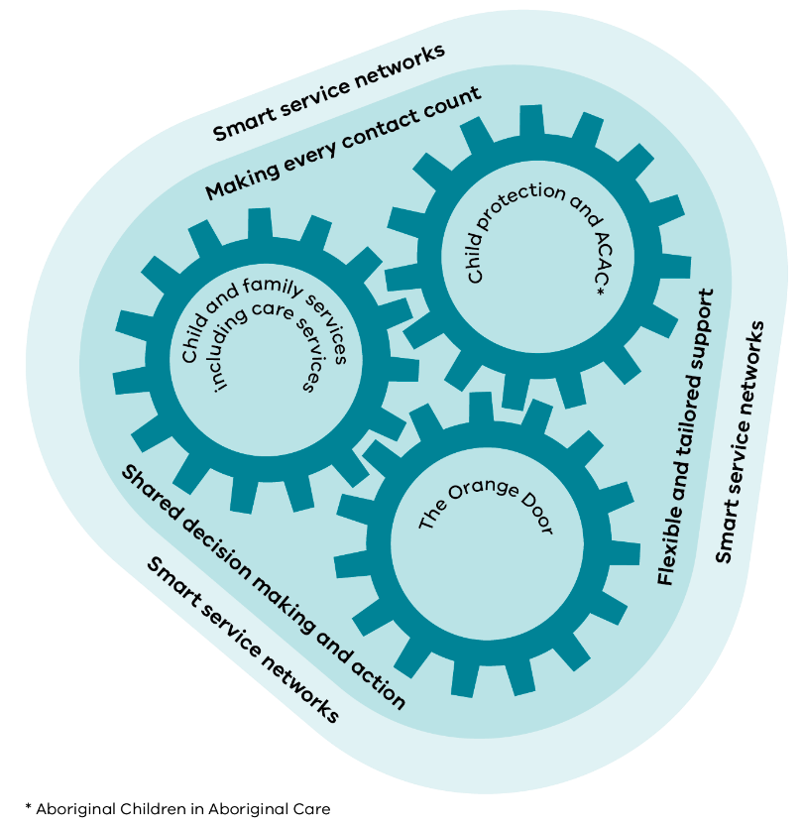

### A contemporary child protection program

The task of reforming the Victorian child protection program sits firmly within the scope of this priority setting plan. Over recent years, considerable design work has been undertaken through the Child Protection Futures project to map out opportunities to reform the child protection program in Victoria. This work recognises the program’s critical statutory role in the protection of children.

To better understand the drivers of workload, we:

* analysed departmental datasets
* ran workshops
* led a jurisdictional review
* conducted an activity survey for child protection practitioners and managers that captured more than 3,000 practitioner days.

The reform opportunities arising from the Child Protection Futures project have been embedded in this priority setting plan and its accompanying 12-month action plan. As such, reforming the child protection program over the next three years is a clear commitment in this plan.

### Family violence platform

Arising from the 2016 Royal Commission into Family Violence, the family violence reform agenda in Victoria is ambitious and far-reaching. Family violence is a major driver of child safety concerns and contact with child protection. The family violence sector is therefore a core element of the ‘pathways to support’ model and a critical platform for keeping vulnerable children and families safe. Progressive rollout of The Orange Door, as well as information sharing and MARAM reforms, are a great step forward in establishing an integrated intake and pathways for families where there are child wellbeing and safety concerns. Given the incidence of family violence as a major driver of harm for children, reforms to the child and family system described in this plan will wrap the family violence platform in wherever possible. This includes joint work on outcomes, governance, service models and practice.

## How to use this plan

This plan sets out reform directions and priorities to inform policy, strategy, planning and resourcing of reform activity over the next three years. This plan does not detail all the activities and inputs that will sit under each priority. Rather, it clarifies where we need to focus our reform efforts across the next three years. Further detail about the activities that will be progressed each year will be presented in rolling 12-month action plans that contain a mix of deep, focused activity at particular sites and broader statewide activity. The first action plan outlines reform actions planned for 2021‑22. Local implementation plans that capture place-based and locally led reform activity will complement the 12-month action plans.

The plan is both a framework for implementation across child and family services and an invitation to universal services, specialist and adult-focused services, and community partners to join up efforts. This will improve the safety, wellbeing and experiences of vulnerable children and families.

### Implementation roles

**For the Department of Families, Fairness and Housing’s central teams**, this plan describes the direction and critical priorities to inform policy, strategy, planning and resourcing of reform activity over the next three years.

**For the Department of Families, Fairness and Housing’s operations divisions and local areas**, the plan will form the basis of local implementation planning that brings together activity, innovations and governance across a range of service platforms – including child protection – in an integrated and strategic way.

**For child and family services**, this plan describes the critical priorities that government will seek to partner with them to deliver through both centrally and locally coordinated reforms. It also provides the foundation for testing innovations to respond earlier and more effectively through timely, flexible and tailored service offerings that draw on strengths, opportunities and supports within the communities that surround children and families This includes the leadership role of the Centre for Excellence in Child and Family Welfare in driving numerous reform projects in collaboration with community service organisations in Victoria.

**For Aboriginal organisations and community partners**, this plan sets out foundational and agreed understandings of reform priorities on which self-determined priorities and approaches will be overlaid and supported. We will work to advance Aboriginal self-determination and self-management across policy, service design and delivery. We will also support development of Aboriginal evidence for what works and Aboriginal-led service responses.

**For practitioners and carers** working across the child and family system, the plan will equip them with the structures, guidance, tools and enabling conditions to support safety, wellbeing, flexibility and capability. Priorities in this plan will pave the way for a contemporary and relational approach to child protection and child and family service provision in Victoria. They will enable meaningful and effective practice that is child-centred and family-focused.

**For specialist services** (including family violence, disability and mental health services), universal services (including education, justice and health services) and community partners (including culturally diverse communities), the priorities in this plan will inform our partnerships and collaborations outside of traditional boundaries. This will mean children and families needing support can experience the right kind of help, when they need it and where they need it.

Our approach to implementing this plan outlines how government and sector partners will work together to achieve major shifts across the child and family system to support improved experiences and outcomes for children and families (refer to page 29).

## How this relates to other reforms

This plan is an important input into the broader social services reform landscape. In this context, this plan does not represent the full range of work underway to progress the Roadmap for Reform vision. Rather, this plan connects with other key reform platforms that will together drive forward the Roadmap for Reform agenda over the next three years. These include:

* proposed amendments to the *Children Youth and Families Act 2005*
* *National Agreement on Closing the Gap*
* *Wungurilwil Gapgapduir: Aboriginal Children and Families Agreement action plan*
* *Korin Korin Balit-Djak: Aboriginal health, wellbeing and safety strategic plan 2017–2027*
* *Residential care action plan*
* *Stronger carers, safer children* *action plan*
* continued rollout of The Orange Door as an integrated access point for vulnerable children and families
* family violence reform
* sexual assault service development
* Child Protection Futures project
* Royal Commission into Victoria’s Mental Health System
* housing and homelessness reform
* alcohol and other drug services reform
* National Disability Insurance Scheme
* health reforms
* education reforms
* social recovery initiatives.

As part of a package of overlapping reforms to the child and family system, this plan does not feature priority activity already being progressed through other action plans. Nor does it feature the continuous improvements and service enhancements being implemented within existing programs across the child and family system. Instead it captures actions not covered elsewhere and that represent innovative, transformative changes towards a ‘pathways to support’ model.

# Pathways to support

The three ‘pathways to support’ represent a new model for the child and family system that puts the child and family at the centre and shapes the service system around their needs and their journey to support, recovery and thriving. The ‘pathways to support’ model brings all parts of the child and family system together to support children and families experiencing vulnerability while also looking at how the system connects with universal and specialist services, including adult services. The model will enable and equip the workforce and carers with the support they need to work more flexibly and responsively.

The idea of the ‘pathways to support’ model is simple. Until now, families seeking help have faced a maze of different services that work in different ways and don’t link up. There are too many barriers that stop families from getting the help and support they deserve and that prevent practitioners from delivering the kind of holistic and joined-up support families need. People with lived experience tell us that the current system of services and supports often doesn’t make sense for people seeking help because it wasn’t set up with the needs and experience of children and families at its centre.

The ‘pathways to support’ model turns this on its head. Instead of a maze of services and barriers to getting help, children and families will experience a clear and coordinated pathway that has been mapped out with them, for them. This pathway will link up and coordinate the right mix, sequence and intensity of services and supports for the child and family. It will do this in a way that makes sense to them and that makes it easy to get help earlier and to access support in a way that reflects their culture, rights and values.

The ‘pathways to support’ model reflects the varied journeys and needs of a child or family. The ‘early help’ pathway will support children and families with emerging needs and vulnerabilities. The ‘targeted and specialist support’ pathway will provide more intensive supports for families with complex needs so children can remain safely in the family home and are supported to thrive. The ‘continuing care’ pathway will provide stability, enable healing and support a strong transition to independent adulthood for children and young people living outside the family home. All three pathways connect to the natural and enduring relationships and resources that exist in every community (refer to Figure 2).

Figure 2: The three pathways to support

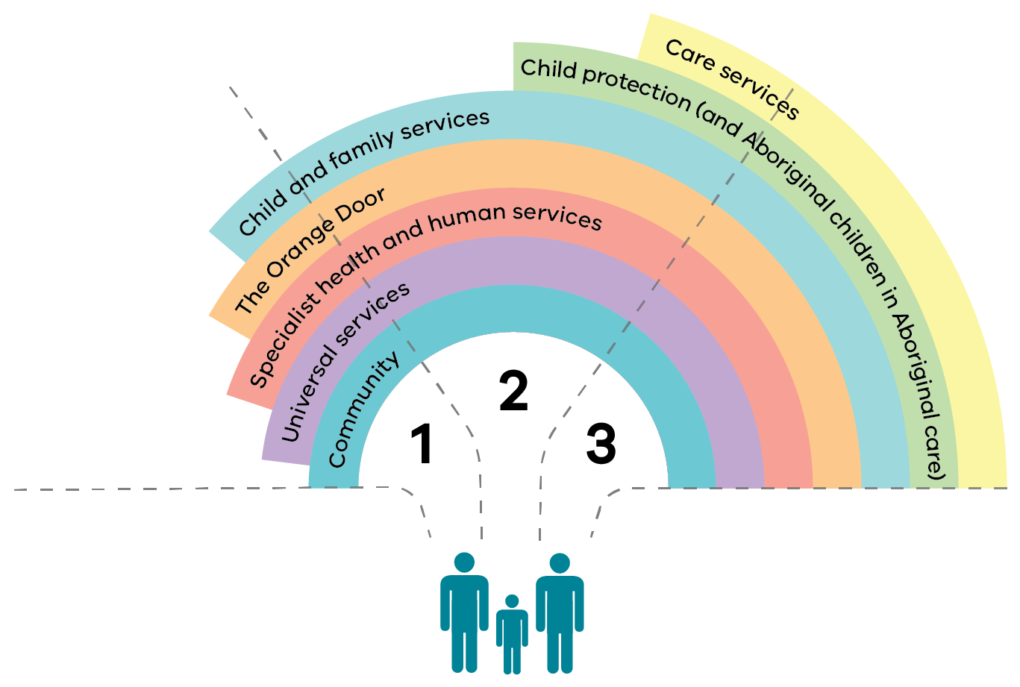

## The three pathways

### Early help

We partner with universal services and communities to identify and respond early when children and families show early signs of need and vulnerability.

### Targeted and specialist

We collaborate with universal services, specialist services and community and work with families to promote children’s wellbeing and keep them safe from harm at home. For some children in this pathway, we partner with carers to give stable and loving care that enables children to be safe, recover and flourish on return to their birth family or through transitions to enduring care.

### Continuing care

We partner with carers, community, universal services and specialist services to work together to ensure stable and loving care for children and young people. Children’s support needs, education, relationships, connections and cultural identity are supported, including during transition to adulthood.

## What is different about the pathways model?

### What change looks like

These reforms will result in improved safety, wellbeing and outcomes for children throughout Victoria.

Bringing the three ‘pathways to support’ model to life will require the system to operate differently to promote the kinds of experiences and outcomes we are seeking for children and families. This represents a move away from traditional service delivery that cycles people though phases of case management, referrals and closures, without supporting enduring change.

In the long-term we are working towards a system in which:

* universal services (such as education and health services) and specialist services (such as family violence, disability and mental health services) take a lead in identifying needs for children and families, early in need and early in life, with targeted and specialist input from child and family services when required
* communities and universal services have the knowledge, skills, capability and confidence to assist families with early help support and families and professionals can access support to navigate the system when they need it
* access to services is easier and clear routes to service responses are visible to families and professionals
* earlier and more effective engagement and partnerships break the cycle of families bouncing between services without making long-term improvements to their health, safety and wellbeing
* more intensive and more targeted support is available earlier to prevent problems from escalating and prevents placement breakdowns, preserves families and reunifies children with their families
* practice and service offerings are informed by evidence – including lived experience, Aboriginal ways of knowing, research evidence and practice insights
* whole-of-family practice is tailored to unique needs (including cultural responsiveness for culturally diverse families) and local conditions
* more support is available for people to build on their community networks through community engagement
* tailored, multi-agency support enables continuity of relationships so people receive the right help, across service boundaries, leading to fewer referrals and fewer handoffs
* integrated and place-based team arrangements create capacity for meaningful engagement with families
* there is transparency and accountability in how services promote, enable and act on children and young people’s rights to express their views, inform their care plan, provide feedback and report concerns about their experiences in care
* a new approach to strategic and operational governance broadens accountability for supporting the safety and wellbeing of vulnerable children and families and involves local decision making, informed by data, to meet locally determined outcomes
* joined-up work and dedicated support for families of children and young people promotes family preservation, reunification and permanency of care
* the care system promotes healing and permanency, supports safe and meaningful connections and manages the impacts of grief and loss
* services working with Aboriginal families have improved cultural competency and all vulnerable Aboriginal children and families in contact with the system experience cultural safety
* the child and family workforce has the skills, time, resources and flexibility to anticipate needs, engage meaningfully and empower the children, young people and families they support (this includes work within communities and a workforce that is more representative of the children and families that we support, including those with lived experience)
* the workforce has access to specialist knowledge and expertise and works effectively with diverse needs.

These changes will enable practitioners to work in ways that:

* facilitate purposeful engagement and flexible solutions
* share information and collaborate across services
* recognise and respect the unique skills and experiences of practitioners
* support professional learning and decision making
* empower them to act in partnership with children and families
* keep workers safe and well
* motivate and inspire them to enjoy fulfilling careers
* promote the Victorian child and family system as a sector of choice.

## How we will achieve these changes – key elements of the future system

The priorities in this plan involve a significant step towards new ways of delivering and governing services. This will be made possible through our dedicated and committed workforce, empowered to work in new ways to improve the experiences and outcomes of children and families. The changes outlined in this plan will also be achieved through:

* relational practice
* community activation
* models of care
* smart service networks.

These are the foundational elements for the new ways of working in the ‘pathways to support’ model.

### Relational approach to practice

Collaboration across different types of services is an essential feature of our future ‘pathways to support’ model. Therefore, a shared approach to practice is needed so that people accessing services can experience consistently safe, effective and responsive practice, with a focus on positive relationships. This will support improved experiences and outcomes for the children and families who use our services. It will also create a unifying contemporary approach for the many dedicated practitioners and carers who work across different parts of our system – statutory and non-statutory services – and will support them to work in safe, meaningful and ethical ways.

### Community activation

Collaborating with communities must become business as usual in a system built on the ‘pathways to support’ model. Our communities have a wealth of experiences, skills, knowledge and relationships. They are also the natural settings in which people live. Our focus on community activation acknowledges the immense value and importance of people’s extended family, friends and communities, which offer enduring, natural networks of support and create a strong sense of belonging, place and community. In practice, community activation depends on the particular needs, context and strengths of a community and place. It fosters social connection, gathering places, peer support and positive community attitudes. These are things we know promote the safety, healing and wellbeing of vulnerable children and families. Community activation also involves shifting the role and presence of child and family services within universal services and communities, enabling early help for families at risk.

### Models of care

A key feature of the ‘pathways to support’ model is a new way of delivering services through targeted and tailored models of care. These models of care cross traditional service boundaries to bring together practitioners in a child-centred and family-focused way, working towards:

* common goals
* a unifying practice approach to support safety, healing and wellbeing.

A model of care broadly defines the way services and community supports are organised and delivered so people get the right response, at the right time, by the right team and in the right place.

Models of care support us to effectively design and deliver the right mix, sequence and intensity of services and supports, tailored to the needs of different groups of vulnerable children and families. By bringing together everything we know about the children and families using our services, we can observe clusters of need and patterns of service use. This information helps us to anticipate some of the service offerings and supports that might be helpful in addressing the needs of different groups.

Models of care also facilitate collaborative and integrated service delivery that builds in community connections and links to universal services as core service offerings. A model of care crosses traditional service boundaries to bring together practitioners in a child-centred and family-focused way, working towards common goals and a unifying practice approach to support safety, healing and wellbeing. Models of care for vulnerable children and families must be culturally safe and responsive and should involve extended family and community networks.

### Smart service networks

To enable the ‘pathways to support’ model, strategic and operational governance will need to look different. Governance will need to work as a learning system, bringing together client voice, data, analytics, research, evidence and evaluation to inform critical decisions about continuous service system development. This type of governance will be place-based, driving local leadership and across the full range of services that work with vulnerable children and families, with a clear focus on outcomes. It will strengthen local strategic planning, decision making and integrated operational management.

Smart service networks will require a shift to:

* shared accountability for community outcomes and resource management
* a proactive approach to evaluating and using data and feedback to inform decisions
* community self-determination through local governance and shared ownership
* place-based coordination and implementation of models of care.

This will support the delivery of safe, effective, connected and person-centred services.

## Pathway enablers

The ‘pathways to support’ model will only be possible if we simultaneously build the critical new system foundations required for reform. These are the pathway enablers that make all the other operational, program and practice changes both possible and effective (refer to Figure 3). Priority reforms for pathway enablers include:

* legislative reform
* contemporary practice
* a supported and skilled workforce
* a rigorous approach to understanding outcomes, evidence and continuous learning
* robust and integrated governance
* strategic investment for impact.

Figure 3: Pathway enablers for system reform

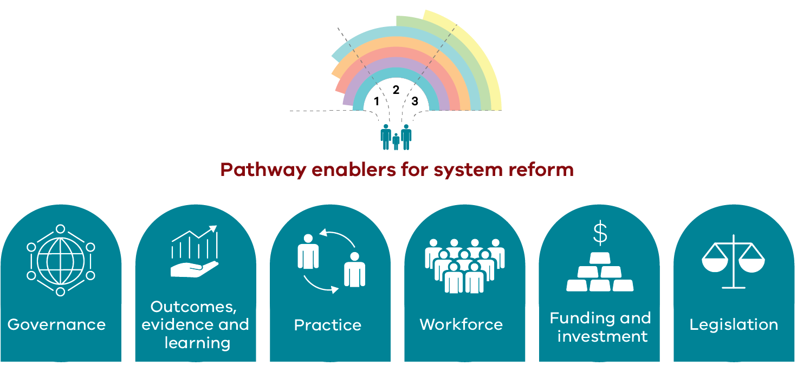

## Change in action: Victorian and Aboriginal Family Preservation and Reunification Response

In April 2020, the Victorian Government announced $46 million through the More Support to Keep Families and Children Safe funding package, including $39.6 million to deliver a new Victorian and Aboriginal Family Preservation and Reunification Response (‘the response’) aimed at keeping families safely together.

The response is an innovative new approach to delivering evidence-informed and integrated support to vulnerable children and families, in partnership with child protection. In delivering the response, practitioners apply evidence-based practice elements known to be effective in family preservation and reunification. They work with other professionals to link families into the services they need and activate community supports.

The response is being implemented in each of the department’s 17 operational areas. ACCOs are also implementing the Aboriginal response in all four departmental divisions.

The response has provided an opportunity to progress Roadmap for Reform priorities and collect meaningful lessons that can be applied as we continue to progress towards improved outcomes for children and families. Described below are some enabling features of system change that we can replicate, build on and scale as we implement further reforms and initiatives.

### A learning system based on data and evidence

The Roadmap for Reform provides the mandate to move towards a learning system that brings together data, analytics, research and evaluation to inform future service system development. The response has enabled the use of data and evidence to identify priority cohorts of children and young people at risk of entry to care. An integral component of the response is developing evidence-based practice modules that support families to stay together. Using implementation science strategies such as training and follow-on coaching and data-informed decision making, these modules are being embedded as business as usual. The department’s Centre for Evaluation and Research and Evidence is establishing a comprehensive monitoring and evaluation framework to measure the impact of the response. The centre will continue to build the evidence base for family preservation and reunification services in Victoria.

### Improving quality and safety

The response’s evidence-informed approach and strong governance mechanisms advance practice and system quality and safety, supported by implementation scientists and practice leads. The response evaluation seeks to understand what is working well and achieving the desired outcomes.

### Models of care for priority cohorts of children and families

Based on data analytics, the response is targeted to children who are most likely to enter care and to benefit from the response. The service offering involves intensive and sustained supports that flexibly wrap around the child and family to:

* build family functioning, safety and wellbeing
* enable children to remain safely at home.

This constitutes a model of care for intensive family preservation and active reunification for vulnerable children and families with multiple and complex needs, which is integrated across service platforms, flexible, evidence-informed and able to be scaled up and down according to need.

### Integrated governance, connected operating models and shared outcomes

The response is a positive step towards better connecting operating models across child protection and child and family services, assisted by the new Child Protection Navigator role and through integrated area-based governance. The response demonstrates that different service platforms can connect in a way that encourages:

* joined-up practice
* a common understanding of risk
* mutual accountability for shared goals and improved outcomes for vulnerable families.

The response progresses a shared accountability for achieving better outcomes for children and families, understanding their unique needs and resourcing the right supports. A range of governance structures have been established to support the response in local areas and centrally, with area level structures comprising both executive and operations groups.

### Expansion of intensive family preservation and reunification

The 2020–21 State Budget provided $335 million over four years to further invest in intensive family preservation and reunification services that are outcomes-focused and evidence-based. These services build on the Victorian and Aboriginal Family Preservation and Reunification Response.

This funding will continue to move the department and the sector towards an outcomes-focused approach to service delivery. It will do this through evidence-based interventions that support family preservation and reunification and drive improved experiences and outcomes for children and families.

# Prioritising our effort

There is a lot of work to do in transitioning our system to a ‘pathways to support’ model that responds earlier and more effectively to safety and wellbeing concerns for vulnerable children and families. Given the extent of change required, and with resource limits, we need to prioritise our focus, effort and investment over the next three years. This will allow us to address the most immediate system pressures that are having a negative effect on outcomes for children and families. It will help to achieve the greatest impact for the people who urgently require a different response. This plan identifies priority cohorts and areas of interest to help us prioritise our effort to achieve the greatest impact where it is most urgently needed.

## The people in focus

This plan focuses effort on four key groups of children and families who:

* have needs that are not adequately met
* experience frequent service use
* have higher rates of entry to care
* may experience higher levels of intergenerational disadvantage and contact with child protection.

These groups have been identified through analysing service data to better understand their needs and journey through the current service system.

The four groups are:

* vulnerable children and families pre-birth and in the first three years of life, with a focus on Aboriginal children and parents
* children and young people experiencing cumulative harm
* children and young people at risk of entering care, particularly Aboriginal children and young people
* children and young people in care, particularly those in residential care.

Vulnerable Aboriginal children and young people are a priority across all identified cohorts. This includes the department’s commitment to closing the gap for Aboriginal Victorians.

While we have we are committed to improving outcomes for all vulnerable children and young people, we recognise that we need a special focus on those children and communities that are most vulnerable and at risk of harm, and that present with critical unmet needs. This includes children with disabilities, who are highly represented across priority groups and have rights to specialised support that help them to thrive within empowered families and communities.

We want to see significant and enduring improvements for these children and families, beginning in the next three years.

## A focus on Aboriginal children and families

For Aboriginal people the evidence is clear that the single biggest factor in improving health and social outcomes is self-determination. Aboriginal people are best placed to lead and inform responses for Aboriginal children and families. Aboriginal people have the right to lead change for their children. In this context, any journey to bring about better outcomes for Aboriginal children and families experiencing vulnerability must also be a journey towards self-determination and self-management. This includes continued work to transition Aboriginal children in care to the care of Aboriginal organisations.

*Wungurilwil Gapgapduir: Aboriginal Children and Families Agreement* is an agreement between the Aboriginal community, government and community service organisations to work together to improve outcomes for Aboriginal children and families. Overseen by the Aboriginal Children’s Forum, the agreement represents a major step in this journey.

There is a long way to go to reduce the high numbers of Aboriginal children in care and in contact with child protection. The impact of colonisation, compounded by continued discrimination, social inequity and injustice, is deep and enduring. The historical, intergenerational and cumulative experiences of harm for Aboriginal people and the legacy of trauma caused by past policies and practices continue to affect Aboriginal communities today.

With this in mind, the *Wungurilwil Gapgapduir strategic action plan* details the steps we collectively need to take to address the over-representation of Aboriginal children and young people in care. This must be at the forefront of our work across all our organisations.

## How we will know we are making a difference

The Roadmap for Reform agenda is ambitious and involves transforming the whole system. This priority setting plan aims to mobilise progressive activity to move the system towards earlier intervention that keeps families safely together where possible, with targeted, timely, coordinated and flexible service responses to address needs and risks.

### Monitoring and evaluation framework

After releasing this plan, the department will work with the child and family services sector, peak bodies and other partners to develop a comprehensive evaluation and monitoring framework. The framework will identify the key result areas, indicators, targets and measures that demonstrate an impact on the experiences and outcomes of children and families. A range of data inputs will be explored to understand progress and impact. This will include a commitment to listening to the experiences of people with lived experience and to the voices of Aboriginal families and communities.

This will enable us to track change and to understand the impact of the changes we are making year on year through the rolling 12-month action plan, as well as through locally led implementation efforts. Monitoring of this plan will also be considered alongside monitoring frameworks for other relevant strategies and plans, including the *Wungurilwil Gapgapduir strategic action plan*, to create efficiencies and avoid duplication of effort.

We propose a transparent approach to sharing progress between implementation partners. This will be based on strong agreed measures that demonstrate the impact that implementation activity is having across all centralised, initiative-specific and locally led activity.

### Areas of interest

Implementation and evaluation learnings will offer deep insights to guide and adapt activity over time. While the indicators and measures that will best reflect progress will be determined through a monitoring and evaluation framework, there are particular areas of interest that we can collectively have our eyes on. As we begin to realise positive impacts in these areas of interest and continue to strengthen the enabling conditions for a ‘pathways to support’ model, we will expand our efforts to new and emerging priority groups and outcomes. Some areas of interest are outlined below.

#### Keeping more vulnerable children and families safely together

An important aim of the reform agenda is to urgently counter the growing number of children entering care and the additional harm that occurs when children are separated from family, culture and community. Without intensive and sustained action, this problem is expected to escalate year on year at an alarming rate, with far-reaching impacts.

Several reform activities over the next three years will concentrate on actions that:

* keep children safe from harm within their families
* safely restore children to their families through the ‘targeted and specialist support’ pathway.

This involves safely reducing the rate of growth in care, especially for Aboriginal children and young people, through intensive family preservation and reunification.

In progressing this activity, we will be interested in understanding to what extent:

* vulnerable children and young people experience safety, security and permanency with their families, as a priority, or home-based care when this is not possible
* vulnerable children and families that have frequent and escalating contact with child protection services experience timely and effective engagement and supports
* the rate of growth in care, especially for Aboriginal children and in residential care.

Over the life of this plan, we hope to see progress reflected in the number of:

* reports and re-reports to child protection services
* early disengagements from child and family services
* entries to care
* children in care and time spent in care, in line with the permanency objective (for reunification, enduring care or leaving care)
* Aboriginal children in care
* children transitioning from residential care to home-based care.

##### Closing the gap for Aboriginal Victorians

Victoria has signed the *Closing the Gap National Agreement*, which includes a target to reduce the rate of over-representation of Aboriginal children in care by 45 per cent by 2031. Agreed actions in *Wungurilwil Gapgapduir* provide the foundation for how to achieve this target in Victoria. They also work to ensure Aboriginal children and young people grow up safe and cared for in family, community and culture.

#### Progressing Aboriginal self-determination and self-management

Aboriginal organisations and communities will be invited to work with the department to consider how we might observe a real impact on outcomes for Aboriginal children and families through this this plan, guided by *Wungurilwil Gapgapduir* as the overarching strategy. This is a paramount commitment of this plan and is in line with the Victorian Government’s commitment to advancing Aboriginal self-determination and closing the gap.

Key result areas, indicators and measures that demonstrate progress towards Aboriginal self-determination and self-management in the child and family system context will align with existing monitoring frameworks for other strategic reform and policy agendas for Aboriginal communities, including:

* *Wungurilwil Gapgapduir* (Aboriginal children and families agreement)
* *Dhelk Dja: Safe our way* (family violence reform in partnership with Aboriginal communities)
* *Korin Korin Balit Djak* (Aboriginal health, wellbeing and safety plan).

Over the next three years, we expect to see this reflected through clear evidence of:

* Aboriginal children, young people, families, carers and communities having autonomy in matters that affect them
* increasing decision-making control and resource allocation proportional to representation/service usage being transferred to Aboriginal people and communities
* increasing use of Aboriginal knowledge systems, cultural practice and Aboriginal-led research
* increasing capability among all sector staff to work in cultural safe ways with Aboriginal people
* an Aboriginal evidence base that is designed, developed and owned by Aboriginal organisations and community.

#### Collaboration, partnerships and integration across service types

A long-term sustainable partnership between family services, child protection and care services will be critical to driving the collaborative effort needed to bring about the change we want to see over the next three years. Through a partnership approach that promotes sustainable engagement with services, children and families receive the right service offerings at the right intensity at every touchpoint with the system. Efforts to build partnerships over the next three years will centre on family services, child protection and care services platforms.

Through priorities in this plan and the rolling 12-month action plan, we expect to see:

* children and young people, and their families and carers, experiencing continuity of relationships and care in their pathway to support
* increasing use of information sharing across service platforms to inform service delivery
* broadening partnerships with universal and community services and specialist services, including adult-focused services
* increasing capacity for practitioners to engage in more direct work with families.

Progress across these areas of interest, and the outcomes and measures that will be identified through the monitoring and evaluation framework, will be indicative of real change in the way children and families experience our system.

# Four priority packages

The **priorities** in this plan are arranged across four packages:

* early help pathway
* targeted and specialist pathway
* continuing care pathway
* pathway enablers.

Over the next three years, the priorities will:

* shift the system to intervene earlier to improve family functioning, keep children with their families and safely reunify children, with a priority focus on Aboriginal families
* build evidence across the system to enable effective services, targeted to the needs of priority groups of children and families
* strengthen partnerships between child protection, family violence, sexual assault and child and family services to enable improved experiences and outcomes for children and families
* advance Aboriginal self-determination and self-management, including through care and case management of Aboriginal children by ACCOs and Aboriginal-led service offerings.

The **actions** that will progress the three-year priorities in this priority setting plan can be found in the rolling **12-month** **action plans**. These plans will be updated annually over the implementation period from 2021 to 2024.

## Early help pathway: priorities for 2021–2024

Through our actions over the next three years in the ‘early help’ package, we aim to strengthen the capability of universal services and communities to prevent and respond to emerging concerns experienced by children and families. Early help actions will also focus on designing front-end system access points for connecting young people and families to the right advice, information, services and support.

| Three-year impact | Priorities |
| --- | --- |
| When children and families show signs of need and vulnerability, universal services and communities identify and respond early with a culturally safe response. | 1. Build capability in universal services, including education and primary health, for identifying and responding to child wellbeing concerns.  2. Improve participation in universal services for vulnerable children and families, including access to education and primary health services.  3. Build capability in the system to better connect children and their families to the right service, early in need.  4. Strengthen communities to actively participate in the support of children and families through identifying early help needs and helping behaviours. |

## Targeted and specialist pathway: priorities for 2021–2024

The actions in the ‘targeted and specialist’ package aim to support effective and responsive early intervention and diversion to enable children to be safe, heal and thrive on reunification with family, or through transition to enduring care. Over the next three years, this will involve continuing to expand intensive family preservation and reunification services. It will also mean improvements in the way different parts of the system work together to support early and sustained engagement with services to prevent cumulative harm and escalation of risk for families experiencing vulnerability.

| Three-year impact | Priorities |
| --- | --- |
| Universal, specialist and community partners work with families to promote children’s safety and wellbeing and keep children safely at home or reunify them when safe to do so.  Carers are supported to provide stable and loving care in accordance with the permanency objective. | 1. Advance Aboriginal-led, culturally safe responses for vulnerable Aboriginal children and families.  2. Strengthen integration and partnership approaches between child protection, family violence, sexual assault and child and family services.  3. Develop models of care and service responses to strengthen support and practice for priority cohorts of children and families.  4. Strengthen early intervention and prevention approaches, practice and services. |

## Continuing care pathway: priorities for 2021–2024

The priorities in the ‘continuing care’ package aim to support improved experiences and outcomes for children in enduring care, particularly residential care, and for young people leaving care. This pathway also aims to improve experiences and supports for carers. This package is strongly complemented by actions in the *Strong carers, stronger children action plan 2021–22* and the *Residential care action plan 2021–22*.

| Three-year impact | Priorities |
| --- | --- |
| Children and young people in enduring care are provided with safe, quality and stable care.  Children and young people in care are supported to achieve positive health and education outcomes. Family connections and cultural identity are supported, including during transition to adulthood.  Carers are empowered and supported to provide safe and nurturing care for as long as children need it. | 1. Strengthen supports and evidence-informed practice for young people in enduring care and young people leaving care.  2. Improve children and young people’s experience of care through implementing care services reforms.  3. Improve experiences and supports for carers through implementing *Strong carers, stronger children*. |

## Pathway enablers: priorities for 2021–2024

The ‘pathway enablers’ priorities over the next three years will focus on progressive action to support:

* legislative reform
* contemporary practice
* an empowered and skilled workforce
* evidence-informed models
* smart service networks
* strategic investment.

| Three-year impact | Priorities |
| --- | --- |
| The pathways system is activated through legislative reform, contemporary practice, a supported and skilled workforce, evidence-informed models, smart service networks and strategic investment for impact. | 1. **Legislation**: Enact legislative changes that enable reform of the child and family system.  2. **Practice**: Embed contemporary, evidence-informed, culturally safe best practice that reflects legislative and policy change and reform across the child and family system.  3. **Workforce**: Strengthen the child and family system workforce through a workforce development plan that identifies requirements for new practice and service models and that supports workforce safety and wellbeing.  4. **Outcomes, evidence and learning**: Demonstrate the impact on outcomes by building the evidence for what works. This should be informed by the expertise of people with lived experience, Aboriginal ways of knowing, research evidence and practice insights, and supported by increased capability in applying implementation science across the system.  5. **Governance**: Establish smart service networks to lead local reform implementation and ongoing local area strategic oversight and operational management functions.  6. **Funding and investment**: Develop a government investment strategy that aligns with reform priorities and delivers resourcing for a sustainable service system. |

# Implementation approach

This priority setting plan lays out the priorities that will inform action over the next three years, beginning with the actions outlined in the 2021–22 action plan. Reform activity over the next three years aims to implement a broad range of innovations and system changes to shift the current child and family system to one that reflects the ‘pathways to support’ model.

We know that ambitious, deep reforms won’t happen without a strategic and sustained approach to implementation that applies learning and best practice from the field of implementation science. Our capability in implementation science is growing across both government and the child and family services sector. We are increasingly implementing changes to the child and family system based on implementation science to ensure new initiatives:

* roll out as intended
* are supported to succeed
* have an impact on experiences and outcomes for children and families.

We also know that systemic change is complex and multifaceted. It requires a number of government and sector implementation partners to coordinate and mobilise change across different parts of the system, based on their particular mandate, scope and strengths. And we know that there is a lot of promising and reformative activity that is already underway that we can learn from and build from.

These are the underpinning elements of our proposed approach to implementation that will include a balance of:

* centrally led and locally led activity
* activity that implements deep changes in some places with activity that achieves breadth across the state for other changes.

## Depth of change

A number of actions implemented over the next three years will seek to bring the intent of the Roadmap for Reform to life, initially in a few locations. This will give us the opportunity to test, refine and learn from these implementation activities ahead of moving to broader adoption in other sites. These actions will build on existing strengths and innovations in the system and will mobilise partners, early adopters, change leaders and experts across:

* lived experience
* research
* practice
* service delivery
* governance.

Some of these ‘deep-dive’ actions will be built around models of care for particular priority cohorts of children and families. This will be alongside intensive efforts to establish the conditions to support these new ways of working.

This approach to testing deep changes will build new evidence and a way to implement change statewide. It will both develop a robust process by which change is implemented and ensure change is sustained and produces the intended results. It will also build the evidence of what works by testing elements of the reform in contained sites and using the lessons learnt in the initial sites to inform progressive rollout of change across the state.

## Breadth of change

Implementation efforts will also build the conditions for whole-of-system changes. We will look to build the conditions for sustained statewide change by providing service providers, operations divisions and local areas across the state with consistent parameters and guidance. They will receive the inputs, support and information they need to continue to drive local reform activity in line with the priorities identified in this plan. Most statewide activity will be centrally led in partnership with operations divisions, local areas and the sector, such as legislative reform.

### Legislative change

Legislative change is an example of a broad reform with statewide application. Reform to the Victorian Children Youth and Families Actwill create a contemporary legislative framework that progresses the Roadmap for Reform and *Wungurilwil Gapgapduir* to:

* modernise the legislative framework
* enhance early intervention, prevention and diversion
* elevate the rights of the child
* advance Aboriginal self-determination and self-management
* promote permanency for children by reducing adversarial court proceedings and delays
* strengthen the system that protects children.

Legislative reform will be supported and complemented by a number of policy and practice reforms that will together lay the foundations for a contemporary child and family system.

## Implementation partners

Implementing reform priorities will require a partnership approach. This means government working in partnership with the following groups to progress changes to the child and family system:

* children and families
* carers
* practitioners
* ACCOs
* community services organisations
* peak and advocacy bodies
* universal and specialist services.

Reform activity will be implemented through a combination of the following:

* **Centralised implementation**: Activity that is centrally coordinated and/or implemented on a statewide basis (for example, legislative and practice reforms).
* **Initiative-specific implementation**: Activity is driven through detailed project planning and led through dedicated project governance. These activities may be statewide, divisional, regionally based or place-based, depending on the nature of the change (for example, intensive family preservation and reunification, Common Clients and other reform projects and pilots that take a piloting or sequenced approach to rollout).
* **Locally led implementation**: Activity led by community services organisations and departmental operations divisions and local areas, where opportunities to progress the priorities have been identified through the various service platforms they deliver, and their local partners (refer to Figure 4).

Centralised implementation and initiative-specific implementation are largely documented within the rolling 12-month action plan. Local activity will be documented in local implementation plans that may bring together activity across a range of strategic frameworks and reform plans.

Reporting and progress updates will highlight progress and impact from all three avenues of implementation activity.

Figure 4: Implementation approach

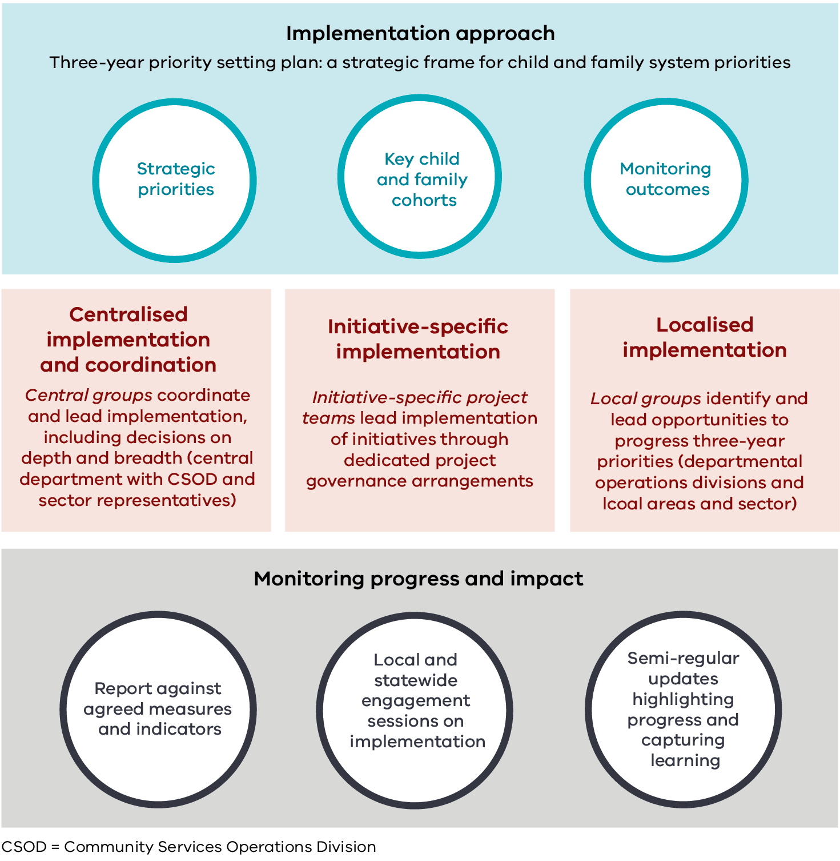

## Approach to locally led implementation

We propose a place-based approach to implementation planning and action. This will authorise and enable locally led implementation activity that both aligns with the strategic priorities in this plan and responds meaningfully to local priorities and opportunities. This approach will also enable system change at the local level, informed by linked data, local intelligence and client voice, to address priority problems and the needs of priority cohorts of children and families.

As a first step for locally led implementation, department operations divisions, their local areas and local sector partners are invited to consider how best to contribute to the three-year priorities outlined in this plan. This approach allows local partners to make implementation decisions based on:

* the highest priorities for the area, including the greatest opportunities or the most pressing needs
* existing vehicles for change that can be leveraged – planned or underway
* gaps that need to be addressed
* critical partnerships
* available resourcing.

### Central coordination and support

The department’s central child and family system reform team and implementation managers will support local planning. Planning will consider how implementation will be incorporated into existing divisional and area strategy and planning. It will also consider how proposed activity aligns with broader reform already underway in the area such as:

* the roll out of The Orange Door
* Common Clients pilot sites
* mental health and education reform initiatives.

Planning and prioritisation will occur through local and statewide engagement sessions. This will be followed by regular engagement sessions between central and local offices of the department (with sector representatives involved as needed) to share implementation progress, lessons learnt and case studies.

### Implementation planning

We recommend that local implementation teams develop a local implementation plan that examines the strengths, needs, priorities and opportunities in their local area against this priority setting plan. Local teams should keep the priority cohorts of children and families, relevant measures and key elements of the future system in focus. A suggested focus for implementation planning is establishing smart service networks.

### Using smart service networks for reform implementation

One of the key vehicles for progressing reform activity in line with the priority setting plan are smart service networks. Smart service networks are a place-based, cross-sector governance arrangement established in the department’s local areas or other locally determined catchments. They will build on the best aspects of existing local governance structures, networks and alliances and be enduring beyond any one particular reform project or program. These networks will wrap in both government and the sector to enable, drive and resource collaborative leadership, strategy and action to create deep practice and system change, based on agreed actions and outcomes.

Smart service networks will have the capacity to:

* embed quality governance
* drive collective action to implement system change and practice reforms designed to improve outcomes for children and their families
* share accountability for community outcomes, with a focus on priority cohorts of children and families
* use data and client feedback to inform decision making for practice, service and system improvement
* build strong relationships across service actors and harness existing networks and resources
* build momentum, advance Aboriginal self-determination and apply co-design with people with lived experience to develop innovative service responses.

Establishing or strengthening integrated area-based governance to achieve the functions of smart service networks is a critical component of the local implementation approach. These functions include reviewing linked data to identify service gaps and defining shared priority outcomes across service platforms.

### Implementation teams

Given the intent to achieve long-term change that transforms the system, we need to consider identifying and progressing local implementation priorities. Departmental operations areas could consider how to establish, manage and resource local implementation teams. These teams would oversee locally identified priority areas for action, guided by the strategic priorities outlined in this plan. Blended implementation teams may be drawn from existing resources for some changes.

These implementation teams may be used to progress broad statewide implementation actions (such as smart services networks) and particular site-specific actions outlined in the action packages where rollout is occurring in an area. One example would be progressing models of care for priority cohorts.

### Implementation support

The department’s central reform team will provide ongoing guidance and support to operations divisions and areas. This will be complemented by the implementation managers, an important resource to engage and support departmental operations divisions in planning for change. In particular, implementation managers will partner with early adopters of integrated area-based governance to support implementation of smart service networks. They will capture and share the learning to support rollout of smart service networks in other areas.

### Implementation guide

An implementation guide will be released alongside this priority setting plan and the 2021–22 action plan. This will support implementation partners to advance the child and family system towards the ‘pathways to support’ model including:

* the department’s central and operations divisions
* the child and family sector
* peak body and lived experience advocates
* other government departments.

The implementation guide provides a step-by-step cycle (shown in Figure 5) to support planning and implementation of changes at the local level in a coordinated way, across programs and operating models. The implementation cycle is designed to support local partners, with a particular focus on department operations areas, to implement programs and initiatives using an approach based on implementation science. Local areas and their implementation teams may use the implementation guide and its step-by-step implementation cycle to:

* ‘sense check’ their existing implementation approaches
* follow in detail from the start of the cycle
* deep dive into specific stages of the cycle only.

Sector partners may also wish to use this cycle to implement changes and work with local operations areas and divisions to align efforts on priority activity.

This guide is not intended to replace or duplicate implementation approaches that are already being used by areas or sector partners, or as part of initiative-specific implementation activities that are already underway. Rather, it is a guide for partners who wish to use it.

The cycle has six steps. It is intended to be iterated and repeated as changes are tested and refined, or as changes become embedded and new priorities emerge:

1. Understand statewide priorities and opportunities.
2. Understand what reform implementation means in your local context.
3. Identify your local implementation lead and create your implementation team.
4. Understand what needs to change and how.
5. Get ready for change and make the transition.
6. Embed evaluation learnings and build on what is working.

Figure 5: Implementation cycle

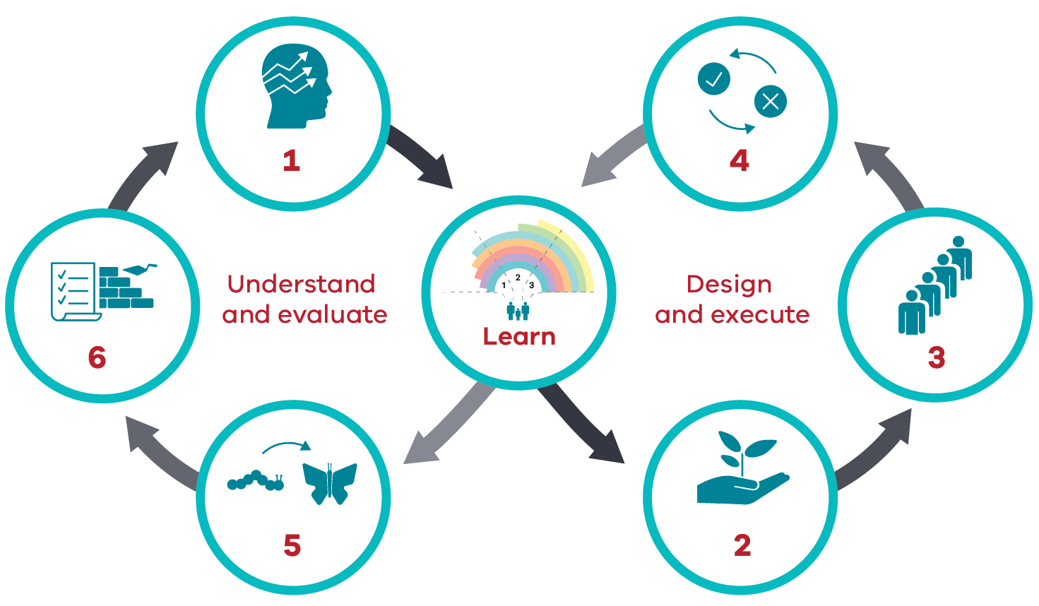

## Sector-led implementation

Victoria has a strong community services sector that actively advocates for and partners in reform design and implementation. The Aboriginal community-controlled sector and the child and family services sector are critical partners in driving both central and local reform efforts. As such, we will engage the sector in both central and local governance and planning. This is in addition to the programs, innovations, evidence creation/translation and practice development work that community sector partners already lead.

### Building on what we’ve learnt

Some reforms and innovations are well underway across the Aboriginal community-controlled sector and the child and family services sector. These existing reforms provide a promising platform for consolidating and scaling innovations more broadly. To enable this, we need to better support evaluation and the scaling up of successful models across the system.

## Sharing data

Critical to achieving whole-of-system change is that we routinely share linked data and information:

* at strategic and operational levels
* across central and local governance groups.

This will foster trust and transparency and will support coordinated planning and service responses. This sharing of data and information will support us to build a learning system that uses data and evidence to understand what works, for whom and when. Information sharing will also be a key element of both central and local tracking of progress against key measures (to be determined in the monitoring and evaluation framework) to inform next steps and year-on-year implementation planning.

## Deep engagement

The partnership approach required for implementing this plan will be supported by deep engagement with:

* communities
* the department’s local areas
* relevant service providers.

This will ensure the right support for localised planning and implementation.

This coordinated approach to implementation will occur through local engagement sessions that provide the opportunity to:

* share information about central and localised activity
* report on progress made against agreed outcomes, measures and indicators
* capture lessons learnt and relevant case studies
* build a more complete picture of the work being undertaken to advance the priorities identified within this plan.

In addition to local engagement sessions, there will be regular updates to highlight progress on central, initiative-specific and locally led implementation activity. This will reflect progress made across all partners, including government, the community services sector and ACCOs, consistent with the partnership approach to working together to progress shared reform priorities.

## Other implementation partners

The Roadmap Implementation Ministerial Advisory Group (RIMAG) was established to guide and advance implementation of the Roadmap for Reform. It is a key partner in implementing this priority setting plan. RIMAG provides strategic leadership, direction and accountability across the sector. RIMAG also has several working groups composed of representatives who are best placed to progress specific priorities and deliverables:

* lived experience members
* representatives from peak bodies and sector organisations
* subject matter experts
* other stakeholders.

For some of the priorities identified in this plan, RIMAG or its working groups may be the lead in progressing the activity.

The Centre for Excellence in Child and Family Welfare is also a key implementation partner for a range of priority reforms, and a co-lead of RIMAG.

Aboriginal leadership and voice and lived experience representation are a priority across all governance structures.

# Conclusion

This is a plan for government, child and family services and universal and community partners to critically review current service offerings in the context of the priority cohorts, key result areas and priority actions. Moving towards a ‘pathways to support’ model will require all services and supports involved in the lives of vulnerable children and families to align our focus, effort and resources with the priorities outlined in the plan.

Over the next three years we can collectively establish the conditions for transforming our system. The ‘pathways to support’ model will provide children and families with the right combination of tailored and flexible supports to address their needs and support them to thrive. We all have a responsibility and an interest in the safety and wellbeing of children and young people. We all have a role to play in supporting families who are more vulnerable so all children and young people have the chance to thrive.

This is important work. It will take energy, commitment and innovation at the statewide, operational, local and community levels. And it will make a significant positive difference in the lives of children and families.

This is what children, families and carers expect from us.

# References

Department of Health and Human Services 2016, *Roadmap for Reform: Strong families, safe children – the first steps,* State Government of Victoria, Melbourne.

Department of Health and Human Services 2018a, *Roadmap for Reform: Strong families, safe children – progress and directions 2018*, State Government of Victoria, Melbourne.

Department of Health and Human Services 2018b, *Wungurilwil Gapgapduir: Aboriginal Children and Families Agreement*, State Government of Victoria, Melbourne.

Dhelk Dja Partnership Forum 2018, *Dhelk Dja: Safe our way – strong culture, strong people, strong families*, State Government of Victoria, Melbourne.

Family Safety Victoria 2019, *Everybody matters: inclusion and equity statement*, State Government of Victoria, Melbourne.

State of Victoria 2021, *Safe and Strong – a Victorian gender equality strategy: Preventing violence against women through gender equality*, State Government of Victoria, Melbourne.