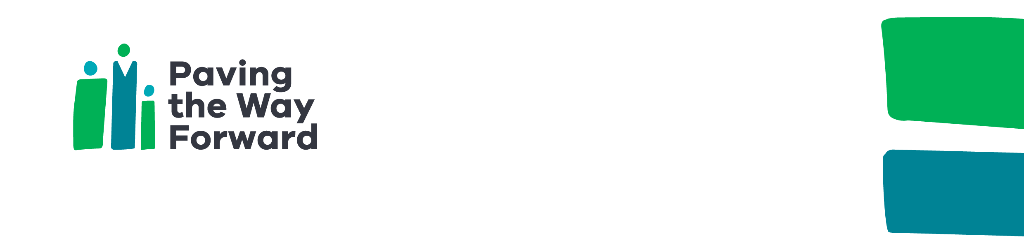

|  |
| --- |
| North Melbourne local action plan 2022–23 overview |
| Paving the Way Forward  Accessible |
| OFFICIAL |

The actions set out in this plan are based on community feedback from 2021–22.

This plan transforms the needs, ideas and goals of residents into five **focus areas** and 65 **achievable actions** that will have positive and lasting effects through **partnerships**, **targeted funding** and **promotion**.

Under each focus area, the plan outlines:

* **What we heard** from residents about the issues they experience
* **What residents want** to see change, their ideas and aspirations
* **What we will achieve** in this focus area
* **What we will do** to address these aspirations, needs and issues. Many of these ideas have been co-developed with residents, and are being delivered in partnership with residents, community organisations, the local council and other partners.

|  |  |  |
| --- | --- | --- |
| **Focus area** | **Our goals** | **Local actions** |
| Communication and participation | * Residents have increased confidence in engaging in decision-making * Residents are involved in the key decisions that impact their home, neighbourhood and services * Residents participate in and own solutions for the issues that they see as the most pressing | * Establish resident action group * Involvement in designing resident decision-making models * Education session on government workings * Grants, community leadership, and governance training * Local council participation * Develop a resident-led organisation * Consultation between residents and stakeholders * Feedback box * Young people podcast |
| Maintenance and amenity | * Residents have increased knowledge of tenancy and neighbourhood management * Property and tenancy management are timely and responsive to resident needs | * Maintenance and housing education series * New resident welcome pack * Regular estate walk-arounds * Simplify housing information * Trial an annual renters conference * Improve community facilities access * Remove unknown vehicles * Parking adherence improvement * Improve digital experience for maintenance requests * Test different communication methods with residents |
| Employment and education | * Residents have increased awareness and access to the support they need to find work and training * Residents have access to more employment pathways and job opportunities in the local area which match their career aspirations, available hours, and cultural needs | * Engage, map & identify employment priorities * Small business and enterprise support * Develop and implement a targeted employment plan * Promote employment access * Support employment initiatives for residents * Help young people find their first job * Link residents with Department of Education and Training |
| Safety, health and wellbeing | * Improved communication between services and residents * Residents are able to access the right service at the right time * Residents feel safe in their homes and neighbourhood | * Health outreach program * Mental health program * Health and wellbeing programs * Health information sessions * Parent-led playgroup * Primary after-school activities * Intergenerational playgroup * Youth activities * Map and promote local services * Services fair * Women’s health and safety awareness * Crime prevention assessment * Improve lighting * Community safety forum * Culturally appropriate swimming * Promote women’s wellbeing * Better information sharing * Neighbourhood networking * Support for parents * Legal education and support * Financial literacy workshops |
| Community connection and spaces | * Improved management of shared spaces to the benefit of residents * Residents build their social and community connections creating stronger communities | * Pampas Street courtyard update * Pampas Street community room activation * Increase litter facilities * Seek opportunities for Sutton Street playground upgrade * Improve signage * Support resident creativity * Promote grant opportunities * PTWF grants program * Wi-fi benches * Community days * North Melbourne cooking project * Community art project * Community groups networking * Community outings * Identify women, youth & student spaces * Identify additional community spaces * Seek opportunities to upgrade Alfred Street basketball court * Explore secure bicycle parking |

For more information on PTWF North Melbourne or to discuss any aspects of the plan, please [email the PTWF team](mailto:pavingthewayforwardNMF@dhhs.vic.gov.au) <pavingthewayforwardNMF@dhhs.vic.gov.au>.

|  |
| --- |
| To receive this document in another format, [email the Paving the Way Forward team](mailto:PavingTheWayForwardNMF@dhhs.vic.gov.au) <PavingTheWayForwardNMF@dhhs.vic.gov.au>.  Authorised and published by the Victorian Government, 1 Treasury Place, Melbourne.  Paving the Way Forward is a Victorian Government initiative supported by the Department of Families, Fairness and Housing. In partnership with Cohealth, North Melbourne Language & Learning, Drummond Street, and Mission Australia.  © State of Victoria, Australia, Department of Families, Fairness and Housing, October 2022.  ISBN 978-1-76130-041-7 (pdf/online/MS word)  Available at [Paving The Way Forward Initiative](https://www.dffh.vic.gov.au/paving-way-forward-initiative) <https://www.dffh.vic.gov.au/paving-way-forward-initiative> |