

|  |
| --- |
| Human Services Regulator compliance and enforcement policy |
|  |
|  |

To receive this document in another format, [email the Human Services Regulator](mailto:hsregulator@dffh.vic.gov.au) <hsregulator@dffh.vic.gov.au>.

Authorised and published by the Victorian Government, 1 Treasury Place, Melbourne.

© State of Victoria, Australia, Department of Families, Fairness and Housing, January 2023.

ISBN 978-1-76130-080-6 (pdf/online/MS word)

Available at [our website's Human Services Regulator page](https://www.dffh.vic.gov.au/human-services-regulator) <https://www.dffh.vic.gov.au/human-services-regulator>

Contents

Purpose 4

Scope 4

Role statement 4

1. Who we are 5

Scope of our regulatory portfolio 6

Our expectation of duty holders 9

2. Our regulatory toolkit 10

3. Compliance monitoring and response to non-compliance 12

The HSR’s regulatory response to non-compliance 12

4. Reviews and appeals 17

Appendix A: Regulatory toolkit 18

Registration 18

Information gathering and ongoing compliance monitoring 18

Remedial actions 19

Collaborative peer regulation 20

Imposition of sanctions 20

Appendix B: Image descriptions 22

Compliance activities emphasis 22

Risk analysis matrix 22

# Purpose

The purpose of this policy is to explain the Human Services Regulator’s (HSR) compliance and enforcement approach and expectations to external stakeholders, duty holders and client group representatives.

|  |
| --- |
| This document applies to the operations of the Human Services Regulator only. With the recent passage of the *Social Services Regulation Bill 2021*, we expect the Social Services Regulator to replace the HSR. We expect the new Social Services Regulator will issue its own statements about how it intends to exercise its regulatory powers under the new legislation. Any such statements will replace this document. |

# Scope

This policy covers the HSR’s:

* purpose and role as a regulator
* approach to monitoring and supporting compliance
* approach to enforcement.

# Role statement

The roleof the HSR is to regulate human services to minimise harm and to protect the safety and rights of children, young people and adults.

HSR achieves this by:

* administering standards
* promoting good practice
* monitoring and enforcing compliance with relevant laws, regulations and standards
* building relationships.

| **What is ‘compliance and enforcement’?** |
| --- |
| In this policy, ‘**compliance**’ is defined as adherence to the legal requirements and obligations under the Acts, Regulations and Standards administered by the HSR. Compliance is an ongoing process where people and businesses need to regularly assess their risk of non-compliance and seek to improve their methods and practices for eliminating or minimising those risks.  ‘**Enforcement**’ is the mechanism used by the HSR to respond to compliance issues and failures through influence, authority and statutory powers. |

# 1. Who we are

The Human Services Regulator (HSR) is a unit within the Department of Families, Fairness and Housing (the department). The HSR was established in the then Department of Health and Human Services in November 2017 to provide an integrated approach to regulating human services providers in Victoria within the regulatory portfolio described in Table 1.

Table : HSR regulatory portfolio

| HSR regulatory portfolio |
| --- |
| **Child Wellbeing and Safety Act 2005**  Support the Commission for Children and Young People to promote the safety of children, prevent child abuse and respond to allegations of abuse.  Oversee compliance with Child Safe Standards. |
| **Children, Youth and Families Act 2005**  Protect children and regulate community services that support children and families.  Investigate allegations of sexual or physical abuse of children.  Oversee compliance with Human Services Standards. |
| **Disability Act 2006**  Promote and protect the rights of people accessing disability services.  Oversee compliance with Human Services Standards. |
| **Supported Residential Services (Private Proprietors) Act 2010**  Protect the safety and wellbeing of residents.  Oversee compliance with Accommodation and Personal Support Standards. |

## Scope of our regulatory portfolio

### The HSR regulates a range of duty holders

The HSR’s regulatory portfolio covers a variety of duty holders as outlined in Table 2. A duty holder is an individual or organisation that:

* is registered under any Act within the HSR regulatory portfolio[1] or
* is required to comply with Human Services Standards, Child Safe Standards or Supported Residential Services Accommodation and Personal Support Standards.

Duty holders include:

* organisations and individuals
* department-funded enterprises, privately operated entities or not-for-profit organisations.

Table : Human services duty holders

| Human services providers | Example service |
| --- | --- |
| Entities and individuals registered under the *Children, Youth and Families Act 2005* (registration, Human Services Standards and Victorian Carer Register, including sections 81 and 82 reports of abuse) | * Community-based child and family services * Out-of-home care such as residential care and foster care * Family violence services |
| Entities subject to the *Child Wellbeing and Safety Act 2005* (Child Safe Standards including the Reportable Conduct Scheme) | * Out-of-home care such as residential care and foster care * Children and youth services * Homelessness support services * Disability and family violence services |
| Entities and individuals registered under the *Disability Act 2006* (registration, Human Services Standards) | Disability service providers including:   * Multiple and Complex Needs Initiative services * behaviour intervention services * supported accommodation services |
| Proprietors registered under the *Supported Residential Services (Private Proprietors) Act 2010* | Privately operated services that provide accommodation and personal support for people of different ages and support needs |
| Government-funded entities and individuals that do not need registration and provide services covered by the Human Services Standards | * Homelessness support services * Some children, youth and family services * Some disability and family violence services |
| Services directly provided by the department | * Disability client services * Residential out-of-home care |

### Regulatory principles and approach

In applying this policy, the HSR is committed to meeting its regulatory principles, as listed in Table 3.

Table : Regulatory principles and commitments

| Principle | Commitments |
| --- | --- |
| **Collaborative** | The HSR supports duty holders to build their capabilities to deliver services that are safe and compliant.  Where regulatory regimes overlap, the HSR works with its regulatory peers to share information and target regulatory effort.  The HSR works with the department’s funding areas to enable coordinated responses to risk.  The HSR engages with stakeholders and client group representatives. |
| **Accountable** | The HSR is objective and open in its decision-making and processes. It assists duty holders to understand its regulatory approach and areas of focus.  The HSR documents decisions appropriately, including justification for actions and exercise of powers.  The HSR reports on its performance to ensure transparency and enable continuous improvement. |
| **Proportionate** | Regulatory measures and responses fit the risks and behaviours they address.  Outcomes from enforcement activities are consistent and predictable. |
| **Effective** | The HSR analyses information to identify risks and set regulatory objectives.  The HSR allocates resources to areas where they have the greatest positive effect and protect the safety, wellbeing and rights of people accessing human services.  Enforcement action is timely to minimise impacts of harms and maximise the deterrent effect of sanctions. |
| **Clear** | The HSR communicates its message, advice and enforcement actions in a clear and easily understood way with stakeholders, duty holders and client groups. |

The HSR aims to protect safety and uphold the rights of people receiving in-scope services. To apply these principles, the HSR monitors compliance and takes enforcement actions to ensure that duty holders are held accountable, particularly where they are falling short of their obligations.

The HSR’s approach promotes a culture of continuous improvement among duty holders to assist them to comply with their obligations and improve the delivery of in-scope services.

The HSR recognises that many human services providers work to make a positive contribution to society and will comply voluntarily with effective engagement and information from HSR. Accordingly, HSR’s compliance approach includes supporting duty holders to understand and meet their obligations through compliance guidance and education materials.

The responsibility for compliance will always rest with the duty holder. The HSR expects those who have obligations under the law to seek out relevant information and stay up to date with changing industry practices.

Where the risks are higher, the HSR will use statutory powers to remedy and/or prevent the non-compliance.

### The HSR works with regulatory and departmental peers

The HSR works with diverse government entities that have regulatory oversight or safeguarding responsibilities that may intersect with our regulatory portfolio.

The HSR takes an active role in liaising and information-sharing with these entities where appropriate and legally permissible.

Although part of the department, the HSR makes regulatory decisions independent of the department’s branches that administer funding contracts and provide operational support.

Figure : Example regulatory ecosystem[2]

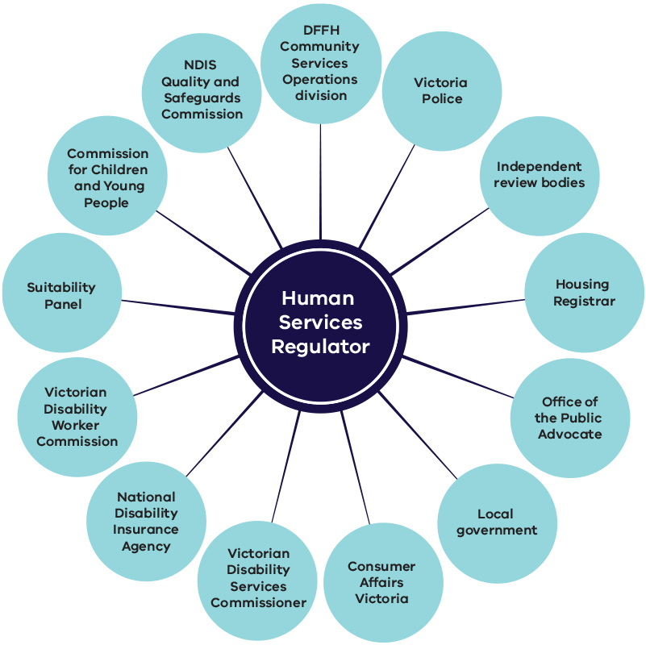

There might be instances where the HSR may not directly act on non-compliance but will instead refer the non-compliance to the primary regulator. This may involve:

* **referral** – where HSR identifies harms, or risks of harm, that are not within its scope, these will be referred to the appropriate primary regulator (including criminal activity which needs to be referred to Victoria Police).
* **referral and review** – where harms are relevant to the functions of the HSR, but HSR is not the primary regulator, it will refer the matter to the primary regulator and will monitor any regulatory action taken and the implications for HSR’s responsibilities. This may include HSR taking concurrent regulatory action.

## Our expectation of duty holders

HSR expects duty holders to comply with their obligations under applicable legislation and standards, and to engage in the following practices:

* continuously work to maintain high service quality
* engage and cooperate with the HSR
* have processes in place to identify, manage, mitigate and communicate risks
* seek feedback from and act on complaints by clients, family members, carers and community visitors
* implement advice provided by HSR
* notify HSR of any adverse incidents.

The HSR understands that many duty holders want to comply with regulatory requirements and are seeking to improve their practice as part of delivering quality services.

The HSR provides duty holders with guidance to improve compliance and recognises good performers in its approach to compliance monitoring.

There are, however, those who fail to comply and may be deliberately non-compliant. The HSR responds more firmly and will escalate its compliance and enforcement response if a duty holder is resistant, uncooperative, evasive or does not take responsibility.

# 2. Our regulatory toolkit

Legislative and policy frameworks provide HSR with a range of regulatory measures or tools to maintain and ensure compliance, and take enforcement action where necessary.

The HSR achieves its regulatory outcomes by combining a variety of regulatory tools to enforce compliance. These range from information provision to exercising legislative powers.

These tools fall under five main categories, as outlined in the following table and described in more detail in **Appendix A**.

Table : Regulatory tools

| Tool category | Role |
| --- | --- |
| **Registration (**approvals and reviews**)** | Preventative risk management, by identifying and screening applicants to ensure that they meet suitability and capacity requirements.  Addressing potential shortcomings and imposing operational requirements or restrictions. |
| **Information gathering and monitoring** | Proactive and responsive measures to monitor performance, detect non-compliance, identify risks and identify compliance guidance needs. |
| **Remedial** | Requiring a duty holder to fix identified non-compliance to ensure the problem is rectified.  Remedial action can include written or verbal advice, enforceable remedial notices or directions, or imposing conditions on registration. |
| **Collaborative peer-regulation** | Sharing information, joint operations and referrals allow better targeting and broader reach. |
| **Sanctions** | Placing limitations or restrictions on duty holders, or imposing penalties.  This may be done to prevent duty holders from committing further compliance breaches and placing people at serious risk and/or to promote compliance through deterrence. |

While the HSR emphasises preventative measures (such as education and guidance) as its starting point for engaging with duty holders, it will escalate to compliance and enforcement action where the risk is greater or where duty holders are uncooperative or repeatedly non-compliant. The emphasis of use of these tools is shown in Figure 2.

Figure : Compliance activities emphasis

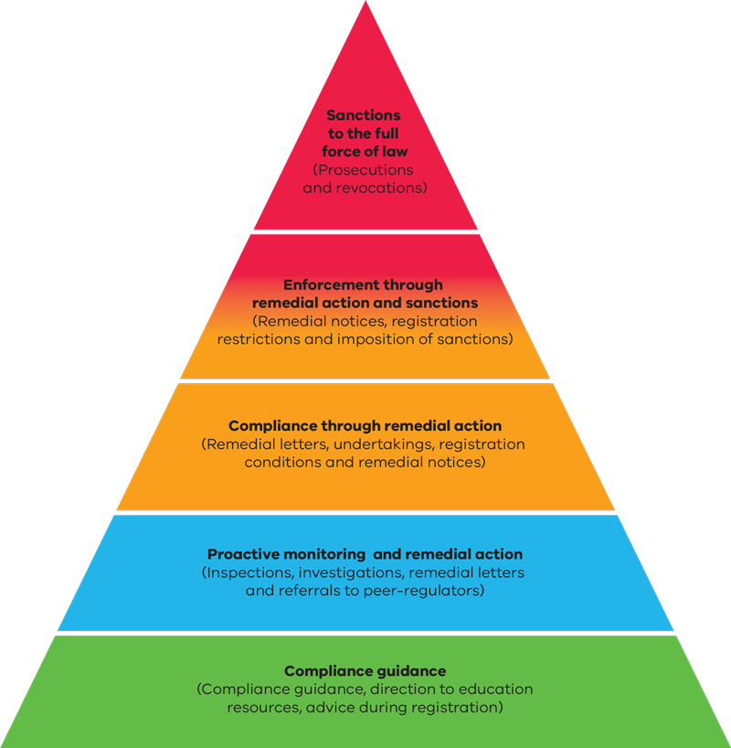

# 3. Compliance monitoring and response to non-compliance

The HSR prioritises its efforts according to an assessment of harms, and risks of harm, to people receiving relevant services.

|  |
| --- |
| **Harm** has a broad definition within HSR’s regulatory portfolio and includes physical, psychological, emotional and financial harm as well as deprivation from or limitation of rights conferred under the Victorian Charter of Human Rights |

The key activities based on this prioritisation include:

* **compliance monitoring** (such as inspections, registration reviews, investigations and desktop assessments)
* **awareness raising** (for example, directing to education resources or providing compliance guidance)
* **compliance enforcement** (for example through remedial action or sanctions).

All duty holders are subject to compliance monitoring. The HSR considers risk and intelligence in deciding the level, frequency and focus of these monitoring activities.

Duty holders who manage their risks well are likely to receive fewer inspections and will be considered to require less oversight.

Those with poor compliance history will likely be subject to more frequent and intensive desktop assessments, registration reviews and unannounced inspections.

The HSR’s *Annual regulatory plan* guides its monitoring programs.

## The HSR’s regulatory response to non-compliance

In responding to non-compliance, the HSR takes action in an outcome-focused, impartial and proportionate manner. The HSR regulatory responses depend on assessment of:

* **risk** – considering the likelihood and consequences of non-compliance; and
* **behaviour and compliance attitude** – considering the degree of fault in the non-compliance related to duty holder behaviours.

When deciding on a regulatory response, the HSR also considers the:

* specific case and circumstances of the non-compliance
* impact of an action.

The primary aim of the HSR’s regulatory response is to detect and address risks to ensure that non-compliances are rectified and to prevent harm from occurring in the future. This is primarily done through a combination of registration reviews and remedial action. While there may be costs associated with remedial actions, they are not punitive and are directed at addressing and stopping non-compliance.

### How the HSR assesses risk

Our risk-based approach uses monitoring data and intelligence to analyse the likelihood of risks occurring and their impact, to determine effective and proportionate regulatory responses.

To assess risk, we analyse the:

* **consequence of harm** – the severity of potential or actual impact of harm on people
* **likelihood of harm occurring or continuing** – how likely it is that the duty holder will breach their obligations, based on their compliance history, systems in place to identify and manage risk, capability to manage risk, the resources they dedicate to risk management and compliance attitude. (See Figure 3.)

Figure : Risk analysis matrix

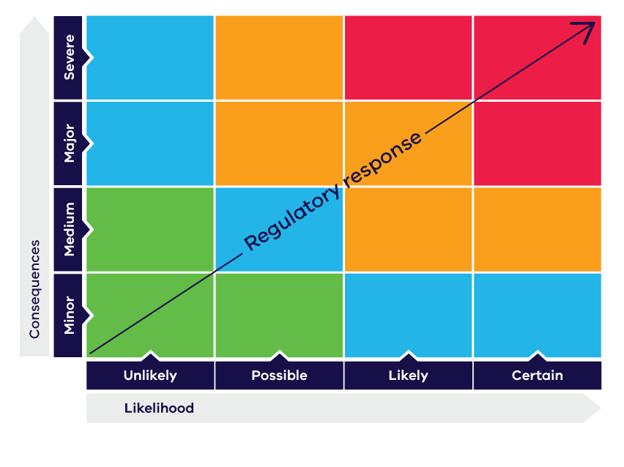

The HSR addresses a wide range of risks, including harm and adverse outcomes due to:

* neglect
* physical abuse
* emotional or psychological abuse
* sexual abuse or exploitation
* financial abuse or exploitation.

These risks can **injure** people in multiple ways, including physically, psychologically and emotionally. Often, the degree of harm to a person may not be known at the time, a risk may worsen over time or may be dependent on the individual. Therefore, the HSR’s assessment of consequence considers both actual harms and potential for harm.

|  |
| --- |
| In this policy, **injury** has a broad meaning and includes physical, psychological and emotional injury (including adverse effects suffered as a result of any form of neglect, abuse or exploitation). |

The following table (Table 5) outlines how the HSR generally considers consequences or potential consequences in risk assessments.

Table : Assessment of risk consequence

| Rating | Description |
| --- | --- |
| Minor | * Minor injury * Minor temporary impairment * Restriction of activity and food choices |
| Medium | * Moderate injury, exacerbation of existing illness or development of injury requiring regular treatment * Developmental issues |
| Major | * Premature expected death * Substantial or long-lasting injury or disability * Financial harm |
| Severe | * Avoidable death * Severe, permanent or life-changing injury or disability |

Similarly, the HSR considers the likelihood of non-compliance based on a duty holder’s behaviours (past and present) and the quality of systems in place to prevent future risks. The most common factors of a duty holder’s likelihood of non-compliance are listed in Table 6.

Table : Assessment of risk likelihood

| Rating | Description |
| --- | --- |
| Unlikely | * Duty holders who are willing to comply and have capacity to comply with only isolated previous incidents of non-compliance and complaints |
| Possible | * Duty holders who engage in repeated non-compliance and have questionable capacity to meet regulatory requirements * Duty holders who demonstrate patterns of non-compliance and have poor risk-management processes in place |
| Likely | * Duty holders who demonstrate repeated patterns of non-compliance with limited resources to meet regulatory requirements * Duty holders who have limited processes and systems in place to identify and manage risks |
| Certain | * Duty holders with a history of repeated severe non-compliance and significant complaint history * Duty holders who repeatedly fail to implement processes and systems to identify and manage risks after being put on notice about their lack of processes and systems |

When planning its responses and prioritising its effort, the HSR assesses both likelihood and consequence to determine an overall risk rating. Generally speaking, the greater the risk rating, the greater priority and seriousness of the response will be.

#### For example

* Registration applications where the duty holder has a history of non-compliance: more evidence may be needed to ensure that the duty holder does not pose any risk to health, safety and wellbeing. If appropriate, their registration may be granted subject to risk-mitigating conditions.
* For a likely non-compliance with major impact: the response will be more demanding of the duty holder and may include an enforceable remedial action.
* Where the impact is severe and likelihood of non-compliance is certain: HSR will take regulatory action as soon as possible to mitigate the risk.

### How the HSR considers duty holder behaviour and attitude to compliance

When deciding on the regulatory response to identified non-compliance, the HSR considers whether the duty holder was at fault and their degree of culpability in relation to the issue. For example, if the duty holder knew of the risk but chose not to take any steps to mitigate it, they are more likely to receive a sanction for the non-compliance.

A summary of the range of duty holder behaviours and attitudes considered by HSR are included in Table 7.

Table : Risk assessment of attitude and culpability

| Rating | Description |
| --- | --- |
| Minor | * Has no intention to cause harm * Proactively engages with regulatory process * Implements changes to prevent harms from recurring |
| Medium | * Acknowledges regulatory process but lacks capacity to comply * Has lax attitude to compliance, requiring intervention by regulator * Demonstrates patterns of disregard towards compliance requirements and fails to address reoccurrence of non-compliance |
| Major | * Reckless conduct that includes repeated non-compliance or systemic avoidance of compliance, ignorance of compliance requirements, behaviour that enables others' non-compliance * Failing to act despite knowing of existing harms and consequences of non-compliance * Non-acknowledgement or non-engagement with regulatory process |
| Severe | * Deliberate, wilful or misleading conduct that includes ongoing non-compliance, deliberate omissions and action driven by personal gain * Deliberately inflicting harm, exploitative acts, predatory behaviour and criminal acts * No regard to obvious harm or consequences, or actively hindering regulatory action |

### The HSR’s proportionate response

Once risk factors are assessed, the HSR will consider and enact a proportionate response.

While it prioritises remedial responses to risks and non-compliances, it will also apply its referral and sanctioning tools, where appropriate, to the risk and the culpability of the duty holder (see Figure 4).

If the HSR identifies or becomes aware of serious non-compliance and the entity in question poses a significant risk to the safety, wellbeing and rights of people in its care, the HSR may impose appropriate sanctions. For example, the *Supported Residential Services (Private Proprietors) Act 2010* includes a number of offences that attract prosecution or financial penalties.

The HSR may also publish and publicise enforcement outcomes that are in the public interest to inform the community of its regulatory actions, increase deterrence and promote compliance.

Figure : Regulatory responses based on duty holder risk and culpability

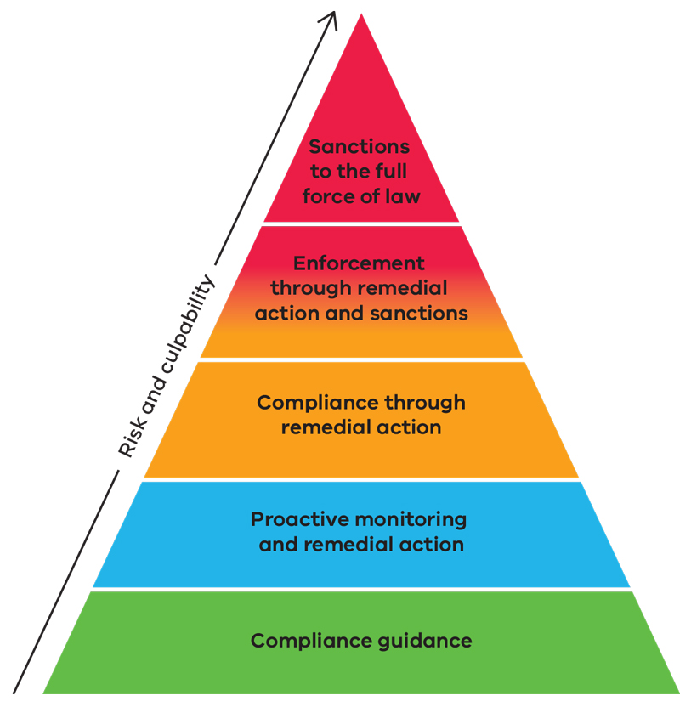

# 4. Reviews and appeals

In some instances, relevant legislation provides for a review of the HSR’s decisions at the Victorian Civil and Administrative Tribunal (VCAT).

HSR does not provide legal advice to duty holders – they should always seek their own legal advice regarding their ability to have a decision reviewed or appealed.

# Appendix A: Regulatory toolkit

## Registration

The HSR assesses and provides registration to duty holders who seek to be registered under our regulatory portfolio (except for the *Child Wellbeing and Safety Act 2005*).

This represents the initial screening point in compliance activities undertaken by HSR. It allows the HSR to prevent unfit entities and individuals from obtaining registration and providing services that would place the public at risk. It is also possible at this stage for the HSR to identify deficiencies in duty holder’s capacity to provide appropriate service and provide conditional registrations (that is, a registration granted subject to specific requirements). Some duty holders are also required to undergo registration renewal; HSR undertakes screening activities at that stage as well.

Examples of screening procedures include:

* undertaking police or criminal history checks to ensure that people with a history of offences against children are not allowed to work with children
* professional background checks to ensure the proprietor of a supported residential service has no previous relevant regulatory issues
* Supported residential services suitability check to ensure that the premises are fit for purpose.

### Practical application example

A duty holder applies to obtain registration under a relevant Act.

The HSR undertakes a professional background check to ensure that the duty holder has no previous systematic or serious non-compliance history and is suitable for registration.

## Information gathering and ongoing compliance monitoring

The HSR gathers information from a variety of sources to allow risk-based targeting of resources.

The information gathered allows the HSR to detect non-compliance early, enabling it to act to prevent or minimise harm.

HSR gathers information through:

* peer regulators
* government agencies
* community visitor reports
* notifications from family, carers, members of the public
* incident reports
* desktop assessments
* planned and responsive inspections
* investigations
* use of statutory powers including using authorised officer powers or search warrants.

### Practical application example

The HSR undertakes a planned unannounced inspection and identifies non-compliance by the duty holder.

The HSR takes regulatory action to mitigate the risk.

The HSR also uses the information obtained to identify non-compliance trends. These will be used in planning subsequent inspections.

## Remedial actions

Remedial action aims to fix identified non-compliance to ensure that the problem is rectified and the duty holder operates in a compliant manner.

Minimising harm through stopping non-compliance is the first goal of enforcement.

The HSR has a broad spectrum of remedial actions available throughout its regulatory portfolio. These remedial actions range from compliance guidance to enforceable remedial notices or directions that carry a penalty provision for non-compliance.

### The most commonly used remedial actions

* **Compliance guidance**: this is information to help a duty holder understand where they may be falling short of their obligations and allow them to rectify the problem. This may include providing the duty holder with examples of how they may remedy the non-compliance and directing them to relevant education resources. The responsibility for compliance will always rest with the duty holder and the HSR expects those who have a duty or obligation under the law to seek out relevant information and stay up to date with changing industry practices.
* **Remedial notices and directions**: these are specific directions given by HSR that have to be fulfilled within a specific timeframe. Depending on the applicable regulatory regime, if a duty holder fails to comply with these, they may face penalties.
* **Enforceable undertakings under the *Supported Residential Services (Private Proprietors) Act 2010*:** these are an instrument that records a formal commitment by duty holders to take specific actions within an agreed timeframe. If the duty holder fails to meet these commitments, they may face penalties.
* **Registration conditions**: these are specific conditions placed on duty holder’s registration to address a longstanding or a complex issue.

#### Practical application examples

**Example 1:**

* An HSR officer conducting a compliance assessment identifies minor non-compliance by a duty holder.
* The officer provides them with compliance guidance outlining the steps the duty holder may take to remediate the risk.

**Example 2:**

* An HSR officer identifies major non-compliance during an inspection.
* The duty holder is subsequently issued with an enforceable remedial notice requiring them to remedy the non-compliance within a specific timeframe.

## Collaborative peer regulation

If appropriate, the HSR shares information with peer regulators, safeguarding bodies and other departmental entities.

Departmental areas we work with include:

* **Community Services Operations division** – manages service agreements that the department enters into with service providers.

External regulators and relevant entities include:

* **Victorian Disability Services Commissioner** – manages complaints about registered disability service providers and investigates critical incidents
* **Victorian Disability Worker Commission** – manages registrations, complaints and investigations related to disability workers
* **National Disability Insurance Agency** – manages NDIS provider registrations
* **National Disability Insurance Scheme Quality and Safeguards Commission** – regulates NDIS providers and workers
* **Commissioner for Children and Young People** – regulates Child Safe Standards and the Reportable Conduct Scheme under the *Child Wellbeing and Safety Act 2005*
* **Suitability Panel** – determines whether out-of-home carers should be disqualified from the Carer’s Register
* **Victoria Police** – investigates criminal offences
* **Office of the Public Advocate** – manages the Community Visitor program and guardianship arrangements
* **Independent review bodies** – accredit and audit regulated entities
* **Housing Registrar** – regulates registered non-government housing agencies and accommodation providers
* **local government** – regulates building and food safety
* **Consumer Affairs Victoria** – regulates rooming houses.

### Practical application examples

**Example 1:**

* Where a duty holder receives government funding, the HSR refers identified issues to the department’s service agreements area

**Example 2:**

* The HSR becomes aware of an entity potentially operating as an unregistered supported residential service or a rooming house.
* To ascertain whether the entity is registered as a rooming house, the HSR shares available information with the relevant local council to determine the entity’s status and establish who is responsible for regulatory oversight of the entity.

## Imposition of sanctions

The HSR may impose sanctions to reduce the likelihood of duty holders committing further compliance breaches and to apply a penalty for breaking the law.

This is important to deter duty holders from breaching their compliance obligations, particularly those who seek to evade their obligations or profit from breaking the law. It also indirectly recognises the efforts of duty holders who do invest in ensuring ongoing compliance.

The first priority is always to prevent further harm and remedy the problem. This may include operational restrictions to mitigate a significant risk. However, where the duty holder is not compliant with the remedy or their actions pose significant risk, sanctions may be imposed.

In cases of severe non-compliance, sanctions may involve revoking registration or prosecuting the duty holder (where applicable).

Depending on the applicable legislation, examples of sanctions include:

* official warnings
* limitations and restrictions – such as limitation of admission rights
* infringement notices and penalties – penalties for failure to comply with a remedial notice or a statutory provision that may be the subject of an infringement notice
* temporary suspension – where significant risks are identified and the duty holder must rectify these before providing service again
* revocation of duty holder’s registration due to severe risks and inability to rectify them.

Under the *Supported Residential Services (Private Proprietors) Act 2010*, in the case of severe or repeated risks or non-compliance, the HSR may decide to prosecute the duty holder. Circumstances where the HSR may decide to prosecute the duty-holder include (but are not limited to):

* significant ongoing safety and wellbeing concerns
* significant impact of non-compliance
* actions and non-compliance to a degree that is incompatible with the duty holder being a suitable person to provide services
* non-compliance that significantly undermines public confidence.

Where available, the HSR can seek the same financial penalty with civil action as it could with criminal prosecution. The HSR will use criminal jurisdiction when it is considered the most effective option, including whether a conviction, fine or imprisonment (where available) is appropriate.

### Practical application examples

**Example 1:**

* In the case of a proprietor of a supported residential service, a duty holder has been issued with a compliance notice.
* The duty holder fails to have the notice displayed in a conspicuous place on the premises as required by section 163 of the *Supported Residential Services (Private Proprietors) Act 2010*.
* As a result, HSR issues an infringement notice.

**Example 2:**

* A duty holder engages in repeated non-compliance that present a severe risk of harm.
* In doing so, the duty holder also fails to cooperate with the HSR and follow previous remedial notices.
* Due to the duty holder’s record and the severity of the identified risks, the HSR revokes the duty holder’s registration.

# Appendix B: Image descriptions

## Compliance activities emphasis

Pyramid of compliance activities with most severe and less frequently used (level 1) at the top and least severe and most used (level 5) at the base.

* Level 1: Sanctions to the full force of the law (prosecutions and revocations)
* Level 2: Enforcement through remedial action and sanctions (remedial notices, registration restrictions and imposition of sanctions)
* Level 3: Compliance through remedial action (remedial letters, undertakings, registration conditions and remedial notices)
* Level 4: Proactive monitoring and remedial action (inspections, investigations, remedial letters and referrals to peer regulators)
* Level 5: Compliance guidance (compliance guidance, direction to education resources, advice during registration)

Return to **Our regulatory toolkit**.

## Risk analysis matrix

The following table outlines the overall risk rating based on the assessment of consequence and likelihood, as shown in Figure 3: Risk analysis matrix.

As overall risk increases, the HSR is more likely to use increasingly severe compliance activities (from guidance through to sanctions).

Table : Consequence, likelihood and overall risk

| Consequence | Likelihood: Unlikely | Likelihood: Possible | Likelihood: Likely | Likelihood: Certain |
| --- | --- | --- | --- | --- |
| Severe | Overall: Medium | Overall: High | Overall: Extreme | Overall: Extreme |
| Major | Overall: Medium | Overall: High | Overall: High | Overall: Extreme |
| Medium | Overall: Low | Overall: Medium | Overall: High | Overall: High |
| Minor | Overall: Low | Overall: Low | Overall: Medium | Overall: Medium |

Return to **How the HSR assesses risk**.

1. With the exception of the Child Wellbeing and Safety Act 2005 (CWS Act)
2. DFFH refers to the Department of Families, Fairness and Housing in this figure