|  |
| --- |
| **Homes Victoria Rental Report**  June Quarter 2024 |
|  |



Contents

List of tables 3

List of figures 3

Overview 4

Trends in rents 4

New lettings 4

Active bonds 4

Turnover 4

Investor lending 4

Vacancy rates 5

Rental affordability 5

Current rents 6

Rent Indices 6

Median rents by region 7

Median rents by major property types 8

Moving annual median rents by suburb or town 8

Where are median rents highest? Where are median rents lowest? 11

Rental availability 12

New Lettings 12

Active bonds 13

Turnover and length of tenancy 15

Investor finance 16

Vacancy rate 17

Rental market affordability 18

Overall trends 18

Trends by household type 18

Trends by region 20

Trends by Local Government Area 20

Notes 38

# List of tables

Table 1: Median rents and metropolitan Melbourne and regional Victoria rent indices 6

Table 2: Median rents for new lettings by statistical region 7

Table 3: Median rents by major property types 8

Table 4: Highest and lowest moving annual median rents in metropolitan Melbourne and regional Victoria 11

Table 5: New lettings for metropolitan Melbourne, regional Victoria and Victoria 12

Table 6: New lettings for statistical regions Victoria 12

Table 7: Turnover and tenancy duration 15

Table 8: Median tenancy duration and turnover by dwelling size 15

Table 9: Rental affordability by indicative households on Centrelink incomes 19

Table 10: Rental affordability for households on the Age Pension or Disability Support Pension 19

Table 11: Affordable lettings by region for indicative households on Centrelink incomes 20

Table 12: Moving annual median rents for suburbs/town by major property type 22

Table 13: Median rents for local government areas by DHS region, by major property type 30

Table 14: Affordable lettings for Local Government Areass 34

Table 15: Active bonds by local government area 37

# List of figures

Figure 1: Metropolitan Rent Index and Regional Rent Index - annual percentage change 6

Figure 2: Moving annual median rents by suburb for two-bedroom flats, metropolitan Melbourne 9

Figure 3: Moving annual median rents by suburb for three-bedroom houses, metropolitan Melbourne 9

Figure 4: Total active residential bonds, Victoria – annual percentage change 13

Figure 5: Number of active bonds, metropolitan Melbourne and regional Victoria 14

Figure 6: Lending to household investors in residential housing, Victoria ($2024 June) 16

Figure 7: Rental vacancy rate 17

Figure 8: Affordable rentals as percentage of all new rentals 18

Figure 9: Affordable dwellings, metropolitan Melbourne and regional Victoria 21

# Overview

## Trends in rents

The Metropolitan Rent Index (MRI) increased by 0.8 per cent over the June quarter 2024, and by 10.9 per cent over the previous year. This annual increase is lower than the annual increase to the June Quarter 2023 (15.7%), but above the long-term average annual increase over the past 10 years (4.0%).

The Regional Rent Index (RRI) increased by 1.2 per cent over the June quarter, and by 6.0 per cent over the previous year. This annual increase is higher than the annual increase to the June quarter 2023 (5.4%) and above the long-term average annual increase over the past 10 years (4.6%).

Rent Indices at a glance

|  |  |  |  |
| --- | --- | --- | --- |
|  | Median Rent (per week) | Quarterly Change* | Annual Change* |
| Metropolitan Melbourne | $550 | 0.8% | 10.9% |
| Regional Victoria | $450 | 1.2% | 6.0% |
| Victoria | $540 | 0.8% | 10.2% |

* Percentage change figures are calculated from relevant Rent Index

## New lettings

Across the state, 48,014 bonds have been lodged for new lettings beginning in the June quarter 2024. This is 6.4 per cent less than have been registered for the June quarter 2023 statewide, 7.0 per cent less for metropolitan Melbourne, and 3.9 per cent less for regional Victoria (see note 4 for qualifications).

Metropolitan Melbourne accounted for 80.9 per cent of all new lettings in Victoria.

## Active bonds

At the end of the June quarter 2024, the total number of active bonds held in Victoria was 654,717, 3.2 per cent less than recorded for the June quarter 2023 (see note 4 for qualifications). On average the number of active bonds has increased by 1.6 per cent annually over the past 5 years, and by 2.9 per cent annually over the past 10 years.

## Turnover

The quarterly turnover rate for rental properties in metropolitan Melbourne was 8.9 per cent, 1.6 percentage points higher than the rate in June 2023 (7.3%). The average length of stay was 24 months, compared to an average stay of 21 months for the June quarter 2023.

The quarterly turnover rate in regional Victoria was 7.9 per cent, 0.7 percentage points higher than the rate in June 2023 (7.2%). The average length of stay was 23 months, slightly longer that the average stay of 22 months for the June quarter 2023.

## Investor lending

In the June quarter 2024, Victorian households borrowed $7.142 billion for the purpose of investment in residential housing, 9.2 per cent more than in the June quarter 2023.

## Vacancy rates

The trend vacancy rate for metropolitan Melbourne remained stable over the quarter at 2.2 per cent, falling from 2.3 per cent in June 2023. The trend vacancy rate for regional Victoria has remained stable over the quarter at 2.1 per cent, falling from 2.2 per cent in June 2023.

## Rental affordability

Statewide, 12.1 per cent of new lettings over the June quarter 2024 met affordability criteria for low-income households. This was a marginal improvement over the March quarter 2024 (12.0%), and an improvement of 1.6 percentage points compared to the June quarter 2023.

In metropolitan Melbourne, 6.3 per cent of new lettings met affordability criteria, a decline of 0.2 percentage points over the quarter, and 0.4 percentage points over the year.

In regional Victoria, 36.5 per cent of new lettings met affordability criteria, a decline of 0.9 percentage points over the quarter, but an improvement of 9.6 percentage points over the year.

# Current rents

## Rent Indices

Table 1 shows median rents and rent indices for both metropolitan Melbourne and regional Victoria for the June quarter 2024.

The Metropolitan Rent Index (MRI) increased by 0.8 per cent over the June quarter, though the median rent for metropolitan Melbourne decreased by $10 to $550 per week. The Regional Rent Index (RRI) increased by 1.2 per cent over the June quarter, with the median rent for regional Victoria increasing by $10 to $450 per week.

The Metropolitan and Regional Rent Indices are a better measure of changes in rents over time than the simple median price measure, because the indices control for variation in the share of new lettings by geographical area and property type. Median rent only measures the mid-point in the distribution of rents (with 50 per cent of rents at or above the median, and 50 per cent of rents at or below), and several properties on the median rent can disguise overall changes in rents over time.

Table 1: Median rents and metropolitan Melbourne and regional Victoria rent indices

|  |  |  |  |  |
| --- | --- | --- | --- | --- |
|  | Median Rent (per week) | Rent Index | Quarterly Change* | Annual Change* |
| Melbourne | $550 | 304.8 | 0.8% | 10.9% |
| Regional Victoria | $450 | 322.5 | 1.2% | 6.0% |
| Victoria | $540 | 303.8 | 0.8% | 10.2% |

* Percentage change figures are calculated from relevant Rent Index

Figure 1 shows the annual percentage change in the Metropolitan Rent Index and the Regional Rent Index over the past 10 years.

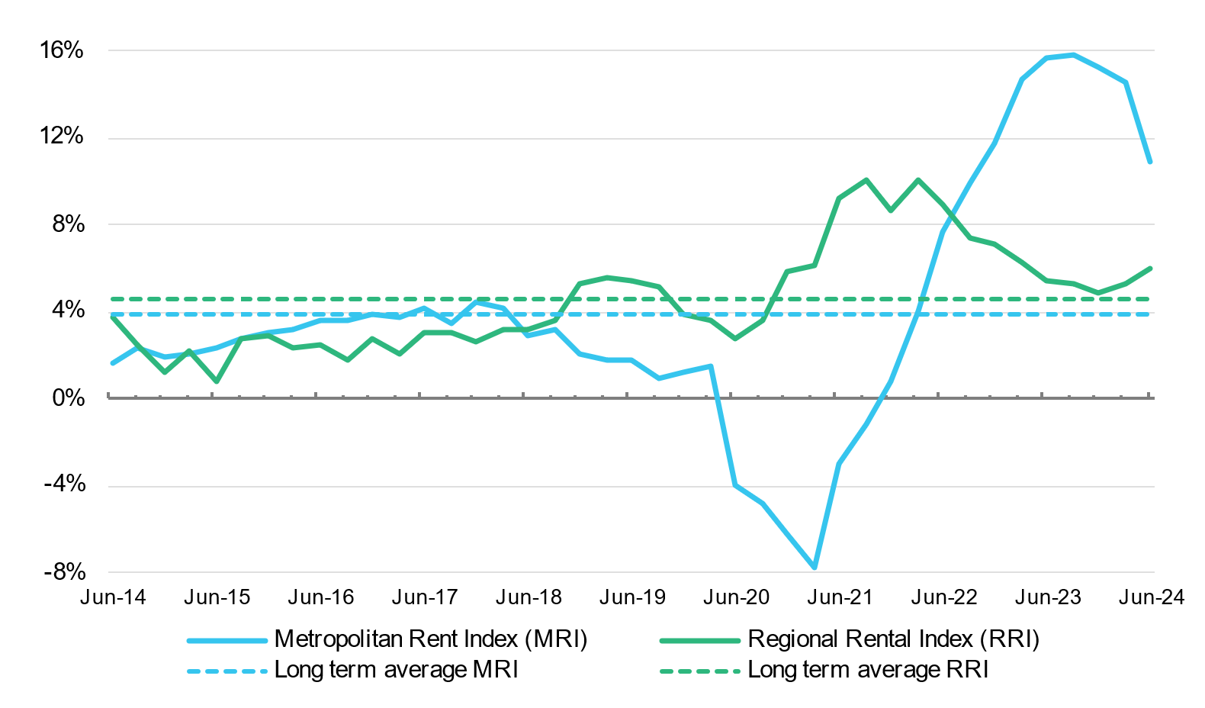Figure 1: Metropolitan Rent Index and Regional Rent Index - annual percentage change

The MRI increased 0.8 per cent over the June quarter 2024, significantly lower than last quarter’s 4.6 per cent increase, and the 4.1 per cent increase seen over the June quarter of 2023. Over the past year the MRI increased 10.9 per cent, lower than the annual increase to the June quarter 2023 (15.7%), but still significantly higher than the ten-year average (4.0%).

In the June quarter, the RRI increased by 1.2 per cent. This increase compares with a 2.6 per cent increase in the last quarter and a 0.4 per cent increase in the June quarter of last year. Over the past year, the RRI has increased 6.0 per cent. This increase is higher than the annual increase to the June quarter 2023 (5.4%) and above the long-term average increase over the past 10 years (4.6%).

## Median rents by region

Table 2 shows median rents for new lettings in the June quarter 2024 for 14 statistical regions in Victoria (9 in metropolitan Melbourne and 5 in regional Victoria).

In metropolitan Melbourne, the median rent ranged from $500 per week in Western Melbourne to $625 per week in Inner Eastern Melbourne. In the June quarter, the median rent increased in Inner Eastern Melbourne (0.8%), Western Melbourne (1.0%), North Western Melbourne (1.0%), North Eastern Melbourne (1.9%), Outer Eastern Melbourne (1.8%) and South Eastern Melbourne (1.9%), remained stable in Southern Melbourne and Mornington Peninsula, and decreased in Inner Melbourne (-4.6%). Over the 12 months to the June quarter, the median rent increased in all regions: Inner Melbourne (5.1%), Inner Eastern Melbourne (11.6%), Southern Melbourne (8.8%), Western Melbourne (11.1%), North Western Melbourne (12.8%), North Eastern Melbourne (12.8%), Outer Eastern Melbourne (12.0%), South Eastern Melbourne (15.8%) and Mornington Peninsula (10.0%).

In regional Victoria, the median rent ranged from $420 per week in Gippsland and Central Highlands-Wimmera, to $480 per week in Barwon-South West. In the June quarter, the median rent increased in Goulburn-Ovens-Murray (2.3%), Loddon-Mallee (3.4%),Central Highlands-Wimmera (1.2%), and remained stable in Barwon South-West and Gippsland. Over the 12 months to the June quarter, the median rent increased in all regions: Barwon-South West (6.7%), Gippsland (5.0%), Goulburn-Ovens-Murray (7.1%), Loddon-Mallee (9.8%) and Central Highlands-Wimmera (7.7%).

Table 2: Median rents for new lettings by statistical region

|  |  |  |  |
| --- | --- | --- | --- |
| Region | Median Rent | Quarterly Change* | Annual Change* |
| **Metropolitan Melbourne** | | | |
| Inner Melbourne | $620 | -4.6% | 5.1% |
| Inner Eastern Melbourne | $625 | 0.8% | 11.6% |
| Southern Melbourne | $620 | 0.0% | 8.8% |
| Western Melbourne | $500 | 1.0% | 11.1% |
| North Western Melbourne | $530 | 1.0% | 12.8% |
| North Eastern Melbourne | $530 | 1.9% | 12.8% |
| Outer Eastern Melbourne | $560 | 1.8% | 12.0% |
| South Eastern Melbourne | $550 | 1.9% | 15.8% |
| Mornington Peninsula | $550 | 0.0% | 10.0% |
| **Regional Victoria** | | | |
| Barwon-South West | $480 | 0.0% | 6.7% |
| Gippsland | $420 | 0.0% | 5.0% |
| Goulburn-Ovens-Murray | $450 | 2.3% | 7.1% |
| Loddon-Mallee | $450 | 3.4% | 9.8% |
| Central Highlands-Wimmera | $420 | 1.2% | 7.7% |

* Percentage change figures are calculated from median rents in the region

## Median rents by major property types

Table 3 provides the median rents for new lettings in the June quarter 2024 for the six major property types, both in metropolitan Melbourne and regional Victoria, as well as the quarterly and annual change in the relevant Rent Index for each property type.

In metropolitan Melbourne, the highest median rent is for three-bedroom flats ($650 per week) and the lowest median rent is for one-bedroom flats ($470 per week). In the June quarter, the Rent Index for metropolitan Melbourne increased for two-bedroom flats (1.3%), three-bedroom flats (0.6%), three-bedroom houses (2.2%) and four-bedroom houses (0.1%), and decreased for one-bedroom flats (-0.8%) and two-bedroom houses (-1.7%). Over the twelve months to the June quarter, the Rent Index increased for all property types in metropolitan Melbourne: one-bedroom flats (13.2%), two-bedroom flats (10.0%), three-bedroom flats (9.4%), two-bedroom houses (9.3%), three-bedroom houses (11.6%) and four-bedroom houses (10.5%).

In regional Victoria, the highest median rent is for four-bedroom houses ($520 per week), and the lowest median rent is for one-bedroom flats ($280 per week). In the June quarter, the Rent Index increased for all property types in regional Victoria: increases ranged from 0.3 per cent for two-bedroom flats to 1.8 per cent for four-bedroom houses. Over the twelve months to the June quarter, the Rent Index increased for all property types in regional Victoria: increases ranged from 3.7 per cent for one-bedroom flats to 6.6 per cent for two-bedroom flats.

Note: The metropolitan Melbourne medians reflect the geographic distribution of different property types. Houses tend to be the dominant rental property type in outer metropolitan areas, whereas flats are more prevalent in areas closer to the centre of Melbourne.

Table 3: Median rents by major property types

|  |  |  |  |  |
| --- | --- | --- | --- | --- |
|  | Property Type | Median Rent | Quarterly Change* | Annual Change* |
| Metropolitan Melbourne | 1 Bed Flat | $470 | -0.8% | 13.2% |
| 2 Bed Flat | $580 | 1.3% | 10.0% |
| 3 Bed Flat | $650 | 0.6% | 9.4% |
| 2 Bed House | $555 | -1.7% | 9.3% |
| 3 Bed House | $550 | 2.2% | 11.6% |
| 4 Bed House | $580 | 0.1% | 10.5% |
| Regional Victoria | 1 Bed Flat | $280 | 1.5% | 3.7% |
| 2 Bed Flat | $360 | 0.3% | 6.6% |
| 3 Bed Flat | $450 | 0.7% | 6.5% |
| 2 Bed House | $380 | 0.5% | 5.7% |
| 3 Bed House | $450 | 1.1% | 6.3% |
| 4 Bed House | $520 | 1.8% | 5.2% |

* Percentage change figures are calculated from relevant Rent Index

## Moving annual median rents by suburb or town

Table 12 shows the moving annual median rents for suburbs and towns across Victoria by major property type (note that the medians in Table 12 are moving *annual* medians, not quarterly medians, and that the annual percentage change is calculated from these moving annual medians).

Figure 2 and Figure 3 show moving annual median rents in metropolitan Melbourne, for two-bedroom flats and for three-bedroom houses, respectively. They show the pattern of concentration of the highest median rents in Inner Melbourne, and in parts of Inner Eastern Melbourne and Southern Melbourne.

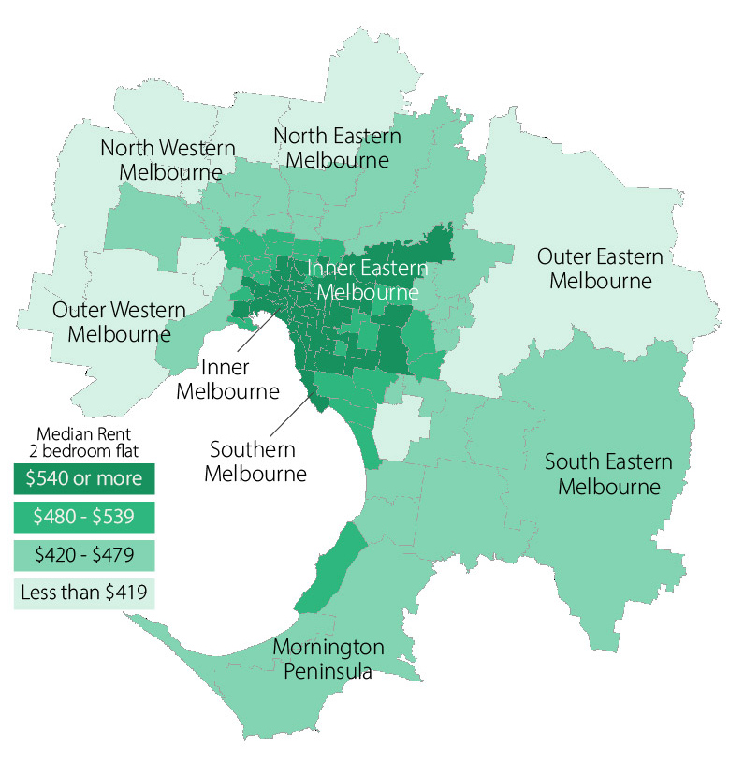Figure 2: Moving annual median rents by suburb for two-bedroom flats, metropolitan Melbourne

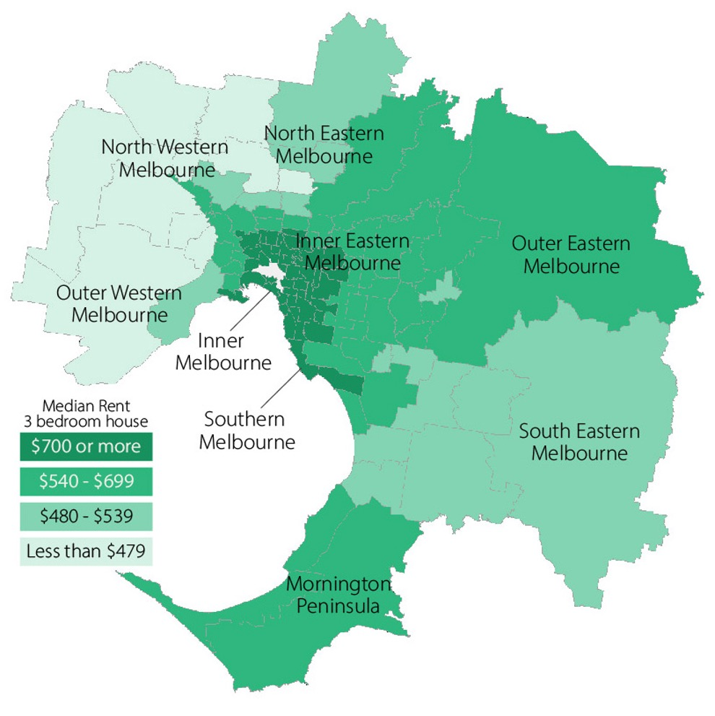Figure 3: Moving annual median rents by suburb for three-bedroom houses, metropolitan Melbourne

For two-bedroom flats in metropolitan Melbourne, the moving annual median rent to the June quarter increased in all suburbs. The highest increases were in Newport-Spotswood (31.6 per cent higher than the moving annual median rent in the June quarter 2023), Chadstone-Oakleigh (22.2%), Clayton (22.2%), West Brunswick (22.0%), Box Hill (21.9%), Hawthorn (21.1%), Yarraville-Seddon (21.1%), Essendon (20.5%), St Kilda (20.0%), and Brighton East (20.0%).

For two-bedroom flats in regional Victoria, the moving annual median rent to the June quarter remained stable in Horsham and Torquay, decreased in Ocean Grove-Barwon Heads (-1.1%) and Seymour (-0.9%), and increased in all other towns. The towns with the highest increases were Swan Hill (15.5%), Geelong-Newcomb (13.4%), Bendigo (11.4%), Shepparton (10.0%), Morwell (9.6%), Traralgon (9.4%), Wodonga (9.4%), Flora Hill-Bendigo East (9.1%), Mildura (9.1%) and Sale-Maffra (9.1%).

For three-bedroom houses in metropolitan Melbourne, the moving annual median rent to the June quarter increased in all suburbs except Hampton-Beaumaris where it remained stable. The highest increases were in Heidelberg-Heidelberg West (27.7%), Keilor (27.3%), Dandenong (22.2%), Springvale (21.4%), Footscray (20.4%), Toorak (19.6%), Thomastown-Lalor (18.8%), West Brunswick (18.7%), North Melbourne-West Melbourne (18.3%) and St Kilda (18.3%).

For three-bedroom houses in regional Victoria, the moving annual median rent to the June quarter remained stable in Hamilton, decreased in Ocean Grove-Barwon Heads (-0.9%), and increased in all other towns. The highest increases were in Swan Hill (12.2%), Horsham (11.1%), Shepparton (10.0%), Echuca (9.3%), Mildura (8.7%), Warrnambool (8.7%), Seymour (8.1%) and Traralgon (7.5%).

## Where are median rents highest? Where are median rents lowest?

Table 4 provides the highest and lowest median rents for metropolitan Melbourne and regional Victoria.

Table 4: Highest and lowest moving annual median rents in metropolitan Melbourne and  
regional Victoria

|  |  |  |  |
| --- | --- | --- | --- |
| Where are median rents highest? | | Where are median rents lowest? | |
| **2 Bedroom flat** | | | |
| *Metropolitan Melbourne* | | | |
| Docklands | $710 | Melton | $335 |
| Fitzroy | $710 | Werribee-Hoppers Crossing | $380 |
| CBD-St Kilda Rd | $700 | St Albans-Deer Park | $385 |
| Port Melbourne | $700 | Dandenong | $400 |
| Southbank | $700 | Sunbury | $400 |
|  |  | Sunshine | $400 |
| *Regional Victoria* | | | |
| Torquay | $480 | Morwell | $285 |
| Geelong-Newcomb | $465 | Moe-Newborough | $290 |
| Ocean Grove-Barwon Heads | $440 | Hamilton | $293 |
| Newtown | $420 | Horsham | $300 |
| Belmont-Grovedale | $410 | Mildura | $300 |
|  |  | Wangaratta | $320 |
| **3 Bedroom house** | | | |
| *Metropolitan Melbourne* | | | |
| Toorak | $1,250 | Melton | $400 |
| East Melbourne | $1,175 | St Albans-Deer Park | $430 |
| Albert Park-Middle Park-West St Kilda | $1,150 | Sunbury | $450 |
| Brighton | $1,100 | Sunshine | $450 |
| South Yarra | $1,100 | Sydenham | $450 |
| Armadale | $1,093 | Werribee-Hoppers Crossing | $450 |
| Elwood | $1,073 | Broadmeadows-Roxburgh Park | $460 |
| *Regional Victoria* | | | |
| Torquay | $630 | Hamilton | $360 |
| Newtown | $530 | Morwell | $360 |
| Ocean Grove-Barwon Heads | $530 | Moe-Newborough | $380 |
| Herne Hill-Geelong West | $500 | Corio | $390 |
| Warrnambool | $500 | Sebastopol-Delacombe | $390 |

More detail on median rents by location and property type can be found in Table 12, and in the expanded version of Table 12 (containing extra property types as well as lower and upper quartile information) that can be found in the Rental Report June Quarter 2024 data tables available for download from the Homes Victoria website: <https://www.dffh.vic.gov.au/publications/rental-report>.

# Rental availability

## New Lettings

The number of new lettings provides an indicator of the overall availability of rental housing for a specific period. A new letting can result from two main sources: turnover in an existing rental property or a new addition to the stock of rental housing. Table 5 shows the number of new rental lettings for the June quarter 2024 and the June quarter 2023.

As of the end of the June quarter 2024, 48,014 bonds have been lodged for tenancies commencing during the June quarter 2024, 6.4 per cent less than for the June quarter 2023. However, these figures are subject to upward revision due to the late lodgement of bonds (see note 4 on page 39 of this report).

Metropolitan Melbourne accounted for 80.9 per cent of all new lettings in Victoria.

Table 5: New lettings for metropolitan Melbourne, regional Victoria and Victoria

|  |  |  |  |
| --- | --- | --- | --- |
|  | **Jun-24** | **Jun-23** | **Change** |
| Melbourne | 38,830 | 41,734 | -7.0% |
| Regional Victoria | 9,184 | 9,559 | -3.9% |
| Victoria | 48,014 | 51,293 | -6.4% |

Table 6 lists the number of new lettings across each of the 14 statistical regions.

Compared to the June quarter 2023, fewer new lettings have been recorded for the June quarter 2024 in all metropolitan Melbourne regions: Inner Melbourne (-10.5%), Inner Eastern Melbourne (-6.3%), Southern Melbourne (-1.5%), Western Melbourne (-3.2%), North Western Melbourne (-6.1%), North Eastern Melbourne (-2.7%), Outer Eastern Melbourne (-17.8%), South Eastern Melbourne (-8.8%) and Mornington Peninsula (-8.4%).

In regional Victoria, fewer new lettings have been recorded for the June quarter 2024 in all regions: Barwon-South West (-3.5%), Gippsland (-5.8%), Goulburn-Ovens-Murray (-2.2%), Loddon-Mallee (-8.5%) and Central Highlands-Wimmera (-0.6%).

Table 6: New lettings for statistical regions Victoria

|  |  |  |  |
| --- | --- | --- | --- |
| **Region** | **Jun-24** | **Jun-23** | **Change** |
| **Metropolitan Melbourne** | | | |
| Inner Melbourne | 9,816 | 10,969 | -10.5% |
| Inner Eastern Melbourne | 4,503 | 4,804 | -6.3% |
| Southern Melbourne | 3,192 | 3,241 | -1.5% |
| Western Melbourne | 7,197 | 7,435 | -3.2% |
| North Western Melbourne | 3,786 | 4,031 | -6.1% |
| North Eastern Melbourne | 3,665 | 3,765 | -2.7% |
| Outer Eastern Melbourne | 1,518 | 1,847 | -17.8% |
| South Eastern Melbourne | 3,530 | 3,871 | -8.8% |
| Mornington Peninsula | 1,623 | 1,771 | -8.4% |
| **Regional Victoria** | | | |
| Barwon-South West | 2,887 | 2,993 | -3.5% |
| Gippsland | 1,521 | 1,614 | -5.8% |
| Goulburn-Ovens-Murray | 1,820 | 1,860 | -2.2% |
| Loddon-Mallee | 1,361 | 1,487 | -8.5% |
| Central Highlands-Wimmera | 1,595 | 1,605 | -0.6% |

## Active bonds

The total number of bonds held by the Residential Tenancies Bond Authority (RTBA) at a given point in time provides an indicator of the total stock of rental housing.

The total number of active bonds held in Victoria was 654,717. This figure is 3.2 per cent lower than for the June quarter 2023, but it is subject to upward revision due to the late lodgement of bonds (see note 4 on page 39 of this report). On average, the number of active bonds has increased by 1.6 per cent annually over the past 5 years, and 2.9 per cent annually over the past 10 years.

On average over the past 5 years, the number of active bonds has increased by 1.7 per cent annually in metropolitan Melbourne and 1.0 per cent annually in regional Victoria.

Figure 4 shows the trend in active bonds over the past five years.

Figure 4: Total active residential bonds, Victoria – annual percentage change

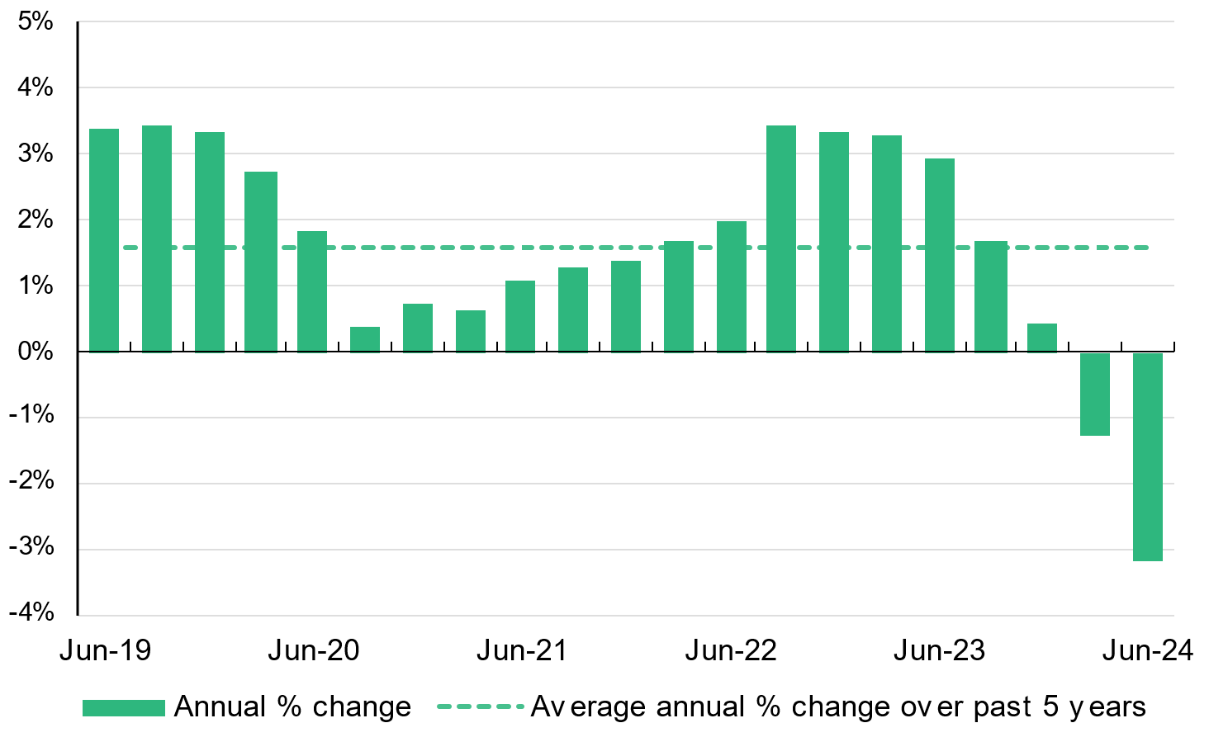

The largest numbers of active bonds in metropolitan Melbourne are in the municipalities of Melbourne (59,935 - 11.3% of the total number of active bonds in metropolitan Melbourne), Wyndham (29,980 - 5.6%), Merri-bek (25,918 - 4.9%), Casey (25,491 - 4.8%), Glen Eira (22,931 - 4.3%), Stonnington (21,712 - 4.1%), Melton (20,875 - 3.9%), Port Phillip (20,625 - 3.9%) and Darebin (19,725 - 3.7%).

Over the five-year period to the June quarter 2024, the highest increases in the number of active bonds have been seen mainly in municipalities on Melbourne’s outer fringe: Melton (54.4%), Wyndham (25.6%), Casey (16.6%), Hume (14.3%) and Whittlesea (13.7%). A high increase was also seen in the municipality of Melbourne (19.0%). Over the past five years, Glen Eira has had no increase in the number of active bonds, and Yarra only a very small increase (0.2%). Decreases of up to 7.9 per cent were seen in Bayside, Boroondara, Brimbank, Darebin, Frankston, Greater Dandenong, Hobsons Bay, Kingston, Knox, Maroondah, Merri-bek, Mornington Peninsula, Nillumbik, Port Phillip, Stonnington, and Yarra Ranges.

The largest numbers of active bonds in regional Victoria are in the municipalities of Greater Geelong (25,072 - 20.4% of the total number of active bonds in regional Victoria), Ballarat (13,433 – 11.0%), Greater Bendigo (10,139 - 8.3%), Latrobe (6,542 - 5.3%), Greater Shepparton (5,515 - 4.5%, Mildura (4,953 - 4.0%) and Wodonga (4,271 - 3.5%). Over the past 5 years, the highest increases have been in the municipalities of Surf Coast (64.5%), Golden Plains (49.9%), Mitchell (39.5%), Ballarat (13.8%), Baw Baw (9.5%), Moorabool (9.4%), West Wimmera (8.2%) and Benalla (5.9%).

Over the past 5 years, the number of active bonds has decreased in twenty-eight of the forty-eight regional municipalities: Bass Coast, Campaspe, Central Goldfields, Colac-Otway, Corangamite, East Gippsland, Gannawarra, Glenelg, Greater Bendigo, Hepburn, Hindmarsh, Horsham, Indigo, Loddon, Mildura, Moira, Mount Alexander, Moyne, Murrindindi, Northern Grampians, Queenscliffe, South Gippsland, Southern Grampians, Swan Hill, Towong, Warrnambool, Wellington, and Yarriambiack. Decreases ranged from 0.3 per cent in Murrindindi to 17.6 per cent in Queenscliffe.

More detail on the number of active bonds in each local government area for the June quarter 2024, and changes in the number active bonds over the past twelve months and over the past 5 years, is available in Table 15 on page 37 of this report.

Figure 5 illustrates the distribution of active bonds for metropolitan Melbourne by suburb, and for regional Victoria by local government area.

Figure 5: Number of active bonds, metropolitan Melbourne and regional Victoria

**Active bonds, metropolitan Melbourne by suburb**

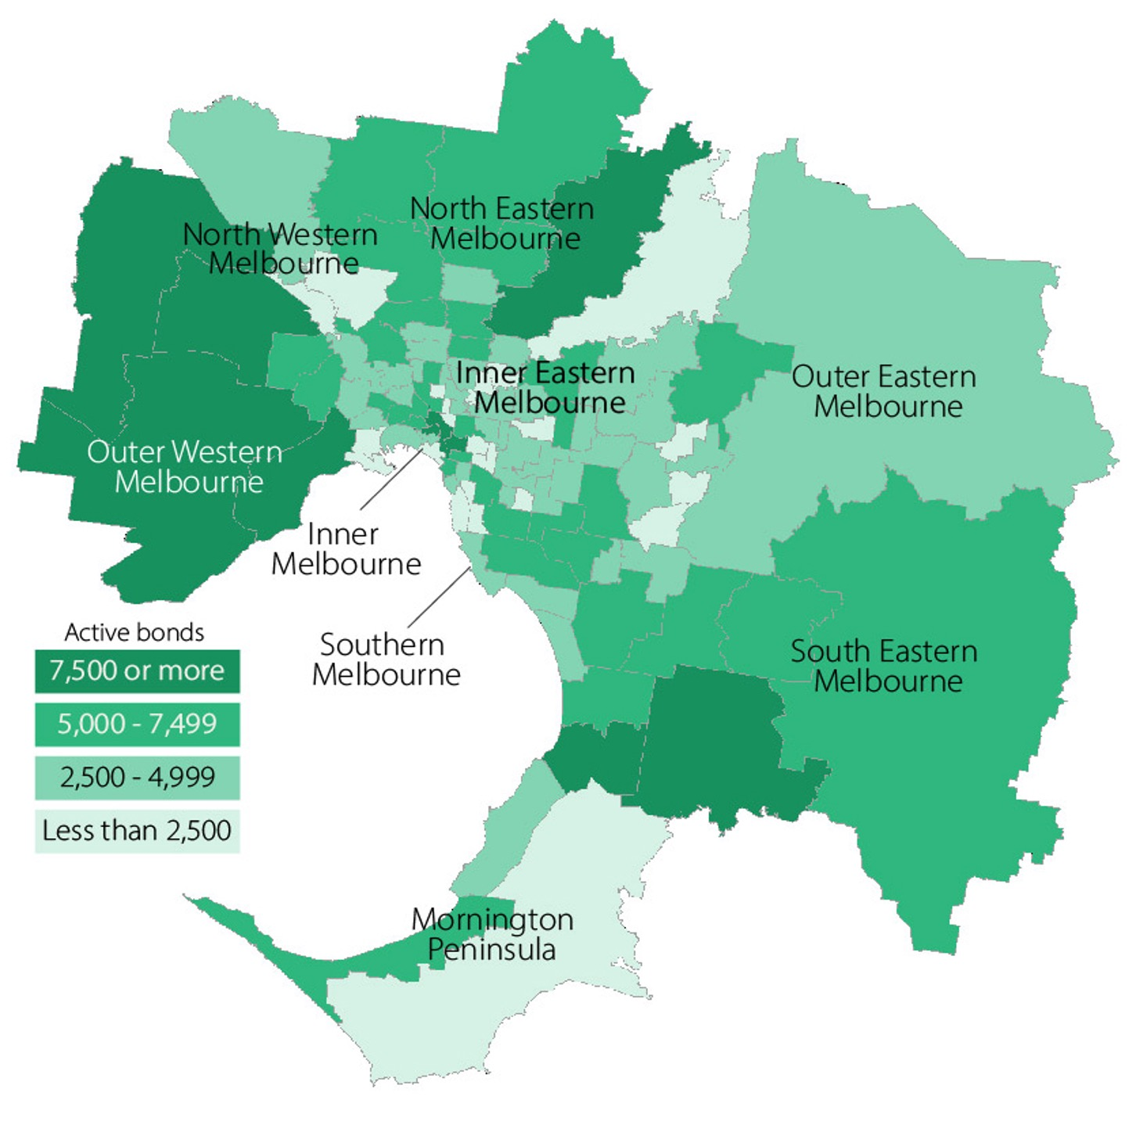

**Active bonds, regional Victoria by local government area**

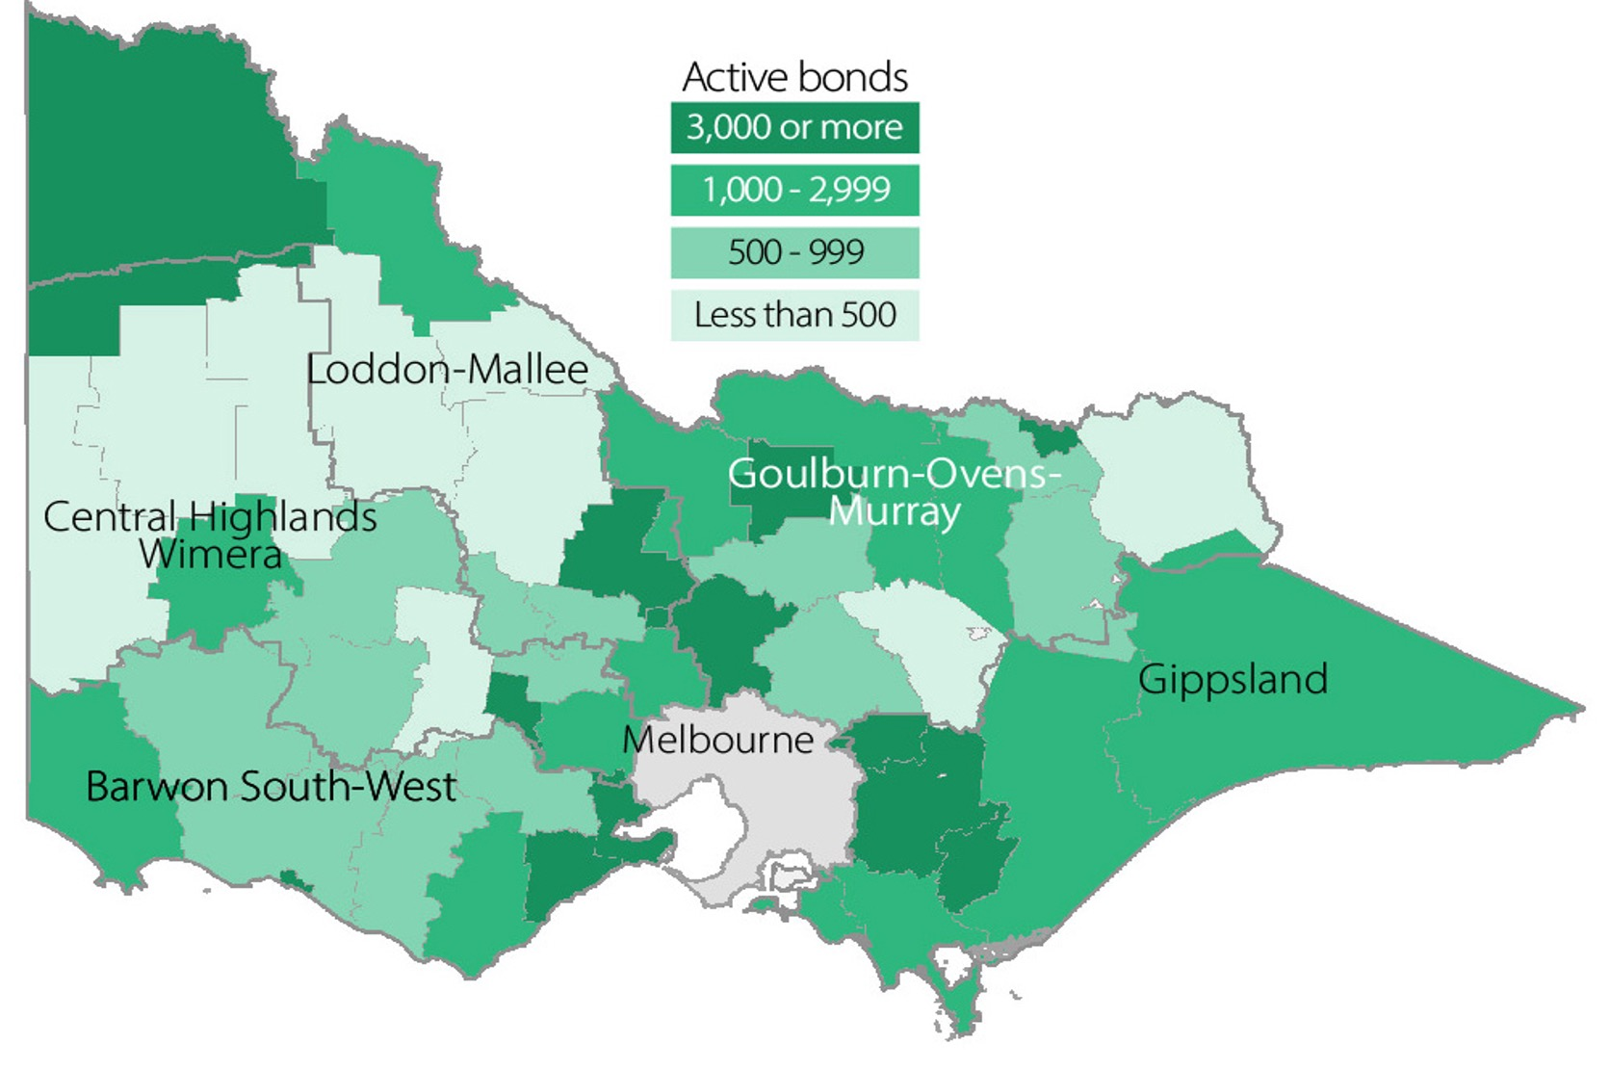

## Turnover and length of tenancy

The number of bond refunds in a quarter, if expressed as a percentage of all bonds held, can be used to provide an estimate of the ‘turnover rate’ in the rental market. The ‘turnover rate’ is an important indicator of the level of natural vacancies that are occurring in the market due to tenancies ending.

Table 7 shows the turnover rate as well as the median length of tenancy (based on bond refunds during the quarter) for both metropolitan Melbourne and regional Victoria.

For the June quarter 2024, the quarterly turnover rate for metropolitan Melbourne was 8.9 per cent (that is, 8.9 per cent of all active bonds were refunded during the quarter), compared to 7.3 per cent in the same quarter last year.

The turnover rate in regional Victoria for the June quarter 2024 was 7.9 per cent, compared to 7.2 per cent in the same quarter last year.

The median length of tenancy for bonds refunded in the June quarter 2024 was 24 months for metropolitan Melbourne and 23 months for regional Victoria.

Table 7: Turnover and tenancy duration

|  |  |  |
| --- | --- | --- |
|  | Jun-24 | Jun-23 |
| **Metropolitan Melbourne** | | |
| Turnover rate | 8.9% | 7.3% |
| Average tenancy duration | 24 | 21 |
| **Regional Victoria** | | |
| Turnover rate | 7.9% | 7.2% |
| Average tenancy duration | 23 | 22 |

Notes: 1. Turnover rate is the number of bond refunds (moving annual total) as % of total active bonds.

2. Average tenancy duration (months) is the median length of the period from the date of bond lodgement to the date of bond claim for refunds for all bonds lodged in that quarter.

Table 8 shows the turnover rate and the median length of tenancy, by dwelling size, for both metropolitan Melbourne and regional Victoria. In metropolitan Melbourne, one-bedroom dwellings have both the shortest median length of tenancy (16 months) and the highest turnover rates (11.3%). In regional Victoria, four-bedroom plus dwellings have the shortest median length of tenancy (20 months) and the highest turnover rate (8.4%).

Table 8: Median tenancy duration and turnover by dwelling size

|  |  |  |  |  |
| --- | --- | --- | --- | --- |
|  | Metropolitan Melbourne | | Regional Victoria | |
|  | **Duration (months)** | **Turnover** | **Duration (months)** | **Turnover** |
| 1 Bedroom | 16 | 11.3% | 21 | 7.6% |
| 2 Bedroom | 24 | 9.0% | 25 | 7.3% |
| 3 Bedroom | 25 | 8.3% | 24 | 8.2% |
| 4+ Bedroom | 24 | 8.7% | 20 | 8.4% |
| All properties | 24 | 8.9% | 23 | 7.9% |

## Investor finance

Loan commitments made by Victorian households for the purpose of investment in residential housing are an indicator of investor activity within the Victorian housing market.

In the June quarter 2024, Victorian households borrowed $7.142 billion for the purpose of investment in residential housing. This is 13.8 per cent more than in the previous quarter, and 9.2 per cent more than in the June quarter 2023.

Of the total value of all loan commitments made by Victorian households (both investors and owner-occupiers) for the purchase or construction of residential dwellings, 31.7 per cent was borrowed for the purpose of investment.

Figure 6 provides an overview of lending to households for residential housing investment in Victoria over the past 5 years.

Figure 6: Lending to household investors in residential housing, Victoria ($2024 June)

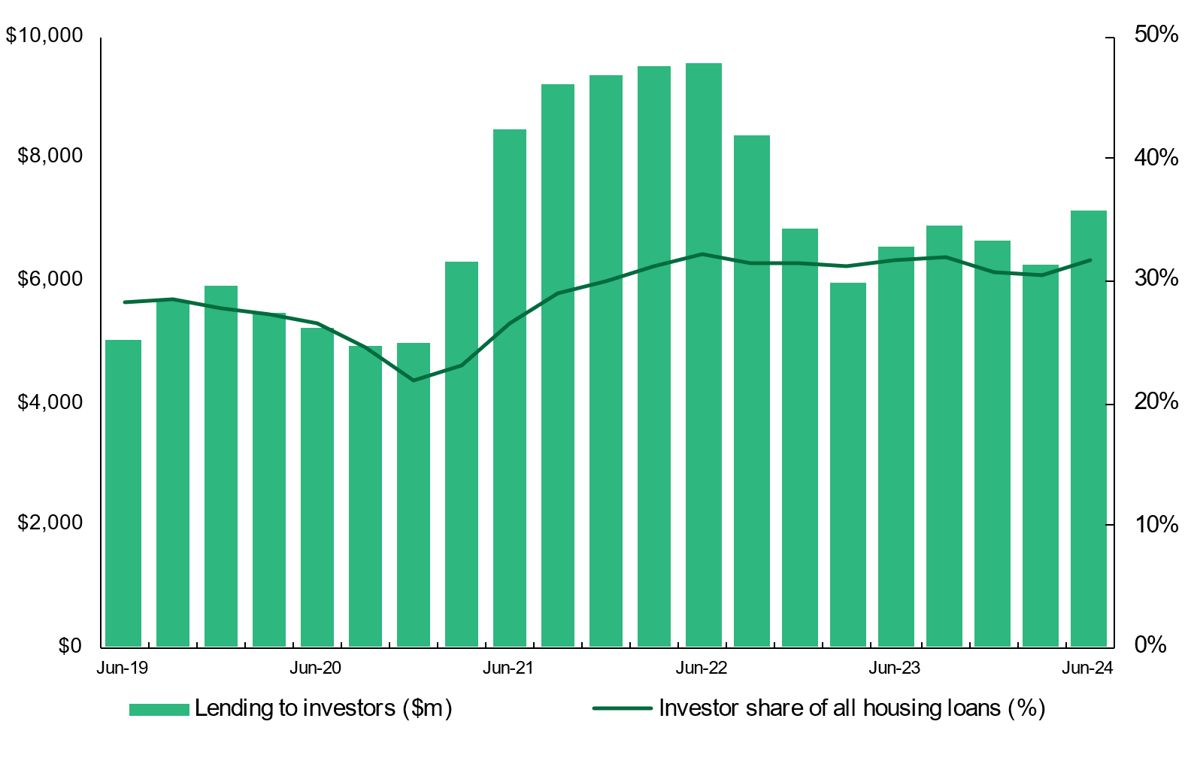

Note: Refer to note 7 (on page 39 of this report) for details of the data sources and method used in this figure.

## Vacancy rate

Figure 7 shows the trend vacancy rate over the past 5 years for metropolitan Melbourne and regional Victoria.

The trend vacancy rate for metropolitan Melbourne remained stable over the quarter at 2.2 per cent, falling slightly from 2.3 per cent in June 2023.

The average vacancy rate for the 4 years from January 2000 to December 2004 was 3.8 per cent, 1.7 per cent for the 7 years from January 2005 to December 2012, and 2.3 per cent over the past 2 years.

The trend vacancy rate reached its lowest point (1.0%) in early 2008 and its highest point (6.6%) in January and February 2021.

The trend vacancy rate for regional Victoria remained stable over the quarter at 2.1 per cent, falling slightly from 2.2 per cent in June 2023.

Figure 7: Rental vacancy rate

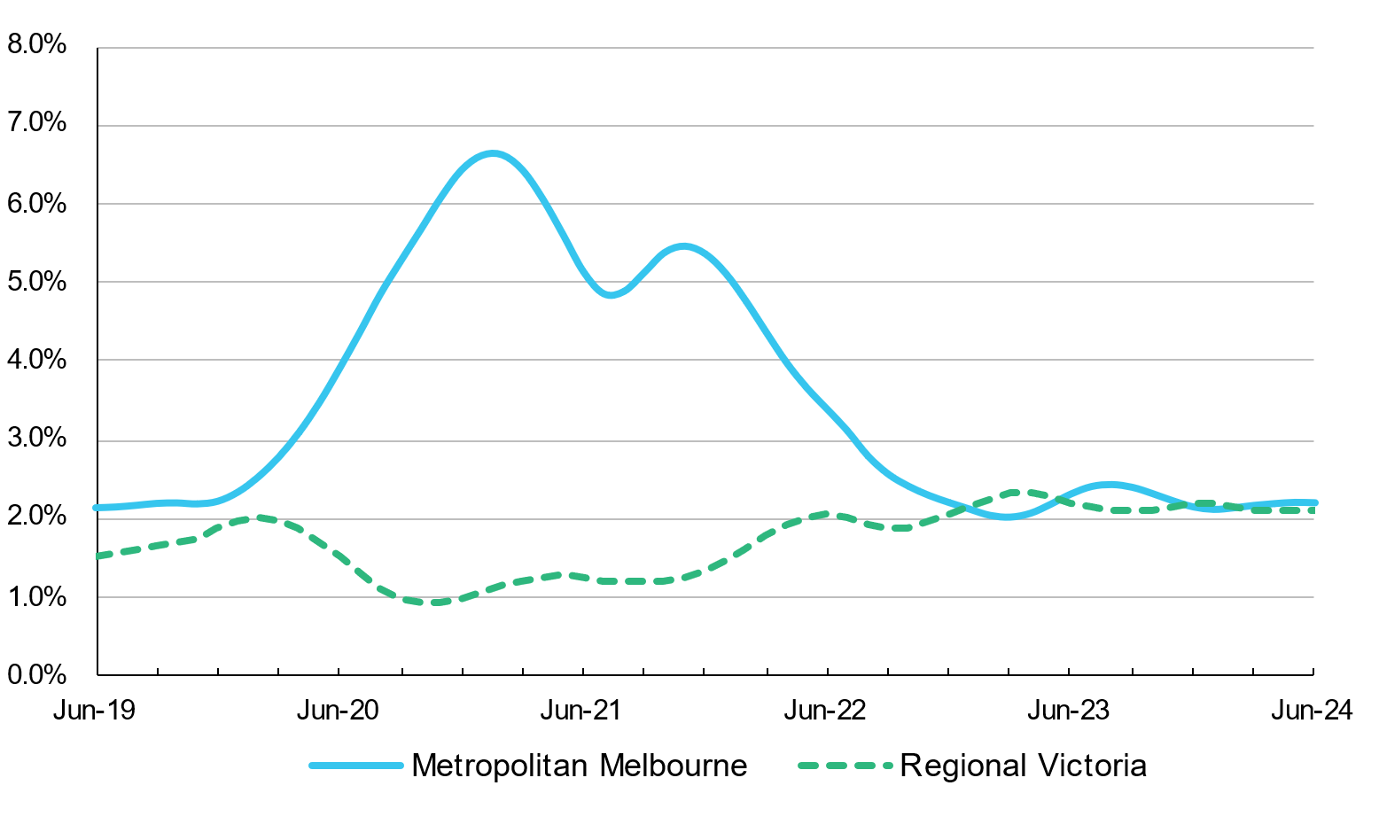

# Rental market affordability

This section of the Rental Report provides a summary of the affordability of rental housing for low-income households in Victoria. The method used in this section measures the supply of affordable new lettings based on RTBA data. The benchmark used is that an affordable rent must not exceed 30 per cent of gross income (plus rent assistance). Low-income households are defined as those receiving Centrelink incomes.

## Overall trends

In the June quarter 2024, 12.1 per cent of all new lettings across the state were affordable to low-income households. This compares with a rate of 12.0 per cent in the March quarter 2024 and 10.5 per cent in the June quarter 2023.

Figure 8 shows the trend in rental affordability over the past 5 years for Victoria, metropolitan Melbourne and regional Victoria.

Figure 8: Affordable rentals as percentage of all new rentals

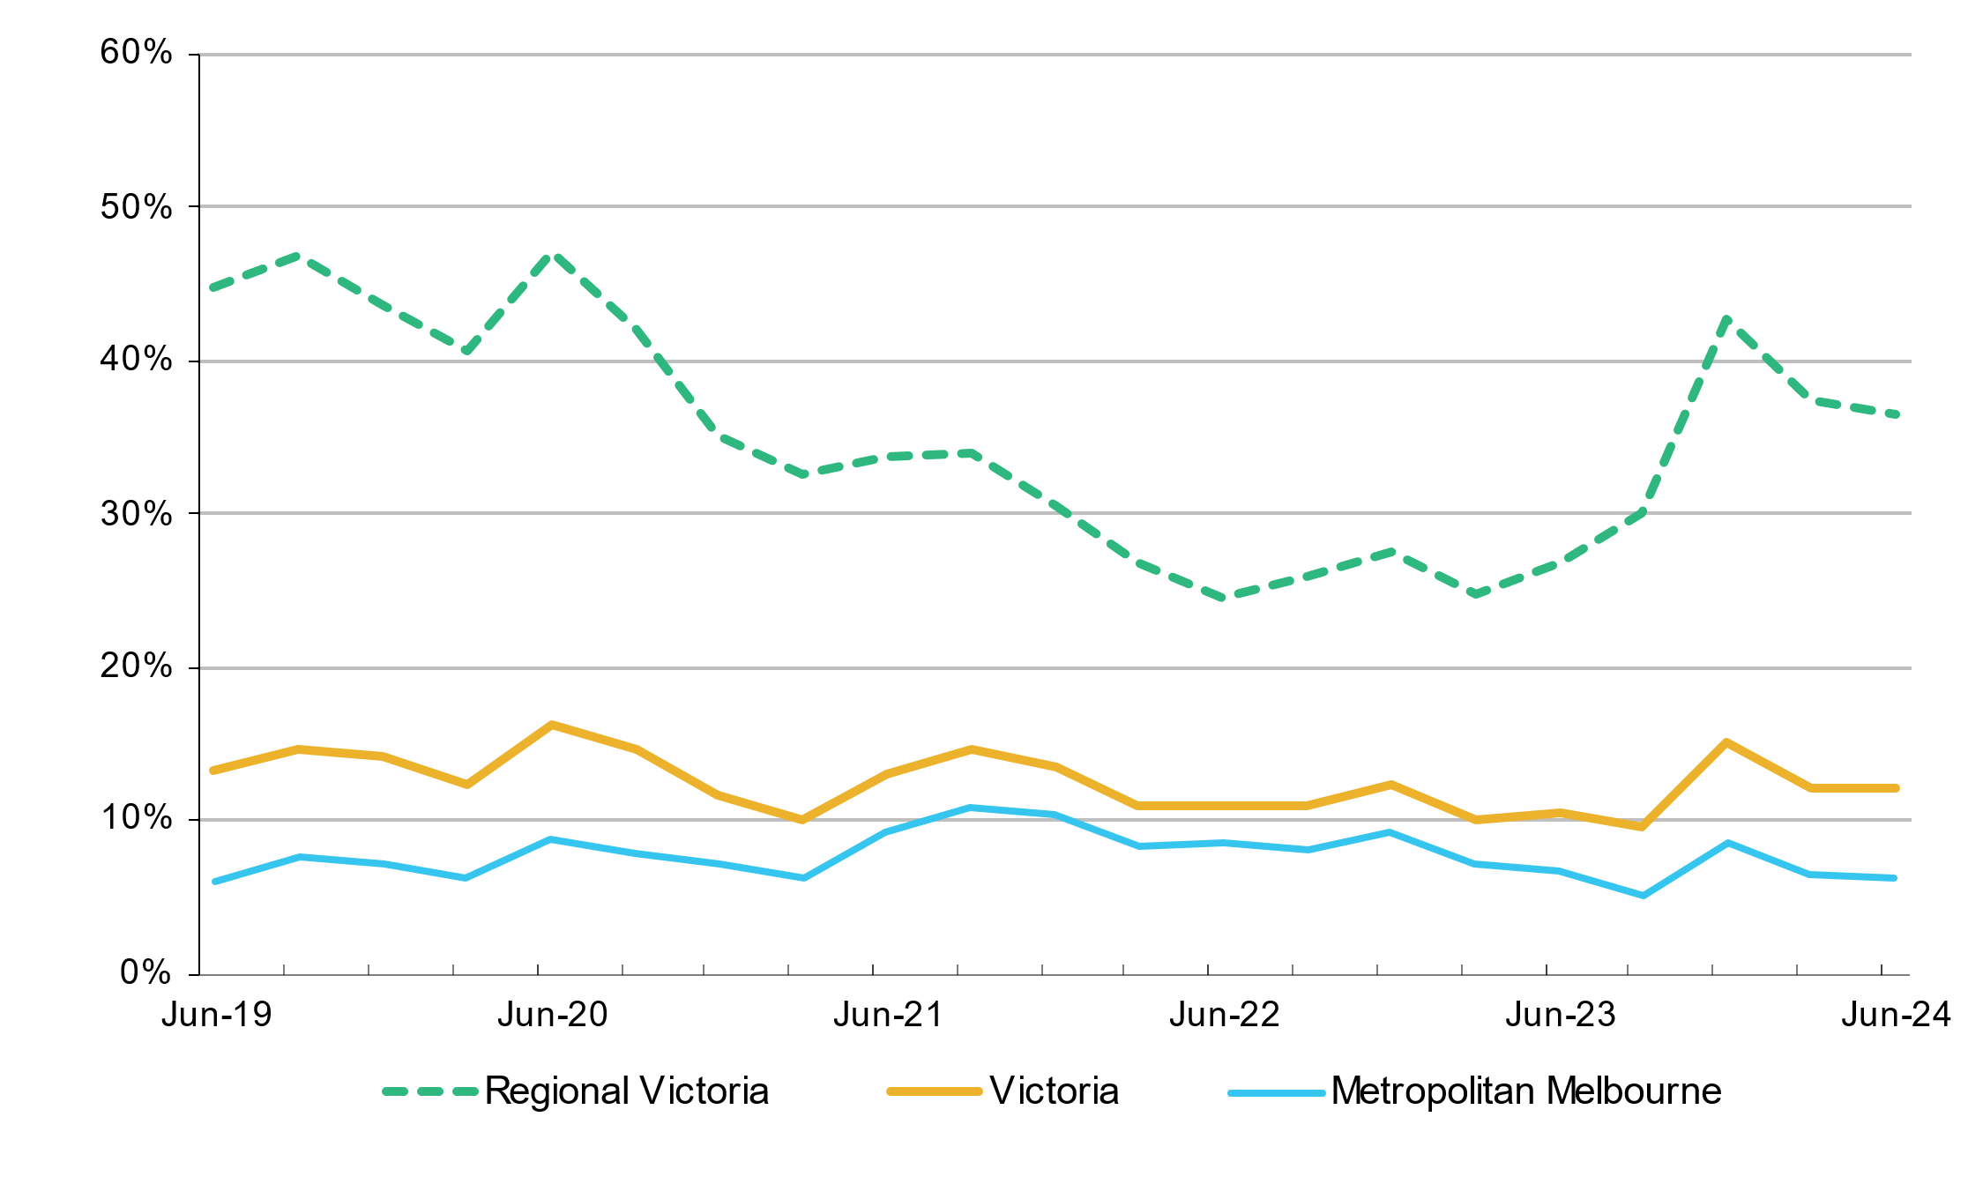

Note: Figure 8 does not consider the change in household income resulting from the temporary coronavirus supplement from 27 April 2020 to 31 September 2021.

In the June quarter 2024, 6.3 per cent of new lettings in metropolitan Melbourne were affordable to low-income households. This rate compares with a rate of 6.5 per cent in the previous quarter and 6.7 per cent in the June quarter of 2023. The availability of affordable housing in metropolitan Melbourne has generally declined from a high of 30.9 per cent in the December quarter 2003 to lows of 5.0 per cent (in the March quarter 2018) and 5.1 per cent (in the September quarter 2023).

In regional Victoria, 36.5 per cent of all new lettings were affordable to low-income households in the June quarter 2024. This compares with a rate of 37.4 per cent in the previous quarter and 26.9 per cent in the June quarter 2023. The proportion of affordable dwellings in regional Victoria has generally declined from a high of 88.3 per cent in the September quarter 2001 to a low of 24.5 per cent in the June quarter 2022.

## Trends by household type

In metropolitan Melbourne, the availability of affordable rental lettings differs depending on the size and type of household. The rental affordability situation for different low-income households is summarised in Table 9 and Table 10. Table 9 outlines rental affordability for four types of households on Centrelink incomes by an assumed property size. These indicative household types are used to calculate the extent of affordable rental lettings for metropolitan Melbourne, regional Victoria, and statewide. Table 10 is a supplementary table which indicates the extent to which dwellings are affordable to singles and couples on the Age Pension or Disability Support Pension.

Table 9 shows that, due to a limited supply of affordable one-bedroom dwellings, low-income single person households face the greatest difficulty accessing affordable rental housing. Across Melbourne, just 1.1 per cent of one-bedroom dwellings let in the June quarter 2024 were affordable to singles on a Centrelink income. For a single parent with one child on a Centrelink income, only 1.8 per cent of two-bedroom dwellings across Melbourne were affordable.

For larger families, the supply of affordable three and four-bedroom dwellings is better, although these figures do reflect the predominantly outer suburban location of this size of dwelling. A couple on Jobseeker with two dependent children could afford 7.2 per cent of three-bedroom dwellings let in Melbourne in the June quarter 2024. A couple on Jobseeker with four dependent children could afford 17.2 per cent of four-bedroom dwellings let in Melbourne in the June quarter 2024.

Table 10 shows that only 1.4 per cent of one-bedroom and two-bedroom dwellings in metropolitan Melbourne are affordable to single persons on the Age Pension or Disability Support Pension and that only 4.1 per cent are affordable to couples on the Age Pension or Disability Support Pension.

Table 9: Rental affordability by indicative households on Centrelink incomes

|  |  |  |  |  |  |  |
| --- | --- | --- | --- | --- | --- | --- |
| **Household type** |  | **Singles on Jobseeker** | **Single parent with 1 child** | **Couple on Jobseeker with 2 children** | **Couple on Jobseeker with 4 children** | **Total** |
| Assumed property size |  | 1 Bed | 2 Bed | 3 Bed | 4+ Bed |  |
| Weekly income (net of RA) |  | $381 | $702 | $1,044 | $1,291 |  |
| Affordable weekly rent |  | $210 | $325 | $425 | $515 |  |
| Affordable rentals (number) | Metropolitan | 75 | 228 | 820 | 1,341 | 2,464 |
| Regional | 85 | 459 | 1,591 | 1,213 | 3,348 |
| **Victoria** | **160** | **687** | **2,411** | **2,554** | **5,812** |
| Affordable rentals (% of total) | Metropolitan | 1.1% | 1.8% | 7.2% | 17.2% | 6.3% |
| Regional | 15.4% | 23.6% | 39.9% | 45.0% | 36.5% |
| **Victoria** | **2.2%** | **4.7%** | **15.6%** | **24.4%** | **12.1%** |

Table 10: Rental affordability for households on the Age Pension or Disability Support Pension

|  |  |  |  |
| --- | --- | --- | --- |
| **Household type** |  | **Singles on Age/Disability** | **Couples on Age/Disability** |
| Assumed property size |  | 1 or 2 Bedroom | |
| Weekly income (net of RA) |  | $510 | $769 |
| Affordable weekly rent |  | $250 | $320 |
| Affordable rentals (number) | Metropolitan | 271 | 796 |
| Regional | 283 | 844 |
| **Victoria** | **554** | **1,640** |
| Affordable rentals (% of total) | Metropolitan | 1.4% | 4.1% |
| Regional | 11.3% | 33.8% |
| **Victoria** | **2.5%** | **7.4%** |

## Trends by region

Table 11 shows the availability of affordable lettings for each of the statistical regions of Victoria.

In metropolitan Melbourne, Western Melbourne (24.0%) has the highest proportion of new lettings affordable to Centrelink households. Western Melbourne has the highest number (78) and the highest proportion (6.4%) of two-bedroom affordable lettings, the highest number (561) and the highest proportion (20.6%) of three-bedroom affordable lettings, and the highest number (1,083) and the highest proportion (37.3%) of four-bedroom plus affordable lettings. The lowest proportions of affordable new lettings are in Southern Melbourne (0.9%), Inner Melbourne (1.0%), Inner Eastern Melbourne (1.2%), Outer Eastern Melbourne (2.8%) and Mornington Peninsula (2.9%).

In regional Victoria, Central Highlands-Wimmera has the highest number (1009) and the highest proportion (63.3%) of affordable new lettings. Loddon-Mallee has the lowest number (446) and Barwon-South West has the lowest proportion (22.3%) of affordable new lettings.

Table 11: Affordable lettings by region for indicative households on Centrelink incomes

|  |  |  |  |  |  |  |  |  |  |  |
| --- | --- | --- | --- | --- | --- | --- | --- | --- | --- | --- |
| Region | 1 Bedroom | | 2 Bedroom | | 3 Bedroom | | 4+ Bedroom | | Total | |
| # | % | # | % | # | % | # | % | # | % |
| Inner Melbourne | 32 | 0.8% | 48 | 1.0% | 18 | 1.8% | 5 | 3.4% | 103 | 1.0% |
| Inner Eastern Melbourne | 7 | 1.2% | 14 | 0.9% | 15 | 1.1% | 17 | 1.7% | 53 | 1.2% |
| Southern Melbourne | 6 | 1.1% | 7 | 0.5% | 11 | 1.4% | 6 | 1.3% | 30 | 0.9% |
| Western Melbourne | 8 | 2.3% | 78 | 6.4% | 561 | 20.6% | 1,083 | 37.3% | 1,730 | 24.0% |
| North Western Melbourne | 4 | 0.7% | 19 | 1.4% | 76 | 6.1% | 84 | 12.9% | 183 | 4.8% |
| North Eastern Melbourne | 13 | 2.7% | 26 | 2.1% | 38 | 3.0% | 71 | 10.0% | 148 | 4.0% |
| Outer Eastern Melbourne | 3 | 3.5% | 10 | 2.5% | 17 | 2.4% | 13 | 3.9% | 43 | 2.8% |
| South Eastern Melbourne | - | 0.0% | 16 | 2.8% | 59 | 3.8% | 52 | 4.1% | 127 | 3.6% |
| Mornington Peninsula | 2 | 1.9% | 10 | 2.7% | 25 | 3.1% | 10 | 2.9% | 47 | 2.9% |
| ***Metropolitan Melbourne*** | **75** | **1.1%** | **228** | **1.8%** | **820** | **7.2%** | **1,341** | **17.2%** | **2,464** | **6.3%** |
| Barwon-South West | 12 | 6.9% | 69 | 10.9% | 292 | 24.3% | 272 | 31.0% | 645 | 22.3% |
| Gippsland | 12 | 12.5% | 106 | 30.5% | 337 | 47.7% | 147 | 39.5% | 602 | 39.6% |
| Goulburn-Ovens-Murray | 16 | 15.5% | 105 | 28.5% | 264 | 34.6% | 261 | 44.5% | 646 | 35.5% |
| Loddon-Mallee | 24 | 27.0% | 77 | 26.5% | 236 | 36.4% | 109 | 32.7% | 446 | 32.8% |
| Central Highlands-Wimmera | 21 | 23.1% | 102 | 32.9% | 462 | 68.9% | 424 | 81.1% | 1,009 | 63.3% |
| ***Regional Victoria*** | **85** | **15.4%** | **459** | **23.6%** | **1,591** | **39.9%** | **1,213** | **45.0%** | **3,348** | **36.5%** |
|  |  |  |  |  |  |  |  |  |  |  |
| ***Victoria*** | **160** | **2.2%** | **687** | **4.7%** | **2,411** | **15.6%** | **2,554** | **24.4%** | **5,812** | **12.1%** |

## Trends by Local Government Area

Table 14 provides data on the number of new lettings that are affordable to households on Centrelink incomes for all Victorian Local Government Areas (LGA) by number of bedrooms.

LGAs with the highest proportion of affordable dwellings in metropolitan Melbourne are Melton (where 41.2% of all dwellings are affordable to low-income households), Wyndham (26.3%), Brimbank (17.2%), Hume (11.7%), Whittlesea (6.8%) and Cardinia (5.0%). The LGAs with lowest proportion are Bayside, Boroondara, Glen Eira, Kingston, Manningham, Port Phillip, Stonnington, and Yarra (all with less than 1% affordable), and Knox, Maribyrnong, Melbourne, Merri-bek, Monash, Moonee Valley, and Whitehorse (all between 1% and 2% affordable).

In regional Victoria, the LGAs with the highest proportion of affordable dwellings are West Wimmera and Yarriambiack (with 100% affordable), Buloke and Hindmarsh (with over 90% affordable), and Central Goldfields, Gannawarra, Northern Grampians, Pyrenees, and Southern Grampians (all between 70% and 90% affordable). The LGAs with the lowest proportion of affordable dwellings are Queenscliffe (0.0%), Macedon Ranges (4.9%), Mansfield (8.1%), Warrnambool (14.1%), Surf Coast (15.9%) and Wodonga (16.9%).

Figure 9, drawn from Table 14, show the proportion of affordable dwellings in each local government area (LGA) across metropolitan Melbourne and regional Victoria.

Figure 9: Affordable dwellings, metropolitan Melbourne and regional Victoria

**Affordable dwellings, metropolitan Melbourne**

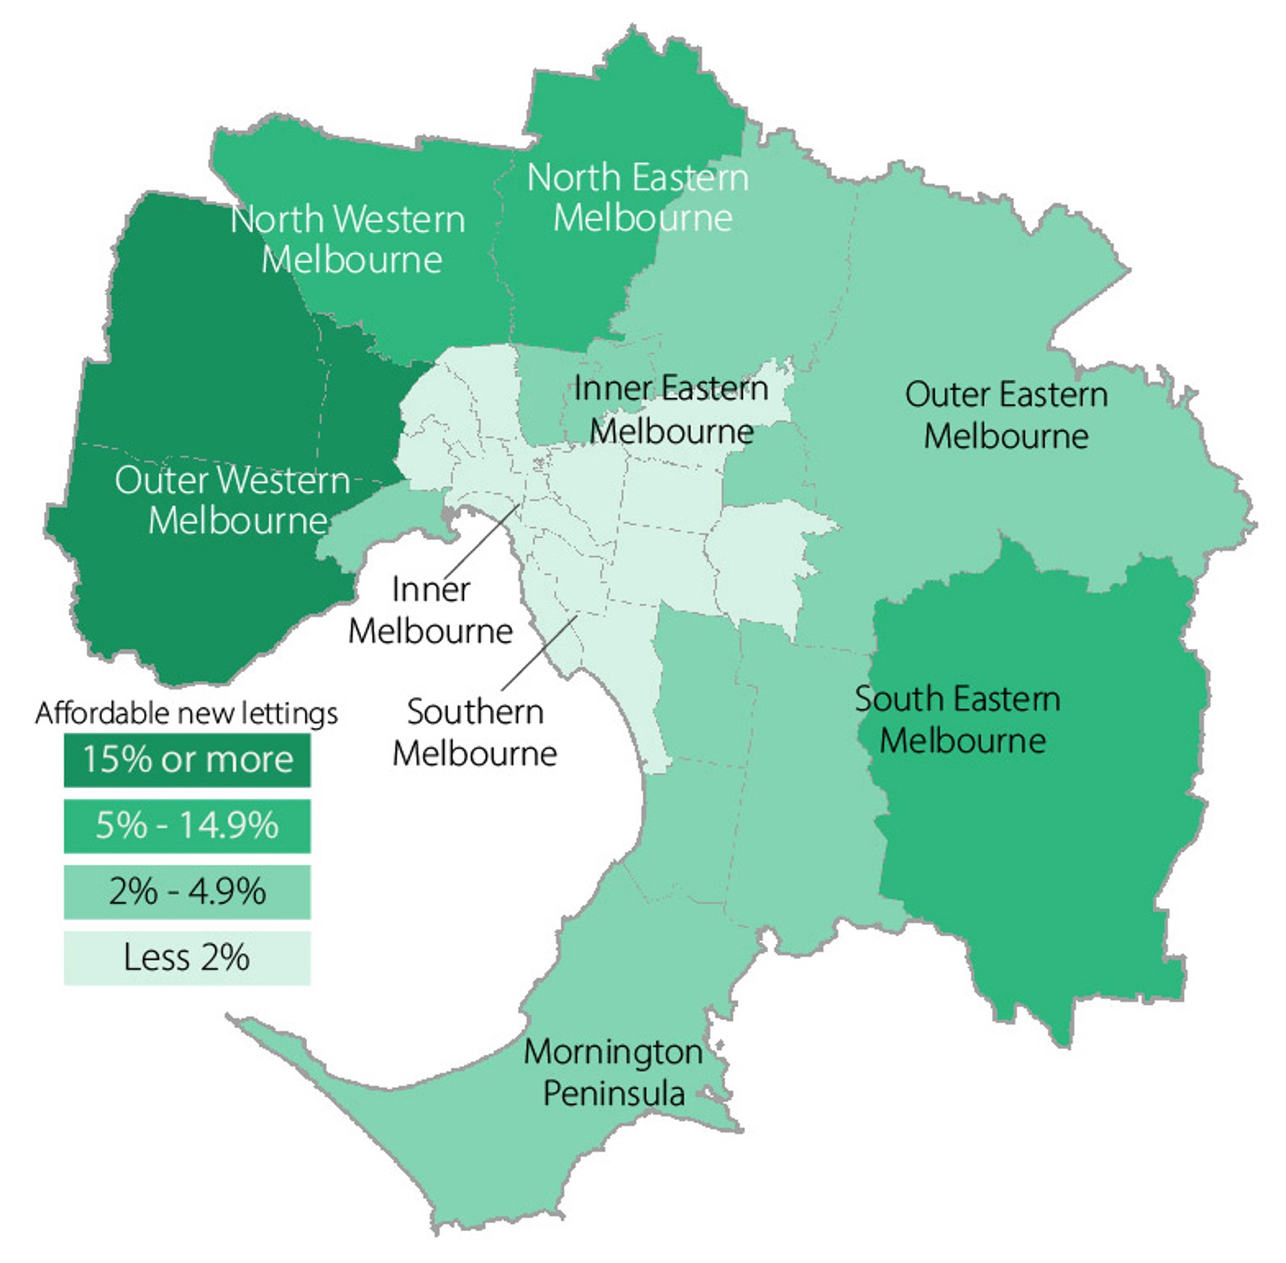

**Affordable dwellings, regional Victoria**

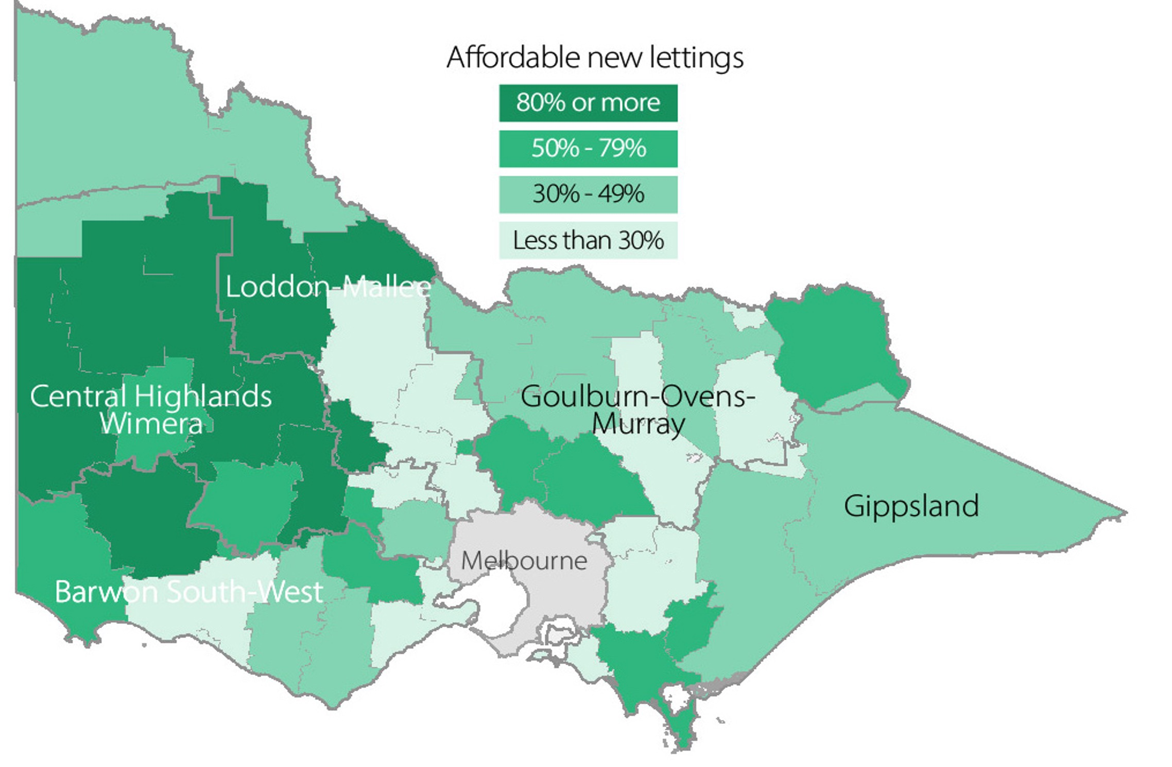

Table 12: Moving annual median rents for suburbs/town by major property type

Medians shown in Table 12 are moving *annual* medians, not quarterly medians, and the annual percentage change is calculated between these moving annual medians

| Suburb/town | | 1 Bed Flat | | | | 2 Bed Flat | | | | | | 2 Bed House | | | | | | 3 Bed House | | | | |
| --- | --- | --- | --- | --- | --- | --- | --- | --- | --- | --- | --- | --- | --- | --- | --- | --- | --- | --- | --- | --- | --- | --- |
| Count | Median | Annual % change | | Count | | Median | | Annual % change | | Count | | Median | | Annual % change | | Count | | Median | | Annual % change |
| **Inner Melbourne** | | | | | | | | | | | | | | | | | | | | | | |
| Albert Park-Middle Park-West St Kilda | 187 | | $426 | | 15.1% | | 164 | | $600 | | 12.6% | | 71 | | $740 | | 8.8% | | 87 | | $1,150 | 8.5% |
| Armadale | 147 | | $450 | | 16.9% | | 276 | | $590 | | 18.0% | | 26 | | $750 | | 7.4% | | 44 | | $1,093 | 9.3% |
| Carlton North | 42 | | $400 | | 5.3% | | 67 | | $565 | | 13.0% | | 108 | | $700 | | 9.4% | | 66 | | $900 | 12.5% |
| Carlton-Parkville | 1,092 | | $470 | | 11.9% | | 1,167 | | $650 | | 12.1% | | 54 | | $655 | | 11.0% | | 46 | | $875 | 9.4% |
| CBD-St Kilda Rd | 5,962 | | $550 | | 14.8% | | 6,585 | | $700 | | 7.7% | | - | | - | | - | | - | | - | - |
| Collingwood-Abbotsford | 668 | | $500 | | 11.1% | | 744 | | $660 | | 10.0% | | 101 | | $700 | | 7.7% | | 71 | | $875 | 9.4% |
| Docklands | 1,026 | | $550 | | 12.2% | | 1,260 | | $710 | | 9.2% | | - | | - | | - | | - | | - | - |
| East Melbourne | 174 | | $500 | | 16.3% | | 203 | | $650 | | 8.3% | | - | | - | | - | | 22 | | $1,175 | 14.6% |
| East St Kilda | 456 | | $395 | | 16.2% | | 652 | | $550 | | 15.8% | | 33 | | $700 | | 4.8% | | 59 | | $900 | 12.5% |
| Elwood | 353 | | $420 | | 13.5% | | 637 | | $580 | | 16.0% | | 21 | | $730 | | 7.7% | | 42 | | $1,073 | 12.9% |
| Fitzroy | 239 | | $500 | | 16.3% | | 224 | | $710 | | 12.7% | | 64 | | $768 | | 12.9% | | 42 | | $973 | 2.4% |
| Fitzroy North-Clifton Hill | 195 | | $435 | | 8.8% | | 217 | | $625 | | 13.6% | | 154 | | $700 | | 4.5% | | 123 | | $900 | 9.8% |
| Flemington-Kensington | 425 | | $436 | | 24.6% | | 540 | | $520 | | 17.4% | | 131 | | $610 | | 10.9% | | 123 | | $750 | 15.4% |
| North Melbourne-West Melbourne | 1,253 | | $490 | | 16.7% | | 1,167 | | $650 | | 12.5% | | 95 | | $620 | | 12.7% | | 73 | | $840 | 18.3% |
| Port Melbourne | 267 | | $520 | | 13.0% | | 369 | | $700 | | 7.7% | | 79 | | $720 | | 15.2% | | 98 | | $970 | 9.6% |
| Prahran-Windsor | 708 | | $450 | | 15.4% | | 760 | | $600 | | 11.1% | | 170 | | $750 | | 11.1% | | 149 | | $990 | 16.5% |
| Richmond-Burnley | 860 | | $480 | | 11.6% | | 835 | | $665 | | 10.8% | | 265 | | $700 | | 9.4% | | 219 | | $950 | 11.8% |
| South Melbourne | 446 | | $525 | | 16.7% | | 454 | | $680 | | 13.3% | | 55 | | $740 | | 13.3% | | 46 | | $950 | 5.6% |
| South Yarra | 1,254 | | $480 | | 17.1% | | 1,253 | | $675 | | 14.4% | | 106 | | $750 | | 7.1% | | 88 | | $1,100 | 10.6% |
| Southbank | 1,582 | | $550 | | 12.2% | | 2,332 | | $700 | | 11.1% | | - | | - | | - | | - | | - | - |
| St Kilda | 1,063 | | $430 | | 16.2% | | 952 | | $600 | | 20.0% | | 39 | | $750 | | 15.4% | | 32 | | $988 | 18.3% |
| Toorak | 128 | | $415 | | 10.7% | | 247 | | $600 | | 11.5% | | 16 | | $705 | | 4.8% | | 47 | | $1,250 | 19.6% |
| ***Inner Melbourne – Total*** | **18,527** | | **$500** | | **13.6%** | | **21,105** | | **$675** | | **12.5%** | | **1,595** | | **$700** | | **9.4%** | | **1,480** | | **$950** | **11.8%** |
| **Inner Eastern Melbourne** | | | | | | | | | | | | | | | | | | | | | | |
| Balwyn | 60 | | $450 | | 17.5% | | 236 | | $550 | | 19.6% | | 27 | | $550 | | 19.6% | | 146 | | $700 | 12.0% |
| Blackburn | 145 | | $420 | | 15.1% | | 192 | | $520 | | 15.6% | | 23 | | $535 | | 18.9% | | 221 | | $580 | 16.0% |
| Box Hill | 397 | | $470 | | 23.7% | | 1,096 | | $595 | | 21.9% | | 88 | | $479 | | 8.9% | | 210 | | $612 | 15.5% |
| Bulleen-Templestowe-Doncaster | 130 | | $450 | | 12.5% | | 437 | | $550 | | 15.8% | | 46 | | $500 | | 11.1% | | 286 | | $620 | 17.0% |
| Burwood-Ashburton | 97 | | $350 | | 14.8% | | 223 | | $520 | | 13.0% | | 44 | | $520 | | 11.8% | | 149 | | $620 | 17.0% |
| Camberwell-Glen Iris | 211 | | $435 | | 14.5% | | 580 | | $560 | | 16.7% | | 46 | | $592 | | 16.1% | | 164 | | $823 | 13.5% |
| Canterbury-Surrey Hills-Mont Albert | 44 | | $425 | | 9.5% | | 253 | | $550 | | 17.5% | | 28 | | $592 | | 28.7% | | 71 | | $750 | 7.1% |
| Chadstone-Oakleigh | 118 | | $460 | | 15.0% | | 319 | | $550 | | 22.2% | | 36 | | $545 | | 23.9% | | 160 | | $600 | 15.4% |
| Clayton | 335 | | $430 | | 19.4% | | 648 | | $550 | | 22.2% | | 47 | | $520 | | 15.6% | | 211 | | $575 | 15.0% |
| Doncaster East-Donvale | 28 | | $455 | | 19.7% | | 227 | | $540 | | 17.4% | | 23 | | $520 | | 23.8% | | 204 | | $628 | 14.2% |
| East Hawthorn | 256 | | $450 | | 12.5% | | 390 | | $572 | | 14.4% | | 27 | | $675 | | 7.5% | | 49 | | $860 | 11.0% |
| Glen Waverley-Mulgrave | 74 | | $483 | | 17.8% | | 253 | | $570 | | 11.8% | | 29 | | $549 | | 14.4% | | 493 | | $600 | 17.6% |
| Hawthorn | 507 | | $420 | | 20.0% | | 631 | | $575 | | 21.1% | | 41 | | $695 | | 6.9% | | 70 | | $900 | 8.4% |
| Kew | 59 | | $450 | | 18.4% | | 376 | | $550 | | 19.6% | | 24 | | $628 | | 9.2% | | 120 | | $820 | 13.1% |
| Mount Waverley | 12 | | $450 | | 21.6% | | 116 | | $520 | | 15.6% | | 21 | | $570 | | 23.6% | | 219 | | $620 | 17.0% |
| Nunawading-Mitcham | 63 | | $390 | | 11.4% | | 209 | | $480 | | 14.3% | | 71 | | $489 | | 14.3% | | 184 | | $585 | 17.0% |
| Vermont-Forest Hill-Burwood East | 78 | | $488 | | 19.0% | | 240 | | $550 | | 19.6% | | 25 | | $480 | | 6.7% | | 294 | | $580 | 11.5% |
| ***Inner Eastern Melbourne - Total*** | **2,614** | | **$450** | | **18.4%** | | **6,426** | | **$550** | | **17.0%** | | **646** | | **$530** | | **11.6%** | | **3,251** | | **$620** | **13.8%** |
| **Southern Melbourne** | | | | | | | | | | | | | | | | | | | | | | |
| Aspendale-Chelsea-Carrum | 23 | | $385 | | 10.0% | | 366 | | $480 | | 9.1% | | 44 | | $500 | | 7.5% | | 210 | | $640 | 10.3% |
| Bentleigh | 173 | | $400 | | 14.3% | | 609 | | $550 | | 14.6% | | 72 | | $595 | | 21.4% | | 345 | | $700 | 10.2% |
| Brighton | 132 | | $465 | | 8.6% | | 326 | | $620 | | 7.8% | | 19 | | $750 | | 9.0% | | 101 | | $1,100 | 15.8% |
| Brighton East | 14 | | $315 | | -- | | 62 | | $600 | | 20.0% | | 23 | | $625 | | 14.7% | | 70 | | $850 | 13.6% |
| Carnegie | 369 | | $390 | | 18.9% | | 529 | | $560 | | 16.7% | | 28 | | $580 | | 13.1% | | 59 | | $725 | 11.5% |
| Caulfield | 616 | | $473 | | 18.3% | | 941 | | $590 | | 18.0% | | 50 | | $593 | | 13.0% | | 129 | | $800 | 6.7% |
| Cheltenham | 131 | | $400 | | 21.2% | | 568 | | $520 | | 15.6% | | 58 | | $565 | | 9.3% | | 352 | | $685 | 14.2% |
| Elsternwick | 172 | | $423 | | 20.9% | | 282 | | $573 | | 14.6% | | 12 | | $665 | | 2.3% | | 40 | | $888 | 3.9% |
| Hampton-Beaumaris | 117 | | $450 | | 23.3% | | 379 | | $600 | | 11.1% | | 38 | | $650 | | 8.3% | | 149 | | $850 | 0.0% |
| Malvern | 107 | | $425 | | 22.1% | | 151 | | $570 | | 17.5% | | 16 | | $750 | | 11.4% | | 47 | | $920 | 2.2% |
| Malvern East | 200 | | $453 | | 13.3% | | 376 | | $570 | | 16.3% | | 15 | | $625 | | 8.7% | | 101 | | $750 | 15.4% |
| Mentone-Parkdale-Mordialloc | 182 | | $388 | | 14.1% | | 401 | | $500 | | 11.1% | | 49 | | $550 | | 6.8% | | 152 | | $705 | 10.2% |
| Murrumbeena-Hughesdale | 186 | | $380 | | 18.8% | | 262 | | $530 | | 17.8% | | 13 | | $540 | | 8.0% | | 73 | | $680 | 13.3% |
| ***Southern Melbourne - Total*** | **2,422** | | **$415** | | **18.6%** | | **5,252** | | **$550** | | **14.6%** | | **437** | | **$599** | | **15.2%** | | **1,828** | | **$730** | **12.3%** |
| **Outer Western Melbourne** | | | | | | | | | | | | | | | | | | | | | | |
| Altona | 73 | | $325 | | 8.3% | | 508 | | $440 | | 15.8% | | 131 | | $450 | | 18.4% | | 1,158 | | $500 | 16.3% |
| Footscray | 531 | | $420 | | 18.3% | | 763 | | $550 | | 19.6% | | 103 | | $550 | | 13.9% | | 125 | | $650 | 20.4% |
| Keilor East-Avondale Heights | 168 | | $425 | | 18.1% | | 345 | | $500 | | 16.3% | | 33 | | $500 | | 17.6% | | 237 | | $540 | 14.9% |
| Melton | 30 | | $369 | | 2.5% | | 94 | | $335 | | 8.1% | | 39 | | $360 | | 14.3% | | 1,075 | | $400 | 11.1% |
| Newport-Spotswood | 83 | | $430 | | 36.5% | | 211 | | $550 | | 31.6% | | 64 | | $550 | | 17.0% | | 174 | | $690 | 15.0% |
| St Albans-Deer Park | 75 | | $310 | | 3.3% | | 317 | | $385 | | 13.2% | | 53 | | $395 | | 8.8% | | 668 | | $430 | 13.2% |
| Sunshine | 112 | | $300 | | 15.4% | | 254 | | $400 | | 14.3% | | 78 | | $430 | | 16.2% | | 427 | | $450 | 12.8% |
| Sydenham | - | | - | | - | | 94 | | $420 | | 7.7% | | 55 | | $420 | | 7.7% | | 1,250 | | $450 | 7.1% |
| Werribee-Hoppers Crossing | 61 | | $330 | | 16.6% | | 479 | | $380 | | 15.2% | | 131 | | $400 | | 14.3% | | 2,804 | | $450 | 15.4% |
| West Footscray | 146 | | $338 | | 20.7% | | 297 | | $455 | | 16.7% | | 83 | | $480 | | 11.6% | | 252 | | $560 | 16.7% |
| Williamstown | 58 | | $413 | | 18.0% | | 130 | | $515 | | 15.7% | | 36 | | $600 | | 9.1% | | 98 | | $740 | 7.2% |
| Yarraville-Seddon | 147 | | $340 | | 25.9% | | 240 | | $500 | | 21.1% | | 164 | | $600 | | 15.4% | | 280 | | $673 | 12.2% |
| ***Outer Western Melbourne - Total*** | **1,489** | | **$375** | | **17.2%** | | **3,732** | | **$450** | | **18.4%** | | **970** | | **$465** | | **12.0%** | | **8,548** | | **$455** | **13.8%** |
| **North Western Melbourne** | | | | | | | | | | | | | | | | | | | | | | |
| Broadmeadows-Roxburgh Park | 42 | | $300 | | 11.1% | | 143 | | $420 | | 13.8% | | 52 | | $423 | | 11.3% | | 499 | | $460 | 15.0% |
| Brunswick | 459 | | $450 | | 18.4% | | 558 | | $553 | | 15.2% | | 163 | | $650 | | 12.1% | | 164 | | $800 | 11.1% |
| Coburg-Pascoe Vale South | 147 | | $410 | | 17.1% | | 338 | | $500 | | 15.5% | | 118 | | $550 | | 10.0% | | 260 | | $655 | 12.9% |
| Craigieburn | - | | - | | - | | 92 | | $410 | | 14.2% | | 55 | | $420 | | 10.5% | | 905 | | $470 | 11.9% |
| East Brunswick | 393 | | $470 | | 17.5% | | 429 | | $590 | | 18.0% | | 48 | | $660 | | 11.9% | | 62 | | $850 | 17.2% |
| Essendon | 482 | | $420 | | 23.5% | | 686 | | $500 | | 20.5% | | 75 | | $495 | | 10.0% | | 274 | | $600 | 15.4% |
| Gladstone Park-Tullamarine | 14 | | $335 | | 11.7% | | 95 | | $450 | | 18.4% | | 19 | | $450 | | 5.9% | | 187 | | $500 | 16.3% |
| Keilor | - | | - | | - | | - | | - | | - | | - | | - | | - | | 20 | | $560 | 27.3% |
| Moonee Ponds-Ascot Vale | 400 | | $430 | | 17.8% | | 555 | | $500 | | 11.1% | | 133 | | $600 | | 14.3% | | 190 | | $700 | 10.2% |
| Oak Park-Glenroy-Fawkner | 84 | | $385 | | 32.8% | | 478 | | $450 | | 12.5% | | 99 | | $460 | | 13.6% | | 351 | | $520 | 16.9% |
| Pascoe Vale-Coburg North | 38 | | $285 | | 3.6% | | 282 | | $480 | | 17.1% | | 81 | | $515 | | 17.0% | | 167 | | $600 | 15.4% |
| Sunbury | 11 | | $300 | | 9.9% | | 96 | | $400 | | 5.3% | | 11 | | $410 | | 13.9% | | 290 | | $450 | 7.1% |
| West Brunswick | 312 | | $380 | | 18.8% | | 425 | | $500 | | 22.0% | | 46 | | $598 | | 9.1% | | 99 | | $730 | 18.7% |
| ***North Western Melbourne - Total*** | **2,390** | | **$420** | | **20.0%** | | **4,180** | | **$500** | | **19.0%** | | **901** | | **$550** | | **12.2%** | | **3,468** | | **$500** | **12.4%** |
| **North Eastern Melbourne** | | | | | | | | | | | | | | | | | | | | | | |
| Bundoora-Greensborough-Hurstbridge | 158 | | $393 | | 15.6% | | 431 | | $450 | | 13.9% | | 83 | | $460 | | 15.0% | | 687 | | $540 | 17.4% |
| Eltham-Research-Montmorency | 25 | | $350 | | 6.1% | | 86 | | $450 | | 7.1% | | 25 | | $470 | | 9.3% | | 154 | | $610 | 10.9% |
| Fairfield-Alphington | 191 | | $368 | | 15.0% | | 200 | | $520 | | 18.2% | | 23 | | $650 | | 12.1% | | 50 | | $830 | 10.7% |
| Heidelberg-Heidelberg West | 271 | | $390 | | 11.4% | | 450 | | $488 | | 13.5% | | 79 | | $480 | | 20.0% | | 233 | | $600 | 27.7% |
| Ivanhoe-Ivanhoe East | 204 | | $475 | | 23.4% | | 359 | | $550 | | 17.0% | | 16 | | $563 | | 4.3% | | 64 | | $690 | 3.0% |
| Mill Park-Epping | 46 | | $360 | | 47.5% | | 227 | | $425 | | 18.1% | | 89 | | $450 | | 18.4% | | 618 | | $500 | 17.6% |
| Northcote | 266 | | $400 | | 14.3% | | 279 | | $570 | | 14.0% | | 122 | | $700 | | 9.4% | | 140 | | $850 | 13.3% |
| Preston | 291 | | $400 | | 14.3% | | 567 | | $500 | | 16.3% | | 105 | | $550 | | 14.6% | | 219 | | $650 | 18.2% |
| Reservoir | 134 | | $380 | | 15.2% | | 601 | | $450 | | 12.5% | | 111 | | $460 | | 15.0% | | 268 | | $520 | 15.6% |
| Thomastown-Lalor | 21 | | $340 | | 6.3% | | 190 | | $420 | | 16.7% | | 32 | | $420 | | 13.5% | | 369 | | $475 | 18.8% |
| Thornbury | 228 | | $375 | | 17.2% | | 299 | | $495 | | 15.1% | | 62 | | $640 | | 6.7% | | 109 | | $775 | 15.7% |
| Whittlesea | - | | - | | - | | 68 | | $410 | | 17.1% | | 40 | | $440 | | 18.9% | | 490 | | $500 | 16.3% |
| ***North Eastern Melbourne - Total*** | **1,839** | | **$390** | | **18.2%** | | **3,757** | | **$480** | | **17.1%** | | **787** | | **$500** | | **13.6%** | | **3,401** | | **$525** | **16.7%** |
| **Outer Eastern Melbourne** | | | | | | | | | | | | | | | | | | | | | | |
| Bayswater | 13 | | $350 | | -6.2% | | 142 | | $450 | | 12.5% | | 23 | | $450 | | 12.5% | | 154 | | $545 | 16.5% |
| Boronia | 20 | | $385 | | 16.7% | | 148 | | $460 | | 15.0% | | 28 | | $450 | | 7.1% | | 156 | | $530 | 15.2% |
| Croydon-Lilydale | 66 | | $320 | | -4.5% | | 382 | | $460 | | 12.2% | | 90 | | $473 | | 11.3% | | 661 | | $550 | 11.1% |
| Ferntree Gully | 12 | | $355 | | 9.2% | | 77 | | $470 | | 14.6% | | 16 | | $445 | | 17.1% | | 184 | | $550 | 17.0% |
|  |  | |  | |  | |  | |  | |  | |  | |  | |  | |  | |  |  |
|  |  | |  | |  | |  | |  | |  | |  | |  | |  | |  | |  |  |
|  |  | |  | |  | |  | |  | |  | |  | |  | |  | |  | |  |  |
| Ringwood | 55 | | $400 | | 5.3% | | 425 | | $469 | | 13.0% | | 81 | | $470 | | 9.3% | | 319 | | $560 | 12.4% |
| Rowville | 10 | | $378 | | - | | 17 | | $490 | | 16.7% | | - | | - | | - | | 131 | | $550 | 10.4% |
| Wantirna-Scoresby | 29 | | $429 | | 19.2% | | 81 | | $500 | | 11.1% | | 16 | | $500 | | 19.6% | | 283 | | $550 | 15.8% |
| Yarra Ranges | 37 | | $360 | | 14.3% | | 73 | | $415 | | 6.4% | | 69 | | $450 | | 4.7% | | 320 | | $550 | 11.1% |
| ***Outer Eastern Melbourne - Total*** | **242** | | **$370** | | **5.7%** | | **1,345** | | **$460** | | **12.2%** | | **326** | | **$460** | | **8.7%** | | **2,208** | | **$550** | **14.6%** |
| **South Eastern Melbourne** | | | | | | | | | | | | | | | | | | | | | | |
| Berwick | 17 | | $350 | | 9.4% | | 54 | | $450 | | 12.5% | | 62 | | $460 | | 8.2% | | 668 | | $520 | 15.6% |
| Cranbourne | 18 | | $340 | | 7.9% | | 108 | | $420 | | 15.1% | | 79 | | $450 | | 12.5% | | 1,354 | | $500 | 11.1% |
| Dandenong | 179 | | $320 | | 12.3% | | 547 | | $400 | | 17.6% | | 42 | | $495 | | 30.3% | | 266 | | $550 | 22.2% |
| Dandenong North-Endeavour Hills | 51 | | $310 | | 10.7% | | 143 | | $440 | | 18.9% | | 24 | | $410 | | 17.1% | | 435 | | $490 | 16.7% |
| Narre Warren-Hampton Park | 32 | | $400 | | 25.0% | | 128 | | $438 | | 15.3% | | 64 | | $450 | | 12.5% | | 820 | | $500 | 13.6% |
| Noble Park | 136 | | $340 | | 23.2% | | 341 | | $450 | | 19.4% | | 27 | | $480 | | 20.0% | | 230 | | $500 | 16.3% |
| Pakenham | 41 | | $350 | | 27.3% | | 113 | | $420 | | 16.7% | | 65 | | $430 | | 10.3% | | 622 | | $485 | 15.5% |
| Springvale | 142 | | $360 | | 10.8% | | 431 | | $490 | | 19.5% | | 39 | | $500 | | 25.0% | | 358 | | $550 | 21.4% |
| ***South Eastern Melbourne - Total*** | **616** | | **$340** | | **17.2%** | | **1,865** | | **$440** | | **18.9%** | | **402** | | **$450** | | **12.5%** | | **4,753** | | **$500** | **13.6%** |
| **Mornington Peninsula** | | | | | | | | | | | | | | | | | | | | | | |
| Dromana-Portsea | 25 | | $390 | | 20.0% | | 172 | | $450 | | 4.7% | | 137 | | $450 | | 0.0% | | 729 | | $540 | 2.9% |
| Frankston | 193 | | $330 | | 10.0% | | 458 | | $440 | | 12.8% | | 76 | | $450 | | 7.1% | | 643 | | $530 | 8.2% |
| Hastings-Flinders | 26 | | $345 | | 15.0% | | 110 | | $445 | | 11.8% | | 30 | | $450 | | 2.3% | | 254 | | $550 | 5.8% |
| Mt Eliza-Mornington-Mt Martha | 18 | | $390 | | 13.0% | | 209 | | $500 | | 4.2% | | 22 | | $550 | | 10.0% | | 328 | | $650 | 6.6% |
| Seaford-Carrum Downs | 58 | | $350 | | 7.7% | | 215 | | $445 | | 12.7% | | 35 | | $460 | | 12.2% | | 524 | | $508 | 10.4% |
| ***Mornington Peninsula - Total*** | **320** | | **$340** | | **9.7%** | | **1,164** | | **$450** | | **12.5%** | | **300** | | **$450** | | **4.4%** | | **2,478** | | **$550** | **10.0%** |
| **Geelong** | | | | | | | | | | | | | | | | | | | | | | |
| Belmont-Grovedale | 84 | | $320 | | 8.5% | | 308 | | $410 | | 3.8% | | 73 | | $430 | | 7.5% | | 647 | | $480 | 4.3% |
| Corio | 41 | | $300 | | 7.1% | | 68 | | $360 | | 5.9% | | 115 | | $350 | | 2.9% | | 442 | | $390 | 5.4% |
| Geelong-Newcomb | 173 | | $380 | | 11.8% | | 322 | | $465 | | 13.4% | | 92 | | $428 | | 1.9% | | 375 | | $450 | 2.3% |
| Herne Hill-Geelong West | 138 | | $320 | | 6.7% | | 130 | | $400 | | 5.3% | | 66 | | $430 | | 2.4% | | 236 | | $500 | 4.2% |
| Lara | - | | - | | - | | 43 | | $390 | | 2.6% | | 16 | | $403 | | 6.1% | | 151 | | $480 | 6.7% |
| Newtown | 40 | | $320 | | 16.4% | | 86 | | $420 | | 7.7% | | 32 | | $455 | | 0.0% | | 93 | | $530 | 6.0% |
| North Geelong | 32 | | $310 | | 12.7% | | 104 | | $400 | | 3.9% | | 60 | | $420 | | 6.3% | | 308 | | $460 | 2.2% |
| ***Geelong - Total*** | **513** | | **$320** | | **6.7%** | | **1,061** | | **$410** | | **5.1%** | | **454** | | **$410** | | **3.8%** | | **2,252** | | **$460** | **4.5%** |
| **Ballarat** | | | | | | | | | | | | | | | | | | | | | | |
| Ballarat | 65 | | $280 | | 16.7% | | 160 | | $340 | | 6.3% | | 170 | | $350 | | 2.9% | | 592 | | $395 | 3.9% |
| Mount Clear-Buninyong | - | | - | | - | | 19 | | $330 | | 6.5% | | 11 | | $350 | | - | | 58 | | $395 | 3.9% |
| Sebastopol-Delacombe | 73 | | $260 | | 8.3% | | 106 | | $330 | | 6.5% | | 54 | | $350 | | 9.4% | | 321 | | $390 | 5.4% |
| Wendouree-Alfredton | 61 | | $250 | | 5.0% | | 96 | | $340 | | 6.3% | | 73 | | $350 | | 2.9% | | 499 | | $395 | 3.9% |
| ***Ballarat - Total*** | **205** | | **$265** | | **10.4%** | | **381** | | **$340** | | **6.3%** | | **308** | | **$350** | | **6.1%** | | **1,470** | | **$390** | **2.6%** |
| **Bendigo** | | | | | | | | | | | | | | | | | | | | | | |
| Bendigo | 37 | | $280 | | -3.4% | | 53 | | $390 | | 11.4% | | 68 | | $400 | | 5.3% | | 144 | | $450 | 7.1% |
| Flora Hill-Bendigo East | 28 | | $283 | | 8.8% | | 158 | | $360 | | 9.1% | | 60 | | $390 | | 5.4% | | 323 | | $450 | 7.1% |
| Golden Square-Kangaroo Flat | 11 | | $275 | | -1.1% | | 59 | | $350 | | 3.6% | | 49 | | $380 | | 0.0% | | 273 | | $450 | 7.1% |
| North Bendigo | 15 | | $270 | | -3.6% | | 102 | | $365 | | 7.4% | | 47 | | $380 | | 5.6% | | 360 | | $440 | 4.8% |
| ***Bendigo - Total*** | **91** | | **$280** | | **0.0%** | | **372** | | **$360** | | **5.9%** | | **224** | | **$390** | | **5.4%** | | **1,100** | | **$450** | **7.1%** |
|  |  | |  | |  | |  | |  | |  | |  | |  | |  | |  | |  |  |
| **Other Regional Centres** | | | | | | | | | | | | | | | | | | | | | | |
| Bairnsdale | 13 | | $300 | | 25.0% | | 59 | | $340 | | 6.3% | | 36 | | $350 | | 0.0% | | 146 | | $440 | 4.8% |
| Benalla | 29 | | $230 | | 0.0% | | 74 | | $350 | | 2.9% | | 25 | | $350 | | 0.0% | | 133 | | $430 | 2.4% |
| Castlemaine | - | | - | | - | | 26 | | $380 | | 8.6% | | 28 | | $400 | | 3.9% | | 92 | | $468 | 1.7% |
| Echuca | 16 | | $268 | | 19.1% | | 90 | | $380 | | 8.6% | | 13 | | $380 | | 8.6% | | 118 | | $470 | 9.3% |
| Hamilton | 21 | | $240 | | 9.1% | | 36 | | $293 | | 2.8% | | 27 | | $310 | | 4.0% | | 98 | | $360 | 0.0% |
| Horsham | 35 | | $430 | | 65.4% | | 91 | | $300 | | 0.0% | | 55 | | $330 | | 3.1% | | 214 | | $400 | 11.1% |
| Mildura | 78 | | $250 | | 0.0% | | 209 | | $300 | | 9.1% | | 83 | | $350 | | 6.7% | | 420 | | $413 | 8.7% |
| Moe-Newborough | 55 | | $235 | | 6.8% | | 87 | | $290 | | 7.4% | | 47 | | $320 | | 3.2% | | 169 | | $380 | 5.6% |
| Morwell | 48 | | $250 | | 4.2% | | 95 | | $285 | | 9.6% | | 68 | | $300 | | 0.0% | | 253 | | $360 | 2.9% |
| Ocean Grove-Barwon Heads | 14 | | $275 | | -5.2% | | 43 | | $440 | | -1.1% | | 21 | | $470 | | 4.4% | | 171 | | $530 | -0.9% |
| Portland | - | | - | | - | | 52 | | $345 | | 7.8% | | 24 | | $375 | | 7.1% | | 155 | | $420 | 5.0% |
| Sale-Maffra | 47 | | $260 | | 4.0% | | 150 | | $360 | | 9.1% | | 52 | | $393 | | 9.2% | | 255 | | $430 | 3.6% |
| Seymour | - | | - | | - | | 43 | | $330 | | -0.9% | | 14 | | $375 | | 1.4% | | 92 | | $400 | 8.1% |
| Shepparton | 134 | | $260 | | 13.0% | | 319 | | $330 | | 10.0% | | 67 | | $350 | | 9.4% | | 499 | | $440 | 10.0% |
| Swan Hill | 56 | | $210 | | 20.0% | | 84 | | $335 | | 15.5% | | 11 | | $370 | | 19.4% | | 112 | | $415 | 12.2% |
| Torquay | 16 | | $320 | | 0.0% | | 40 | | $480 | | 0.0% | | 29 | | $525 | | 1.9% | | 165 | | $630 | 5.0% |
| Traralgon | 70 | | $275 | | 3.8% | | 125 | | $350 | | 9.4% | | 47 | | $375 | | 7.1% | | 405 | | $430 | 7.5% |
| Wangaratta | 64 | | $255 | | 15.9% | | 96 | | $320 | | 3.2% | | 32 | | $365 | | 4.3% | | 236 | | $440 | 4.8% |
| Warragul | 11 | | $295 | | 22.9% | | 65 | | $365 | | 4.3% | | 25 | | $395 | | 6.8% | | 157 | | $450 | 7.1% |
| Warrnambool | 37 | | $300 | | 20.0% | | 237 | | $380 | | 8.6% | | 78 | | $433 | | 8.3% | | 321 | | $500 | 8.7% |
| Wodonga | 42 | | $260 | | 4.0% | | 209 | | $350 | | 9.4% | | 35 | | $380 | | 0.0% | | 451 | | $450 | 7.1% |
| ***Other Regional Centres Total*** | **811** | | **$260** | | **8.3%** | | **2,230** | | **$340** | | **6.3%** | | **817** | | **$360** | | **2.9%** | | **4,662** | | **$440** | **8.6%** |

Table 13: Median rents for local government areas by DHS region, by major property type

| LGA | 1 Bed Flat | | | | 2 Bed Flat | | | | 2 Bed House | | | | 3 Bed House | | | |
| --- | --- | --- | --- | --- | --- | --- | --- | --- | --- | --- | --- | --- | --- | --- | --- | --- |
| Count | Median | Annual % change | | Count | Median | Annual % change | | Count | Median | Annual % change | | Count | Median | Annual % change | |
| Colac-Otway | - | - | - | | - | - | - | | 10 | $365 | 4.3% | | 42 | $430 | -2.3% | |
| Corangamite | - | - | - | | - | - | - | | - | - | - | | 27 | $420 | 9.7% | |
| Glenelg | - | - | - | | 23 | $330 | 3.1% | | - | - | - | | 45 | $400 | -2.4% | |
| Greater Geelong | 124 | $330 | 6.5% | | 273 | $420 | 5.0% | | 139 | $420 | 5.0% | | 668 | $460 | 2.2% | |
| Moyne | - | - | - | | - | - | - | | - | - | - | | 13 | $470 | 10.6% | |
| Queenscliffe | - | - | - | | - | - | - | | - | - | - | | - | - | - | |
| Southern Grampians | 10 | $240 | - | | - | - | - | | - | - | - | | 34 | $360 | 2.9% | |
| Surf Coast | - | - | - | | 23 | $470 | -4.1% | | - | - | - | | 125 | $500 | 0.0% | |
| Warrnambool | - | - | - | | 49 | $370 | -2.6% | | 16 | $450 | 17.5% | | 79 | $520 | 4.0% | |
| ***Barwon-South West*** | **161** | **$320** | **6.7%** | | **402** | **$410** | **3.8%** | | **205** | **$420** | **9.1%** | | **1,036** | **$470** | **4.4%** | |
| Ararat | - | - | - | | 10 | $355 | 7.6% | | 10 | $335 | 9.8% | | 29 | $375 | 2.7% | |
| Ballarat | 48 | $280 | 16.7% | | 95 | $340 | 3.0% | | 84 | $355 | 4.4% | | 350 | $400 | 3.9% | |
| Golden Plains | - | - | - | | - | - | - | | - | - | - | | - | - | - | |
| Hepburn | 14 | $120 | - | | 11 | $350 | - | | 10 | $425 | 25.0% | | 34 | $500 | 2.5% | |
| Hindmarsh | - | - | - | | - | - | - | | - | - | - | | 11 | $300 | 9.1% | |
| Horsham | - | - | - | | 18 | $298 | -3.9% | | 13 | $350 | 0.0% | | 58 | $390 | 1.3% | |
| Moorabool | - | - | - | | 19 | $380 | 10.1% | | - | - | - | | 67 | $450 | 7.1% | |
| Northern Grampians | - | - | - | | 12 | $260 | 4.0% | | - | - | - | | 19 | $380 | 1.9% | |
| Pyrenees | - | - | - | | - | - | - | | - | - | - | | 10 | $360 | - | |
| West Wimmera | - | - | - | | - | - | - | | - | - | - | | - | - | - | |
| Yarriambiack | - | - | - | | - | - | - | | - | - | - | | - | - | - | |
| ***Grampians*** | **85** | **$270** | **12.5%** | | **168** | **$340** | **3.0%** | | **136** | **$350** | **6.1%** | | **599** | **$400** | **2.6%** | |
|  |  |  |  | |  |  |  | |  |  |  | |  |  |  | |
|  |  |  |  | |  |  |  | |  |  |  | |  |  |  | |
|  |  |  |  | |  |  |  | |  |  |  | |  |  |  | |
|  |  |  |  | |  |  |  | |  |  |  | |  |  |  | |
| Buloke | - | - | - | | - | - | - | | - | - | - | | - | - | - | |
| Campaspe | - | - | - | | 35 | $340 | -2.9% | | - | - | - | | 51 | $430 | 7.5% | |
| Central Goldfields | - | - | - | | - | - | - | | - | - | - | | 27 | $360 | 5.9% | |
| Gannawarra | - | - | - | | - | - | - | | - | - | - | | 13 | $350 | 16.7% | |
| Greater Bendigo | 25 | $290 | 3.6% | | 71 | $375 | 8.7% | | 57 | $380 | 5.6% | | 285 | $450 | 4.7% | |
| Loddon | - | - | - | | - | - | - | | - | - | - | | - | - | - | |
| Macedon Ranges | - | - | - | | 13 | $450 | 12.5% | | 11 | $430 | 2.4% | | 62 | $545 | 4.8% | |
| Mildura | 17 | $260 | 2.0% | | 54 | $330 | 14.6% | | 22 | $355 | 9.9% | | 112 | $433 | 8.3% | |
| Mount Alexander | - | - | - | | - | - | - | | - | - | - | | 28 | $465 | 3.3% | |
| Swan Hill | 19 | $220 | 10.0% | | 13 | $340 | 9.7% | | - | - | - | | 37 | $410 | 7.9% | |
| ***Loddon Mallee*** | **86** | **$250** | **8.7%** | | **205** | **$345** | **4.5%** | | **124** | **$378** | **8.0%** | | **625** | **$450** | **7.1%** | |
| Alpine | - | - | - | | 12 | $400 | 4.4% | | - | - | - | | 42 | $455 | -4.2% | |
| Benalla | - | - | - | | 15 | $350 | 9.4% | | - | - | - | | 37 | $450 | 7.1% | |
| Greater Shepparton | 44 | $283 | 8.8% | | 69 | $370 | 23.3% | | 26 | $360 | 10.8% | | 150 | $440 | 7.3% | |
| Indigo | - | - | - | | - | - | - | | - | - | - | | 19 | $460 | 2.2% | |
| Mansfield | - | - | - | | - | - | - | | - | - | - | | 17 | $550 | 4.8% | |
| Mitchell | - | - | - | | 13 | $375 | 7.1% | | 15 | $375 | 3.6% | | 86 | $445 | 11.3% | |
| Moira | - | - | - | | 20 | $335 | 15.5% | | 15 | $350 | 9.4% | | 57 | $450 | 4.7% | |
| Murrindindi | - | - | - | | - | - | - | | - | - | - | | 24 | $408 | 3.3% | |
| Strathbogie | - | - | - | | - | - | - | | - | - | - | | 21 | $450 | 7.1% | |
| Towong | - | - | - | | - | - | - | | - | - | - | | - | - | - | |
| Wangaratta | - | - | - | | 22 | $350 | 9.4% | | - | - | - | | 56 | $440 | 7.8% | |
| Wodonga | - | - | - | | 45 | $350 | 6.7% | | 10 | $393 | 6.2% | | 129 | $470 | 6.8% | |
| ***Hume*** | **84** | **$270** | **12.5%** | | **210** | **$350** | **9.4%** | | **109** | **$375** | **7.1%** | | **643** | **$450** | **7.1%** | |
|  |  |  |  | |  |  |  | |  |  |  | |  |  |  | |
|  |  |  |  | |  |  |  | |  |  |  | |  |  |  | |
|  |  |  |  | |  |  |  | |  |  |  | |  |  |  | |
| Bass Coast | - | - | - | | - | - | - | | 17 | $400 | 6.7% | | 67 | $450 | 7.1% | |
| Baw Baw | 13 | $290 | 7.4% | | 29 | $390 | 8.3% | | 14 | $405 | 9.5% | | 90 | $470 | 9.3% | |
| East Gippsland | 10 | $290 | - | | 30 | $330 | 3.8% | | 32 | $378 | 5.0% | | 91 | $430 | 2.4% | |
| Latrobe | 41 | $250 | 0.0% | | 74 | $300 | 7.1% | | 43 | $330 | 3.1% | | 228 | $400 | 6.7% | |
| South Gippsland | - | - | - | | 15 | $350 | - | | 15 | $370 | - | | 47 | $410 | 2.5% | |
| Wellington | 15 | $260 | 0.8% | | 33 | $350 | 2.9% | | 24 | $368 | 6.7% | | 92 | $415 | 1.2% | |
| ***Gippsland*** | **86** | **$250** | **0.0%** | | **187** | **$340** | **6.3%** | | **145** | **$370** | **5.7%** | | **615** | **$430** | **7.5%** | |
| Banyule | 182 | $460 | 21.1% | | 317 | $500 | 13.6% | | 52 | $500 | 14.9% | | 208 | $590 | 18.0% | |
| Brimbank | 60 | $315 | 8.6% | | 148 | $418 | 19.4% | | 46 | $430 | 7.5% | | 344 | $473 | 12.6% | |
| Darebin | 258 | $395 | 9.7% | | 455 | $500 | 11.1% | | 100 | $580 | 5.5% | | 190 | $650 | 16.1% | |
| Hobsons Bay | 37 | $375 | 10.3% | | 155 | $480 | 18.5% | | 45 | $540 | 8.4% | | 171 | $610 | 17.3% | |
| Hume | 10 | $315 | 8.6% | | 115 | $445 | 14.1% | | 37 | $430 | 7.5% | | 443 | $490 | 14.0% | |
| Maribyrnong | 220 | $420 | 16.7% | | 331 | $530 | 9.3% | | 80 | $565 | 13.0% | | 184 | $650 | 18.2% | |
| Melbourne | 2,156 | $540 | 8.0% | | 2,284 | $700 | 3.7% | | 84 | $650 | 5.7% | | 61 | $870 | 5.1% | |
| Melton | - | - | - | | 93 | $375 | 10.3% | | 22 | $395 | 9.7% | | 591 | $450 | 8.4% | |
| Merri-bek | 324 | $450 | 15.4% | | 598 | $530 | 11.6% | | 121 | $600 | 9.1% | | 261 | $650 | 12.1% | |
| Moonee Valley | 294 | $410 | 7.9% | | 343 | $520 | 13.0% | | 68 | $594 | 10.0% | | 134 | $660 | 15.2% | |
| Nillumbik | - | - | - | | - | - | - | | - | - | - | | 46 | $580 | 20.8% | |
| Whittlesea | 11 | $380 | 15.2% | | 106 | $450 | 16.0% | | 36 | $480 | 20.0% | | 381 | $510 | 13.3% | |
| Wyndham | 21 | $350 | 5.1% | | 125 | $420 | 16.7% | | 57 | $423 | 15.9% | | 802 | $465 | 13.4% | |
| Yarra | 524 | $500 | 11.1% | | 462 | $680 | 8.8% | | 154 | $745 | 9.6% | | 113 | $950 | 5.6% | |
| ***North and West Metro*** | **4,112** | **$490** | **8.9%** | | **5,538** | **$600** | **8.1%** | | **908** | **$560** | **9.8%** | | **3,929** | **$500** | **11.1%** | |
|  |  |  |  | |  |  |  | |  |  |  | |  |  |  | |
|  |  |  |  | |  |  |  | |  |  |  | |  |  |  | |
|  |  |  |  | |  |  |  | |  |  |  | |  |  |  | |
|  |  |  | |  |  |  | |  |  |  | |  |  |  | |
|  |  |  |  | |  |  |  | |  |  |  | |  |  |  | |
| Boroondara | 272 | $450 | 11.1% | | 492 | $585 | 11.4% | | 53 | $650 | 3.5% | | 159 | $800 | 6.7% | |
| Knox | 29 | $410 | 18.8% | | 93 | $490 | 11.4% | | 21 | $475 | 9.2% | | 202 | $569 | 13.8% | |
| Manningham | 35 | $480 | 12.9% | | 138 | $580 | 9.4% | | 23 | $560 | 19.1% | | 123 | $640 | 12.3% | |
| Maroondah | 30 | $319 | -18.2% | | 159 | $480 | 11.6% | | 33 | $500 | 13.6% | | 136 | $585 | 12.5% | |
| Monash | 82 | $460 | 10.0% | | 280 | $570 | 14.0% | | 38 | $560 | 16.7% | | 255 | $620 | 12.7% | |
| Whitehorse | 186 | $475 | 12.3% | | 426 | $580 | 13.7% | | 71 | $510 | 4.1% | | 245 | $600 | 9.1% | |
| Yarra Ranges | 19 | $360 | 5.9% | | 37 | $490 | 15.3% | | 30 | $523 | 27.6% | | 161 | $550 | 10.0% | |
| ***Eastern Metro*** | **653** | **$450** | **9.8%** | | **1,625** | **$550** | **10.0%** | | **269** | **$530** | **15.2%** | | **1,281** | **$600** | **9.1%** | |
| Bayside | 101 | $475 | 18.8% | | 259 | $600 | 7.1% | | 28 | $620 | 12.5% | | 88 | $860 | 2.4% | |
| Cardinia | 13 | $400 | - | | 29 | $430 | 10.3% | | 25 | $450 | 12.5% | | 213 | $520 | 15.6% | |
| Casey | 19 | $375 | 17.2% | | 69 | $460 | 15.0% | | 42 | $475 | 14.5% | | 733 | $530 | 15.2% | |
| Frankston | 72 | $345 | 8.5% | | 154 | $450 | 9.8% | | 24 | $465 | 3.3% | | 297 | $540 | 9.1% | |
| Glen Eira | 379 | $400 | 8.1% | | 669 | $580 | 10.5% | | 42 | $600 | 6.2% | | 149 | $790 | 9.3% | |
| Greater Dandenong | 78 | $348 | 16.0% | | 273 | $450 | 18.4% | | 24 | $520 | 30.0% | | 234 | $550 | 17.0% | |
| Kingston | 99 | $420 | 10.5% | | 350 | $525 | 11.7% | | 37 | $550 | 7.8% | | 166 | $675 | 12.5% | |
| Mornington Peninsula | 28 | $365 | 1.4% | | 122 | $480 | 9.1% | | 51 | $460 | 2.2% | | 320 | $573 | 6.1% | |
| Port Phillip | 614 | $460 | 9.5% | | 661 | $640 | 11.3% | | 74 | $740 | 12.1% | | 77 | $1,050 | 10.5% | |
| Stonnington | 625 | $480 | 11.6% | | 686 | $650 | 8.3% | | 92 | $750 | 7.1% | | 119 | $1,000 | 11.4% | |
| ***Southern Metro*** | **2,028** | **$450** | **12.5%** | | **3,272** | **$570** | **14.0%** | | **439** | **$585** | **14.7%** | | **2,396** | **$550** | **10.0%** | |

Table 14: Affordable lettings for Local Government Areas

See note 9 on method

| **LGA** | **1 Bedroom** | | **2 Bedroom** | | **3 Bedroom** | | **4+ Bedroom** | | **Total** | |
| --- | --- | --- | --- | --- | --- | --- | --- | --- | --- | --- |
| **#** | **%** | **#** | **%** | **#** | **%** | **#** | **%** | **#** | **%** |
| Alpine | 0 | 0.0% | 4 | 22.2% | 10 | 22.7% | 1 | 11.1% | 15 | 20.8% |
| Ararat | 0 | 0.0% | 8 | 36.4% | 29 | 85.3% | 5 | 38.5% | 42 | 57.5% |
| Ballarat | 6 | 12.5% | 47 | 25.7% | 308 | 77.2% | 362 | 87.0% | 723 | 69.1% |
| Banyule | 1 | 0.5% | 12 | 3.0% | 10 | 3.0% | 4 | 3.0% | 27 | 2.6% |
| Bass Coast | 1 | 14.3% | 0 | 0.0% | 29 | 24.4% | 20 | 25.6% | 50 | 20.8% |
| Baw Baw | 2 | 13.3% | 6 | 14.0% | 26 | 25.7% | 20 | 21.1% | 54 | 21.3% |
| Bayside | 3 | 2.9% | 1 | 0.3% | 2 | 1.1% | 0 | 0.0% | 6 | 0.9% |
| Benalla | 0 | 0.0% | 7 | 30.4% | 14 | 36.8% | 6 | 31.6% | 27 | 29.7% |
| Boroondara | 0 | 0.0% | 3 | 0.5% | 3 | 1.0% | 4 | 1.9% | 10 | 0.7% |
| Brimbank | 2 | 3.1% | 20 | 9.1% | 106 | 20.9% | 33 | 22.8% | 161 | 17.2% |
| Buloke | 3 | 100.0% | 2 | 100.0% | 8 | 88.9% | 1 | 100.0% | 14 | 93.3% |
| Campaspe | 4 | 40.0% | 14 | 31.8% | 24 | 45.3% | 13 | 35.1% | 55 | 38.2% |
| Cardinia | 0 | 0.0% | 2 | 3.3% | 8 | 3.2% | 18 | 7.6% | 28 | 5.0% |
| Casey | 0 | 0.0% | 1 | 0.8% | 33 | 3.8% | 27 | 3.1% | 61 | 3.2% |
| Central Goldfields | 3 | 60.0% | 8 | 66.7% | 28 | 93.3% | 8 | 100.0% | 47 | 85.5% |
| Colac-Otway | 0 | 0.0% | 5 | 27.8% | 20 | 45.5% | 9 | 47.4% | 34 | 37.8% |
| Corangamite | 0 | 0.0% | 8 | 42.1% | 15 | 53.6% | 3 | 50.0% | 26 | 47.3% |
| Darebin | 11 | 4.2% | 13 | 2.2% | 9 | 2.6% | 6 | 9.1% | 39 | 3.1% |
| East Gippsland | 2 | 15.4% | 15 | 23.8% | 47 | 46.5% | 20 | 44.4% | 84 | 37.8% |
| Frankston | 0 | 0.0% | 6 | 3.2% | 17 | 4.3% | 5 | 3.8% | 28 | 3.5% |
| Gannawarra | 0 | 0.0% | 10 | 90.9% | 9 | 69.2% | 4 | 100.0% | 23 | 76.7% |
| Glen Eira | 1 | 0.3% | 3 | 0.4% | 8 | 2.3% | 3 | 1.6% | 15 | 0.9% |
| Glenelg | 1 | 16.7% | 12 | 37.5% | 31 | 66.0% | 11 | 73.3% | 55 | 55.0% |
| Golden Plains | 0 | 0.0% | 1 | 50.0% | 3 | 42.9% | 23 | 71.9% | 27 | 65.9% |
| Greater Bendigo | 4 | 13.3% | 18 | 14.0% | 101 | 31.9% | 73 | 38.6% | 196 | 29.5% |
| Greater Dandenong | 0 | 0.0% | 13 | 4.2% | 18 | 4.9% | 6 | 4.2% | 37 | 4.1% |
| Greater Geelong | 9 | 6.9% | 15 | 3.5% | 166 | 21.0% | 142 | 31.1% | 332 | 18.4% |
| Greater Shepparton | 4 | 8.9% | 26 | 27.1% | 66 | 41.3% | 29 | 27.9% | 125 | 30.9% |
| Hepburn | 9 | 52.9% | 6 | 27.3% | 4 | 11.8% | 3 | 60.0% | 22 | 28.2% |
| Hindmarsh | 1 | 50.0% | 3 | 100.0% | 11 | 100.0% | 3 | 100.0% | 18 | 94.7% |
| Hobsons Bay | 0 | 0.0% | 6 | 2.7% | 8 | 3.1% | 4 | 5.6% | 18 | 3.1% |
| Horsham | 1 | 10.0% | 15 | 46.9% | 51 | 71.8% | 12 | 85.7% | 79 | 62.2% |
| Hume | 0 | 0.0% | 6 | 3.3% | 62 | 11.1% | 76 | 15.9% | 144 | 11.7% |
| Indigo | 0 | 0.0% | 3 | 30.0% | 6 | 30.0% | 6 | 37.5% | 15 | 31.3% |
| Kingston | 1 | 1.0% | 2 | 0.5% | 2 | 0.7% | 2 | 1.4% | 7 | 0.7% |
| Knox | 1 | 3.3% | 1 | 0.8% | 3 | 1.0% | 3 | 2.0% | 8 | 1.3% |
| Latrobe | 5 | 11.9% | 61 | 52.1% | 147 | 61.5% | 43 | 54.4% | 256 | 53.7% |
| Loddon | 1 | 100.0% | 0 | 0.0% | 0 | 0.0% | 0 | 0.0% | 1 | 25.0% |
| Macedon Ranges | 1 | 25.0% | 2 | 8.0% | 3 | 3.6% | 3 | 4.2% | 9 | 4.9% |
| Manningham | 0 | 0.0% | 0 | 0.0% | 1 | 0.5% | 4 | 2.0% | 5 | 0.8% |
| Mansfield | 0 | 0.0% | 0 | 0.0% | 2 | 10.0% | 1 | 11.1% | 3 | 8.1% |
| Maribyrnong | 6 | 2.7% | 4 | 0.9% | 8 | 2.9% | 1 | 2.3% | 19 | 1.9% |
| Maroondah | 2 | 6.5% | 9 | 4.4% | 8 | 4.0% | 3 | 2.7% | 22 | 4.0% |
| Melbourne | 23 | 1.1% | 31 | 1.3% | 10 | 2.9% | 1 | 2.4% | 65 | 1.3% |
| Melton | 0 | 0.0% | 34 | 26.6% | 240 | 32.3% | 582 | 48.5% | 856 | 41.2% |
| Merri-bek | 3 | 0.9% | 11 | 1.3% | 12 | 2.5% | 4 | 4.5% | 30 | 1.8% |
| Mildura | 3 | 15.0% | 31 | 39.2% | 57 | 44.9% | 13 | 33.3% | 104 | 39.2% |
| Mitchell | 0 | 0.0% | 3 | 10.3% | 46 | 45.1% | 165 | 75.0% | 214 | 60.6% |
| Moira | 5 | 71.4% | 16 | 45.7% | 23 | 34.3% | 12 | 44.4% | 56 | 41.2% |
| Monash | 3 | 3.6% | 4 | 1.2% | 6 | 1.3% | 5 | 1.6% | 18 | 1.5% |
| Moonee Valley | 1 | 0.3% | 5 | 1.1% | 3 | 1.2% | 6 | 6.7% | 15 | 1.4% |
| Moorabool | 1 | 25.0% | 1 | 4.3% | 22 | 28.6% | 31 | 49.2% | 55 | 32.9% |
| Mornington Peninsula | 2 | 6.3% | 4 | 2.2% | 8 | 1.9% | 5 | 2.4% | 19 | 2.3% |
| Mount Alexander | 0 | 0.0% | 2 | 14.3% | 8 | 27.6% | 4 | 33.3% | 14 | 23.3% |
| Moyne | 0 | 0.0% | 1 | 9.1% | 3 | 17.6% | 7 | 58.3% | 11 | 27.5% |
| Murrindindi | 2 | 100.0% | 6 | 42.9% | 14 | 56.0% | 3 | 37.5% | 25 | 51.0% |
| Nillumbik | 1 | 14.3% | 0 | 0.0% | 1 | 1.4% | 6 | 6.1% | 8 | 4.2% |
| Northern Grampians | 1 | 33.3% | 16 | 88.9% | 16 | 80.0% | 4 | 66.7% | 37 | 78.7% |
| Port Phillip | 1 | 0.2% | 8 | 1.0% | 2 | 0.9% | 2 | 6.3% | 13 | 0.8% |
| Pyrenees | 0 | 0.0% | 2 | 66.7% | 7 | 70.0% | 4 | 100.0% | 13 | 72.2% |
| Queenscliffe | 0 | 0.0% | 0 | 0.0% | 0 | 0.0% | 0 | 0.0% | 0 | 0.0% |
| South Gippsland | 0 | 0.0% | 6 | 20.0% | 32 | 66.7% | 12 | 75.0% | 50 | 51.0% |
| Southern Grampians | 2 | 20.0% | 8 | 50.0% | 33 | 91.7% | 13 | 92.9% | 56 | 73.7% |
| Stonnington | 7 | 1.1% | 5 | 0.6% | 3 | 1.2% | 1 | 1.5% | 16 | 0.9% |
| Strathbogie | 0 | 0.0% | 0 | 0.0% | 10 | 43.5% | 3 | 33.3% | 13 | 35.1% |
| Surf Coast | 0 | 0.0% | 7 | 18.4% | 5 | 3.6% | 64 | 21.9% | 76 | 15.9% |
| Swan Hill | 9 | 47.4% | 4 | 23.5% | 22 | 55.0% | 3 | 33.3% | 38 | 44.7% |
| Towong | 0 | 0.0% | 2 | 40.0% | 5 | 83.3% | 1 | 100.0% | 8 | 57.1% |
| Wangaratta | 0 | 0.0% | 10 | 34.5% | 23 | 37.1% | 4 | 21.1% | 37 | 30.8% |
| Warrnambool | 0 | 0.0% | 12 | 17.9% | 15 | 17.0% | 0 | 0.0% | 27 | 14.1% |
| Wellington | 2 | 13.3% | 18 | 31.0% | 55 | 56.7% | 32 | 54.2% | 107 | 46.7% |
| West Wimmera | 1 | 100.0% | 0 | 0.0% | 5 | 100.0% | 0 | 0.0% | 6 | 100.0% |
| Whitehorse | 5 | 2.6% | 7 | 1.4% | 5 | 1.3% | 5 | 2.0% | 22 | 1.6% |
| Whittlesea | 0 | 0.0% | 1 | 0.6% | 18 | 3.6% | 55 | 13.3% | 74 | 6.8% |
| Wodonga | 1 | 16.7% | 14 | 24.6% | 21 | 14.8% | 17 | 15.6% | 53 | 16.9% |
| Wyndham | 0 | 0.0% | 14 | 7.1% | 199 | 21.7% | 462 | 32.2% | 675 | 26.3% |
| Yarra | 1 | 0.2% | 2 | 0.3% | 1 | 0.5% | 1 | 3.7% | 5 | 0.4% |
| Yarra Ranges | 0 | 0.0% | 0 | 0.0% | 7 | 3.5% | 7 | 9.5% | 14 | 3.8% |
| Yarriambiack | 1 | 100.0% | 4 | 100.0% | 10 | 100.0% | 0 | 0.0% | 15 | 100.0% |
| Total | 160 | 2.2% | 687 | 4.7% | 2,411 | 15.6% | 2,554 | 24.4% | 5,812 | 12.1% |

Table 15: Active bonds by local government area

|  |  |  |  |  |  |  |  |  |
| --- | --- | --- | --- | --- | --- | --- | --- | --- |
| LGA | June 2024 | % change | |  | LGA | June 2024 | % change | |
| **1 year** | **5 years** | **1 year** | **5 years** |
| Alpine | 834 | -0.7% | 0.7% |  | Mansfield | 435 | -8.2% | 1.6% |
| Ararat | 789 | 2.5% | 2.7% |  | Maribyrnong | 14,855 | -4.2% | 10.3% |
| Ballarat | 13,433 | 0.4% | 13.8% |  | Maroondah | 9,138 | -5.5% | -4.4% |
| Banyule | 13,198 | -2.3% | 3.5% |  | Melbourne | 59,935 | -2.8% | 19.0% |
| Bass Coast | 2,900 | 0.6% | -1.6% |  | Melton | 20,875 | 4.4% | 54.4% |
| Baw Baw | 3,507 | -1.5% | 9.5% |  | Merri-bek | 25,918 | -5.1% | -1.9% |
| Bayside | 7,922 | -1.8% | -6.1% |  | Mildura | 4,953 | -4.2% | -0.8% |
| Benalla | 1,136 | -1.8% | 5.9% |  | Mitchell | 3,708 | 10.3% | 39.5% |
| Boroondara | 18,877 | -5.6% | -7.8% |  | Moira | 1,895 | -0.9% | -3.2% |
| Brimbank | 16,412 | -4.0% | -0.5% |  | Monash | 18,633 | -5.7% | 4.6% |
| Buloke | 199 | 4.2% | 3.1% |  | Moonee Valley | 14,214 | -2.1% | 2.9% |
| Campaspe | 2,053 | -2.6% | -8.6% |  | Moorabool | 1,923 | -1.3% | 9.4% |
| Cardinia | 8,745 | -3.8% | 7.4% |  | Mornington Peninsula | 10,368 | -1.9% | -7.9% |
| Casey | 25,491 | -0.8% | 16.6% |  | Mount Alexander | 904 | 3.3% | -2.1% |
| Central Goldfields | 806 | -0.9% | -0.5% |  | Moyne | 605 | -3.8% | -10.9% |
| Colac-Otway | 1,377 | -1.9% | -1.1% |  | Murrindindi | 651 | -2.4% | -0.3% |
| Corangamite | 665 | -4.7% | -5.9% |  | Nillumbik | 3,199 | -6.4% | -7.0% |
| Darebin | 19,725 | -4.6% | -2.4% |  | Northern Grampians | 711 | -3.9% | -4.8% |
| East Gippsland | 2,947 | -2.5% | -4.9% |  | Port Phillip | 20,625 | -6.0% | -7.7% |
| Frankston | 13,170 | -5.5% | -7.0% |  | Pyrenees | 227 | -5.0% | 0.9% |
| Gannawarra | 449 | -5.1% | -13.5% |  | Queenscliffe | 98 | 3.2% | -17.6% |
| Glen Eira | 22,931 | -4.1% | 0.0% |  | South Gippsland | 1,319 | -1.6% | -2.2% |
| Glenelg | 1,074 | -0.5% | -5.0% |  | Southern Grampians | 850 | 0.1% | -14.5% |
| Golden Plains | 616 | 9.8% | 49.9% |  | Stonnington | 21,712 | -5.4% | -6.5% |
| Greater Bendigo | 10,139 | -2.1% | -4.1% |  | Strathbogie | 609 | -3.2% | 3.0% |
| Greater Dandenong | 16,148 | -4.9% | -3.7% |  | Surf Coast | 4,041 | 21.7% | 64.5% |
| Greater Geelong | 25,072 | -2.9% | 5.8% |  | Swan Hill | 1,307 | -3.4% | -2.8% |
| Greater Shepparton | 5,515 | -2.0% | 1.1% |  | Towong | 250 | -6.4% | -10.1% |
| Hepburn | 763 | 1.2% | -3.8% |  | Wangaratta | 2,100 | -2.2% | 1.6% |
| Hindmarsh | 270 | -7.8% | -4.9% |  | Warrnambool | 3,003 | -2.3% | -10.2% |
| Hobsons Bay | 8,530 | -3.7% | -3.9% |  | Wellington | 2,794 | -2.9% | -6.8% |
| Horsham | 1,682 | -3.3% | -7.8% |  | West Wimmera | 105 | 5.0% | 8.2% |
| Hume | 17,720 | -3.4% | 14.3% |  | Whitehorse | 18,094 | -3.6% | 3.8% |
| Indigo | 740 | -0.8% | -2.8% |  | Whittlesea | 15,894 | -2.3% | 13.7% |
| Kingston | 14,641 | -5.4% | -2.8% |  | Wodonga | 4,271 | -2.5% | 3.0% |
| Knox | 11,018 | -4.9% | -1.5% |  | Wyndham | 29,980 | -2.8% | 25.6% |
| Latrobe | 6,542 | -3.7% | 2.8% |  | Yarra | 18,694 | -5.6% | 0.2% |
| Loddon | 196 | -0.5% | -2.5% |  | Yarra Ranges | 6,602 | -4.1% | -6.2% |
| Macedon Ranges | 1,948 | -2.2% | 0.1% |  | Yarriambiack | 212 | -6.2% | -14.9% |
| Manningham | 8,829 | -5.7% | 2.4% |  | ***Total*** | **654,716** | **-3.2%** | **4.6%** |

# Notes

#### 1. Major data source

The Rental Report provides the most accurate information on the private rental market in Victoria. The data come from records kept by the Residential Tenancies Bond Authority (RTBA). The RTBA is responsible for receiving, registering and refunding all bonds associated with private residential leases in Victoria.

Where known, some tenancies are excluded from the Rental Report, viz. student housing, rooming houses, caravans, rooms in dwellings, carparks and storage units. Both student housing and rooming houses are different to normal tenancies as other costs (such as internet, utilities (water, gas, electricity), food and outings) may be included in rents for these properties. At times, the data is reviewed retrospectively to exclude these types of tenancies.

#### 2. Rent Indices methodology

The Rent Indices have been developed because of strong seasonality in the rental data, especially in metropolitan areas. The share of new rental lettings, accounted for by different suburbs and/or property types, can show significant variation over the course of a typical year. A simple median price measure will tend to reflect those compositional shifts and be pushed higher or lower as a result.

The method used to calculate the Rent Indices used in this report is based on the methodology proposed by Nalini Prasad and Anthony Richards in their paper ‘Measuring housing price growth — using stratification to improve median based measures’, Research Discussion Paper 2006–4, Reserve Bank of Australia.

The method uses stratification to control for compositional change. Two variables have been used to stratify the RTBA data: geography (suburbs for metropolitan Melbourne and LGAs for regional Victoria) and dwelling type/size (the six major property types as used in Table 3).

For each of the major property types, metropolitan suburbs were ranked by median weekly rent for the five-year period 2002/03 to 2006/07. From this ranking 6 median rent based strata were derived for each property type, from least expensive to most expensive. The size of each strata was made, as far as possible, equal on the basis of the number of new lettings. This method yielded 36 strata for the metropolitan market. For regional Victoria the number of strata derived for each property type was 4, yielding a total of 24 strata. Median rents for each of the 60 strata were produced and the arithmetic mean of the strata medians for each property type calculated. To produce aggregate metropolitan and regional figures the six dwelling type means were then weighted together (based on the average number of new lettings for each property type over the past 5 years) and this aggregated mean converted to an index with June quarter 1999 = 100.

A detailed methodology paper is available on request.

*Reviewing the strata for the Metropolitan Rent Index*

In the March 2009 Rental Report, the Metropolitan Rent Index (MRI) was adjusted resulting from a review of the strata on which it is based. Growth in many suburbs, predominantly on Melbourne’s fringe, along with shifts in stock composition, prompted this review of the strata. The strata were reviewed in line with the process outlined above but using the latest property and rental prices.

To avoid a sudden shift in the indices due to this change, the new Index was linked to the old Index back to March 2009. The change has had a small but noticeable effect on the MRI over that time. Because of this change, MRI values viewed in editions of the Rental Report between March 2009 and December 2010 will differ from those cited in the current and future editions that relate to those earlier years.

To re-reference the Metropolitan Rent Index (MRI) from the June quarter 1999 to the March quarter 2009 the index for the March quarter was divided by 100 (176.8/100 = 1.768) and all index numbers were subsequently adjusted by this figure. To link the two index series in the June quarter 2009 take the ratio of the weighted median for the June quarter 2009 and March quarter 2009 and multiply by 100 (100 * $337/$335 = 100.6). Then adjust this figure by the factor derived above (100.6*1.768 = 177.9). Note that this is equivalent to the simpler calculation of the multiple of the pre-review link period index and the ratio of the weighted median for June 2009 and the weighted median for March 2009 (176.8 * $337/$335 = 177.9).

#### 3. Median rents

The rent figures included in the Rental Report are weekly median rents. Median rents represent the mid-point in the distribution of all rents. Fifty per cent of rents are higher than the median and fifty per cent are below the median.

#### 4. Active bonds and new bonds

Data on active bonds and new bonds is based on the data available from the RTBA at the end of quarter. It should be noted, however, that the data presented in this Report are subject to upward revision over time due to two factors: some bonds are lodged late with the RTBA, and; the Residential Tenancies Act 1997 (VIC) allows for the preparation of residential rental agreements with a commencement date that predates the written agreement. These revisions are included in subsequent quarterly Reports.

#### 5. Rental report geography

The Rental Report presents statistics at four main geographic levels:

* Metropolitan Melbourne and Regional Victoria
* Regions
* Local Government Areas, and
* Suburbs and towns.

The Regions used for the Rental Report are derived from the Australian Bureau of Statistics (ABS) Australian Standard Geographical Classification (ASGC) Statistical Regions (ABS Ref 1216.0). There are fourteen statistical regions in Victoria (9 metropolitan and 5 regional). The Mornington Peninsula is a metropolitan region.

Local Government Areas have been included because there are many administrative uses for housing market statistics, particularly in local government housing strategies (Tables 12 & 13).

The suburbs and towns are derived from the Victorian Gazetted localities. Where the distribution of rental properties in a suburb is insufficient for regular statistical reporting of median rents (for at least two-bedroom flats or three-bedroom houses) suburbs have been aggregated into synthetic suburbs. In combining suburbs, consideration was given to joining with adjacent suburbs of similar housing market characteristics (for example, Albert Park, Middle Park and West St Kilda have been combined into one). For towns, only those large enough to sustain regular statistical reporting have been included.

#### 6. Tenancy duration and turnover

Tenancy duration is measured (in months) from bond lodgement date to bond claim date for refunds made in the current quarter. The turnover rate is calculated based on bond refunds (moving annual total) as a percentage of total active bonds. Median tenancy duration represents the midpoint in the distribution of all tenancies terminated in the quarter - fifty per cent of tenancies were longer than the median and fifty per cent shorter than the median.

#### 7. Investor finance

Figure 6 on lending to household investors in residential housing in Victoria is constructed from the ABS series, 5601.0 - Lending to households and businesses. For household investor data, Table 16: Lending to households for investment dwellings including refinancing - Value of Commitments – Victoria (A85331259L). For owner-occupied housing data, Table 11: Lending to households for owner occupier dwellings including refinancing, by purpose and state and territory, value of commitments, original (Victoria) (A85331353J). The monthly values are smoothed to dampen random fluctuations using the Henderson 13 term moving average. These values are converted in current dollars using the Consumer Price Index.

Figure 6 is not comparable with Figure 6 in editions of the Rental Report prior to the December quarter 2018. At that time, the Australian Bureau of Statistics consolidated its data on business finance, including finance for construction, and for the purchase of property. It now no longer differentiates, as a separate data item, loan commitments by businesses for the construction or purchase of residential dwellings, from loan commitments for construction or property purchase for other purposes. Consequently, the data presented here in Figure 6 includes only loan commitments made by households. It does not include loan commitments made by businesses. Over the 10 years to the December quarter 2018, lending to businesses for the construction or purchase of residential dwellings averaged around 23 per cent of the total loan commitments made by businesses for construction, or for the purchase of property, for all purposes.

#### 8. Vacancy rate

The rental vacancy rate is calculated monthly by the Real Estate Institute of Victoria based on a survey of real estate agents, and measures the proportion of all rental properties managed by agents which are unlet at a given point in time. The Vacancy Rate chart shows a smoothed vacancy rate using the Henderson 13 term moving average. The Henderson averages are calculated by the ABS as a form of weighted moving mean to dampen random fluctuations in the data and highlight the trend.

#### 9. Rental market affordability - methods used

*Fitting statutory income households to dwellings by bedroom number*

These calculations show the distribution of private rental properties in Victoria that were affordable to households on statutory incomes, by bedroom number, for newly leased properties during the current quarter. It shows the number of properties by local government area that were affordable for different bedroom numbers, and the proportion of that LGA’s stock of those properties. For example, if there are 100 one-bedroom properties deemed to be affordable in Port Phillip, and there are 1000 one-bedroom properties leased during that quarter, then the percentage of affordable one-bedroom properties in Port Phillip during the quarter will be 10.0 per cent.

*Calculating Incomes for Age Pensioners or Disability Support Pensioners*

In calculating the incomes of singles and couples on the Age Pension and the Disability Support Pension in Table 10, the Pension Supplement is not included as its purpose is to assist pensioners meet particular costs, viz. phone, internet, utility and pharmaceutical costs.

*Calculating affordability – net rent method*

The assessment of affordable supply is based on the number of suitably sized properties that are within 30 per cent of gross income for low-income households. The rental thresholds are taken from the household incomes for whom that number of bedrooms is a minimum and may have been rounded up to the nearest $5 increment. For one-bedroom properties, we have taken the income of singles on Jobseeker allowance; for two-bedroom properties, we have taken a single parent pensioner with one child aged under 5; for three-bedroom properties we have taken a couple on Jobseeker with two children; and for four-bedroom properties, we have taken a couple on Jobseeker with four children.

The method used in these calculations assumes rent assistance is fully offset against the weekly rent by subtracting rent assistance from the rent and then calculating the resulting rent as a proportion of the Centrelink income. This is the net-rent method which treats rent assistance as a housing payment, not an income supplement. Other methods are available, such as used by the Australian Institute of Health and Welfare.

#### 10. Cells with no data

Where tables have cells with no data (particularly Table 12 and Table 13), this is because we have limited the reporting of median rents to cells with at least 10 cases to report. A blank cell, therefore, means there may have been no lettings, or fewer than 10 for that quarter (Table 13), or for the year to that quarter (Table 12), or for previous years or quarters to which indicated change is being compared.

#### 11. Spreadsheets

Tables 1–15 are available for download in Excel format from the Homes Victoria website: <https://www.dffh.vic.gov.au/publications/rental-report>.

Published by Homes Victoria, Victorian Government, Australia.  
June 2024

© Copyright State of Victoria 2024

This publication is copyright; no part may be reproduced by any process except in accordance with the provisions of the Copyright Act 1968.

ISBN 978-0-7311-6446-2

This document may also be downloaded from: <https://www.dffh.vic.gov.au/publications/rental-report>.

Authorised by the State Government of Victoria, 50 Lonsdale Street, Melbourne.

For further information about the Rental Report contact the Social Housing Reform unit, Homes Victoria via email at: [shr@homes.vic.gov.au](mailto:shr@homes.vic.gov.au).

To receive this publication in an accessible format, please email the Social Housing Reform unit, Homes Victoria at: [shr@homes.vic.gov.au](mailto:shr@homes.vic.gov.au)