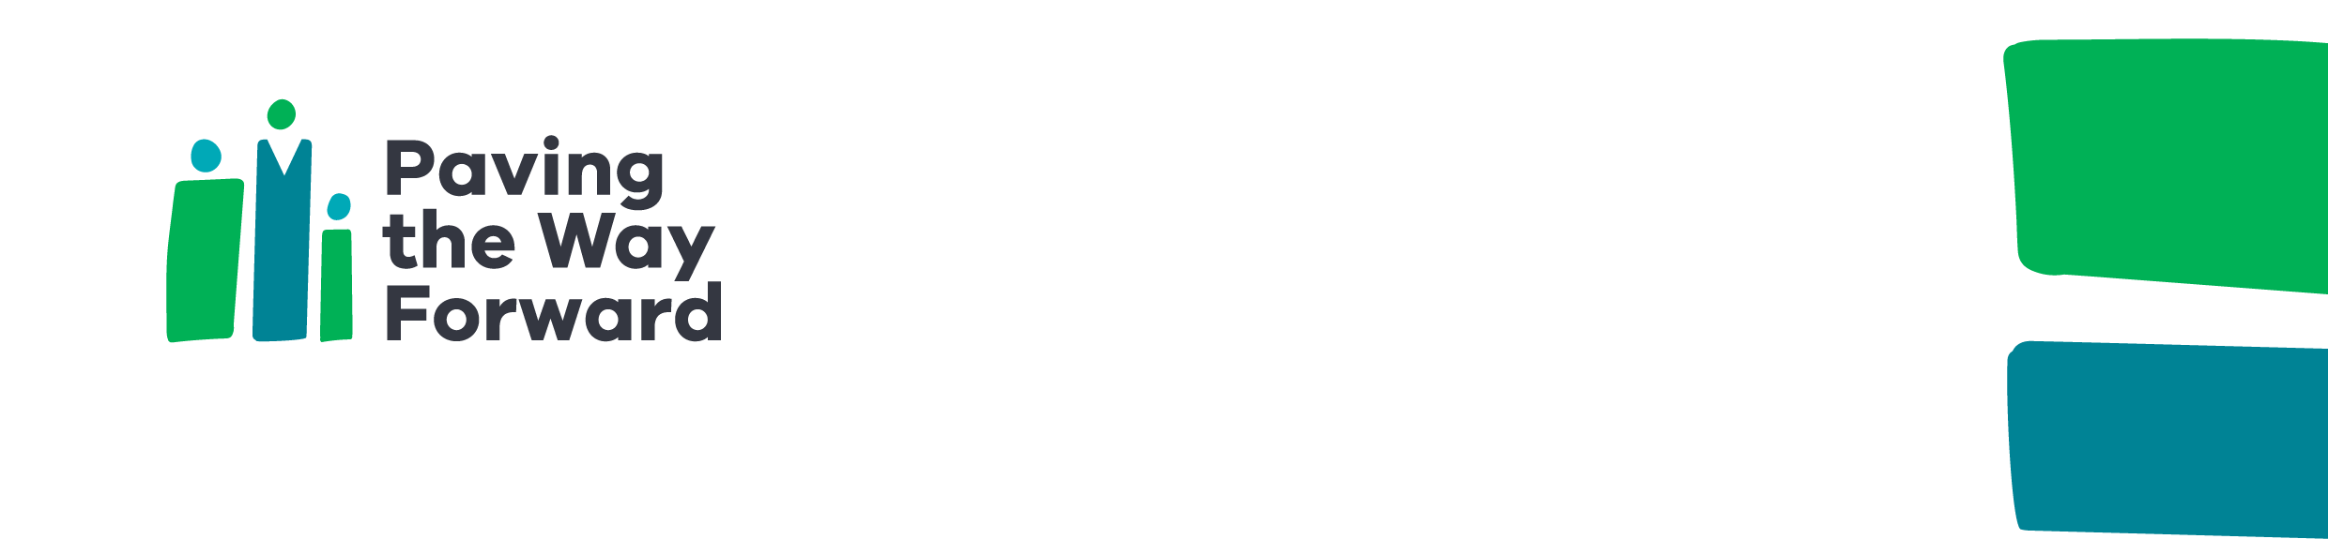

|  |
| --- |
| Flemington local action plan 2022–23 overview |
| Paving the Way Forward  Accessible |
| OFFICIAL |

This plan transforms the needs, ideas and goals of residents into **five focus areas** and **63 actions**, which will be implemented through **partnerships,** **targeted funding** and **promotion**.

The actions set out in this plan are based on community feedback from 2021–22.

Under each focus area, the plan outlines:

* **What we heard** from residents about the issues they experience.
* **What residents want** to see change, their needs and their aspirations.
* **What we aim to achieve** in this focus area. These are outcomes identified by residents.
* **How we will do it** –the agreed actions to address these needs and implement local solutions to priority issues. Many of these ideas have been co-developed with residents. Some of these actions started rolling out in January 2022. Others will be delivered in partnership with residents, community organisations, the local council and other partners over the next 12 months.

|  |  |  |
| --- | --- | --- |
| **Focus area** | **Our goals** | **Local actions** |
| Communication and participation | * Residents are more confident to take part in decision making * Residents are involved in the key decisions that affect their home, neighbourhood and services * Residents take part in and own solutions for the issues they see as the most pressing | * Establish resident action group * Involvement in designing resident decision-making models * Education sessions on how government works * New communication channels * Promote housing officer roles * Community grants, leadership and governance training * Local council participation * Youth leadership development * Consultation between residents and stakeholders * Youth podcasting * Feedback and suggestion box |
| Maintenance and amenity | * Residents know more about tenancy and neighbourhood management * Property and tenancy management responds to residents’ needs | * Maintenance and housing education series * Welcome pack for new renters * Regular state walk-arounds * Simplify housing information * Secure carparking system * Abandoned vehicle removal * Improve adherence to parking rules * Install bins and remove litter * Housing and renters conference * Community safety audit * Improve lighting and safety * Improve digital experience for maintenance requests |
| Employment and education | * Residents can more easily get the support they need to find work and training * Residents have access to more job opportunities in the local area that match their career goals, available hours, accessibility and cultural needs | * Engage, map and identify employment priorities * Small business and entrepreneurship support * Develop and implement a targeted employment plan * Promote employment access * Support employment initiatives for residents * Help young people find their first job |
| Safety, health and wellbeing | * There is better communication between services * Residents and services work together to meet the needs of residents * Residents can get the right service at the right time | * Health outreach programs * Mental health program * Health and wellbeing activities * Health information sessions * Support for older people * Access to sports programs for kids * Map and promote local services * Services fair * Women’s health and safety awareness * Culturally appropriate swimming * Community safety forum * Legal education and support * Youth hub and programs for youth * After-school activities for children * Toddler playgroup * Support for parents * Financial literacy workshops |
| Community connection and spaces | * Shared spaces are better managed to the benefit of residents * Residents build social and community connections, creating stronger communities | * Improve community room access * Community facilities upgrades * Upgrade playgrounds near 120 Racecourse Road * Outdoor seating and shade * Improve basketball court * Youth hub * Support resident creativity * Secure bike parking * Promote multicultural and other community grants * PTWF community grants program * Community celebration days * Intergenerational storytelling * Food security project * Community art * Community group networking * Community outings * Kids cooking classes |

For more information about PTWF Flemington or to discuss any aspects of the plan, please [email the PTWF team](mailto:pavingthewayforwardNMF@dhhs.vic.gov.au) <pavingthewayforwardNMF@dhhs.vic.gov.au>.

|  |
| --- |
| To receive this document in another format, [email the Paving the Way Forward team](mailto:PavingTheWayForwardNMF@dhhs.vic.gov.au) <PavingTheWayForwardNMF@dhhs.vic.gov.au>.  Authorised and published by the Victorian Government, 1 Treasury Place, Melbourne.  Paving the Way Forward is a Victorian Government initiative supported by the Department of Families, Fairness and Housing. In partnership with cohealth, North Melbourne Language and Learning, Drummond Street, and Mission Australia.  © State of Victoria, Australia, Department of Families, Fairness and Housing, October 2022.  ISBN  978-1-76130-042-4 (pdf/online/MS word)  Available at [Paving The Way Forward Initiative](https://www.dffh.vic.gov.au/paving-way-forward-initiative) <https://www.dffh.vic.gov.au/paving-way-forward-initiative> |