

|  |
| --- |
| eBusiness and Restrictive Intervention Data System access |
|  |
| OFFICIAL |

Contents

eBusiness access 1

eBusiness User access 2

Restrictive Intervention Data System (RIDS) access 2

Provider Authority 2

Authorised Program Officer (APO) 3

Service Outlet Authority 3

Service Recorder 3

Appendix 5

Quick guide eBusiness access 5

Disability service providers (DSP) require eBusiness access to gain access to the Restrictive Intervention Data System (RIDS).

eBusiness is the web environment or portal where organisations have access to one or many business applications hosted by the Department of Families, Fairness and Housing. RIDS is one of those.

Each provider will need to complete the necessary documentation for their organisation to have access to eBusiness. This will enable employees to establish an eBusiness account.

# eBusiness access

Implementing providers will need to use RIDS to seek authorisation of the use of regulated restrictive practices.

Follow these steps to gain access to RIDS via eBusiness.

1. Email [eBiz@support.vic.gov.au](mailto:eBiz@support.vic.gov.au) for information and assistance and state you wish to register your organisation in eBusiness to get access to RIDS, (this will be the quicker option).

Or

1. Call 1300 799 470. Select 1 on the first set of prompts then select 4 on the second set of prompts to talk to a service desk analyst to assist you with your eBusiness inquiry and registration.
   1. Please ask the service desk analyst to check to see whether your organisation is already registered in eBusiness, and whether you have an existing eBusiness account with that organisation.
   2. If your organisation is registered and you have an existing eBusiness account, the service desk analyst may advise you to log-in to your account and click on ‘additional application access’ on the blue menu banner, then follow the prompts to request access to RIDS.
   3. If your organisation is registered but you do not have an existing eBusiness account, you may be advised to register online.
   4. You can register online at [eBusiness Login](https://eus.webapp.dhs.vic.gov.au/EUSPortal/) https://eus.webapp.dhs.vic.gov.au/EUSPortal/. Select ‘I want to register’ and follow the process. (see Appendix 1)
2. If your organisation is not registered, please ask the service desk analyst to forward your request to the eBiz team who will email you the ‘eBusiness Access Agreement' and 'Organisational Authority (OA) nomination form' and instructions on how to complete the forms and the registration process.
   1. As expressed in the agreement, this is a contract between the Provider and the Department of Health (with corporate support to the Department of Families, Fairness and Housing) securing the proper usage by the organisation in the eBusiness environment, and is the means to which the Provider appoints a person to perform the duties of the ‘Organisation Authority’.
   2. The role of the Organisation Authority is to manage User and organisational matters related to the Organisation for the department’s eBusiness Environment. The department views the Organisation Authority as a key local resource having inherent knowledge and capacity to undertake important tasks relating to access and registration of the Organisation’s Users.
   3. The chief executive officer or equivalent needs to complete and sign the Access Agreement and Organisation Authority nomination form, scan them as separate documents, then return them to the department at [eBiz@support.vic.gov.au](mailto:eBiz@support.vic.gov.au).  There is a capacity to delegate this also on the form.
3. Once approved, the eBiz team will create the organisation in eBusiness.
4. The eBiz team will advise the nominated Organisation Authority how to set-up access to the Enterprise User Service. The Enterprise User Service is used to grant staff in the organisation access to RIDS.
5. When an organisation initially requests access to RIDS, the request will be referred to a delegate within the department for approval.
6. You can then seek approval to access RIDS through online (see RIDS access below).

## eBusiness User access

Once the Provider has established access for the organisation the organisation’s users are now able to set up their individual eBusiness accounts. This is an online registration via the eBusiness portal, see Attachment 1 Quick guide and is also the method of accessing the RIDS application via the eBusiness Portal. Once the access has been validated by the Organisation Authority and the RIDS System Administrator the user will be required to nominate a responsibility with the RIDS application. (see below).

# Restrictive Intervention Data System (RIDS) access

1. If your organisation is registered in RIDS will need to select the ‘Enter RIDS’ option to enter RIDS. Your name and email and alphabet will appear on the questionnaire page.
2. Select the letter which represents your organisation and select from the list. (If your organisation does not appear go to step 5).
3. Once you have selected an organisation 4 responsibilities will appear. The Provider Authority Role needs to be the first role approved for new providers.

## Provider Authority

* 1. A Provider Authority represents the provider and should hold a senior posting to Authorised Program Officers. This access is approved by the System Administrator.
  2. Must authorise all ‘Authorised Program Officers’ (APOs) for the Provider.
  3. The only authority able to revoke an ‘Authorised Program Officer’s’ access, other than the System Administrator.

## Authorised Program Officer (APO)

* 1. A Provider can be made up of one or several Service Outlets. Each Outlet, who employs the use of restrictive practices in Victoria, must have an appointed and qualified APO. This responsibility is approved by the Provider Authority.
  2. Will be responsible for authorising Behaviour Support Plans submitted to the Victorian Senior Practitioner (VSP) via RIDS.
  3. Can authorise ‘Service Recorder’ and ‘Service Outlet Authorities’ System Access Requests for their Outlet.
  4. Can authorise ‘Request for Additional Provider Access’ for Service Recorders and Service Outlet Authorities associated with their authorised ‘Service Outlet(s)’.
  5. Can ‘Revoke’ access to a ‘Service Recorder’ and ‘Service Outlet Authorities’ for their authorised Service Outlet(s).
  6. Will be responsible for authorised Service Outlet to ‘Monthly Report to SP’ for State Funded Clients.
  7. Will authorise RI Event Transactions for State Funded Clients. their Service Outlets.
  8. Will inherit the ability to perform all tasks a Service Recorder or Service Outlet Authorities may perform.

## Service Outlet Authority

* 1. The Service Outlet Authority is set by the ‘Authorised Program Officer’ for the Service Outlet and can be any System User for the Provider that the Authorised Program Officer acknowledges their supervisory role (for example, Team Leader or House Supervisor). This responsibility is approved by the Authorised Program office but can also be approved by the Provider Authority.
  2. Will ‘endorse’ RI Transactions for State Funded Clients that occur for State Funded Clients.
  3. Can record BSPs that occur in their Service Outlet.
  4. Can authorise ‘Service Recorder’ System Access Requests for their Service Outlet.
  5. Can ‘Revoke’ access to a ‘Service Recorder’ only for their authorised Service Outlet(s).

## Service Recorder

* 1. Service Recorders will belong to a Provider. They will perform most of the data entry and will be associated with one or more Service Outlets. This responsibility is approved by Service Outlet Authority but can also be approved by the Authorised Program Officer or Provider Authority.
  2. Will be the primary user for entering RI Transactions in the System for State Funded Clients
  3. Will be the primary user for entering BSPs in the System.
  4. Will be able to view data associated with the Service Outlet(s) that have been authorized within the System.
  5. Can view the Service Outlet(s) associated with their Provider.
  6. Can edit RI Transactions that they have authored that has the Status of ‘Draft’ for State Funded Clients.
  7. Can Request Additional Outlet access.

1. New Users will need to nominate the responsibility on their first access to RIDS via the Questionnaire that appears on first entry. Existing RIDS users can nominate for additional access to other or additional outlets via the ‘Request Additional Access’ option via the RIDS menu.
2. If your organisation does not appear in the drop down, you will need to step back and select the register provider option.
3. Complete the on-line Provider RIDS registration. You will be notified when your organisation is registered once the organisation is registered in RIDS, you can continue your individual RIDS access process. (Step 3).

For assistance with providing a NDIS behaviour support plan to the Victorian Senior Practitioner or accessing RIDS, contact the RIDS Helpdesk:

* Phone 9456 3151, or
* email [RIDS.Helpdesk@dffh.vic.gov.au](mailto:RIDS.Helpdesk@dffh.vic.gov.au).

# Appendix

## Quick guide eBusiness access

To use the RIDS system you will need to have an Department of Families, Fairness and Housing eBusiness account.

To access this go to [eBusiness Login](https://hns.dhs.vic.gov.au/EUSPortal/index.jsp) <https://hns.dhs.vic.gov.au/EUSPortal/index.jsp>. Once there select, I want to register.

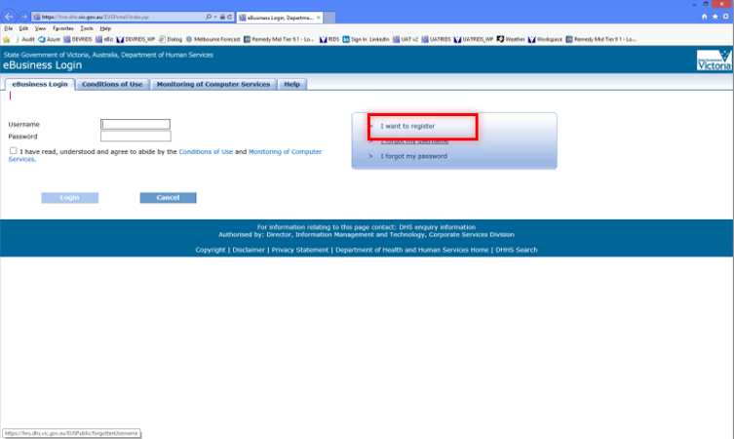

This will take you to the eBusiness request for registration screen. Select (double click) Restrictive Intervention Data System (RIDS) from the Application drop down box. Then complete the online registration. Ensure you complete the information with red stars as they are mandatory fields.

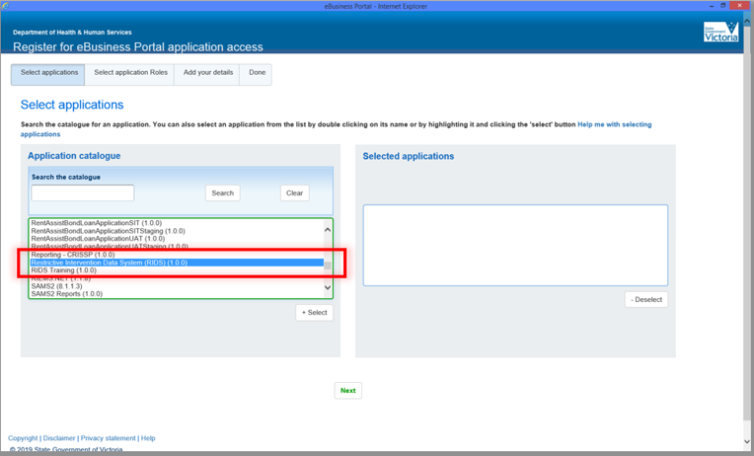

Select the next button when the application appears in the ‘Selected Application List’ box.

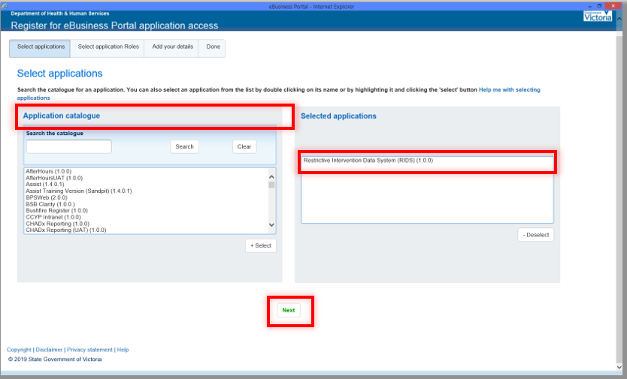

For the RIDS application role select General User

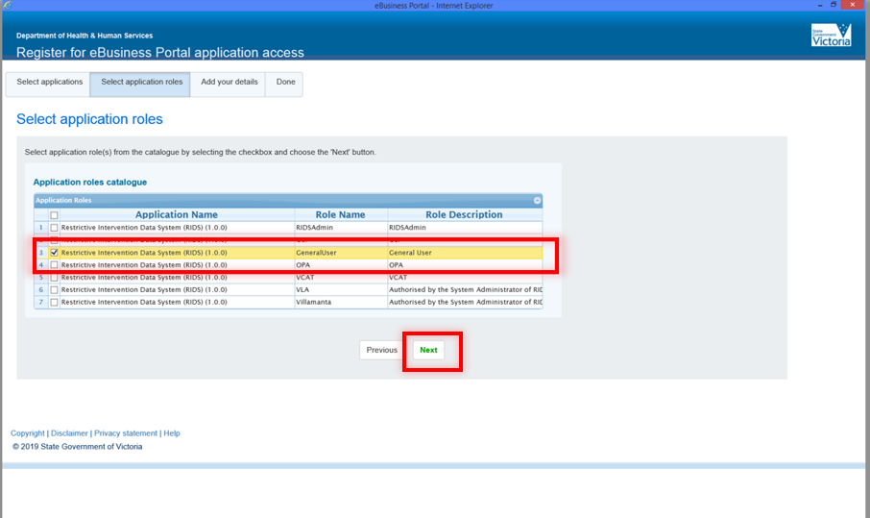

Complete the rest of the eForm on the Add your details page.

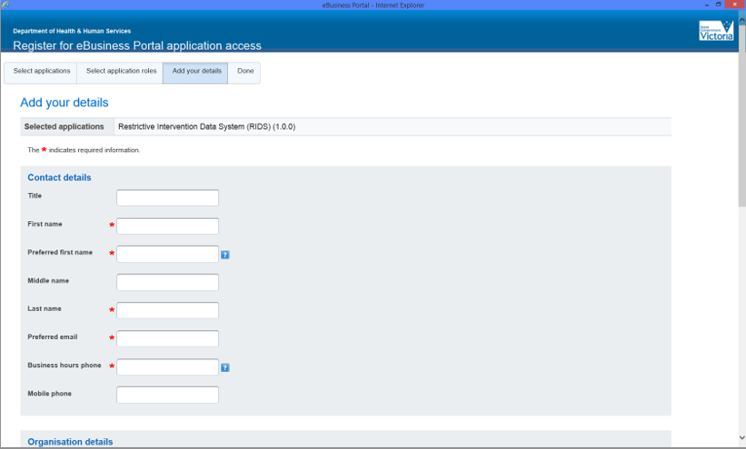

Once you have completed the online registration submit by clicking the Register button at the bottom of the page and you will notified that you have access when approved.

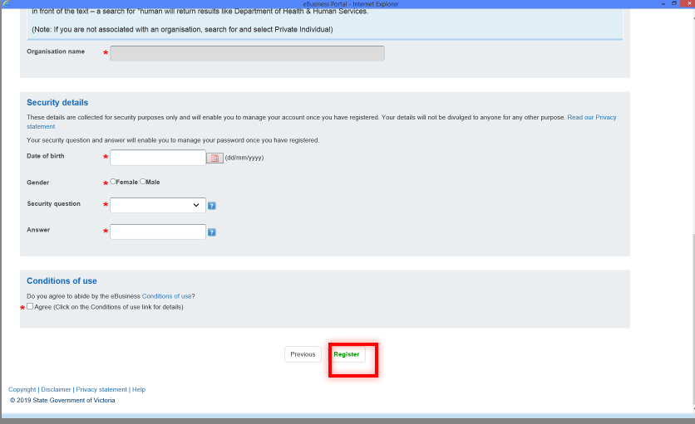

|  |
| --- |
| To receive this document in another format, phone the Victorian Senior Practitioner on 9096 8427 or email [victorianseniorpractitioner@dffh.vic.gov.au](mailto:victorianseniorpractitioner@dffh.vic.gov.au)  Help for people with hearing or speech communication difficulties  Contact us through the National Relay Service (NRS). For more information, visit [National Relay Service](https://www.accesshub.gov.au/about-the-nrs) (https://www.accesshub.gov.au/about-the-nrs) to choose your preferred access point or call the NRS Helpdesk on 1800 555 660. Authorised and published by the Victorian Government, 1 Treasury Place, Melbourne.  Authorised and published by the Victorian Government, 1 Treasury Place, Melbourne.  © State of Victoria, Australia, Department of Families, Fairness and Housing, June 2024  **ISBN** 978-1-76130-545-0 **(pdf/online/MS word)**  Available at [Restrictive Intervention Data System (RIDS)](https://www.dffh.vic.gov.au/restrictive-intervention-data-system-rids) https://www.dffh.vic.gov.au/restrictive-intervention-data-system-rids |