|  |
| --- |
| Children and Families Research Strategy 2017–2019  Supporting the Roadmap for Reform |
|  |



Department of Health

|  |
| --- |
| Children and Families Research Strategy 2017–2019  Supporting the Roadmap for Reform |
|  |

|  |
| --- |
|  |
| To receive this publication in an accessible format, email [roadmapforreform@dhhs.vic.gov.au](mailto:roadmapforreform@dhhs.vic.gov.au)  Authorised and published by the Victorian Government, 1 Treasury Place, Melbourne.  © State of Victoria, Department of Health and Human Services, June 2017.  Except where otherwise indicated, the images in this publication show models and illustrative settings only, and do not necessarily depict actual services, facilities or recipients of services. This publication may contain images of deceased Aboriginal and Torres Strait Islander peoples.  Where the term ‘Aboriginal’ is used it refers to both Aboriginal and Torres Strait Islander people. Indigenous is retained when it is part of the title of a report, program or quotation.  ISBN 978-0-7311-7226-9 (Print)  ISBN 978-0-7311-7227-6 (pdf/online/MS word)  Available at [The Roadmap for Reform: strong families; safe children website](http://www.strongfamiliessafechildren.vic.gov.au/) <http://www.strongfamiliessafechildren.vic.gov.au/>  Printed by Impact Digital, Melbourne  (1706004) |
|  |

Contents

Acknowledgements 6

Minister’s foreword 7

Introduction – establishing a learning system 8

Types of evidence to drive the learning system 8

The learning system architecture 8

Principles for the learning system 11

Measuring outcomes is essential 11

Using diverse forms of strong evidence 11

Fostering innovation and promising practice 11

Empowering Aboriginal children and families 11

Conducting ethical research 11

Translating and implementing evidence 12

Strengthening collaboration between practitioners and researchers 12

Children and families research priorities 13

Appendix A: Development of the children and families research priorities 19

Appendix B: Work underway 20

# Acknowledgements

The Department of Health and Human Services would like to thank the Learning System and Practice Implementation Group for their commitment, time, expertise and guidance in developing the Children and Families Research Strategy. The department is also very grateful to the members of the children and families sector who provided thoughtful and expert input into the research priority areas through completing the learning system survey distributed in 2017. We would also like to thank the Centre for Excellence in Child and Family Welfare for their ongoing support and contribution to progress the learning system.

# Minister’s foreword

In April last year, I launched the Government’s landmark [Roadmap for Reform: Strong families, safe children](https://urldefense.proofpoint.com/v2/url?u=https-3A__www.vision6.com.au_ch_47492_279f9_2076980_222c4ydpt.html&d=DwMCAw&c=JnBkUqWXzx2bz-3a05d47Q&r=7i-7ruLz5eX1ftQGlctRrFRL5iy05ApXq8QFpoQ5Bmo&m=4Tx0QdtBr1VUjslC-OLsw5_zvxXTONfUpxANBD00Fug&s=2DdExluIowuNAyYAI_yYBpHxl3hDl7xI4sp_Q1raDj0&e=) which outlined our commitment to deliver improved and lasting outcomes for vulnerable children, young people and families. To achieve our vision we need to shift the children and families services system from crisis response to one focused on prevention and early intervention.

To support this transformation, it is critical that our network of services operates as a learning system. This means working together to deliver children and families services that are backed by rigorous evidence and are continually re-evaluated, refined and shared to improve the outcomes for children, young people and families.

This Children and Families Research Strategy is a central component of the learning system   
and the Roadmap, prioritising our evidence needs and focusing our efforts in areas that require improvement and innovative solutions. It will lead to more rigorous and locally relevant evidence that responds to our greatest challenges and provides the foundation for strategic partnerships between the sector and research organisations.

Building the evidence needed to deliver better services requires a shared understanding of purpose and this research strategy provides direction on the type of knowledge we need; the standard of evidence we require; and how we can embed evidence in everything we do.

The newly established Outcomes, Practice and Evidence Network (OPEN) is another critical component of the learning system. OPEN – led by the Centre for Excellence in Child and Family Welfare – builds on a sector-led initiative to bring together practitioners, researchers and policy makers to generate and share relevant and much needed evidence to support best practice.

Through the release of this research strategy and the establishment of OPEN, I expect to see an increase in rigorous evidence that can be directly applied to children and families services. I look forward to stronger relationships between government, children and families services and the research community, and new opportunities to work together to increase the delivery of best practice services.

We have made significant progress in implementing our reform agenda, and now we will build on this work. I would like to thank the service providers and other stakeholders who provided input into the development of this Research Strategy, as well as those that continue to look for ways to improve the services for vulnerable Victorian children, young people and their families.

**Jenny Mikakos MP**  
Minister for Children and Families

# Introduction – establishing a learning system

The Roadmap for Reform: Strong families, safe children highlights the pressures and challenges faced by the children and families services system and sets out the directions and first steps for reform. An essential enabler for this reform is for the sector[1] to become a learning system, where outcomes are measured and children and families services are continually re-evaluated, refined and improved.

The learning system is ‘service providers, funders and policy makers, intermediary organisations, service users, program developers and researchers driving the development and implementation of evidence and innovation across the service system to improve outcomes for children and families’.

## Types of evidence to drive the learning system

Evidence can take many forms and employ a range of methods to generate useful knowledge. To meet the needs of the learning system, the sector requires evidence that:

* defines and measures the issues so that the challenges the service system aims to address are better understood (such as rates of family violence, drivers of child protection, forecasts of future service demand)
* identifies what works to address the issues (such as family therapy, parent coaching, cognitive behavioural approaches)
  + monitors and evaluates to ensure responses are having the intended outcome (such as using outcome indicators and program evaluations).

## The learning system architecture

Figure 1 outlines the architecture of the learning system – that is all the elements that will work together to create, generate, share, implement and refine an evidence-based service system, including this research strategy. A description of each element is provided below the figure.

Figure 1: The learning system architecture

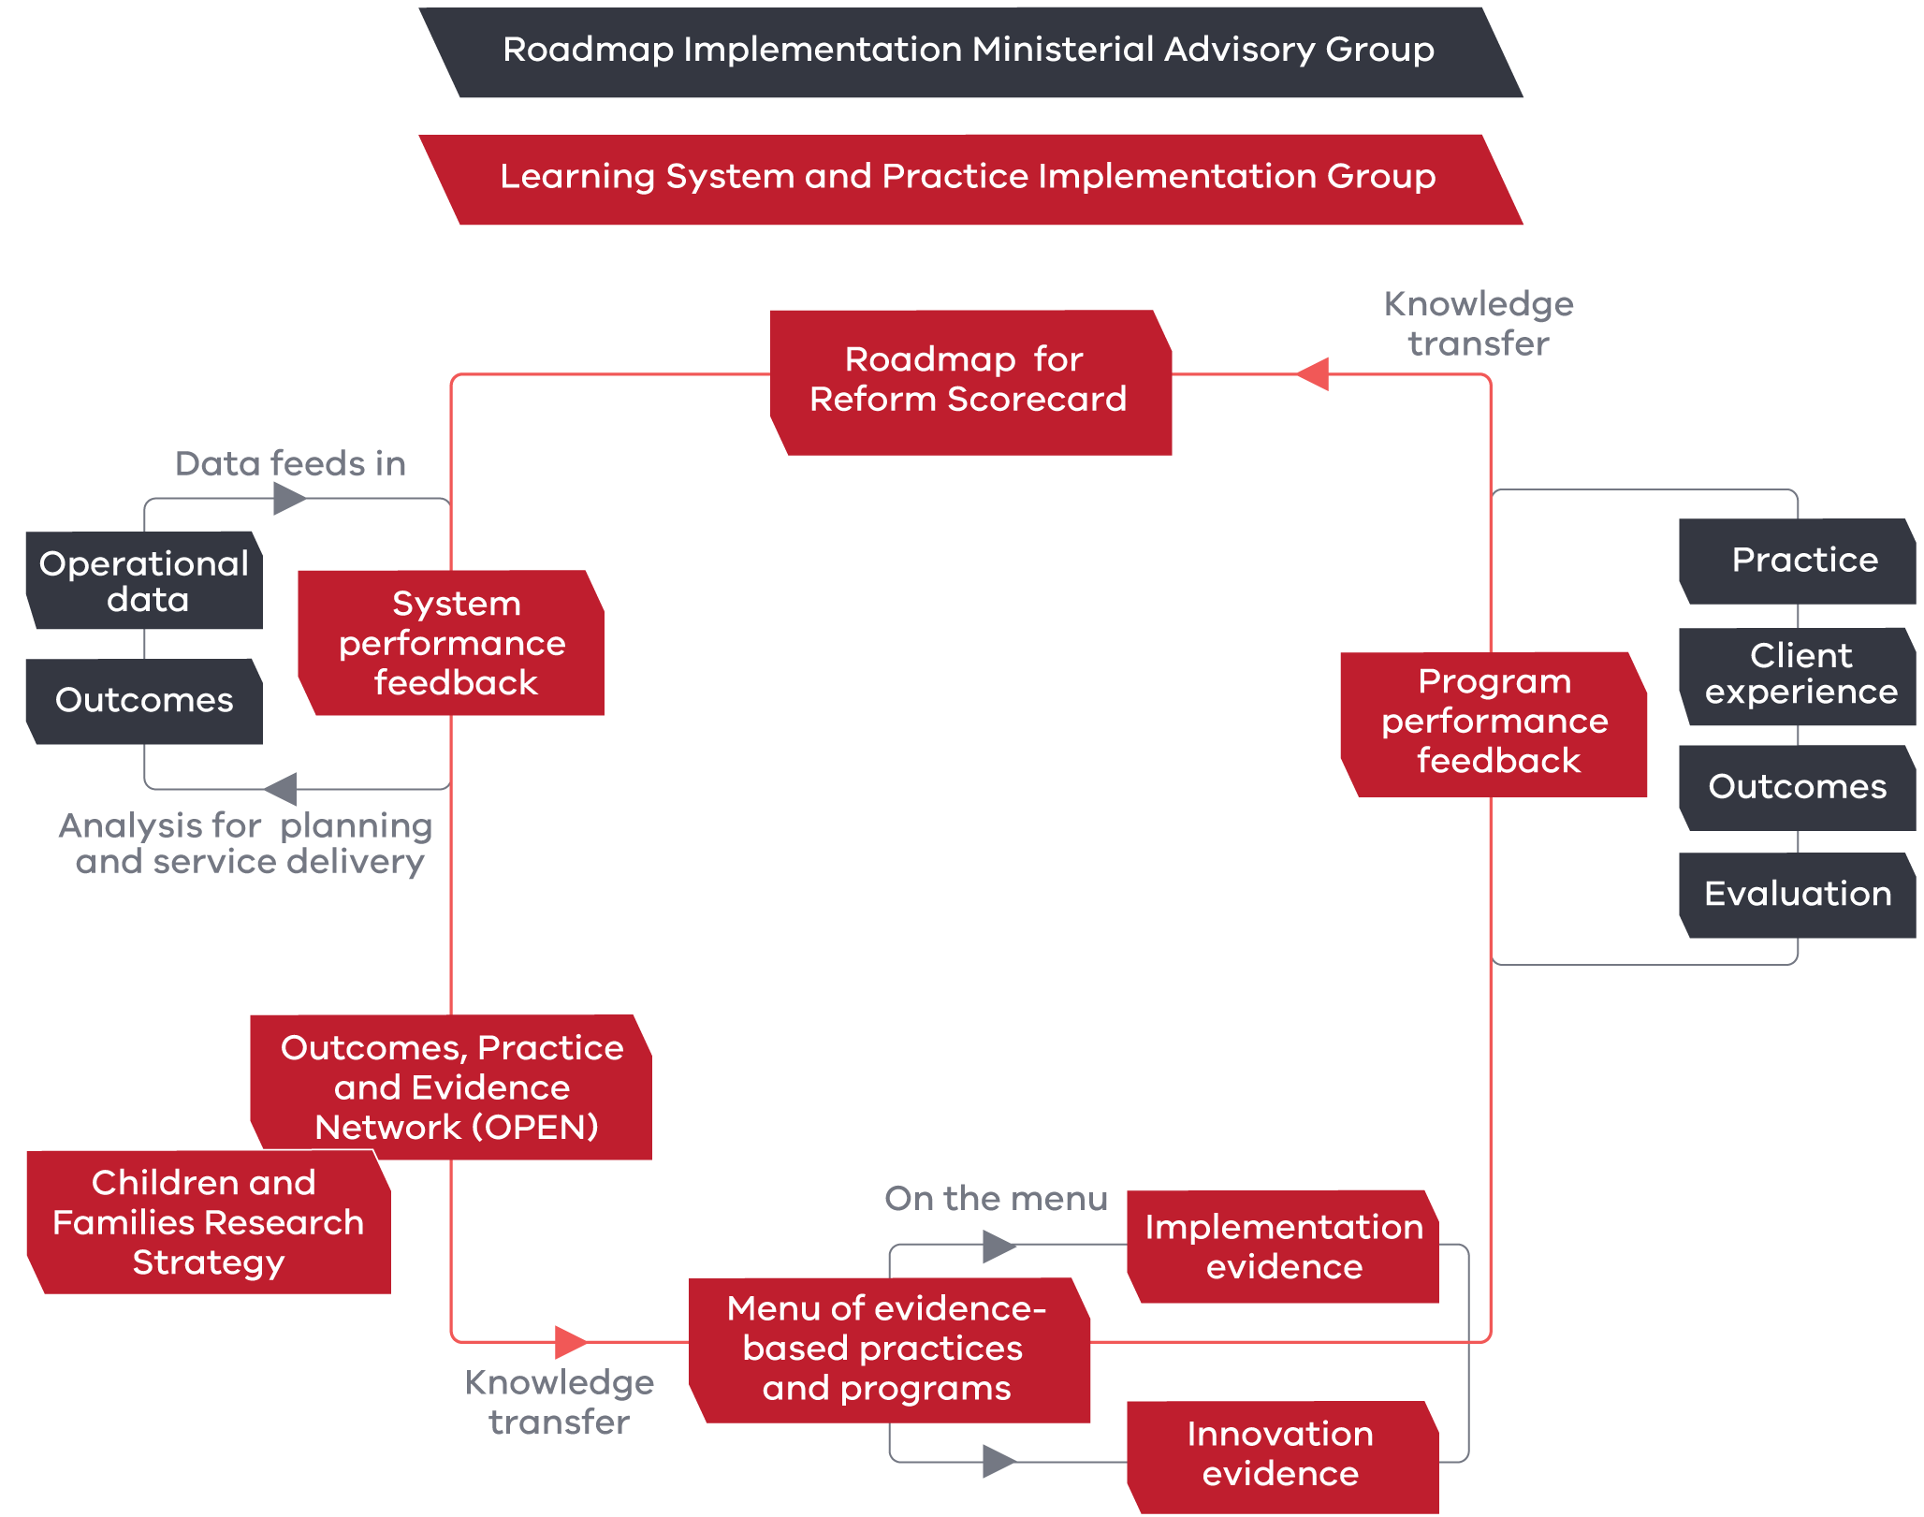

The elements of the learning system that will enable the delivery of evidence-based services include:

* Learning System and Practice Implementation Group –brings stakeholders together to develop a shared vision and direction of the key elements. The group reports to the Roadmap Implementation Ministerial Advisory Group to guide and oversee the implementation of the learning system.
* System performance feedback mechanisms – strengthen the collection and use of data and analytics and ensure the insights generated are fed back to service providers to inform practice and program decisions. This involves improving data collection so that it is comprehensive with a focus on outcomes.
* Children and Families Research Strategy – defines the research priority areas to strategically focus efforts and resources; and describes the ways in which the sector can work together as a learning system.
* Outcomes, Practice and Evidence Network (OPEN) – a shared network of researchers, service providers, practitioners and policy makers to facilitate and build collaboration in generating, disseminating, translating and implementing evidence. OPEN will promote innovation, fostering local solutions to challenges and oversee practice development and change.
* Menu of evidence-based practice and programs – a continually updated ‘living’ menu. The menu will span the full service continuum from early intervention and prevention, to placement prevention, family reunification, leaving care and post care support. It will contain practice modules and evidence-based programs that enable services to be flexed up and down and tailored to meet the individual needs of service users.
* Program performance feedback – evaluates the response to an issue in the children and families services system. Program performance evidence should draw on multiple sources including outcomes measurement, client experience, implementation and practice, along with more traditional evaluative techniques that examine process, impact and effectiveness.

# Principles for the learning system

The seven principles for the learning system are a statement of values that set expectations for an evidence-informed children and families services system. These acknowledge the complexity of the issues and challenges for this service system in generating and using evidence.

## Measuring outcomes is essential

Having consistent and clearly defined outcomes and measures that the sector is working toward will assist in the integration of service provision and provide a strong evidence base of the interventions that are most effective in improving the lives of vulnerable children and families.

## Using diverse forms of strong evidence

Practice, program and policy decisions should be based on the strongest evidence available. However, where strong evidence is not available, this should not prevent using less developed evidence, such as the documentation of good practice, until a stronger evidence base is established.

The learning system supports a range of research types and methodologies. To ensure the delivery of effective interventions that improve outcomes, it is essential that the sector lift standards of evidence. This requires that local research, regardless of methodology, is of a high standard with outputs that are directly relevant and can be applied to children and families services. High quality research employs a best practice methodology, clearly reports whether the results are representative or statistically significant and provides conclusions supported by research findings.

## Fostering innovation and promising practice

The learning system is an environment that fosters innovation and promising practice or programs. These are approaches that have not been rigorously researched or evaluated, but are based on the principles of best practice and have strong indications (such as a case study or an evaluation) that they will improve outcomes. It is critical that evidence is collected on these promising locally grown practices and programs so that children and families benefit from innovative approaches to delivering services.

## Empowering Aboriginal children and families

Aboriginal children and families will be involved in each step of any research undertaken with, or for, Aboriginal communities in Victoria. Enacting self-determination requires Aboriginal control of the process, from the design and generation of evidence to its interpretation, dissemination and implementation. This will require building capacity and authority of the Aboriginal community in evidence-gathering and championing Aboriginal peoples’ specialist skills, leadership and unique ways of knowing and being. Systematic mechanisms to support Aboriginal-led research, including Aboriginal data sovereignty, represent a key principle of the learning system.

## Conducting ethical research

Ensuring that research is ethical is the responsibility of all research stakeholders including those who fund and undertake the project, and those who use the findings. Research that involves vulnerable children and families must adhere to Australia’s National Statement on Ethical Conduct in Human Research (2007) and be approved by a registered Human Research Ethics Committee. This process addresses issues such as potential harms and benefits to participants, informed consent, and privacy and confidentiality of sensitive information.

## Translating and implementing evidence

The use of evidence – applying rigorous knowledge to practice – is crucial to ensure service delivery results in real positive change for vulnerable children and families. Implementation of evidence involves supporting the delivery of local, evidence-based practice and programs developed for Victorian populations as well as the adaptation of established evidence to the local context. Strong implementation means tailoring practices and programs to meet client needs, goals and values and addressing the service context. It means developing ways to sustain and scale up evidence-based service delivery and continuously testing, adapting   
and improving services through the collection and measurement of outcomes.

## Strengthening collaboration between practitioners and researchers

Practitioners have unique insight into the issues they tackle on the ground and what evidence will make a difference to services and service users. The learning system will thrive when practitioners and researchers are working collaboratively to address the complex issues and needs of service users.

# Children and families research priorities

Becoming a learning system requires the best evidence of what works or shows promise in Victoria and around the world. Yet, while the sector invests significantly in research and evaluation, there are gaps in rigorous evidence on what works and limited systematic and established avenues for translating and implementing evidence.

This section of the research strategy identifies and prioritises gaps in knowledge and sets a strategic direction for generating evidence that will provide most benefit to vulnerable Victorian children and families. The purpose of the children and families research priorities is to guide investment over the next two years to strengthen the evidence base to improve responses to the needs of children and families at risk. Development of the research priorities was through consultation with the sector and an independent assessment of published evidence. Further detail on this process provided in Appendix A.

Outlined below are two levels of priorities with three crosscutting themes and five specific priority research areas. The crosscutting themes and priority research areas will feed directly into the development of the menu of evidence-based practice and programs as this living document will require further evidence that is suitable for the Victorian service system and its service users.

The three crosscutting themes are broad and relevant to all of the priority research areas across the full spectrum of the children and families services system. For instance, evidence on trauma-informed practice is required across all of the priority research areas and the full spectrum of children and families services. The crosscutting themes are:

* prevention and early intervention
* measuring effectiveness and outcomes
  + trauma-informed practice.

Whereas the five priority research areas identify evidence needs relating to specific issues of focus for the children and families services system. They are:

* effective service models and practice for Aboriginal children and families
* children and young people in out-of-home care
* high-risk young people
* children and young people with disabilities
  + family violence.

Figure 2 and Table 1 below provides more details.

Figure 2: Overview of the crosscutting themes and the priority research areas

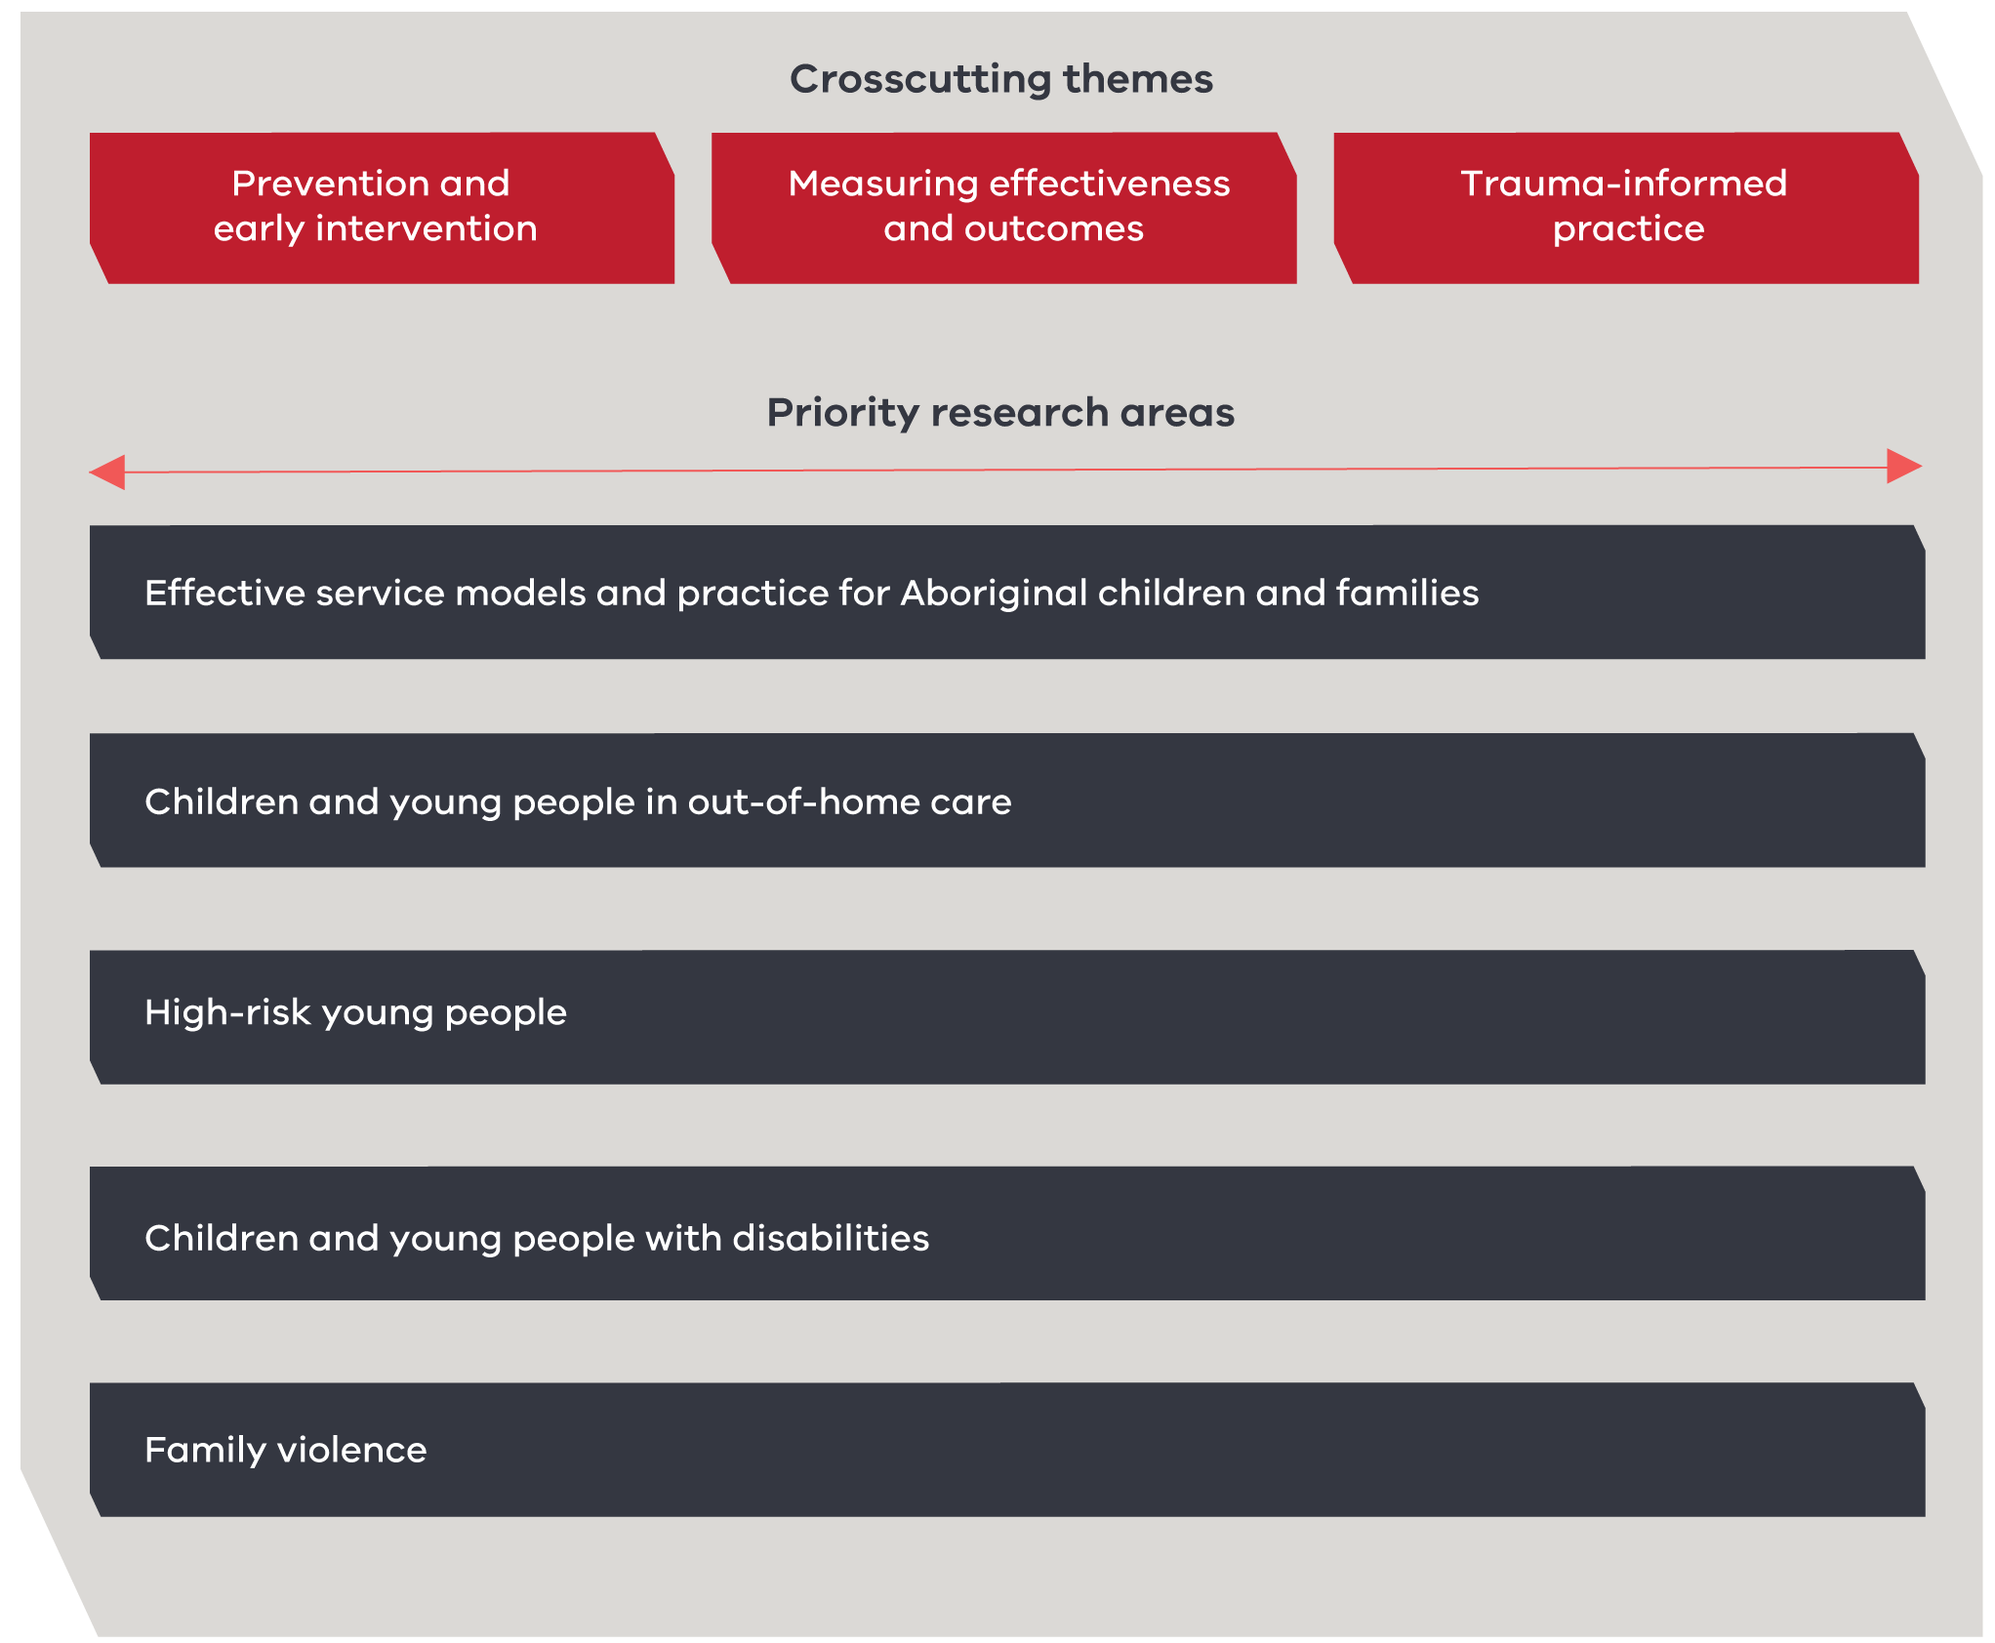

Table 1: Crosscutting themes and priority research areas

| Crosscutting theme  **Prevention and early intervention**  A better understanding of risks and effective early responses will result in earlier preventative support and better outcomes for children and families. | Crosscutting theme  **Prevention and early intervention**  Better and more systematic understanding of outcomes will enable services to direct investments towards interventions that work and scaling up of promising responses. | Crosscutting theme  **Prevention and early intervention**  Recognising and taking into account the effects of trauma to deliver interventions that are more effective for children and young people in the service system. |
| --- | --- | --- |
| Understanding prevalence, vulnerabilities and risk factors for children and families in relation to maltreatment and abuse.  Identifying critical touch points of intervention prior to, and at early entry into the service system for children and families to prevent maltreatment and abuse | Identifying effective practices and programs that improve outcomes of vulnerable children, young people and families.  Developing and using appropriate outcome measures that determine effectiveness and in order to enable continual improvement and comparison of interventions. | Identifying the universal elements of trauma-informed interventions associated with improved outcomes that can be used to develop evidence-based locally grown programs.  Developing an evidence-based trauma-informed framework for service delivery.  Identifying effective trauma-informed interventions for vulnerable children or young people including their specific delivery modes. |
| Identifying critical touch points of early intervention for children and families across the service systems (including prior to entry, at early entry and prior to use of tertiary services such as out-of-home care) to deliver better outcomes for children and families. | Identifying universal elements of effective practice and programs to develop and implement locally grown programs that can be tailored to children and family’s needs.  Adapting overseas findings and programs to the Australian and Victorian context, measuring barriers and enablers of local implementation.  Evaluating the cost effectiveness of interventions across children and families services to direct investment towards what works. | Adapting and testing the delivery modes of trauma-informed cognitive behavioural therapy (the current gold standard trauma intervention) for specific groups of children and young people who  have experienced sexual abuse. |

| Priority research areas  **Effective service models and practice for Aboriginal children and families**  Building evidence to understanding what works for Aboriginal children and families in the children and families services system by identifying, documenting and embedding what works and for whom, through strengthening existing resilience consistent with community values. |
| --- |
| Culturally safe practices, programs and associated implementation requirements that lead to improved outcomes for Aboriginal children and families.  Programs and services that identify and measure cultural wellbeing outcomes.  Culturally-safe, healing-informed programs and services for Aboriginal children and families.  Programs and services that work for Aboriginal children and young people in out-of-home care that foster culture, pride and identity and improve outcomes, including stable reunification (where appropriate).  Programs and services that target young Aboriginal people at risk of youth justice involvement that foster their culture, pride and identity and improve outcomes.  Culturally appropriate interventions that improve outcomes for Aboriginal children and young people with disabilities and their families.  Early intervention, treatment and recovery programs in family violence that promote the safety and wellbeing of Aboriginal children and families. |

| Priority research areas  **Children and young people in out-of-home care**  Building evidence on the needs, trajectories and outcomes of children who enter out-of-home care and their families, including through longitudinal research. Developing evidence on effective placement models and support for children and young people in out-of-home care: What are the core elements of interventions that lead to sustained good health and wellbeing outcomes during and after care? What are the costs and benefits of different interventions? |
| --- |
| Interventions that target and improve the cognitive development and educational achievement of children and young people in out-of-home care.  Develop and test interventions centred on evidence-based practices within out-of-home care that improve children and young people’s outcomes, including in the areas of physical and mental health.  Interventions that support children and young people in out-of-home care to maintain safe and stable placements.  Interventions that support children to be reunified with their families where appropriate, including providing support for the family unit.  Interventions that support children and young people post care, including effective support of stable reunification (where appropriate).  Interventions that support and enable quality transition towards independent living and adulthood.  Post-care interventions that support and sustain children and young people in the long term and enable improved outcomes.  Interventions that are culturally safe for Victoria’s culturally and linguistically diverse communities and improve children and young people’s outcomes. |

| Priority research areas  **High-risk young people**  Building evidence on effective interventions for high-risk young people in the children and families services system: What works for young people and their parents and carers? What are the key elements of practice and programs that need to be implemented? Are there specific delivery modes that influence outcomes for specific groups of young people? What are the costs and benefits of different interventions? |
| --- |
| Interventions that target, monitor and improve the cognitive development, educational achievement, school engagement, problem-solving and decision-making skills of young people at risk of child protection, disengagement from education and youth justice involvement.  Interventions that improve the capability of parents and carers to effectively address high-risk behaviours displayed by young people and improve their wellbeing.  Develop and test effective interventions for high-risk young people, including identification of core components or elements of practices and programs and the associated implementation requirements to reduce risky behaviour. |

| Priority research areas  **Children and young people with disabilities**  Building evidence on effective interventions for children and young people with disabilities and their families in the children and families services system: What are the most effective prevention and early intervention strategies? What are the key elements of practice and programs that need to be implemented to provide the best care for children and young people with disabilities? What are the existing barriers for effective interventions? What are the costs and benefits of different interventions? |
| --- |
| Interventions that work for children and young people with disabilities and their families and carers across the full spectrum of child and family services, including entry into and leaving out-of-home care and child protection.  Interventions that identify and address triggers that lead to engagement with and entry into children and families services.  Interventions that address risk factors for maltreatment and abuse such as cumulated parent and carer stress over time.  Bridge understanding, knowledge and evidence between the children and families services system with other relevant service systems, such as the disability service system, to deliver effective interventions for children and young people with disabilities.  Culturally appropriate interventions that improve outcomes for culturally and linguistically diverse children and young people with disabilities. |

| Priority research areas  **Family violence**  Building evidence on ending family violence in relation to the children and families services system, supporting the work already occurring under the Victorian Government’s Ending family violence: Victoria’s plan for change and the Family Violence Rolling Action Plan 2017–2020: What works to increase the safety of children and young people in the context of family violence? How to best support children and young people who are victim survivors of family violence? What are the costs and benefits of different interventions? |
| --- |
| Bridge understanding, knowledge and evidence between the children and families services system with the family violence service systems to deliver effective social and psychological interventions for children, young people and families.  Effective ways to develop and execute safety plans involving children and young people and aligned to existing work underway, such as the Multiagency Risk Assessment and Management Framework.  Parenting and fatherhood focused interventions that decrease ongoing and future violence including comparing modes of delivery by group-based to individually–based and behaviourally-based to other approaches.  Family violence interventions that are culturally safe for Victorian’s culturally and linguistically diverse communities in contact with the children and families services system.  Effective early interventions, treatment and recovery programs in family violence that target young people who display and/or use violence in the home. |

# Appendix A: Development of the children and families research priorities

Developing the Research Strategy has been a collaborative process initiated by the department with input from the Centre for Excellence in Child and Family Welfare, the Learning System Practice and Implementation Group, children and families services and research organisations. This process has acknowledged the importance of both practitioners’ on-the-ground knowledge and academic expertise.

The group’s role is to guide the development of the learning system. Comprising of service providers and researchers in the children and families services system it reports to the Roadmap Implementation Ministerial Advisory Group. The Learning System Practice and Implementation Group played a key role in developing this research strategy and identifying areas of evidence need.

To gain substantial practitioner input, a survey of Victorian service providers was conducted in early 2017. The aim was to determine the level and types of evidence required by service providers to deliver high-quality practices and programs to vulnerable children and families and the amount of promising practices and programs that service providers are delivering. The survey was distributed by the Centre for Excellence in Child and Family Welfare and was completed by 36 organisations.

At the same time, the department commissioned independent experts from the University of Melbourne to undertake an evidence gap analysis of published literature relevant to children and families services. The analysis was to identify areas where more high quality and rigorous evidence was required.

Input from the Learning System Practice and Implementation Group `and the findings from the service provider survey and the gap analysis strongly aligned and these were synthesised to determine the priority research areas outlined in the research strategy. These identified priorities represent the critical evidence needs of the sector in order to deliver improved outcomes for children, young people and families in Victoria.

# Appendix B: Work underway

The department provides support to research across children and families services in many ways. These include:

* directly commissioning high priority research
* making financial or in-kind contributions to larger research projects
* providing access to departmental data, information and other knowledge that supports research
* providing information and support to researchers who are working with our clients or data
  + supporting a Human Research Ethics Committee.

There are a number of research projects underway in Victoria that will contribute to the evidence needs of children and families services. Table 2 outlines some of the projects the department is leading or contributing to.

Table 2: Selected children and families research that the department is contributing to

| Project name | Description | Duration |
| --- | --- | --- |
| **Beyond 18: The longitudinal study on leaving care** | The department commissioned this project to improve understanding of the factors associated with successful transitions from out-of-home care to independence. The study will interview young people three times over three years and to date has recruited around 200 young people. | 2012–2018 |
| **The PATRICIA Project: PAThways and Research In Collaborative Inter-Agency working** | This project focuses on exploring the relationship between statutory child protection, family law, and community-based services who seek to support women and children exposed to domestic violence. | 2014–2017 |
| **kContact: Keeping Contact between parents and children in care** | A three-year study to develop and trial an enhanced model to manage and support contact between children in care and their birth parents. The aim is to reduce current and future distress related to contact, improve children’s relationships with their birth parents and increase successful reunifications in the long term. | 2014–2017 |
| **CREATE Foundation’s annual report cards** | The report cards are annual snapshots of how well child protection systems are functioning in particular areas. Each report card focuses on a key issue impacting the care, protection and wellbeing of children and young people in out-of-home care. | 2017 |

1. The ‘sector’ is understood to include all organisations that provide support to vulnerable children, young people and families, spanning across universal, targeted and tertiary services and including the Department of Health and Human Services.