|  |
| --- |
| *Strong carers, stronger children* – Victorian Carer Strategy |
| Findings of the Home-based carer census |
| Infographics |

|  |
| --- |
| **Liability limited by a scheme approved under Professional Standards Legislation**  **EY Sweeney is accredited under the International Standard, ISO 20252.**  **All aspects of this study will be completed in accordance with the requirements of that scheme.** |

Strong Carers, stronger children – Victorian Carer Strategy: Findings of the Home-based carer census
Infographics

Table of contents

Kinship carers: Department of Families, Fairness and Housing 3

Permanent carers: Department of Families, Fairness and Housing 5

Foster carers: Department of Families, Fairness and Housing 7

Accessibility 9

# Kinship carers: Department of Families, Fairness and Housing

## Carer profile

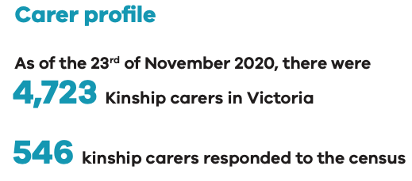

### Gender

### Gender of carers: Male 6.3%, Female 93.7%, Other 0%.Age

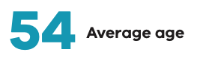

### Location

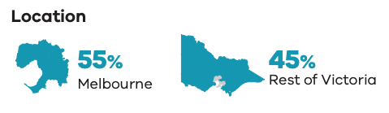

### Average number of children cared forBar chart of average number of children. 1 child 53%, 2 children 27%, 3 to 4 children 15%, 5 or more 3%

### Aboriginal carers

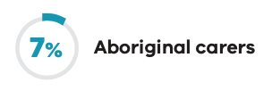

### Education

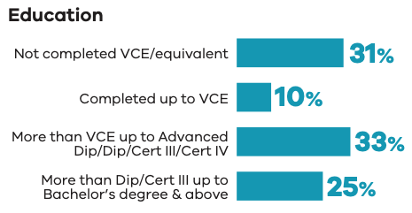

### Employment commitment

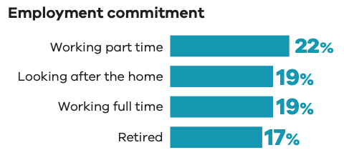

### Household income

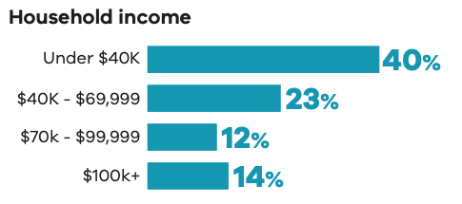

### Top 3 relationship to child

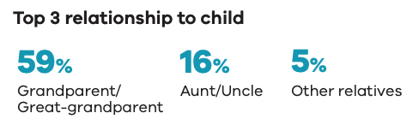

### Culturally and linguistically diverse carers

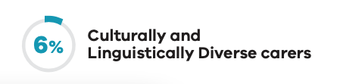

## Carer experience

### Top 3 motivations

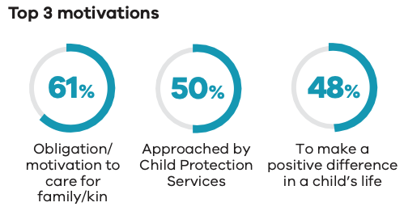

### Top 2 reasons for placements ending

Reunification with family 22%
Behavioural or mental health issues 22%

### Top 3 financial impacts personally

Used personal savings 72%
Regularly use own funds to pay for other expenses (like medical, dental, therapies) 66%
Borrowed money from family or friends 27%

### Top 3 child challenges

History of trauma 66%
Behavioural issues 56%
Learning difficulties 45%

### Top 3 system challenges

Lack of consistency in support 59%
Lack of key documentation 52%
Access to practical support 50%

### Top 3 sources of support

DFFH 39%
Agencies 37%
Support groups 28%

### Likelihood to continue caring

Very likely 27%
Likely 13%
Neither 21%
Unlikely 22%
Very unlikely 18%

### Negative impact on social relationship

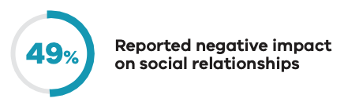

## Carer needs and possible support

### Navigating the system

54% of total respondents see this as a challenge
71% of total respondents were unaware this support was available

### Support for complex needs

43% of total respondents see this as a challenge.
65% of total respondents were unaware this support was available

### Mental health and wellbeing

43% of total respondents see this as a challenge.
60% of total respondents were unaware this support was available.

# Permanent carers: Department of Families, Fairness and Housing

## Carer profile

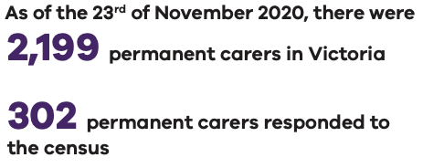

### Gender

### Gender of carers: Male 10.3%, Female 89.7%, Other 0%.Age



### Location



### Average number of children cared forBar chart of average number of children. 1 child 48%, 2 children 30%, 3 to 4 children 18%, 5 or more 5%

### Aboriginal carers

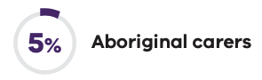

### Education

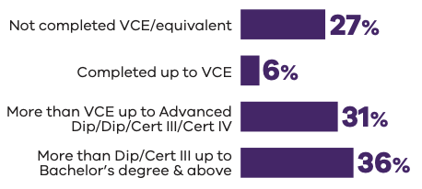

### Employment commitment

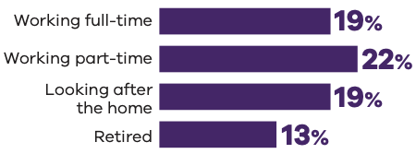

### Household income

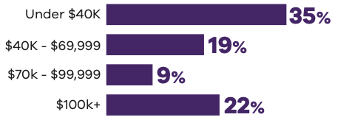

### Culturally and linguistically diverse carers

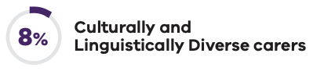

## Carer experience

### Top 3 motivations

To make a positive difference in a child's life 61%
Obligation or motivaton to care for family or kin 38%
Approached by Child Protection services 27%

### Top 2 reasons for placements ending

Reunification with family 24%
Behavioural or mental health issues 25%

### Top 3 financial impacts personally

Regularly use own funds to pay for other expenses (like medical, dental, therapies) 71%
Used personal savings 70%
Borrowed money from family or friends 24%

### Top 3 child challenges

History of trauma 64%
Behavioural issues 55%
Learning difficulties 46%

### Top 3 system challenges

Lack of consistency in support 57%
Lack of key documentation 53%
Navigating child protection systems 52%

### Top 3 sources of support

Agencies 50%
Peak and advocacy bodies 41%
DFFH 34%

### Likelihood to continue caring

Very likely 28%
Likely 13%
Neither 18%
Unlikely 22%
Very unlikely 19%

### Negative impact on social relationship

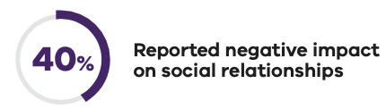

## Carer needs and possible support

### Navigating the system

52% of total respondents see this as a challenge
60% of total respondents were unaware this support was available

### Support for complex needs

42% of total respondents see this as a challenge.
52% of total respondents were unaware this support was available

### Mental health and wellbeing

39% of total respondents see this as a challenge.
52% of total respondents were unaware this support was available.

# Foster carers: Department of Families, Fairness and Housing

## Carer profile

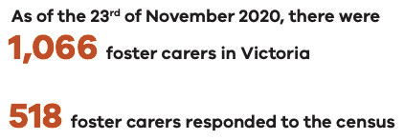

### Gender

### Gender of carers: Male 13.9%, Female 85.7%, Other 0.4%.Age



### Location

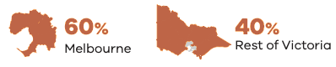

### Average number of children cared forBar chart of average number of children. 1 child 50%, 2 children 30%, 3 to 4 children 16%, 5 or more 3%

### Aboriginal carers

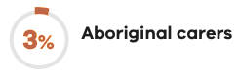

### Education

Education level bar chart.
Not completed VCE or similar 13%, Up to VCE 9%, More than VCE and up to Advanced Dip, Dip, Cert III or Cert IV 32%, More than Dip or Cert III up to Bachelor's degree and above 46%

### Employment commitment

Bar chart of employent status.
Working full-time 30%, Working part-time 27%, Looking after the home 14%, Retired 8%

### Household income

Bar chart of household income.
Under $40,000 22%, $40,000 to $69,999 16%, $70,000 to $99,999 12%, $100,000 and over 33%

### Culturally and linguistically diverse carers

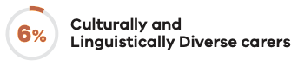

## Carer experience

### Top 3 motivations

To make a positive difference in a child's life 89%
To play a positive part in the community 57%
Prompted by advertising or communications 14%

### Top 2 reasons for placements ending

Reunification with family 19%
Behavioural or mental health issues 17%

### Top 3 financial impacts personally

Regularly use own funds to pay for other expenses (like medical, dental, therapies) 59%
Used personal savings 58%
Unable to pay a utility bill on time 11%

### Top 3 child challenges

History of trauma 72%
Behavioural issues 57%
Learning difficulties 47%

### Top 3 system challenges

Lack of key documentation 63%
Lack of consistency in support 59%
Navigating child protection systems 55%

### Top 3 sources of support

Agencies 80%
Carer KaFE 51%
Peak and advocacy bodies 43%


### Likelihood to continue caring

Very likely 43%
Likely 23%
Neither 14%
Unlikely 12%
Very unlikely 8%

### Negative impact on social relationship

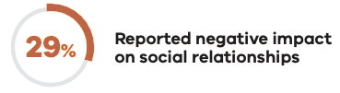

## Carer needs and possible support

### Navigating the system

55% of total respondents see this as a challenge.
41% of total respondents were unaware this support was available.

### Support for complex needs

44% of total respondents see this as a challenge.
32% of total respondents were unaware this support was available.

### Mental health and wellbeing

32% of total respondents see this as a challenge.
32% of total respondents were unaware this support was available.

EY | Assurance | Tax | Transactions | Consulting

**About EY**

EY is a global leader in assurance, tax, transaction and consulting services. The insights and quality services we deliver help build trust and confidence in the capital markets and in economies the world over. We develop outstanding leaders who team to deliver on our promises to all of our stakeholders. In so doing, we play a critical role in building a better working world for our people, for our clients and for our communities.

EY refers to the global organisation, and may refer to one or more, of the member firms of Ernst & Young Global Limited, each of which is a separate legal entity. Ernst & Young Global Limited, a UK company limited by guarantee, does not provide services to clients. For more information about our organisation, please visit ey.com.

© 2021 Ernst & Young, Australia. All Rights Reserved. Liability limited by a scheme approved under Professional Standards Legislation.

eysweeney.com.au

# Accessibility

If you need this data in another format, please [email DFFH’s Quality Improvement and Service branch](mailto:gisr@dffh.vic.gov.au)

<gisr@dffh.vic.gov.au> or phone (03) 9500 6446, using the National Relay Service (13 36 77) if required.