|  |
| --- |
| NORTH RICHMOND PRECINCT COMMUNITY GRANTS PROGRAM 2023 – 2024 |
| Application questions and guidance: Community Infrastructure Capital Works Grants |
|  |



This document has been prepared to help you complete the Community Infrastructure Capital Works Grants online application form. It includes:

* Each question that appears on the online application form and guidance on how to respond
* How to attach documents to your application form
* How to use Grants Gateway to complete and submit your application.

Use this form and the [North Richmond Precinct Community Grants Program Guidelines 2023 -2024](https://www.dffh.vic.gov.au/north-richmond-community-grants-2023-24-guidelines) (program guidelines) to help you prepare your responses to the application form questions and your mandatory documents.

**Please note that this document is to help you plan your application only. All grant applications must be submitted online through Grants Gateway.**

The [Resources and Support section of the North Richmond Precinct website](https://www.dffh.vic.gov.au/grant-resources-and-support) has a range of tools and templates to help you plan, write and submit your application.

If you have any questions, contact the North Richmond Precinct Team:  
[engagenorthrichmond@dffh.vic.gov.au](mailto:engagenorthrichmond@dffh.vic.gov.au) / 0477 765 743.

**Part 1: ABN (Australian Business Number)**

The questions in this section determine whether you are an incorporated organisation or if you need to apply through an auspice organisation. If you need more information about ABNs, go to the [*Commonly used grant terms* document in the Resources and Support section of the Precinct website](https://www.dffh.vic.gov.au/grant-resources-and-support).

Do you have an eligible current Australian Business Number (ABN)? Yes / No

* If you answer yes: provide your Australian Business Number (ABN)
* If you answer no: you will be asked if you are using an auspice organisation
  + If you answer yes: provide details of your auspice organisation

Have you met the terms and conditions of all previous grants and do not have any outstanding reports with DFFH? Yes / No   
*To check if your organisation is up to date on reporting requirements, please view your current grants in the Grants Gateway Portal. Any report which is showing as red is overdue.*

**Part 2: Eligibility**

The questions in this section assess your eligibility to apply for grant funding. Your organisation must meet all required eligibility criteria to apply.

For more information on eligibility, [refer to page 9 in the Program Guidelines](https://www.dffh.vic.gov.au/north-richmond-community-grants-2023-24-guidelines) or contact the North Richmond Engagement Team.

What is your connection / your organisation’s connection to North Richmond? Select all that apply:

*Projects must have a connection to North Richmond.*

* Organisation provides services in North Richmond
* Auspice org on behalf of an individual who studies in North Richmond
* Auspice org on behalf of an individual or group that volunteers in North Richmond
* Auspice org on behalf of an individual who access services in North Richmond
* Auspice org on behalf of group that provides services in North Richmond
* Other, please state
* None of the above

Will your project be delivered in North Richmond? Yes / No

*Projects must be delivered in North Richmond.*

Will your project address one or more of the key priority areas outlined in the North Richmond Precinct Community Action Plan? Yes / No

*All applications must address at least one of the key priority areas in the Community Action Plan to be eligible for funding.* [*Refer to pages 6-9 of the Action Plan for more information.*](https://www.dffh.vic.gov.au/sites/default/files/documents/202302/North%20Richmond%20Precinct%20Community%20Action%20Plan_2022-24.pdf)

Is your organisation (please select one):

* Not-for-profit organisation
* Social enterprise
* Local government
* School
* Other, please state
* None of the above

**Part 3: Applicant organisation**

You are required to provide information on your organisation, even if you have previously applied for a grant with DFFH.

Organisation name

Organisation type

Organisation address

Postal address (if different from organisation address)

Provide a brief explanation of the primary purpose and mission of your group or organisation, including its specific goals, objectives, and impact within the community (150 word limit)

Organisation website

Organisation email address

Organisation phone

**Part 4: Contacts**

Each organisation must provide the details of two representatives who are authorised to enter into a contract between your organisation and the department. The authorised representatives usually hold the positions of either President, Chief Executive Officer, Treasurer, or Secretary.

The first and second authorised representatives cannot be the same person and cannot have the same email address.

Applicant – first signatory / authorised person

* Title
* Pronouns (optional)
* Given name
* Last name
* Position title
* Email address
* Phone number
* Mobile number
* Preferred communication method
* Email
* Mobile
* Phone

Applicant – second signatory / authorised person

* Second signatory given name
* Second signatory last name
* Second signatory email address (must be different to the first signatory’s email address)

Primary contact person

*The primary contact is the day-to-day contact person from the applicant organisation. They may or may not also be one of the authorised representatives.*

* Title
* Pronouns (optional)
* Given name
* Last name
* Position title
* Email address
* Mobile
* Phone
* Is an interpreter required? *Include your preferred language and any other relevant information*
* Do you have accessibility requirements for communication with us? *Include all accessibility requirements to communicate with the department.*

**Part 5: Project details**

Project title   
  
Project start date  
*Projects cannot start until funding has been received, the earliest start date will be 1 March 2024.*Project end date  
*Projects must be completed by 30 June 2025.*Project description   
*This is a free text question with a 100-word limit. Consider including in your response:*

* *What activities will your organisation complete with this project?*
* *How will the grant funding be used?*

Project location

Project address  
*Project must take place in North Richmond*

Who are the Traditional Owners of the land your project will be delivered on? (optional)  
  
Are there any key partners who will be involved in the project? Yes / No   
If you answer yes, you will be prompted to provide a list of all key partners and the roles they will play in your project.

Project audience

*These are the groups who will benefit from your project. The questions in this section are drop down lists where you can select 1 or more options that best match your project.*

What age groups will your project support?

Will your project target or support any priority communities? Yes/No   
*If you answer yes: Which of the following groups, if any, will your project target or support?*

Will your project target or support any specific cultural or ethnic group(s)? Yes/No  
*If you answer yes: Which cultural or ethnic groups will your project target or support?*

Will your project target or support any specific language group?  
*If you answer yes: Which language groups will your project target or support?*

Will your project target or support any specific faith group?  
*If you answer yes: What faith groups will your project target or support?*

**Part 6: Assessment criteria**

Your responses to this section will be assessed and scored against the Infrastructure Planning Grants assessment criteria. [Please refer to pages 20 and 25 of the grant guidelines](https://www.dffh.vic.gov.au/north-richmond-community-grants-2023-24-guidelines) for further information on the criteria and the assessment process.

What evidence / outcomes from your community consultation demonstrate a need for this project? Please include demographic and other data (300 word limit)

Have you developed and attached a finalised business case? Your business case must include full, itemised costings; evidence of specific building and planning permit requirements and contractors and suppliers who will undertake the works. Yes / No

*This question requires you to confirm you developed a business case, using the* [*business case template in the Resources and Support section of the Precinct website.*](../../application%20resources/Commonly%20used%20grant%20terms%20document%20in%20the%20Resources%20and%20Support%20section%20of%20the%20Precinct%20website.) *You will be prompted to attach your project business case to your application in a later step.*

**Part 7: Budget**

All income and expense figures added in this step must be exclusive of GST. [Please refer to pages 8-9 of the program guidelines](https://www.dffh.vic.gov.au/north-richmond-community-grants-2023-24-guidelines) for further information on eligible and ineligible grant activities.

What is the expected total cost of your project?

**Grant details – this program**

Amount requested from this grant program (income)

What do you intend to spend funding from this grant on?*Click on the Add button to add details of each project expense:*

* Category
* Description
* Amount
* Supporting documents (optional)

Total expenses

Difference between grant received from this program, and expenses

What other income sources contribute to this total project cost (other than the amount requested from this program?

Total income and expense for this project

Total income

Total expense

Difference between income and expense

Volunteering Hours – Value*  
Please calculate the approximate cost/value of your volunteering hours using the following calculator: <https://stateofvolunteering.org.au/volunteer-replacement-cost-calculator/>

**Part 8: Attachments**

Upload all documentation required for your application.

Business case*

Insurance details*

Equipment quotes

Other attachments  
*Any other documentation that supports your application, including photos, letters of support*

*\*These documents are mandatory – you will not be able to submit your application if they are not attached.*

**Declaration**

To be completed by a person with delegated authority to apply – I.e., chairperson, secretary, or treasurer.

I declare that I am authorised by the applicant organisation to complete and submit this grant application on its behalf.

I certify that the information in this application and attachments is true and correct to the best of my knowledge.

I will notify the department of any changes to this information and any circumstances that may affect this application.

I state that the applicant organisation has acquitted all previous grants from DFFH and provided all required reports.

I acknowledge that this application may be referred to external experts or other Government Departments for assessment, reporting, advice, comment or for discussions regarding alternative or collaborative grant funding opportunities.

|  |
| --- |
| Using Grants Gateway |

Grants Gateway is the department’s online grant application system. All applications must be lodged through Grants Gateway to be eligible for funding. Contact the North Richmond Precinct Team with any questions: [engagenorthrichmond@dffh.vic.gov.au](mailto:engagenorthrichmond@dffh.vic.gov.au) / 0477 765 743.

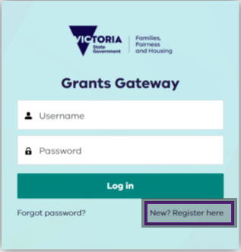Step 1. Register

*If you applied for a North Richmond  
  
Precinct Grant in the previous (2023)   
  
round, you are already registered.**If   
  
you can’t remember your password,   
  
enter your email address then click   
  
‘forgot password’.*

Otherwise, select **New? Register her****e**

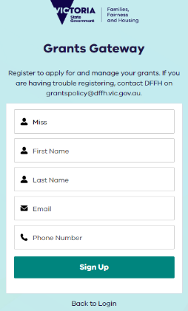Step 2. Enter details

Enter your details, and select **Sign Up.**

Step 3. Confirm email address

Check for a confirmation email for the registered account. Open your email inbox and search for subject line ‘Welcome to Grants Gateway’ [email from No Reply Salesforce](mailto:noreply@salesforce.com) [noreply@salesforce.com](mailto:noreply@salesforce.com)  
on behalf of Grants Gateway.

Confirmation email after registering for the Grants Gateway for the Victorian Governments Department of Families, Fairness and Housing. The email includes a link for the user to choose their password. 

Password setting page for access the Grants Gateway for the Victorian Governments Department of Families, Fairness and Housing. Outlines the password requirements and instructions set and confirm the password. 

Step 4. Choose password

Create a password for your account. The password must be:

* 13 characters
* 1 letter
* 1 number
* 1 special character

Confirm your password by retyping it and then select **Change Password.**

Congratulations! You now have access to Grants Gateway.

Navigating Grants Gateway

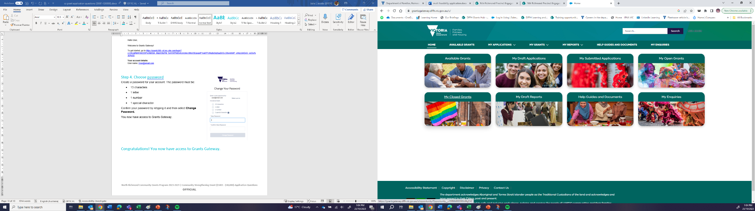

**3******

**2**

**1**

**4**

1. **Available Grants** – scroll through to find the North Richmond grant you are applying for.
2. **My Draft Applications** – this is where your application will be saved until you submit it.
3. **My Submitted Applications** – any previous grant applications you have submitted through Grants Gateway will be here.
4. **Help Guides and Documents** – resources to help you use Grants Gateway
5. **Available grants:** scroll through to find the North Richmond grant you are applying for.
6. **My draft applications:** where you application is saved until you submit it.
7. **My submitted applications:** previous applications you have submitted through Grants Gateway are saved here.
8. **Help guides and documents:** resources to help you use Grants Gateway.