

|  |
| --- |
| Aboriginal Children’s Forum  December 2024 |
| Communique |
|  |

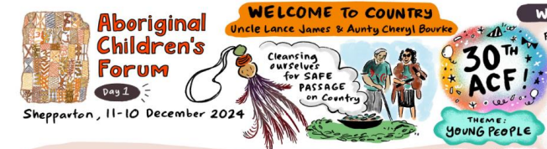

The 30th Aboriginal Children’s Forum (ACF) was held on Yorta Yorta country and hosted by the Rumbalara Aboriginal Co-operative (Rumbalara). On both days, Uncle Lance James and Aunty Cheryl Bourke warmly welcomed everyone to Country with a Smoking Ceremony.

This ACF was an opportunity to hear about Rumbalara’s strengths and so many of its successes, through the stories and case studies woven through the two days.The ACF’s theme of ‘young people’ drove robust discussions about how to engage with young people earlier, ensure they have a voice and are fully engaged with decisions that impact their future, and most importantly, are set up for a successful transition to adulthood. The video footage provided throughout the ACF by Rumbalara was a constant reminder of what can be achieved when Aboriginal organisations wrap services, support and culture around families.

Muriel Bamblett, CEO of the Victorian Aboriginal Child & Community Agency and Jason Kanoa, CEO of the Victorian Aboriginal Children & Young Peoples’ Alliance, set the tone for the two days reminding participants:

‘...you are who you are because you once were young. With the benefit of maturity, experience, wisdom and culture – informed by the contemporary lived experience of today’s young people – we will come up with ways of making a difference, not only to each individual Aboriginal young person, but to our collective future.’

Rumbalara’s CEO, Felicia Dean, and staff shared the journey of their Galnya Yarka program which is progressing well towards Aboriginal Children in Aboriginal Care (ACAC) authorisation. Like all ACAC programs, Galnya Yarka demonstrates the positive impact a culturally attuned approach can make for Aboriginal children and families. By the end of the 2024-25 financial year, the ACF will celebrate the capacity for 648 children to be placed with ACAC providers in both metropolitan and regional locations.

Hearing the voices of young people was powerful for ACF members and a reminder that we can never assume we know what is best. The ACF has made a commitment to establish a mechanism for the voice of young people to influence and impact the business of the ACF and the implementation of Wungurilwil Gapgapduir. Young people’s voices need to be heard through the forum and contribute to what we do.

The department was acknowledged for its work and the adaption of processes to better support the work of the ACF, the implementation of Wungurilwil Gapgapduir, and more broadly, Aboriginal self-determination. In particular, the responsiveness to produce and share data and information has helped to gain a common understanding of where we are at and enabled evidence-based decisions on where to focus future efforts.

The commitment to action by the Wungurilwil Gapgapduir signatories has never been stronger. The proposed Wungurilwil Gapgapduir Strategic Action Plan (2024 – 2028) will continue to drive the ACF agenda and shared collaboration and reform across the sector. This shared collaboration is a hallmark of the 30 ACFs that have been and will remain into the future.

|  |
| --- |
| To receive this document in another format, email Aboriginal Children’s Forum [Aboriginal.Childrens.Forum@dffh.vic.gov.au](mailto:Aboriginal.Childrens.Forum@dffh.vic.gov.au)  Authorised and published by the Victorian Government, 1 Treasury Place, Melbourne.  © State of Victoria, Australia, Department of Families, Fairness and Housing, March 2025  Except where otherwise indicated, the images in this document show models and illustrative settings only, and do not necessarily depict actual services, facilities or recipients of services. This document may contain images of deceased Aboriginal and Torres Strait Islander peoples.  In this document, ‘Aboriginal’ refers to both Aboriginal and Torres Strait Islander people. ‘Indigenous’ or ‘Koori/Koorie’ is retained when part of the title of a report, program or quotation.  **ISSN** 2982-3064 **- Online (pdf/word)**  Available at [DFFH Aboriginal Children’s Forum](https://www.dffh.vic.gov.au/aboriginal-childrens-forum) https://www.dffh.vic.gov.au/aboriginal-childrens-forum |