

|  |
| --- |
| Aboriginal Children’s Forum October 2022 |
| Communique  OFFICIAL |
|  |

# Communique

## Purpose

The 25th Aboriginal Children’s Forum (ACF) was held in-person on Wednesday 5 October and Thursday 6 October 2022, hosted by Mungabareena Aboriginal Corporation and the Department of Families, Fairness and Housing. The Minister for Child Protection and Family Services, the Hon. Colin Brooks attended both days of the Forum and gave a welcome speech on day two. This document contains key findings and topics of discussion from the ACF.

#### Wungurilwil Gapgapduir: Objective One Encourage Aboriginal children and families to be strong in culture and proud of their unique identity, with a focus on Early Help

Aboriginal culture and identity is a protective factor and a source of resilience and strength for Aboriginal children, families and communities. Cultural identity and cultural strengthening are vital for Aboriginal peoples’ health and wellbeing. Participation in cultural practice promotes social and emotional wellbeing and strengthens pride in Aboriginal identity.

Across the child and family services sector, it is critical to recognise the significant role of the Aboriginal voice in strengthening and maintaining culture for children and families. Respect for ancestors and Elders represents one aspect of Aboriginal culture and remains a vital part of modern cultural practice.

## Early Help

Early Help is one of the key reform pathways where collaboration is essential to support vulnerable families, to identify and respond early when children and families show early signs of need and vulnerability. It is vital that children and families have strong natural supports through their community and linked into universal services that provide the supports required in a culturally attuned way.

The Early Help pathway aims to support more people, more often – both early in need and early in life.

ACCOs have expressed their desire to be involved with vulnerable families at the earliest possible point to avoid entry into the child protection system. The ACF discussed new opportunities to link up longer term reforms with broader efforts to drive social and economic recovery and service delivery reform.

The Department of Families, Fairness and Housing, The Department of Health, The Department of Education and the Department of Justice and Community Safety came together with ACCOs to:

* Discuss what an agreed definition of early help means for the sector
* reflect on the current early help funding allocations, and
* plan how ACCOs can be involved with their community at the earliest possible opportunity to ensure that Aboriginal children and families receive the early help they need in a culturally safe and supported way.

Visual explanation of the ACF caucus group discussions.

Main headline: Caucus group discussions.

Column one: ACCOs. 
Early help can happen at any point.
Gaps with flexibility and soft entry.
Increase focus on leading the conversation.

Colum two: Government
Create a holistic definition.
It’s a busy space.
Place based. 
Join up funding.
Increase focus on listening to ACCOs. 
Increase focus on Aboriginal - led.

Colum three: CSOs
Basics: what do families need?
Definition needs to add prevention.
Join up to connect community!

## Closing the Gap

Over the past four years this Government has committed, through the Roadmap to Reform and *Wungurilwil Gapgapduir* to prioritise efforts to reduce the over-representation of Aboriginal children involved in child protection and out-of-home care.

We know, and evidence indicates, Aboriginal children do better when connected to culture and the Aboriginal community and every Aboriginal child must have the opportunity to learn, practice, thrive and pass on their culture. Connection to culture is widely regarded as key to providing good health and wellbeing outcomes for Aboriginal children, families, and communities.

Panel members spoke to reform priorities to steer a pathway towards Closing the Gap through initiatives identified in *Wungurilwil Gapgapduir*.

## Farewell

A farewell was held for both Raylene Harradine and Connie Salamone who are retiring from their current roles. Speeches were held and their significant achievements acknowledged.

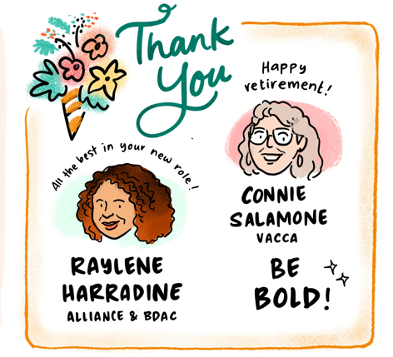

## Background

The Aboriginal Children’s Forum gives practical effect to the implementation and monitoring of [*Wungurilwil Gapgapduir: Aboriginal Children and Families Agreement*](https://www.dhhs.vic.gov.au/publications/wungurilwil-gapgapduir-aboriginal-children-and-families-agreement) <https://www.dhhs.vic.gov.au/publications/wungurilwil-gapgapduir-aboriginal-children-and-families-agreement> to promote the safety, health and resilience of Aboriginal children and young people, so they thrive and live in culturally rich and strong Aboriginal families and communities.

*Wungurilwil Gapgapduir* supports the government’s commitment to increase Aboriginal self-determination for Aboriginal people and is the foundation on how this government and the children and families sector will address the over-representation of Aboriginal children involved within the child protection system.