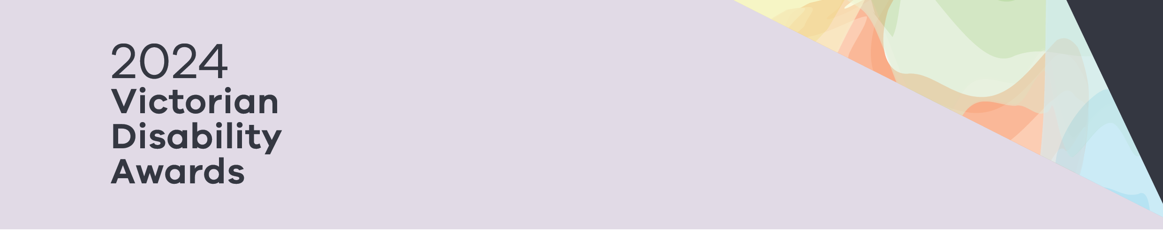

|  |
| --- |
| 2024 Victorian Disability Awards |
| Finalists |
|  |

Contents

Finalists – Advocacy for People 2

Finalists – Disability Pride Champion 2

Finalists – Leadership in Co-design 2

Finalists – Lifetime Achievement Award 2

# Advocacy for People

## Winner - Advocacy for People

**Terry Symonds and Matt Warren, Yooralla**

Terry and Matt designed a program for leaders with disability.

## Finalists – Advocacy for People

Uli Cartwright, Life is a Battlefield

Dr Jane Hickey, Victoria University

# Disability Pride Champion

## Winner – Disability Pride Champion

**Cameron Bloomfield, Rainbow Rights and Advocacy**

Cameron has been a positive role model for queer people with disability.

## Finalists – Disability Pride Champion

Melanie Lewis

Emily Unity, Children and Young People with Disability Australia

# Leadership in Co-design

## Winner – Leadership in Co-design

**Co-design for better access to mental health services, Monash Health**

Monash Health co-designed a website with people with disability.

## Winner – Leadership in Co-design

**Together, Youth Disability Advocacy Service (YDAS)**

YDAS made training that helps people with disability.

## Finalist – Leadership in Co-design

Peer Relationship Education Partners Program - Gippsland, Gippsland Centre Against Sexual Assault

# Lifetime Achievement Award

# Winner – Lifetime Achievement Award

**Heather Forsyth, Victorian Advocacy League for Individuals with Disability (VALID)**

Heather has advanced disability rights for more than 20 years.

# Finalists – Lifetime Achievement Award

Marita Baker, Guide Dogs Victoria

Phil Burgoine, Western Autistic School

|  |
| --- |
| To receive this document in another format, phone (03) 9285 3873, using the National Relay Service 13 36 77 if required, or email the Victorian Disability Awards on <awards@dffh.vic.gov.au>.  Authorised and published by the Victorian Government, 1 Treasury Place, Melbourne.  © State of Victoria, Australia, Department of Families, Fairness and Housing, December 2024.  Available at <https://www.dffh.vic.gov.au/2024-victorian-disability-awards> |